“How do we remember? Using three at least three, examples, discuss the social, political and historical aspects of commemoration”
How do we remember the fallen LGBT through memorial?
Cameron Ridgway
P149876
BA Graphic Design
1896 words
Tutor: Louise Burston

Before being able to comprehend the events of … it is first important to understand the foundations on which these were built. From holocaust victims to heroes fighting for equality, these lives were triumphant, deaths that were so tragic and all too often forgotten. Over time citizens have chosen to honour the fallen gay, lesbian, bisexual, and transgender (LGBT) individuals that history tried to leave behind. The LGBT acronym stands for lesbian, gay, bisexual and transgender members suffered fighting for their rights and freedom, and we as people today take for granted. All over the globe, memorials have been built to commemorate the fallen LGBT community from parks to public spaces, where people of all ages and backgrounds come together to show respect.
While historical, political, and social events have been commemorated throughout history, they do not always appear within that period- acts against gay men occurred in the mid 20th Century, but he memorial was not erected until 2008. By 1928 there was an estimated 1.2 million gay men living in Germany, and since Hitler’s rise to power in 1919, all gay organisations had been banned, and all books involving homosexuality were burnt (Dearden, 2017) The first major movement to note was in 1935 with the introduction of (Nazi Act).
Due to the racial state of Nazi Germany gays were branded as not ‘parasites’ but also seen as enemies to Germany. In 1935, (Dearden, 2017) Nazi government made homosexuality an act of criminalisation. Under the new law, police created the Pink List which led to a cruel crackdown on gay men and woman. Many were to be sent to mental institutions; by court order over 5,000 to 15,000 gay men and woman were sent to concentration camps, a Pink Triangle was to be placed on the prisoners marking that they were gay an estimate of over 55,000 gay men and woman were executed (Ridley, 2015). Even after concentrations camps liberated and Jewish victims were free and acknowledged, persecution of homosexuals post-war Germany. While there were many survivors tried to rebuilding lives, many still faced the social exclusion of the time, many that serviced were rearrested and still seen as deviants in the eyes of a post-war country.
Heinz Dormer was a German gay man who was imprisoned under Paragraph 175 by Nazis for homosexuality (Tatchell, 2015) contently being released and rearrested, spending nearly over ten years in institutions and concentration camps. Many survivors who had been liberated still often found themselves targets of society. Not welcomed back in their own homes for the ‘shame’ that they brought upon their family. Those who did return often kept the experience to themselves, some never even spoke of the suffering they endured.
Remembering the 55,000 deaths of the gay men and woman was something Germany did not do until recently, on May 27th 2008 Artists Michael Elmgreen and Ingar Dragset created the memorial to Homosexuals Persecuted Under Nazism the origins of the art piece began in parliament in 2003 after many campaigns by several LGBT charities to bring the recognition of the many homosexuals that suffered in the persecution and death in the time of Germanys darkest years (Breitenbach, 2018). This led to the discussion and the approval of the piece getting created.
The memorial piece is a cuboid creation made of concrete. It is a visually striking piece along the green that is surrounding it. There’s a small window that was cut out of the cube, inside a short video plays depicting two men kissing. But as many pieces this did come with some controversy, before it was created, over the many years there had been many who complained about the location being so close to the Jewish memorial. Many others see the memorial as too much, that the video that plays inside is too provoking for certain people of the public, whist some in the LGBT community appealed for footage depicting two women kissing as to remember that also lesbian woman was effect by what happened in Nazi Germany. Thankfully, the change was successful, and the footage now includes gay men and woman kissing.
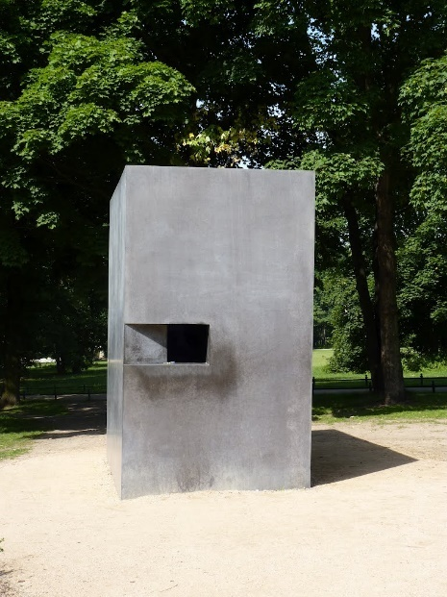
Figure 1. Michael Elmgreen and Ingar Dragset (2008) Homosexuals Persecuted Under Nazism, Berlin. [Four meters (13 feet): concrete]

Stonewall riots, also known as The Stonewall uprising, were riots consisting of a series of violent confrontations that began on June 28th, 1969 (Eastmond 2017) between police and gay rights activists outside Stonewall Inn, a gay bar which is found in Greenwich Village in New York. As riots progressed, a gay rights movement was born. In 1969 homosexual acts were illegal in New York. Gay bars were a place of sanctuary for gay, lesbian and transgendered people to socialize without fear of public harassment. However, many of those bars weren’t save from the harassment of the police. During the early hours of Saturday, nine police officers raided the Stonewall Inn, arresting employees, gays, lesbians and drag queens, the state of New York authorised that anyone not wearing at least three pieces of gender appropriate-clothing was to be taken into custody. (Worthen, 2017)

Peoples anger was seen and vocal as people watched their community being forced into police vans. The final straw was when a scuffle between a police officer and Storm Delarverie, she was arrested for being a lesbian, was hit over the head by an officer and thrown into a van, this ignited the anger, even more, bottles, bricks, and bins, anything people could find was thrown (Robertson 2017)
Larger groups of gays and others off the street came together and over 400 people rioted. The police were not expecting or prepared for the power of the LGBT community to fight back or for people outside the community to help fight on their side. The riot ended at 4am in the morning, the Stonewall Inn was trashed from windows to pay phones. 13 people was arrested and many more hospitalised. Stonewall was the first incident that gay, lesbian and transgendered people coming together for civil rights and feminist movements (Worthen, 2017) The riots became a galvanising force in LGBT.
The Gay liberation monument is four sculptures created by George Segal was commissioned in 1979 (Finkelstein 2016) In honour of the gay right movement at the Stonewall Inn opposite of the park the sculptures stand, the land in which thousands rioted became the symbol of modern gay liberty. The monument consists of two standing males with one with his hand on the others shoulder and two seated females on a bench, with one of the females having her hand on the other female’s thigh. The simple gestures strike people today as innocent, but enough to trouble the neighbourhood in which they stand. The sculptures were created using a process of plaster moulds, from human models, painted with a white lacquer, resulting into something hauntingly beautiful, drawing an audience towards the work. (Ryan 2016)
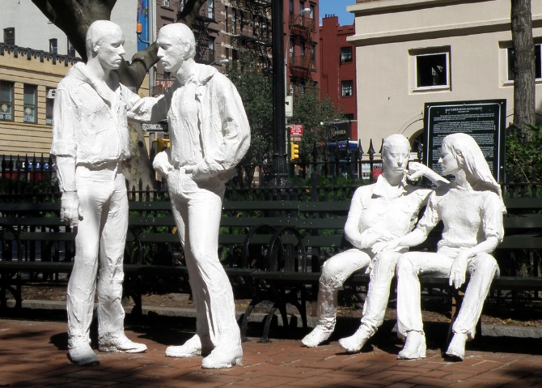
Figure 2. George Segal (2008) The Gay liberation monument, Adjoining Sheridan Square, Christopher, Grove and West 4th Streets [H: 5'11" W: 16): Figures--bronze (white lacquer); benches--steel (black paint)

In 1981 the beginning of the HIV/AIDs crisis started in the US/UK, gay/bisexual men made most of the aids epidemic many being particularly young African Americans men (France 2016) To this day HIV/AIDS continues to be one of the biggest health crisis to affect a community. The gay community was given no mercy during the start of the HIV/AIDS crisis. Since there was very little care offered, during the 1980s, there was little understood about the virus, the misinformation along with the heavy homophobia was at a large. HIV/AID was given the name the “gay plague” (Clews 2014) pointing out that this was spread by men who had sex with other men. For six months in 1982, the virous was given falsely labelled “Gay Related Immune Deficiency”. Over, 35 million people worldwide have died because of HIV/AIDS since 1980 (McNeill, 1998)

Homophobia was a large aspect that played along within the AIDS crisis in the 80s, in the US gays and lesbians were openly discriminated against in every aspect of their life, Homophobia was still a dominant social reality. HIV/AIDS became a pollical tool, against gay men a target for political, fear, misunderstanding and discrimination. With each of the passing months, more death and suffering became increasing at an arming rate. The idea for the memorial quilt was brought to the tables in 1985 by gay rights/AIDS activist Cleve Jones during a candlelight march in remembrance for Harvey Milk and George Moscone both who were assassinated in 1978 (Teeman 2017) He wrote the names of loved one who lost their lives due the HIV/AIDS crises on signs and taped on San Francisco’s Federal building, because of this the building looked like a large patchwork and that is when he became inspired. It was first brought to the table by, Cleve Mike Smith and many other volunteers. During this time many of the people who had died of HIV/AIDS did not receive any funerals, due to the homophobia and the stigma that came along with HIV/AIDS and the refusal of many funeral home was felt by the surviving family of the lost lives of their loved ones.

The memorial quilt was first displayed on the National mall, Washington, DC, October 11th, 1987, during the lesbian and gay right march more than 20,000 attended the parade (Jones 2016). During 1988 the memorial quilt went on tour and displayed in 20 different cites, raising over $500,000 for HIV/AIDS organisations (Jones 2016). Each time the quilt returned over the years, the quilt would grow bigger. Each of the panels are different, featuring love letters, painting, photographs from friends, families and lovers. The quilt was nominated for a Nobel Peace prize in 1989 and has been viewed by over 15 million people (Smith 2012). The quilt was an opportunity for survivors and family to remember and to celebrate the lives of their loved ones. The goal of this was to bring attention and awareness to show how the HIV/AIDS crisis was, this brought the support and healing to the people effect that the government failed to do. From 1996 over $1.7 million has been raised and still to this day the affect of the quilt continues (Norman, 2012)
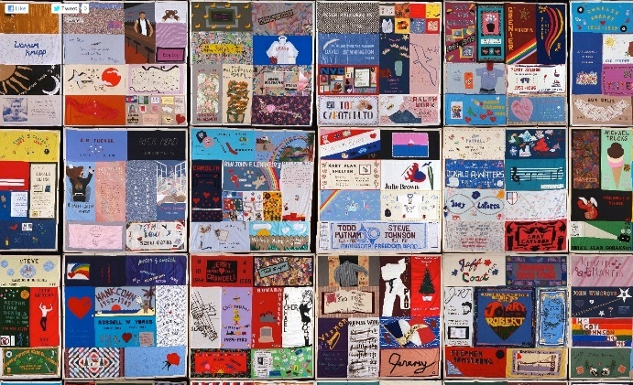
Figure 3 Cleve Jones (1985) NAMES Project AIDS Memorial Quilt, Washington, 3' by 6' panel of fabric, Fabrics, e.g. lace, suede, leather, mink, taffeta, also Bubble Wrap and other kinds of plastic and even metal.

Even though all these of these memorials are different from one other, they all share something important. They represent pain, emotion, loss, anger, sadness, from mass persecution, HIV/AIDS to the first brick thrown all these are reminder to people that we as community had no intention of giving up.
Sometimes Remembering can be a painful thing but remembering the past should be one of the reasons why a spear our time at every memorial we see, but it’s important to think that because of these memorials the victims and heroes continue to live on through people and history a collection of meanings, emotion, memories and symbols. All three of these memorials they’ve done one thing, they brought and continue to bring a community together though it darkest times.

Bibliography

Book
France, David (2016) How to Survive a Plague, UK: Pan Macmillan, Picador.

E- Book
Haacker, Markus (2016) The Economics of the Global Response to HIV/AIDS. Available at: http://www.oxfordscholarship.com.ezproxy.uwtsd.ac.uk/view/10.1093/acprof:oso/9780198718048.001.0001/acprof-9780198718048 (Accessed:26.02.18)

Websites:
Breitenbach,Dagmar (2018) New film for Berlin's memorial to commemorate persecuted homosexuals, DW. Available at: http://www.dw.com/en/new-film-for-berlins-memorial-to-commemorate-persecuted-homosexuals/a-42124314 ( Accessed:05.01.2018)

Bush, Lawrence (2012) JUNE 9: GEORGE SEGAL'S PUBLIC ART, Jewish Currents. Available at: http://jewishcurrents.org/june-9-george-segals-public-art/ (Accessed: 04.02.2017).

Colin Clews (2014) 1980s. HIV/AIDS: Why was AIDS called ‘the gay plague’?, gayinthe80s. Available at:http://www.gayinthe80s.com/2014/04/1980s-hivaids-why-was-aids-called-the-gay-plague/ (Accessed: 24.02.2018)

Cleve, Jones (2016) How one man’s idea for the AIDS quilt made the country pay attention, The Washington Post. Available at:https://www.washingtonpost.com/national/health-science/how-one-mans-idea-for-the-aids-quilt-made-the-country-pay-attention/2016/10/07/15917576-899c-11e6-b24f-a7f89eb68887_story.html?utm_term=.af9f63d894e0 (Accessed:24.02.18)

Dearden, Lizzie (2017) Germany to officially pardon 50,000 gay men convicted under Nazi-era law criminalising homosexuality, Independent Available at http://www.independent.co.uk/news/world/europe/germany-pardon-gay-men-50000-nazi-law-criminalising-homsexuality-west-paragraph-175-adolf-hitler-a7643656.html (Accessed:02.03.18)
Dunst, Charles (2017) The Forgotten Gay Holocaust, Huffington Post. Available at: https://www.huffingtonpost.com/entry/the-forgotten-gay-holocaust_us_58f12cd2e4b0156697224f1e (Accessed: 01.12.2017).
Dale (n.d) Remembering The Persecuted-Memorial To LGBT Community In Berlin, Slow Vegan Travel. Available
Eastmond, Dean (2017) What the Stonewall Riots Were Like, Teen Vouge. Available at: https://www.teenvogue.com/story/what-it-was-like-night-of-stonewall-riots ( Accessed: 20.02.18)

Finkelstein,

Avram & Ryan, Hugh (2016) Ten Queer Reimaginings of New York's 'Gay Liberation Monument', Vice. Available at: https://www.vice.com/en_uk/article/mgv9b4/ten-queer-reimaginings-of-new-yorks-gay-liberation-monument ( Accessed: 10.03.2018)
History.com (2018) The Stonewall Riots begin. History.com. Available at http://www.history.com/this-day-in-history/the-stonewall-riot (Accessed: 29.11.2017).
Norman, Brett After 22 years, AIDS meeting in D.C., Politico. Available at: https://www.politico.com/story/2012/07/after-22-years-aids-conference-comes-to-dc-078829 (Accessed: 12.12.2017)
Ridley, Louise (2015) The Holocaust's Forgotten Victims: The 5 Million Non-Jewish People Killed By The Nazis, HuffPost. Available at: http://www.huffingtonpost.co.uk/entry/holocaust-non-jewish-victims_n_6555604 (Accessed: 27.01.2017)
Stop-homophobia (n.d) The Gay Holocaust. Stop-homophobia. Available at: http://www.stop-homophobia.com/thegayholocaust.htm (Accessed: 29.11.2017).

Smith, K. Annabelle (2012) Unfolding the AIDS Memorial Quilt at the Folklife Festival, Smithsonian. Available at:https://www.smithsonianmag.com/smithsonian-institution/unfolding-the-aids-
memorial-quilt-at-the-folklife-festival-155695/ (Assessed: 24.02.18)
Tatchell, Peter (2015) The Nazi war on gay people, Jewish News. Available at:http://jewishnews.timesofisrael.com/peter-tatchell-nazi-war-gay-people/ (Accessed: 04.02.2018)
Teeman,Tim (2017) Cleve Jones on Harvey Milk. ‘When We Rise’, and Fighting for LGBT Equlity Under Trump, Daily Beast. Available at: https://www.thedailybeast.com/cleve-jones-on-harvey-milk-when-we-rise-and-fighting-for-lgbt-equality-under-trump (Assessed: 24.02.18)
Walk About New York (2017) The Gay Liberation Monument. Walk About New York. Available at: https://walkaboutny.com/2017/06/25/the-gay-liberation-monument/ (Accessed: 02.12.2017).
Wockner, Rex (2008) Berlin Gay Holocaust Memorial Vandalized, QX. Available at : https://www.qx.se/english/7858/berlin-gay-holocaust-memorial-vandalized/ (Accessed: 05.12.2017)
Worthen, Meredith (2017) Stonewall: The People, the Place, and the Lasting Significance of "Where Pride Began", Biography. Available at: https://www.biography.com/news/stonewall-riots-history-leaders (Accessed: 04.02.2018)

