
Module Name: Marketing Management
Module Code: LCMB7024
Developing A Sustainable Brand Extension Strategy for Starbucks: EcoSip Smart Tumbler
Student Name: Humbal Shivani Gagubhai
Student Id: 2544428

Table of Contents
Element 1: Sustainable Brand Extension Poster 3
Element 2: Segmentation, Targeting, Differentiation and Positioning (STDP) Analysis 3
2.1 Segmentation 3
2.2 Targeting 5
2.3 Differentiation 7
2.4 Positioning 8
Element 3: Marketing Mix (4Ps) 10
Element 4: Reflection 13
References 16
Appendix: Element 1 Content 19

Element 1: Sustainable Brand Extension Poster

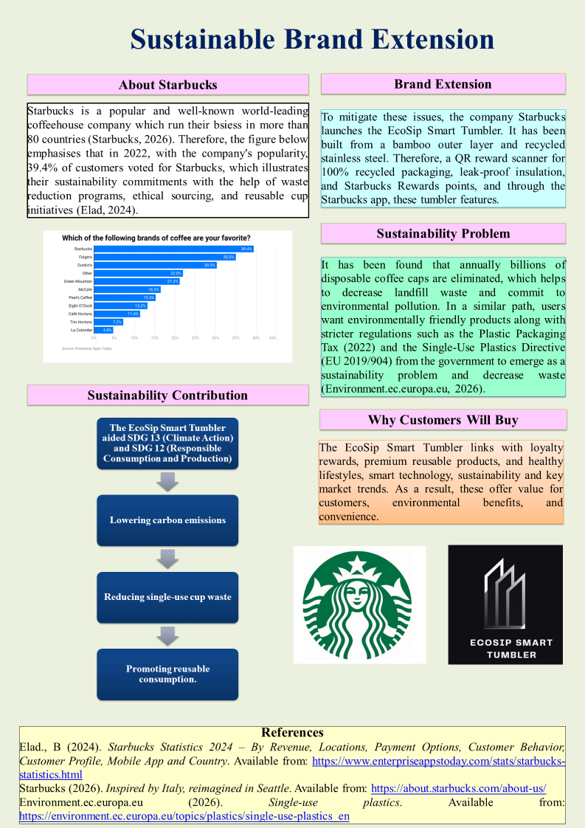

Element 2: Segmentation, Targeting, Differentiation and Positioning (STDP) Analysis

2.1 Segmentation
Helmold (2022) emphasised that market segmentation separates a market into different groups of users who have the same kind of behaviours, characteristics, and needs. Therefore, the company Starbucks for the EcoSip Smart Tumbler is able to segment the market by utilising the behavioural, psychographic, demographic and geographic variables.
Segmentation Variable | Characteristics | Relevance to EcoSip Smart Tumbler
Geographic | - Urban cities,  - University towns,  - business districts,  - Countries with the Starbucks app, found in South Korea, Japan, Canada, the UK and the USA. | - High Starbucks store density,  - Strong sustainability awareness,  - Digital adoption aided product demand.
Demographic | - Age 18–40,  - Upper- and middle-income consumers,  - Students,  - Professionals,  - Remote workers,  - Coffee enthusiasts | - Users possess purchasing power  - Continuously purchase coffee products (Alsafra et al. 2022).
Psychographic | - Environmentally conscious,  - Technology enthusiasts,  - Premium lifestyle seekers,  - Health-conscious consumers,  - Ethical buyers | - Product links with wellness goals, sustainability values, and digital lifestyles.
Behavioural | - Frequent Starbucks customers,  - Rewards members,  - Reusable cup users,  - High app engagement,  - Daily coffee drinkers (Mazeaud et al. 2022) | - Adopt EcoSip for the reason of regular usage habits and loyalty programme implementations (Chitez et al. 2025).
Table 1: Market Segmentation for Starbucks EcoSip Smart Tumbler
(Source: Self-developed)
Analysis
From the table it has emphasised that companies target consumers are the campus town, urban social, and business centre, which are the areas where Starbucks typically has strong footing. Besides that, Korea, Canada, UK, Japan, and the US are attractive markets where there is high Starbucks app usage, increasing environmental awareness and smartphone ownership. Moreover, the target market segment is the market which is based on the age group of 18-40 years old with upper to middle income people. As a result, this group includes freelancers, young executives, and university students, and those who take regular coffee with a tendency to spend premium prices for superior products (Silalahi and Novenson, 2024). These are consumers who are socially conscious and spend in a long term alternative for their everyday use. Apart from that, the item appeals to an environment-minded consumer concerned about waste reduction and those looking to aid sustainable manufacturers. This helps to raise the company profitability and eliminate waste from society.

2.2 Targeting
The company Starbucks must integrate a differentiated targeting strategy, which will permit the company to address several customer segments while tailoring value propositions to their specific needs.
Target Segment | Age | Characteristics | Reason for Selection
Primary Target | 22–35 | - Young professionals | - High purchasing power,  - frequent coffee consumption,  - strong digital engagement (XUAN, 2025)  - sustainability awareness
Secondary Target | 18–25 | - University students | - Technology-oriented,  - environmentally conscious,  - active social media users
Tertiary Target | 28–40 | - Eco-conscious millennials | - Strong commitment to ethical purchasing behaviour and sustainable consumption (Lim et al. 2023).
Table 2: Target Market Selection
(Source: Self-developed)
Analysis
The main Target Market is divided in ages between 22- 35. This offers high potential for its willingness to adopt busy lifestyles and purchasing power to include premium sustainable products. Therefore, university students emerge as a good Secondary Market since they are very active in Digital technologies and aided sustainability brands (XUAN, 2025). Finally, the Eco-friendly Millennials is the target audience as many Millennials live in a green minded mindset and want sustainable products.

2.3 Differentiation
Differentiation empowers the company Starbucks to develop a different competitive advantage across the reusable drinkware market.
Competitor | Sustainability Features | Smart Technology | Starbucks Rewards Integration | Hydration Tracking
Generic Reusable Bottle | Moderate | No | No | No
Standard Tumbler | Limited | No | No | No
Stanley | High | No | No | No
Yeti | High | No | No | No
Starbucks EcoSip Smart Tumbler | High | Yes | Yes | Yes
Table 3: Competitive Differentiation Analysis
(Source: Self-developed)
Analysis
From the table it has emphasised that conventional reusable tumblers offer a primary functionality though they have upgraded smart technological features. Besides that, the generic reusable bottles have provided durability and it has not connected the user within larger brand eco systems. Therefore, the premium competitors like Yeti and Stanley provide insulated drinkware with high quality, in contrast, they do not offer the company direct app connectivity, hydration tracking, or Rewards integration.
On the other hand, the EcoSip Smart Tumbler crete differentiation incorporating the temperature monitoring and hydration tracking where smart technology is included. Besides that, the QR reward scanner also helps to connect loyalty rewards with sustainable behaviour (Dessie, 2025). As a result, these different features develop advanced customer value when raising the Starbucks customer loyalty and brand equity.

2.4 Positioning
Positioning is the way users feel a product is relative to other similar products. Therefore, EcoSip Smart Tumbler's which is a high quality long term smart drink water solution which raises convenience while aided environmentally responsible consumption.
Positioning Statement
It is stated that the environmentally conscious coffee users want smart technology and convenience, as a result the Starbucks EcoSip Smart Tumbler which is an advanced drinkware solution mixes exclusive Starbucks Rewards, digital innovation, and sustainability and assist the users to decrease the waste when raise their coffee experience.
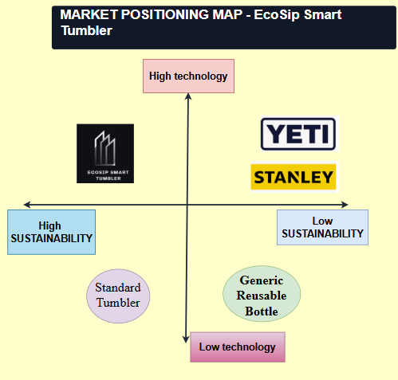
Figure 1: Positioning Map
(Source: Self-developed)
These positioning maps emphasised that these products become able to occupy a different market position which is characterised through the high technological innovation and high sustainability. As a result, these differentiations empower the company Starbucks to reply instantly to the enhancing user’s requirements for connected and sustainable products and it will raise the user’s loyalty with the help of its rewards ecosystem.

Element 3: Marketing Mix (4Ps)
Marketing Mix provides a strategic framework that enables organisations to align with organisational objectives and consumers' needs that support business growth and strengthen consumer value. 4Ps marketing mix has been applied to the Starbucks EcoSip Smart Tumbler case for supporting its sustainable brand extension and competitive position.
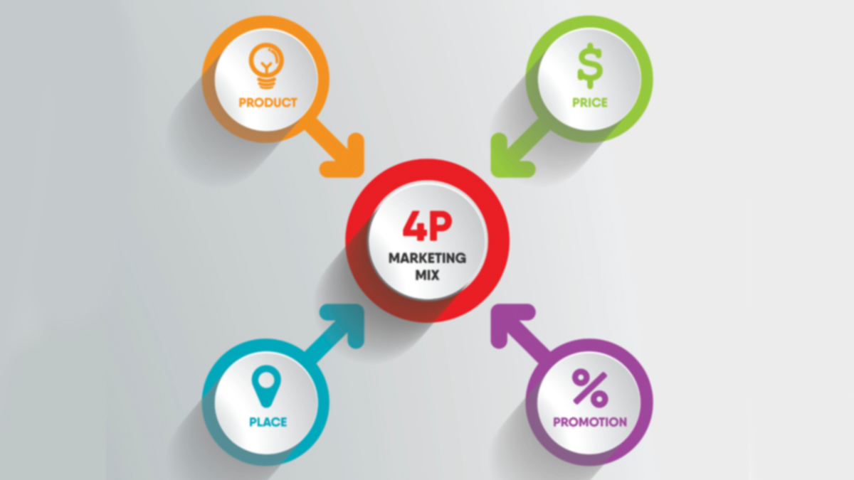
Figure 2: 4P Marketing Mix
(Source: Creative-solution, 2026)

Product:
Starbucks EcoSip Smart Tumbler product strategy has been designed making well-alignment between its sustainability objectives and consumer value. The core product for consumers is gaining the benefits of a sustainable and convenient way to enjoy beverages. Single-use coffee cup reduction from this alternative is also effective for minimising waste and protect environmental degradation. Starbucks is highly committed to adopting more sustainable approaches in its operations that enable it to reduce its carbon and waste footprint by 50% by 2030 (Starbucks, 2026). Its sustainability product offering thus aligns well with its sustainability commitment and meets consumer preferences. The premium reusable smart tumbler is the actual product in Starbucks’ operation. Recycled stainless steel with a bamboo exterior is used in this product. This product is effective for achieving environmental value, offering durability and ensuring an attractive appearance. In Starbucks’ mobile application, there is the integration of a digital temperature display that helps in monitoring beverage temperature and a smart hydration sensor that gives reminders to consumers and promotes healthier drinking habits.
Automatic Starbucks Rewards can be gained through a QR code scanner. This tumbler also helps keep drinks hot for 12 hours and cold for 24 hours. Augmented product is its value-added services, which help it in strengthening consumer experience and increasing their active engagement in business. Starbucks, throughout its overall operation, successfully embedded sustainability that enables it to strengthen its positive brand image (Mehrad et al., 2024). Virgin materials dependence is reduced when there is the use of renewable bamboo and recycled stainless steel. Extension of product lifecycle and disposable cup consumption reduction is supportive for progressing towards a circular economy. However, additional cost burden may be experienced by the firm with the use of smart technology in its business. Overall, an innovative product offering at Starbucks supports it in strengthening its market position and sustaining long-term growth.
Price:
A premium value-based pricing strategy is valuable for brands in strengthening brand image and attracting high-value and conscious consumers. Therefore, this pricing approach is recommended to be adopted at Starbucks for its EcoSip Smart Tumbler product. Quality offering, innovation and sustainability priority in Starbucks’ operation enable it in maintaining a positive brand image (Singh et al., 2024). A strong global brand image is supportive for charging US$55–65 for its products. Use of recycled materials, smart technology and reward integration in the proposed strategy reflects that consumers can receive greater value from its offering. Under this pricing approach, the focus is on consumer value rather than only prioritising cost of production. However, competition can be expected as there is the availability of a wide range of premium reusable drinkware brands such as Stanley and MiiR (Grandviewresearch, 2026). Differentiation and premium position can be maintained with the offering of the EcoSip Smart Tumbler that adds hydration tracking and automotive rewards features. Consumers like first-time buyers, students and middle-class families are price-sensitive, which can discourage them from using Starbucks’ products. This limitation can be addressed by the brand by introducing discounts and bundle offerings into operation. Consumers receiving benefits in product trials may be encouraged to repeat buying even at a premium price in offering. This approach is supportive for strengthening consumer value and maintaining a higher level of profitability in operation.
Place:
An omnichannel approach for distribution of EcoSip Smart Tumbler needs to be adopted at Starbucks’ operation so that consumers easily receive its products. A seamless purchasing experience encourages consumers to make repetitive purchases from the business (Darvidou, 2024). In Starbucks stores, the availability of products enables consumers for experiencing its features. Besides that, impulse purchases alongside beverage orders enhance its store operation. Besides retail stores, digital channels selling is equally important in today’s dynamic and competitive business market. Starbucks need to ensure that through its official website and mobile application, consumers can easily purchase the EcoSip Smart Tumbler. Convenient service and availability of product information and associated benefits are effective for capturing the attention of consumers, especially younger generations like Millennials and Gen Z (Zamborita et al., 2024). There is also a requirement of ensuring seamless ordering, real-time delivery and secure payment option for becoming the first choice for buying. In order to increase market reach, there is also a requirement making strategic partnership with e-commerce platforms like Amazon. Reusable and portable drinkware must also be available at university stores and airport stores so that students and frequent travellers can receive it. In comparison to a single sales channel, this approach is supportive for the sustainable growth of Starbucks.
Promotion:
A consistent brand message for EcoSip Smart Tumbler can be carried out by Starbucks with its successful implementation of an Integrated Marketing Communications (IMC). Traditional and digital brand messages are well-aligned under IMC. In gaining unified consumer experience, this is supportive for consumers (Jusuf, 2024). "Sip Smart. Reuse More." this tagline is used during campaigns and is supportive in capturing the attention of a wide range of consumers, especially eco-conscious consumers. In today’s digitally driven business environment, the use of social media tools like YouTube, Instagram, Facebook and TikTok is useful. Brand credibility can be strengthened by posting sustainable and innovative features of the product (Li and Lin, 2024). Personalised offering through app notifications and email marketing is effective for strengthening consumer value of consumers and increasing active engagement of consumers. "Bring Your Cup Challenge" can be another effective campaign approach that can be adopted at Starbucks’ operations. Under this campaign, when consumers share their positive experience of using a reusable cup, using build interest among other consumers to use those. Moreover, awareness through digital media is supportive for building sustainable behaviour among consumers and increasing their engagement and strengthening loyalty level for the brand. In Starbucks’ sustainability offering, IMC supports it in achieving long-term sustainable growth.

Element 4: Reflection
Description
My participation in developing the Starbucks EcoSip Smart Tumbler as a brand extension was a fantastic experience to apply marketing theories to a product. The task involved analyzing the sustainability issues faced by Starbucks and coming up with a novel idea for a product that would be consistent with the brand ethos of the company and its plans. I had to prepare a promotional poster and a presentation to present my idea effectively. In this process, I used the STDP model and the marketing mix to come up with a marketing strategy based on Gibbs' Reflective Cycle.
Feelings
At the start of the project, I had some doubts regarding the development of a sustainable product that was innovative and also profitable. The balance of environmental sustainability on one hand and customers' needs and profitability on the other seemed tough to manage. Also, I had some reservations regarding my ability to communicate my thoughts effectively in the limited time frame provided. However, I have gained confidence in my strategies by analyzing academic material and sustainability efforts by Starbucks.
Evaluation
This assignment provided me with an opportunity to learn many important things. The use of STDP made it easier for me to understand the concept of market segmentation, targeting, and positioning, and the marketing mix that combines product, price, place, and promotion in one marketing strategy (Mahohoma and Agbenyegah, 2025). However, sustainable marketing and digital customer engagement were also issues on which I gained more knowledge. Nevertheless, time management, poster design and presentation still posed challenges for me.
Analysis
Through this project, I learned about brand development, consumer behavior, and sustainability impact marketing strategy. Whereas I realized that any effective brand extension should not only be in line with the original brand but also reflect changes in customer expectations (Keller, 1993). In addition, studying consumer needs helped me identify growing customer preferences toward environmental products with technological innovation. It was beneficial for me to rely on academic literature when making certain strategic decisions, as this helped develop my critical thinking skills and made me understand that sustainable marketing could benefit everyone (Elkington, 1998).
Conclusion
This assignment provided me with an understanding of the concept of strategic marketing planning, brand management, and decision-making through evidence. I gained confidence in applying marketing theories in the context of business. It helped in improving my skills such as research, communication, and critical thinking. Preparing the poster and presentation has taught me the significance of communicating the marketing strategy. The integration of sustainability and technology proved helpful for the branding process.
Action Plan
For the improvement of my future performance, I will make efforts to improve my presentation skills through practice and getting constructive feedback. In addition to this, I will try to improve my Canva design skills so that I can develop my marketing designs engagingly. Additionally, I would like to integrate peer-reviewed literature along with critical analysis in my academic work. Moreover, I will also focus on sustainable marketing and digital innovation for better strategic decision-making.

References
Alsafra, Z.,et.al, 2022. Consumption habits and brand loyalty of Belgian coffee consumers. Foods, 11(7), p.969. https://www.mdpi.com/2304-8158/11/7/969
Chitez, C.F.,et.al, (2025), April. ‘The Factors Influencing Customer Loyalty in UK-Based Coffee Businesses’. In International Conference on Business and Technology (pp. 557-570). Cham: Springer Nature Switzerland. https://myresearchspace.uws.ac.uk/ws/files/62315735/2025_04_02_Florin-Chitez_et_al_Loyalty_accepted.pdf
Creative-solution (2026). 4P Marketing Mix. Available from: https://creative-solution.com/4-ps-of-marketing-mix/ (Accessed July 29,2026)
Darvidou, K., (2024). ‘Omnichannel marketing in the digital age: Creating consistent, personalized and connected customer experiences’. Technium Business and Management, 10, pp.34-54. https://pdfs.semanticscholar.org/1c59/2a4545a5e7968b709784a9016395e35c86a6.pdf
Dessie, T., (2025). ‘Designing Personalized Coffee Experiences in Modern E-commerce for Enhanced User Engagement and Sales’. https://www.theseus.fi/bitstream/handle/10024/891941/Dessie_Tewodros.pdf?sequence=2
Elad., B (2024). Starbucks Statistics 2024 – By Revenue, Locations, Payment Options, Customer Behavior, Customer Profile, Mobile App and Country. Available from:https://www.enterpriseappstoday.com/stats/starbucks-statistics.html (Accessed July 29,2026)
Elkington, J., (1998). ‘Partnerships from cannibals with forks: The triple bottom line of 21st‐century business.’ Environmental quality management, 8(1), pp.37-51. https://proppg.ufersa.edu.br/wp-content/uploads/sites/11/2016/10/Referencia-de-Lilian-Giesta-Triple-bottom-line-in-21-century-2.pdf
Environment.ec.europa.eu (2026). Single-use plastics. Available from: https://environment.ec.europa.eu/topics/plastics/single-use-plastics_en
Grandviewresearch (2026). Reusable Water Bottle Market (2026 - 2033). Available from: https://www.grandviewresearch.com/industry-analysis/reusable-water-bottle-market (Accessed July 29,2026)
Helmold, M., (2022). ‘Market segmentation, targeting, differentiation and positioning’. In Performance Excellence in Marketing, Sales and Pricing: Leveraging Change, Lean and Innovation Management (pp. 105-116). Cham: Springer International Publishing. https://link.springer.com/chapter/10.1007/978-3-031-10097-0_10
Jusuf, D.I., (2024). ‘Integrated Marketing: A Powerful Strategy for Increasing Brand Awareness’. Best Journal of Administration and Management, 2(3), pp.104-109. https://internationalpublisher.id/journal/index.php/Bejam/article/download/149/159
Keller, K.L., (1993). ‘Conceptualizing, measuring, and managing customer-based brand equity.’ Journal of marketing, 57(1), pp.1-22. https://www.academia.edu/download/61822590/Keller20200118-72367-159uocs.pdf
Li, Y.F. and Lin, F.S., (2024). ‘Exploring design strategies for cultivating sustainability and enhancing brand image in personal care product brands’. Sustainability, 16(6), p.2476. https://www.mdpi.com/2071-1050/16/6/2476
Lim, M.Y., Robb, D.A., Wilson, B.W. and Hastie, H., (2023), ‘August. Feeding the coffee habit: A longitudinal study of a robo-barista’. In 2023 32nd IEEE International Conference on Robot and Human Interactive Communication (RO-MAN) (pp. 1983-1990). IEEE. https://arxiv.org/pdf/2309.02942
Mahohoma, N. and Agbenyegah, A.T., (2025). ‘The impact of the 4Ps marketing mix on Durban's Micro and Small Enterprises.’ International Journal of Business Ecosystem & Strategy (2687-2293), 7(2), pp.67-74. https://bussecon.com/ojs/index.php/ijbes/article/download/593/424
Mazeaud, S.,et.al, (2022). ‘Coffee drinking and adverse physical outcomes in the aging adult population: a systematic review’. Metabolites, 12(7), p.654. https://www.mdpi.com/2218-1989/12/7/654
Mehrad, A., Adiewere, F.C., Bouzedif, M. and Rweramila, N.G., (2024). ‘A Case Study of Starbucks in Spain: Sustainable Operations Management’. European Journal of Management Issues, 32(3), pp.139-145. https://mi-dnu.dp.ua/index.php/MI/article/download/468/343
Silalahi, R.V. and Novenson, N., (2024). ‘Unlocking customer loyalty in Indonesian local coffee shops: An in-depth analysis of the influential factors’. Jurnal Manajemen Bisnis, 15(2), pp.419-446. https://journal.umy.ac.id/index.php/mb/article/download/22441/9647
Singh, P., Chaturvedi, M. and Mittal, S., (2024). ‘Starbucks: Brewing a Successful Global Strategy’. LEADERSHIP ETHICS, p.161. https://www.bhartipublications.com/chapters/ethical-leadership.pdf#page=171
Starbucks (2026). BECOMING RESOURCE POSITIVE. Available from: https://www.starbucks.ca/responsibility/planet/ (Accessed July 29,2026)
Starbucks (2026). Inspired by Italy, reimagined in Seattle. Available from: https://about.starbucks.com/about-us/
XUAN, L.L., (2025). ‘EXPLORING THE INFLUENCE OF LOYALTY PROGRAMS ON CUSTOMER LOYALTY AMONG UNIVERSITY STUDENTS IN MALAYSIA’. http://eprints.utar.edu.my/7606/1/2305128_Liew_Lok_Xuan_LIEW_LOK_XUAN_1.pdf
Zamborita, D.Z., Muflikh, Y.N. and Burhani, A.M.A.I., (2024). ‘Purchasing decisions and consumer preferences of millennials and zoomers at Coffee Shops’. Journal of Consumer Sciences, 9(1), pp.102-121.

Appendix: Element 1 Content
About Starbucks
Starbucks is a popular and well-known world-leading coffeehouse company which runs their business in more than 80 countries. Therefore, the figure below emphasises that in 2022, with the company's popularity, 39.4% of customers voted for Starbucks, which illustrates their sustainability commitments with the help of waste reduction programs, ethical sourcing, and reusable cup initiatives (Elad, 2024).
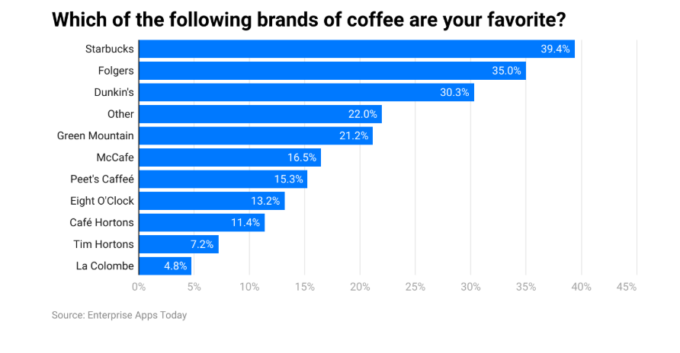
Figure 1: Starbucks Statistics
(Source: Elad, 2024)
Sustainability Problem
It has been found that annually billions of disposable coffee caps are eliminated, which helps to decrease landfill waste and commit to environmental pollution. In a similar path, users want environmentally friendly products along with stricter regulations such as the Plastic Packaging Tax (2022) and the Single-Use Plastics Directive (EU 2019/904) from the government to emerge as a sustainability problem and decrease waste.
Brand Extension: Starbucks EcoSip Smart Tumbler
To mitigate these issues, the company Starbucks launches the EcoSip Smart Tumbler. It has been built from a bamboo outer layer and recycled stainless steel. Therefore, a QR reward scanner for 100% recycled packaging, leak-proof insulation, and Starbucks Rewards points, and through the Starbucks app, these tumbler features.
Why Customers Will Buy
The EcoSip Smart Tumbler links with loyalty rewards, premium reusable products, and healthy lifestyles, smart technology, sustainability and key market trends. As a result, these offer value for customers, environmental benefits, and convenience.
Sustainability Contribution
The EcoSip Smart Tumbler aided SDG 13 (Climate Action) and SDG 12 (Responsible Consumption and Production) through lowering carbon emissions, reducing single-use cup waste, and promoting reusable consumption.

