

University of Wales Trinity Saint David
School of Engineering

Transportation Container for
Vaccines
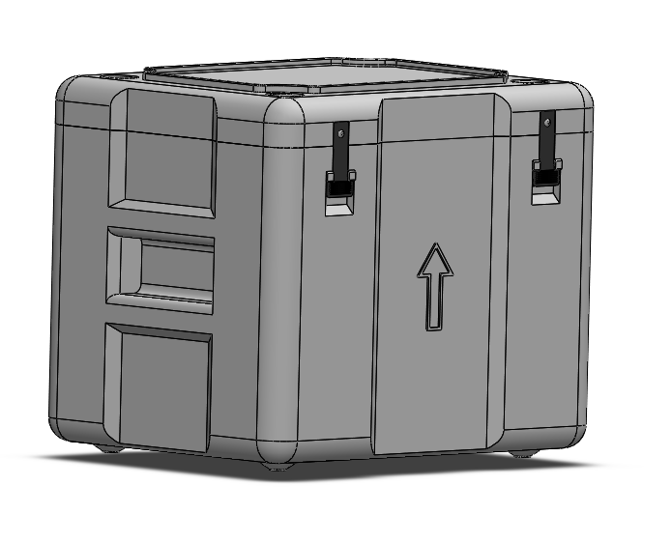

Jordan Ross Jenkins (1650374)
MSc Mechanical Engineering
05/06/2021
Design for Manufacture
ACEA 7004

Table of Contents

Table of Contents …………………………………………………………….………………. i
List of Figures and Tables...………………………...……………………….….…….……… ii
1 Introduction 1
1.1 Broad Aim 1
1.2 Objectives 1
2 Supporting Theory 2
2.1 Design for X 2
2.1.1 Design for Manufacture 4
3 Manufacturing Proposal 5
3.1 Design Requirements 5
3.2 Review of Manufacturing Processes 6
3.2.1 Polymer Forming Processes Review 6
3.3 Manufacturing Process Selection 11
3.4 Material Selection 12
3.5 Vaccine Container Design 13
3.5.1 Design Discussion 22
3.6 Filling Procedure 24
3.7 Failure Modes & Effects Analysis 25
4 Numerical Methods 26
4.1.1 Constitutive Equation 26
4.1.2 Explicit Finite Difference Method 27
4.1.3 Initial and Boundary Conditions 29
4.2 Benefits and Limitations of the Finite Difference Method 30
4.3 Apparent Heat Capacity Method 31
4.3.1 Benefits and limitations of the AHCM 33
4.3.2 Alternative Methods 33
5 Conclusion 34
6 References 35
7 Appendices 37

List of figures and Tables
Figure 1: Summary of Common Design for X Approaches (Kremer & Chiu, 2010) 3
Figure 2: Design Requirements 5
Figure 3: 5 Key Additive Manufacturing Challenges 7
Figure 4: Injection Moulding Process (XcentricMould, 2020) 8
Figure 5: Blow Moulding Process Diagram (Alleycho, 2020) 9
Figure 6: Double-Walled Component 9
Figure 7: Application Specific Benefits and Limitations of Blow Moulding 9
Figure 8: Application Specific Benefits and Limitations of Rotational Moulding 10
Figure 9: Material Selection Matrix Data From (SPI, 2021) 12
Figure 10: Vaccine Container Front View 13
Figure 11: Vaccine Container Rear View 13
Figure 12: Vaccine Container Top View 14
Figure 13: Vaccine Container Bottom View 14
Figure 14: Vaccine Container Open View 15
Figure 15: Vaccine Container Integrated Handle 16
Figure 16: Vaccine Container Lid Fastener Strap 16
Figure 17: Vaccine Container Lid Hinge Strap 17
Figure 18: Vaccine Container Locating Pin Feature 17
Figure 19: Vaccine Container Cross Section 18
Figure 20: Vaccine Container Lid Stacking Feature 18
Figure 21: Vaccine Container Base Stacking Feature 19
Figure 22: Vaccine Container Feet 19
Figure 23: Vaccine Container Stack 20
Figure 24: Vaccine Container Stacking Direction 21
Figure 25: Vaccine Container Internal View 21
Figure 26: Vaccine Container Filling Procedure 24
Figure 27: Filling Procedure Flow Diagram 24
Figure 28: Failure Modes and Effects Analysis 25
Figure 29: Summary of FDM Limitations (Özişik et al., 2017) 30
Figure 30: Vaccine Box Lid Technical Drawing 37
Figure 31: Vaccine Lowe Box Technical Drawings 38
Figure 32: Strap Fastener Technical Drawings 39
List of Equations
Equation 1: Thermal Diffusion Equation (Özişik et al., 2017) 26
Equation 2: Simplified Thermal Diffusion Equation (Özişik et al., 2017) 26
Equation 3: Laplacian Operator & Thermal Diffusivity (Özişik et al., 2017) 27
Equation 4: Taylor Series (Rapp, 2017) 27
Equation 5: Taylor Series Expansions for Difference Approximations (Recktenwald, 2004) 27
Equation 6: Fourier Number Equation (Özişik et al., 2017) 29
Equation 7: Fully defined Explicit FDM for the Heat Equation (Recktenwald, 2004) 29
Equation 8: Ice Density Polynomial (Bader, 1964) 31
Equation 9: Mushy Zone Density (Scanlon, 1970) 31
Equation 10: Water Density Polynomial (Jones & Harris, 1992) 31
Equation 11: Thermal Diffusivity Equation (Recktenwald, 2004) 32
Equation 12: Fourier Number Equation (Özişik et al., 2017) 32
Equation 13: Conductivity of the Mushy Zone (Zeneli et al., 2021) 32
Equation 14: Specific Heat Capacity of the Mushy Zone (Zeneli et al., 2021) 32

Introduction
Intense competition within the modern manufacturing landscape has forced many manufacturers to develop strategies to decrease production costs while simultaneously increasing product quality and decreasing time-to-market. Six Sigma has rapidly established itself as a fundamental tool for achieving continuous quality improvements whilst driving down the cost of quality. There exist numerous tools within the Six Sigma framework that can be applied from the initial design ideation/conceptualisation stages all the way through to full-scale production, however it can be argued that application of targeted approaches, such as design for six sigma principles (DFSS), early in the design process can have the most significant impact on overall product quality and cost reduction.
Conventional approaches to cost reduction aim to identify and reduce the significant cost heads within production (labour rates & suppliers costs etc). It is now generally accepted that these approaches suffer diminishing returns, regardless of how well these cost reduction approaches are implemented, if the given design is inherently difficult to manufacture or susceptible to quality issues, the company will always incur the cost of poor quality. In this sense, product design has the largest influence, or ‘casts the largest shadow’, over product quality and cost.

Broad Aim
The aim of this study is twofold, firstly to understand how DFSS principles can be applied to the design of a transportation container for medical applications in order to develop an effective and robust solution. Secondly, to develop a MATLAB script based on the Apparent heat capacity method (AHCM) to model the heat transfer that occurs as a result of the material phase change within such a container.

Objectives
- To review the supporting theory around DFSS and specifically design for manufacture (DFM) and design for assembly (DFA) to identify relevant design tools/approaches.
- To review appropriate manufacturing techniques and material selections as part of manufacturing proposal.
- To develop a preliminary design prototype which incorporates the design tools identified, providing CAD models and technical drawings within the manufacturing proposal and perform analysis of the preliminary design using FMEA.
- To review the AHCM and thus develop a Matlab script to model the non-linear heat transfer (ice-water phase change) within the cooler box to determine the effect of ice thickness on passive cooling rates.

Supporting Theory

Design for X
Design for X (DFX) describes a family of targeted tools/techniques within the Design for Six Sigma framework. (Jack, 2013) states that the DFX has been developed through the culmination of specific expert knowledge, that aim to challenge the limitations of traditional sequential design processes and provide design engineers with tools/techniques for optimal product design, redesign, and analysis.
In conventional sequential design scenarios, the product design engineer/department develop the design over a series of iterations, once the design meets some acceptance criteria it is passed to the manufacturing department, where the manufacturing procedures and tooling are developed to produce the design, this is often referred to informally as ‘over-the-wall-design’. As a result of this sequential process, by the time the design reaches the manufacturing depart the scope for altering the design to accommodate a given manufacturing process is extremely limited, or put simply, the design has been created with little consideration given to how it will be manufactured.
The potential outcomes of this ‘over-the-wall’ design process are numerous:
- The design and intended manufacturing process work well.
- The design is achievable but is costly or difficult to manufacture.
- The manufacturing department alter the design to accommodate the production method.
- The manufacturing department pass the design ‘back-over-the-wall’ for redesign to resolve the issues.
(Kent, 2016) notes that unless the developed design is right first time, the sequential design process can be subject to numerous redesigns/alterations and subsequently excessive delays and inefficiency.
The author notes that concurrent engineering offers an alternative to the ‘over-the-wall’ approach. Here, the design and manufacturing departments collaborate during each stage of the design process. A commonly cited issue with concurrent engineering is that it seemingly doubles the number of issues being addressed at any one time (both design and manufacturing considerations), making the process more complex and increasing the design process time and effort. However, the benefits of this approach far outweigh the limitations, typically the outcome of concurrent engineering is a design that is much easier to produce, requires fewer alterations and tooling redesigns.
Similarly, application of DFX principles will add complexity and time to the design process in the form of increased design activity/tasks but will ultimately reduce the manufacturing effort and subsequent quality issues /defects. (Mital et al., 2014) explains that although DFX refers to specific targeted approaches they share some generic benefits, these include:
- Reduced production times and time-to-market.
- Increased manufacturing efficiency/efficacy.
- Decreased component inventory and increased component standardisation.
- Simplistic designs that are inherently more robust.
- Lower production, tooling, and rework costs.
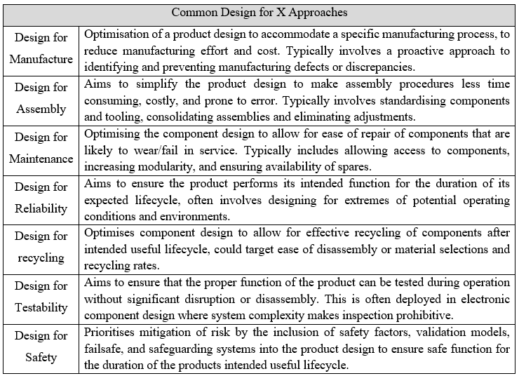
The targeted nature of DFX means there is no definitive list of approaches, rather the X is substituted for the desired design attribute, it is also important to note that any combination of DFX approaches may be used in the design of a given product. Common DFX approaches are summarised in Figure 1 below.
Figure 1: Summary of Common Design for X Approaches (Kremer & Chiu, 2010)

Design for Manufacture
As mentioned above designing for manufacturability aims to leverage the product design in order to accommodate a specific manufacturing process whilst reducing production costs and time-to-market. However proper implementation of DFM should prioritise all the manufacturing functions, including fabrication, assembly, testing, logistics, service, and maintenance. (Kuo et al., 2011) provide an extensive review of design for manufacturing principles which can be summarised into 5 key DFA steps:
- Standardise Components
Use of standardised components enables the design team to focus on the features and functions that add value rather than menial design tasks for components that can be readily outsourced. Further, the availability and proven track record of standardised components means that the performance and reliability characteristics of these components are well known.
- Use Modular Design
Component modularity can, to some extent, relieve the manufacturing effort across different product lines by consolidating the number of bespoke components required for each product. It also has advantages through the component’s lifecycle, allowing components to be removed, modified, or replaced more easily. Modular assemblies are typically more simplistic and offer a shorter learning curve to assembly operatives.
- Simplify the Design
Simplistic designs tend to be more robust and can often be achieved with fewer components, the benefits of component consolidation are numerous; reduced production & assembly effort, tooling, handling, procurement, inventory, and quality control/assurance activity.
- Analyse & Consolidate Component Functionality
Development of multi-functional designs can also decrease the total part count and thus offer the same benefits described above. Multi-functional design is essential, particularly in design scenarios where component weight and cost reduction are targeted.
- Consider Tolerance Capabilities
The design team should consider tolerances at each stage in the design development and ensure that tight/restrictive tolerances are only used when absolutely necessary. Needlessly tight tolerances typically require additional processing steps which can significantly increase manufacturing effort, time, and cost.

Manufacturing Proposal
In this section, a proposal for the manufacture of a vaccine transport container is presented including manufacturing process and materials selections, a preliminary design prototype, technical drawings, and analysis of the design in the form of Failure Modes and Effects Analysis (FMEA). Before the process selection is presented, the design requirements and constraints are presented and discussed.

Design Requirements
The developed container will be used to transport two expanded polystyrene (EPS) boxes with wall thicknesses of 20mm, the first of which will store 9x100mm vials. The second EPS box will house the first box within a uniform layer of ice (60mm suggested thickness). There exist numerous potential solutions to this design challenge, by interpreting the design requirements in figure 2, the potential solutions will be narrowed, and design constraints applied. The design requirements for the vaccine transport container are displayed below.
Design Requirements
1. | The container must be reusable.
2. | The structural integrity of the container must be maintained over multiple uses.
3. | The container must be stackable (3-high)
4. | Provision for handling the container should be incorporated.
5. | Preparing, filling and use of storage containers should be as efficient and free from potential error as possible
Figure 2: Design Requirements
The thin wall thickness of the EPS boxes described above, combined with the inherent flexibility of the EPS material leaves them susceptible to crushing under load, this is particularly significant when it comes to design requirement 3. This, combined with the stipulated reusability and structural rigidity criteria suggest that a hard shell-type solution may be more appropriate compared to an insulated cooler bag solution.
To allow for stacking of the containers a solution must be developed to ensure they don’t slide or topple in transit, which could potentially result in damage to the medical vials. An effective carrying solution must also be developed without excessive use of sub-components, however the ergonomics of the handle solution should also be considered here.
Finally, the developed solution should be intuitive and easy to use, it should not be assumed that everyone that uses the container is familiar with how it should be filled, sealed, stored, stacked, transported, opened and emptied.

Review of Manufacturing Processes
In the previous section it was determined that the developed solution should be a hard shell-type container in order to have sufficient structural rigidity and allow for stacking during storage/transport. It is assumed that such as solution would consist of a lower box/shell region, a watertight lid, and some form of hinge and clasp fastener mechanism. The material selection for the lower box and lid will directly influence the bulk of the manufacturing process selections (discussed in further detail in Ch.3.3).
Appropriate material selections for the lower box are generally limited to metallic, polymeric, or fibre-matrix composite (glass-fibre for example) materials. Metallic build materials are unfavourable for three main reasons:
- The increased thermal conductivity of metallic materials means that the ambient temperature conditions surrounding the container will be transferred more quickly to the inner EPS boxes, resulting in decreased passive cooling performance.
- Selection of metallic build materials would significantly limit the available fabrication methods for achieving complex geometries and thus limit the design freedom.
- The cost and mass of metallic materials is generally higher than polymeric equivalents
The low mass properties of composite materials make them an intriguing option; however, they are generally more costly, complex and require significantly increased manual intervention, effort and lead times during manufacture compared with polymeric components. For these reasons they have been ruled out in this application.
Considering the points described above, it has been deduced that the lower box and lid sections should be manufactured using polymeric build materials (further details in Ch.3.3) for this reason, only polymer fabrication processes are considered here.

Polymer Forming Processes Review
In this section, a series of polymer fabrication processes are reviewed with the aim of identifying appropriate production methods for the lower box and lid of the medical transport container described above. A series of assumptions must be made here:
- The production scenario is high-volume / low variation.
- Components should be optimised for mass and cost.
- Fewer sub-components and assemblies are preferred (DFM principle).
- Manufacturing processes and assembly processes steps should be consolidated where practicable (DFM principle).
(Subramanian, 2017) Noted that although there are a large number of polymer forming processes described in literature, industrial polymer fabrication is dominated by 10 processes, namely:

- Injection moulding
- Thermoforming
- Polymer Extrusion
- Compression moulding
- Blow moulding
- Rotational moulding
- Cold pressing
- Vacuum moulding
- Calendaring
- Additive manufacturing processes

Some of these processes can be disregarded immediately, for example the calendaring process involves drawing molten polymer between calendar rollers in order to create thin polymer sheets and films (BPF, 2020) and is thus not appropriate in this application. Similarly, compression moulding, cold pressing, thermoforming, and vacuum moulding are all used to create thin-walled components from plastic sheet, and this will significantly reduce the design freedom in this application.
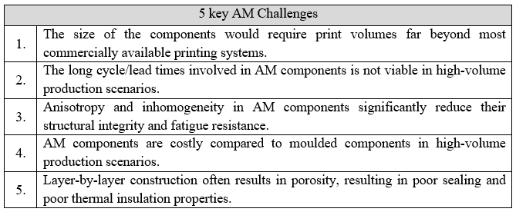
Whilst additive manufacturing (AM) methods (FDM, SLS, SLM, Material jetting & stereolithography etc.) offer tangible benefits in terms of customisability, achievable geometric complexity, design freedom and component consolidation, they have to be disregarded in this instance, there are 5 key reasons for this:
Figure 3: 5 Key Additive Manufacturing Challenges
The process described above have been reduced to three potential methods, these will be discussed in further detail in subsequent sections:
- Injection moulding
- Extrusion blow moulding
- Rotational moulding

Injection Moulding
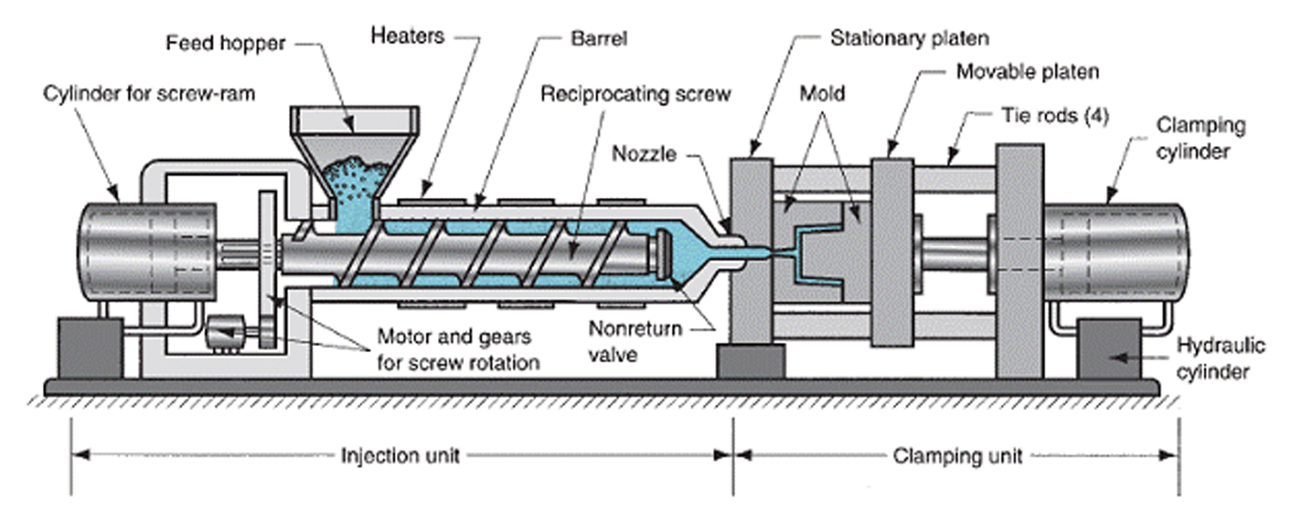
(Singh & Verma, 2017) provide an extensive review of injection moulding processes for polymer fabrication.
Figure 4: Injection Moulding Process (XcentricMould, 2020)
The authors describe the generic process, molten thermoplastic polymer is forced into the die cavity (or mould) under pressure by rotation of feed screw. As the molten polymer fills the mould cavity, the dwell speed and pressure are carefully controlled (key process parameters). The mould cavity is then cooled (passive or water fed), once the polymer has solidified, the mould is separated, and the component ejected.
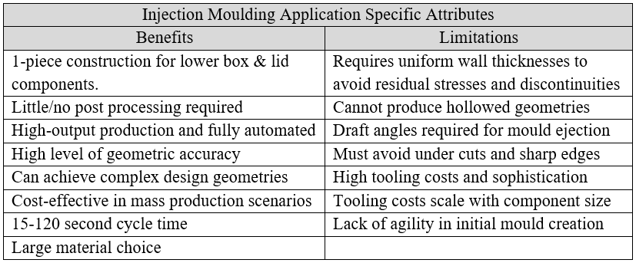
(Singh & Verma, 2017) note that injection moulding is a cost-effective means of producing components with high geometric complexity to extremely high levels of accuracy and at high production volumes (typical production runs between 10,000-750,000 components), however the method cannot create hollowed geometries and is susceptible to warping and shrinkage depending on operating parameters (dwell speed, pressure, and cooling rates).
Figure 4: Application Specific Benefits and Limitations of Injection Moulding

Extrusion Blow Moulding
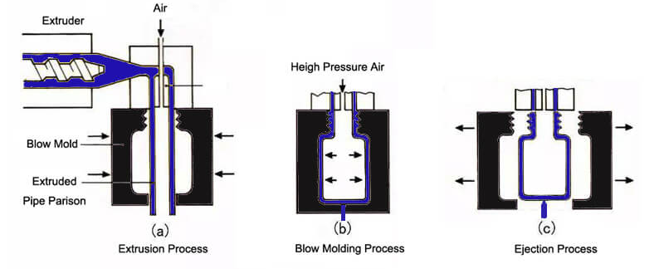
(Belcher, 2017) reviews modern blow moulding processes and equipment. The author explains that although there are numerous forms of blow moulding, they are all based on three basic steps: plasticisation, extrusion and blowing.

Figure 5: Blow Moulding Process Diagram (Alleycho, 2020)
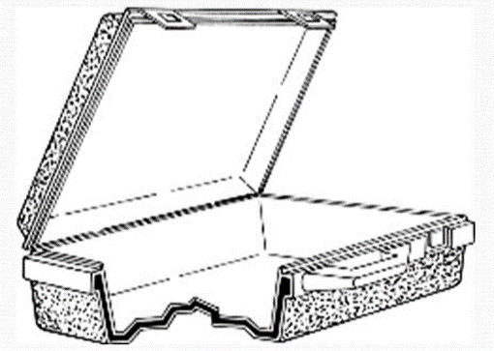
The authors explain that similar to injection moulding, a feed screw with heating elements is used to plasticise the polymer and force it through an extrusion nozzle to create a hollow cylinder of material called a parison. The mould dies are then closed around the parison and pressurised air is used to inflate it the parison to the shape of the mould. After cooling, the mould splits and the products are ejected.
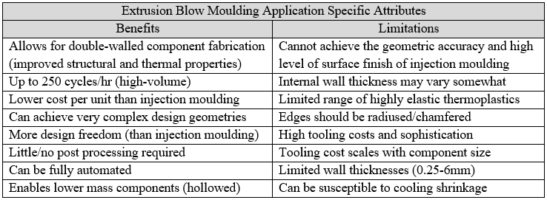
The authors further note that using a process called co-extrusion blow moulding (multiple extruders per mould), double-walled components (figure 6) can be manufactured, a major advantage over injection moulding methods. Double-walled components can significantly reduce component mass whilst maintaining structural and increasing passive cooling/ thermal transfer properties.
Figure 6: Double-Walled Component
(Hancock, 2019)
Figure 7: Application Specific Benefits and Limitations of Blow Moulding

Rotational Moulding
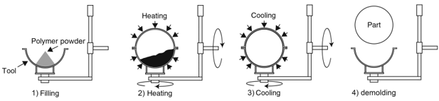
Rotational moulding is a significantly different forming process than those described above. (Torres, 2009) explains that the process typically involves loading powdered polymeric material into a mould. The mould it then rotated about 2-axes and heated. This motion combined with the increasing temperature plasticises the polymer. As the powder melts in ‘lays-up’ against the walls of the mould. The mould is then left to cool, and the component solidifies. Once this process is completed, the mould is split, and the component ejected.
The Author notes that, similar to extrusion blow moulding, rotational moulding can create double-walled components, however it is important to recognise that unlike blow moulding, the wall-thickness is much more uniform/consistent in this process. A major limitation to this method is the tooling cost, wear and complexity compared to blow moulding processes.
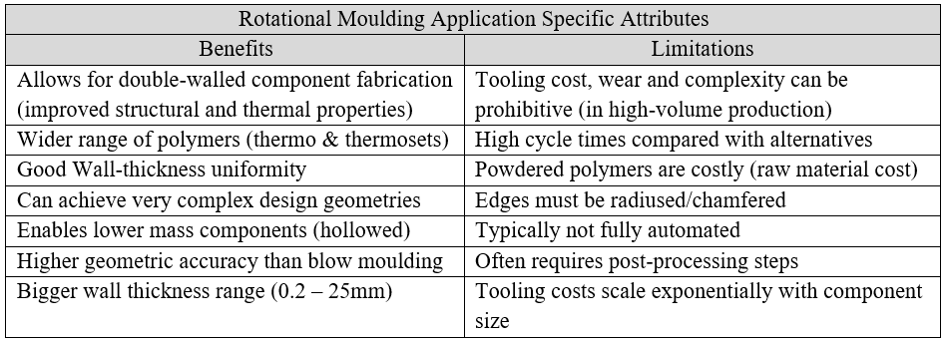
Another major limitation compared with the two methods described above is the high cycle time, (Torres, 2009) stated that this can be more than an hour per component, which often damages the processes viability in high-volume applications.
Figure 8: Application Specific Benefits and Limitations of Rotational Moulding

Manufacturing Process Selection
A similar deductive approach to that used in Ch.3.2.1 is used here to identify the most appropriate polymer forming process from the three described above.
The injection moulding process described is promising both in terms of the large range of thermoplastic and thermoset materials that can be moulding, the low cycle times and the fact that it allows 1-piece construction for lower box & lid components. However, the process has to be disregarded in this application. The reason for this is the process can only create solid components with no option for hollowed or double-walled components. The double-wall characteristic offers two main benefits to the medicine container in this application, Mass reduction whilst retaining the required structural properties, and increased thermal insulating properties attributed to the air gap (lower thermal conductivity) between the container walls.
This leaves rotational moulding and extrusion blow moulding as potential manufacturing methods. Both methods can produce double-walled and hollowed components, and whilst rotational moulding methods boast better wall thickness uniformity and a wider range of mouldable polymers (thermoplastics and thermosets), the limitations in terms of the significantly increased cycle times, tooling costs and complexity suggest that blow moulding may be a more appropriate choice in this instance.
Extrusion blow moulding is inherently suited to applications such as this and is commonly used within other applications that have similar design requirements, for example, polymeric fuel tanks, expansion bottles and ducting components are often used in automotive and aerospace applications where structural integrity, longevity, and design freedom requirements in terms of geometric complexity far exceed those encountered in this design problem.
Whilst there are certainly limitations to the blow moulding process, such as the limited range of mouldable materials, limited wall thicknesses of between 0.25-6mm and design constraints (edges should be radiused etc) it is believed that these limitations can be mitigated to some extent by applying appropriate design features (discussed further in Ch.3.5).
The selection of the blow moulding process in this application also concurs with the preferred manufacturing method for many domestic and commercially available passive cooling solutions. This suggests that the functionality, performance, and longevity characteristics of components manufactured in this manner are already well ascertained in industry. All these factors combined indicate a level of confidence in the blow moulding process in this instance.

Material Selection
The selection of the manufacturing process for the lower box and lid of the medicine container limits the number of material choices for this application. (Rosato et al., 2004) explain that there are 5 commonly used thermoplastic polymers used in blow moulding applications, these include: High-density Poly Ethelene (HDPE), Acrylonitrile Butadiene Styrene (ABS), Polypropylene (PP), Polyvinyl Chloride (PVC) and Thermoplastic Elastomer (TPE).
The authors also identify key selection criteria for each material, these include:

- Cost per kg (lower is better)
- Density (lower is better)
- Flexural modulus (higher is better)
- Lower deflection temperature (lower is better)
- Higher deflection temperature (higher is better)
- Shore hardness (higher is better)
- Recyclability code (lower is better)

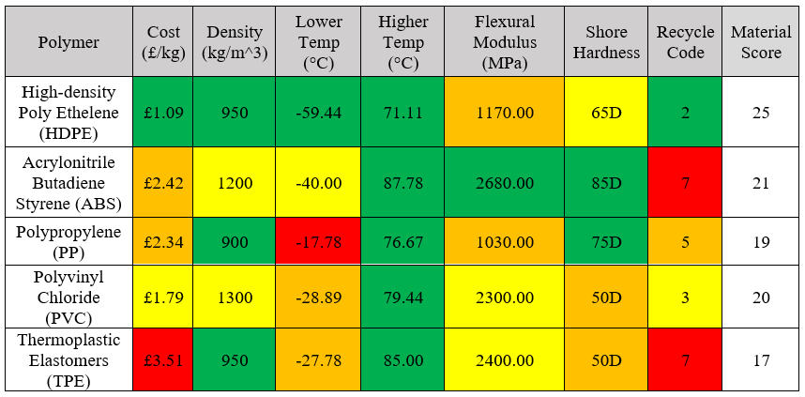
Using the above parameters, a material selection matrix has been created to identify the optimal material for this application, green regions represent favourable values and red regions represent unfavourable values, each attribute is scored 1-4 with red being 1 and green being 4, the final column represents the sum of each materials score (higher is better).
Figure 9: Material Selection Matrix Data From (SPI, 2021)
The material selection matrix above shows that HDPE is generally the best performing polymer and thus is recommended as the optimal material for this application. Whilst the matrix method is not perfect as it assumes all the parameters share the same significance/weighting, it offers a simplistic method of comparing materials across multiple selection criteria. This selection also concurs with (Belcher, 2017; Rosato et al., 2004), both authors state that HDPE is often the favourable and most commonly used material due to its low cost, recyclability, thermal resistance, and respectable structural properties.

Vaccine Container Design
In this section, the final design prototype for the vaccine container system is presented. The design features used, and their intended functions will be summarised on page 22. (see appendix 1 for technical drawings).
Front View
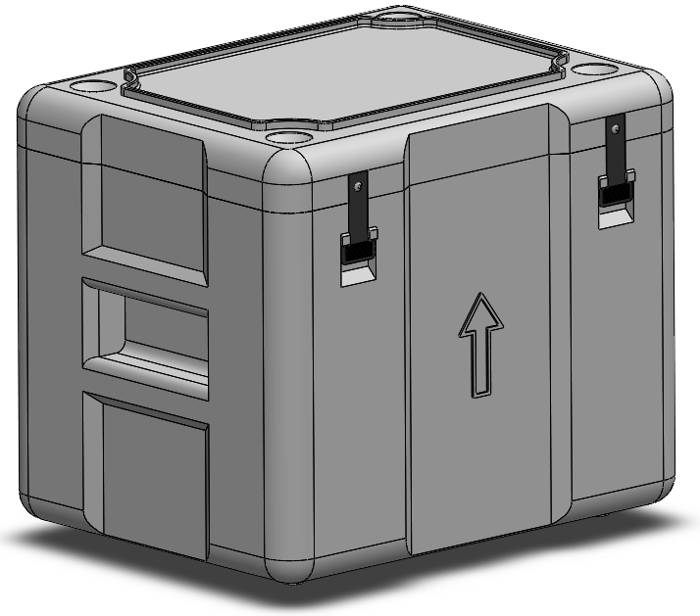

Figure 10: Vaccine Container Front View

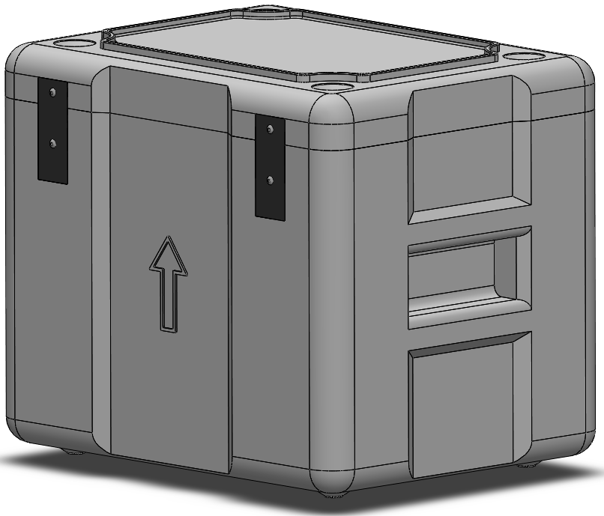
Rear View

Figure 11: Vaccine Container Rear View

Top View
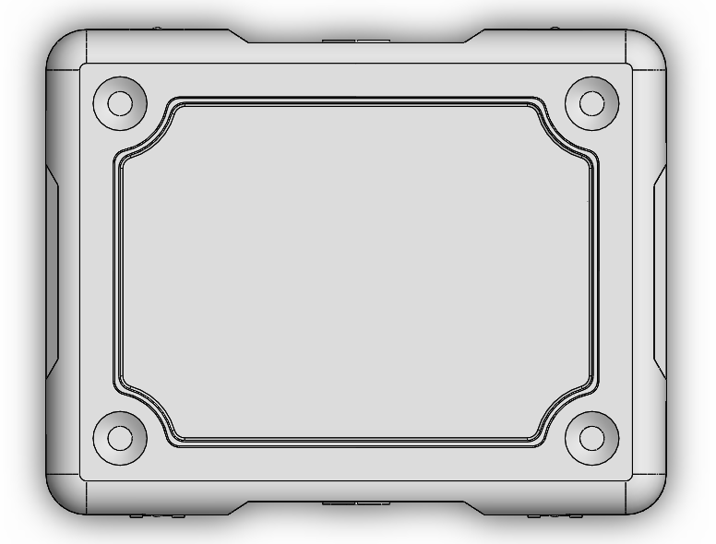

Figure 12: Vaccine Container Top View

Bottom View

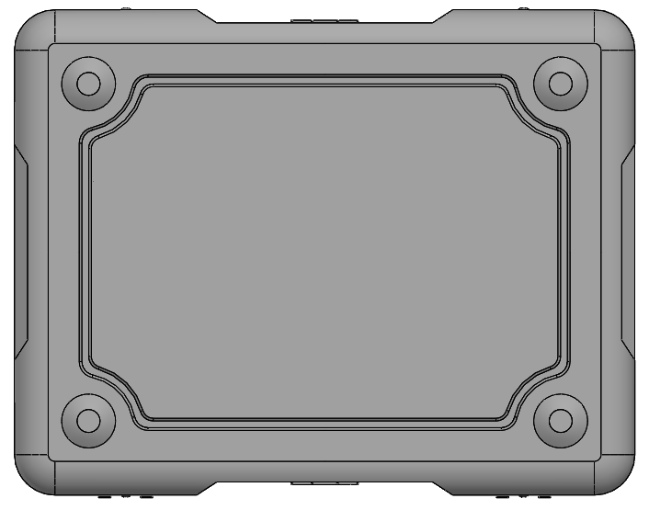

Figure 13: Vaccine Container Bottom View
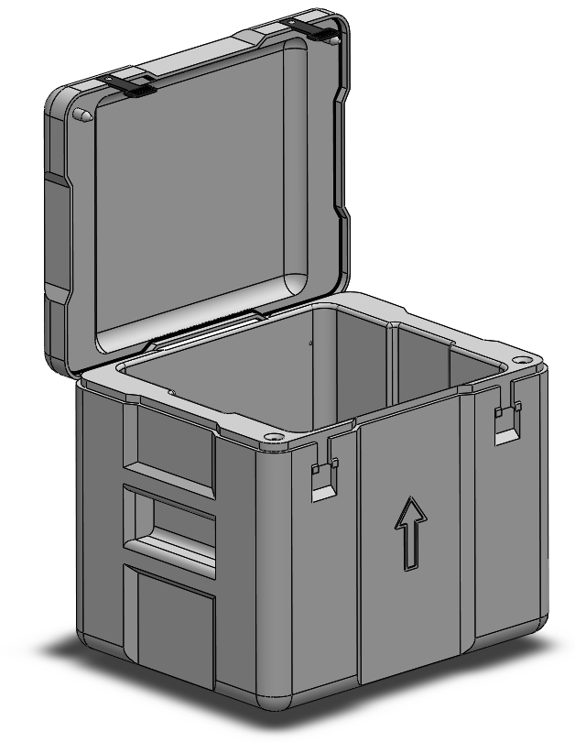
Open View
Figure 14: Vaccine Container Open View
Integrated Handle
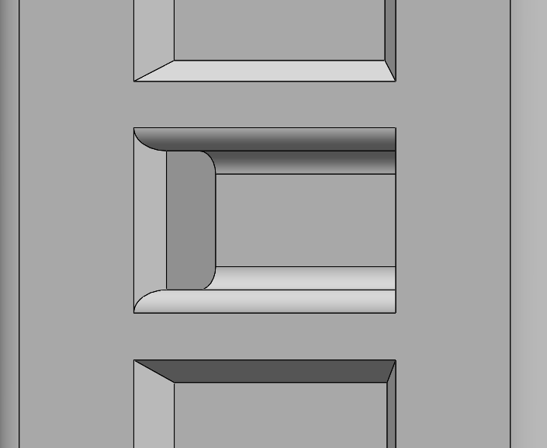

Figure 15: Vaccine Container Integrated Handle

Lid Fastener Strap
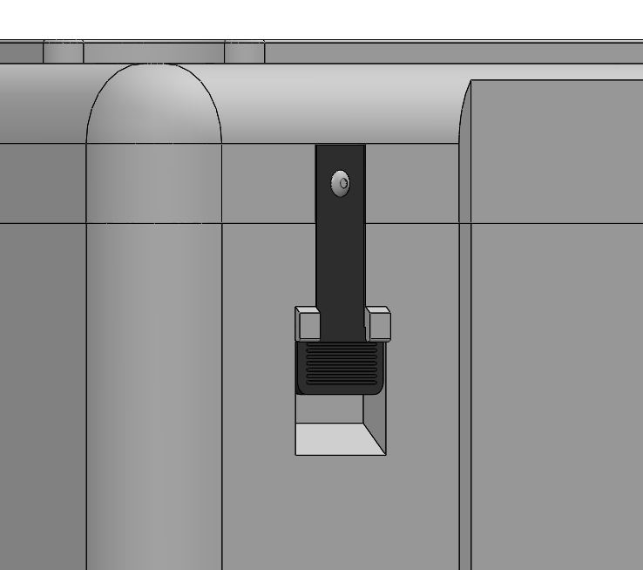

Figure 16: Vaccine Container Lid Fastener Strap

Lid Rear Hinge Strap
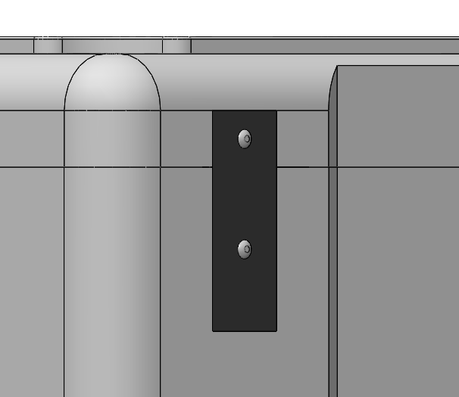

Figure 17: Vaccine Container Lid Hinge Strap

Lid Locating Pin Feature

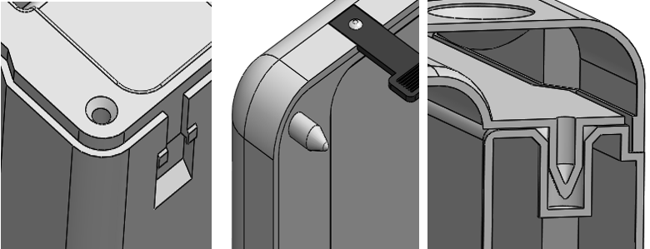
Figure 18: Vaccine Container Locating Pin Feature

Cross section View
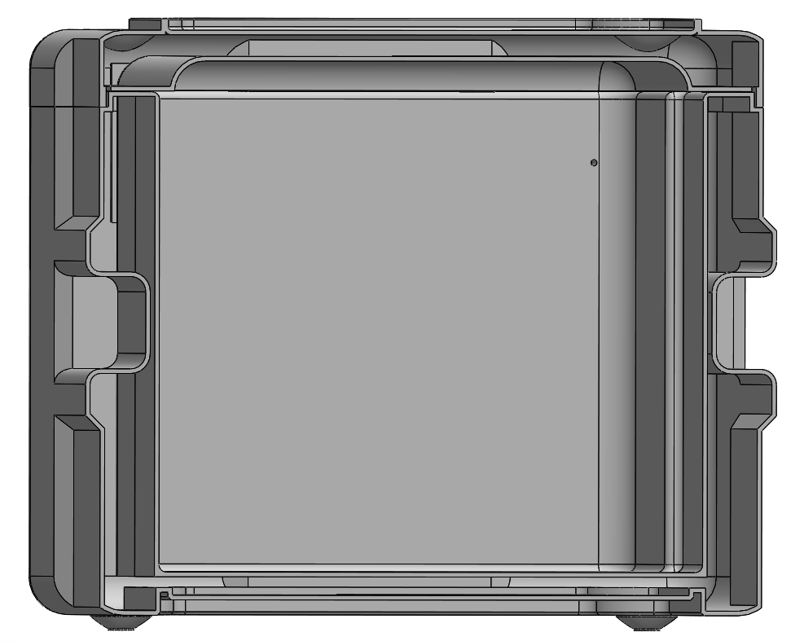

Figure 19: Vaccine Container Cross Section

Lid Stacking Feature
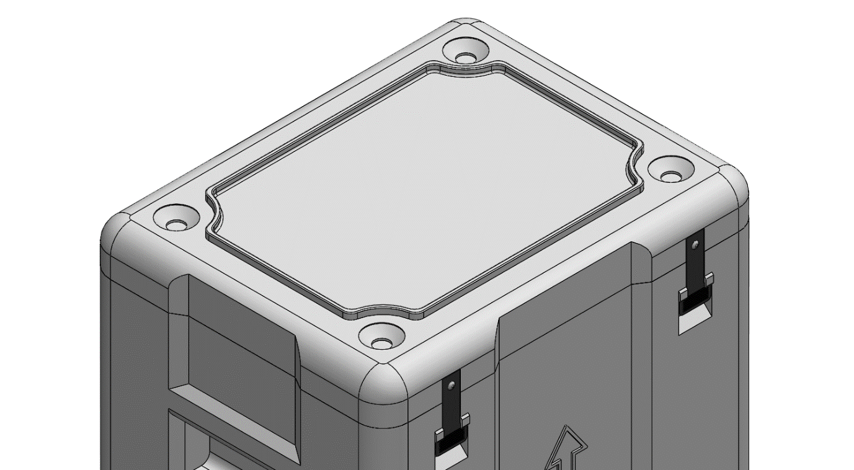

Figure 20: Vaccine Container Lid Stacking Feature
Base Stacking Feature

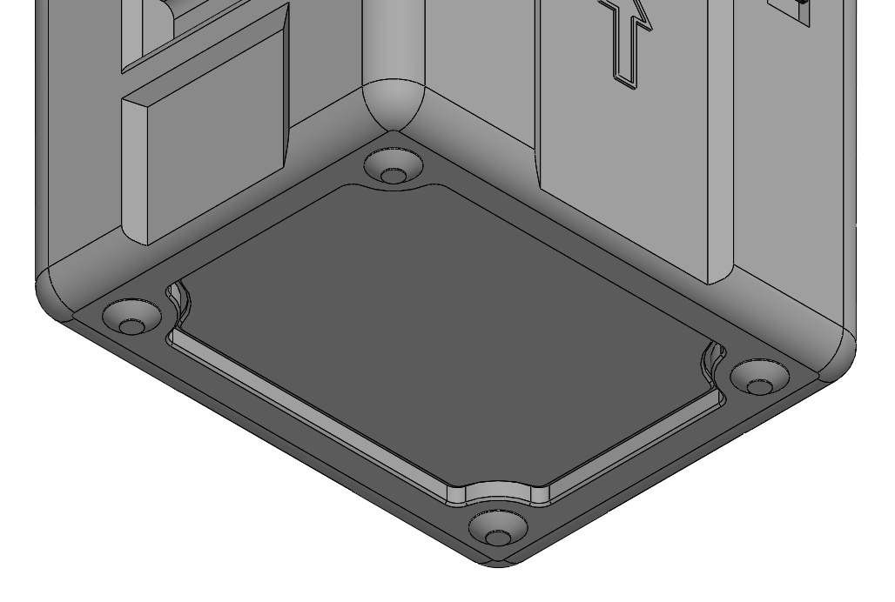

Figure 21: Vaccine Container Base Stacking Feature

Interlocking feet and lid
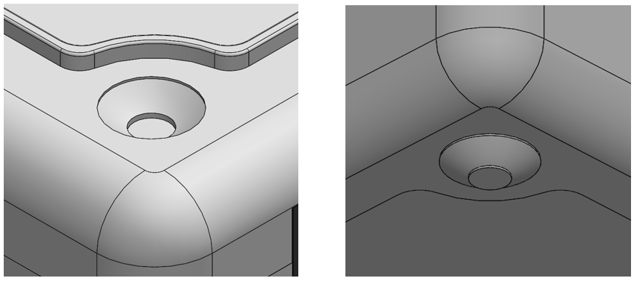

Figure 22: Vaccine Container Feet
Vaccine Container Stack

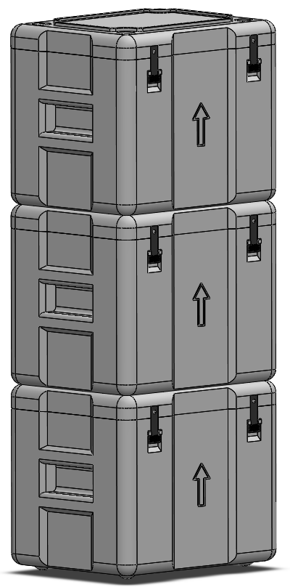
Figure 23: Vaccine Container Stack

Vaccine Container Stacking direction

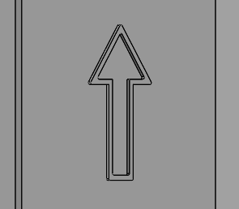

Figure 24: Vaccine Container Stacking Direction

Vaccine Container Internal View
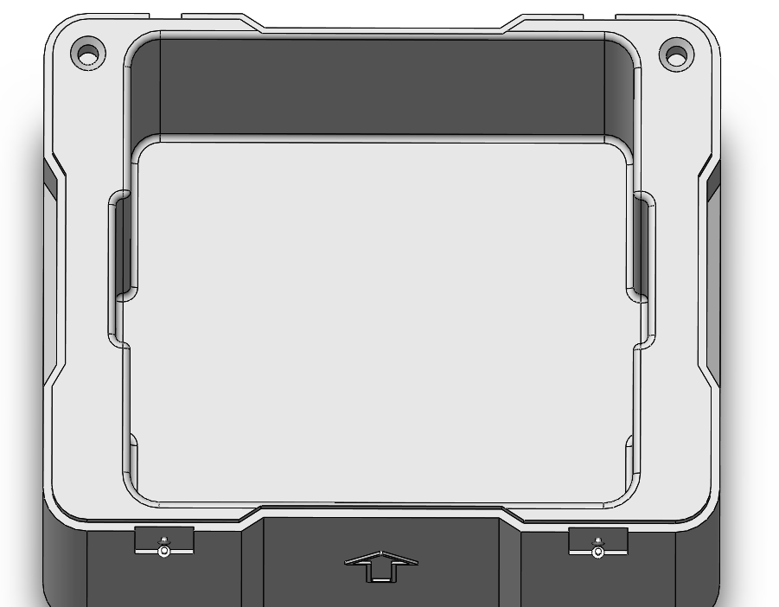

Figure 25: Vaccine Container Internal View

Design Discussion
Figures 10 through 14 are general images of the final design prototype. the primary design drivers here are simplicity and robustness/ruggedness. As discussed in Ch.3.2.1.2, there are two main design constraints when using an extrusion blow moulding process:
- There is a need to radius or chamfer edges to avoid residual stresses formation and reduce localised wall thinning.
To address this issue, radii have been added to all 90º edges and major changes in cross section as far as reasonably practicable. In Addition to this, the large 30mm radii applied to the outermost edges of the container offer a level of drop protection in the event of a fall from height
- The process can only achieve limited wall thicknesses (0.25-6mm).
The main concern here is that the thin wall thickness (see cross-section in figure 19) will allow the structure to flex under load, to address this a series of corrugations with 45º chamfers are made to the external shell of the container.
Figure 15 shows the integrated handle design proposed in this solution. DFM principles, in terms of design simplification and component/assembly consolidation, state we should aim to limit the use for sub-components where possible. This handle design uses no extra components and is instead integrated and recessed into the side walls of the outer container shell. The radii applied to the handle are multifunctional in that they improve the ergonomics of the handle (reduction of sharp edges) whilst decreasing the probability of fatigue crack initiation as a result of stress concentrations and localised cyclic loading after repeated lifting of the container by the handles.
Figures 16 and 17 show the flexible nitrile butadiene rubber (NBR) strap fasteners used to secure the lid to the lower box section. the rear strap in figure 17 acts as a hinge to stop the lid from becoming detached from the box when opened (removing the possibility of it being misplaced/lost). The rear strap is simply stamped from a sheet of 3mm NBR and fastened to the lid and lower box using a two 4x30mm blind rivets. To avoid the strap rotating about the single rivet it sits within a close fit recess, this removes the need for a second rivet at each location and allows the strap to sit flush with the outer shell surface, avoiding potential snagging and tears. It is believed that the use of these straps over conventional hinges is more simplistic, easy to fabricate and requires fewer sub-components than conventional hinges.
The front strap shown in figure 16 is used to fasten the lid closed when in operation. The intended function leverages the elasticity of the NBR strap. To fasten the lid, the operator pulls the strap downwards stretching it somewhat, the operator then pushes the strap into the recessed region. the small protruding tabs stop the rubber fastener from slipping out of the recessed region until the operator once again pulls the strap to open the lid. The front straps include ridged sections to allow the operator to maintain a firm grip. The front strap is also fastened using a singular 4x30mm rivet and sits flush to the container surface. The use of rivet fasteners as opposed to threaded fasteners can also be considered a DFM/DFA principle as they consolidate the number of components and remove adjustment/torquing steps during assembly.
It is assumed that the rubber straps on the rear of the lid may allow some lateral movement of the lid during closing, which in turn may cause it to sit out of line with the lower box. Figure 18 shows the locating pin system used on the underside of the lid, which is a Poke Yoke feature, used to ensure the lid always remains properly aligned with the lower box, this feature combined with the black NBR gasket (shown in figure 14) are essential in maintaining the boxes insulating properties and a watertight seal. The locating pin system is integrated into the mould and requires no further components.
Figures 20-24 show the stacking features of the proposed design. The corrugation on the base of the lower box (figure 21) and the raised track on the lid (figure 20) are multifunctional. They aim to reinforce the local regions to improve the base/lid structural rigidity, but also act as interlocking regions when multiple boxes are stacked. Similarly, the dome shaped feet also sit within alike-shaped regions on the lid. It is acknowledged that these features will not prevent the stacked boxes from toppling, but rather aim to prevent any movement/slipping between the boxes in transit.
The high degree of symmetry in the proposed design means it is conceivable that the containers may be mistakenly stacked upside down which could lead to damage of the vaccine vials, damage to the gasket and potential loss of containment. For this reason, an arrow is embossed into the outer shell of the lower box to show the correct direction for storage and stacking (figure 24). Although a sticker would have achieved the same function, they are likely to become damaged with time.
Finally, figure 25 shows the inner region of the container. The indentations on either side of the inner region are intended to allow the operator some space to the remove the inner EPS boxes, in addition to this, handles could be incorporated into the EPS boxes also.

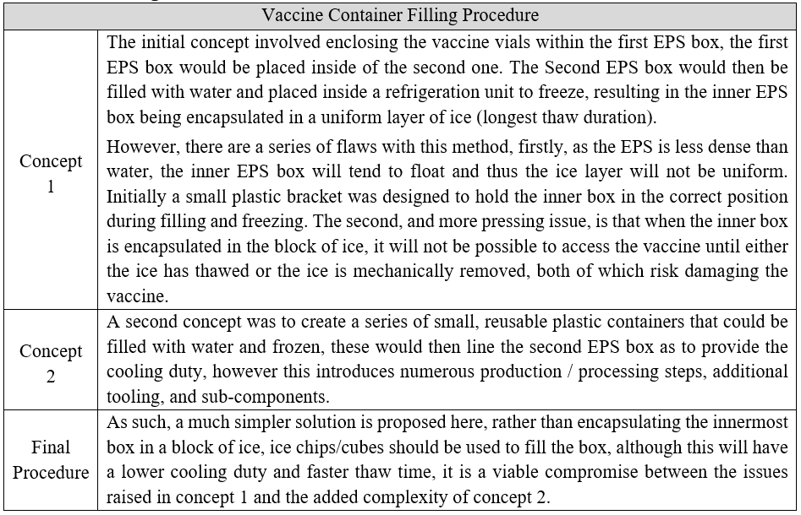
Filling Procedure
Figure 26: Vaccine Container Filling Procedure
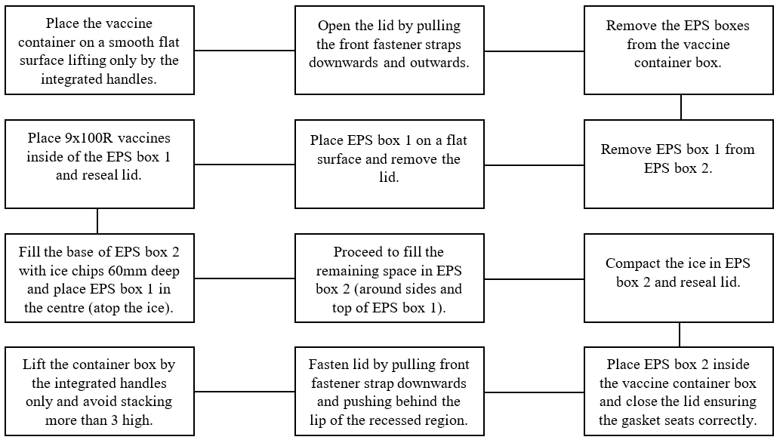
A flow diagram is presented below outlining the suggested filling procedure described in Figure 26 above.
Figure 27: Filling Procedure Flow Diagram

Failure Modes & Effects Analysis
Below an FMEA is carried out to identify the significant sources of failure in the proposed design, the results show that gasket failure and fracture failure of the outer shell and handle regions are among the most significant failure modes, mitigating actions are suggested below.
Figure 28: Failure Modes and Effects Analysis

Numerical Methods
This section describes the development of two scripts in MATLAB to study the heat transfer within a 2D cross-section of the inner EPS boxes described above. The first script (Task 2 in appendix 5) is developed to model the evolution of temperature through the cross-section when the second EPS box contains only air and is achieved through discretisation of the heat equation using the explicit finite difference method (FDM).
The second script (Task 2 in appendix 6) is developed to model the evolution of temperature through the cross-section when the second EPS box contains a uniform layer of ice, of course this necessitates the modelling of the phase change between ice and water, this is achieved by application of the apparent heat capacity method, again discretised using the explicit finite difference scheme.
Both the FDM and the AHCM are discussed further below, including the benefits and limitations of both methods and a review of alternative numerical methods for modelling heat transfer in phase changing materials (PCMs).

Constitutive Equation
The constitutive equation throughout the tasks described above is the thermal diffusion equation (also known as the heat equation), which is a partial differential equation used to determine transient conductive heat transfer through solids and fluids within a region of interest (ROI) at some point in time.
For $T\left(x,y,z,t\right)$ where $x,y,z$ are spatial coordinates and $t$ is the time variable, the thermal diffusion equation is given by:
Equation 1: Thermal Diffusion Equation (Özişik et al., 2017)

Where:$\dot{q}=$Heat Transfer Rate, $k$ = Thermal Conductivity, $ρ=$ Density, $C_{p}$ = Specific Heat Capacity.
Given that the given problem is two dimensional (box cross-section) and that there is no internal heat generation ($\dot{q}=0$), this can be further simplified to:
Equation 2: Simplified Thermal Diffusion Equation (Özişik et al., 2017)
By substituting in the Laplacian operator $∇^{2}T= \frac{∂^{2}T}{∂x^{2}}+\frac{∂^{2}T}{∂y^{2}}$and the thermal diffusivity equation $α=\frac{k}{ρ∙C_{p}}$, the equation becomes:

Equation 3: Laplacian Operator & Thermal Diffusivity (Özişik et al., 2017)
Being a partial differential an exact analytical solution to the given thermal diffusion equation is not viable , and as such, a numerical approach must be employed here. The numerical method implemented in this study is the Explicit FDM.

Explicit Finite Difference Method
Applying the finite difference method to the above heat equation describes the process of replacing the first and second order derivatives with difference approximations using the Taylor series expansion. Here the forward difference approximation (explicit FDM) is used to discretise the 1st order derivative (time). When using the Taylor series expansion, the second order derivative can only be discretised using the central difference approximation (space) (Recktenwald, 2004).
The Taylor series is given by:

Equation 4: Taylor Series (Rapp, 2017)

Taylor series expansions for forwards (first order) and central difference (second order) approximations are given by:

2nd order Central Difference = $f^{''}\left(x_{0}\right)≈\frac{f\left(x_{0}+h\right)-2.f\left(x_{0}\right)+f\left(x_{0}-h\right)}{h^{2}}$
Equation 5: Taylor Series Expansions for Difference Approximations (Recktenwald, 2004)

Now the forward difference equation must be substituted into the 1st order derivatives in the thermal diffusion equation:
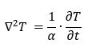

Substitute forward difference approximations.

Hence,
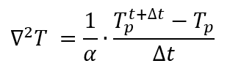

Secondly, the central difference approximation must be substituted into the the second order derivatives within the thermal diffusion equation:

Thus:

Substitute central difference approximation:

Therefore,

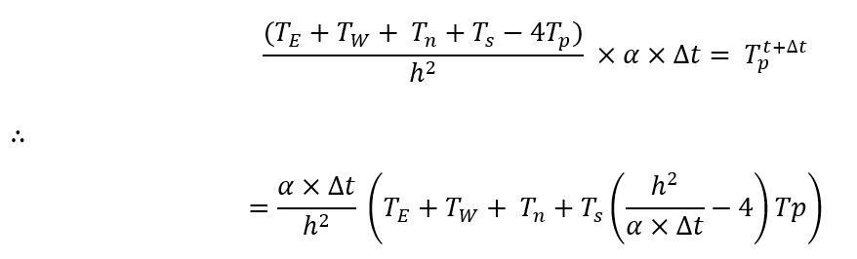
Rearrange for $T_{p}^{t+∆t}$:

Given that the Fourier number is expressed as:
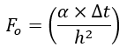

Equation 6: Fourier Number Equation (Özişik et al., 2017)

Thus substitute into the final explicit FDM equation:

Equation 7: Fully defined Explicit FDM for the Heat Equation (Recktenwald, 2004)

Initial and Boundary Conditions
As with any heat transfer problem, the initial domain and boundary conditions must be defined. Put simply, the initial domain conditions are time dependent (temperature initialisation) and the boundary conditions as spatially dependent. In this instance the boundary and initial domain conditions are simplistic. In both task 2 and 3, the entire domain is set to -20⁰c.
Dirichlet boundary conditions are used on all four boundaries of the outer EPS region in task 2 and 3. Dirichlet conditions simply refer to those where the boundary temperature is known or specified, as such, a 12⁰c boundary condition is specified in this instance.

The Dirichlet boundary condition is expressed by:

Where $T_{b}=$Boundary Temperature.

Benefits and Limitations of the Finite Difference Method
There exist numerous numerical methods that can be used to solve partial differentials such as the heat equation, such as the finite element, finite volume, and boundary element methods for example. These methods have inherent strengths and weaknesses. It is important to consider these in order to leverage them when selecting the most appropriate method for a given application, this is certainly true with the FDM.
(Özişik et al., 2017) provide an extensive review of the benefits and limitations of FDM, the author generally attributes the benefits of FDM to its simplicity and ease of implementation, stating that it is a favourable technique to implement when the geometry of the modelling problem allows it (Square or rectangular geometries). The authors also note that the computational effort required in many FDM applications is significantly smaller that the alternative methods described above.
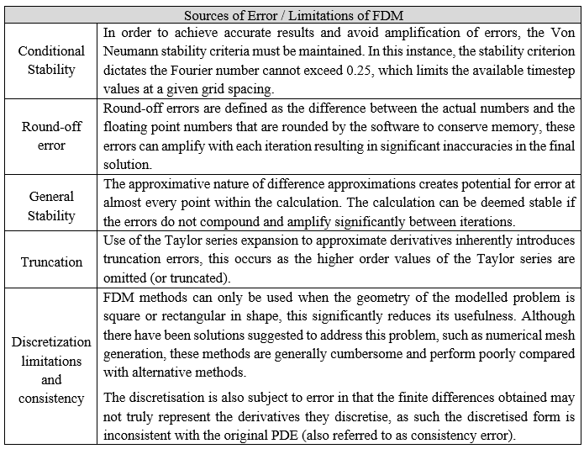
The authors explain that FDM has a series of limitations, these are summarised and tabulated below.
Figure 29: Summary of FDM Limitations (Özişik et al., 2017)

Apparent Heat Capacity Method
The AHCM was developed to address the challenge of modelling material phase changes during transient heat transfer between solids and fluids. Methods for Modelling phase change materials (PCMs), also called the Stefan problem, typically rely on moving boundaries to define and track the phase change interface (Hu & Argyropoulos, 1996).
The authors note that the AHCM uses this moving boundary approach but also calculates “temperature profiles” at each note in the mesh at each timestep. The authors also note how an “artificial increase” of the heat capacity of materials deemed to be in the mushy zone account for the latent heat.
In this application of the AHCM (Appendix 6), the temperature profiles described above are generated by recognising that the density of each material is temperature dependent. As such, the density of the water and ice at each node are recalculated at each timestep using polynomial approximations.
When the temperature at some point P is less than -0.5ºc the following polynomial is used to estimate ice density:

Equation 8: Ice Density Polynomial (Bader, 1964)
Where T = node temperature, 𝑎0=916.50, 𝑎1=157.556, 𝑎2=0.2779, 𝑎3=0.008854, 𝑎4=0.0001778
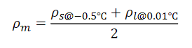
When the temperature at some point P is greater than -0.5 ºC but less than 0.01 ºC the mushy density is calculated using the following equations:

Equation 9: Mushy Zone Density (Scanlon, 1970)
Where 𝜌𝑠 = the density of ice at -0.5 ºC and 𝜌𝑙 = is the density of water at 0.01ºC
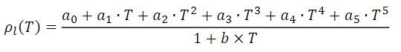
When the temperature at some point P is greater than 0.01 ºC the water density is calculated using the following polynomial:

Equation 10: Water Density Polynomial (Jones & Harris, 1992)

Where T = node temperature, 𝑎0=999.83952, 𝑎1=16.945176, 𝑎2=−7.9870401×10−3, 𝑎3=−46.170461×10−6, 𝑎4=105.56302×10−9, 𝑎5=−280.54253×10−12, 𝑏=16.897850×10−3
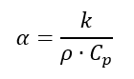
The density values for water and ice are then fed back into the equation for thermal diffusivity:

Equation 11: Thermal Diffusivity Equation (Recktenwald, 2004)
Where $k$ = thermal conductivity, $ρ$ = the calculated density and $C_{p}$ is specific heat capacity
Finally, the Calculated thermal diffusivity is then fed into the equation for the Fourier number:

Equation 12: Fourier Number Equation (Özişik et al., 2017)
Where $α$=thermal diffusivity, t=times step and h=grid spacing
The Fourier number for the mushy zone is constant in this application due to the very small temperature range (-0.5 – 0.01 ºC) and is calculated using the Fourier number equation, firstly however the specific heat capacity and conductivity must be defined, these are given by:
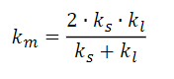
Equation 13: Conductivity of the Mushy Zone (Zeneli et al., 2021)
Where: 𝑘_{𝑙} = thermal conductivity of the mushy zone, 𝑘_{𝑠} = thermal conductivity of ice & 𝑘_{𝑙} = thermal conductivity of water.

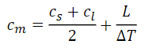

Equation 14: Specific Heat Capacity of the Mushy Zone (Zeneli et al., 2021)
Where 𝑐_{m} = specific heat of the mushy zone, 𝑐_{𝑠} = specific heat of ice, 𝑐_{𝑙} = is the specific heat of water, 𝐿 = latent heat of fusion & ∆𝑇 = 0.51k

Benefits and limitations of the AHCM
Much like FDM, (Hu & Argyropoulos, 1996) state that the benefits of the AHCM are largely attributed to its relative simplicity and ease of implementation. The authors note that the method is particularly proficient when applied to materials that display an observable finite temperature range in which phase change occurs (i.e. a mushy zone).
The authors explain that while the apparent heat capacity method certainly has many tangible use cases, it also suffers a range of limitations and often underperforms compared with alternative methods (see figure 4.3.2). The authors note that if the time step value used is too large, the temperature may jump over the mushy zone temperature range, and thus the latent heat for this region isn’t accounted for. As a result, very small time step values must be used to address this issue, significantly impacting the methods computational efficiency.
The authors also note that the method does not perform particularly well when modelling ‘pure materials’ that don’t have a significant range in which phase change occurs (no/small mushy zone). The results when modelling such materials may be a poor representation of the actual phase change characteristics.

Alternative Methods
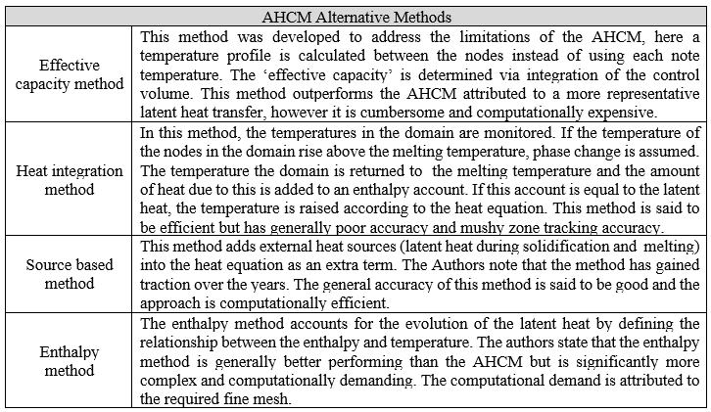
(Hu & Argyropoulos, 1996) Also provide an extensive review of alternative methods to modelling PCMs, these are summarised and tabulated below.
Figure 34: Alternative Phase Change Modelling Methods (Hu & Argyropoulos, 1996)

Conclusion
The aim of this study was twofold, to determine how DFM principles could be applied to the design of a vaccine container system, and to develop a MATLAB script to model phase change between ice and water used within the container system. It is believed that both of these aims have been met:
- The preliminary design serves as a proof of concept, showing DFM principles can be applied to seemingly simplistic products with few sub-components, but can still offer tangible benefits over conventional sequential design.
- A deductive approach to both design process and material selection identified extrusion blow moulding as an optimal production method and HDPE polymer as an optimal build material.
- The proposed design successfully incorporates poke yoke, design simplification, design for robustness, component consolidation and design for assembly features.
- The FMEA identified gasket failure and fatigue failure as significant failure modes, further work here could be to analyse the design further using finite element analysis (FEA).
- A review of the FDM and AHCM methods showed that whilst both methods are subject to limitations in terms of stability and sensitivity to time step, they remain useful tools in modelling transient heat transfer and PCM problems.
- The developed MATLAB scripts can successfully model the evolution of temperature through air (task 2), and the ice to water phase changing problem (task 3).

References
Alleycho. (2020). Blow Moulding Process Diagram. Alleycho. https://alleycho.com/plastic-extrusion-blow-molding-process/
Bader, H. (1964). Density of ice as a function of temperature and stress.
Belcher, S. L. (2017). Applied Plastics Engineering Handbook Applied Plastics Engineering Handbook - Blow Molding Ch.13. In M. B. T.-A. P. E. H. (Second E. Kutz (Ed.), Plastics Design Library (2nd ed., pp. 265–289). William Andrew Publishing. https://doi.org/https://doi.org/10.1016/B978-0-323-39040-8.00013-4
British Plastics Federation. (2020). Polymer Calendaring Process Review. https://www.bpf.co.uk/plastipedia/processes/calendering.aspx
Hancock, M. (2019). Double-Walled Component Illustration. https://slideplayer.com/slide/4457544/
Hu, H., & Argyropoulos, S. A. (1996). Mathematical modelling of solidification and melting: a review. Modelling and Simulation in Materials Science and Engineering, 4(4), 371–396. https://doi.org/10.1088/0965-0393/4/4/004
Jack, H. (2013). Universal Design Topics - Ch.9 (H. B. T.-E. D. Jack Planning, and Management, Ed.; pp. 323–380). Academic Press. https://doi.org/https://doi.org/10.1016/B978-0-12-397158-6.00009-7
Jones, F. E., & Harris, G. L. (1992). ITS-90 density of water formulation for volumetric standards calibration. Journal of Research of the National Institute of Standards and Technology, 97(3), 335.
Kent, R. (2016). Design quality management - Ch.8 (R. B. T.-Q. M. in P. P. Kent, Ed.; pp. 227–262). Elsevier. https://doi.org/https://doi.org/10.1016/B978-0-08-102082-1.50008-3
Kremer, G., & Chiu, M.-C. (2010). Evolution of Design for X Tools Applicable to Design Stages: A Literature Review. In Proceedings of the ASME Design Engineering Technical Conference (Vol. 6). https://doi.org/10.1115/DETC2010-29091
Kuo, T., Huang, S., & Zhang, H.-C. (2011). Design for manufacture and design for “X”: Concepts, applications, and perspectives. Computers and Industrial Engineering, 41. https://doi.org/10.1016/S0360-8352(01)00045-6
Löhner, M., & Drummer, D. (2016). Characterization of layer built-up and inter-layer boundaries in rotational molding of multi-material parts in dependency of the filling strategy. Journal of Polymer Engineering, 37. https://doi.org/10.1515/polyeng-2016-0175
Mital, A., Desai, A., Subramanian, A., & Mital, A. (2014). 1 - The Significance of Manufacturing (A. Mital, A. Desai, A. Subramanian, & A. B. T.-P. D. (Second E. Mital, Eds.; pp. 3–19). Elsevier. https://doi.org/https://doi.org/10.1016/B978-0-12-799945-6.00001-6
Ngo, T. D., Kashani, A., Imbalzano, G., Nguyen, K. T. Q., & Hui, D. (2018). Additive manufacturing (3D printing): A review of materials, methods, applications and challenges. Composites Part B: Engineering, 143, 172–196. https://doi.org/https://doi.org/10.1016/j.compositesb.2018.02.012
Özişik, M., Orlande, H., Colaco, M., & Cotta, R. M. (2017). Finite difference methods in heat transfer: Second Edition. In Finite Difference Methods in Heat Transfer: Second Edition. https://doi.org/10.1201/9781315121475
Rapp, B. E. (2017). Microfluidics: Modeling, Mechanics and Mathematics - Chapter 4 - Taylor Series. In B. E. B. T.-M. M. Rapp Mechanics and Mathematics (Ed.), Micro and Nano Technologies (pp. 51–80). Elsevier. https://doi.org/https://doi.org/10.1016/B978-1-4557-3141-1.50004-6
Recktenwald, G. (2004). Finite-Difference Approximations to the Heat Equation. Mechanical Engineering, 10.
Rosato, D. v, Rosato, D. v, & Rosato, M. v. (2004). Plastic Product Material and Process Selection Handbook - BLOW MOLDING Ch.6 (D. v Rosato, D. v Rosato, & M. V. B. T.-P. P. M. and P. S. H. Rosato, Eds.; pp. 282–307). Elsevier. https://doi.org/https://doi.org/10.1016/B978-185617431-2/50009-8
Scanlon, T. J. (1970). A numerical model of the ice melting process. WIT Transactions on Engineering Sciences, 29.
Singh, G., & Verma, A. (2017). A Brief Review on injection moulding manufacturing process. Materials Today: Proceedings, 4(2, Part A), 1423–1433. https://doi.org/https://doi.org/10.1016/j.matpr.2017.01.164
SPI. (2021). Blow Moulding Materials Dataset. SPI BLOW MOLDING & THERMOFORMING. https://moldedparts.com/blow-molding-materials/
Subramanian, M. (2017). Basics of Polymers: Fabrication and Processing Technology (1st ed.). Momentum Press.
Torres, F. G. (2009). Advances in Polymer Processing - Rotational moulding of polymers Ch.8 (S. Thomas & Y. B. T.-A. in P. P. Weimin, Eds.; pp. 204–225). Woodhead Publishing. https://doi.org/https://doi.org/10.1533/9781845696429.2.204
XcentricMould. (2020). Injection Moulding Diagram. Xcentric Engineering. https://www.xcentricmold.com/injection-molding-process/
Zeneli, M., Nikolopoulos, A., Karellas, S., & Nikolopoulos, N. (2021). Numerical methods for solid-liquid phase-change problems. In Ultra-High Temperature Thermal Energy Storage, Transfer and Conversion (pp. 165–199). Elsevier.

Appendices
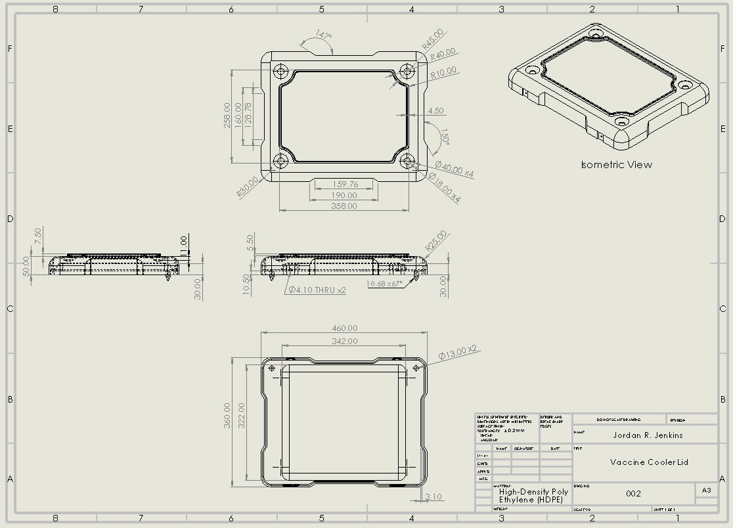
Appendix 1
Figure 30: Vaccine Box Lid Technical Drawing
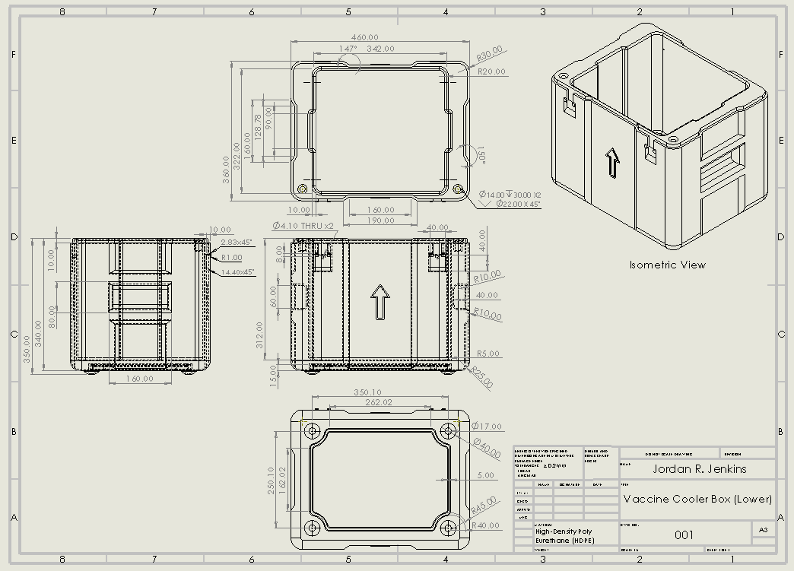
Appendix 2
Figure 31: Vaccine Lowe Box Technical Drawings
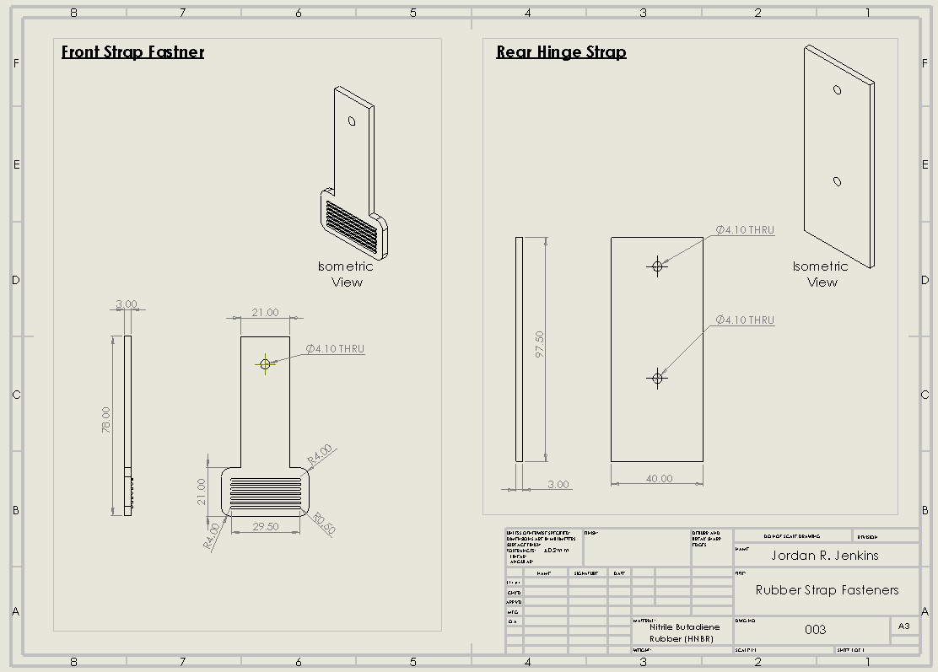
Appendix 3
Figure 32: Strap Fastener Technical Drawings
Appendix 4 (Task 1)
%%%%%%%%%%%%%%%%%%%%%%%%%%%%%%%%%%%%%%%%%%%%%%%%%%%%%%%%%%%%%%%%%%%%%%%%%%%
% Design for Manufacture %
% Transportation Container for Medicine %
% ACEA7004 %
% Task 1 %
% Jordan Ross Jenkins %
%%%%%%%%%%%%%%%%%%%%%%%%%%%%%%%%%%%%%%%%%%%%%%%%%%%%%%%%%%%%%%%%%%%%%%%%%%%
clc
clear
close all
%% Task 1 %%
% Get Ice Thickness %
while (true)
IT = inputdlg(('Enter Ice Thickness (Must be a Multiple of 0.001M)'),'Ice Thickness Properties',[1 51],{'0'});
if isempty(IT)
return
end
IT = str2double(IT);
if isempty(IT) || IT <=0 ||isnan(IT)|| IT<0.001 || (mod(IT,0.001)==0)<1
Warning = questdlg({'Ice Thickness Value is Incorrect!','Would you Like to Retry?'},...
'Retry','Retry',...
'Abort','Retry');
switch Warning
case 'Abort'
return
end
else
break
end
end

box_1_int_xyz =[0.140, 0.12, 0.140];
box_1_ext_xyz =[0.180, 0.16 0.180];
box_2_int_xyz =[(0.180+2*IT),(0.16+2*IT),(0.180+2*IT)];
box_2_ext_xyz =[(0.220+2*IT),(0.20+2*IT),(0.220+2*IT)];

% plotcube %
figure(1);
title(['Box Dimensions at Ice Thickness = ',(num2str(IT)),'M']);
zlabel(['Box Length:',(num2str((box_2_ext_xyz(3)))),'M'])
ylabel(['Box Length:',(num2str((box_2_ext_xyz(2)))),'M'])
xlabel(['Box Width:',(num2str((box_2_ext_xyz(1)))),'M'])
plotcube(box_2_ext_xyz, [ 0 0 0], 0.08,(rgb('wheat')));
plotcube(box_2_int_xyz, [ 0.02 0.02 0.02], 0.2, (rgb('lightblue')));
plotcube(box_1_ext_xyz, [ IT+0.02 IT+0.02 IT+0.02], 0.3,(rgb('DarkKhaki')));
plotcube(box_1_int_xyz, [ IT+0.04 IT+0.04 IT+0.04], 1, (rgb('Lightgreen')));

% cross-section %
figure(2);
title(['Box Cross-Section at Ice Thickness = ',(num2str(IT)),'M']);
ylabel(['Box Length:',(num2str((box_2_ext_xyz(3)))),'M'])
xlabel(['Box Width:',(num2str((box_2_ext_xyz(1)))),'M'])
rectangle('Position',[0 0 0.22+2*IT 0.22+2*IT],'FaceColor',[0.9583 0.8672 0.6992 0.1],'EdgeColor','k')
rectangle('Position',[0.02 0.02 0.18+2*IT 0.18+2*IT],'FaceColor',[0.6758 0.8438 0.8984 0.2],'EdgeColor','k')
rectangle('Position',[0.02+IT 0.02+IT 0.18 0.18],'FaceColor',[0.7383 0.7148 0.4180 0.3],'EdgeColor','k')
rectangle('Position',[0.04+IT 0.04+IT 0.14 0.14],'FaceColor',[0.5625 0.9297 0.5625 1],'EdgeColor','k')

% Return Box Dimensions %
table = array2table([box_1_int_xyz;box_1_ext_xyz;box_2_int_xyz;box_2_ext_xyz],'VariableNames',{'Length(M)','Width(M)','Depth(M)'},'RowName',{'Box 1 Inner','Box 1 Outer','Box 2 Inner','Box 2 Outer'});
disp(table);

% Calculate volumes for Both Boxes and Ice %
A = table2array(table);
vol = prod(A, 2);
vol_eps1 = vol(2)-vol(1);
vol_eps2 = vol(4)-vol(3);
vol_ice = vol(3)-vol(2);

% Calculate Mass %
eps1_mass = (23*vol_eps1);
eps2_mass = (23*vol_eps2);
ice_mass = (919.4*vol_ice); % Constant Density from Table
total_mass = eps1_mass+eps2_mass+ice_mass;
mass_vect = [eps1_mass,eps2_mass,ice_mass,total_mass];

% Return Mass %
table1 = array2table(mass_vect,'VariableNames',{'Box1','Box2','Ice','Total'},'RowName',{'Mass (kg)'});
disp(table1);

Appendix 5 (Task 2)
%%%%%%%%%%%%%%%%%%%%%%%%%%%%%%%%%%%%%%%%%%%%%%%%%%%%%%%%%%%%%%%%%%%%%%%%%%%
% Design for Manufacture %
% Transportation Container for Medicine %
% ACEA7004 %
% Task 2 %
% Jordan Ross Jenkins %
%%%%%%%%%%%%%%%%%%%%%%%%%%%%%%%%%%%%%%%%%%%%%%%%%%%%%%%%%%%%%%%%%%%%%%%%%%%

clc
clear
close all
%% Task 2 %%
% Get Ice Thickness %
while (true)
IT = inputdlg(('Enter Ice Thickness (Must be a Multiple of 0.02M)'),'Ice Thickness Properties',[1 51],{'0'});
if isempty(IT)
return
end
IT = str2double(IT);
if isempty(IT) || IT <=0 ||isnan(IT)|| IT<0.02 || (mod(IT,0.02)==0)<1
Warning = questdlg({'Ice Thickness Value is Incorrect!','Would you Like to Retry?'},...
'Retry','Retry',...
'Abort','Retry');
switch Warning
case 'Abort'
return
end
else
break
end
end

% Box Dimensions %
box_1_int_xyz =[0.140, 0.12, 0.140];
box_1_ext_xyz =[0.180, 0.16 0.180];
box_2_int_xyz =[(0.180+2*IT),(0.16+2*IT),(0.180+2*IT)];
box_2_ext_xyz =[(0.220+2*IT),(0.20+2*IT),(0.220+2*IT)];

%% Task 2 %%
% Matrix Initialisation %
GridSpacing = 0.02;
Ax = uint16(((box_2_ext_xyz(1))/GridSpacing)+1);
Ay = uint16(((box_2_ext_xyz(3))/GridSpacing)+1);
NewMatrix = zeros([Ay Ax]);

% Initial Conditions %
NewMatrix(:,:)=12;
NewMatrix (2:end-1,2:end-1)=-20;

% EPS & Air Coordinates %
ice_gap = (IT/GridSpacing);

% Required Values %
Alpha_eps = 0.0345/((23)*(1.28*10^3)); % Conductivity/(Density*Specific Heat)
Alpha_air = 0.02/((1.3)*(1006)); % Conductivity/(Density*Specific Heat)
[TimeStep,MaxTimeStep]=GetTimeStep(GridSpacing,Alpha_eps,Alpha_air);
Fo_eps = (Alpha_eps*TimeStep)/(GridSpacing^2);
Fo_air = (Alpha_air*TimeStep)/(GridSpacing^2);

% Plot Initialisation %
figure;
[~,val] = contourf(NewMatrix, 'ShowText','on');
set(gca,'ydir','reverse', 'xtick',[],'ytick',[]);
title('Heat Distribution Map');
ylabel(['Box Width:',(num2str((box_2_ext_xyz(3)))),'M'])
xlabel(['Box Length:',(num2str((box_2_ext_xyz(1)))),'M'])
colorbar('Ticks',[-20,-15,-10,-5,0,5,10,15,20]);
colormap(jet);
caxis([-20,12])

% Counter %
Iteration = 0;
tic
while NewMatrix(ice_gap+4:end/2,(ice_gap+4):end/2)<=0

Iteration = Iteration + 1;
Matrix = NewMatrix;

% This section computes the top left quadrant (Q1) of the matrix
% EPS BOX OUTER Q1
NewMatrix(2:end/2,2) = Fo_eps*(Matrix((2:end/2)-1,2)+Matrix(2:end/2,(2)+1)+Matrix((2:end/2)+1,2)+Matrix(2:end/2,(2)-1)+((1/Fo_eps)-4)*Matrix(2:end/2,2));
[~, n] = size(NewMatrix(2:end/2,2)); NewMatrix(2,3:end/2) = NewMatrix(2+n:end/2,2).'; %copy left region to top
% Air Outer Q1
NewMatrix(3:end/2,3:ice_gap+1) = Fo_air*(Matrix((3:end/2)-1,3:ice_gap+1)+Matrix(3:end/2,(3:ice_gap+1)+1)+Matrix((3:end/2)+1,3:ice_gap+1)+Matrix(3:end/2,(3:ice_gap+1)-1)+((1/Fo_air)-4)*Matrix(3:end/2,3:ice_gap+1));
[~, n] = size(NewMatrix(3:end/2,3:ice_gap+1)); NewMatrix(3:(ice_gap+1),(ice_gap+2):end/2) = NewMatrix(3+n:end/2,3:ice_gap+1).'; % Copy to Top Air Region.
% EPS Inner Q1
NewMatrix((ice_gap+2):(end/2),(ice_gap+2):(ice_gap+3)) = Fo_eps*(Matrix(((ice_gap+2):(end/2))-1,(ice_gap+2):(ice_gap+3))+Matrix((ice_gap+2):(end/2),((ice_gap+2):(ice_gap+3))+1)+Matrix(((ice_gap+2):(end/2))+1,(ice_gap+2):(ice_gap+3))+Matrix((ice_gap+2):(end/2),((ice_gap+2):(ice_gap+3))-1)+((1/Fo_eps)-4)*Matrix((ice_gap+2):(end/2),(ice_gap+2):(ice_gap+3)));
[~, n] = size(NewMatrix((ice_gap+2):(end/2),(ice_gap+2):(ice_gap+3))); NewMatrix((ice_gap+2):(ice_gap+3),(ice_gap+4):end/2) = NewMatrix((ice_gap+2+n):(end/2),(ice_gap+2):(ice_gap+3)).'; %copy left region to top
% Air Inner Q1
NewMatrix(ice_gap+4:end/2,(ice_gap+4):end/2) = Fo_air*(Matrix((ice_gap+4:end/2)-1,(ice_gap+4):end/2)+Matrix(ice_gap+4:end/2,((ice_gap+4):end/2)+1)+Matrix((ice_gap+4:end/2)+1,(ice_gap+4):end/2)+Matrix(ice_gap+4:end/2,((ice_gap+4):end/2)-1)+((1/Fo_air)-4)*Matrix(ice_gap+4:end/2,(ice_gap+4):end/2));
% This section mirrors the top left quadrant (Q1) into the remaining 3 quadrants (Q2-Q4)
NewMatrix(2:end/2,(end/2)+1:end-1) = fliplr(NewMatrix(2:end/2,2:end/2));% Mirror to Q2
NewMatrix((end/2)+1:end-1,2:end-1) = flipud(NewMatrix(2:end/2,2:end-1));% Mirror to Q3&Q4

%Update graph when iteration is a multiple of 100 %
if (mod(Iteration,10)==0)
val.ZData=NewMatrix;
drawnow
end
end
toc

EquilibriumTime_S = Iteration*TimeStep;
EquilibriumTime = duration(seconds(EquilibriumTime_S)); EquilibriumTime = char(EquilibriumTime,'hh:mm:ss');
title({'Heat Distribution at Equilibrium',['Total Iterations = ',(num2str(Iteration))],['Equilibrium Time = ',(EquilibriumTime),' (' num2str(EquilibriumTime_S),' Seconds)']});

Appendix 6 (Task 3)
%%%%%%%%%%%%%%%%%%%%%%%%%%%%%%%%%%%%%%%%%%%%%%%%%%%%%%%%%%%%%%%%%%%%%%%%%%%
% Design For Manufacture %
% Transportation Container for Medicine %
% ACEA7004 %
% Task 3 %
% Jordan Ross Jenkins %
%%%%%%%%%%%%%%%%%%%%%%%%%%%%%%%%%%%%%%%%%%%%%%%%%%%%%%%%%%%%%%%%%%%%%%%%%%%

clc
clear
close all
%% Task 3 %%
% Get Ice Thickness %
while (true)
IT = inputdlg(('Enter Ice Thickness (Must be a Multiple of 0.005M)'),'Ice Thickness Properties',[1 51],{'0'});
if isempty(IT)
return
end
IT = str2double(IT);
if isempty(IT) || IT <=0 ||isnan(IT)|| IT<0.005 || (mod(IT,0.005)==0)<1
Warning = questdlg({'Ice Thickness Value is Incorrect!','Would you Like to Retry?'},...
'Retry','Retry',...
'Abort','Retry');
switch Warning
case 'Abort'
return
end
else
break
end
end

% Box Dimensions %
box_1_int_xyz =[0.140, 0.12, 0.140];
box_1_ext_xyz =[0.180, 0.16 0.180];
box_2_int_xyz =[(0.180+2*IT),(0.16+2*IT),(0.180+2*IT)];
box_2_ext_xyz =[(0.220+2*IT),(0.20+2*IT),(0.220+2*IT)];
%% Task 3 %%
% Matrix Initialisation %
GridSpacing = 0.005;
Ax = uint16(((box_2_ext_xyz(1))/GridSpacing)+1);
Ay = uint16(((box_2_ext_xyz(3))/GridSpacing)+1);
NewMatrix = zeros([Ay Ax]);

% Initial Conditions %
NewMatrix(:,:)=12;
NewMatrix (2:end-1,2:end-1)=-20;

% EPS & Air Coordinates %
ice_gap = (IT/GridSpacing);

% Required Values %
Alpha_eps = 0.0345/((23)*(1.28*10^3)); % Conductivity/(Density*Specific Heat)
Alpha_air = 0.02/((1.3)*(1006)); % Conductivity/(Density*Specific Heat)
[TimeStep,MaxTimeStep]=GetTimeStep(GridSpacing,Alpha_eps,Alpha_air);
Fo_eps = (Alpha_eps*TimeStep)/(GridSpacing^2);
Fo_air = (Alpha_air*TimeStep)/(GridSpacing^2);

% Mushy Values %
conductivity_mushy = (2*2.3*0.56)/(2.3+0.56);
density_mushy = (916.5721+999.84)/2;
specific_heat_mushy = (((2*10^3)+(4.2*10^3))/2)+(334*10^3/0.51);
Alpha_mushy = conductivity_mushy/(density_mushy*specific_heat_mushy);
Fo_mushy = (Alpha_mushy*TimeStep)/(GridSpacing^2);

% Plot Initialisation %
figure;
[~,val] = contourf(NewMatrix, 'ShowText','on');
set(gca,'ydir','reverse', 'xtick',[],'ytick',[]);
title('Heat Distribution Map');
ylabel(['Box Width:',(num2str((box_2_ext_xyz(3)))),'M'])
xlabel(['Box Length:',(num2str((box_2_ext_xyz(1)))),'M'])
colorbar('Ticks',[-20,-15,-10,-5,0,5,10,15,20]);
colormap(jet);
caxis([-20,12])

% Counter %
Iteration = 1;
tic
Ax = double(Ax);Ay = double(Ay);
while NewMatrix(ice_gap+10,ice_gap+10)<=0

Iteration = Iteration + 1;
Matrix = NewMatrix;

% This section computes the top left quadrant (Q1) of the matrix
% EPS BOX OUTER Q1
NewMatrix(2:(end/2)+0.5,2:5) = Fo_eps*(Matrix((2:(end/2)+0.5)-1,2:5)+Matrix(2:(end/2)+0.5,(2:5)+1)+Matrix((2:(end/2)+0.5)+1,2:5)+Matrix(2:(end/2)+0.5,(2:5)-1)+((1/Fo_eps)-4)*Matrix(2:(end/2)+0.5,2:5));
[~, n] = size(NewMatrix(2:(end/2)+0.5,2:5)); NewMatrix(2:5,2+n:(end/2)+0.5) = NewMatrix(2+n:(end/2)+0.5,2:5).';

% Ice Region Q1
for i=6:(Ax/2)+0.5
for j=6:(Ay/2)+0.5
if i>=6||i<=ice_gap+4
if Matrix(i,j)<-0.5
ice_density = 916.50*(1-10^-6*NewMatrix(i,j)*(157.556+0.2779*NewMatrix(i,j)+0.008854*NewMatrix(i,j)^2+0.0001778*NewMatrix(i,j)^3));
Alpha_ice = 2.3/(ice_density*(2*10^3));
Fo_ice = (Alpha_ice*TimeStep)/(GridSpacing^2);
NewMatrix(i,j)=Fo_ice*(Matrix(i-1,j)+Matrix(i+1,j)+Matrix(i,j-1)+Matrix(i,j+1)-(4-1/Fo_ice)*Matrix(i,j));% ice zone
end
if Matrix(i,j)>=-0.5 && Matrix(i,j)<0.01
NewMatrix(i,j)=Fo_mushy*(Matrix(i-1,j)+Matrix(i+1,j)+Matrix(i,j-1)+Matrix(i,j+1)-(4-1/Fo_mushy)*Matrix(i,j)); %mushy zone
end
if Matrix(i,j)>=0.01
water_density = (999.83952+16.945176*NewMatrix(i,j)+(-7.9870401*10^-3)*NewMatrix(i,j)^2+(-46.170461*10^-6)*NewMatrix(i,j)^3+(105.56302*10^-9)*NewMatrix(i,j)^4+(-280.54253*10^-12)*NewMatrix(i,j)^5)/(1+16.897850*10^-3*NewMatrix(i,j));
Alpha_water = 0.56/(water_density*(4.2*10^3));
Fo_water = (Alpha_water*TimeStep)/(GridSpacing^2);
NewMatrix(i,j)=Fo_water*(Matrix(i-1,j)+Matrix(i+1,j)+Matrix(i,j-1)+Matrix(i,j+1)-(4-1/Fo_water)*Matrix(i,j));% water zone
end
end
end
end
[~, n]=size(NewMatrix(6:(end/2)+0.5,6:ice_gap+4)); NewMatrix(6:(ice_gap+4),(ice_gap+5):(end/2)+0.5) = NewMatrix(6+n:(end/2)+0.5,6:ice_gap+4).';
% EPS Inner Q1
NewMatrix((ice_gap+5):(end/2)+0.5,(ice_gap+5):(ice_gap+9)) = Fo_eps*(Matrix(((ice_gap+5):(end/2)+0.5)-1,(ice_gap+5):(ice_gap+9))+Matrix((ice_gap+5):(end/2)+0.5,((ice_gap+5):(ice_gap+9))+1)+Matrix(((ice_gap+5):(end/2)+0.5)+1,(ice_gap+5):(ice_gap+9))+Matrix((ice_gap+5):(end/2)+0.5,((ice_gap+5):(ice_gap+9))-1)+((1/Fo_eps)-4)*Matrix((ice_gap+5):(end/2)+0.5,(ice_gap+5):(ice_gap+9)));
[~, n]=size(NewMatrix((ice_gap+5):(end/2)+0.5,(ice_gap+5):(ice_gap+9))); NewMatrix((ice_gap+5):(ice_gap+9),(ice_gap+10):(end/2)+0.5) = NewMatrix((ice_gap+5)+n:(end/2)+0.5,(ice_gap+5):(ice_gap+9)).';
% Air Inner Q1
NewMatrix(ice_gap+10:(end/2)+0.5,(ice_gap+10):(end/2)+0.5) = Fo_air*(Matrix((ice_gap+10:(end/2)+0.5)-1,(ice_gap+10):(end/2)+0.5)+Matrix(ice_gap+10:(end/2)+0.5,((ice_gap+10):(end/2)+0.5)+1)+Matrix((ice_gap+10:(end/2)+0.5)+1,(ice_gap+10):(end/2)+0.5)+Matrix(ice_gap+10:(end/2)+0.5,((ice_gap+10):(end/2)+0.5)-1)+((1/Fo_air)-4)*Matrix(ice_gap+10:(end/2)+0.5,(ice_gap+10):(end/2)+0.5));
% This section mirrors the top left quadrant (Q1) into the remaining 3 quadrants (Q2-Q4)
NewMatrix(2:(end/2)+0.5,(end/2)+1.5:end-1) = fliplr(NewMatrix(2:(end/2)+0.5,2:(end/2)-0.5));% Mirror to Q2
NewMatrix((end/2)+1.5:end-1,2:end-1) = flipud(NewMatrix(2:(end/2)-0.5,2:end-1));% Mirror to Q3&Q4

%Update graph when iteration is a multiple of 100 %
if (mod(Iteration,100)==0)
val.ZData=NewMatrix;
drawnow
end
end
toc

EquilibriumTime_S = Iteration*TimeStep;
EquilibriumTime = duration(seconds(EquilibriumTime_S)); EquilibriumTime = char(EquilibriumTime,'hh:mm:ss');
title({'Heat Distribution at Equilibrium',['Total Iterations = ',(num2str(Iteration))],['Equilibrium Time = ',(EquilibriumTime),' (' num2str(EquilibriumTime_S),' Seconds)']});

