MSc Digital Transformation
for the Health and Care Professions
BMDS7005

Evaluating AI-Assisted Performance Reporting: Developing and Piloting an Evaluation Framework

Dissertation submitted in partial fulfilment of the award of
Master of Science in Digital Transformation for the Health and Care Professions

Jenny Jones
2215853
5th May 2026

Acknowledgements

My sincere thanks to my supervisor Dr. Ed Conley; his time, encouragement, support, and feedback throughout this research project have been invaluable.

I would also like to extend huge thanks to my family for their support, encouragement, and patience throughout my studies.

Contents Page
Page Number
Acknowledgements i
Contents Page ii
List of Figures v
List of Tables v
List of Abbreviations vi
Chapter 1: Introduction 1
1.1 Background and context 1
1.2 Challenges in current performance reporting 2
1.3 Artificial intelligence -assisted performance reporting:
opportunities and risks 2
1.4 Policy and strategic context 3
1.5 The problem: absence of evaluation standards 4
1.6 Rationale and contribution of the study 5
1.7 Aim, research question, and scope 6
1.8 Structure 7
Chapter 2: Literature Review 8
2.1 Introduction 8
2.2 Search strategy 9
2.3 Study selection and PRISMA flow diagram 10
2.4 Performance information and decision-making in
organisational contexts 12
2.5 Digitalisation and the transformation of performance
reporting 13
2.6 Automation, analytics, and AI as decision support 15
2.7 Human factors 17

2.8 Evaluative frameworks for AI-assisted performance
reporting 19
2.9 Summary 22
Chapter 3: Methods 23
3.1 Study design and methodological approach 23
3.2 Stakeholder questionnaire 23
3.3 Identification and selection of AI-assisted use cases 24
3.4 Development of the evaluation framework 28
3.5 AI-assisted report production and operationalisation 30
3.6 Production of performance reporting outputs 32
3.7 Data collection: semi-structured interviews 33
3.8 Data analysis 35
3.9 Ethical and governance considerations 36
Chapter 4: Results 37
4.1: Introduction 37
4.2: Respondent characteristics 37
4.3: Questionnaire findings: quantitative perceptions of value
and confidence in interpreting performance reports 38
4.4: Questionnaire findings: quantitative views on AI-assisted
performance reporting 41
4.5: Questionnaire findings: qualitative free-text responses 44
4.6: Interview findings: evaluation of performance reporting
outputs 47
4.7: Overall suitability for use in practice 50
Chapter 5: Discussion 52
5.1: Overview 52
5.2: Summary of key findings 52
5.3: Stakeholder views of AI-assisted reporting 53
5.4: Pilot of the draft evaluation framework 54

5.5: Interpretation of the example AI-assisted performance
report 56
5.6 Implications for practice 58
5.7 Strengths and limitations of the study 60
5.8 Recommendations for further research and future
development 62
Chapter 6: Conclusion 65
Reference List 67
Appendix A: Project Brief 73
Appendix B: Ethical approval confirmation 81
Appendix C: Questionnaire informed consent form 95
Appendix D: ChatGPT prompt structure 97
Appendix E: Screenshots of the data table used in the generation of
the AI-assisted report 102

Wordcount: 16454

List of Figures

Figure 1.1: Rich text picture of the study problem and rationale 5
Figure 2.1: PRISMA flow diagram 12
Figure 2.2: Different modes of automation 16
Figure 2.3: An adapted version of the NASSS framework 20
Figure 3.1: Evaluation framework tool for assessing performance
reporting outputs 30
Figure 4.1: Respondent involvement in performance reporting
activities 38
Figure 4.2: Positive perceived importance of performance report
components 39
Figure 4.3: Positive responses about confidence in interpreting report
components 41
Figure 4.4: Usefulness of AI-assisted content in performance reporting 42
Figure 4.5: Confidence in AI’s ability to summarise performance data
correctly 43

List of Tables

Table 2.1: Literature review search strings 9
Table 3.1: Candidate AI-assisted activities in healthcare
performance reporting 25-26
Table 3.2: Short-listed AI-assisted use cases 27
Table 4.1: Primary role of questionnaire respondents 37
Table 4.2: Perceived importance of performance report components 39
Table 4.3: Confidence in interpreting performance report elements 40
Table 4.4: Agreement with statements about AI-assisted reporting 44
List of Abbreviations

Artificial Intelligence AI
Automatic Text Summarisation ATS
Business Source Complete BSC
Fit between Individuals, Task and Technology FITT
Fit between Individuals, Task and Technology and Environment FITTE
Generative Pre-Trained Transformer GPT
Health Education and Improvement Wales HEIW
Health Information Technology HIT
Human, Organisation and Technology-fit framework HOT-fit
Key Performance Indicator KPI
Non-adoption, Abandonment, Scale-up, Spread, and
Sustainability NASSS
National Health Service NHS
Performance Information PI
Performance Measurement and Management PMM
Performance Measurement Systems PMS
Preferred Reporting Items for Systematic Reviews and
Meta-Analyses PRISMA
Red, Amber, Green RAG
Statistical Process Control SPC

Chapter 1: Introduction

1.1 Background and context
This dissertation examines how AI-assisted performance reporting in health services can be evaluated. Informed by literature and staff stakeholder perspectives, it focuses on developing and piloting an evaluation framework, with particular attention to whether AI-assisted reporting outputs are considered useful, interpretable, and suitable for assurance and decision-making. The study addresses the problem that, although performance reports are central to governance and organisational oversight, there is currently no agreed standard for judging report quality, including where AI-assisted elements are introduced.
Performance reporting is a core component of governance, accountability, and organisational oversight within the National Health Service (NHS), supporting the monitoring of strategic objectives, national and local targets, emerging risks, escalation, and decision-making (Audit Commission, 2009). However, the increasing volume, complexity, and frequency of performance data means that reports need to do more than present data accurately, but also support interpretation, prioritisation, and assurance within complex and time-pressured settings. This creates a problem where reporting methods, including AI-assisted approaches, might evolve faster than the standards used to assess whether they are genuinely useful in practice.
Performance data has increased in volume and complexity, with routine reporting drawing on multiple data sources. Whilst this reflects improvements in digital infrastructure and data availability, it also creates the practical challenge of selecting, prioritising, interpreting, and communicating information in ways that support action. This can make reports more demanding cognitively, both for producers and readers, which increases the risk that important patterns may be overlooked or misinterpreted (Dimara et al., 2022; Eppler & Mengis, 2004). This is part of the reason why AI-assisted tools have become attractive in reporting environments as they appear to offer ways of managing complexity and reducing manual burden. However, they also raise the question about how the quality and suitability of such outputs should be evaluated.
Performance reports are, therefore, not simply summaries of data, but sociotechnical documents impacted by data quality, organisational context, reporting conventions, and assumptions about what counts as meaningful insight (Ammenwerth, Iller, and Mahler, 2006; Dimara et al., 2022).

1.2 Challenges in current performance reporting
In practice, the production of NHS performance reports remains largely manual and analyst-intensive. Decisions regarding KPI (key performance indicator) selection, visualisation design, and supporting narrative are often made under time pressure and driven by local practices. This can lead to variation and inconsistency in how performance issues are selected, contextualised, and escalated across reports. From an assurance perspective, such variability could undermine confidence in reported performance, fail to support appropriate scrutiny, or delay the recognition of risk (Audit Commission, 2009; Betsi Cadwaladr University Health Board, 2023). These risks are particularly relevant where reports are intended for diverse audiences, including operational managers and Board members, who may approach the same information with different expectations, professional language, and levels of analytic expertise.
These reporting challenges are particularly relevant because they make report quality difficult to judge consistently. If existing human-produced reports are impacted by variable judgement, presentation choice, analyst capacity, and differing audience expectation, then adding AI-assisted elements does not remove these issues; instead, it amplifies the need to evaluate reporting quality more consistently where outputs might be shaped by both humans and AI.

1.3 Artificial intelligence (AI) -assisted performance reporting: opportunities and risks
Advances in AI have led to increased exploration of their use within performance reporting. In this study, AI-assisted performance reporting refers to the use of AI-enabled tools to support elements of the reporting process, rather than replace professional judgement. This may include support with KPI prioritisation, identifying patterns or anomalies, suggesting visualisations, drafting narrative summaries, and identifying related metrics that could assist with contextual interpretation. Used appropriately, such tools might be able to support analysts with routine or time-consuming tasks, improve consistency, and highlight patterns that might be missed through manual analysis (Soori et al., 2024; Sutton et al., 2020).
However, the use of AI in performance reporting also raises concerns. AI-enabled tools are dependent on the quality and representativeness of the data made available to them, and may reproduce or amplify issues such as missing data and bias if their outputs are not reviewed critically (Alves et al., 2024; O’Leary et al., 2014; Obermeyer et al., 2019). Generative AI also brings concerns about transparency, explainability, and the potential for misleading or ‘hallucinated’ outputs. In performance reporting, where outputs may inform escalation, assurance and decision-making, such risks are particularly significant. If AI-assisted outputs are biased, misleading, insufficiently transparent, or accepted without adequate scrutiny, the consequence is not merely technical weakness, but instead the possibility of skewed or erroneous judgements within the organisational governance and assurance processes. Thus, the issue in question is not only whether AI can support performance reporting work, but how the quality and suitability of AI-assisted reporting outputs can be evaluated before they are relied upon for assurance or decision-making.

1.4 Policy and strategic context
The interest in AI-assisted analytics within the NHS reflects a wider policy emphasis on digital transformation and data-driven decision-making. In Wales, the ‘Wales Innovates’ strategy identifies digital infrastructure as a key enabler for improving the use of health data, delivering services digitally and supporting the adoption of AI across public services, and strengthening the sustainability of future service delivery (Welsh Government, 2023).
Guidance from bodies such as the Department of Health and Social Care and the World Health Organization outlines that AI-enabled technologies should be transparent, fair, interpretable, and accountable (Department of Health and Social Care, 2021; World Health Organization, 2021). Although this guidance largely focuses on clinical applications, the underlying principles are equally relevant to performance reporting, where AI-generated outputs may influence organisational behaviours and resource allocation.
This policy context matters because interest in AI-assisted analytics is no longer only theoretical. If digital and AI-enabled approaches are increasingly encouraged within the public sector then the quality, transparency, interpretability, and suitability of AI-assisted reporting outputs need to be considered before they become embedded within routine governance processes.

1.5 The problem: absence of evaluation standards
The problem addressed in this study has two related parts: firstly, the absence of a clear, consistently applied standard for evaluating traditional performance reports, and secondly, the added uncertainty created by the addition of AI-assisted elements. Despite the central role of performance reporting within NHS governance and assurance, there is limited agreement on what constitutes a ‘gold-standard’ performance report in practice. Whilst characteristics such as accuracy, relevance, timeliness, and clarity are frequently acknowledged, they are rarely operationalised in a consistent or systematic way. As a result, performance reports often vary considerably in structure, emphasis, and interpretative quality, making it difficult to judge whether they support appropriate scrutiny, prioritisation, and escalation, or whether they contribute to information overload and misinterpretation. Existing governance frameworks emphasise the importance of performance intelligence, but provide limited practical guidance on how reports should be designed or evaluated to achieve this in complex organisational settings.
These challenges are further compounded by the emergence of AI-assisted approaches to performance reporting. In the absence of an agreed standard for traditional performance reporting, there is even less clarity regarding what constitutes a high-quality AI-assisted performance report. The gap is not simply a lack of technical evaluation tools, but the lack of a clear evaluative approach for judging whether AI-assisted reporting outputs are useful, interpretable, trustworthy, transparent, and suitable for governance and managerial use.
Taken together, these issues create a clear evaluative problem. Performance reporting is already difficult to evaluate consistently, and the introduction of AI-assisted elements increases both the opportunity and uncertainty. This study, therefore, focuses not on whether AI can be used in reporting in principle, but on how the quality and suitability of AI-assisted reports can be evaluated in practice.
Figure 1.1 summarises the problem addressed in this study.
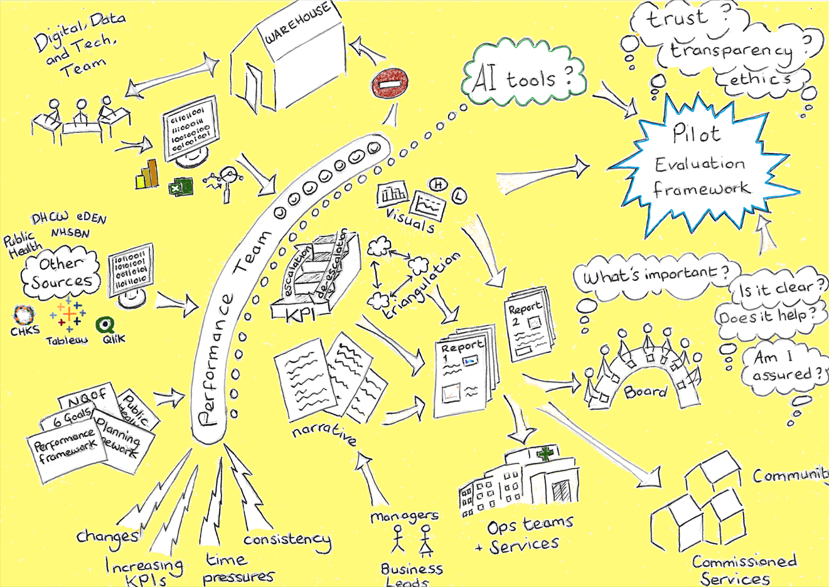

1.6 Rationale and contribution of the study
This study responds to the practical and conceptual problem outlined above by developing and piloting an exploratory evaluation framework for assessing the quality of performance reports that include AI-assisted elements, such as prioritisation, visualisation, and narrative support. The focus is on whether reporting outputs appear useful for interpretation, assurance, and decision-making, rather than assessing organisational readiness for AI or the technical performance of tools themselves.
The rationale for this approach reflects the practical challenges faced by performance teams operating in complex and time-pressured environments. In the absence of agreed standards for performance reporting, and with growing interest in AI-assisted tools, there is a need to look beyond efficiency alone and consider whether reporting outputs are interpretable, transparent, and sufficiently supported by context.
The contribution of this study is both conceptual and practical. Conceptually, it brings together literature on performance reporting, decision support, human factors, and governance to identify dimensions relevant to evaluating AI-assisted reporting outputs. Practically, it develops and pilots a stakeholder-informed framework using an example AI-assisted output. The framework is exploratory and limited in scope, and is intended to provide an evaluative starting point rather than a final standard or prescriptive implementation model.

1.7 Aim, research question, and scope
The aim of this study was to develop and pilot an evaluation framework for AI-assisted performance reporting in health services.
The primary research question was:
How can an evaluation framework be developed and piloted to assess the quality, interpretability, and practical suitability of AI-assisted performance reports in health services?
The scope of the study was limited to performance reporting used for managerial or governance purposes within health services. It did not seek to develop or validate AI algorithms, assess technical model performance, or evaluate wider organisational readiness for AI adoption. Nor did it attempt to measure downstream effects on decision outcomes. Its focus was on the reporting outputs themselves and on whether these appeared suitable for interpretation, assurance, and practical organisational use.

1.8 Structure
The chapters that follow develop the argument and practical work of the study. The literature review establishes the conceptual basis for evaluating AI-assisted reporting, the methodology chapter explains the design and piloting of the framework, and the later chapters present findings and reflect on the implications for the future use and evaluation of AI-assisted performance reporting in health services. Taken together, the chapters set out the need for a structured approach to evaluating AI-assisted performance reporting outputs and consider what this might mean for future reporting practices.

Chapter 2: Literature Review

2.1 Introduction
This chapter reviews literature relevant to evaluating AI-assisted performance reporting in healthcare organisations. Rather than providing a general review of AI in healthcare, it focuses on literature that helps to explain how AI-assisted reporting outputs might be judged in practice. The review, therefore, considers evidence on performance reporting, decision support, digital reporting, interpretability, usability, trust, and governance factors, with the aim of identifying the dimensions most relevant to evaluating whether AI-assisted reporting is useful, workable, and appropriate in practice.
Performance reporting is a central part of public-sector performance measurement and management (PMM) intended to support monitoring, accountability, and decision-making (Garengo and Sardi, 2021). In healthcare organisations, however, the production of performance reports is often labour-intensive and dependent on a substantial amount of analytical and interpretative work. This has led to growing interest in whether digital and AI-enabled tools might be able to support elements of the reporting process more efficiently, particularly in systems facing continuing pressure on staff time, service performance, and workforce capacity (Mistry, 2025b; Moulds and Horton, 2024).
At the same time, the literature suggests that the value of AI in health and care cannot be assumed simply because a tool can generate an output. Recent work has instead pointed to the importance of the setting in which these technologies are introduced, including aspects such as infrastructure, data quality, system readiness, and governance arrangements (Mistry, 2025a; World Health Organization, 2021). These considerations are especially important in relation to performance reporting, where outputs are expected to summarise information, as well as support judgement about trends, risks, priorities, and potential action.

2.2 Search strategy

2.2.1 Literature search strategy
A structured literature search was undertaken to identify peer-reviewed evidence relevant to AI-assisted performance reporting within healthcare. The search was deliberately broad because no significant body of literature addresses performance reporting, healthcare, and AI together. For this reason, the search was structured around adjacent conceptual areas that could help to inform the evaluation problem; Table 2.1 shows the BSC search strings by conceptual area. Therefore, literature was selected not only because it used shared terminology, but because it contributed to understanding how AI-assisted reporting outputs might be produced, interpreted, evaluated, or used in practice.
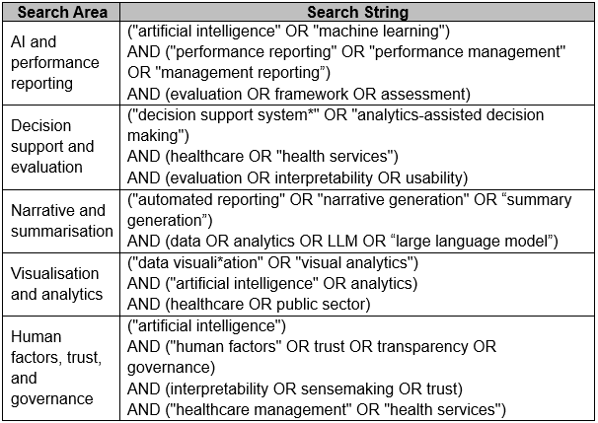

Business Source Complete (BSC) was used as the primary database because of its strong coverage of management, and organisational literature. Search terms were developed iteratively around these areas and searched separately. Studies were included if they were peer-reviewed journal articles, published in English within the last ten years, and available in full text. Retracted papers were excluded.

2.2.2 Grey literature and supplementary searching
In addition to database searching, grey literature searches were undertaken to identify relevant policy documents and guidance related to performance reporting and the use of AI within healthcare and public-sector settings. These documents were used to provide context on current practice, infrastructure, governance, and assurance issues that were not well represented in the literature.
Reference list screening was also undertaken to identify additional relevant literature from included papers. This was particularly useful given the dispersed nature of the topic across performance management, digital health, AI implementation and health information technology (HIT).

2.2.3 Limitations of the search strategy
Only one primary database was used for the structured search, which is a clear limitation given the interdisciplinary nature of the topic. Relevant papers may be indexed across health informatics, management, information systems, and computer science sources. BSC was selected because the study’s focus is organisational and evaluative rather than technical, and because of its coverage of management and organisational literature. It is possible that some relevant papers were not captured directly, and the findings of the review should, therefore, be interpreted within that threshold.

2.3 Study selection and PRISMA flow diagram
Search results were exported from BSC and screened in stages. Across the five search areas, 63 records were identified before duplicate and eligibility checks. Titles and abstracts were reviewed to exclude clearly irrelevant papers. Full texts were then screened to assess eligibility against the purpose of the review, which was to identify literature that could inform the evaluation of AI-assisted performance reporting in practice. Papers were excluded where they mainly focused on technical AI development without organisational relevance, where they were concerned solely with clinical care without implications for reporting or decision support, or where they did not contribute conceptually to the evaluation problem. Citation and grey literature searching were used to supplement the database search.
A key finding from the search process was that there appears to be little directly focused literature on AI-assisted performance reporting in healthcare organisations as a distinct evaluative problem. Instead, the relevant evidence was dispersed across adjacent topics including performance management, digital reporting, decision support, summarisation, usability, and AI implementation. This fragmented evidence base justifies the present review, which brings these elements together to support the development of an evaluative approach suited to AI-assisted reporting practice.
In total, the final review included 28 studies and documents. The study selection process is summarised in Figure 2.1.

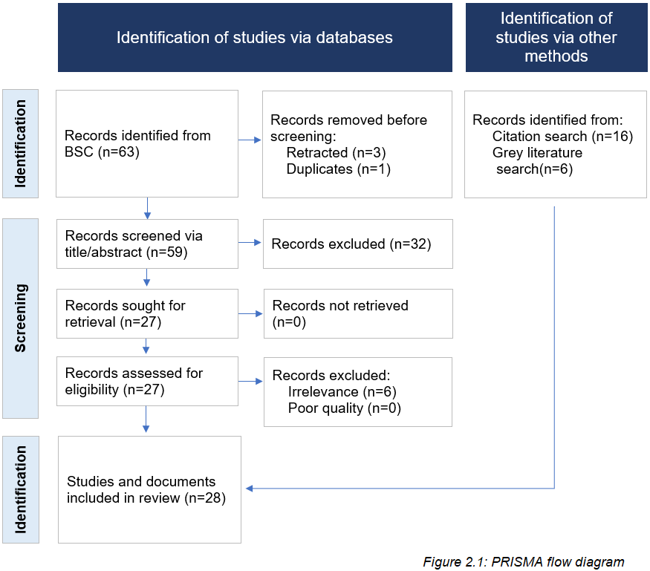

Although this literature is useful conceptually, its relevance to AI-assisted performance reporting is often indirect. Its value in this review is, therefore, not as direct evidence of what works in AI-assisted reporting, but as a way of identifying concepts and evaluative dimensions relevant to this context.

2.4 Performance information and decision-making in organisational contexts
Performance information (PI) is often presented as though collecting and reporting it will, in itself, support decision-making. Earlier work on performance measurement systems (PMS) tended to frame performance measurement as a structured process linked to managerial control and strategic alignment, with Neely, Gregory, and Platts stating that “strategy is only realised as decisions are made and courses of action are pursued” (1995, p. 1240), while Micheli and Mura (2017) similarly emphasise the role of PMS in strategy implementation. More recent literature is less confident that the presence of data is enough on its own, and instead draws attention to the conditions under which information is actually used and acted upon (Han and Moynihan, 2022).
Han and Moynihan (2022) argue that the relationship between PI and organisational performance depends partly on how that information is used. In their study, strategic uses of PI were associated with stronger organisational outcomes than more routine uses. They also note several reasons why PI might fail to improve performance, including goal ambiguity, political constraints, difficulty inferring what data means for actions, and the influence of cognitive bias. This suggests that the value of PI is impacted by not only what is measured, but by the setting in which it is interpreted and the extent to which it can be connected to practical decisions and actions.
Healthcare performance reports are rarely produced for their own sake; they are intended to support judgements about performance, risk and improvement, often across complex services under time pressure. A report may be technically accurate and still be of limited use if it does not make clear what matters most, what has changed, or what needs attention. The issue is not only whether data is available, but whether it is presented in a form that supports understanding and action.
The use of PI is selective rather than automatic. Managers do not respond to all information equally, and the same data might be read differently depending on organisational priorities and audience. Han and Moynihan (2022) note that managers need time to follow PI and learn how to use it, and that prioritising a smaller number of goals may help to sustain meaningful engagement with PI. In relation to AI-assisted reporting, this suggests that the value of an output is likely to depend less on the amount of information it contains, and more on whether it is useful in helping users identify significance, context, and potential areas for action.

2.5 Digitalisation and the transformation of performance reporting
PI is increasingly produced and communicated through digital systems such as dashboards, reporting platforms, and integrated data systems. Within healthcare and public-sector literature, these systems are often associated with improved visibility, more timely access to information, and stronger support for monitoring and oversight, although these claims are usually tied to wider questions of governance, implementation, and data quality rather than to interpretation alone (Garengo and Sardi, 2021; Moulds and Horton, 2024).
As well as making reporting faster, digitalisation can also change how information is organised, what is made visible, and how findings are presented. Digital systems might, therefore, change how PI can be interpreted and acted upon, rather than simply making reporting faster. Nørreklit and Cinquini (2023) argue that digitalisation should not be considered as a straightforward translation of organisational activity into digital form. They suggest that where digitally produced information is used without reflection, then decision-making could become removed from the actual situation, creating a risk of ‘decontextualisation’. Read in this way, digital systems might increase the apparent clarity of reporting whilst making it easier to overlook the circumstances/context that give PI its meaning. Performance reports are often read quickly and under pressure, and visually clear outputs could still be considered weak if they narrow or divert the reader’s attention.
The visual analytics literature makes a similar point. Qaurooni et al. (2024) note that data relevant to healthcare decision-making is often spread across different systems and that limitations in completeness, quality, and timeliness affect what dashboards can support. They state that “elaborately created data visualizations are not useful unless they can be used to develop and support practical decisions” (Qaurooni et al., 2024, p. 4). This refocuses attention from visual sophistication alone. Reporting tools may be technically advanced and still contribute very little if they do not help users to decide what the information means and what requires attention.
Digitalisation is not simply a more efficient way of producing the same reports. It changes how PI is produced, presented, and how easily it can be interpreted; it potentially improves access without necessarily improving understanding. For AI-assisted reporting, this means evaluation needs to consider whether outputs make information easier to interpret without stripping away the context needed for evidence-based judgement.

2.6 Automation, analytics, and AI as decision support
In organisational and public-administration literature, AI is more often discussed in terms of efficiency, automation, and decision support than as a direct replacement for human judgement (Raisch and Krakowski, 2021; Wirtz and Müller, 2019; Wirtz, Weyerer, and Geyer, 2018). In this context, the distinction between automation and augmentation is important. Raisch and Krakowski (2021) describe automation as situations where “machines take over a human task” (p. 193), whereas augmentation refers to situations where “humans collaborate closely with machines to perform a task” (p. 193). Their wider argument is that automation and augmentation should not be treated as completely separate options. In practice, if an organisation pushes too far towards automation, it may remove too much human judgement or oversight, whereas if it relies only on augmentation, it might miss chances to make systems more efficient. This distinction is important in relation to performance reporting. In this study, AI is, therefore, considered as a support mechanism within the reporting process itself, including prioritising indicators, identifying patterns, suggesting visualisations, drafting narrative, or highlighting related metrics for contextual interpretation.
These activities can be supported by AI, but that does not remove the need for human review. Performance reporting still involves interpretation, contextual judgement, and professional accountability. Raisch and Krakowski (2021) also note that more complex tasks cannot simply be handed over because domain experts need to remain ‘in the loop’ when rules are not fully known or readily available.
In practice, performance teams work with large volumes of data, with changing and often short deadlines, to produce reports for managers who have little time to read and properly absorb the information contained within them. Han and Moynihan (2022) argue that, where managerial attention is stretched across competing demands, PI may be more useful when it is tied to a smaller number of priorities rather than a broad set of competing goals. This points to one possible role for AI in helping to identify and prioritise issues that require attention. Such a role should remain supportive rather than autonomous though, because priority still needs to be interpreted in relation to organisational context, audience, and risk.
Moulds and Horton (2023) discuss technology and AI in terms of how different tools may support, strengthen, substitute, or supersede existing work. Their framework, visualised in Figure 2.2, shows that AI tools might assist with drafting narrative, or prioritising metrics without removing the need for human judgement and accountability. It helps distinguish between the augmentative uses of AI and those that may be more automatic.
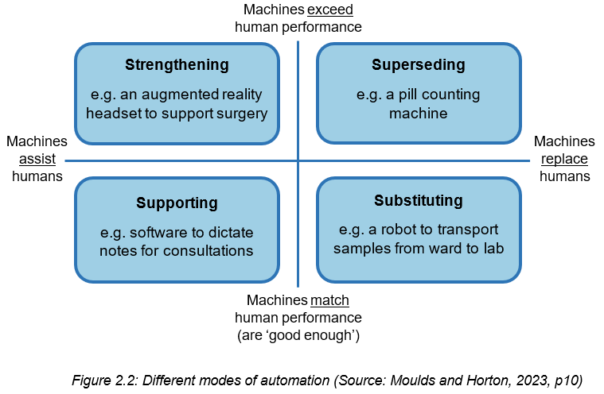

A related body of literature concerns automatic text summarisation (ATS). El-Kassas et al. (2021) and Mridha et al. (2021) both outline that ATS can condense multiple sources, classified as ‘multi-document’ systems, or a single source with perhaps large volumes of material via a ‘single-document’ system, into shorter narrative outputs. They, and other review papers, distinguish between extractive, abstractive, and hybrid approaches. Liu and Lapata explain that abstractive summarisation aims to produce shorter versions of text using “novel words and phrases not featured in the source text” (2019, p. 3730). Where several indicators, updates, or contextual points need to be amalgamated, it is likely that performance reporting would involve more than just selecting and reproducing text, so is perhaps more likely to use an abstractive or hybrid approach. However, performance reporting is not only a summarisation task. It also involves judgement about significance, priority, and context, which means that ATS literature is useful but not fully transferable.
This summarisation literature is particularly concerned with technical performance above practical use. The main emphasis tends to be on model development and approach comparison, with less attention on whether generated summaries are appropriate or useful within an organisational setting (Liu and Lapata, 2019; El-Kassas et al., 2021; Mridha et al., 2021). Even where ATS performs well technically, its value in reporting is limited if readers cannot interpret it clearly.
As well as being interpretable, summaries also need to represent the data and contexts fairly, reliably, and appropriately. This is where a wider set of concerns in the AI literature come to the fore, particularly around bias, transparency, and accountability. Bias remains a recognised concern in AI-assisted systems, particularly where outputs might influence judgement or prioritisation (Ntoutsi et al., 2020). In health-related settings, this is particularly relevant as unequal performance across groups might affect the fairness and reliability of AI-assisted outputs (Nazer et al., 2023). Other public-sector literature raises concerns about transparency and accountability, especially when systems operate as ‘black-box’ and their decision-making processes are difficult to explain or examine (Wirtz, Weyerer, and Geyer, 2018).
Overall, the literature suggests that AI in this area is better understood as decision support rather than automatic decision making. Its value is, therefore, unlikely to depend only on whether it can prioritise indicators, draft narrative, or suggest visualisations, but on whether these outputs can be reviewed, interpreted, contextualised, and used appropriately within existing reporting processes. This reinforces the need to evaluate AI-assisted reporting as a part of a wider sociotechnical process rather than a technical output alone.

2.7 Human factors
Recent literature has also considered the human factors associated with AI adoption and use, particularly in relation to usability, trust, and workflow (Abareshi et al., 2025; Alami et al., 2024; Kamel Rahimi et al., 2024). In performance reporting contexts, AI-assisted outputs still need to be understood, interpreted, and worked with by people in practice. Literature on HIT suggests that poor usability may increase workload, inefficiency, and the risk of error, which makes it difficult to treat technical performance as the sole basis for evaluation (Abareshi et al., 2025). Where reporting is intended to support interpretation and decision-making, usability is, therefore, part of what determines whether the output is clear, meaningful, and suitable for use in practice.
Workload and cognitive burden are part of the problem. Performance teams are working with large volumes of information, tight deadlines, and competing priorities. In these circumstances, one possible benefit of AI-assisted reporting is that it may help users identify patterns or focus attention more quickly. Although focused on sports analytics, O’Brien and O’Keeffe (2022) make a transferable argument, in that where large datasets create cognitive overload, AI used alongside human judgement might help to identify and decipher patterns that are otherwise difficult to see through the ‘noise’. Thus, AI-assistance may be useful where the amount and complexity of information has itself become part of the issue. However, the opposite is also possible; if outputs are vague, difficult to verify, or poorly aligned with user preference, it could add to workload rather than reduce it, which is consistent with wider literature linking poor usability in HIT to inefficiency, increased workload, and greater risk of error (Abareshi et al., 2025).
Trust and interpretability are also key. A recurring concern in the literature is the ‘black-box’ problem, where systems generate outputs without making their reasoning transparent. Sousa et al. (2024) linked black-box models to lower trust and weaker practical uptake in healthcare settings. Reddy (2022) argues that in medicine, highly accurate models might still be difficult to accept if they cannot be interpreted properly, and limited explainability creates problems for trust, accountability, and regulation. Although clinically focused, the issue is transferable. Similar concerns appear in implementation work on explainable clinical decision support, where opacity may discourage use in practice if users cannot judge whether outputs are reliable or appropriate (Pumplun et al., 2023). If users cannot understand why a summary has been framed in a particular way, why one issue has been prioritised over another, or even what information has been omitted, then confidence in the output will be lower. Thus, interpretability is not just a technical issue, as producers and users ultimately remain responsible for explaining and using report contents. Qaurooni et al. make a related point from a visual analytics perspective, describing biomedical informatics as “fundamentally a sociotechnical discipline” (2024, p. 2), and arguing that systems need to take users into account throughout the design cycle if they are to be useful and usable. They also note that easier access to underlying data sources might improve user trust in visualisations, partly because users are better able to judge where information has come from and how it should be read.
Hesitation around AI may reflect organisational fit as much as technical concern. Kamel Rahimi et al. (2024) identify barriers and enablers that include staff capability, training, workflow integration, compatibility with existing systems, and processes for user feedback. Alami et al. (2024) make a similar argument, suggesting that difficulties with AI in healthcare are often rooted in wider sociotechnical conditions rather than in the technology itself. Workload and workflow are important human factors, but a full assessment of their operational impact is outside the scope of this study. Instead, they are considered where they shape how AI-assisted reporting outputs are likely to be interpreted, trusted, and judged by users. The evaluation, therefore, focuses on whether outputs appear clear, useful, sufficiently contextualised, credible, and transparent enough to scrutinise.

2.8 Evaluative frameworks for AI-assisted performance reporting
Existing literature does not appear to offer a framework designed specifically for evaluating AI-assisted performance reporting. Existing health information system evaluation frameworks are useful in identifying relevant sociotechnical dimensions, but they tend to focus on issues such as adoption, usability, implementation, technical performance, and organisational fit, rather than on whether a reporting output supports interpretation, assurance, prioritisation, and governance decision-making in practice.
However, a number of frameworks and approaches are useful in identifying the dimensions likely to be significant. One of the clearest is the NASSS (Non-adoption, Abandonment, Scale-up, Spread, and Sustainability) framework, which has been used to examine the integration of AI in healthcare, and highlights the importance of the interaction between technology, the organisation, the value proposition, the intended adopters, the wider system, and adaptation over time (Alami et al., 2024). Alami et al.’s (2024) adapted version is visualised in Figure 2.3. This suggests that, although accuracy and efficiency are obviously important, AI-assisted reporting should not be evaluated as a standalone technical tool, but as something whose value depends on how it fits with existing systems, roles and practices.
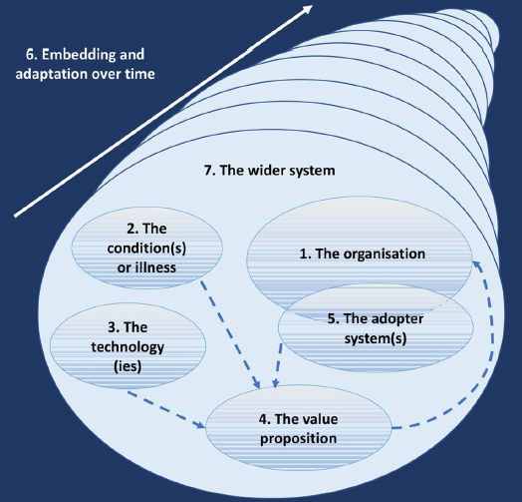

Nair et al. (2024) make a similar point; they identify a range of factors affecting AI implementation in healthcare, including leadership, buy-in, workflow, training, data, legal issues, evaluation and monitoring, maintenance and ethics. The OneLondon framework is more directly focused on implementation in practice, bringing together issues such as partnership working, infrastructure and data, use cases, delivery, and workforce development (OneLondon, 2025). Kamel Rahimi et al. (2024) argue that, as well as analytical capability, the use of AI in hospitals depends on infrastructure, interoperability, and organisational readiness. Similar concerns appear in policy and implementation literature, where weak infrastructure, fragmented systems and poor-quality data are presented as barriers to the practical use of AI tools, even where they seem promising technically (Mistry, 2025a; Department of Health and Social Care, 2021).
Implementation frameworks are useful for understanding conditions for adoption, but they do not, on their own, explain what good reporting outputs should look like, though some of the literature around PMM within the public sector goes some way to exploring this, suggesting that reporting is not simply a technical exercise in presenting data. Instead, it is part of a wider system intended to support monitoring, accountability, and decision-making (Garengo and Sardi, 2021). In the context of AI-assisted performance reporting, this shifts attention from output generation alone towards the quality, contextualisation, and practical usefulness of what is produced.
A further set of principles comes from guidance on trustworthy and well-governed AI in healthcare. Although this work is not specific to performance reporting, it is still relevant because it identifies concerns likely to be important regardless of whether AI is used to support professional or managerial judgement. These include transparency, accountability, fairness, safety, and the continued role of human oversight (World Health Organization, 2021). The Department of Health and Social Care guidance also gives importance to ethical design, usability, data protection, interoperability and evidence generation (Department of Health and Social Care, 2021). These concerns overlap with issues already discussed earlier in the chapter, particularly usability and interpretability. If outputs are difficult to understand, poorly aligned with workflow, or not transparent enough to scrutinise properly, then their practical value is likely to be limited even where model performance appears acceptable (Abareshi et al., 2025).
Taken together, these frameworks and related approaches do not provide a ‘ready-made’ model for evaluating AI-assisted performance reporting. Their value lies instead in identifying dimensions that are relevant across implementation, governance, and use, including organisational fit, usability, interpretability, transparency, trust, and meaningful human oversight. The literature does not yet provide a direct or settled evidence base for AI-assisted reporting in healthcare, so these dimensions need to be brought together and adapted cautiously for the specific problem of assessing AI-assisted reporting outputs. This provides the justification for the exploratory evaluation framework developed in this study.
2.9 Summary
The literature reviewed in this chapter does not provide a settled model for AI-assisted performance reporting, but it does suggest that such outputs need to be viewed holistically and cannot be assessed effectively in technical terms alone. Existing work on PI and decision-making shows that data does not become useful simply by being available, but depends on how it is interpreted and linked to action within organisational settings. Literature on digitalisation further suggests that reporting formats can impact on what is made visible and how easily information can be understood. Research on AI as decision support indicates that such tools may assist with prioritisation and drafting, but do not remove the need for human judgement. Human factors literature adds that usability, trust, interpretability, and organisational fit are likely to be key in whether AI-assisted outputs are workable in practice. Together, these themes provide the conceptual basis for the exploratory evaluation framework developed in this study, which considers whether AI-assisted outputs are clear, contextualised, useful, credible, and sufficiently transparent to support scrutiny and decision-making in healthcare organisational contexts.

Chapter 3: Methods

3.1 Study design and methodological approach
This chapter describes the exploratory study design used to develop and pilot an evaluation framework for assessing an AI-assisted performance output. The study examined both the practical usefulness of the draft framework and stakeholder response to a single AI-assisted reporting example.
A sequential mixed-methods design was adopted. Questionnaire findings were used to inform the development of the use cases, the draft evaluation framework, and subsequent semi-structured interviews. The evaluation framework was applied to a single AI-assisted performance reporting output, which was reviewed through the semi-structured stakeholder interviews. This sequencing meant that early findings could inform later stages of the project in a structured way.
In this study, AI-assisted functions were operationalised through prompted outputs that supported prioritisation, metric triangulation, narrative drafting, and elements of visual presentation, whilst interpretive judgement and final decisions remained with human stakeholders. This allowed AI to be evaluated as assistive to reporting, rather than as an autonomous decision-making system.

3.2 Stakeholder questionnaire
A short questionnaire was administered to stakeholders involved in performance reporting and review processes. The questionnaire sought to capture views on current reporting practice, perceptions of good-quality PI, and attitudes towards the use of AI in reporting. The questionnaire was intended to inform the development of the use cases, the evaluation framework, and subsequent interview design, rather than function as a standalone validated measurement tool.
The questionnaire was pragmatically designed to reflect issues relevant to the production and interpretation of performance reports in a Welsh health service context. Its content was informed by relevant literature and by the researcher’s professional experience, and it was refined following informal review by five colleagues to improve clarity and ease of completion.
The questionnaire consisted of a combination of closed questions and free-text responses. Closed questions were used to capture engagement with performance reports and views on specific report elements and AI-assisted reporting. Free-text questions were included to allow respondents to elaborate on their views.
Participants were recruited purposively through existing performance reporting distribution lists in order to reach individuals with direct experience of receiving, producing, or using performance reports. A small number of additional participants were invited where relevant roles were not represented within those lists. Recruitment was constrained by the project timeframe, but the sampling approach sought to include a range of stakeholder roles relevant to performance reporting.
Information about the study purpose, data handling, and consent procedures was provided to participants in advance of participation, as set out in Appendix C. Participation in the questionnaire was voluntary, and submission of the completed questionnaire was taken as confirmation of consent to participate. Responses were collected anonymously unless the participant opted to leave their contact details for future involvement.
Questionnaire data was analysed using descriptive statistics and simple content coding, as outlined in Section 3.8.

3.3 Identification and selection of AI-assisted use cases
Use cases were informed by three sources: the aims and scope outlined within the project brief, that is provided in Appendix A, findings from the staff stakeholder questionnaire, and the researcher’s professional experience of healthcare performance reporting. Together, these inputs were used to define AI-assisted activities that reflected routine reporting practice, and remained consistent with stakeholder expectations about oversight, trust, and contextual interpretation.
An initial longlist of potential AI-assisted activities was developed to reflect common tasks undertaken during the production of healthcare performance reports. These activities aligned with the project brief, which identified prioritisation, narrative generation, visualisation selection, and triangulation as candidate areas for evaluation.
Table 3.1 presents the candidate AI-assisted activities that are considered for inclusion, alongside the corresponding human task, the potential role of AI as a supportive tool, and also where the activity would typically appear within a performance report. AI was intended to remain as augmentative, with outputs still subject to human review and validation.
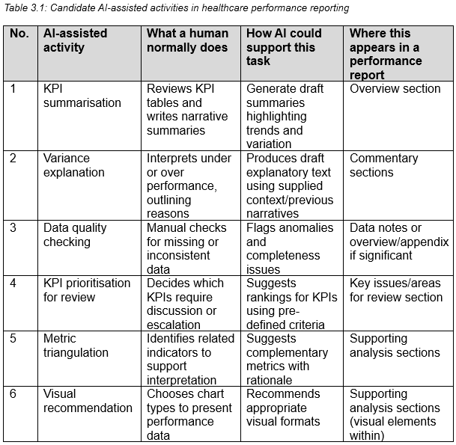

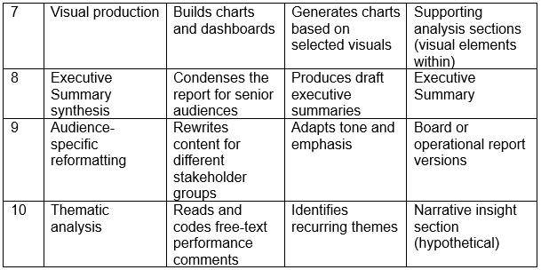

3.3.1 Shortlisting criteria and rationale
Given the exploratory scope of the study, candidate activities were shortlisted using five criteria: (1) alignment with the stated aims of the project brief, (2) relevance to routine performance reporting tasks, (3) perceived usefulness based on questionnaire findings, (4) feasibility of implementation using publicly available data and open-source tools, and (5) suitability regarding the maintenance of human review.
Questionnaire findings indicated strong stakeholder support for AI-assisted tasks that improved efficiency, consistency, and clarity. Activities such as narrative summarisation, triangulation across indicators, and visual recommendation were, therefore, prioritised. Activities requiring a greater degree of automated judgement, independent data validation, or technically complex implementation were excluded because they fell outside the practical, governance, and feasibility boundaries of the present study.

3.3.2 Shortlisted use cases for evaluation
Based on the criteria detailed above, five AI-assisted use cases, seen in Table 3.2, were selected for evaluation. These use cases represented a balance between stakeholder-informed priorities and areas of potential value identified through professional practice.
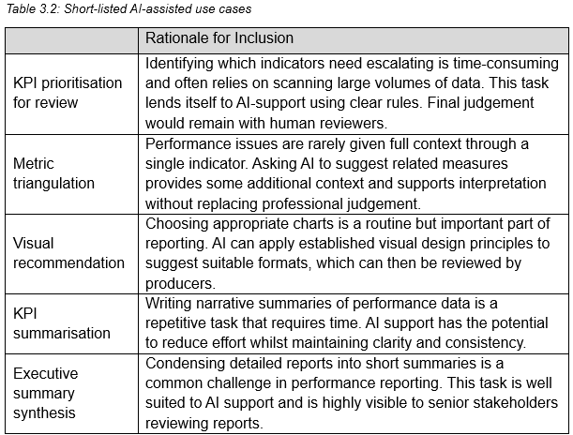

KPI prioritisation for review was retained as an advisory use case as it represents a time-intensive element of performance reporting. Although questionnaire findings highlighted caution regarding AI-generated judgement, the prompt used pre-defined criteria to suggest priorities only. Escalation and decision-making, therefore, remained the responsibility of human reviewers.
Metric triangulation and visual recommendations were selected to support contextual interpretation and clearer presentation of complex information; reflecting respondents’ emphasis on bringing multiple data sources together and communicating findings clearly. KPI summarisation and executive summary synthesis were included due to their repetitive and time-intensive nature, alongside evidence from questionnaire findings that clear narrative and synthesis are highly valued elements of effective reports.

3.3.3 Scope and exclusions
The scope of this study was limited to examining how AI might support routine activities involved in the interpretation and communication of PI, rather than evaluating the technical performance of AI tools specifically. The focus was on the acceptability, perceived usefulness, and interpretability of performance reporting outputs, including those produced with AI-assistance, within existing performance reporting practices.
AI involvement was deliberately restricted to assistive functions, such as highlighting potential areas for review, suggesting related metrics, and supporting narrative and summary production. Activities such as AI-led data quality validation, automated visual production, thematic analysis of free-text, and any form of unsupervised escalation were excluded, as they would require autonomous judgement or validation beyond the scope of this evaluation. These exclusions reflected both stakeholder concerns about governance, and the practical limits of the study.

3.4 Development of the evaluation framework
The evaluation framework was developed as a structured tool for assessing how performance reporting outputs are interpreted, trusted, and used in practice. Although the wider study focused on an AI-assisted output, the framework itself was intended to assess reporting quality more broadly rather than AI as a technology in isolation.
The framework was developed iteratively, drawing upon three main inputs: relevant literature, findings from the staff stakeholder questionnaire, and the researcher’s professional experience of producing and reviewing healthcare performance reports. These inputs helped to identify aspects of reporting that stakeholders consistently described as important when interpreting and using PI.
The domains reflected recurring themes identified in the questionnaire findings, including clarity of interpretation, contextual explanation, usefulness for decision-making, trust and oversight, visual presentation, and perceived limitations. These domains are interrelated, for example, clear presentation supports interpretability, contextual information supports appropriate judgement, and trust is influenced by transparency and oversight. When viewed in aggregate, the domains represent stakeholder-defined characteristics of effective performance reporting in practice.
These domains were translated into a draft evaluation framework tool comprising domain descriptions, example prompts, scoring guidance, and space for qualitative comment, as shown in Figure 3.1. In this study, the tool was applied to an AI-assisted report, although the domains were concerned with reporting quality more broadly rather than AI-assistance alone, and so could potentially be applied to other reporting outputs.
The framework was subsequently applied during stakeholder interviews to a single AI-assisted report. The structured scoring and prompts were used to guide reflection on the report and to explore whether the domains captured aspects of reporting that participants considered meaningful when interpreting and using PI. Interview data was analysed separately using a qualitative Framework Analysis approach, as described in Section 3.8.
The framework was also considered in relation to established sociotechnical and interoperability models during interpretation, including those concerned with fit between technology, users, tasks, and organisation, although a full formal comparative mapping was outside the scope of this study.

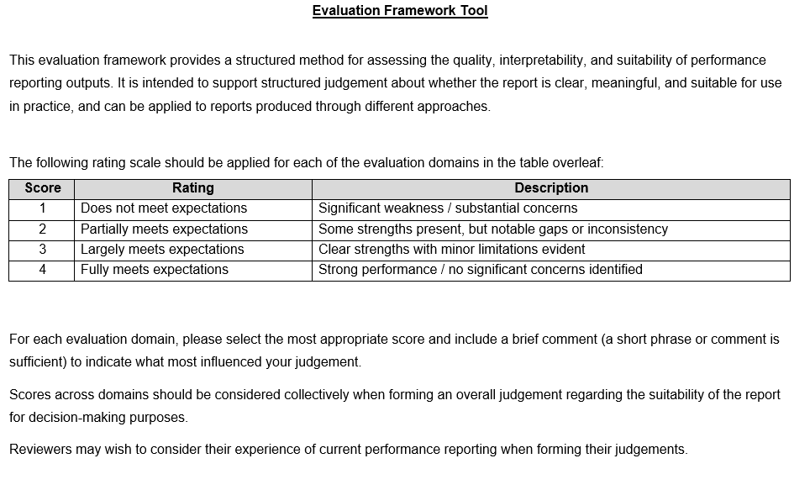

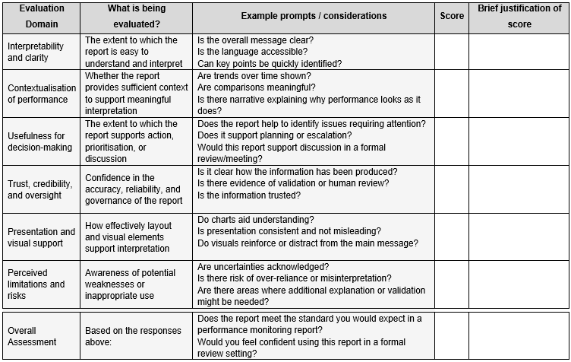

3.5 AI-assisted report production and operationalisation
AI-assisted elements were incorporated within a single performance reporting output to reflect how such tools could be used alongside existing reporting processes, rather than as a complete replacement for them. The intention was to examine how AI-assisted functions could operate within routine reporting practice, whilst retaining human oversight and professional judgement. This was in line with the wider aim of piloting the evaluation framework rather than undertaking a full comparison between human-only and AI-only reporting.
AI-assisted outputs were generated using ChatGPT (OpenAI, GPT-5 series model, March 2026). Appendix D summarises the main prompt structure used to guide the AI-assisted report production. The prompt drew on the shortlisted use cases identified in Section 3.3.2 and was used alongside a researcher-supplied Excel workbook, with screenshots shown in Appendix E. The prompt included contextual instructions to guide narrative generation, visual recommendations, and advisory escalation prompts. The AI was not permitted to access external data sources and was directed to the Excel workbook. All outputs were treated as draft and subject to manual review and editing prior to the stakeholder evaluation.
Prompt development was iterative. Initial design was informed in part by a MS training module on effective prompt construction (Microsoft Learn, 2024, Write effective prompts to achieve optimal results). A first draft was developed based on the identified reporting requirements and refined through testing and adjustment to improve clarity of instruction and alignment with the expected output structure. The final prompt was intentionally detailed because the task required linked outputs, including data interpretation, chart recommendation, PowerPoint production, validation checks, and timing. This specificity helped define the task limits, keep the output linked to the Excel workbook, align it with familiar reporting structures, and reduce the risk of unsupported interpretation, given that large language model outputs can vary according to model version, context available, and prompt framing.
As testing progressed, refinements were also made in response to variation observed in the narrative sections of the report. Earlier prompt versions gave clear direction on the dataset, analytical steps, and report structure, but allowed greater flexibility in how summary content and triangulated commentary were organised and expressed. Later iterations introduced more explicit instructions, including the prioritisation of statistical process control (SPC) charts unless there was a clear reason not to use them. This reflected familiar performance reporting practice and the value of SPC in supporting interpretation of variation and direction of travel over time. The triangulation instructions were also revised to encourage a more integrated system narrative, with greater emphasis on interdependencies across demand, capacity, flow, and outcomes, rather than a series of separate metric linkages. These refinements were intended to improve consistency in presentation and synthesis, whilst retaining human review of the final outcome.
The production process involved drafting and refining prompts, generating AI-assisted output, manual review for accuracy and contextual fit, making minor amends where necessary, producing visual elements in line with AI-recommendation, and integration into a single reporting output. Prompt refinement was not recorded as a separate timed stage within the final workflow.
To reduce the risk of priming prior to the interview, the report was presented as an example performance report for stakeholder evaluation rather than emphasising AI-assistance within the main title. However, a footnote was included to advise about the draft report being AI-assisted to retain transparency.
In addition to qualitative stakeholder evaluation of the reporting output, the production process was observed by the researcher. The time required for the final stages of the AI-assisted production process was noted, including AI output generation, manual review, and integration of visual elements. Prompt development formed part of the wider development process and was iterative, but not systematically timed. AI-reported processing time was recorded as a supplementary indicator only. Overall production time was compiled by the researcher on the basis of observed workflow stages rather than as a formal time-and-motion study.
The example report was also developed with supporting artefacts, including charts, chart build lists, self-validation checks, and timing data. These supported exploratory assessment of transparency, reviewability, format alignment, and timeliness, rather than full technical validation of the AI tool.

3.6 Production of performance reporting outputs
A single AI-assisted example performance report was produced for stakeholder review. The purpose of this report was to provide an example reporting artefact that participants could use during the interviews, rather than to reproduce a full organisational reporting pack. This was consistent with the project brief, which outlined the use of one representative AI-generated report for exploratory evaluation.
The report incorporated selected AI-assisted elements within a familiar format. It included an executive summary, prioritised risks and improvements, escalation content, KPI-focused triangulation, a scorecard, and caveats. These components reflected the shortlisted use cases identified in Section 3.3 and were intended to give participants sufficient material to comment on clarity, context, usefulness, trust, and presentation.
The report was produced in PowerPoint format because this reflects the Board-style format in which performance reports are commonly encountered in practice. The slides were styled to resemble the general structure and tone of a Board report so that stakeholders could focus on the content rather than unfamiliar format. However, they were not intended as exact replicas of official organisational reports and did not include official logos or corporate branding.
The final report was not presented as raw AI output. Material generated was reviewed during report compilation, and minor amendments were made in order to improve local understanding and fit within the reporting context. In line with AI recommendations, charts were produced manually within Power BI using the same dataset that had been supplied to ChatGPT. This ensured that visual elements reflected AI-assisted suggestions whilst remaining subject to human construction and review. These changes did not materially alter the analytical content of the report and replicated how the outputs may be utilised in reality. The final version, therefore, represented an AI-assisted and researcher-reviewed report, and formed the basis of subsequent stakeholder interviews.

3.7 Data collection: semi-structured interviews
Semi-structured interviews were undertaken with stakeholders who had experience of producing, reviewing, or using performance reports. Recruitment was constrained by the project timeframe, but the sample was intended to provide sufficient representation across relevant stakeholder roles. In line with the project brief, the interviews were intended as an exploratory means of assessing both the usefulness of the draft evaluation framework, and participant responses to the AI-assisted example report.
During each interview, participants were asked to review the example report and apply the evaluation framework to it. The framework consisted of six domains: interpretability and clarity; contextualisation of performance; usefulness for decision making; trust, credibility, and oversight; presentation and visual support; and perceived limitations and risks. Each domain was scored on a four-point scale, with space for a brief justification, followed by an overall assessment. The framework was used to structure discussion and to support a degree of consistency across interviews, whilst still allowing participants to explain their judgements in their own words.
The structured scoring was not treated as a validated measure. Rather, it functioned as a practical tool to support systematic discussion of the report and to explore whether the framework domains were meaningful and usable in practice. This was consistent with the project aim of assessing framework usefulness rather than conducting full validation.
A participant information sheet was provided with the interview booking invite email and verbal informed consent, including consent to recording, was obtained at the start of each interview. Interviews were conducted via Microsoft Teams and in person, and typically lasted 30-40 minutes. Interviews were audio recorded in full, and auto-transcription used for Teams meetings. Auto-transcriptions, where available, were checked for accuracy before anonymising, and the in-person recordings were transcribed prior to deleting the audio recording.
Interviews were guided by the framework domains and supplemented by follow-up questions on practical use, governance, and implementation. Whilst all participants applied the same framework to the same report, prompts were adapted slightly to reflect participant role and experience. This allowed participants to comment on issues most relevant to their experience without changing the core domains under review.

3.8 Data analysis
This section describes the approach used to analyse questionnaire and interview data. Given the exploratory and evaluative aims of the project, analysis focused on descriptive and interpretive approaches. Questionnaire and interview data was analysed separately. Findings are presented separately in the Results chapter and considered together in the Discussion.
Within the questionnaire, categorical variables were summarised using frequencies and percentages to describe response patterns. Likert-scale items were treated as ordinal data and analysed using median and interquartile ranges. Responses were numerically coded and then interpreted using the original response category.
Free-text questionnaire responses were analysed using a simple descriptive coding approach informed by the organising principles of Framework Analysis (Gale et al., 2013). The aim was to identify recurring issues relevant to the study rather than to undertake a full independent qualitative analysis of questionnaire text. Free-text responses were reviewed iteratively to gain familiarity with the data, and an initial coding framework was developed based on the study aims and the content of the responses. Responses were coded descriptively, with some comments contributing to more than one category. Coding was used to support descriptive interpretation and identify recurring themes across responses.
Interview data was also analysed using Framework Analysis. To support comparison across study stages, the analysis drew on the same broad evaluative domains that had informed the questionnaire and interview framework, while remaining open to additional issues raised by participants. Transcripts were then coded in line with the analytical framework, with attention to how participants interpreted the report, applied the framework domains, and identified strengths, limitations, and risks in AI-assisted reporting. Domain scores were considered alongside qualitative comments with a view to supporting interpretation of the interview data. Analysis, therefore, focused on the perceived usefulness, interpretability, trustworthiness, and practical applicability of both the example report and the draft evaluation framework.

3.9 Ethical and governance considerations
Ethical considerations were addressed throughout the study. Questionnaire participants were provided with information in advance, and submission of a completed response was taken as consent. Interview participants received written information and gave verbal consent, including for recording, prior to interview. Questionnaire responses were anonymous unless participants chose to provide contact details for follow-up. Interview data was anonymised during analysis and stored securely in line with organisational and university requirements. In relation to AI use, only publicly available data was used, and no unpublished, identifiable, or sensitive data was entered into publicly accessible AI tools. Ethical approval for the study was obtained through UWTSD, reference: Appendix B.

Chapter 4: Results

4.1 Introduction
This chapter presents the findings from the questionnaire first, followed by the interview findings. Results are presented descriptively and organised around key aspects of performance reporting and views on the potential use of AI-assisted reporting.

4.2 Respondent characteristics
A total of 37 questionnaire responses were received from stakeholders involved in the production, review, and use of performance reports. Most respondents described themselves as working in managerial or business roles, with smaller numbers reporting clinical or corporate responsibilities.
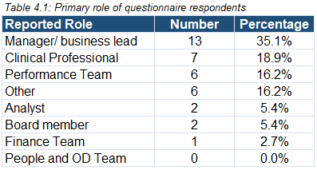

Most respondents (n=26, 70.2%) had at least weekly involvement with performance reports, and 97.2% (n=36) reported at least monthly involvement. This reflects the intended focus of the questionnaire on individuals with direct experience of performance reporting processes.
Figure 4.1 summarises respondent involvement in performance reporting activities. Respondents were able to choose more than one option as applicable. The majority of respondents reported involvement in more than one aspect of performance reporting, most commonly viewing reports.
This indicates that the questionnaire captured views from respondents with direct experience of performance reporting processes.
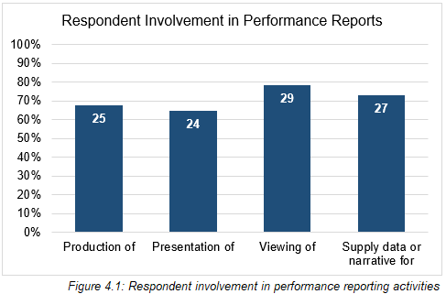

4.3 Questionnaire findings: quantitative perceptions of value and confidence in interpreting performance reports
This section presents questionnaire findings on respondents’ views of the value of commonly used performance report components and their confidence in interpreting them.

4.3.1 Perceived value of performance reporting components
Respondents rated the importance of a range of performance reporting components commonly used in routine reports. As shown in Table 4.2, median ratings for most items fell between ‘somewhat important’ and ‘very important’, indicating that respondents generally regarded these report components as useful features of routine performance reporting.

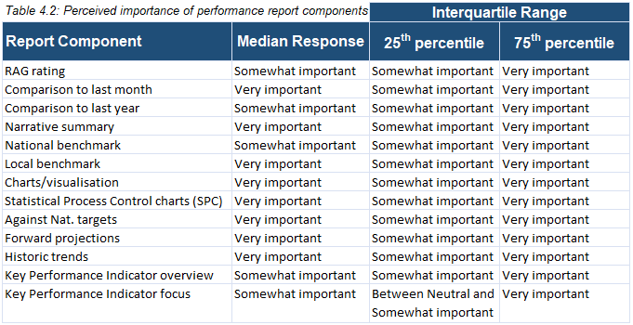

When combined positive responses were examined in more detail, charts or visualisations and performance against national targets attracted the highest ratings, followed by narrative summary and comparison with last year. Looking only at ‘very important’ responses also highlighted forward projections as particularly valued. These results can be viewed in Figure 4.2.
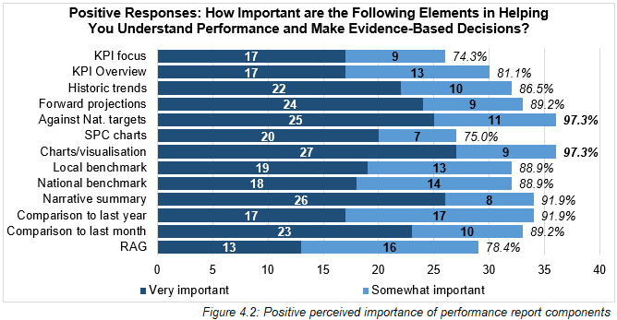

In contrast, despite their routine use, SPC charts and RAG (red, amber, green) rating attracted a lower proportion of positive responses, as did KPI focus. RAG rating received the lowest number of ‘very important’ ratings. This suggests that respondents valued the report elements that support interpretation and comparison over those that display the status alone.
It is worth noting that the only component to receive responses in the ‘Unsure/Not applicable’ category was ‘SPC charts’ (n=4). Given that SPC charts are routinely included in Performance Team reporting, this might suggest some uncertainty about how they support interpretation and decision-making, and might indicate a possible training need.

4.3.2 Confidence in interpreting performance reporting components
Respondents reported high levels of confidence across all elements with the median ratings falling into the ‘very confident’ category throughout. Upper quartile values were similarly high, although lower quartile values showed some variation, indicating that confidence was not uniform across all elements. This matters to later review of the AI-assisted report because variation in confidence might influence how different report elements are interpreted and valued in practice.
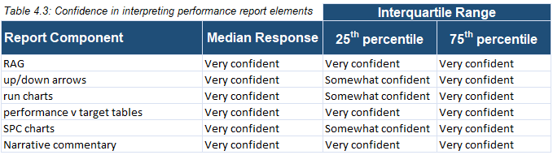

When the proportion reporting high confidence (‘somewhat confident’ and ‘very confident’) was examined, clearer differences emerged. As shown in Figure 4.3, ‘run charts’, ‘performance versus target tables’, and ‘narrative commentary’ garnered particularly high confidence, whereas confidence was lower for more technical visualisations such as SPC charts. This pattern was reinforced by responses to the question asking which chart types were hardest to interpret, where SPC charts were selected frequently alongside other technical chart types, including radar and scatter plots, which were entered under ‘other’.
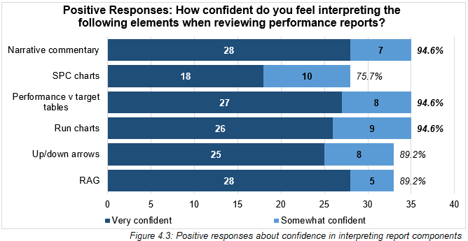

SPC charts displayed the highest number of negative responses (8.1%), and similarly to the importance metric, four respondents selected ‘unsure/not applicable’.
When confidence and importance ratings were compared, most report components showed broadly similar levels of positive responses across both measures. RAG rating was the clearest exception: although 89.2% of respondents felt confident interpreting it, only 78.4% rated it positively in terms of importance.

4.4 Questionnaire findings: quantitative views on AI-assisted performance reporting
This section presents quantitative questionnaire findings relating to respondents’ views on AI-assisted performance reporting. These questions were intended to gather stakeholder views prior to any exposure to the example AI-assisted output used later in the study.
Respondents were asked if they had previously used or reviewed AI-assisted content or insights within their work. Responses indicated a broadly even split in prior exposure: 44.4% (n=16) reported they had, 41.7% (n=15) reported no prior experience, and 13.9% (n=5) indicated that they were unsure.
Additionally, respondents were asked how comfortable they would feel using AI-assisted report content in their work. Although positive responses predominated, only half of respondents (50.0%, n=18) reported feeling somewhat or very comfortable using AI-generated report content in their work. The remaining responses were evenly divided between discomfort and uncertainty.

4.4.1 Perceived usefulness of AI-assisted content
Respondents were asked to rate how useful AI-assisted content could be in supporting performance reporting. Responses to this item were generally positive, with most respondents indicating that AI-assisted content could be useful in supporting performance reporting. No respondents rated it as not useful. These results can be seen in Figure 4.4.
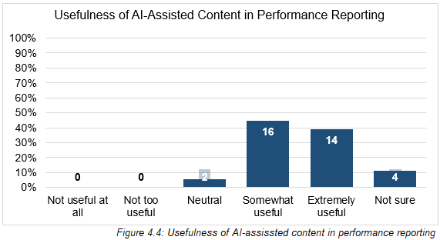

4.4.2 Confidence in AI-generated summaries of performance data
Respondents were also asked how confident they were that AI could summarise performance data accurately. Responses indicated a broader spread of answers than for perceived usefulness but were still weighted to positive. Just over half of respondents (52.8%, n=19) reported feeling ‘somewhat confident’ or ‘extremely confident’ in AI’s ability to summarise performance data accurately. However, this leaves a notable minority who reported either low confidence or uncertainty. Taken alongside the perceived usefulness findings, this suggests that respondents were more positive about the potential usefulness of AI than about its ability to summarise performance data accurately.
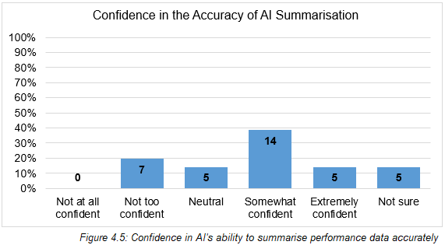

4.4.3 Agreement with statements on AI-assisted reporting
Respondents were asked to indicate their level of agreement with a series of statements relating to the potential benefits and limitations of AI-assisted performance reporting. As shown in Table 4.4, median responses indicated agreement across all statements.
The strongest agreement related to the assistive use of AI. Most respondents agreed that AI could save staff time (80.6%), support decision-making (80.6%), improve consistency in reporting (77.8%), and help make narrative reports clearer (72.2%). The statement that AI-assisted reports would still require human review attracted the strongest agreement overall, with a median of ‘strongly agree’ and 97.2% (n=35 of 36) in agreement, including 72.0% who selected ‘strongly agree’. Similarly, there was a high level of agreement that AI-assisted outputs should be used only with clear oversight (94.4%, n=34 of 36). Taken together, these findings suggest support for AI as an augmentative aid to reporting rather than as an autonomous system.
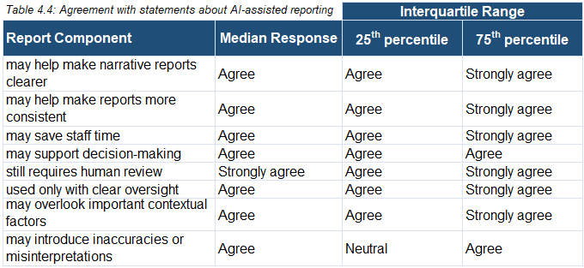

Agreement was also common for statements highlighting the potential limitations and risks associated with AI-assisted reporting. A substantial proportion of respondents agreed that AI may overlook important contextual factors (77.8%), and that it could introduce inaccuracies or misinterpretations (66.7%). For these items, interquartile ranges were wider, which reflects greater variability in views from respondents. The pattern of the responses suggests greater support for AI as an aid to reporting than as a tool for judgement.

4.5 Questionnaire findings: qualitative free-text responses
This section presents findings from the free-text responses included within the questionnaire. A framework analysis approach was used, with responses coded across the six predefined categories of interpretation, context, trust, usefulness, visualisation, and limitations. Individual responses could be coded to more than one category where relevant.
Findings are presented below according to these framework categories.

4.5.1 Interpretation
Many respondents linked good performance with clarity, understanding, and ease of interpretation. For example, one respondent described a strong report as having “readability and clarity” and being easy to take in quickly, whilst another referred to the importance of a “concise and easily identifiable position at a point in time against the target or objective”.

4.5.2 Context
The need for contextual explanation and narrative emerged consistently across the free-text responses. In many comments, narrative and context appeared closely linked, with respondents describing explanatory narrative as necessary for understanding why performance was changing rather than simply reporting what had happened. Several contributors referred to the role of narrative in linking information and supporting interpretation, for example, expressing how valuable “a narrative that draws together data from a number of sources converting it into a coherent interpretation” is. Context was also discussed in relation to trends over time and comparison with targets or expectations.

4.5.3 Trust
Trust emerged as a prominent theme across the qualitative responses regarding AI-assisted performance reporting in particular. Respondents consistently associated confidence in report quality with human oversight, validation, and assurance processes. Accuracy and data quality were consistently identified as important factors influencing trust.
Many comments emphasised the importance of professional judgement in validating both the data and the narrative produced by AI tools. Human review was viewed as essential to assuring accuracy, interpretation, and relevance, with contributors referring to the need for reports to be “quality checked / DQ checked” and signed off. In this context, trust was closely linked to accountability, oversight, and assurance processes.

4.5.4 Usefulness
Usefulness was one of the most consistently emphasised themes, and effective performance reporting was often described in terms of its practical value. Reports were viewed as more useful when they linked PI to actions, milestones, or improvement plans. As such, usefulness was closely associated with reports that enabled readers to move beyond data review towards decision-making.
In relation to AI-assisted reporting, usefulness was most often linked to time-saving. Contributors described potential benefits including staff time, faster synthesis of large volumes of data, and the identification of trends and insights that may otherwise be overlooked. These benefits were linked to practical benefits such as reducing administrative burden, and allowing staff to focus time on interpretation.

4.5.5 Visualisation
Visualisation, including charts, layout, and presentation, was generally discussed less frequently than the other themes and was rarely raised as a standalone issue. Where visual elements were mentioned, they were usually discussed in relation to their role in supporting interpretation or usefulness. Simplicity, and consistency of presentation were noted as valuable features.
Where concerns were raised, these related to specific tools rather than visualisation broadly speaking. In particular, some respondents expressed reservations about the use of RAG ratings, describing these as difficult to interpret, or unhelpful when overused. Overall, visualisation was described as a supporting element that could aid interpretation when used appropriately, rather than as a primary driver of perceived report quality or usefulness.

4.5.6 Limitations
As might be expected from the framing of the question, limitations, also taken as risks, concerns, or bias, were most evident in the responses about the perceived risks of using AI for performance reporting. Contributors highlighted the risk of over-reliance on AI outputs, particularly where data quality issues may be present, for example, “garbage in, garbage out”, or where outputs might not be adequately reviewed and validated. The loss of contextual understanding and the potential for misleading or inaccurate narrative were also cited.

4.5.7 Summary of qualitative questionnaire findings
Overall, the qualitative questionnaire findings emphasise clarity, contextual narrative, trust, and usefulness as central to how respondents engage with performance reports. Although AI-assisted reporting was perceived to offer potential benefits, in terms of efficiency in particular, confidence in outputs remained closely linked to human oversight, validation, and the preservation of contextual understanding. These findings informed the subsequent interview evaluation, where participants were asked to apply the pilot evaluation framework tool to an AI-assisted example report using domains relating to interpretability, contextualisation, usefulness, trust, presentation, and perceived limitations.

4.6 Interview findings: evaluation of the AI-assisted performance reporting output
The draft evaluation framework tool, shown in Figure 3.1, was both a study output and a practical way of structuring stakeholder review of the example AI-assisted report. Participants scored each domain and provided qualitative commentary whilst doing so. Findings are presented below by domain, followed by overall assessments. Participants frequently compared the example report with reports they routinely receive or produce, particularly in relation to readability, level of detail, and practical usefulness.
Although broad themes were consistent across interviews, some differences in emphasis appeared to reflect participant role, particularly between those in senior management positions and those in more analytical roles.
Participants also commented briefly on the framework itself after applying it to the report. Overall, the six domains appeared to cover the main issues that participants considered relevant, and no additional domains were clearly identified as necessary. Regarding the scoring approach, although one participant suggested that a slightly wider scale may have allowed for greater flexibility, another felt this would have been “too much”, with the existing four-point scale generally viewed as simple and acceptable.

4.6.1 Interpretability and clarity
Participants commented on report clarity in their initial impressions, before the framework domains were introduced. Interpretability and clarity were generally rated positively, as one participant noted, “the message is clear and concise. It takes you straight to the point without the waffle”.
However, some areas for improvement were identified, and these appeared to vary to some extent by participant role. Participants with more senior responsibilities were more likely to emphasise the need to avoid or explain jargon, particularly for public-facing use, whereas others were more likely to comment on layout preferences, including whether additional visuals would aid interpretation. There was mixed opinion about the narrative-based pages, with some participants advising they would prefer the inclusion of visuals, but others noting that they liked the layout.

4.6.2 Contextualisation of performance
Participants generally felt that the report provided some contextual explanation of performance, particularly through the executive summary, escalation sections, and triangulated slides, though this was generally viewed more positively by managerial participants than by those with an analytical background. Interviewees though repeatedly commented that deeper service-level context was missing; one participant observed, it “feels like it’s data rather than telling a story and understanding the service”. Several participants also wanted more forward-looking intelligence, including trajectories and action planning.

4.6.3 Usefulness for decision-making
Participants generally considered the report to be helpful in identifying areas requiring attention. The summary and escalation sections in particular were often seen as useful in focusing attention and supporting preparation for meetings. Overall, the report was viewed as a useful starting point for highlighting issues and preparing for discussion, but not as a sufficient basis for formal decision-making on its own. Additional context, detail, and discussion with colleagues closer to the issue were usually seen as necessary before formal decisions could be made.

4.6.4 Trust, credibility, and oversight
Trust, credibility, and oversight were central to participants’ evaluation of the report. Confidence in the report output was notably linked to its having been reviewed by a human analyst. Several participants were clear that AI-assistance was not necessarily a problem in itself, but that trust depended on the quality of the underlying data, confirmed checking processes, and keeping “a professional critical eye on it”. Human review, fact-checking, and validation were repeatedly described as essential if such reporting were to be used confidently in practice. More than one participant also viewed the report’s objectivity positively, particularly where it appeared to avoid apportioning blame.
Concerns in this domain related mainly to transparency and governance. Some participants questioned how AI had prioritised issues or generated particular statements, and others highlighted concerns about wider governance arrangements, and data/source quality. A number of comments suggested that an assurance process and ‘kite-mark’ would be useful, as trust in the report was dependent on having confidence in the check procedures. Overall, trust was present, but conditional on review, oversight, and data assurance.

4.6.5 Presentation and visual support
Presentation and visual support were generally viewed positively, with first impressions often referring to these points in a positive way. Participants described the report as clean, easy to read and professional. Several commented positively on the fact that the report looked similar to reporting formats already used in practice, and also that visuals were explained. The layout and overall organisation were also helpful in making the report easier to read.
Even so, some interviewees felt like presentation could be strengthened. These were potentially areas of personal preference and not widely recurring. Suggestions included a greater use of colour, more visual highlighting of areas of concern, and a closer pairing of visuals with associated narrative. Additionally, feedback suggested that some pages, such as the executive summary, were too word-heavy. A particular oversight noted was a lack of legend for the SPC charts, including the icons that also featured within the scorecard. Overall though, despite the suggested improvements, presentation was widely regarded as a strength of the report.

4.6.6 Perceived limitations and risks
Several of the issues raised within this domain had already been touched on in earlier discussion of contextualisation, usefulness, and trust. When asked to consider limitations and risks specifically, participants largely reiterated concerns about the depth of context available within the report, the level of analysis it could support, and the level of human involvement required if participants were to trust it.
Over-reliance was also identified as a potential risk, especially where the readers may be less familiar with the underlying data or service context. Another concern related to the expertise of those developing the prompts. Some participants questioned whether prompt writers would always understand the full range of services well enough to frame appropriate prompts, and whether they would then be able to check and challenge the outputs effectively. This linked to wider concerns about skills, training, and governance.
Security was not a major concern for most interviewees, with only one participant raising it explicitly. For that individual, governance included assurance around security, storage and how AI tools use the data made available to them.

4.7 Overall suitability for use in practice
Overall, participants’ assessments of the example report were generally positive, particularly in relation to clarity, conciseness, and ease of reading. The report was often viewed as useful for providing a high-level overview, highlighting issues, and supporting preparation. Several participants also commented that it compared favourably to some of the reports they were used to receiving, particularly in relation to length and layout.
At the same time, participants did not generally view the report as sufficient on its own for more detailed interpretation or operational use. Instead, stronger contextual narrative, forward-looking information, and human review would be required if such reporting were to be relied upon routinely in practice. Overall, the example report was viewed most positively as a high-level, AI-assisted, human-reviewed reporting output that could support preparation and early interpretation, rather than as a replacement for detailed reporting or professional judgement.

Chapter 5: Discussion

5.1 Overview
Health and care organisations are increasingly exploring AI-assisted tools to support the efficiency, consistency, and interpretability of performance reporting. However, concerns remain around reliability, contextual understanding, how much oversight is required, and whether such tools add value for assurance and decision-making. This study explored whether AI-assisted outputs met stakeholders’ expectations for effective performance reporting, and whether such approaches appeared suitable in routine practice. The findings point to a potential role for AI in supporting reporting, whilst reinforcing the importance of human oversight, contextual review, and governance processes.
This chapter will first provide a summary of key findings, followed by an exploration of stakeholder views on AI-assisted reporting. It will then assess the pilot framework’s usefulness, before discussing the implications for practice, including workforce, governance, and future research.

5.2 Summary of key findings
The study found that stakeholders were generally receptive to AI-assisted performance reporting, but that this acceptance was conditional. Whilst participants were open to the potential for AI to assist with performance reporting, they emphasised the importance of human oversight in ensuring that AI outputs were accurate, relevant, and contextually meaningful. As highlighted in earlier sections, the AI-assisted example report was seen as clear and concise, but there were concerns about its ability to fully capture the complexity and context required for informed decision-making.

5.2.1 Stakeholder expectations of effective performance reporting
Stakeholders generally expressed a preference for performance reports that go beyond just showing performance status, instead prioritising report elements that help with decision-making and interpretation. This reflects concerns in some performance measurement literature that simple measures can be useful in drawing attention to particular performance issues, but might also narrow understanding if they are not supported by context (Bevan and Hood, 2006). In this study, participants valued reporting components that supported contextual understanding, such as charts, trends, and benchmark comparisons. This is also consistent with Nadj and Schieder’s (2017) discussion of business intelligence, where the value of reporting lies in supporting timely interpretation and action as well as presenting data. The importance of clarity and visual presentation was also a recurring theme in the interviews, reinforcing the finding that effective performance reporting needs to help users understand what the data means, rather than simply indicate whether performance is above or below target. This fits with Han and Moynihan’s (2022) argument that PI only becomes useful when it can be interpreted and linked to action within organisational settings.

5.2.2 Conditional acceptability of AI-assisted reporting
Whilst participants were generally open to AI-assisted reporting, they emphasised that its acceptance was conditional on the inclusion of human review, contextual review, and accountability. This supports the idea that AI in decision support should not replace human judgement, but rather augment it (Raisch and Krakowski, 2021). Participants appeared confident in AI’s potential to assist with drafting and summarisation, but there was clear preference for ensuring that the final report incorporated sufficient contextualisation, and human-led intelligence and oversight. This is consistent with Sutton et al. (2020), who present AI as most useful when it supports human decision-making rather than operating autonomously.

5.3 Stakeholder views of AI-assisted reporting
Stakeholders’ views suggested that AI-assisted reporting was acceptable where there were clear limits on what AI would be used for. Participants appeared open to it where it was used as a support for tasks such as summarising performance, suggesting visualisations, and identifying key issues, providing it did not replace human judgement, contextual understanding, or governance oversight.
A key limitation to note is that these findings are based on stakeholder views of AI-assisted reporting rather than its specific use in practice, meaning that the results relate to perceived acceptability rather than proven operational performance. These views may differ once AI-assisted reporting is used in practice, where factors such as real-time data, workflow integration, governance requirements, and variable user expertise could potentially impact both the quality of the output and the level of trust placed in it. However, understanding how such tools are anticipated and interpreted remains an important step in evaluating their potential role within performance reporting.
The conditional support from participants was particularly evident in responses to the AI governance items. In Section 4.3.3, 94.4% of respondents agreed that AI-generated outputs should only be used with clear oversight, whilst 97.2% agreed that AI-assisted reports would still require human review. Although these figures should not be treated as generalisable beyond the sample, they suggest that respondents were not opposed to AI-assisted reporting in principle, but they viewed human control, checking, and accountability as essential, meaning stakeholders aligned with an augmentative model of AI use rather than with an autonomous one (Raisch and Krakowski, 2021). It also reflects wider decision-support literature, with Sutton et al. (2020) suggesting that AI can improve analytical efficiency where it is used to support human judgement rather than replace it. For performance reporting, this suggests that AI might be most acceptable where it helps with drafting and suggesting prioritisation, whilst interpretation, contextual judgement, assurance, and accountability remain the responsibility of staff.

5.4 Pilot of the draft evaluation framework
Overall, the pilot suggested that the framework could provide a useful structure for assessing AI-assisted reporting outputs. Participants were able to apply it to the example report in a structured way, and the domains generally reflected issues that were important to stakeholder judgement, particularly trust, contextualisation, and usefulness. However, the pilot also suggested that further refinement would be needed before wider testing, particularly around domain wording and overlap between domains. Although the framework’s domains were separate for the purpose of evaluation, in practice they often overlapped. For example, a poorly designed chart could affect clarity, contextual understanding, and usefulness for decision-making at the same time. This indicates that whilst the framework used separate domains for evaluation, these domains are interdependent in routine reporting practice. Nørreklit and Cinquini (2023) argue that when evaluating performance, domains like contextual understanding and clarity often overlap in practice, making it difficult to assess them in isolation.
The pilot also suggested that trust, credibility, and oversight should be treated more distinctly in future versions of the framework. These were grouped together in the draft framework, though the pilot has highlighted that they are different in practice. For example, stakeholders may trust the figures in an AI-assisted report, but still question whether the narrative interpretation is credible, or whether the report has been subject to sufficient review and sign-off. This distinction is also reflected in wider AI governance literature, where trust is linked to accountability, transparency, and appropriate human review as much as the accuracy of an output (Reddy, 2022; Wirtz, Weyerer, and Geyer, 2018). Future iterations of the framework should, therefore, consider separating this domain so that confidence in the data, credibility of the reporting process, and oversight arrangements can be assessed more distinctly.
In addition to the framework’s structure, interviewees provided feedback on the rating scale used to assess the AI-assisted report. Most felt that a 1 – 4 rating scale was clear and usable, providing a simple structure for evaluating the domains. However, some participants suggested that more points might allow for greater precision. This highlights a trade-off between simplicity and precision, which should be considered in future versions of the framework. Further testing could explore whether additional scale points improve discrimination between reports, or whether they make scoring less consistent between reviewers. Additionally, future iterations might include clearer guidelines on how to apply the rating scale consistently where domains overlap.
The framework also shows some alignment with established sociotechnical and implementation evaluation models, which emphasise that digital tools need to be assessed in relation to users, tasks, workflow, organisational context, and wider implementation conditions. This is reflected in the framework’s attention to interpretability, contextualisation, usefulness, trust, presentation, and risk, rather than just the technical performance of the AI. However, the framework differs from models such as FITT, FITTE, HOT-fit, and NASSS, because its primary focus is on evaluating the output of AI-assisted reports rather than on implementation or organisational readiness (Alami et al., 2024; Ammenwerth, Iller and Mahler, 2006; Prgomet et al., 2019; Yusof et al., 2008). Wider implementation issues such as infrastructure, workflow, security and governance, sustainability, and training were out of scope for this study. The contribution of the draft framework is, therefore, not that it replaces wider sociotechnical or implementation models, but that it provides a more focused structure for assessing the reporting output itself. In particular, it supports judgement about whether an AI-assisted performance report appears useful, interpretable, trustworthy, and decision-relevant to stakeholders. This narrower focus was appropriate for the present study, although future work would need to test whether the framework remains useful across different reporting contexts and organisational settings.

5.5 Interpretation of the example AI-assisted performance report
Participants commented positively that the example report looked similar to reporting formats they were accustomed to. The report was deliberately produced using a familiar Board-style format so that stakeholders could focus on the content, interpretation and usefulness of the AI-assisted output rather than be distracted by unfamiliar presentation style. This design choice aligns with human factors literature, which suggests that usability, fit, and user expectations influence how health information technologies are interpreted and accepted (Abareshi et al., 2025; Kamel Rahimi et al., 2024). However, this also introduces a possible familiarity effect, as participants may have responded positively because the report resembled existing Board-style formats rather than because the AI-assisted content was strong independently. Positive views on usability should, therefore, be interpreted cautiously and separated from claims about analytical quality.
Questionnaire responses suggested that RAG ratings were not rejected, but they were not as strongly valued as components that support understanding around change, variation, and comparison, such as charts, trends, and benchmarks. As seen in the results, RAG ratings received the lowest number of ‘very important’ ratings, suggesting that stakeholders placed greater value on elements that supported interpretation or decision-making rather than those that simply indicated a snapshot performance status.
A related point concerns the use of SPC charts in the example AI-assisted performance report. The AI prompt instructed the tool to prioritise SPC charts unless there was a clear reason not to use them, reflecting the increasing expectation within NHS Wales performance reporting that they should feature as a way of showing variation and direction of travel. Although questionnaire findings showed comparatively lower confidence and some uncertainty in relation to interpreting them, this was not a dominant issue in the interviews. Taken together, the findings suggest that the issue is not simply whether SPC charts are used, but how they are introduced and explained. This points to a possible training need, alongside clearer supporting features such as legends, explanatory narrative, and visual cues.
This also links to wider visual analytics literature, which highlights that the quality, completeness, and timeliness of data shapes the usefulness of visualisations, and that siloed data can limit more joined-up interpretation (Qaurooni et al., 2024). This is relevant to the present study because stakeholders recognised some value in the slides that brought together multiple related indicators, but still wanted deeper contextual explanation of the relationships between those indicators. As a result, the issue was not only whether the visualisations were clear, but whether the available data allowed them to bring together enough related information to support meaningful interpretation.
Contextualisation was one of the areas where the example report was judged more critically. Participants recognised that the report provided some useful elements of contextual explanation through the executive summary, escalation material, and triangulated slides, however, several felt that this was not detailed enough to fully explain the performance or allow for confident decision-making. This reinforces Han and Moynihan’s (2022) argument that PI does not become useful simply by being available, and its value depends on how it can be interpreted, prioritised, and linked to action within organisational settings. It also reflects Nørreklit and Cinquini’s (2023) concerns regarding the decontextualisation of digital PI when it is removed from the wider situation it is meant to represent. In this study the limitation partly reflected the deliberate use of publicly available data and the absence of internal operational intelligence, as unpublished or sensitive internal information could not appropriately be shared with publicly accessible AI tools. As Hamidi and Jusoff (2009) highlight, organisational memory plays a crucial role in enhancing data interpretation by integrating past knowledge and decisions into current performance reporting. This suggests that AI-assisted performance reporting might be more useful if it can draw on historical data, internal reporting repositories, previous management narratives, and current action updates. In contrast, an output generated from a single dataset is likely to remain limited, because the tool can only use the context made available to it. The central implication is that AI-assisted reports are not inherently context-rich; they depend on access to relevant, reliable, and appropriately governed contextual information. This also links to wider implementation guidance, which suggests that AI creates greater value when it is embedded into workflows and operational processes rather than used as a standalone tool (KPMG, 2025).

5.6 Implications for practice
The findings suggest several practical considerations for any future use of AI-assisted performance reporting. These relate not only to the quality of the report itself, but also to staff skills, review processes, governance, and the data available to the tool.
The findings have implications for staff education and capability. Participants’ emphasis on human review, prompt quality, contextual judgement, and avoiding over-reliance suggests that AI-assisted reporting would require more than just access to an AI tool. Staff would need sufficient AI literacy to understand the limitations of generated outputs, challenge unclear or unsupported narrative, and recognise where service context or data quality issues may affect interpretation. This aligns with Health Education and Improvement Wales’s (HEIW) ‘Artificial Intelligence Education and Skills within NHS Wales Landscape Review’ (2025), which identified fragmented and insufficient AI education across NHS Wales and recommended foundational AI education alongside tailored role-specific learning pathways. Within this context, the use of AI would still depend on a skilled workforce. Staff need enough data, service, and prompt-design knowledge to validate AI-generated narrative, recognise unsupported claims, interpret visualisations, and judge whether risks warrant escalation.
There may also be wider workforce implications to consider. In the interviews, concerns were raised about whether those staff developing prompts would have enough service-specific knowledge to frame appropriate instructions and then check the outputs were true to context. This indicates that AI-assisted reporting may change, rather than remove, aspects of performance reporting work, so should be understood as a catalyst for role redesign, not simply as an efficiency tool. If AI undertakes more of the initial drafting, summarisation and prioritisation, this does not remove the need for human review, but may shift staff time towards prompt design, validation, challenging outputs, and assurance. This is consistent with Mertens et al. (2026), who found that AI capability appears to be improving across a wide range of text-based tasks, but warned against treating task success as evidence of workforce replacement because adoption still depends on workplace integration, implementation costs, and how work is organised. Such a shift in work could be beneficial if it allows analysts to focus more on higher-value interpretation, but it may also impact how staff develop core analytical skills, particularly in junior or entry-level roles. As a result, AI-assisted reporting should be considered as a potential change to the fundamental nature of performance work as well as a technical or process change.
Reproducibility is a practical issue requiring awareness. Although a structured prompt was used in this study, it cannot be assumed that narrative would be reproduced identically if run repeatedly. Abstractive summarisation could generate fresh wording rather than simply reproducing the source material (Liu and Lapata, 2019; El-Kassas et al., 2021). This variability could potentially be amplified if larger volumes of historic local narrative were provided to improve contextualisation. In performance reporting, variation in wording, order, or emphasis is significant as it might influence interpretation of risks, improvements, or priorities. This links to wider concerns about explainability and accountability in AI-assisted outputs, especially where users need to understand, and be able to challenge, how information has been generated (Reddy, 2022). Organisational use in routine performance reporting would, therefore, require controls such as prompt versioning, retained outputs, documented review, audit trails, and human sign-off on accuracy, interpretation, and emphasis.
Bias should also be considered as part of the review process. In this study, using publicly available aggregated data reduced the information governance risks associated with patient-level information, but the reporting output could still be shaped, and potentially biased, by which indicators were selected, how data was grouped, and what was omitted. Nazer et al. note that aggregation can create bias “when a ‘one-size-fits-all’ model is used for groups with different conditional distributions” (2023, p. 4). In performance reporting, this could occur if an aggregated organisational position masks important variation between sites, specialties, or services. This reinforces the need for human review, particularly where reports are used to identify risk, prioritise action, or escalate concerns.
A further implication is that human oversight should not be understood as a simple proofreading stage. In this study, human review could check whether the report reflected available information accurately, but it could not add missing operational intelligence where the reviewer did not personally hold that knowledge, or have access to it through governed internal sources. In practice, reviewers would need to assess factual accuracy, data interpretation, narrative emphasis, missing context, service plausibility, and the appropriateness of any escalation suggested by the report. A practical consequence is that future AI-assisted reporting would need review by people with both analytical skills and sufficient domain understanding. It also reinforces the importance of secure access to relevant internal information, as AI outputs can only reflect the context made available to the tool. This aligns with Alami et al.’s (2024) argument that AI should be considered in relation to organisational knowledge and workflows, rather than treated as a standalone technical tool.

5.7 Strengths and limitations of the study
Several strengths and limitations need to be considered when interpreting the findings of this study. A key strength is that it moved beyond a theoretical discussion of AI-assisted reporting by developing an example report, piloting a draft evaluation framework, and gathering stakeholder views on usefulness, trust, contextualisation, and governance. However, the findings should also be interpreted alongside limitations in sample size, scope, and the artificial nature of the pilot setting.
The study was limited by its modest sample size. Although the questionnaire captured responses from stakeholders with direct experience of performance reporting, the number of respondents was not sufficient to support inferential statistical analysis or claims of statistical generalisability. Thus, the findings are descriptive of the particular stakeholder group rather than evidence of the wider views across NHS Wales or healthcare performance reporting more broadly. This limitation also applies to the interview phase, meaning the findings should be seen as an initial test of the evaluation framework rather than evidence of its wider applicability.
The project brief originally proposed that visualisation recommendations would be assessed by experienced performance analysts. Although visualisation choices were reviewed by the researcher, who had professional experience as a performance analyst, they were not independently reviewed by multiple analysts. The assessment of visual presentation, therefore, combined researcher judgement with stakeholder feedback, but did not include separate expert validation of the visualisation choices.
Some elements originally included in the project brief, for example, prioritisation, were addressed through the development of the example report, researcher review, and stakeholder feedback, rather than through a direct comparison with human-only reporting. This was appropriate for the scope of the study, but as a result, it cannot conclude that the AI-assisted report was faster, more accurate, more consistent, or more useful than an equivalent report produced through existing manual processes.
A further limitation is that participants evaluated a single example AI-assisted report, meaning responses might have been influenced by the particular topic, dataset, format, and visual choices used. The researcher also contributed to the design of both the example report and the draft evaluation framework. Although this was appropriate for a practice-based pilot, future testing would benefit from applying the framework across different reporting topics and involving more independent review.

5.8 Recommendations for further research and future development
The findings suggest several areas for future development before AI-assisted performance reporting could be considered for wider use. These can be grouped into five areas: further testing of the evaluation framework, staff education and capability, assurance processes, secure infrastructure for internal data use, and sustainability if AI-assisted reporting becomes routine or high-volume.
Future work should include further testing and refinement of the evaluation framework. This could involve applying it to a wider range of manual and AI-assisted reporting outputs and stakeholder groups, alongside more formal mapping against established sociotechnical and implementation evaluation models, such as HOT-fit, FITT/FITTE, and NASSS. This would help to assess whether the framework remains useful across different reporting contexts, and whether it sufficiently captures wider implementation issues such as workflow, infrastructure, governance, training, and organisational readiness.
Alongside framework development, NHS Wales organisations considering AI-assisted performance reporting should develop role-specific education for analysts, managers, and reviewers, covering AI literacy, prompt design, output validation, data quality, governance, and safe escalation. This would be consistent with HEIW’s recommendation for foundational and tailored AI learning pathways across NHS Wales. In the short term, any use of AI-assisted reporting should include a defined assurance process, specifying the requirements surrounding human review, data quality checks, narrative validation, reviewer accountability, and a visible assurance sign-off marker indicating that the report has been checked before use.
Further work could test specific areas of the AI-assisted reporting process more directly. Areas include prioritisation, visualisation selection, production time, consistency of framework scoring between different stakeholder groups, and readability of AI-assisted narrative. Although participants commented on clarity and conciseness of the example report, this study did not apply a readability index to compare it with human-produced counterparts. Including a measure such as readability alongside stakeholder judgement could provide a more structured assessment of whether AI-assisted narrative is accessible to different audiences.
Future development of AI-assisted reporting would also depend on secure infrastructure. This study intentionally used publicly available data because unpublished or sensitive information could not be shared with publicly accessible AI tools. This was appropriate for the study, but it also limited the extent to which the AI-assisted report could include internal operational intelligence, previous narrative, or plan and action updates. It also creates a timeliness issue, as publicly available performance data is usually released in arrears so will likely be too old to support routine performance management or timely assurance. In practice, much of the information needed for meaningful PI is both sensitive and time-critical. Wider public-sector AI literature also identifies privacy, safety, and cybersecurity as key implementation challenges, requiring governance structures that define responsibility, accountability, and safe data handling (Wirtz, Weyerer, and Geyer, 2018). Therefore, without a secure and governed AI infrastructure that will support the use of sensitive information, AI-assisted reporting is likely to remain limited to low-risk structural drafting, such as templates, but not be viable for timely assurance or operational decision-making.
Finally, future development of the framework could consider whether sustainability should be included as an additional evaluation domain or implementation consideration. Sustainability was not addressed within the scope of the present study, but the increasing use of AI-assisted tools raises concerns about the energy, water, and infrastructure demands associated with digital technologies. The World Health Organization (2021) highlights that AI and other digital health tools can lead to significant resource demands if not managed carefully. If AI-assisted reporting became routine or high-volume, then environmental sustainability could become a relevant consideration within the framework.
Overall, the findings indicate that AI-assisted performance reporting should be approached as a support to reporting practice rather than a reporting solution in itself. The example report was generally viewed as clear and useful as a starting point, but its limitations around context, judgement, and assurance show why AI-generated outputs cannot be separated from the people and processes that review them. The draft framework, therefore, offers a useful starting structure for asking these questions more systematically, whilst also showing that future use would require clear governance, appropriate staff capability, secure access to relevant information, and explicit sign-off.

Chapter 6: Conclusion

This study set out to develop and pilot an exploratory framework for evaluating AI-assisted performance reporting in health services. It was not intended to test whether AI could replace existing reporting practice, or to validate a particular AI tool or the framework. Instead, it focused on a more practical issue in how the quality and usefulness of AI-assisted reporting outputs might be evaluated before they are relied upon within performance assurance, or decision-making processes.
Overall, the findings indicate that AI-assisted performance reporting might have a useful role, but that this role is likely to be augmentative rather than autonomous. The areas where AI appeared most relevant were routine but time-consuming elements of reporting, particularly identifying possible priorities, supporting narrative, suggesting visual approaches, and supporting triangulation between related indicators. However, these outputs still required human review, particularly in relation to contextual accuracy, relevance, emphasis, and the possible implications for escalation or assurance. This is significant because performance reporting is not only a technical process of presenting data, but also an interpretive process impacted by organisational context, professional judgement, and audience need.
The evaluation framework developed in this study offers one way of structuring assessment. By focusing on interpretability, contextualisation, usefulness for decision-making, trust, presentation, and perceived limitations, it provides a practical starting point for considering whether the report is clear, credible, and suitable for use. However, the piloting also suggests that some domains might need clearer separation or refinement in future versions. The framework should not be viewed as finished, or validated, but as an exploratory tool that can be refined through future use. Its value is, therefore, in helping to make the assessment of reporting quality more structured, rather than providing a definitive conclusion about the role of AI in this area.
Although developed in response to the introduction of AI into reporting practice, the framework may also have value in reviewing existing performance reports. In that sense, the study highlights that AI does not create the underlying need to assess report quality in itself, but brings existing issues around clarity, context, assurance, and accountability into sharper focus by prompting closer attention to why a report is considered reliable, useful, or suitable for decision-making.
There are clear limitations to this study. The framework was piloted using a single AI-assisted report and a limited stakeholder sample, so the findings should be interpreted cautiously. The study cannot establish whether AI-assisted reporting is more accurate, efficient, or useful than existing approaches. It does though, provide evidence that structured criteria may help focus the review of AI-assisted outputs on the issues that matter in practice, including clarity, trust, context, and usefulness, rather than technical capability alone.
To conclude, AI-assisted performance reporting might be useful within health service reporting, but only where it remains subject to human judgement, transparent review, and clear governance. Its future usefulness will also depend on secure and governed environments that allow sensitive performance information to be used safely. Without this, AI-assisted reporting is likely to remain limited in its practical value. The framework should, therefore, be tested across different types of reports, services, and stakeholder groups, with clear governance and sign off arrangements in place, before it is considered suitable for wider use.

Reference List

Abareshi, F., Zand, F., Sharifian, R. and Choobineh, A. (2025) ‘The most used methods for evaluating health information technology systems usability: A scoping review’, WORK: A Journal of Prevention, Assessment & Rehabilitation, 82(1), pp. 22–34. Available at: https://doi.org/10.1177/10519815251333406 (Accessed: 27 January 2026)
Alami, H., Lehoux, P., Papoutsi, C., Shaw, S.E., Fleet, R. and Fortin, J-P. (2024) ‘Understanding the integration of artificial intelligence in healthcare organisations and systems through the NASSS framework: A qualitative study in a leading Canadian academic centre’, BMC Health Services Research, 24, p.701. Available at: https://doi.org/10.1186/s12913-024-11112-x (Accessed: 09 February 2026)
Alves, M., Seringa, J., Silvestre, T. and Magalhães, T. (2024) ‘Use of Artificial Intelligence tools in supporting decision-making in hospital management’, BMC Health Services Research, 24(1), pp. 1–13. Available at: https://doi.org/10.1186/s12913-024-11602-y (Accessed: 2 February 2025)
Ammenwerth, E., Iller, C. and Mahler, C. (2006) ‘IT-adoption and the interaction of task, technology and individuals: a fit framework and a case study’, BMC Medical Informatics and Decision Making, 6(1), pp. 1–13. Available at: https://doi.org/10.1186/1472-6947-6-3 (Accessed: 3 February 2025)
Audit Commission (2009) Taking it on trust: A review of how boards of NHS trusts and foundation trusts get their assurance. London: Audit Commission. Available at: https://www.audit-commission.gov.uk (Accessed: 22 January 2025)
Betsi Cadwaladr University Health Board (2023) Integrated Performance Framework (IPF) 2023–2027. Available at: https://bcuhb.nhs.wales/about-us/key-documents/health-board-wide-strategies-and-plans/integrated-performance-frameworks/integrated-performance-framework-2024/our-integrated-performance-framework-final-20102023-1pdf/ (Accessed: 3 January 2025).
Bevan, G. and Hood, C. (2006) ‘What’s measured is what matters: targets and gaming in the English public health care system’, Public Administration, 84(3), pp. 517–538. Available at: https://doi.org/10.1111/j.1467-9299.2006.00600.x (Accessed: 18 January 2026)
Department of Health and Social Care (2021) A guide to good practice for digital and data-driven health technologies. Available at: https://www.gov.uk/government/publications/code-of-conduct-for-data-driven-health-and-care-technology/initial-code-of-conduct-for-data-driven-health-and-care-technology (Accessed: 20 January 2026)

Dimara, E., Zhang, H., Tory, M. and Franconeri, S. (2022) ‘The unmet data visualization needs of decision makers within organizations’, IEEE Transactions on Visualization and Computer Graphics, 28(12), pp. 4101–4112. Available at: https://doi.org/10.1109/TVCG.2021.3074023 (Accessed: 19 January 2025)
El-Kassas, W.S., Salama, C.R., Rafea, A.A. and Mohamed, H.K. (2021) ‘Automatic text summarization: A comprehensive survey’, Expert Systems with Applications, 165, 113679. Available at: https://doi.org/10.1016/j.eswa.2020.113679 (Accessed: 25 January 2026)
Eppler, M.J. and Mengis, J. (2004) ‘The concept of information overload: A review of literature from organization science, accounting, marketing, MIS, and related disciplines’, The Information Society, 20(5), pp. 325–344. Available at: https://doi.org/10.1080/01972240490507974 (Accessed: 18 December 2025)
Gale, N. K., Heath, G., Cameron, E., Rashid, S. and Redwood, S. (2013) 'Using the framework method for the analysis of qualitative data in multi-disciplinary health research', BMC Medical Research Methodology, 13, pp. 117–124. Available at: https://doi.org/10.1186/1471-2288-13-117 (Accessed: 5 January 2026)
Garengo, P. and Sardi, A. (2021) ‘Performance measurement and management in the public sector: State of the art and research opportunities’, International Journal of Productivity and Performance Management, 70(7), pp. 1629–1654. Available at: https://doi.org/10.1108/IJPPM-03-2020-0102 (Accessed: 25 January 2026)
Hamidi, S.R. and Jusoff, K. (2009) ‘The characteristic and success factors of an organizational memory information system’, Computer and Information Science, 2(1), pp. 142–151. Available at: https://www.ccsenet.org/journal/index.php/cis/article/view/1879 (Accessed: 1 December 2025)
Han, X. and Moynihan, D.P. (2022) ‘Does managerial use of performance information matter to organizational outcomes?’, The American Review of Public Administration, 52(2), pp. 111–128. Available at: https://doi.org/10.1177/02750740211048891 (Accessed: 24 January 2026)
Health Education and Improvement Wales (HEIW) (2025) Artificial intelligence education and skills within NHS Wales: Landscape review. Available at: https://heiw.nhs.wales/files/ai-landscape-review/ (Accessed: 17 March 2026)
Kamel Rahimi, A., Pienaar, O., Ghadimi, M., Canfell, O.J., Pole, J.D., Shrapnel, S., van der Vegt, A.H. and Sullivan, C. (2024) ‘Implementing AI in hospitals to achieve a learning health system: systematic review of current enablers and barriers’, Journal of Medical Internet Research, 26, e49655. Available at: https://doi.org/10.2196/49655 (Accessed: 1 March 2026)
KPMG (2025) Intelligent healthcare: A blueprint for creating value through AI-driven transformation. KPMG International. Available at: https://kpmg.com/xx/en/what-we-do/services/ai/intelligent-healthcare.html (Accessed: 28 October 2025)
Liu, Y. and Lapata, M. (2019) ‘Text summarization with pretrained encoders’, in Proceedings of the 2019 Conference on Empirical Methods in Natural Language Processing and the 9th International Joint Conference on Natural Language Processing (EMNLP-IJCNLP). Hong Kong, China: Association for Computational Linguistics, pp. 3730–3740. Available at: https://aclanthology.org/D19-1387/ (Accessed: 22 March 2026).
Mertens, M., Kuzee, A., Harris, B.S., Lyu, H., Li, W., Rosenfeld, J., Anto, M., Fleming, M. and Thompson, N.C. (2026) Crashing waves vs. rising tides: preliminary findings on AI automation from thousands of worker evaluations of labor market tasks. arXiv preprint arXiv:2604.01363. Available at: https://arxiv.org/abs/2604.01363 (Accessed: 4 April 2026).
Micheli, P. and Mura, M. (2017) ‘Executing strategy through comprehensive performance measurement systems’, International Journal of Operations & Production Management, 37(4), pp. 423–443. Available at: https://doi.org/10.1108/IJOPM-08-2015-0472 (Accessed: 22 January 2026)
Microsoft (2024) Write effective prompts to achieve optimal results. Available at: https://learn.microsoft.com/en-us/training/modules/write-effective-prompts-do-more-prompting/ (Accessed: 7 October 2025).
Mistry, P. (2025a) Infrastructure for innovation: getting the NHS and social care ready for AI. London: The King’s Fund. Available at: https://www.kingsfund.org.uk/insight-and-analysis/long-reads/infrastructure-nhs-social-care-ai (Accessed: 15 December 2025)
Mistry, P. (2025b) More than just hype: how emerging AI use is assisting health and social care. London: The King’s Fund. Available at: https://www.kingsfund.org.uk/insight-and-analysis/long-reads/emerging-ai-use-health-and-social-care (Accessed: 15 December 2025)
Moulds, A. and Horton, T. (2023) What do technology and AI mean for the future of work in health care? London: The Health Foundation. Available at: https://www.health.org.uk/reports-and-analysis/briefings/what-do-technology-and-ai-mean-for-the-future-of-work-in-health-care (Accessed: 23 October 2025)
Moulds, A. and Horton, T. (2024) Which technologies offer the biggest opportunities to save time in the NHS? London: The Health Foundation. Available at: https://www.health.org.uk/reports-and-analysis/briefings/which-technologies-offer-the-biggest-opportunities-to-save-time-in (Accessed: 23 October 2025)

Mridha, M.F., Lima, A.A., Nur, K., Das, S.C., Hasan, M. and Kabir, M.M. (2021) ‘A survey of automatic text summarization: Progress, process and challenges’, IEEE Access, 9, pp. 156043–156070. Available at: https://doi.org/10.1109/ACCESS.2021.3129786 (Accessed: 22 March 2026)
Nadj, M. and Schieder, C. (2017) ‘Towards a taxonomy of real-time business intelligence systems’, in Proceedings of the 25th European Conference on Information Systems (ECIS 2017). Guimarães, Portugal, 5–10 June. Association for Information Systems. Available at: https://aisel.aisnet.org/ecis2017_rp/33/ (Accessed: 19 January 2026)
Nair, M., Svedberg, P., Larsson, I. and Nygren, J.M. (2024) ‘A comprehensive overview of barriers and strategies for AI implementation in healthcare: mixed-method design’, PLOS ONE, 19(8), e0305949. Available at: https://doi.org/10.1371/journal.pone.0305949 (Accessed: 9 March 2026)
Nazer, L.H., Zatarah, R., Waldrip, S., Ke, J.X.C., Moukheiber, M., Khanna, A.K., Hicklen, R.S., Moukheiber, L., Moukheiber, D., Ma, H. and Mathur, P. (2023) ‘Bias in artificial intelligence algorithms and recommendations for mitigation’, PLOS Digital Health, 2(6), e0000278. Available at: https://doi.org/10.1371/journal.pdig.0000278 (Accessed: 22 February 2026)
Neely, A., Gregory, M. and Platts, K. (1995) ‘Performance measurement system design: a literature review and research agenda’. International Journal of Operations & Production Management, 15(4), pp. 80–116. Available at: https://doi.org/10.1108/01443579510083622 (Accessed: 22 January 2026)
Nørreklit, H. and Cinquini, L. (2023) ‘Introduction to the special issue: performance, management and governance in the digital age’, Journal of Management and Governance, 27(3), pp. 689–693. Available at: https://doi.org/10.1007/s10997-023-09684-7 (Accessed: 26 January 2026)
Ntoutsi, E., Fafalios, P., Gadiraju, U., Iosifidis, V., Nejdl, W., Vidal, M. E., Ruggieri, S., Turini, F., Papadopoulos, S., Krasanakis, E. and Kompatsiaris, I. (2020) ‘Bias in data-driven artificial intelligence systems—An introductory survey’, WIREs Data Mining and Knowledge Discovery, 10(3), e1356. Available at: https://doi.org/10.1002/widm.1356 (Accessed: 22 March 2026)
O’Brien, K. A. and O’Keeffe, M. (2022) ‘Reimagining the role of technology in sport officiating: how artificial intelligence (AI) supports the design and delivery of ecologically dynamic development processes’, Managing Sport and Leisure, 1–13. Available at: https://doi.org/10.1080/23750472.2022.2126996 (Accessed: 30 January 2026)
O’Leary, P., Carroll, N. and Richardson, I. (2014) ‘The practitioner's perspective on clinical pathway support systems’. IEEE International Conference on Healthcare Informatics, Verona, Italy, 2014, pp. 194–201. Available at: https://doi.org/10.1109/ICHI.2014.33 (Accessed: 17 January 2025)
Obermeyer, Z., Powers, B., Vogeli, C. and Mullainathan, S. (2019) 'Dissecting racial bias in an algorithm used to manage the health of populations', Science, 366(6464), pp. 447–453. Available at: https://doi.org/10.1126/science.aax2342 (Accessed: 19 January 2026)
OneLondon (2025) A Framework for the safe, efficient and effective implementation, use and maintenance of AI in health and care in London. London: NHS London ICS. Available at: https://www.onelondon.online/wp-content/uploads/2025/03/A-Framework-for-the-safe-efficient-and-effective-implementation-use-and-maintenance-of-AI-in-health-and-care-in-London.pdf (Accessed: 23 January 2026)
Prgomet, M., Georgiou, A., Callen, J. and Westbrook, J.I. (2019) ‘Fit between individuals, tasks, technology, and environment (FITTE) framework: a proposed extension of FITT to evaluate and optimise health information technology use’, in L. Ohno-Machado and B. Séroussi (eds) Studies in Health Technology and Informatics, vol. 264: MEDINFO 2019 – Health and Wellbeing e-Networks for All. Amsterdam: IOS Press, pp. 744–748. Available at: https://doi.org/10.3233/SHTI190322 (Accessed: 25 February 2023)
Pumplun, L., Peters, F., Gawlitza, J.F. and Buxmann, P. (2023) ‘Bringing machine learning systems into clinical practice: a design science approach to explainable machine learning-based clinical decision support systems’, Journal of the Association for Information Systems, 24(4), pp. 953–979. Available at: https://doi.org/10.17705/1jais.00820 (Accessed: 2 February 2026)
Qaurooni, D., Herr, B.W. II, Zappone, S.R., Wojciechowska, K., Börner, K. and Schleyer, T. (2024) ‘Visual analytics for data-driven understanding of the substance use disorder epidemic’, Inquiry: The Journal of Health Care Organization, Provision, and Financing, 61, 00469580241227020. Available at: https://doi.org/10.1177/00469580241227020 (Accessed: 8 March 2026)
Raisch, S. and Krakowski, S. (2021) ‘Artificial intelligence and management: the automation–augmentation paradox’, Academy of Management Review, 46(1), pp. 192–210. Available at: https://doi.org/10.5465/amr.2018.0072 (Accessed: 24 January 2026)
Reddy, S. (2022) ‘Explainability and artificial intelligence in medicine’, The Lancet Digital Health, 4(4), pp. e214–e215. Available at: https://doi.org/10.1016/S2589-7500(22)00034-3 (Accessed: 9 March 2026)
Soori, M., Karimi Ghaleh Jough, F., Dastres, R. and Arezoo, B. (2026) ‘AI-based decision support systems in Industry 4.0: a review’, Journal of Economy and Technology, 4, pp. 206–225. Available at: https://doi.org/10.1016/j.ject.2024.08.005 (Accessed: 19 January 2026)

Sousa, S., Paredes, S., Rocha, T., Henriques, J., Sousa, J. and Gonçalves, L. (2024) ‘Machine learning models’ assessment: trust and performance’, Medical & Biological Engineering & Computing, 62(11), pp. 3397–3410. Available at: https://doi.org/10.1007/s11517-024-03145-5 (Accessed: 27 January 2026)
Sutton, R.T., Pincock, D., Baumgart, D.C., Sadowski, D.C., Fedorak, R.N. and Kroeker, K.I. (2020) ‘An overview of clinical decision support systems: benefits, risks, and strategies for success’, NPJ Digital Medicine, 3, article 17. Available at: https://doi.org/10.1038/s41746-020-0221-y (Accessed: 4 January 2025)
Welsh Government (2023) Wales innovates: creating a stronger, fairer, greener Wales. Available at: https://www.gov.wales/wales-innovates-creating-stronger-fairer-greener-wales-html (Accessed: 13 November 2025)
Wirtz, B.W. and Müller, W.M. (2019) ‘An integrated artificial intelligence framework for public management’, Public Management Review, 21(7), pp. 1076–1100. Available at: https://doi.org/10.1080/14719037.2018.1549268 (Accessed: 22 March 2026)
Wirtz, B.W., Weyerer, J.C. and Geyer, C. (2018) ‘Artificial Intelligence and the Public Sector—Applications and Challenges’, International Journal of Public Administration, 42(7), pp. 596–615. Available at: https://doi.org/10.1080/01900692.2018.1498103 (Accessed: 22 March 2026)
World Health Organization (2021) Ethics and governance of artificial intelligence for health. Geneva: World Health Organization. Available at: https://www.who.int/publications/i/item/9789240029200 (Accessed: 19 January 2026)
Yusof, M., Kuljis, J., Papazafeiropoulou, A. and Stergioulas, L. (2008) ‘An evaluation framework for Health Information Systems: human, organization and technology-fit factors (HOT-fit)’, International Journal of Medical Informatics, 77(6), pp. 386–398. Available at: https://doi.org/10.1016/j.ijmedinf.2007.08.011 (Accessed: 5 February 2023)

Appendix A: Project Brief

This appendix contains the project brief, which was used to define the initial aims and scope of the project.

Proposed Title
Evaluating AI-Assisted Performance Reporting: Developing and Piloting an Evaluation Framework

Introduction
Context
This dissertation will focus on the development and initial validation of an evaluation framework for AI-assisted performance monitoring reports in health services. The framework will define the key characteristics of effective reports and evaluate how AI may be able to contribute to achieving these standards through automated KPI prioritisation, visualisation selection, the generation of supporting narrative, and suggestions of relationships for triangulation so that report authors can explore additional context. Whilst AI driven tools are emerging, their performance remains under-evaluated and there is currently no structured method to determine whether they genuinely enhance prioritisation, visual interpretation, narrative generation, or triangulation suggestions. Existing reporting processes remain manual, administratively heavy, and inconsistent, contributing to the wider pressures facing performance teams. This project addresses a clear gap by piloting an evidence-based evaluation framework that examines both the technical capabilities of AI tools and some of the human factors influencing their use.
The framework is intended as an initial step toward a validated, scalable tool that can inform future organisational adoption and wider research.
Across the NHS, the increasing volume and complexity of performance data presents challenges for timely interpretation and action. Performance monitoring teams must synthesise hundreds of indicators spanning access, safety, quality, and efficiency. However, these teams often operate under resource and time pressures, as well as an increased level of under-performance against key performance indicators (KPIs) and targets. Consequently, emerging and/or high-priority risks may be overlooked or reported without sufficient context. Often, existing performance reporting is inadequate to support timely and meaningful decision-making. Rather than adaptive and insight driven, it is more likely retrospective data and static in format, where risk and prioritisation are interpreted via manual processes.
Artificial Intelligence (AI) and data analytics offer opportunities to enhance these processes. AI tools have the potential to assist in identifying patterns of deterioration, recommending appropriate visualisations, generating supporting narrative, and even suggesting other relevant datasets that provide further context through triangulation. Integrating these capabilities into performance reporting could help establish an evaluation approach for timely, accurate, and interpretable information to support decision-making.
Whilst existing literature acknowledges administrative burden across the health sector, highlighting bureaucratic inefficiencies such as duplication, there remains limited empirical work that evaluates whether AI tools can reliably assist with and streamline tasks in a health based administrative setting. Much of the current literature focuses on the clinical field or tool design rather than establishing transparent, role-specific evaluation criteria. This dissertation offers an original contribution by developing a pilot evaluation framework to assess AI-assisted performance reporting.
Aim
The project aims to develop and pilot an evaluation framework for AI-assisted performance reporting in health services, encompassing the prioritisation of key indicators, generation of supporting narrative, suggestion of appropriate visualisations, and integration of complementary data for contextual interpretation. The study evaluates the usefulness of the framework rather than performing a full technical evaluation of AI tools. Whilst full organisational validation would be ideal, the timeframe of this dissertation will allow for only the development and piloting of the framework. The intention is to establish an initial evaluative structure that can subsequently be validated, expanded, adapted, and embedded through further research and operational testing.
Success for the dissertation will be defined as stakeholders being able to apply the framework consistently to assess an AI-generated performance report. Accordingly, they would also be able to successfully apply the framework to human-generated reports to establish good quality.

Research Question
How can an evaluation framework be developed and piloted to guide the use of Artificial Intelligence in generating, prioritising, and communicating performance monitoring information within BCUHB?
Scope
Problem Summary
Traditional performance reports rely heavily on manual compilation, requiring analysts to extract, clean, and interpret multiple datasets under tight deadlines. This can be time-consuming and vulnerable to human bias and inconsistencies. As the volume and complexity of data grows, it can become increasingly difficult to maintain a timely oversight of risks and trends. A structured, evidence-based framework is needed to evaluate and guide how AI can enhance these processes while maintaining interpretability, ethical integrity, and stakeholder trust.
Stakeholders
Stakeholders will play a critical role in shaping the interpretation and use of performance data within health services. These include those responsible for supplying data or compiling reports, those who rely on them for decision making, and those who govern performance reporting. Their perspectives are essential in defining what constitutes a gold-standard report and ensuring that the proposed framework reflects operational realities, decision-making needs, and ethical considerations regarding AI use. Each stakeholder group contributes specific insights that will be essential to the evaluation. Performance Analysts can assess technical accuracy, ease of use, and interpretability; Service and Business Managers can comment on operational relevance; Board and Committee members can provide information regarding effectiveness, ease of interpretability, and expectations linked to assurance; HR may be able to contribute regarding potential workforce impacts, training needs, and acceptability; and Data Digital and Technology Team staff can speak to data governance and integration.
Defining the Performance Report (Working Definition)
At present, no evidence-based definition exists within the NHS for what constitutes a gold-standard AI enabled report. For the purposes of this project, a performance report can provisionally be defined as one that communicates performance information that is accurate, timely, interpretable, transparent, and ethically produced. It will integrate quantitative data, appropriate visualisations, and concise narrative to highlight risks, trends (positive and negative), and organisational priorities to enable decision-makers to act on a concise and reliable evidence base.
This definition will serve as a starting point but will be refined through the study via review of the literature and stakeholder feedback gathered via questionnaires and interviews.

Objectives
- Conduct a literature review to explore the current challenges, best practices, frameworks, standards, and ethical principles relevant to AI in performance monitoring
- Gather stakeholder insights via questionnaires and interviews to define what constitutes a real-world ‘gold-standard’ performance report for health care
- Develop an evaluation framework integrating academic and stakeholder perspectives
- Use AI tools to generate example performance reports using publicly available data (for example, StatsWales, and published NHS Board reports)
- Evaluate AI outputs against the framework for clarity, interpretability, and value
- Begin to evaluate the framework through stakeholder review and thematic comparison with established interoperability models
- Make recommendations regarding practical implementation, governance, and future research.
Methods
Ethical Approval
Ethical aspects of the project are referenced in the separate document ‘Application for Ethical Approval’ (see Appendix G).
Literature Review
The study will begin with a structured literature review to identify existing frameworks, evaluation criteria, and best practices relevant to AI-assisted performance reporting. This will serve to both establish the theoretical foundation for the research, and also inform the design of the pilot evaluation framework. Initial searches will begin with Business Source Complete and expand to further databases if required. Literature sources will include peer-reviewed journals via the database/s, and also include quality grey literature, including NHS and Governmental documents and standards.
Data Sources
Only publicly available (for example, StatsWales or published Board Report papers) will be used. Ethical considerations will include ensuring that no unpublished, identifiable, or sensitive data will be shared with public / open-access AI tools. AI outputs will be reviewed for accuracy, bias, and interpretability.
Stakeholder Mapping
Stakeholders will be identified through mapping with the NHS ‘9 Cs’ Model (NHS England, 2021). Key groups are likely to include Performance Analysts, Service Managers, Business Leads, Programme Leads, Board and Committee members, Data, Digital and Technology Team members, and Information Governance Team members.
Stakeholders will be involved in the exploratory phase via questionnaires to identify valued features of effective performance reports, and also perceptions about AI use. They will then, through interviews and framework testing, be involved in the initial validation phase to assess feasibility, interpretability, and perceived trustworthiness of AI-generated outputs.
Questionnaires
Structured mixed question questionnaires (ethical approval required and questionnaire to include informed consent) will be employed with staff stakeholders to identify valued attributes of performance reports. It will also explore stakeholders’ perceptions, perceived benefits, and potential concerns regarding the use of AI in performance reporting, providing context for the framework’s ethical and practical dimensions. A purposive sampling approach will be used to recruit staff stakeholders who have direct experience of producing, reviewing, or using performance reports. The questionnaire will be distributed via existing performance reporting distribution lists, potentially supplemented by targeted invitations to relevant stakeholders whose roles are not captured within these lists. A target of approximately 30-50 questionnaire responses is anticipated. Given the limited sample size, results will undergo descriptive analysis and content analysis to identify the frequency and patterns of themes, rather than formal inferential statistics. Recruitment will be limited by the project timeframe and sufficient role representation.
Framework Development
The key themes generated from the questionnaires will be used in conjunction with insights from the literature to produce a framework for effective performance monitoring reports.

AI Tools
A single representative AI-generated report will be used for evaluation. It is envisioned that the AI tool/s utilised will be influenced by the literature, as well as access. Publicly accessible models such as ChatGPT, Microsoft Copilot, or Google Gemini are an initial reserve option where privacy will be protected by using only publicly available aggregated data. The tool/s will be used to prioritise KPIs, generate narrative, suggest appropriate visual outputs, and suggest appropriate datasets for effective triangulation. Best practice regarding AI prompts will be noted. Subsequently, visualisations based on AI suggestions will be created manually with software such as Power BI or Excel and integrated into reports, unless an appropriate alternative tool is highlighted through the literature.
Each AI task category will be evaluated against predefined performance expectations. These will be developed further following insights from the stakeholder feedback and literature, but broadly:
- Prioritisation AI: Success will be assessed by the extent to which the tool can reduce the requirement for manual triaging. A prioritisation model could be considered successful if it can consistently rank indicators with a minimum of, for example, 90% alignment to the decisions made by experienced performance analysts.
- Narrative generation: Success will be assessed by the extent to which the tool can reduce the requirement for manual narrative writing and editing. For instance, AI output may be viewed as successful if it produces a clear, accurate and insightful first-draft summary that requires minimal editing. The number of relevant points referenced, readability (potentially using a readability index), and context will be scrutinised by experienced performance analysts. Stakeholder interviews will also support in this assessment.
- Visualisation AI: What success looks like will be impacted partly by the AI tool used and whether its role will involve the creation of or suggestions regarding the charts. Reliability, appropriateness, clarity and interpretability will be assessed by experience performance analysts. Stakeholder interviews will also support in this assessment, in particular by measuring comprehension.
- Additional elements, such as timeliness, will also be observed as part of the success criteria.
Framework Validation
An AI-generated performance monitoring report will be evaluated against the pilot framework by multiple stakeholders to assess quality and perceived usability. Given the scope of the project, this validation will be exploratory rather than full, with the intention of laying the groundwork for future testing and exploration.
Semi-structured interviews with staff stakeholders (ethical approval required and informed consent obtained) will be carried out with subsequent transcription and thematic analysis using tagging/coding. Comparative mapping will also take place to established interoperability or quality models found in the literature.
Stakeholder Interviews
Semi-structured interviews with staff stakeholders will explore perceptions of the AI-generated performance reports and gather feedback on the proposed framework. Interviews will be audio recorded, transcribed, anonymised, and analysed using thematic coding. Data will be stored securely on Microsoft cloud infrastructure, and deleted a year after the project is completed. Recruitment will be limited by the project timeframe and sufficient role representation.
Integration of Findings
The study will adopt a mixed-methods approach, integrating quantitative and qualitative data analysis. A mixed-methods approach is necessary because the success and effectiveness of AI-assisted reporting will depend on not only technical performance, which can be quantified more readily, but also on human factors such as trust and acceptance, which will necessitate the capture of qualitative insights. While the specific integration model will be refined as the project progresses, convergence of findings will follow a broadly sequential explanatory approach.
Risks and Mitigation
Several practical risks are identified in relation to the project. A key risk is limited stakeholder participation, which may impact on the breadth of perspectives that are captured, either generally with respect to total numbers, or relating to distribution across job roles and experiences. This will be mitigated through targeted distribution via established performance reporting networks.
There is also a risk that participants may be influenced by prior attitudes towards AI, which may influence their evaluation of AI-assisted reports. This will be mitigated by focussing discussion on specific report outputs and evaluation domains, rather than general views on AI technology.
Time constraints represent another risk, particularly in relation to the qualitative data collection. This will be mitigated by focussing interviews on a single AI-assisted report with a defined set of use-cases.
Deliverables
- Literature review.
- Stakeholder questionnaire analysis
- Pilot evaluation framework
- AI-generated sample performance monitoring report.
- Stakeholder interview analysis.
- Integrated discussion and recommendations.
The project will contribute a piloted, transferable framework for evaluating AI-assisted reporting in healthcare, providing a basis for full validation, ethical adoption and future digital innovation in NHS performance monitoring. Further work will be required to refine and fully validate the framework, embed it within performance-reporting processes, scale it to other service areas or Health Boards, as well as adapt it as AI technologies evolve.
Draft Timeline
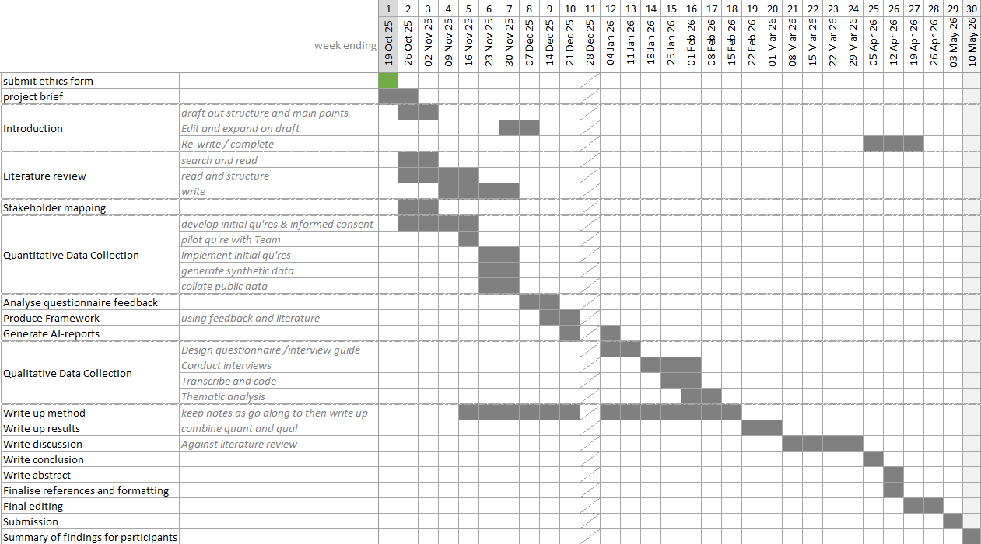
A draft project outline in the form of a Gantt chart can be viewed overleaf. This covers the key stages of the study and will be used to guide project planning.

Appendix B: Ethical Approval Confirmation

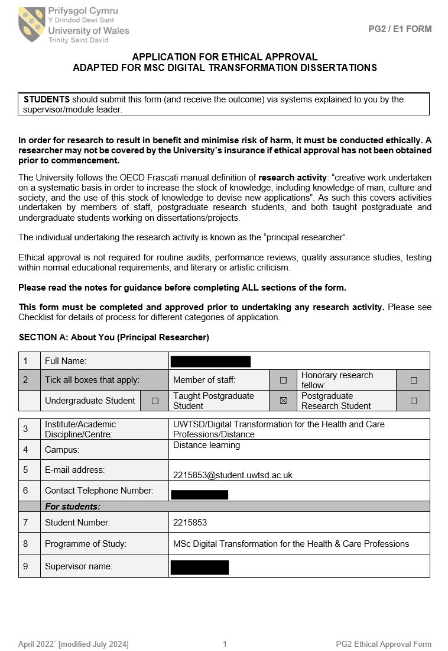
This appendix provides confirmation of ethical approval for the study.

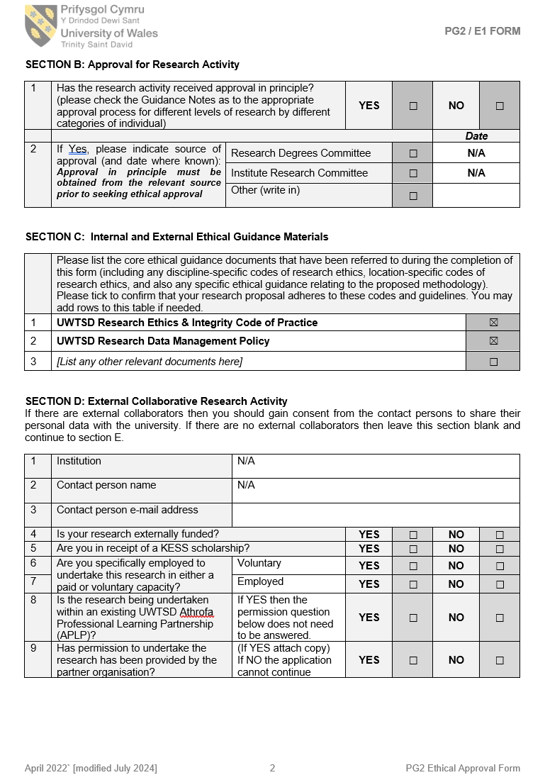

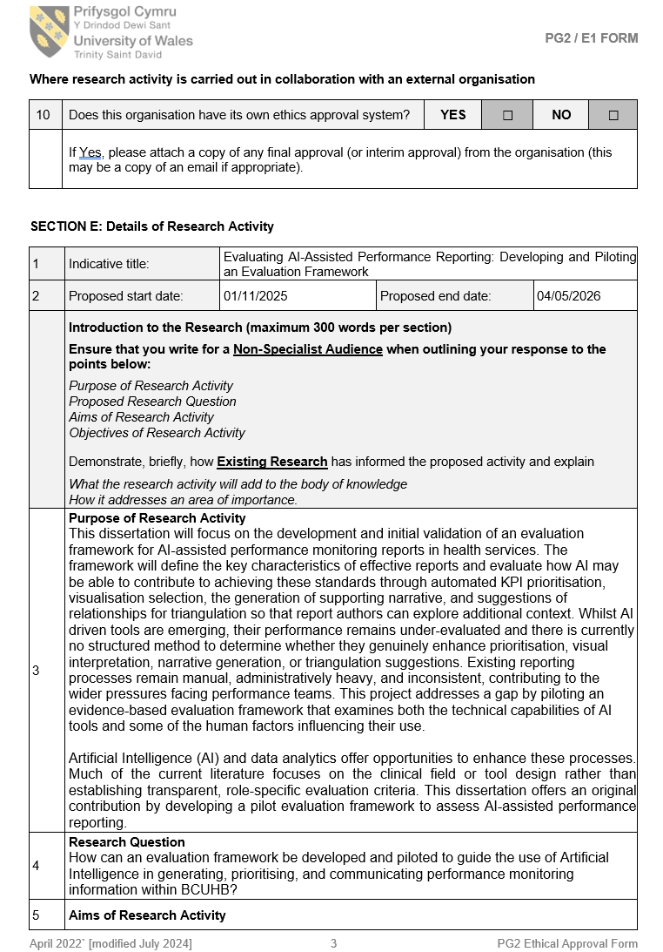

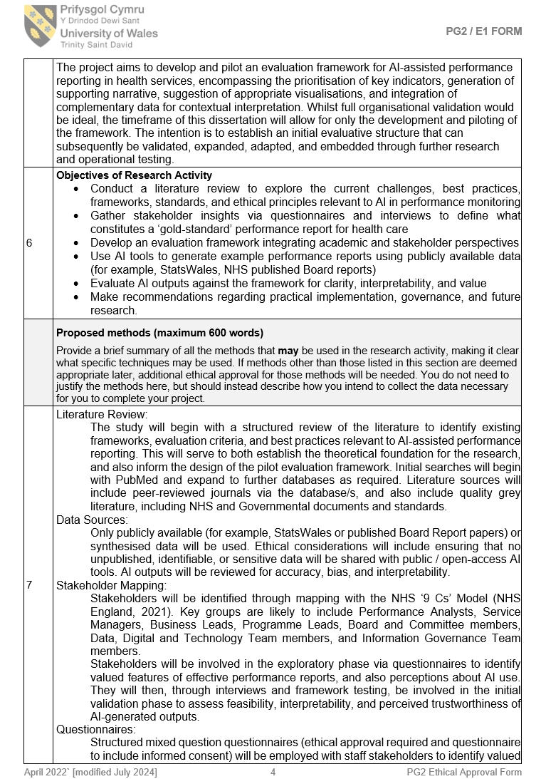

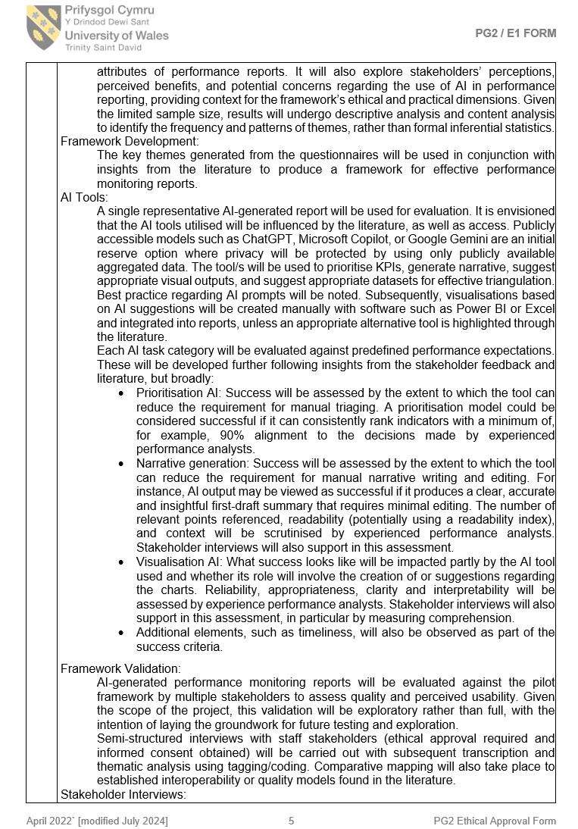

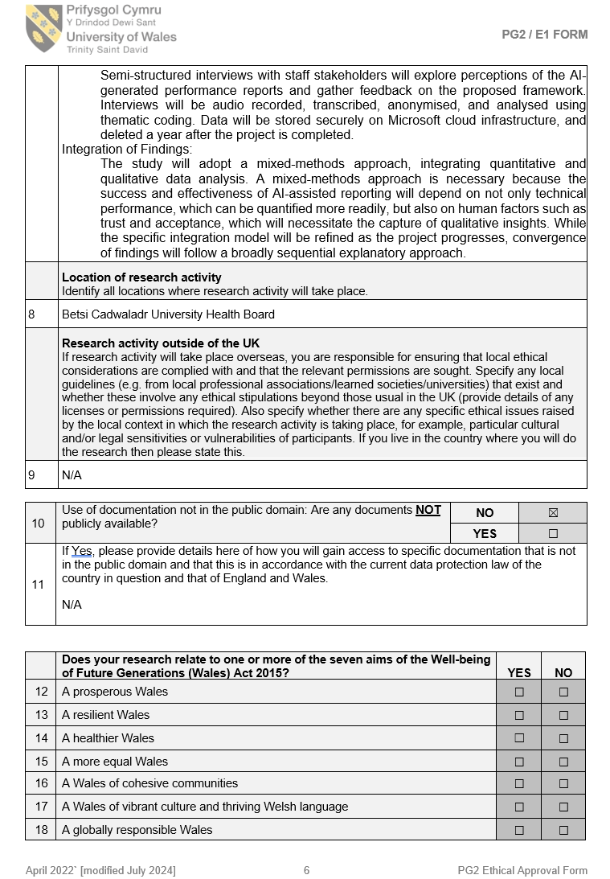

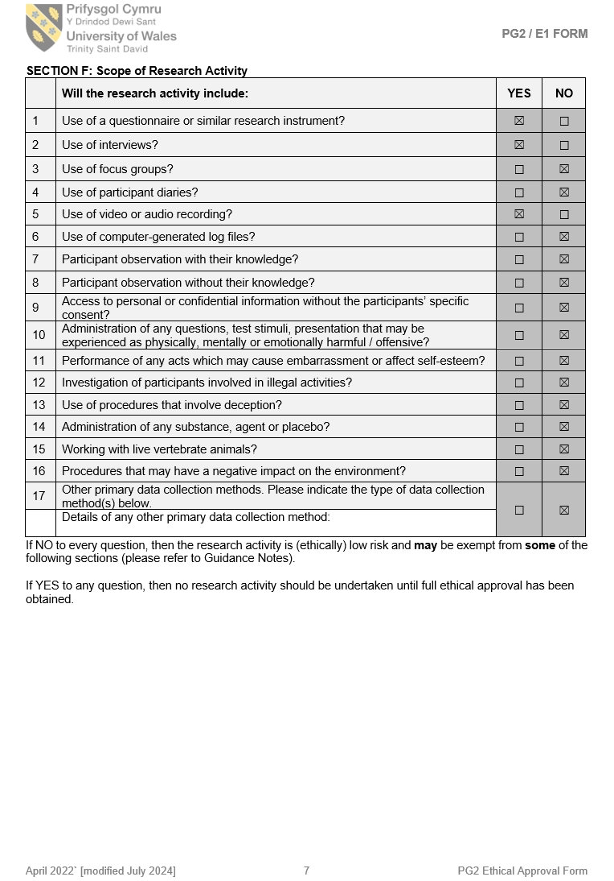

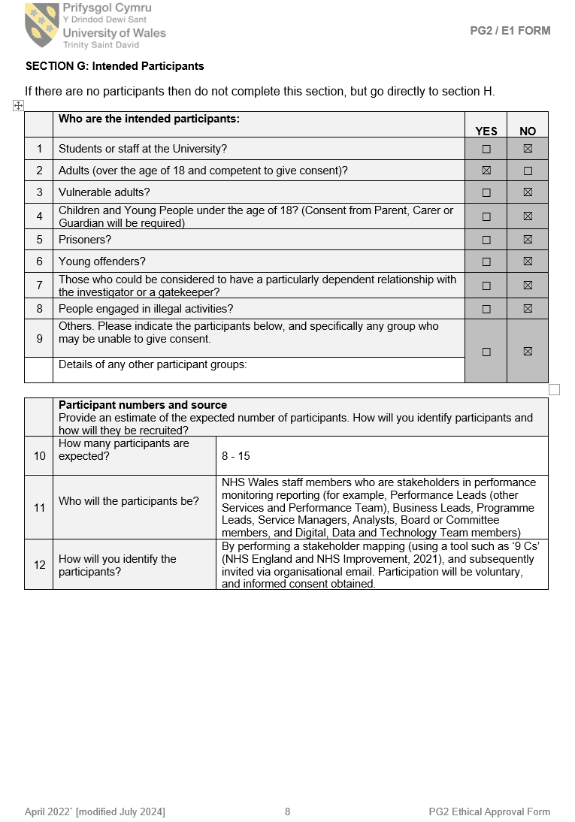

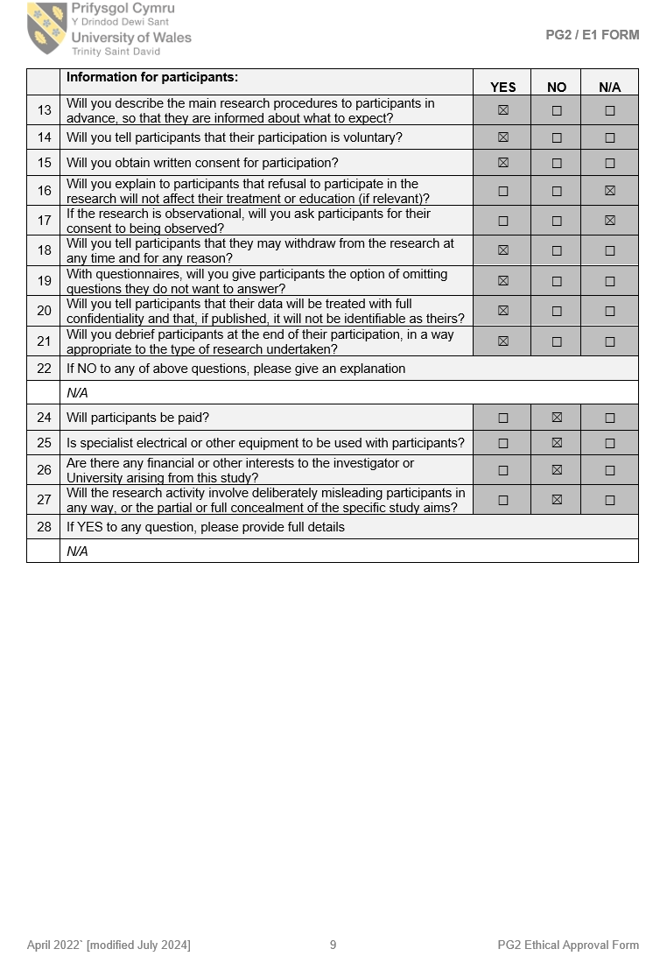

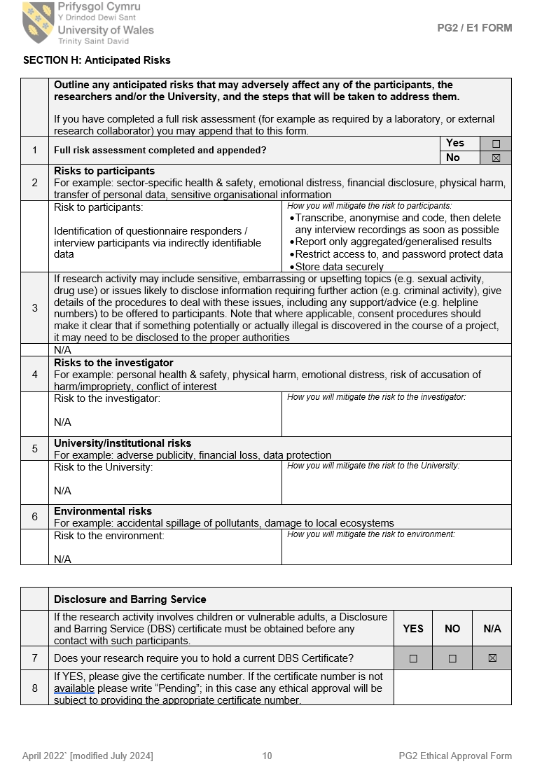

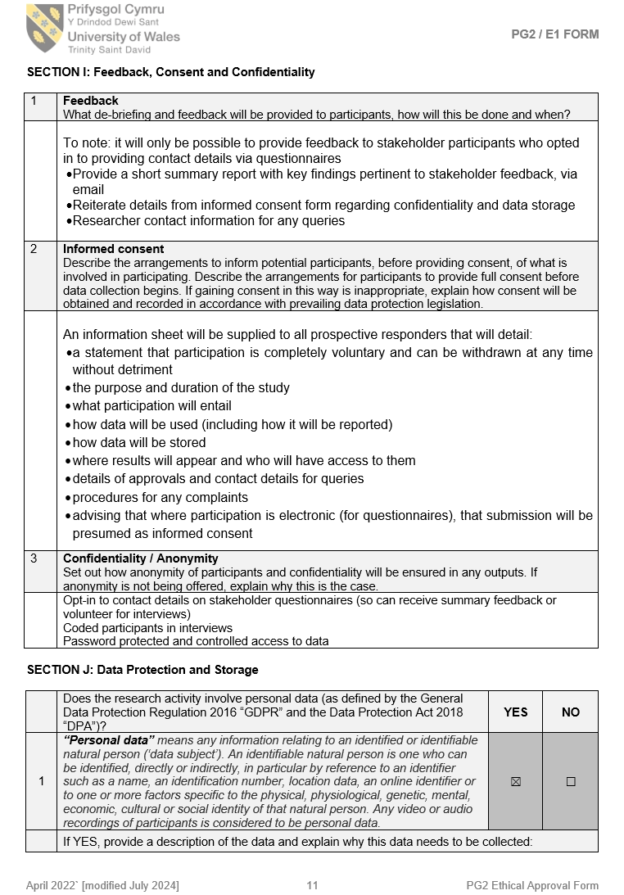

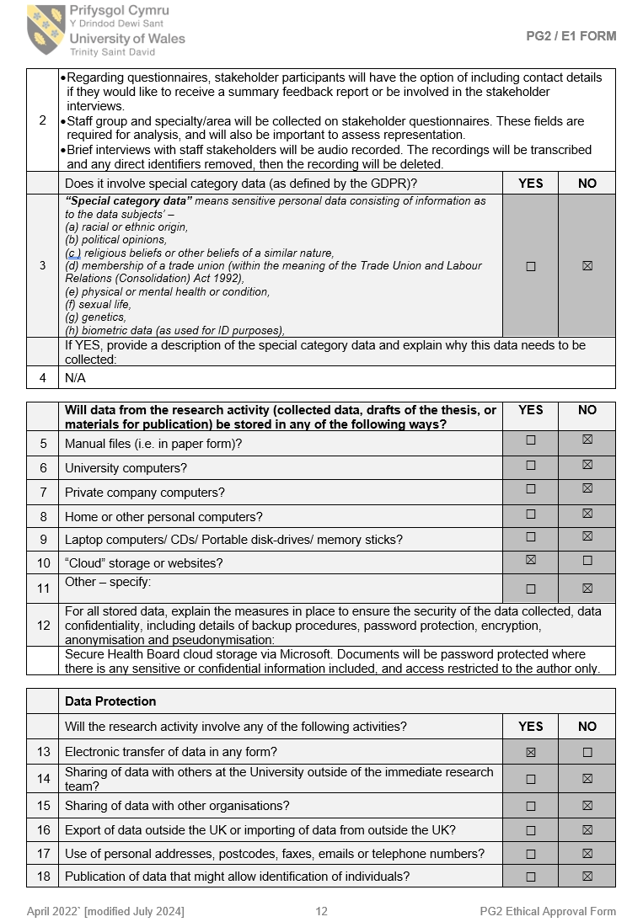

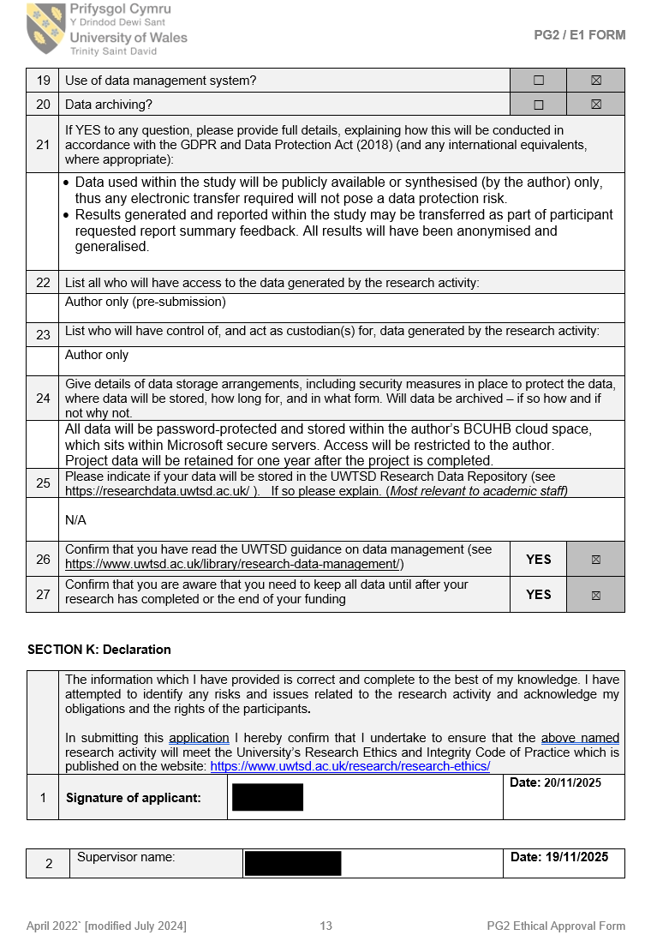

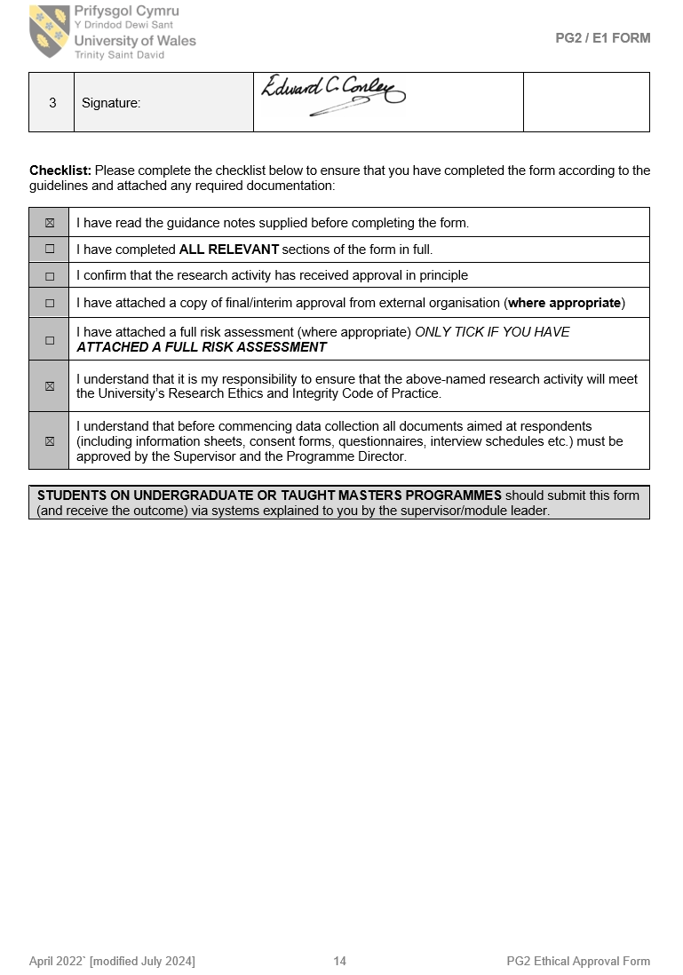

Appendix C: Questionnaire Informed Consent Form

This appendix contains the patient information form provided to interview participants before data collection.

Participant Informed Consent Form

Study Title: | Evaluating AI-Assisted Performance Reporting: Developing and Piloting an Evaluation Framework
Researcher: | Jenny Jones (Performance Officer, BCUHB)
Institution: | University of Wales Trinity Saint David
Contact email: | jenny.jones24@wales.nhs.uk
What is the study about?
You are invited to take part in a project that aims to develop and pilot an evaluation framework for AI-assisted performance reporting in health services.
Specifically, this questionnaire will gather information about what elements you consider important within a gold-standard performance monitoring report and also explore your opinions about the use of AI in performance reporting.
In addition, it may be used to inform future development work undertaken by the BCUHB Performance Team with respect to performance monitoring and reporting.

What will my involvement be?
You will be asked to complete a questionnaire that will take approximately 10 minutes.
Your questionnaire feedback will be grouped with that from other respondents and analysed for common themes.
You will also be asked if you consent to being contacted about taking part in a short interview (approximately 15 minutes) later on in the study, where we will discuss your views of a sample, AI-generated performance report and your opinions about the evaluation framework (a separate information sheet and consent form would be supplied at a later date if you opt in to this).

Do I have to take part?
Participation is voluntary and there are no negative consequences if you choose not to take part.
There are no anticipated risks and you may skip any question that you would prefer not to answer.
There are no direct personal benefits to taking part, however, your responses will help to inform the development of an evaluation framework for AI-assisted performance reporting and may contribute to improvements in performance monitoring and reporting within BCUHB.

Will my information be anonymous?
Your questionnaire responses will be treated as confidential and will be anonymised for analysis and reporting. Your name will not be used in the dissertation or in any subsequent development work undertaken by the Performance Team.
Your staff group will be used so the researcher can monitor the range of participation. It will not be reported in a way that could identify you.
If you choose to provide your email address for follow-up contact or to receive a summary of findings, this will be stored separately from your questionnaire responses and will not be linked to your anonymised data.
Only the author will have access to the raw data. Data will be stored securely in line with data governance policies and relevant data protection legislation. It will be retained for 1 year following project submission and will then be deleted securely.

What will my information be used for?
Aggregated information will be used within the author’s dissertation, and potentially subsequent presentation of the dissertation content.
It will also be used, where relevant, to inform future development work undertaken by the BCUHB Performance Team regarding performance monitoring and reporting.

Who has reviewed this study?
This study has undergone ethics review in accordance with the UWTSD Research Ethics Policy and Procedure.

How do I withdraw from the study?
You can withdraw from the study without giving reason at any point while completing the questionnaire by closing your browser window.
If you choose to provide your email address, you may request the removal of your data up until 16th Jan 2026. To do this please contact the researcher by email.
If you do not provide an email address, your response will be anonymous, and it will not be possible to withdraw it after submission.
Appendix D: ChatGPT Prompt Structure

This appendix summarises the main instruction areas used to guide AI-assisted report production.
Role:
You are a performance analyst working in the health sector in Wales.
Task:
Produce a concise Board-style sample performance report for stakeholder interview use. The report should resemble the tone, structure, and analytical style of an NHS Board Integrated Performance Report, but it should be shorter, selective, unbranded, and proportionate to the number of metrics included. The purpose is to support piloting of an evaluation framework for AI-assisted performance reporting, enabling stakeholders to comment on content, interpretability, usability, trustworthiness, presentation, and missing context.
Use the uploaded Excel workbook named “Data”.
Data source:
- Worksheet “Data”, Table1: Row 1 contains KPI short names; rows 2–22 contain time-series data from April 2024 onwards.
- Worksheet “Targets”, Table2:
- Column A = KPI short name
- Column B = full metric name
- Column C = target or threshold
- Column D = direction of improvement
- Column E = whether the metric is a Performance Framework KPI or supporting metric
Use Table2 as the authoritative source for metric names, targets, direction of improvement, and KPI/supporting metric classification. Treat the latest uploaded workbook and prompt as authoritative. Do not carry forward assumptions from previous iterations.
Do not invent data, targets, thresholds, causes, or explanations. All statements must be supported by the workbook data or, where an external target is required, by official NHS Wales or Welsh Government sources only, with the source stated. If information is ambiguous, state the assumption clearly. All outputs must be concise, evidence-led, and suitable for Board-style presentation.
Before writing the report, analyse the dataset and produce a short analytical findings table for each metric showing:
- latest value;
- direction of improvement;
- change from previous period;
- change over the latest 12 months;
- variance versus target, where available;
- variance versus 3-month average and 6-month median;
- whether the metric is improving, deteriorating, breaching target, or showing meaningful/sustained change.
Meaningful change should be identified using one or more of the following:
- SPC signal detected;
- movement across a defined target threshold;
- ≥10% change versus the 6-month median.
Where the target is narrative, trajectory-based, milestone-based, or year-end rather than a simple monthly numeric threshold, assess assurance using a simple linear regression over the latest 12 months. If the slope is in the required direction, assign positive assurance (A+). If the slope is not in the required direction, assign negative assurance (A-). This indicates whether the metric is moving in the required direction, not whether it has reached the final target.
Chart and visualisation requirements:
- Recommend and produce appropriate charts for all KPI metrics.
- Also produce charts for supporting metrics where the analysis identifies significant change.
- Use SPC charts where there are at least 15 sequential data points and SPC is appropriate.
- Use run charts where SPC is not appropriate, there are fewer than 15 data points, or trend direction is the main objective.
- Use column charts for categorical comparison where appropriate.
- Use combo charts where two related series need to be compared.
- Explain briefly why each chart type is suitable.
Create an Excel workbook containing one chart per worksheet. Use XlsxWriter if generating charts programmatically. Each chart worksheet should be named clearly. For each chart, provide a chart build list showing:
- chart name;
- source data range;
- chart type;
- axis fields;
- target lines;
- sort/order;
- filters.
For SPC charts, apply XmR rules and identify:
- points above the upper control limit or below the lower control limit;
- seven or more consecutive points on one side of the mean;
- six consecutive points increasing or decreasing;
- two of three consecutive points between 2 and 3 sigma.
Use the direction of improvement to determine whether special cause variation is positive or negative:
- positive special cause variation = SC+;
- negative special cause variation = SC-;
- common cause variation = CC.
Where a target exists, classify assurance as:
- positive assurance = A+;
- negative assurance = A-.
Use clear, colour-blind-friendly chart formatting:
- primary chart colour: Blue Accent 1, 50% Darker;
- chart text: Blue Accent 1, 50% Darker;
- target lines: Orange Accent 2;
- control limit lines: Blue Accent 5;
- mean line: Blue Accent 1;
- white background;
- x-axis as time period, formatted as mmm yy or Q# yy/yy;
- font Arial;
- legend bottom centre, Arial size 9;
- no axis titles unless essential.
Produce a compact Board-style performance scorecard for all KPI metrics. Include:
- full metric name;
- latest value;
- target or expected level;
- variance to target, absolute and percentage where possible;
- comparison with previous period;
- comparison with same period in previous year, where available;
- direction of travel;
- domain, where identifiable;
- status indicator.
Where SPC charts are appropriate, include NHS Making Data Count-style variance and assurance indicators. Where SPC is not appropriate, use a clear visual status indicator for improving, stable, or deteriorating performance.
Order the scorecard as follows:
1. Metrics breaching target and deteriorating.
2. Metrics breaching target but improving.
3. Metrics meeting target.
4. Metrics with no defined target.
Below the scorecard, include no more than 75 words summarising:
- number of KPIs improving versus deteriorating;
- domains showing consistent deterioration;
- domains showing system-wide improvement.
Use triangulation to produce integrated system narratives. Use all relevant KPI and supporting metrics to explain featured KPIs through:
- upstream pressures;
- downstream consequences;
- demand, capacity, flow, outcome, quality, finance, or workforce links where relevant;
- Board-level operational implications.
Avoid isolated metric-by-metric commentary. Do not claim causality unless directly supported by the data. Where causality is plausible but not demonstrable, use cautious wording such as “consistent with”, “may be contributing to”, or “occurs alongside”.
Produce a valid PowerPoint presentation using python-pptx. The presentation should be saved as a .pptx file and reopened programmatically to confirm it loads without error before returning it.
Use the following PowerPoint style:
- white background;
- Arial font throughout;
- title font size 32;
- body font size 18;
- text colour: Blue Accent 1, 50% Darker;
- concise Board-facing wording;
- no official branding;
- no methodological narration on visible stakeholder-facing slides.
Visible slide wording should prioritise:
- current position;
- trend;
- target or expected level;
- operational implication;
- action or assurance requirement.
Avoid reproducing full analytical reasoning on slides. Avoid discovery-style wording. Use full metric names. Write out abbreviations in the first instance. Use full sentences where possible and bullet points only where they improve readability.
PowerPoint slide structure:
1. Front page: report title, reporting period, date produced in dd-mm-yyyy format.
2. Contents page.
3. Executive Summary: Summary Position. One continuous paragraph of no more than 5 sentences. Start with the overall position, present risks first, then counterbalancing improvements. End with a sentence beginning exactly: “Board attention required:”
4. Executive Summary: Key Risks. Select the top 3 risks, ranked by Board materiality. For each risk, show the metric heading followed by a compact Board-facing paragraph covering current position, meaningful comparator, trend or signal interpretation, and operational consequence. End each risk with a short sentence beginning exactly: “Implication:”
5. Executive Summary: Key Improvements. Select the top 3 improvements, ranked by organisational significance. Improvement does not require the metric to be on target. For each improvement, show the metric heading followed by a compact paragraph covering latest position, evidence of improvement, meaningful comparator or baseline, and service significance. End each improvement with a short sentence beginning exactly: “Service significance:”
6. Header page: “Performance Escalations Report”.
7. Priority Escalations: show escalation items ranked 1–3 in a table.
8. Priority Escalations: show escalation items ranked 4–6 in a table.
9. KPI deep-dive using system triangulation.
10. KPI deep-dive using system triangulation.
11. KPI deep-dive using system triangulation.
12. Header page: “KPI Scorecard”.
13. KPI Scorecard.
14. Header page: “Appendix”.
15. Caveats, data quality concerns, and how AI was used in producing the report.
For Slides 7 and 8, escalate metrics where one or more of the following apply:
- breaching target and deteriorating over 2 consecutive periods;
- ≥10% adverse variance versus target or 6-month median;
- material access, safety, flow, quality, finance, or operational risk.
Rank escalation items by patient risk and system impact. Present the visible table using only these columns:
- Metric
- Current Position
- Target
- Trend
- Immediate Implication
- Immediate Action
- Medium-term Action
- Risk Level
For the Trend column, use a short plain-English phrase beginning with one of:
- Worsening
- Improving
- Stable
- Sustained deterioration
- Sustained improvement
- No material change
For Slides 9–11, each slide should focus on one featured KPI and explain:
- the current KPI position;
- relevant upstream pressures;
- downstream consequences;
- whether the evidence suggests demand pressure, capacity shortfall, flow blockage, outcome deterioration, or recovery offset by pressure elsewhere;
- the operational implication for the Board.
Suggest one main chart and up to three supporting charts for each deep-dive. The narrative should read as a connected system pathway, not as separate metric updates.
Do not include methodological artefacts such as chart build lists, validation notes, analytical workings, or timing data on stakeholder-facing slides unless specifically requested. Provide these separately for dissertation analysis.
Before finalising, complete a self-validation check:
- confirm every narrative statement is supported by a metric value or trend from the dataset;
- confirm escalated KPIs meet the escalation criteria;
- confirm no targets or policy thresholds have been invented;
- confirm all charts reference real data columns from the workbook;
- verify calculations including variance, percentages, change, averages, and medians;
- confirm threshold polarity is taken from the current Targets table;
- correct any issues before returning the final output.
Record:
- task start time;
- task completion time;
- total duration.
Return:
1. the PowerPoint file;
2. the chart workbook;
3. the analytical findings table;
4. the chart build list;
5. the validation summary;
6. the timing information.

Appendix E: Screenshots of the Data Table Used in the Generation of the AI-Assisted Report

This appendix contains screenshots the publicly available performance data compiled for use alongside the prompt to generate AI outputs.


