ROBYN TRUBEY
1708724

RESEARCH METHODS
MARCH 2018

A REPORT OF AN INDIVIDUAL’S ABILITY FOR FACE RECOGNITION ACROSS DIFFERENT RACIAL GROUPS

A framework has been outlined to demonstrate an individual’s ability for face recognition both across their own racial group and other racial groups. Copious amounts of previous research state how an individual has an exceptional ability for face recognition, even after delayed periods of time. However, it has been argued that humans can be relatively poor at face recognition when the face(s) displayed are from different racial groups, and are better at successfully recognising people from their own racial group. This study was carried out to test whether or not that hypothesis is in fact correct. A study was carried out where participants were shown 12 faces, one at a time, for a 2 second period in Part 1. Participants were soon asked to view another 36 faces, on 6 different slides, again for a 2 second period in Part 2. Participants were then asked to note how many faces they recognised in Part 2 from Part 1 of the study, as a proportion of the faces from Part 1 were amongst the faces in Part 2. The results demonstrated that in fact, participants were more successful in correctly recalling black faces (M = 3.34, SD = 2.42) than white faces (M = 2.67, SD = 2.42), despite all participants being of a white origin.

Over the years, a human being’s ability for face recognition has been put under the microscope. Meissner & Brigham (2001) stated that despite research finding that humans are experts in recognising copious amounts of faces after delayed periods of time, it is argued that individuals are comparatively insufficient at identifying and recognising faces of those from a different racial group to themselves. It has been suggested that members of a certain race are better able to distinguish the individuating information needed to recognise an individual who is the same race as them. Individuation is the concept in which a person or object can be identified, allowing for a person to differentiate against its other factors. Lindsay et al. (1991) carried out a study which investigated an individual’s immediate identification deficits when remembering other-race faces. The study found that individuals were much more able to successfully recognise own-race faces, especially amongst White participants. Further research was conducted, where African Americans and European Americans were shown pictures of faces from an alternative race, whilst their brain activity was monitored. The area of the brain in which is said to be crucial for face recognition, the fusiform face area (FFA), was discovered to be more active when participants were viewing faces from their own racial group (Eberhardt, 2001). This study below was conducted to measure whether participants were able to recall more white or black faces following a period of distraction. A great deal of research has been conducted into same-race face recognition over the years. Therefore, its proposed the results from this study will demonstrate that participants will be able to more successfully recognise own-race faces when recalling face recognition.

Method

Participants
29 students from the Counselling Skills and Psychology course acted as subjects for the purpose of the study. Participants were asked to take part in the study whilst studying for their Research Methods module. There were 22 females and 7 males taking part. Participants aged from between 18 and 60, with a mean age of 27.31 and a standard deviation of 10.81. All participants were White.

Design
The study had a within-subject design. A paired samples t-test was used to analyse the results from the study. The independent variable was the faces of the individuals shown to the participants, while the dependant variable was how many faces the participant(s) could recall correctly.

Materials
Participants were firstly provided with a consent form (see appendix A) to complete in order to agree to participate in the study. The consent form required a signature and date from the participant. Before taking part, participants were provided with an answer sheet (see appendix B). The document included 3 short demographic questions asking their gender, age and ethnicity. The document also allowed space for the participant to record their responses to Part 2 of the study. The study was then presented to the participants through a PowerPoint Presentation and was divided into two separate parts. Part 1 showed 12 different faces of individuals from different ethnic backgrounds, and Part 2 showed 36 different faces from different ethnic backgrounds. Finally, participants were provided with a de-brief document (see appendix C) once the study had concluded.

Procedure
Firstly, participants were asked to sign and date the given consent form in order to agree to take part in the study. Once the consent form has been collected, participants were provided with an answer sheet. The document asked participants to answer 3 demographic questions regarding their gender, age and ethnicity. The answer sheet document also provided space to record responses for Part 2 of the study. Next, the PowerPoint Presentation explained Part 1 of the study, which demonstrated 12 different faces of individuals from different ethnic backgrounds. Each of the 12 faces were shown separately, one at a time, for 2 seconds each. This concluded Part 1 of the study and Part 2 was explained. In Part 2, the participants were shown 6 separate slides, which presented 6 different faces at a time for a 2 second period; 36 faces being shown altogether. After the faces had been shown, participants were asked to record how many faces they could recognise from Part 1 in each of the 6 slides shown in Part 2 on their answer sheets. The study had now been completed, and after the participants had recorded their answers, the answer sheets were collected. The final part of the study involved the participants receiving a de-brief. The de-brief involved thanking participants for taking part, explained the aim of the study and gave participants the opportunity to withdraw their data if they wished.

Results
For the purpose of the study, a paired-samples t-test (see appendix D) was piloted to establish whether the participants were able to recall more black or white faces following a period of distraction for the purpose of the study. After calculating the results from the study, it demonstrated that participants were able to in fact recall significantly more black faces (M = 3.34, SD = 2.42) than white faces (M = 2.67, SD = 2.42); t (28) = 3.13, p < .05. The original hypothesis for this study (stated above) suggested that participants would recall more white faces than black. However, as the results have demonstrated, this hypothesis must be rejected as the results suggest otherwise.

From the results of the study, it demonstrated that individuals were able to successfully recall more black faces that white. With all participants of the study being of White ethnicity, the results therefore rejected the hypothesis. Considering the research literature discussed in the introduction, it is clear that the results from this study contradict what has been demonstrated in previous studies within the subject field. For example, in Meissner & Brigham’s study conducted in 2001, the results demonstrated that whilst humans are exceptionally good at being able to recognise faces after delayed periods of time, they are less capable if the face(s) they have viewed is one from an alternative race. However, as all participants of this study were in fact of White ethnicity, and were more capable of recalling the faces of black individuals rather than white, this study contradicts this study. Likewise, the results from this study also contradicts that of Lindsay et al. in 1991, which stated that participants were more successful in recognising same-race faces, especially in White participants. Despite the study carried out above having only White participants, the results still proved to contradict that of the previous study carried out.

One limitation of this study was that all participants were all of White ethnicity. When recruiting participants for the study, the ethnic background of the participants involved should have been considered more cautiously. If for example, people from a Asian or European ethnic backgrounds were participating in the study, this could have demonstrated different results and perhaps allowed for a different conclusion to be drawn.

Another limitation to consider would be the materials used for the purpose of the study. When participants were provided with an answer sheet to record their answers for Part 2 of the study, a blank space was given. This didn’t provide enough structure for participants to record their answers, whereas, designated areas to record an answer for each slide shown to the participants would have perhaps allowed the study to generate more precise results. The opportunity for a blank space to provide answers was perhaps too brief in this instance, and distracted participants from the task at hand.

Participants were only shown the faces on the PowerPoint presentation for a 2 second period. In order to gage a better understanding over face recognition, participants could have been given the opportunity to record their answers both immediately after seeing the faces displayed, as well as after a delayed period of time. This would have allowed the study to demonstrate both the immediate effects of memory recall, as well as an individual’s ability to successfully recall faces over a period of time. If the study was to be repeated again, this would be something to consider.

Furthermore, if individuals from different ethnic backgrounds were considered as participants, it would have allowed the results from this study to differentiate how different racial groups react to same / different race face recognition. For example, if participants differed in racial groups, the study would have been able to gage what effects face recognition has on individuals in the given environment. If for instance, an individual of an Asian background was surrounded and brought up in a majority of White background individuals, would this have an effect on their ability to recognise faces of White origin perhaps. If this study was to be taken further, this would be again, another key idea to consider.

Appendices

- Consent Form

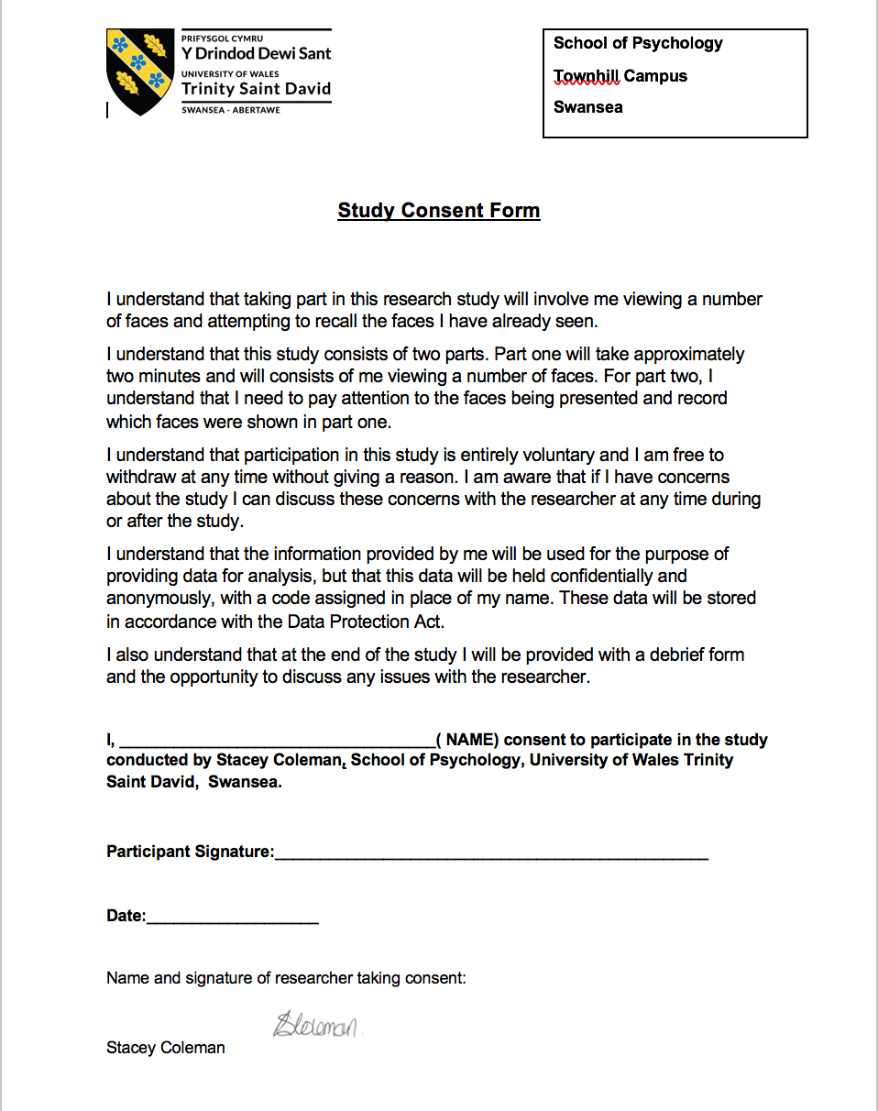

- Answer Sheet



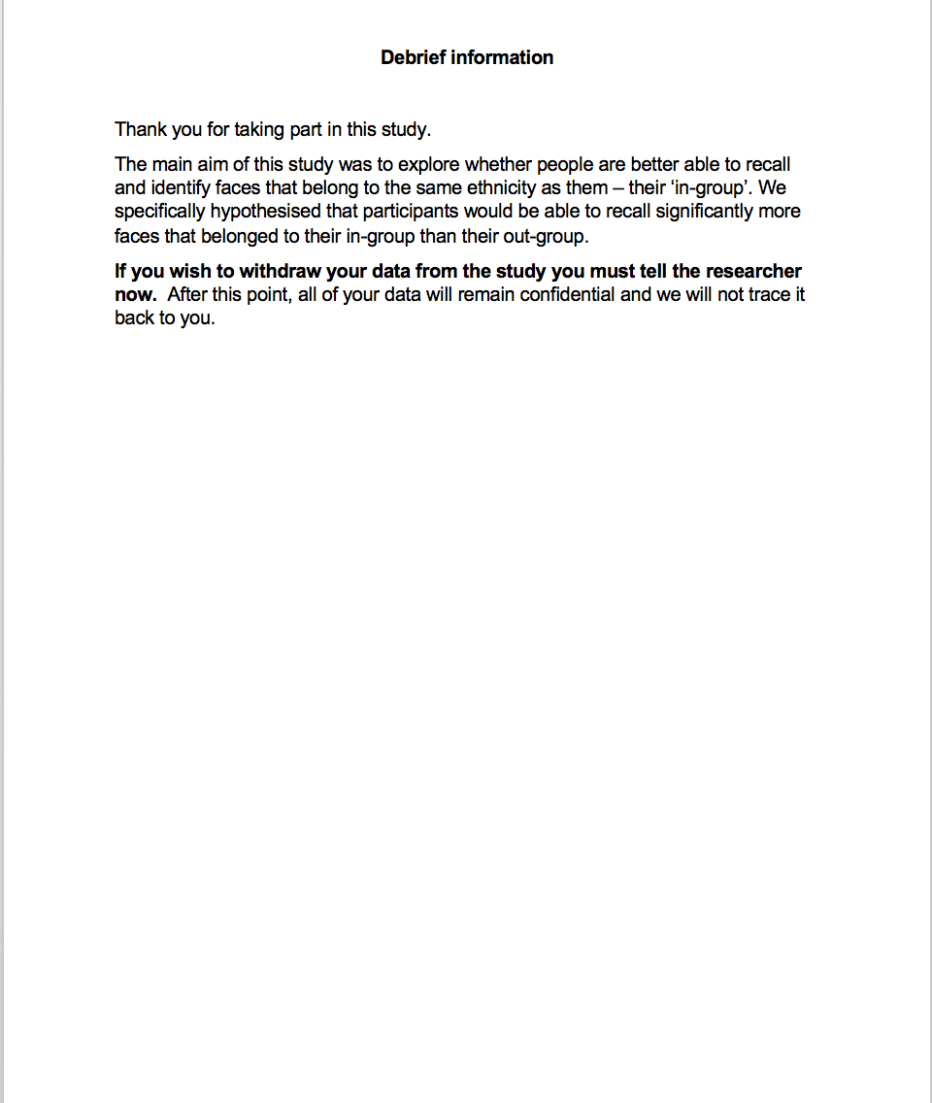
- De-Brief Document


- T-Test Calculations

Reference List

Ding, X. P., Fu, G., & Lee, K. (2014). Neural correlates of own-and other-race face recognition in children: a functional near-infrared spectroscopy study. Neuroimage, 85, 335-344.

Malpass, R. S., & Kravitz, J. (1969). Recognition for faces of own and other race. Journal of Personality and Social Psychology, 13(4), 330-334.

Valentine, T. (1991). A unified account of the effects of distinctiveness, inversion, and race in face recognition. The Quarterly Journal of Experimental Psychology Section A, 43(2), 161-204.

Wright, J., Yang, A. Y., Ganesh, A., Sastry, S. S., & Ma, Y. (2009). Robust face recognition via sparse representation. IEEE transactions on pattern analysis and machine intelligence, 31(2), 210-227.

