

Student name: ELOIDA KARINA CHAVEZ SIFUENTES
Student ID: 2437214
Student code: Introduction to Health and Social Care

Module code : LCHS4003
Lecturer name : Mark Kane

Content page

Element 1 ……………………………………………………………. page

Element 2……………………………………………………………. page
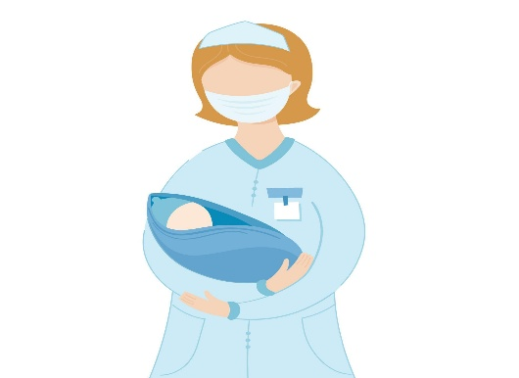
INTRODUCTION: Community midwifery is the centre of maternity care in the UK. It offers personalised, accessible support to pregnant women outside of hospitals. These services are deeply rooted in local communities, where midwives provide holistic care that includes routine check-ups, health monitoring, childbirth education, breastfeeding support, mental health guidance, parenting resources, and postnatal follow-up (NIHR, 2025). Midwives are not just clinicians they’re companions, educators, and protectors of dignity and wellbeing for both mother and baby (Nursing in Practice, 2025).

community midwifery also plays a vital role in reducing health inequalities, especially for vulnerable populations, by offering culturally sensitive and inclusive care (NMC, 2025). As the first point of contact for many women with the NHS, midwives help with trust and confidence in the healthcare system. Their work is essential not only for physical health but also for emotional confort, empowering families during one of life’s most transformative experiences (ICM, 2025).

Community antenatal midwifery services
Introduction to health and social care
Eloida Karina Chavez Sifuentes 2437214@student.uwtsd.ac.uk

“
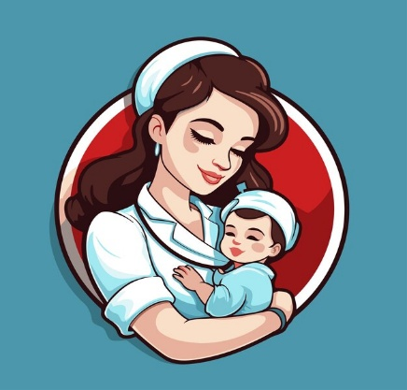



References: British Medical Association (2025) Medical staffing in the NHS. Available at: https://www.bma.org.uk/advice-and-support/nhs-delivery-and-workforce/workforce/medical-staffing-in-the-nhs (Accessed: 2 November 2025
Care Quality Commission (2025) State of Care 2024–2025: Focus on Maternity. Available at: https://www.cqc.org.uk/publications/major-report/state-care/2024-2025/focus/maternity. (Accessed: 2 November 2025).
MBRRACE-UK (2025) Saving Lives, Improving Mothers’ Care. Available at: https://www.npeu.ox.ac.uk/mbrrace-uk/reports (Accessed: 2 November 2025).
Royal College of Midwives (2025) New midwives ready to work but no jobs available despite understaffed services. Available at: https://rcm.org.uk/media-releases/2025/06/new-midwives-ready-to-work-but-no-jobs-available-despite-understaffed-services-says-rcm/ (Accessed: 2 November 2025). NIHR (2025) Improving maternity care outcomes. National Institute for Health and Care Research. Available at: https://www.nihr.ac.uk/story/improving-maternity-care-outcomes [Accessed 16 Nov. 2025].

CHALLENGES:
Workforce Shortage & Job Insecurity the NHS faces a shortfall of thousands of midwives, putting maternity units under immense pressure. In 2025, over 80% of student midwives expressed uncertainty about securing employment after graduation, despite widespread understaffing (The Workers Union, 2025). This contradiction stems from poor workforce planning and limited funding (Royal College of Midwives, 2025). Many midwives are responsible for too many patients, leading to stress, burnout, and reduced quality of care (Care Quality Commission, 2025). Some maternity services have even closed temporarily due to unsafe staffing levels (British Medical Association, 2025).
Gender Pay Gap & Valuation of Care Work Despite midwifery being a female-dominated profession, midwives earn less than professionals in male-dominated NHS roles with similar skill levels (British Medical Association, 2025). This reflects deeper issues in how care work is undervalued and contributes to the gender pay gap.
Inequality & Systemic Racism Midwives from minority backgrounds face additional challenges, including systemic racism and unequal career progression (Royal College of Midwives, 2025). Continuity of care is often disrupted—many women do not see the same midwife throughout pregnancy, which undermines trust and personalised support (Care Quality Commission, 2025). According to the 2025 MBRRACE-UK report, Black women in the UK are more than twice as likely to die during or shortly after pregnancy compared to white women (MBRRACE-UK, 2025). The Royal College of Midwives has called this disparity “shocking” and demands urgent reform.

“The history of maternity care in Britain is a story of resistance resilience, reform, and resistance.”
BRIEF HISTORY OF THE SERVICE: Midwifery in the United Kingdom has deep roots that stretch back to ancient times but 1948 marked a turning point for midwifery in the United Kingdom with the establishment of the National Health Service (NHS). This landmark reform integrated midwifery into a publicly funded healthcare system, making maternity carefree and accessible to all. Midwives became NHS employees, working in hospitals and communities to support women throughout pregnancy, birth, and the postnatal period.
In the early decades of the NHS, maternity care became increasingly institutionalised. By the mid-1970s, over 95% of births occurred in hospitals, a dramatic shift from earlier decades when home births were more common. This medicalisation of childbirth led to debates about the loss of personal, woman-centred care. Many women and midwives began advocating for more autonomy, continuity, and respect in maternity services.
The 1980s saw the emergence of community midwifery programmes, designed to restore personalised care and improve maternal outcomes. These programmes allowed midwives to work more independently, often visiting women in their homes and building long-term relationships. This approach was especially valuable in underserved areas, helping to reduce health inequalities and promote culturally sensitive care. Throughout the late 20th and early 21st centuries, midwifery continued to evolve in response to social change, policy reform, and public demand. Midwives took on expanded roles in perinatal mental health, safeguarding, and health education, becoming key advocates for holistic wellbeing. The profession also faced challenges such as workforce shortages, increasing birth rates, and the need to support diverse communities.
Recent reports, including the Birth Trauma Inquiry (2024), have highlighted the importance of compassionate, well-resourced maternity care. These findings have reinforced the role of midwives in building a more equitable and empowering healthcare system.

Recommendations for a Better Future:
Invest in Workforce Planning and Retention-The NHS must focus on recruiting, training, and keeping midwives. New graduates need clear pathways into employment, and experienced staff need support to stay in the profession. This means better funding, smarter planning, and more respect for midwifery as a career.
Recognition and Fair Pay-Midwifery should be valued equally to other healthcare roles. Pay structures must reflect the complexity and importance of the job. Midwives are vital—they deserve fair compensation and professional respect.
Community Engagement and Education-Outreach programs should be expanded so that all women feel informed, supported, and empowered to access care. Education builds confidence and trust. It helps women make choices that are right for them and their families.
Continuity of Care Models-Seeing the same midwife throughout pregnancy improves trust, satisfaction, and outcomes. Continuity of care should be a priority. It makes women feel safe, heard, and respected.
Birth is about making mothers… strong, competent, capable mothers who trust themselves and know their inner strength.”

The founding of the National Health Service (NHS) in the United Kingdom on July 5, 1948, represented a radical transformation in the way healthcare was conceived. Emerging in the post-war context, the NHS was a direct response to the social inequalities that had intensified during the conflict. Its creation was based on the principles of universality, free at the point of use, and public funding, with the aim of ensuring that all people, regardless of their economic situation, had access to health services (British Council, 2021).
The chief architect of the National health service was Aneurin Bevan, Minister of Health in Clement Attlee's Labour government. Bevan was inspired by the 1942 Beveridge Report, which identified five 'social giants' that needed to be eradicated: disease, ignorance, poverty, idleness, and squalor. The NHS was designed as a tool to fight these evils, especially disease, through a healthcare system accessible to everyone (Talking Cambridge House, 2025).
Before 1948, the British healthcare system was fragmented and unequal. Medical care relied on private insurance, charitable organizations, voluntary hospitals, and direct payments. This meant that many people, especially those from the working class, could not access adequate treatments. The nationalization of more than 2,500 hospitals allowed the NHS to reorganize health services under a centralized structure, eliminating economic and social barriers (El Ibérico, 2025).
During the following decades, the NHS faced multiple challenges. In the 1960s and 1970s, reforms were introduced to improve regional planning and coordination between services. In the 1980s, under Margaret Thatcher's government, internal market policies were implemented, which introduced competition among service providers. These reforms were controversial, as some sectors believed they threatened the founding principles of the NHS (British Council, 2021).
In the 1990s and 2000s, the NHS modernized with the incorporation of digital technologies, electronic records, and new forms of clinical management. NHS Foundation Trusts were created, granting greater autonomy to hospitals, and patient choice was promoted as a mechanism for improvement. However, funding problems, staff shortages, and waiting lists also intensified, leading to questions about the system's sustainability. The COVID-19 pandemic demonstrated an extraordinary capacity for adaptation, with healthcare staff working in extreme conditions to save lives at the same time, structural weaknesses became evident, such as the lack of investment in mental health, regional inequality in access to services, and the urgent need for modernization (British Council, 2021).
Currently, the NHS is divided into four autonomous systems: NHS England, NHS Scotland, NHS Wales, and Health and Social Care Northern Ireland. Although they share common principles, each has its own competencies and faces specific challenges. In England, for example, reforms have been proposed to reduce bureaucracy and improve direct care, which has generated debates about the future of the original model (El Ibérico, 2025).
Beyond its structure, the NHS has been a battleground for equity. In recent decades, it has made progress in recognizing cultural diversity, including neurodivergent communities, and addressing mental health needs. These changes reflect an evolution toward a more person-centred model that acknowledges the complexity of social and healthcare needs.
The NHS represents an emblematic case of public policy geared towards collective well-being. Its history reflects tensions between universalism and efficiency, between equity and sustainability. For those of us who study health and social care, the NHS is not just a system: it is a symbol of the struggle for healthcare justice, and a space where ethical values, political decisions, and human experiences intersect.

THE ORIGINS & AND DEVELOPMENT OF THE NATIONAL HEALTH SERVICE (NHS)
ELOIDA KARINA CHAVEZ SIFUENTES 2437214

British Council (2021) El NHS: el sistema sanitario en el Reino Unido. Available at: https://www.britishcouncil.es/blog/nhssanidad-reino-unido [Accessed 8 Nov. 2025].
El Ibérico (2025) Historia, cifras y curiosidades del NHS. Available at : https://www.eliberico.com/historia-cifras-y-curiosidades-del-nhs-el-sistema-sanitario-britanico-en-datos/ [Accessed 8 Nov. 2025].
Talking Cambridge House (2025) The History of the National Health Service (NHS) in the UK. Available at: https://talking.cambridge-house.com/the-history-of-the-national-health-service-nhs-in-the-uk/ [Accessed 8 Nov. 2025].

