Audit of Hilton Hotel Group
Report

BMIH5004
Management and Organisational Behaviour
Module Lead: Lola Villard-Coles
Student: Teodor Catalin Belu (216226)

Table of contents

Introduction…………………………………………………………………………. 3
- Organisational structure………………………………………………….. 3
- Organisational environment and culture………………………………. 5

- Hilton mission, vision, and core values……………………………. 6
- Hilton organisational change……………………………………….... 6
- Hilton strategic direction……………………………………………… 7

- Hilton Business performance……………………………………………..8

Recommendations…………………………………………………………………..8
Conclusions…………………………………………………………………….…….8
References…………………………………………………………………….……. 10
Appendix A………………………………………………………………………….. 13
Appendix B………………………………………………………………………….. 13
Appendix C…………………………………………………………………………. 14
Appendix D…………………………………………………………………………. 15

Introduction

With a portfolio of 22 world-class brands, nearly 7,400 properties, and more than 1.1 million rooms spread across 124 countries and territories, Hilton is a prominent global hospitality company (Hilton, 2023) In Cisco, Texas, Conrad Hilton founded the company as Hilton Hotels Corporation in 1919. The company's headquarters were in Beverly Hills, California, from 1969 until 2009. The business moved to Tyson’s Corner, distinct Fairfax County, Virginia, close to McLean, in August 2009. Hilton Hotels Corporation currently operates hotels and conducts business in the United States, Asia, and Europe. Major cities such as New York, Rome, London, Sydney, Tokyo, Paris, Shanghai, Beijing, Stockholm, Toronto, and Sao Paulo are home to Hilton Hotels. Hilton is dedicated to realising its original mission of bringing light and hospitality to people all over the world. Throughout its more than a century-long existence, the company has welcomed more than 3 billion visitors, ranked first on Fortune's list of the 100 Best Companies to Work For, and been recognised for six consecutive years as a global leader on the Dow Jones Sustainability Indices. (Hospitality Net organisation, 2023).

- Organisational structure

A work organization's defined feature is its structure (Mullins and McLean, 2019, p.451). Corporate strategy and organisational structure are strongly correlated. The hospitality establishment's structure governs how the management process is applied and tasks are carried out. Organisational structure may contribute to managerial innovation, which is the process by which a company devises new methods for enhancing its managerial capabilities and practises (Su et al., 2019, p.253). This innovation is a major driver of the company's competitive advantage and superior performance. The work division, tasks and responsibilities, work role and relationship, and communication channel are all to be defined by the organisational proposed structure (Mullins and Dossor, 2013, p. 140).

Hilton is a global hospitality company which includes multiple brands (Appendix C) in more than 124 countries. Its organisation's formal structure can be described as hierarchical because of its massive size and divisional because the company is dividing its properties into three categories. Hilton Hotels & Resorts is in charge of the first two divisions: ownership, management, and franchise. Hilton Grand Vacations is in charge of the third division, timeshares, and has operated as an entirely independent organisation since splitting off from Hilton Hotels & Resorts, a publicly traded company, in 2008 (0rganimi, 2023).

Hilton

Hilton Grand Vacations
Hilton Hotel and Resorts

Timeshare
Management and franchise
Ownership

The organization's members divide up the work into different jobs that are related to one another and organised based on certain common characteristics. Hilton's institutional level is divided into multiple scalar chains, by major purpose or function, by product or service or by location. The framework for superior-subordinate relationships and the vertical graduation of authority and responsibility are established by the scalar chain in Hilton. Geographic boundaries define the range of services that are offered based on specific needs or demands so some Hilton divisions are made taking into consideration the location of the multinational. Analysing the organisation charts on the higher level we can see under the CEO are vice-presidents for divisions such as Asia Pacific, for Americas or Middle East, Africa, and Turkey (appendix B). The same chart illustrates how the hierarchical structure of the Hilton organisation permits the development of cross-functional relationships between group structure and divisions. Having a vertical structure, the organisation can be listed as a mechanistic organisation with centralised control, highly specialised rules and procedures, and standard operating procedures (Bloisi et al, 2007, p. 708) controlled at the managerial level through departments and units.
In reality, work organisations don't operate like carts or structures. The behaviour of individuals cannot be analysed in isolation from other factors that compromise the organisation, such as the social context of work and the significance of informal organisation. This is due to the fact that people are unique and have different perspectives, emotions, and attitudes towards the organisation as well as different management philosophies and roles.

- Organisational environment and culture

A system of shared meaning that sets an organisation apart from others is referred to as its organisational culture (Robbins and Judge, 2022, p. 299). The need for organisation culture has increased due to increased competition, globalisation, alliances, mergers, acquisitions, and various workforce developments ( Őnday, 2016, p.39005). The organization's guiding principles, assumptions, and values are all part of this shared meaning system. Organisational culture clearly has a significant influence on business operations, procedures, attaining corporate goals, and performance (Rahman et al., 2023). Employee performance would increase if the organization's norms and values were shared by all members (Akpa, 2021, p. 362). The qualities of employees and the culture of the organisation are complementary (Alassaf et al., 2020). Employee dedication is a critical component of an innovative culture where knowledge and talent are valued as intangible assets that the company uses to stay competitive.

- Hilton's mission, vision, and core values

The company's mission statement, "To be the preeminent global hospitality company - the first choice of guests, team members, and owners alike," places the company in the middle of its stakeholders: guests, employees, and owners. A vision statement indicates the direction that a company wants to go in and acts as its North Star for the organisation, setting a destination (Schulze and Merrill, 2019, p.180). 'To fill the earth with the light and warmth of hospitality –by delivering exceptional experiences – every hotel, every guest, every time' is Hilton's vision statement (Hospitality on, 2023). Similar to the six primary characteristics of an organisation, Hilton has six main core values (Appendix A) that fall on a continuum from low to high (Robbins and Judge, 2022, p. 543). The first one speaks specifically to the industry in which the business operates, discussing 'hospitality' and reaffirming the organization's strong commitment to delivering exceptional guest experiences. 'Integrity' is Hilton's second core value, and it refers to the primary tenet that directs the business's operations. Hilton's third core value relates to 'leadership', specifically how the company is guiding the hospitality sector and setting an example for the communities it operates in.
Since employees are an organization's most valuable resource (Wood, 2019, p. 37), the fourth core value of Hilton the 'teamwork' highlights employees' importance, the power of group effort and cooperation. The owner's accountability for the direction and actions of the business and personal responsibility is the subject of the fifth core value of the Hilton organisation. It motivates workers to take responsibility for their jobs, produce quality work, and look for chances for personal development. The organization's final core value is 'now', which is referenced to the company's dedication to remaining flexible, creative, and aware of the quickly evolving demands and expectations of both visitors and the hospitality sector.

- Hilton organisational change

Organisational leaders are involved in promoting positive change in addition to making sure that employees perform better at work. In 2007 Christofer Nassetta became the CEO of Hilton and started to change the organisation. With a business that was nearly entirely acquired, Nassetta was able to provide the direction, inspiration, and leadership required to transform the hotel's operations. The new leadership had the ability to create teamwork in the organisation. Through his exceptional skills, Nassetta, who supported Lewin's 3-Stage Model of Change, was able to unfreeze, alter, and refreeze the Hilton hotel (Robbins and Judge, 2022, p. 327). After dismantling the previous system and promising employees new opportunities, he brought people together behind a common objective. This motivated staff members and produced a cohesive team that supported Nassetta's reimagined vision for Hilton. By opening up direct lines of communication, the Nassetta leadership took things a step further and made everyone feel involved in all the initiatives aimed at bringing about the necessary changes to the Hilton hotel.

- Hilton strategic direction

The company's strategic direction is to redefine and advance sustainable travel globally (Hilton ESG, 2022). One of the primary objectives of the hospitality industry's organisations is sustainability and green hospitality, which is both a smart business strategy and a customer driver (Legrand et al. 2023, p. 16). Hilton has set important corporate social responsibility goals involving the three sustainability pillars: economic, environmental, and social (Cooper, 2021, p.151).
The organisation uses customer segmentation techniques to increase revenue, foster customer loyalty, and improve guest satisfaction (The Brand Hopper, 2023). Hilton crafts specialised solutions that meet each customer's requirements and expectations by closely examining their behaviours, preferences, and motivations.
Hilton is set to expand its portfolio and reach into seven new markets, planning more than 100 European openings within the next five years (Stories from Hilton, 2022) and more than 750 new opening hotels in China in the next 10 years (Ao, 2023), adding even more locations where budget-conscious travellers can enjoy its exceptional hospitality. The organisation plans expansion in the Americas, Middle East, and Africa in the next years (Africa Hotel Report, 2022).

- Hilton Business performance

Hilton appears to be using three insight-driven pillars as part of their strategy to rekindle confidence in their brand and in travel: customer connection, marketing creativity, and product innovation. Hilton Worldwide Holdings Inc. increased its revenue from 5.79 billion USD in 2021 to roughly 8.77 billion USD in 2022 (Appendix D) (Statista, 2023). Hilton downgraded its 2023 outlook to 5% in the previous quarter, and now expects net unit growth in 2024 of 5.5% to 6.0%. The hotel operator's previous estimate of $5.93 to $6.06 per share has been replaced with an expectation of an annual adjusted profit between $6.04 and $6.09 per share (Doyinsola and Priyamvada, 2023).

Recommendations

It is recommended that an organisation have a strong organisational culture because it benefits the organisation, unites the workforce, engages employees, and helps draw and retain top talent. The organization's prevailing culture articulates the fundamental principles that the majority of its members uphold, endowing it with a distinct identity. Employee education through stories, rituals, symbols, and language will help organisations stand out from one another and foster a sense of identity that makes it easier for people to commit to causes greater than their own self-interest.
For the organisation, planned change is advised and might even be required in light of political, social, or economic shocks. It can also improve the activity and performance of the organisation. Embracing change by transforming the organisational culture will bring innovation into the organisation, transform the workplace, reduce work stress and as a consequence reduce turnover.

Conclusions

In conclusion, any organization's success depends on its company culture. This is particularly true for the hospitality sector, where satisfied customers are largely dependent on positive employee experiences. Hilton is an excellent example of how a hotel company ought to be run to achieve long-term success. Strong mission, vision, and value statements that guide every organisational function have shaped Hilton's culture. A solid organisational foundation and culture are critical to the expansion of any business and serve as the cornerstone of its operations. In today's business environment, having strong leadership qualities is crucial for success, particularly given the increasing disruptions brought about by technology, internationalisation, globalisation, and competition. Strong leadership is essential for any organisation that wishes to embrace change, as it calls for the redesign, reformation, and restructuring of its core operations and businesses. Hilton provides an excellent illustration of organisational change following the arrival of new CEO Christopher Nassetta in 2007.

References:

Africa Hotel Report (2022) Hilton’s Global Expansion In 2023: New Hilton Properties In EMEA. 27th Dec. Available at: https:// africahotelreport.com/23-hottest-hilton-properties-opening-in-2023/ (accessed: 05.11.2023)

Akpa, V. O., Asikhia, O. U., & Nneji, N. E. (2021) 'Organizational culture and organizational performance: A review of literature'. International Journal of Advances in Engineering and Management, 3(1), 361-372. DOI: 10.35629/5252-0301361372. Available at: https://ijaem.net/issue_dcp/Organizational%20Culture%20and%20Organizational%20Performance%20%20A%20Review%20of%20Literature.pdf (accessed: 19.10.2023)

Alassaf, D. et al. (2020) ‘The impact of open-border organization culture and employees’ knowledge, attitudes, and rewards with regards to open innovation: an empirical study’, Journal of knowledge management, 24(9), pp. 2273–2297. Available at: https://doi.org/10.1108/JKM-02-2020-0122 (accessed: 30.10.2023)

Ao, Y. (2023) 'Hilton bets on China’s middle class as it eyes about 730 hotels in next 10 years'. South China Morning Post. Available at: https:// www.scmp.com/business/china-business/article/3231478/hilton-bets-chinas-middle-class-it-eyes-about-730-hotels-next-10-years (accessed: 07.11.2023)

Bloisi, W., Cook, C.W. and Hunsaker, P.L. (2007) Management and organisational behaviour. 2nd European ed. Maidenhead: McGraw-Hill Education.
Bora, S. (2015) 'A presentation on the Hilton Hotels and Resorts. A tourism and Hospitality industry project'. SlideShare. Available at: https:// www.slideshare.net/sam101187/hilton-hotels-56451858 (accesed: 30.10.2023)

Cooper, C. (2021) Essentials of tourism. Third edition. London: SAGE.

Doyinsola, O., Priyamvada, C. (2023) 'Hilton's revenue beats Street estimates on record lodging prices'. Reuters. Available at: https://www.reuters.com/business/retail-consumer/hilton-raises-annual-profit-outlook-strong-travel-demand-2023-10-25/#:~:text=Hilton%20expects%20net%20unit%20growth,%245.93%20to%20%246.06%20per%20share. (accessed: 11.11.2023)

Hilton (2023) 'Welcome to Hilton'. Available at: https://www.hilton.com/en/corporate/ (accessed: 01.11.2023)

Hilton ESG (2022) Travel with propose ESG – environmental, social and governance report. Available at: https:// esg.hilton.com/wp-content/uploads/sites/4/2023/04/Hilton-2022-Environmental-Social-and-Governance-Report.pdf (accessed: 03.11.2023)

Hospitality Net Organisation (2023) 'Hilton'. Available at: https:// /www.hospitalitynet.org/organization/17000754.html (accessed: 01.11. 2023)

Hospitality On (2023) 'Candidat Grand Prix Hospitality Awards – Hilton'. Available at: https:/ hospitality-on.com/en/worldwide-hospitality-awards/hilton/hilton/ (accessed: 01.11.2023)

Legrand, W., Chen, J.S. and Laeis, G.C.M. (2023) Sustainability in the hospitality industry: principles of sustainable operations. Fourth edition. London; Routledge.

Mullins, L.J. and McLean, J.E. (2019) Organisational behaviour in the workplace. Twelfth edition. Harlow, United Kingdom: Pearson Education Limited.

Őnday, O. (2016). Organization culture theory: From organizational culture of Schein to appreciative inquiry of Cooperrider & Whitney. Elixir Organiz Behav, 92, 39002-39008.Available at: https:// www.researchgate.net/profile/Oezguer-Oenday/publication/309037093_Organization_Culture_Theory_From_Organizational_Culture_of_Schein_to_Appreciative_Inquiry_of_Cooperrider_Whitney/links/57fef7f008ae72756401684e/Organization-Culture-Theory-From-Organizational-Culture-of-Schein-to-Appreciative-Inquiry-of-Cooperrider-Whitney.pdf (accessed: 01.11.2023)

Organimi (2023) 'Hiltons organisational structure'. Available at: https://www.organimi.com/organizational-structures/hilton/#:~:text=Hilton%27s%20organizational%20structure%20can%20be%20described%20as%20divisional (accessed: 02.11.2023)

Rahman, M.M. et al. (2023) ‘Corporate Sustainability by Combating Bribery: The Role of an Organisation Culture and Its Impact on the Organisation’s Performance’, Sustainability (Basel, Switzerland), 15(8), pp. 6557-. Available at: https://doi.org/10.3390/su15086557. (accessed: 01.11.2023)

Robbins, S.P. and Judge, T. (2022) Organizational behavior. Updated 18th edn. Global edition. Harlow: Pearson Education Limited.

Robbins, S.P. and Judge, T. (2022) Essentials of Organizational behavior. 15th edn. Global edition. Harlow: Pearson Education Limited.

Schulze, H., Merrill, D. (2019) Excellence wins – A no-nonsense guid to become the best in a world of compromise. Michigan: Zondervan.

Su, Z., Chen, J. and Wang, D. (2019) ‘Organisational structure and managerial innovation: the mediating effect of cross-functional integration’, Technology analysis & strategic management, 31(3), pp. 253–265. Available at: https://doi.org/10.1080/09537325.2018.1495324 (accessed: 01.11.2023)

Statista (2023) 'Revenue of Hilton Worldwide Holdings from 2009 to 2022'. Available at: https:// www.statista.com/statistics/297760/revenue-of-hilton-worldwide-holdings-inc/#:~:text=International%20hotel%20company%20Hilton%20Worldwide,year%27s%20total%20of%205.79%20billion (accessed: 11.11.2023)

Stories from Hilton (2022) 'Hilton’s European Expansion Continues at Pace as Six New Hotels Announced'. Accessed: https:// stories.hilton.com/releases/hilton-continues-european-growth-with-6-new-sites (accessed: 08.11.2023)

The Brand Hopper (2023) Braking down marketing strategy of Hilton. Available at: https:// thebrandhopper.com/2023/09/24/breaking-down-hilton-marketing-strategy/ (accessed: 03.11.2023)

Appendix A

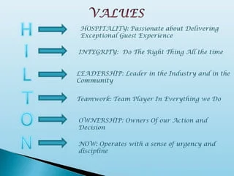
(Bora, 2015)

Appendix B
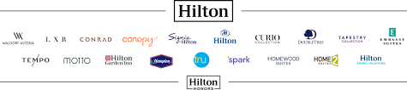

Appendix C

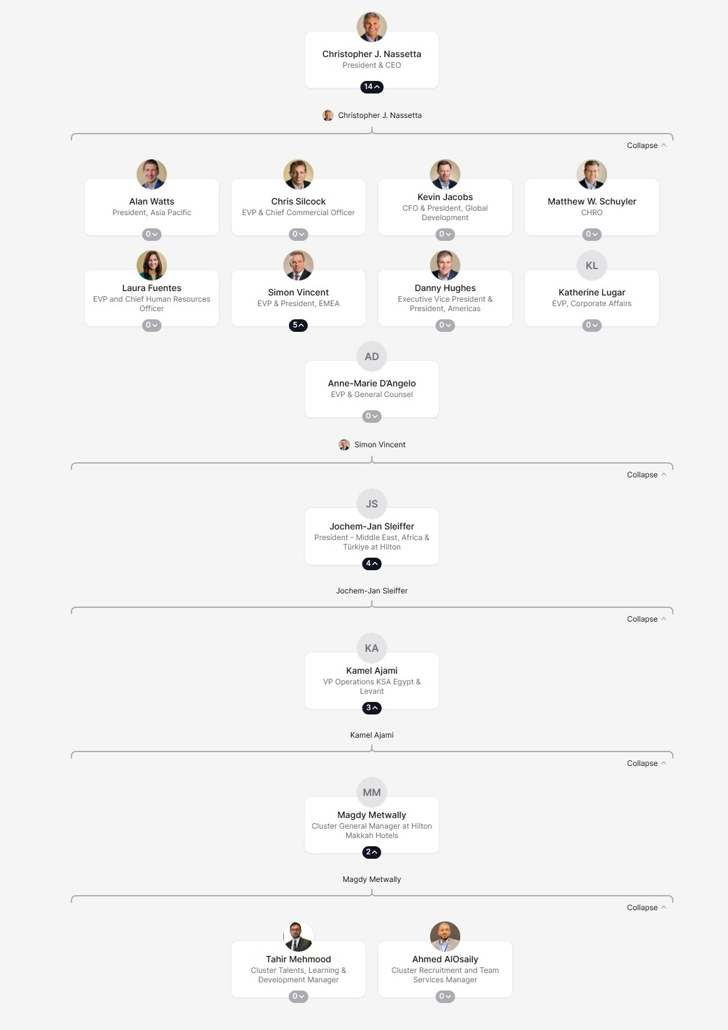

Appendix D
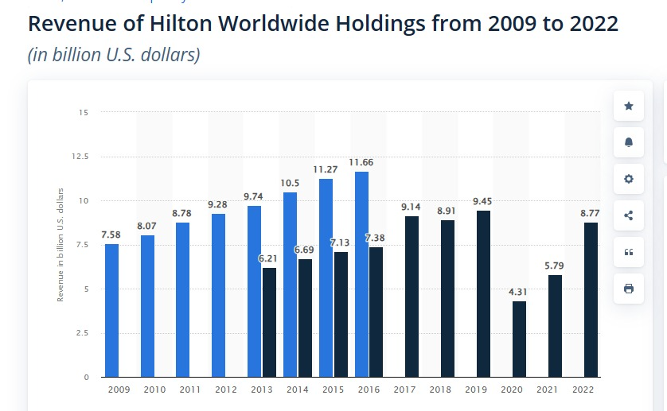
(Statista, 2023)

