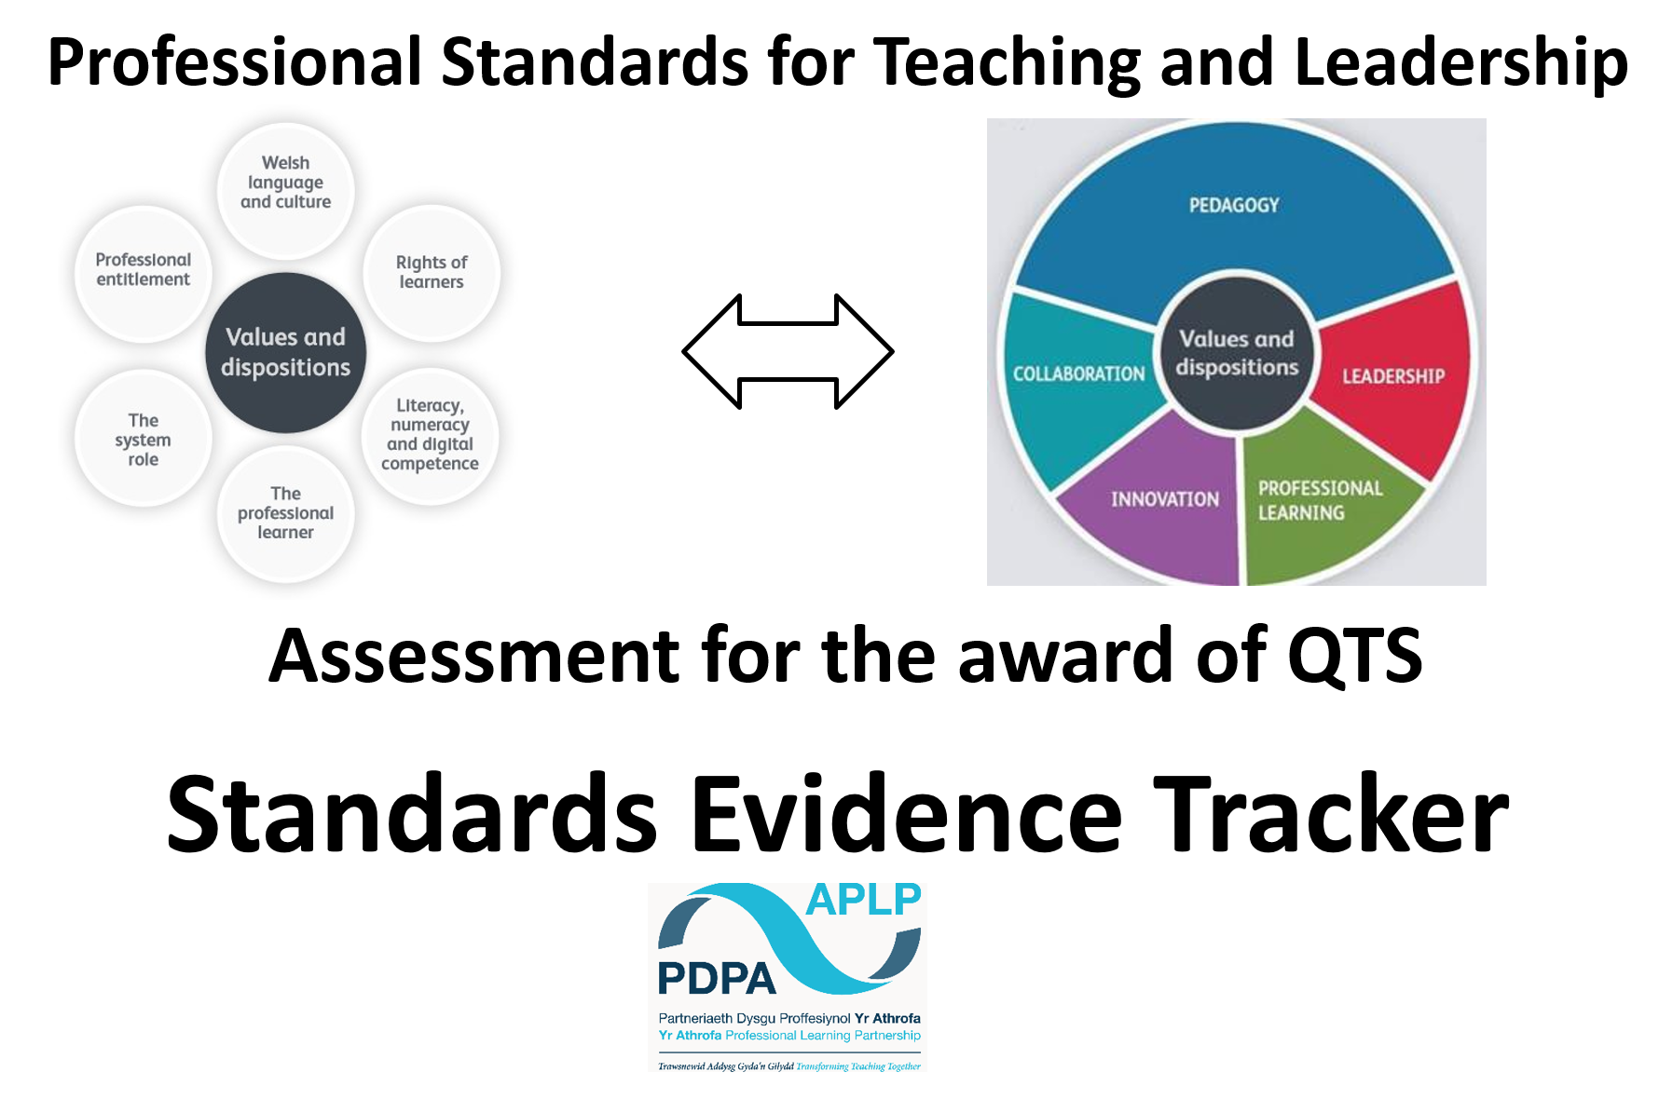

Pedagogy: Refining | On track Descriptor | Experience/Rationale | Literature Links | Evidence
Managing the learning environment | The student-teacher understands the importance and demonstrates the effective establishment and on- going management of the learning environment, in promoting positive learning habits and behaviours that meet the four purposes and are understood by learners in that context.
Assessment | The range of purposes and practices for assessment is understood and articulated.
Differentiation | The student-teacher demonstrates knowledge, understanding and experience of high expectations and effective practice in meeting the needs of all learners, whatever their different needs.
Recording and reporting | The student-teacher produces appropriate, timely and accurate records and reports and gives feedback to facilitate a deeper  understanding of learning and enhance the learning experience.
Involving partners in learning | The importance of positive parent/carer involvement is understood and opportunities are taken to observe and evaluate processes.

Pedagogy: Advancing | On track Descriptor | Experience/Rationale | Literature Links | Evidence
Exploiting subject disciplines in areas of learning | The student-teacher demonstrates a knowledge and understanding of relevant pedagogies and disciplines within and across subject content, areas of learning and cross-curricular themes, and  plans appropriately.
Four purposes for learners | The student-teacher demonstrates a knowledge and understanding of the needs of all learners in planning, preparation and teaching, ensuring that the four purposes are the drivers for learners’  Experiences.
Blended learning experiences | The student-teacher understands the selection, use and justification of a range of imaginative approaches to meet pedagogic challenges to the benefit of all  Learners.
Real life, authentic contexts | The student-teacher demonstrates an understanding of the use of real life, authentic contexts for learning being provided as a natural part of the learning experience. This extends the learner’s cultural, linguistic, religious and socio- economic experience and illustrates applications of concepts and  abstracts in practice.
Progression in learning | The student-teacher demonstrates an understanding of how learning develops incrementally and tangentially, building on prior experience and learning, and plans for progress in learning based on this.
Cross- curricular themes | The student-teacher knows, understands and engages with the principles of curriculum design and innovation, with development of cross-curricular themes relevant to areas of learning and justifies decisions.
Pedagogy: Influencing | On track Descriptor | Experience/Rationale | Literature Links | Evidence
Challenge and expectations | The student-teacher provides appropriate levels of challenge and expectations for the range of student abilities and characteristics, motivating learners to achieve.
Listening to learners | The student-teacher demonstrates a willingness to seek, listen to and take account of the views of learners in order to engage and  encourage them as active participants in their own learning.
Learners leading learning | In planning and delivery, the student-teacher demonstrates an awareness of the importance of encouraging learners to reflect upon their own learning.
Sustained effort and resilience in  learners | The student-teacher promotes and secures learners’ self-motivation and self-direction in their learning.
Reflection on Learning | In planning, the student-teacher demonstrates awareness of the importance of encouraging learners’ reflection around  behaviours and outlooks for learning.
Learning outcomes and well- being | The student-teacher raises awareness of how high-quality learning experiences and performance outcomes lead to  improved learning and a heightened sense of well-being.

Collaboration | On track Descriptor | Experience/Rationale | Literature Links | Evidence
Seeking advice and support | The student- teacher actively seeks and engages with support from a range of formal and informal sources. This includes observation and team teaching, whilst demonstrating increasing levels of independence.
Working with in-school colleagues | Organised and constructive work with a range of colleagues to enhance learners’ experience is a consistent feature of the student- teacher’s practice. Reflection on developing expertise is structured as a personal or a collaborative  process, as appropriate.
Supporting and developing others | The student-teacher develops high quality relationships with colleagues in order to have a positive impact upon learners’ experiences within  the school.
Enabling improvement | There are examples of improvement in outcomes for learners following the student-  teacher’s seeking and adoption of advice.

Professional Learning | On track Descriptor | Experience/Rationale | Literature Links | Evidence
Wider reading and research findings | The student- teacher demonstrates an increasingly confident understanding of the theories and research about assessment, pedagogy, human development and learning relevant to planning and day-to-day practice.
Professional networks and communities | The student-teacher engages in small scale action research, alone or in collaboration with peers, to examine learning in depth and tease out implications for practice.
Continuing professional learning | The Professional Learning Passport influences the ongoing learning of the student-teacher and is developmental in prompting further professional growth.
Welsh Language Skills | There is a commitment to incremental development of personal skills in the use of the Welsh language.

Leadership | On track Descriptor | Experience/Rationale | Literature Links | Evidence
Taking responsibility for self | The student-teacher demonstrates professional attitudes and behaviours, developing positive relationships with learners and colleagues, which illustrate a personal commitment to the fundamental principles of equity and of maximising the potential of  all learners.
Exercising corporate responsibility | Contractual, pastoral, legal and professional responsibilities are known and understood by the student-teacher.
Leading colleagues, projects and programmes | The student-teacher’s understanding of, and commitment to, leading learning is demonstrated through collaborative placement experiences.
Supporting formal leadership roles | The student-teacher demonstrates an understanding of the nature of responsibilities within and across teams and of the contributions individuals make towards the successful fulfilment of the school’s vision.

Innovation | On track Descriptor | Experience/Rationale | Literature Links | Evidence
Offering expertise | The student-teacher models an increasing repertoire of teaching techniques, as expertise emerges and flourishes, in order to inform and enhance the development of  Others.
Developing new techniques | Research on cognitive, social, emotional and physical development has a positive impact upon pedagogy. The student- teacher can demonstrate how professional discernment and critical analysis are brought to bear in shaping developing practice.
Evaluating the impact of changes in practice | The student-teacher actively seeks support and advice from colleagues in developing innovative approaches within the classroom so that their impact can be evaluated, analysed and shared.

