

BMHP6021_BIRM Health, Wellbeing, and Sustainable Development
Dr Robert Nartowski
Ruhela begum 1714385

Table of Contents
Introduction 3
The Sustainable Goals and UK strategies 4
Progress of UK in Goal implementation 8
Impact of goals on health and Well-being, UK 11
Important challenges in implementing these goals 12
Recommendations for improvement to current strategies 15
Conclusion 16
References 17

Introduction
Health and well-being for all individuals are universal rights, which, along with literacy, are unquestionably our strongest civilisation instrument for constructing a permanent peaceful, inclusive, and just development. Sustainable development is the judicious use of resources ensuring that the present use does not compromise the need of the future generation (Tang, 2009). The United Nations Sustainable Development Goals Report 2017 recently examined the advances achieved toward SDG 17 goals, stressing both the gains and problems that remain to be completed to meet the agenda. This report successfully brings to vision these developmental goals and strategies projecting its prime focus on SDG 3, SDG 11, and SDG 17 and their impact on health and wellbeing. It also narrates the challenges faced in their implementation.

The Sustainable Goals and UK strategies
Historic progress has been made in combating diseases including HIV/AIDS, TB, and malaria since the inception of the Millennium Development Goals. New HIV infections have decreased from 3.1 close to 2 million annually, and more than 6.2 million lives have been saved as a result of malaria prevention over the past 15 years. Preventable child fatalities have decreased by more than half since 1990, and maternal mortality has decreased by almost as much (45%) (Walker, Pekmezovic and Walker, 2019).
In addition to a lack of resources, chronic and catastrophic illness continues to be a major contributor to families falling into poverty. The global burden on human health caused by NCDs is substantial (Sivakumar and Rajan, 2013). Noncommunicable diseases (NCDs) are currently responsible for 63% of all deaths worldwide. These diseases include cancer, cardiovascular disease, chronic respiratory disease, and diabetes. It is projected that by 2025, the combined costs of these four diseases will cost poor and middle-income countries more than US$ 7 trillion. Furthermore, there is ongoing underfunding in the social and environmental elements that influence health.
The successor of the MDG, the SDGs (Sustainable Development Goals), aims to end the inequalities that contribute to poor health and developmental outcomes, and they give an ambitious, all-encompassing action plan for people, the planet, and prosperity (Sachs, 2017).
Sustainable Development Goals 3
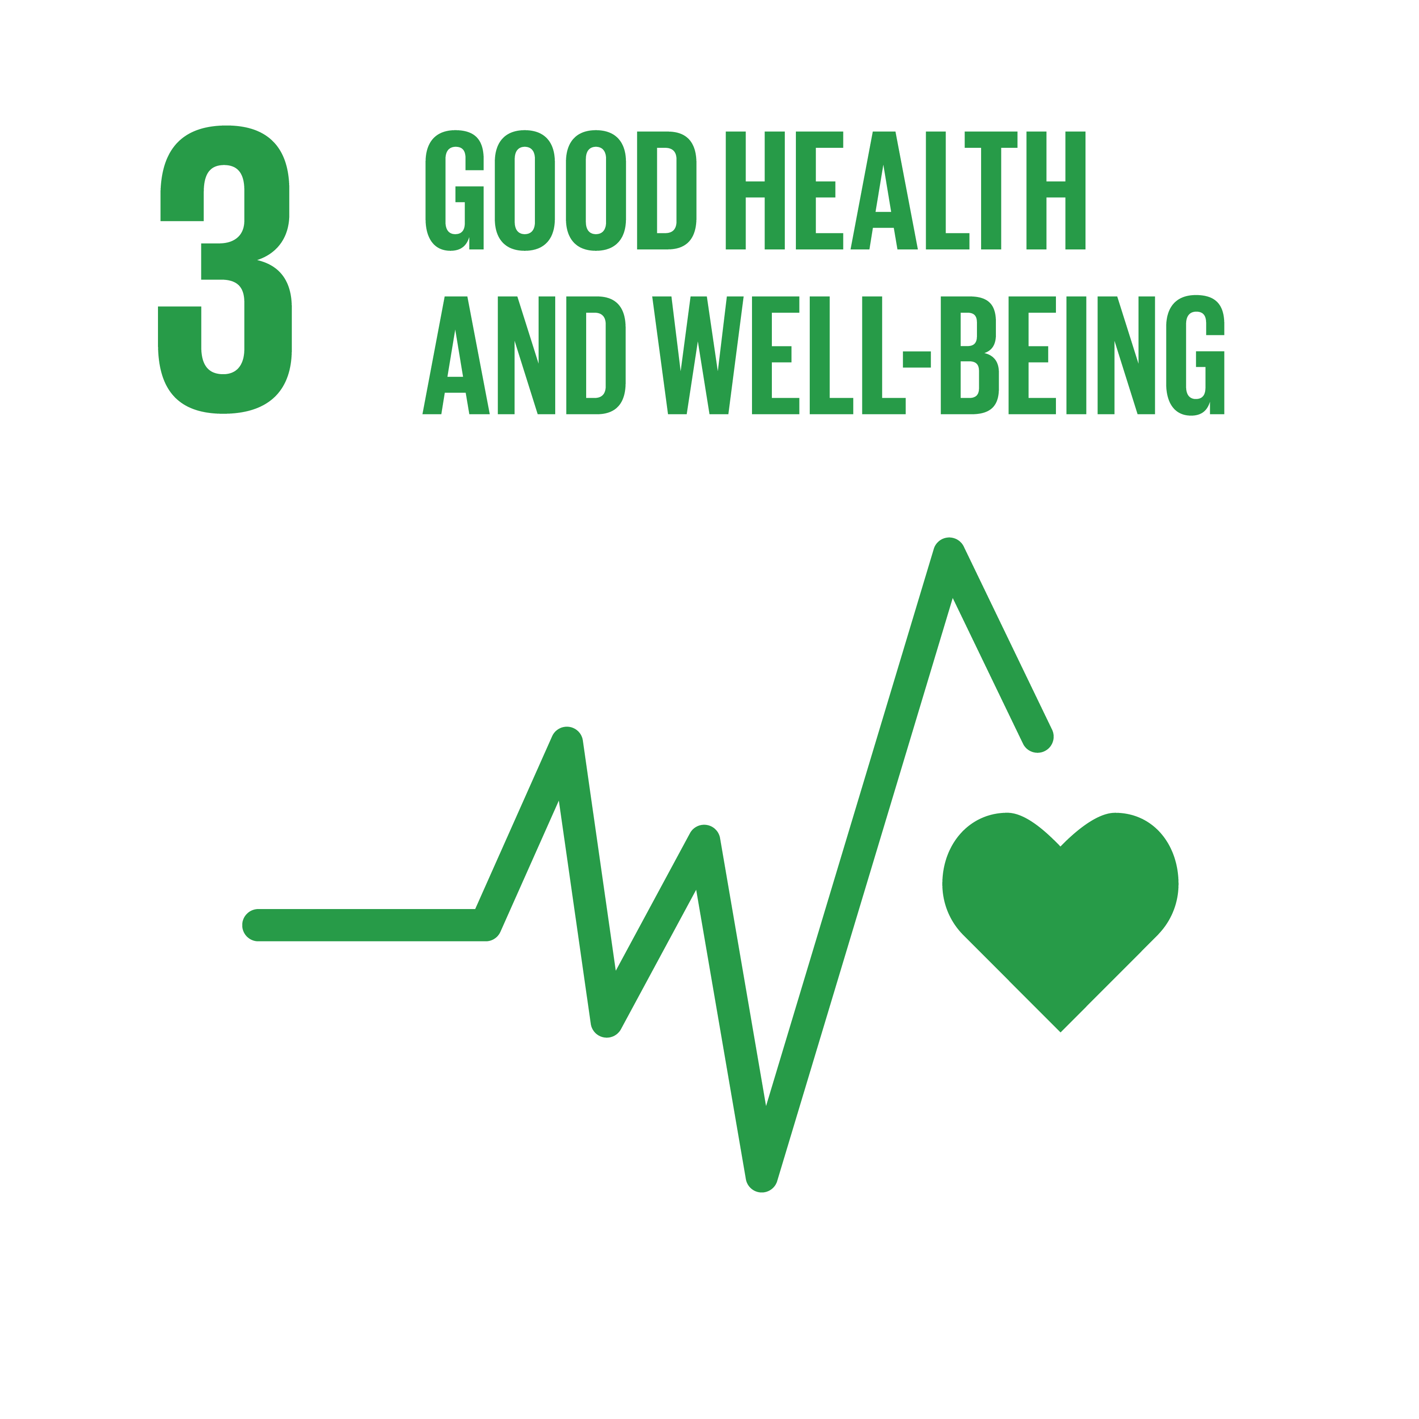
As part of SDG 3, ensuring health and well-being for everyone, there is a strong commitment to ending the AIDS, malaria, tuberculosis, and, other transmittable disease epidemics by 2030. It also seeks to give everyone access to high-quality, cost-effective medical care and preventative measures like immunizations. Increasing access to inexpensive medicines and funding vaccine R&D are both crucial steps in this direction.
Targets: One of the 17 Global Targets that comprise the 2030 Agenda for Sustainable Development is "health and well-being." For the sake of achieving the many objectives at hand, a unified strategy is essential (Nhamo, Togo and Dube, 2015).
Significance: Achieving sustainable development requires prioritising people's health and happiness at every stage of life. The recent COVID-19 is causing widespread human suffering, disrupting the global economy, and changing the lives of billions of people all over the world; it is the world's worst health disaster in modern history.
Before the pandemic, significant strides were achieved to improve the health of the general population. Improvements in healthcare have led to longer life expectancies and lower rates of maternal and child mortality (Le Blanc, 2015). However, more work is required to eradicate numerous diseases and treat many distinct recurrent and rising health challenges. Millions of lives can be saved with better health care infrastructure, cleaner water and better sanitation, and easier access to medical professionals.
Sustainable Development Goals 11
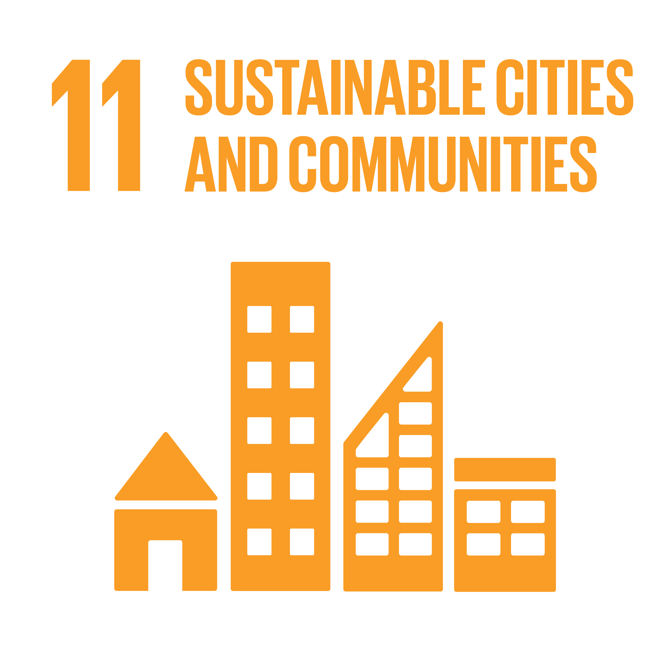
SDG 11 (also known as Global Goal 11) is one of the 17 Sustainable Development Goals adopted in 2015 by the United Nations General Assembly. Its official title is "sustainable cities and communities." Making cities that are "inclusive, safe, resilient, and sustainable" is the stated goal of SDG 11.
Significance: Specifically, sustainable cities and communities are based on four pillars i.e Sustainable Communities are well-kept and energy-efficient, making them environmentally friendly. It focuses on improving the quality of air and municipal as well as other waste management to lower cities' negative per capita environmental effects by the year 2030.
Targets: SDG11 targets to improve road safety, especially through the expansion of public transportation, paying particular attention to the requirements of vulnerable groups like women, children, people with disabilities, and the elderly by the year 2030 and making transportation systems available to everyone at a reasonable price (Landon, 2007).
Sustainable Development Goals 17
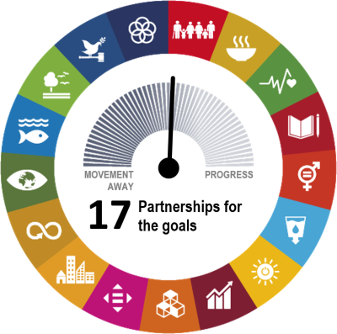
As a global, regional, national, or even local organisation, these integrated partnerships based on ideas, values, and common goals that put people and the earth at the centre are needed. Goal 17 of the Sustainable Development Goals asks for worldwide cooperation to promote sustainable development (Kumagai and Partidario, 2018). This objective emphasises the significance of macroeconomic stability on a worldwide scale and the necessity of securing financial means for developing nations from international sources, in addition to enhancing domestic capabilities for revenue generation.
Significance: To achieve its aims SDG11 need to work with governments, businesses, and non-profit organisations. Having a common aim gives it the capacity to do everything it puts our minds to. To have a vision is to share a set of goals. "We all have lofty goals, such as eradicating poverty, reducing inequality, and halting global warming", as per SDG11.
Partnership: The SDGs can only be achieved via collaboration between the public and corporate sectors, as well as civil society and other organisations. The 2030 Agenda for Sustainable Development can be implemented in underdeveloped nations using public and private, local and international resources from the EU and other wealthy economies (Khan and Hussain, 2021).
Targets: The goal comprises 17 milestones that need to be accomplished by the year 2030, and they are separated into the following categories: trade, capacity building, finance, technology, and technology. The 25 indicators will be used to evaluate how far progress had been made.
The UK'S strategy to achieve SDG
It was in 2015 that the UK government, together with other UN member nations, vowed to achieve the SDGs. Data on UK's progress toward the Sustainable Development Goals (SDGs) is monitored and reported on by the ONS, the country's official statistical institute (Jindal and Vatta, 2018).
In the UK, every department has implemented the Sustainable Development Goals (SDGs) into its outcome delivery strategic planning. Monitoring progress toward these goals requires that appropriate data and statistics be available from the ONS.
UK's net zero emissions
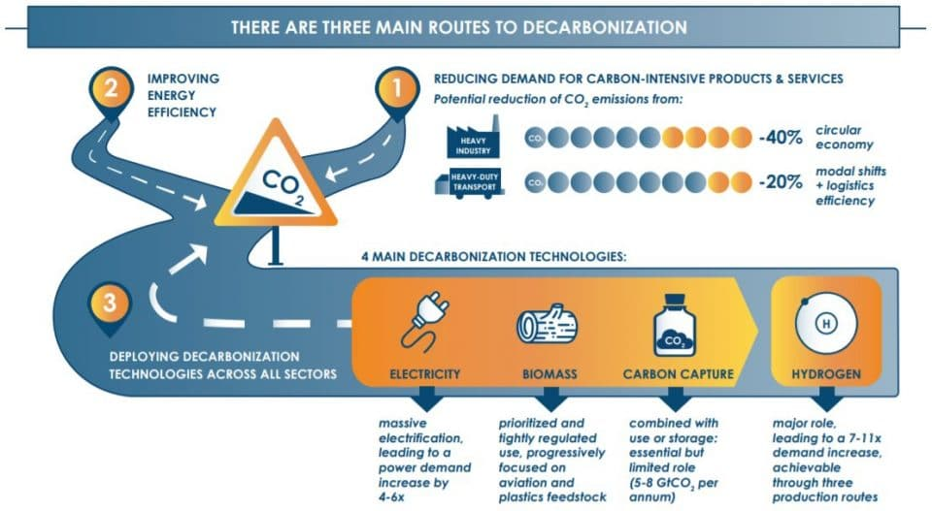
In the run-up to the United Nations Climate Conference (COP26) in Glasgow in November 2021, environmental issues will be increasingly on the minds of decision-makers and the general public. Build Back Greener: The UK Government's Net Zero Strategy was released recently. Policy and initiatives in this strategy can have a beneficial influence on the UK's global SDG contribution, according to recent data.
In short, as a part of the UK government's Net Zero Strategy, all aspects of the UK economy — from transportation to agriculture — are targeted for decarbonization and reduction of climate-damaging emissions (James, Nadarajah, Haive and Stead, 2015).
ONS data is used to measure progress toward the Sustainable Development Goals for renewable energy and energy efficiency and climate action. ONS also unveiled a new UK climate change data portal, making a larger spectrum of data and insights on climatic changes more approachable.
Green Finance Strategy
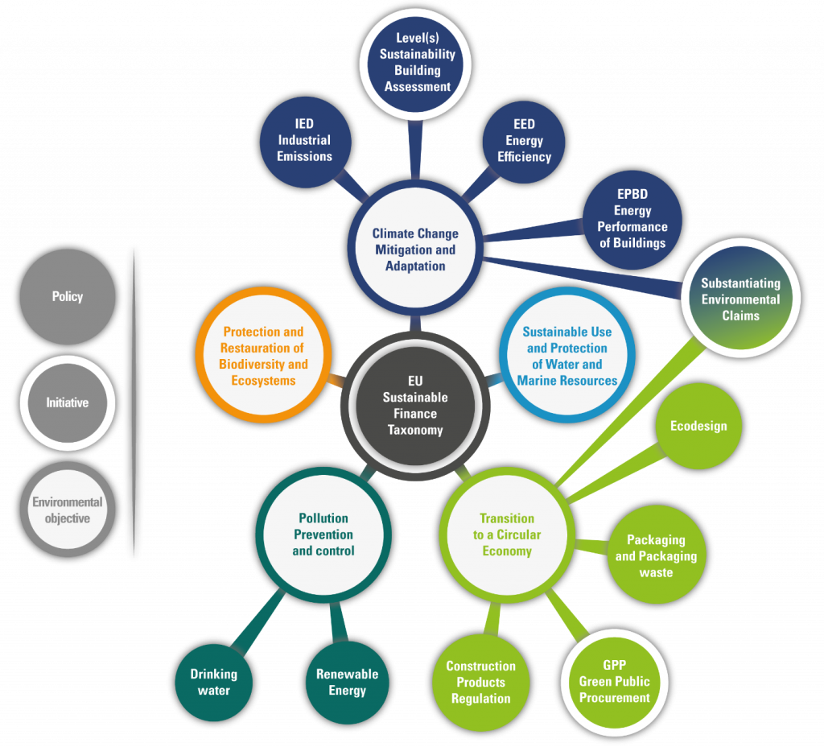
The Green Financing Strategy for 2019 laid forth a detailed strategy for greening financial systems, organizing finance for clean and sustainable growth, and seizing the opportunities that resulted for the United Kingdom as a result of these activities (Halisçelik and Soytas, 2019).
During this round of consultation, the government wants the opinions and evidence of many stakeholders so that it may better design an update to the Green Finance Strategy, which is scheduled for release in the latter portion of 2022.
The revised Green Finance Strategy must take stock of efforts so far and outline how the sector of finance can better support the UK's energy supplies, climate, and environmental goals.

Progress of UK in Goal implementation
Towards Net Zero Emissions
The United Kingdom is the first large country to formally support a goal to reduce carbon emissions to virtually zero in a little more than 30 years. According to the assessment of one authority on climate change, the plan, in addition to removing potentially hazardous emissions from the atmosphere, will also have unexpected knock-on implications for the general population (Cropper, 2007).
The commitments to halt sales of new automobiles powered by fossil fuels by the year 2030 and sales of gas boilers by the year 2035 were included in the net zero plan when it was unveiled in October.
Human activity is the primary source of carbon emissions. The use of electricity for home and office heating. Then there's the transportation and the combustion of gasoline and diesel that occurs when people take a train, fly, or ship their purchases. Industrial operations such as steel manufacturing generate carbon dioxide emissions. (Corbin et al., 2021) Carbon emissions will either be eliminated by 2050 or the government will have the authority to eliminate them from its environment, known as "carbon offsetting," by that time.
However, the question is how the UK implement its aimed at,
Becoming carbon zero.
There are currently non-carbon emission alternatives available to the general population. The use of zero-carbon energy sources like wind and solar power and electric public transportation, such as trains and trams, reduces the number of pollutants emitted into the environment (Chen and Cooper, 2014).
As a result of the enormous amount of energy required in the production process, the industry will be the hardest to break. The quest for ways to reduce these levels at the source continues, but in the meanwhile, nature is offering some of the answers.
In the UK, we're focusing on forestry land use modification, increasing tree planting, and environmental protection. According to the climate change committee, need to plant more trees; roughly 25% of the area should be covered in trees by the year 2050. Even if all of our emissions were absorbed, it would still not be enough. It's also being encouraged that large corporations cut the number of fossil fuels they use and switch to alternative energy sources in the meantime (Apostolopoulos et al., 2013). Another method of capturing carbon is carbon sequestration. More than 90 per cent of the waste carbon generated by large enterprises and power plants is collected and stored in a secure location before it can be released into the environment.
Reducing the amount of aviation pollution
Using biofuels for longer journeys will reduce emissions much further, while a new method of getting to Europe would reduce emissions even more.
High-speed rail would be an ideal way to improve communication across Europe. If people want to travel to Australia, they'll have to resort to biofuel, which can be created to the same quality as the gasoline that we currently use.
A healthier road system
Light-duty vehicles like automobiles and vans can be electrified, but a better infrastructure is needed. This includes better trains with more riders so fewer automobiles are needed. More bike lanes would cut commute times (Walker, Pekmezovic and Walker, 2019). Cycling is faster and more effective than driving in the city. Some European countries ban vehicles to boost bike use.
Larger vehicles like lorries and tankers could use hydrogen-based fuels. The UK might follow Germany's model of using overhead electric cables on the autobahn to power larger vehicles, such as buses, instead of their battery. The relocation will reduce congestion. It'll be cleaner and quieter. The NHS will benefit from healthier, more active people.
Towards Green Finance Strategy
An initial strategy for Green Finance found that leveraging private capital to support UK climate and environmental goals may be achieved by judicious use of public funding, lengthy regulatory policies, and signalling (Tang, 2009).
According to government policy, natural capital-based results need more private investment. Investing in natural capital can provide carbon capture, biodiversity, water management, and flood risk reduction. According to the UK government's Spending Review for 2021, private investment in nature recovery should equal £500 million by 2027 and $1 billion by 2030. The UK's Natural Environment Agency has started this.
A £10 million Investment Readiness Fund (NEIRF) helps English environmental projects attract private finance (Sivakumar and Rajan, 2013). The Big Nature Impact Fund, a public-private blended finance vehicle, will be created to leverage private money into new natural financial markets and ecological processes.
However, with this regard, Toward a greener financial sector, the Government published Greening Finance: A Roadmap to Sustainable Investing in October 2021.
Phase 1 - informing consumers and investors
One of the primary goals of this phase is to educate investors and consumers about environmental sustainability and to ensure that corporations and financial market players have access to decision-useful details on this topic.
Phase 2- Action on information reception
Making it mandatory for companies to incorporate sustainability data into their business and financial choices, such as in risk management or investor responsibility (Sachs, 2017).
Phase 3- Transitioning financial flows
Ensuring that economic-financial flows correspond with the UK's net zero objective, climate change adaptation needs and broader environmental aims are the third and final phases.
The financial sector faces both clear threats and opportunities as a result of climate change and natural resource depletion. To mitigate risks, resolve market flaws, and safeguard the interests of consumers, the United Kingdom's government aims to maximise prospects while also helping the country's financial sector preserve and enhance its worldwide recognition as a green finance leader.
These strategies expand on that approach to ensure that the UK remains on track to meet the Nationally Determined Contribution for 2030.

Impact of goals on health and Well-being, UK
The United Nations Sustainable Development Objectives Report 2017 recently assessed the progress made towards these 17 goals, stressing both the gains and obstacles that are yet to be achieved to reach the agenda. Let us unveil its impacts on health and Well-being among the UK population and sector (Nhamo, Togo and Dube, 2015).
SDG 3 - Too far, remarkable progress has been made on SDG 3 in the fight against HIV/AIDS and tuberculosis, as well as poverty reduction and access to clean drinking water for marginalised populations. There are three Sustainable Development Goals (SDGs), and the overarching goal of all of them is to improve the well-being of people who live in nations. This is done to reduce the immense amount of suffering that is caused by diseases and deaths that might have been averted. This aim was decided upon so that the Sustainable Development Goals may be completed by its target year of 2030. Some of these areas include those with the greatest incidence of disease as well as those that have been disregarded in the past. To accomplish Goal 3, it will be required to increase the amount of money invested in research and development, health care funding, screening, and the treatment of health disorders (Le Blanc, 2015). The promotion of healthy pregnancies and the provision of universal immunization coverage for children are the two key focuses of UNICEF's efforts directed toward the accomplishment of Goal 3. In addition to this, UNICEF has a responsibility to monitor other indicators that are associated with universal health coverage.
SDG17 - Goal 17 aspires to resurrect the worldwide partnership for sustainable development to strengthen support for the conclusions. As a unifying factor that maintains the Framework of the course, partnerships are critical to the effective implementation of the Sustainable Development Goals (SDGs). When it comes time to accomplish Goal 17, it is essential to expand and strengthen ties with a broad variety of stakeholders. Goal 17's goals reflect one of the most effective approaches to improving the lives of children throughout the world. Examples of this purpose include whether or not appropriate data exists to identify youngsters most in danger of falling behind in their academics. In 2018, more nations implemented national statistical plans, even though many territories required the funding to do so; in fact, just 23% of proposals in Sub-Saharan Africa were completely financed. UNICEF has concentrated on measures that have the greatest impact on children as part of the global SDG monitoring framework (Landon, 2007). Although all Sustainable Development Goals are required for attaining children's rights, this is not the case. Despite a significant boost in information covering between 2018 and 2019, an aggregate of 75% of all child-related 17 SDGs are either lacking data or making poor progress toward attaining global targets by 2030. That remains true, although growth in the amount of data available for these metrics between 2018 and 2019.

Important challenges in implementing these goals
By putting sustainable development objectives into practice, some of the world's most pressing problems, including environmental issues and the restriction of women's rights, may be resolved. According to Secretary of State John Kerry, no plans have been made for a national strategy to achieve the objectives. The government aspires to help achieve the Sustainable Development Goals by focusing on electoral campaign promises (SDGs). American policymakers think that the SDGs offer a good foundation for government legislation and a fresh perspective on the difficulties they must overcome. The SDGs are pushed into existing targets, but the UK seems willing to dismiss any parts that don't fit, no matter how significant they may be (Kumagai and Partidario, 2018). These are the UK's priorities, ignoring the fact that not all of them are crucial.
Governments are being held accountable for their global commitments in part because civil society actors are actively involved in monitoring and reporting on the condition of the SDG implementation. In addition, they contribute to the implementation of the 2030 Agenda via several other programs. There is a focus on SDGs in particular, with a special emphasis on decreasing poverty (SDG1), eliminating hunger, reaching gender equality (SDG5), providing adequate jobs and economic growth, and combatting climate change (SDG13). International Co-operative Alliance (link goes to an external website) has developed a website dedicated to the sharing of successful strategies for putting the 2030 Agenda into action (link goes to an external website) (Khan and Hussain, 2021). Indonesian, Mongolian, and Cambodian panellists discussed the lessons they'd learned through their VNR involvement. As part of Mongolia's VNR process, the Prime Minister decided to form a Sustainable Development Goals Committee that would include representatives from all sectors of the country's economy. These new SDG institutions and alliances were activated in response to this and a few of these CSOs have requested that it continue.
Systemic barriers
Several speakers observed that despite the progress achieved, none of the socially sustainable development goals will be accomplished by 2030 collectively and that there may even be a regression concerning key targets (Jindal and Vatta, 2018). As part of the process of brainstorming, participants highlighted several systemic impediments, including an absence of a democratic will, a lack of technical know-how and the inability to detect and access potential financial resources. The absence of data, political will, capability, and technological know-how are only a few examples of the many systemic obstacles that need to be overcome.
Overpopulation
The United Kingdom is already regarded to be one of the nations in the world that have lost most of its natural resources; therefore, unchecked population expansion poses a genuine threat to the surviving ecosystems as well as to the health and well-being of humans. The United Kingdom's population is projected to reach 70 million by the year 2031, according to the most recent data from the Office of National Statistics (ONS), which puts the current estimate at 66.7 million people (James, Nadarajah, Haive and Stead, 2015). Despite having a relatively modest amount of land, the United Kingdom is projected to have the highest population density in all of Europe by the year 2050. Increases in the world's population put increasing strain on the planet's resources, such as water, forest and land use and the atmosphere, which in turn contributes to global warming and poses a threat to environmental sustainability.
Natural disasters
Natural calamities such as earthquakes, tremors, and flooding can be a threat to sustainability since they have the potential to alter the water flow and potentially inflict damage to infrastructure. Furthermore, they can disrupt arable land or habitable land, which both pose problems for human habitation and sustainability.
Global warming
As a result of global warming, attention has been drawn around the world. Increasing sea levels and land subsidence pose a direct threat to humanity's living environment and social and economic growth because of the effects of climate change (Halisçelik and Soytas, 2019). Adaptation and mitigation efforts must be frenetic to prevent the secondary consequences of climate change, such as global warming, skin infections, floods, drought, and other severe weather occurrences. One particularly urgent example of climate change is caused by industrialised countries (including the United Kingdom, which is considered the "birthplace" of the Industrial Revolution), which will cause millions of people to be compelled to move from their homes and become "climate refugees."
Inequality
On multiple fronts, inequalities can make the achievement of sustainable development more difficult to achieve and accelerate the destruction of the natural environment. Variations in consumption habits, power, and capabilities between governments can harm the overall health of the country at the global level (Cropper, 2007). If there is disparity, then the Sustainable Development Goals (SDGs) will be impossible to achieve. Inequality has a profound impact on many aspects of life, including the quality of life, access to essential resources (such as food, health care, and education), and one's income. The inequity, in the end, results in poverty as well as social upheaval.

Recommendations for improvement to current strategies
Today, action to fulfil the Goals is not yet progressing at the appropriate speed or scale, although there is progress being made in many different locations. To accomplish the Goals by 2030, the year 2020 must mark the beginning of a generation of ambitious action. Health care policy and practice must be built on evidence-based collaborations to address health disparities and establish trusting, long-term solutions to guarantee everyone has access to good health and wellness (Corbin et al., 2021).
In both developing and developed countries, population growth can improve the labour market, but it can also increase inequities around the world, depending on the country's readiness. Some countries may benefit from increased urbanisation, population expansion, and the ageing of their populations, but these trends could also place a major strain on their national infrastructures, public finances, education systems, and healthcare facilities.
To address these issues on a worldwide scale and gain a position for sustainable development, programmes that stimulate changes in government administration, products and services delivery, job growth, global consumption patterns, and natural resource management must be advanced.
Continual efforts are being made by organisations to raise the quality of climate risk disclosure reports and expand their scope. When companies plan their growth strategies for the future and report their accomplishments, they should put climate risks and possibilities at the forefront of their thinking (Chen and Cooper, 2014).
There is a significant possibility that, by the year 2030, the Sustainable Development Goals (SDGs) in the area of health will be substantially closer to being fully attained if these initiatives, as well as centralised attempts for sustainable health financing and a dependable digital framework for health care, research, and analysis techniques, are implemented. We have high hopes that this report will serve as a solid foundation for pursuing these goals.

Conclusion
Personal well-being and advancement forward into sustainable development are closely linked. The study's findings demonstrate a positive trend toward bigger marginal returns on capital when it comes to overall well-being and environmental responsibility. Because of this separation, investigators have been able to examine the probable trade-offs between sustainable growth and enhancing the quality of life for everyone. Subjective well-being (SWB) was shown to be negatively correlated with both Objectives 12 and 13, in contradiction to the other purposes, which were found to be positively correlated (Apostolopoulos et al., 2013). When comparing SWB to the Environmental Protection Index, a positive correlation may be seen. Climate policy has a favourable relationship with SWB, independent of the method used to accomplish it. Many people's emotional health may be at risk, making it more difficult for the administration to take reasonable action in these sectors.

References
Apostolopoulos, N., Al-Dajani, H., Holt, D., Jones, P. and Newbery, R., 2013. Entrepreneurship and the sustainable development goals.
Bennett, C., 2008. Owning and implementing labour market research. Equal Opportunities International, 27(2), pp.181-198.
Bissessar, A., 2012. Problems in the implementation of government policies in the West Indies. Lewiston, N.Y.: Edwin Mellen Press.
Chen, P. and Cooper, C., 2014. Wellbeing: a Complete Reference Guide, Work and Wellbeing. Hoboken: Wiley-Blackwell [Imprint].
Corbin, J., Abdelaziz, F., Sørensen, K., Kökény, M. and Krech, R., 2021. Wellbeing as a policy framework for health promotion and sustainable development. Health Promotion International, 36(Supplement_1), pp.i64-i69.
Cropper, S., 2007. Community health and wellbeing. Bristol, UK: Policy Press.
Halisçelik, E. and Soytas, M., 2019. Sustainable development from millennium 2015 to Sustainable Development Goals 2030. Sustainable Development, 27(4), pp.545-572.
James, P., Nadarajah, Y., Haive, K. and Stead, V., 2015. Sustainable Communities, Sustainable Development.
Jindal, S. and Vatta, L., 2018. ICT : A Deed for Sustainable Development Goals. Journal of National Development, 31(1), pp.222-235.
Khan, S. and Hussain, I., 2021. Impact of safe drinking water and clean fuels on health and wellbeing in Pakistan: A spatial analysis. Groundwater for Sustainable Development, 15, p.100677.
Kumagai, Y. and Partidario, M., 2018. Lasting community wellbeing: Comparison of Lisbon and Tokyo. Sustainable Development, 27(1), pp.84-95.
Kuzma, J., 2010. Accessibility design issues with UK e-government sites. Government Information Quarterly, 27(2), pp.141-146.
Landon, M., 2007. Environment, Health and Sustainable Development. Maidenhead: McGraw-Hill International (UK) Ltd.
Le Blanc, D., 2015. Towards Integration at Last? The Sustainable Development Goals as a Network of Targets. Sustainable Development, 23(3), pp.176-187.
Nhamo, G., Togo, M. and Dube, K., 2015. Sustainable development goals for society.
Rendle, D., 2018. Overcoming barriers to implementing targeted worming strategies. UK-Vet Equine, 2(6), pp.168-173.
Sachs, J., 2017. The age of sustainable development.
Sivakumar, P. and Rajan, S., 2013. Sustainable development goals and migration.
Tang, Y., 2009. Psychological Wellbeing of Elderly Caregivers. Journal of Sustainable Development, 1(2).
Walker, J., Pekmezovic, A. and Walker, G., 2019. Sustainable Development Goals. Newark: John Wiley & Sons, Incorporated.

