Habitat management plan for peatlands at Blaenpedol, Brecon Beacons
Lucy Fairbrother
21 March 2023

Contents
1 Introduction 1
2 Site overview 2
3 Methodology 3
3.1 Summary 3
3.2 Desk-based study 3
3.3 Field visits 3
3.4 Limitations 3
4 Evaluation 4
4.1 Topography and land use 4
4.2 Peatland Code assessment 4
4.3 Historical interest 5
4.4 Access and safety 6
4.5 Peatland habitat 7
4.5.1 Overview 7
4.5.2 Vegetation and peat depth 9
4.5.3 Hydrology 10
4.6 General influences 11
5 Objectives 12
5.1 Summary 12
5.2 Prevent erosion 12
5.3 Restore hydrological function 12
5.4 Promote peat-forming vegetation 12
5.5 Enable long-term sustainable management 12
6 Actions 13
6.1 Summary 13
6.2 Surveying 13
6.3 Engage stakeholders 14
6.4 Restoration works 14
6.4.1 Hagg re-profiling 14
6.4.2 Hydrology action 15
6.5 Sustainable management 15
6.5.1 Burning 15
6.5.2 Grazing 15
6.5.3 Manual intervention 16
6.5.4 Vegetation diversity 16
6.6 Access provision 16
6.7 Monitoring and review 16
7 Conclusion 17
8 References 18

Tables and figures
Figure 2.1: Site location (Map source: Esri, 2023) 2
Figure 4.1: Nant Pedol (Photo: Fairbrother, 2023) 4
Figure 4.2: Peat assessment units under the Peatland Code (IUCN, 2022) 5
Figure 4.3: Assessment of peat depth 5
Figure 4.4: Old track (Photo: Fairbrother, 2023) 6
Figure 4.5: Site habitat and survey points 7
Figure 4.6: Survey point 6 in Area A (Photo: Fairbrother, 2023) 7
Figure 4.7: Survey point 2 in Area B (Photo: Fairbrother, 2023) 8
Figure 4.8: Survey point 15 in Area C (Photo: Fairbrother, 2023) 8
Figure 4.9: Vegetation coverage and peat depth at each survey point. a) Area A; b) Area B; c) Area C 9
Figure 4.10: Molinia at survey point 5 (Photo: Fairbrother, 2023) 10
Figure 4.11: Sphagnum moss in sedge-dominated bog at survey point 4 (Photo: Fairbrother, 2023) 10
Figure 4.12: Signs of burn damage on heather at survey point 8 (Photo: Fairbrother, 2023) 11
Table 1: Summary of actions and timescale 13

Introduction
Peatlands are wetland habitats where peat soils are formed from the decomposition of plant materials in anaerobic conditions created by waterlogging (Thom et al., 2019). Peatlands can provide a range of ecosystem goods and services, including nutrition (for both humans and livestock), materials, water purification, flood mitigation through runoff attenuation (Goudarzi et al., 2021), climate regulation, and wildfire control (Bonn et al., 2016). Peat soils are Wales’s biggest terrestrial carbon store, holding an estimated 157 million tonnes of carbon (Welsh Government, 2015).
Functioning peatlands remove CO₂ from the atmosphere by accumulating dead organic material (Evans and Warburton, 2010). However, CO₂ and other greenhouse gases (GHG), such as CH₄ and N₂O, are emitted by peat oxidation in degraded peatlands (Leifeld and Menichetti, 2018). In addition, where peatlands are unable to perform their usual function of water storage, other ecosystems services such as drinking water can be affected and flood risk exacerbated.
There are multi-layered peatland programmes and policies at a national and devolved level in the UK, including the National Peatland Action Programme (NPAP), a 5 year plan for peatland restoration in Wales. The restoration of peatland is a key part of meeting net zero targets, and the Welsh Government’s has ambitious plans to restore 45,000ha of peatland by 2050, at a rate of 1,800ha per year (Welsh Government, 2022).
The goal of peatland restoration is to re-establish natural peat-formation function, with the associated benefits to climate mitigation and resilience, biodiversity (Minayeva, Bragg and Sirin, 2016) and other ecosystem services. Management should be focused on ensuring that the habitat is stable in the long-term and meets the needs of the local community, with any pressures on the site kept under control as sustainably as possible.

Site overview
The subject of this management plan is a 59ha site located at Blaenpedol, in BBNP (Figure 2.1). The site is within Mynydd Du Special Site of Scientific Interest (SSSI) and the land is owned and managed by the Brecon Beacons National Park Authority (BBNPA). The site has been identified as an area of blanket bog with deep peat soils, at an estimated average depth of 100cm (Natural Resources Wales (NRW), 2022a).
Figure 2.1: Site location (Map source: Esri, 2023)
The site stores an estimated 100-200 kg/m² of carbon, with an average emissions factor of 4-5.6 tCO₂e/ha/year (NRW, 2022a). These estimations are not uniform throughout the site, with the emissions factor in actively eroding areas (23.84 tCO₂e/ha/year) significantly higher than areas of drained (4.54 tCO₂e/ha/year) or modified bog (2.54 tCO₂e/ha/year) (IUCN, 2022).
A field survey of wildlife fauna was not conducted. However, there are recent records of several Category 1 priority species, including Lagopus lagopus (Red Grouse), Pluvialis apricaria (Golden Plover) and Ceramica pisi (Broom Moth) (LERC, 2023).

Methodology

Summary
A desk-based survey and two field surveys, carried out in February and March 2023, were carried out to assess the condition of the peatland, evaluate management options and provide baseline information.
Using standardised methodologies is important when managing peatlands, in order to enable monitoring, meet funding-body requirements and add to wider knowledge. The BBNPA does not currently have a set methodology for assessing peatland for restoration work (Sam Ridge, BBNPA, 2023, personal communication). A habitat and vegetation methodology for NPAP is in draft form (Jones, 2022) and was followed wherever practicable.

Desk-based study
A desk-based survey was conducted of the site, using:
- Unified Peat Map of Wales (NRW, 2019);
- NRW Phase 1 Survey (NRW, 2022b);
- NRW Flood Risk Map (NRW, 2015);
- Aerial photography of the site, 2017-2021.

Field visits
A walk-over assessment was conducted of the whole site to validate the major elements of topography mapped during the desk-based stage.
Based on aerial photography, sample points were chosen to be representative of the range of vegetation types in the survey area. Coverage of indicator bog vegetation (Calluna vulgaris (heather), Molinia caerulea, sedges, grass other than Molinia, Sphagnum sp. and Eriophorum sp.) was sampled in 10x10m quadrats and the mean depth of peat calculated by three samples at each survey point, using depth rods (Jones, 2022).

Limitations
Field surveys were conducted out of the fruiting season for peatland vegetation. Some indicator vegetation was not identified to species level and some species may have been present but not recorded.
The site’s hydrology was not surveyed except for a visual assessment of surface water. Both surveys were conducted during rainy weather. Natural England (2022) recommends a one-year baseline to allow for seasonable variability in meteorological conditions and vegetation.

Evaluation

Topography and land use
The site slopes down south-westerly from the small pool Llyn y Fignenfelen, with the stream Nant Pedol running through the centre (Figure 4.1). It sits in a gentle and gradually steepening valley on a bedrock of Twrch Sandstone.
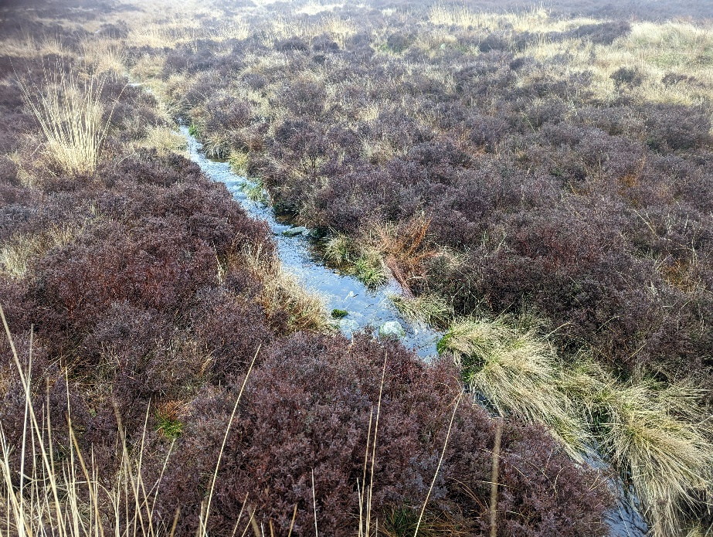
Figure 4.1: Nant Pedol (Photo: Fairbrother, 2023)
The immediate area’s land use is predominantly rough sheep grazing and occasional recreational use as a walking area, towards the historically-significant site at Carn Pen-y-Clogau.
The climate is cool and wet, with average monthly rainfall during the rainiest months (October to March) being approximately 210mm (Welsh Government, 2021).

Peatland Code assessment
Under the Peatland Code, restoration works focus on areas that are classified as “actively eroding” or “drained”, as these are assumed to release the most GHG (Evans et al., 2017). The site includes an estimated total of 1,811m of haggs. Actively eroding areas were therefore calculated by multiplying the length by 2m (IUCN, 2022), giving a total of 0.36ha (Figure 4.2). Drained areas were mapped as being in a 30m radius from the haggs, giving a total of 5.04ha. The remaining area of site (53.31ha) is classified as grass or heather-dominated modified bog.
Figure 4.2: Peat assessment units under the Peatland Code (IUCN, 2022)
The average peat depth was 39cm, with a maximum of 184cm (Figure 4.3). To be eligible for a Peatland Code agreement, 75% of peat depths surveyed must be >0.5m. Further surveys may wish to narrow the assessment to the deeper peat in the actively eroding and drained areas.
Figure 4.3: Assessment of peat depth

Historical interest
Within the site boundary there is one record of a historical asset: a post-medieval shooting stand at grid reference SN71331757 (Welsh Archaeological Trusts, 1988). There are numerous Bronze Age monuments in the wider area, with the most significant being Carn Pen-y-Clogau. A minor Bronze Age cairn is located 150m from the north of the site.

Access and safety
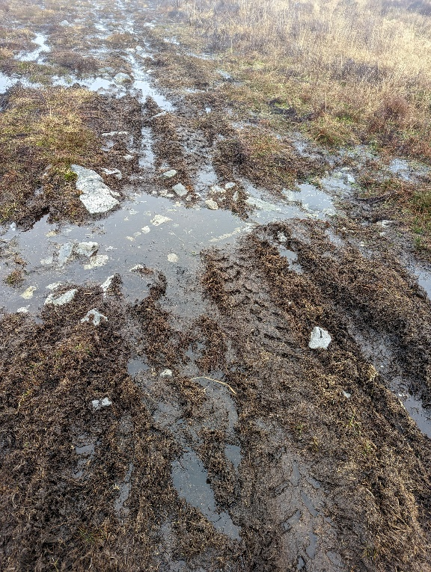
A former droving track to the now dis-used limeworking pits (Murphy and Ludlow, 2000) bisects the site, and is currently used as access for light vehicles. The nearest road is the A4069, which is approximately 300m from the nearest point of the site, but over steep and boggy terrain. Access for vehicles is likely to be via a rough track from the limeworking pits. The area is sparsely populated, with the nearest urban centre being the village of Brynamman approximately 5km to the south.
Figure 4.4: Old track (Photo: Fairbrother, 2023)
No serious falling or tripping hazards were identified. However, evidence of burning suggests that there is likely to be a fire risk. An appropriate fire assessment should be carried out during extended periods of warm, dry weather and safety precautions put in place.

Peatland habitat

Overview
Figure 4.5: Site habitat and survey points
The site can be broadly divided into three areas (Figure 4.5), with different compositions of vegetation, surface moisture and peat depth:
- North-eastern area (A) (Figure 4.6): a mosaic of acid grassland and grass-dominated dry modified bog. The vegetation is dominated by short swards of grass, and burn-damaged heather. There are areas of deep peat (>50cm) towards the north, with some haggs, but surveys lower down the slope showed areas of peat less than a few centimetres. There were occasional, small patches of sphagnum in shallow pools.
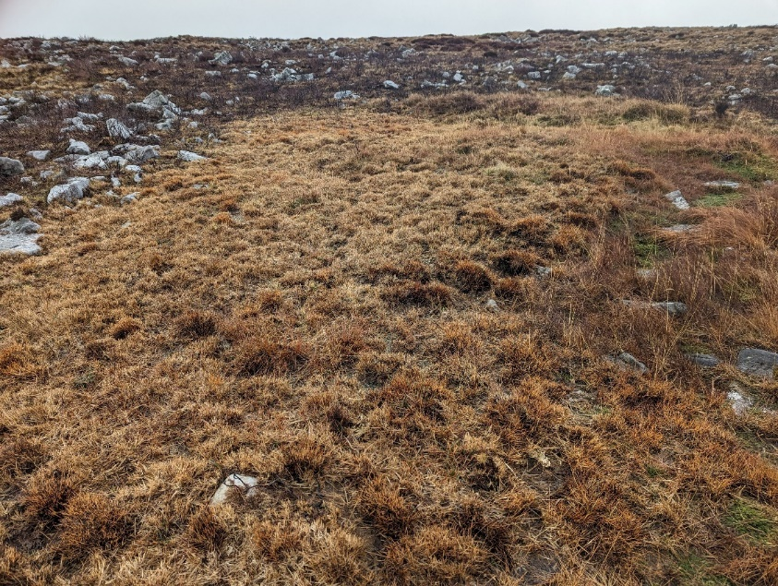
Figure 4.6: Survey point 6 in Area A (Photo: Fairbrother, 2023)
Middle area (B) (Figure 4.7): heather-dominated dry modified bog, with raised hummocks of sedge-dominated blanket bog with haggs between 1-2m high and substantial patches of Molinia. The area contained the deepest peat surveyed, at over 180cm. Area B is sharply delineated by the track and shows no evidence of burning. It is speculated that the muddy track may have acted as a fire break and protected B from damage. Alternatively, B was more resilient to fire because of the higher moisture content.
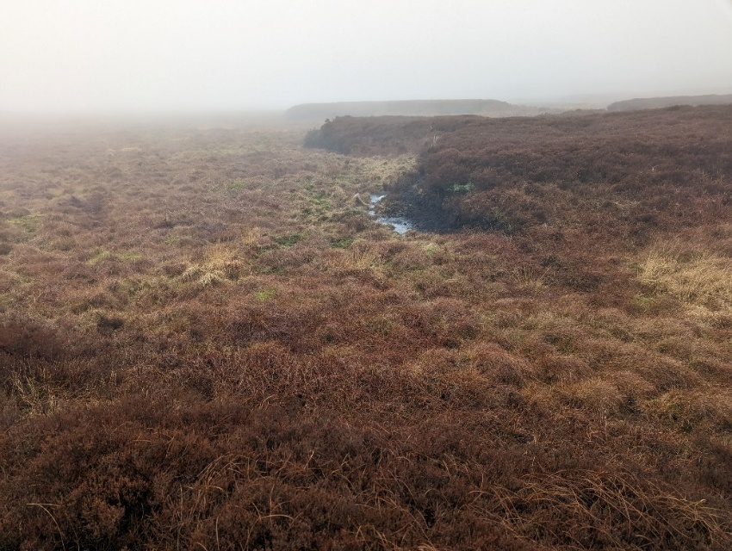
Figure 4.7: Survey point 2 in Area B (Photo: Fairbrother, 2023)
- South-western area (C): principally heather-dominated. The eastern part of the area, which contains greater coverage of sedge, shows evidence of hagg erosion. The surface is drier than Area B and the peat is shallower (50-85cm).
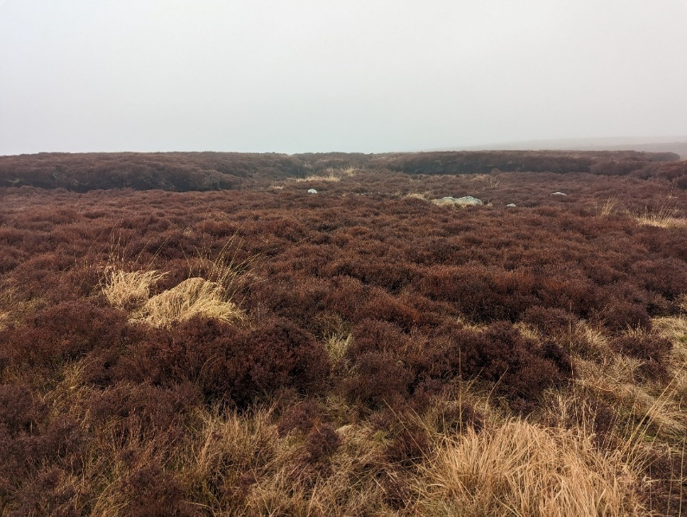
Figure 4.8: Survey point 15 in Area C (Photo: Fairbrother, 2023)

Vegetation and peat depth
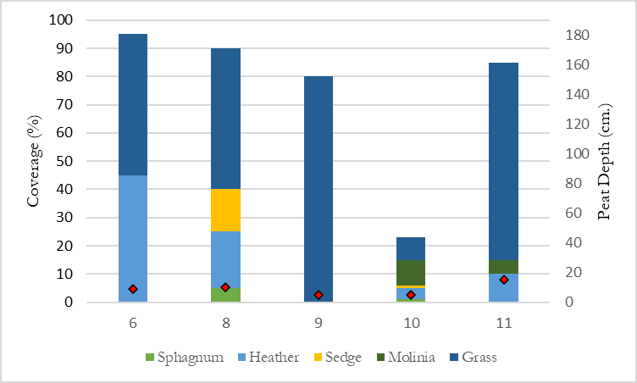
a)
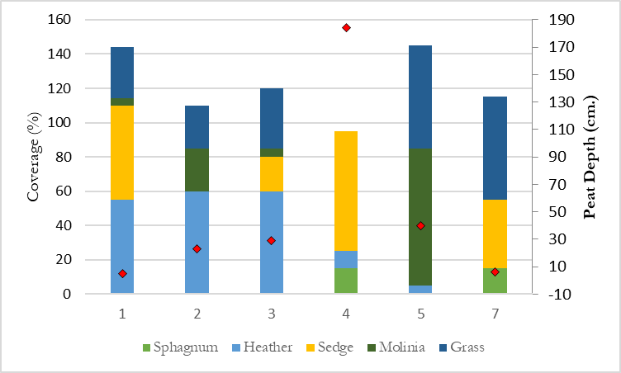
b)
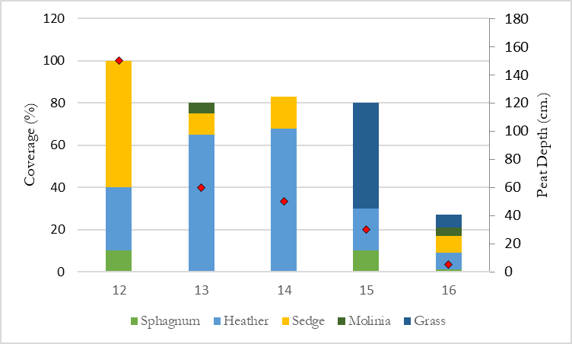
c)
Figure 4.9: Vegetation coverage and peat depth at each survey point. a) Area A; b) Area B; c) Area C
The vegetation coverage and peat depth varied across the site (Figure 4.9). Heather was dominant or abundant across the site, other than on the tops of hummocks, where sedge was more abundant. Molinia is a common feature in degraded peatlands in BBNP but only Area B contained significant areas where it was dominant (Figure 4.10). Sphagnum was found in each area but in small, isolated patches, in particular where there was a high level of surface moisture (Figure 4.11).
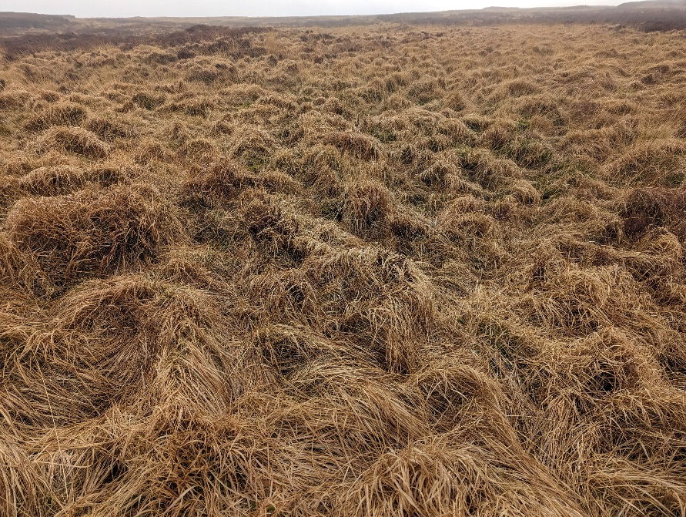
Figure 4.10: Molinia at survey point 5 (Photo: Fairbrother, 2023)
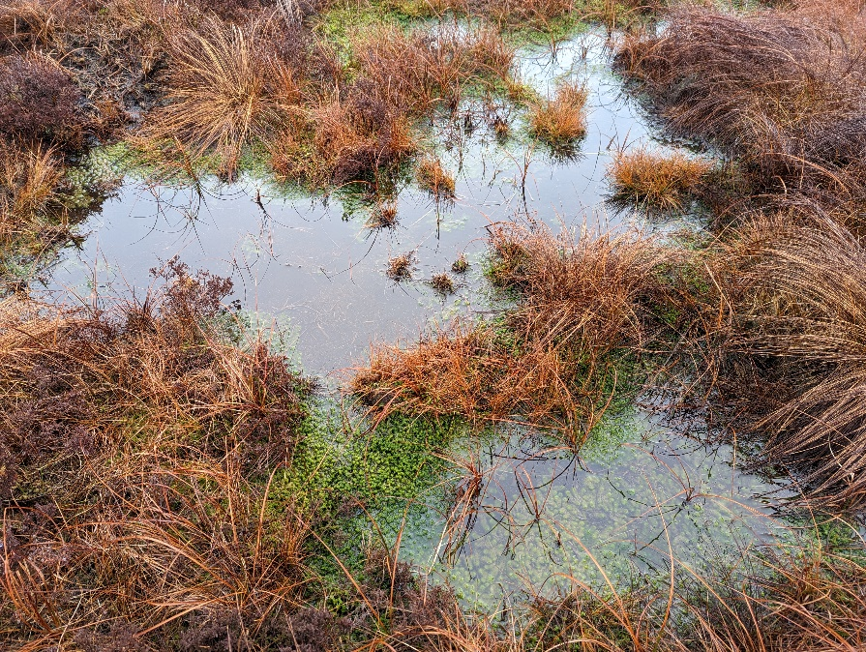
Figure 4.11: Sphagnum moss in sedge-dominated bog at survey point 4 (Photo: Fairbrother, 2023)

Hydrology
The current state of hydrology needs to be assessed in order to make effective management interventions; poorly planned measures may have negative impacts elsewhere (Joosten and Duene, 2021).
As observed on field visits, the water tends to flow south-west down the slope. Areas A and C appeared relatively dry at the surface, with occasional standing pools. Area B appeared wetter, particularly in the hummocks and hollows.
Blanket bog has complex hydrology so, without targeted hydrological surveys, it is not possible to accurately detail the precise flow. Generally water diffuses directionally in accordance with slope, but this may be interrupted or altered due to anthropogenic interference or natural soil permeability variability (Thom et al., 2019). Hummock-hollow microtopography also tends to have complex and heterogenous hydrology (Wang et al., 2021).

General influences
Peatlands in BBNP have historically been subject to a number of anthropogenic pressures, including atmospheric pollution, burning, overgrazing and trampling, all of which can lead to a loss of or negative change in vegetation (Sinnadurai, 2022).
Without further surveying it is unclear what range of influences have led to the bog becoming degraded, but grass and heather-dominated bogs are associated with drying, burning and overgrazing (Evans et al., 2017). The visible evidence of burning (Figure 4.12) suggests that the dryer areas are at risk of uncontrolled burning.
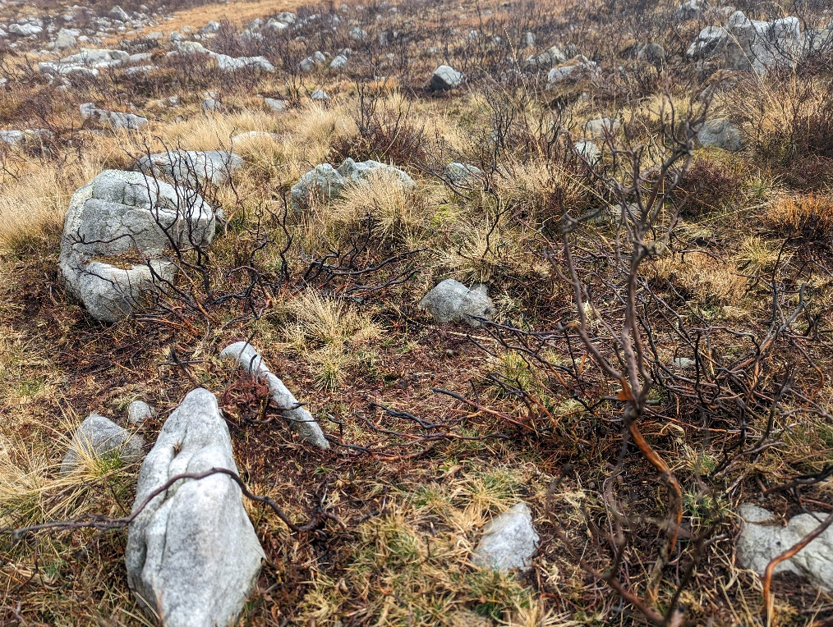
Figure 4.12: Signs of burn damage on heather at survey point 8 (Photo: Fairbrother, 2023)
The impact on rainfall and temperatures from climate change are also likely to pose increasing threats to its condition, exacerbating the risk of erosion and burning (Clark et al., 2010).

Objectives

Summary
The highest priority is the mitigation of climate emissions through restoration of eroded and drained areas. Longer term actions depend on developing deeper understanding of the site and its use, and should be aimed at creating a management regime that sustainably maintains good hydrological function and vegetation across the site.

Prevent erosion
Eroding peat can result in oxidation, leading to the release of CO₂, and a reduction in water quality. The Peatland Code prioritises restoration work on actively eroding areas and, although only 0.36ha is so classified, this objective is likely to be the most easily achievable in terms of known management actions and funding eligibility.

Restore hydrological function
The hydrology of peatland is key to its management. Water levels need to be high enough to ensure peat formation and avoid peat oxidation, but not so high as to damage plants and cause erosion by water (Joosten and Duene, 2021).
Although there is evidence that re-wetting damaged peatlands leads to slightly higher CH₄ emissions through anaerobic decomposition of plant material, the substantial lowering of CO₂ emissions results in an overall net reduction in GHG emissions where peatlands are restored promptly (Günther et al., 2020).
The urban settlements downstream are not at high risk of direct flooding from Nant Pedol (NRW, 2015). However, slowing run-off may make a small contribution to mitigating storm peaks in the River Amman (Goudarzi et al., 2021).

Promote peat-forming vegetation
Key to the natural function of peatlands is maintaining vegetation communities that support peat formation. Vegetation may also help to slow water flow and stabilise slopes to prevent erosion.
Peatlands contain specialised species and high ecosystem diversity, the value of which is mostly in the vegetation (Minayeva, Bragg and Sirin, 2016). Ensuring a healthy mosaic of vegetation will also help to meet biodiversity goals.
Where areas are dominated by Molinia or heather, the aim will be to reduce their dominance to allow for greater diversity, in particular Sphagnum mosses.

Enable long-term sustainable management
Prescriptions should ultimately be aimed at reaching a point where sustainable local management is effective in retaining condition in the long term.

Actions

Summary
Table 1: Summary of actions and timescale
Timescale | Objective(s) | Action
Ongoing | All | Conduct further surveys of site
 | All | Engage stakeholders
Short-term (from year 1) | Prevent erosion | Reprofile haggs
 | Promote peat-forming vegetation; sustainable management | Evaluate grazing regime
 | Restore hydrological function | Reducing drainage, e.g. dam gullies
Long-term (from year 2) | Promote peat-forming vegetation; sustainable management | Establish sustainable grazing regime
 | Restore hydrological function | Raise water table, e.g. construct bunding in dry areas
 | Promote peat-forming vegetation; sustainable management | Mowing/cutting heather or Molinia where dominant
 | Promote peat-forming vegetation | Burning (only where considered strictly necessary)
 | Promote peat-forming vegetation | If necessary, introduce additional bog species

The variability of peat bogs pose challenges to applying restorations techniques used elsewhere, making monitoring and adaptability crucial (Monteverde et al., 2022). However, many peat bogs have been subject to common pressures (Thom et al., 2019) and therefore it is likely that solutions developed elsewhere, particularly within BBNP, are commonly applicable.
Restoration works are eligible under the Peatland Code only on actively eroding and drained areas, because of the disproportionate effect restoring these areas has on meeting climate mitigation objectives. For the remaining, modified areas, management should focus on improving management practices to achieve long-term restoration.

Surveying
To gain further understanding of the functioning of the site and the restoration actions that are likely to be successful, the following additional surveys should be carried out:
- Vegetation surveys for a further 10 months to account for seasonable variability;
- Hydrological survey, measuring rainfall, water levels, seepage/discharge and evapotranspiration (Thom et al., 2019);
- Biodiversity survey, to note any species of importance, to inform mitigation requirements and provide a baseline;
- Drone photography. It was not possible to safely fly a drone during field visits due to the weather, but drones provide replicable, high-resolution images to measure changes;
- Soil sampling and peat depth. An understanding of the peat properties, such as humification, and underlying mineral soil will provide a better indication of the historical context of degradation (Chambers et al., 2013) and whether action to rewet the habitat will be successful (Thom et al., 2019);
- Archaeological survey. Given the historical significance of the area and nearby points of historical interest, a specialist survey can identify any potential conflicts.

Engage stakeholders
The key stakeholders that are likely to be relevant to the site, and who should be consulted on management prescriptions, include:
- BBNPA: as the owners and managers of the land;
- NRW: as the site is within Mynydd Du SSSI, their consent will be required for certain operations, including changing grazing patterns, cutting vegetation, burning, and modifying field drainage (CCW, 1986). NRW also oversees NPAP, which can provide financial and technical support;
- Meithrin Mynydd Advisory Group: this group includes representatives from the local authority, BBNPA and commoners associations (Sinnadurai, 2022). The group would be an important forum for discussion and consultation about the site, particularly with graziers, and should be engaged from the outset;
- National Trust: play a role in communicating with the public and would be useful consultees if access needed to be restricted;
- Dŵr Cymru: poor management of upland peatlands has been linked to water quality problems and Dŵr Cymru’s biodiversity strategy includes peat restoration work, including as land owner in the restoration project at Waun Figlen Felen (Dŵr Cymru, 2018).

Restoration works

Hagg re-profiling
Peat erosion can occur on the vertical sides of haggs. The haggs should be stabilised before they can be recolonised by vegetation (Yorkshire Peat Partnership, 2018).
The haggs on site are less than 3m high and have substantial vegetation on top. Reprofiling their sides can therefore be carried out by “rolling back” vegetation on top and removing the peat underneath to create a 33-35º slope (Thom et al., 2019). The vegetation is then re-laid on top. Where there is insufficient vegetation to cover the whole of the slope, the bare peat can be stabilised with other materials, such as heather brash or geo-jute netting.
Hagg works should be carried out in late summer, after the bird-breeding season. Although heavy machinery raises challenges for access and potential damage, hagg re-profiling was successfully carried out with two excavators at Waun Rydd, despite its location in open heath (BBNPA, 2019).

Hydrology action
A hydrological survey of the site is needed before planning any interventions, to confirm what will be feasible or effective. There does not on the surface of it appear to be drainage via underground drains or ditches, so interventions are likely to be over the surface. These might include the blocking of gullies by dams or the installation of contour bunding to raise the water table in the driest areas of Area A (Joosten and Duene, 2021).

Sustainable management

Burning
The IUCN’s position is that burning should be avoided as a peatland restoration tool on blanket bog (IUCN, 2022), although the exact impacts are still unclear (Ashby and Heinemeyer, 2021). Burning is linked to the increase in Molinia and heather dominance on peatlands where it is not supported by other interventions (Bruneau and Johnson, 2014). Even prescribed burning risks damage to Sphagnum and other positively-indicated vegetation (Noble et al., 2019). It is not recommended that burning be routinely used as a management tool on site until it is more clear what the impact will be.
Consultation of stakeholders will be needed to understand the reasons for why Area A has been subject to burning. The site is in an area at moderate risk of burning but spontaneous wildfires are rare (Trippler et al., 2022). Improved grazing on Molinia-dominated areas and re-wetting dry areas are likely to reduce the risk of future wildfire.

Grazing
Although overgrazing is among historical pressures on peatlands in BBNP, seasonal, sustainable and supervised grazing is a core part of the BBNPA’s uplands management strategy (Sinnadurai, 2022) and the rights of commoners need to be taken into account. Consultation will be important to understand the extent of grazing currently on site, how it may have changed and the likely effects of its increase or decrease.
Grazing, particularly by cattle, tends to result in a more uneven structure, and can open up the vegetation and reduce grass and heather dominance (Evans, Young and Jenkins, 2008). The effects of grazing will depend on the choice of livestock species, timing and frequency of grazing, and stocking density. Light, supervised, summer grazing by a mix of livestock, including cattle and ponies, tends to be recommended on blanket bog (CCW, 1986; Rowell, 1988; Thom et al., 2019), but the exact prescriptions will depend on consultation with local graziers and will need to be monitored for unexpected results. Successful schemes have been put in place between landowners and Welsh farmers to transition towards an agri-environmental model, which includes peatland management through sustainable grazing (Sinnadurai, 2009; National Trust, 2021).
Livestock will tend to graze where access is easier and the vegetation is more palatable (Thom et al., 2019). Although the grass and heather-dominated areas are most likely to benefit from grazing, Area A may be more susceptible to grazing pressure because of the short swards and drier ground. Access may need to be restricted or Areas B and C made more attractive to grazing by manual intervention or shepherding.

Manual intervention
Cutting and/or mowing Molinia and heather in the short term may open up the vegetation to improve diversity. In the long term, it may be effective to use mowing to improve access for grazing. The long term management of Manor Penderyn by BBNPA and local graziers included controlled burning and mowing to encourage grazing on the newer growth (Sinnadurai, 2009).

Vegetation diversity
Where vegetation diversity is poor, it can be enhanced by introducing additional bog species currently rare or absent on site, such as cotton-grasses, by applying seeds or plug plants. Sphagnum distribution can be supported by inoculation.

Access provision
The track shows evidence of occasional use by pedestrians and vehicles but trampling damage appears limited to the track, whose extent appears stable. It is unlikely to be acceptable to stakeholders to block access to the track itself, and track users would likely simply reroute to more sensitive areas.

Monitoring and review
Ongoing monitoring is needed to measure the impact of any prescriptions and the success at achieving objectives. Given the slow growth rate of peat soils, it is difficult to directly assess the effectiveness of management action on the formation of peat. Monitoring success must therefore initially focus on key indicators that the habitat is returning to a near-natural state, such as an increase in positive indicator species – particularly Sphagnum – and improved hydrological function, such as a rise in the water table. In the long-term, indicators of success may include increased peat depth, an improvement in biodiversity and improved water quality in Nant Pedol.

Conclusion
This management plan sets out suggested actions that can be taken towards protecting and restoring a peatland site to a near-natural function with long-term sustainable management. The recommendations are based on limited data and further surveys are recommended to understand what actions will be most effective. However, this should not prevent restoration works being planned, as timely action to prevent erosion is likely to be important. Intrusive action that can affect the water table should only be carried out with a full understanding of its effects on hydrology.
The function of peatlands is complex and monitoring over time is necessary to ensure that management action is effective and is not causing adverse impact either on site or elsewhere. Prescriptions for the site are likely to evolve with greater understanding of the site and peatlands generally, and as the site is restored to a more natural function.

References
Ashby, M.A. and Heinemeyer, A. (2021) ‘A Critical Review of the IUCN UK Peatland Programme’s “Burning and Peatlands” Position Statement’, Wetlands, 41(5), p. 56. Available at: https://doi.org/10.1007/s13157-021-01400-1.
BBNPA (2019) ‘Waun Rydd Peat Protection Method v2’.
Bonn, A., Allott, T., Evans, M., Joosten, H. and Stoneman, R. (2016) ‘Peatland restoration and ecosystem services: an introduction’, in Peatland restoration and ecosystem services: science, policy and practice, pp. 1–16.
Bruneau, P.M.C. and Johnson, S.M. (2014) Scotland’s peatlands - definitions and information resources. Scottish Natural Heritage Commissioned Report No 701. Available at: https://digital.nls.uk/pubs/e-monographs/2014/701.pdf (Accessed: 21 March 2023).
CCW (1986) ‘Site of Special Scientific Interest: Operations requiring consultation with the Countryside Council for Wales - Mynydd Du (Black Mountains)’. Countryside Council for Wales. Available at: https://naturalresources.wales/media/653752/SSSI_0854_PDO_EN00177da.pdf.
Chambers, F.M., Cloutman, E.W., Daniell, J.R.G., Mauquoy, D. and Jones, P.S. (2013) ‘Long-term ecological study (palaeoecology) to chronicle habitat degradation and inform conservation ecology: an exemplar from the Brecon Beacons, South Wales’, Biodiversity and Conservation, 22(3), pp. 719–736. Available at: https://doi.org/10.1007/s10531-013-0441-4.
Clark, J., Gallego-Sala, A., Allott, T., Chapman, S., Farewell, T., Freeman, C., House, J., Orr, H., Prentice, I. and Smith, P. (2010) ‘Assessing the vulnerability of blanket peat to climate change using an ensemble of statistical bioclimatic envelope models’, Climate Research, 45, pp. 131–150. Available at: https://doi.org/10.3354/cr00929.
Dŵr Cymru (2018) ‘Making time for nature: Dwr Cymru Welsh Water’s plan for maintaining and enhancing biodiversity’. Available at: https://www.dwrcymru.com/ga/library/~/media/6a23e9f49c5940fc99aa1fecf91cc498.ashx (Accessed: 18 March 2023).
Evans, C., Artz, R., Moxley, J., Smyth, M.-A., Taylor, E. and Archer, N. (2017) Implementation of an Emissions Inventory for UK Peatlands. Report to the Department for Business, Energy and Industrial Strategy. Bangor: Centre for Ecology and Hydrology, p. 88.
Evans, F., Young, N. and Jenkins, R. (2008) Core Management Plan including Conservation Objectives for Migneint-Arenig-Dduallt SAC/SPA. Countryside Council for Wales. Available at: https://naturalresources.wales/media/672797/MigneintADd%20WES32%20plan%20English.pdf.
Evans, M.G. and Warburton, J. (2010) ‘Peatland Geomorphology and Carbon Cycling: Peatland geomorphology and carbon cycling’, Geography Compass, 4(10), pp. 1513–1531. Available at: https://doi.org/10.1111/j.1749-8198.2010.00378.x.
Goudarzi, S., Milledge, D.G., Holden, J., Evans, M.G., Allott, T.E.H., Shuttleworth, E.L., Pilkington, M. and Walker, J. (2021) ‘Blanket Peat Restoration: Numerical Study of the Underlying Processes Delivering Natural Flood Management Benefits’, Water Resources Research, 57(4). Available at: https://doi.org/10.1029/2020WR029209.
Günther, A., Barthelmes, A., Huth, V., Joosten, H., Jurasinski, G., Koebsch, F. and Couwenberg, J. (2020) ‘Prompt rewetting of drained peatlands reduces climate warming despite methane emissions’, Nature Communications, 11(1), p. 1644. Available at: https://doi.org/10.1038/s41467-020-15499-z.
IUCN (2022) ‘Peatland Code: Field protocol - Version 1.2’. IUCN UK Peatland Programme. Available at: https://www.iucn-uk-peatlandprogramme.org/sites/default/files/2022-05/Peatland%20Code%20Field%20Protocol%20v1.2.pdf (Accessed: 10 March 2023).
Jones, P. (2022) National Peatlands Action Programme: Draft habitat and vegetation monitoring methodology Version 2.0. Natural Resources Wales.
Joosten, H. and Duene, e. V. (2021) ‘Global guidelines for peatland rewetting and restoration’, in Convention on Wetlands. Ramsar Technical Report No. 11., Gland, Switzerland: Secretariat of the Convention on Wetlands.
Leifeld, J. and Menichetti, L. (2018) ‘The underappreciated potential of peatlands in global climate change mitigation strategies’, Nature Communications, 9(1), p. 1071. Available at: https://doi.org/10.1038/s41467-018-03406-6.
LERC (2023) ‘Aderyn’, Local Environmental Records Centres Wales. Biodiversity Information & Reporting Database. Available at: http://aderyn.lercwales.org.uk/ (Accessed: 13 March 2023).
Minayeva, T., Bragg, O. and Sirin, A. (2016) ‘Peatland biodiversity and its restoration’, in A. Bonn, T. Allott, M. Evans, H. Joosten, and R. Stoneman (eds) Peatland Restoration and Ecosystem Services. 1st edn. Cambridge University Press, pp. 44–62. Available at: https://doi.org/10.1017/CBO9781139177788.004.
Monteverde, S., Healy, M.G., O’Leary, D., Daly, E. and Callery, O. (2022) ‘Management and rehabilitation of peatlands: The role of water chemistry, hydrology, policy, and emerging monitoring methods to ensure informed decision making’, Ecological Informatics, 69, p. 101638. Available at: https://doi.org/10.1016/j.ecoinf.2022.101638.
Murphy, K. and Ludlow, K. (2000) ‘Black Mountain and Mynydd Myddfai Volume 1’, Carmarthenshire Historic Landscape Characterisation, ACA Report PRN 40373.
National Trust (2021) ‘Fferm Ifan Ecosystem Service Improvement Scheme’. Available at: https://businesswales.gov.wales/walesruralnetwork/sites/walesruralnetwork/files/Fferm%20Ifan%20Case%20Study.pdf (Accessed: 13 March 2023).
Natural England (2022) ‘Annex 3 Environmental Monitoring in Annex C Nature for Climate Peatland Grand Scheme: Restoration Grant, Guide for Applicants’. Available at: https://www.contractsfinder.service.gov.uk/Notice/9e0efb7e-ab49-4596-a10d-f65709baea10 (Accessed: 10 February 2023).
Noble, A., Crowle, A., Glaves, D.J., Palmer, S.M. and Holden, J. (2019) ‘Fire temperatures and Sphagnum damage during prescribed burning on peatlands’, Ecological Indicators, 103, pp. 471–478. Available at: https://doi.org/10.1016/j.ecolind.2019.04.044.
NRW (2015) ‘National Flood Risk Maps’. Available at: http://lle.gov.wales/catalogue/item/NationalFloodRiskMaps/?lang=en (Accessed: 10 January 2023).
NRW (2019) Unified Peat Map of Wales, Lle. Available at: https://lle.gov.wales/catalogue/item/UnifiedPeat/?lang=en (Accessed: 20 January 2023).
NRW (2022a) ‘Peatland Data Portal’. Natural Resources Wales. Available at: https://naturalresources.wales/evidence-and-data/maps/peatland-data-portal-map-layers/?lang=en (Accessed: 10 March 2023).
NRW (2022b) Terrestrial Phase 1 Habitat Survey. Available at: https://lle.gov.wales/catalogue/item/TerrestrialPhase1HabitatSurvey/?lang=en (Accessed: 22 December 2022).
Rowell, T.A. (1988) The peatland management handbook. 1st edn. Nature Conservancy Council.
Sinnadurai, P. (2009) The Brecon Beacons National Park: a good place for Glastir Sustainable Land Management Scheme. Brecon Beacons National Park Authority. Available at: https://www.beacons-npa.gov.uk/wp-content/uploads/oldsite/environment/farming-in-the-brecon-beacons/The%20Brecon%20Beacons%20National%20Park_a%20good%20place%20for%20Glastir_final_cover1x.pdf (Accessed: 15 March 2023).
Sinnadurai, P. (2022) ‘Draft Peatland Restoration Strategy for the Brecon Beacons National Park’. Brecon Beacons National Park Authority.
Thom, T., Hanlon, A., Lindsay, R., Richards, J., Stoneman, R. and Brooks, S. (2019) Conserving Bogs: The Management Handbook. 2nd Edition. IUCN UK Peatland Programme.
Trippler, B., Jones, A., Harris, M., Woodcock, P., Hassall, L. and Wright, E. (2022) Brecon Beacons Fire Risk Modelling Tool. JNCC Report 701. Peterborough: Joint Nature Conservation Committee. Available at: https://data.jncc.gov.uk/data/7691fb4a-b77a-4f8e-8660-a06b567ba345/jncc-report-701.pdf (Accessed: 21 March 2023).
Wang, M., Wang, S., Cao, Y., Jiang, M., Wang, G. and Dong, Y. (2021) ‘The effects of hummock-hollow microtopography on soil organic carbon stocks and soil labile organic carbon fractions in a sedge peatland in Changbai Mountain, China’, CATENA, 201, p. 105204. Available at: https://doi.org/10.1016/j.catena.2021.105204.
Welsh Archaeological Trusts (1988) ‘Archwilio’. Available at: https://archwilio.org.uk/ (Accessed: 15 March 2023).
Welsh Government (2015) ‘Evidence Statement’, Peatlands for the Future: A programme for restoring Welsh peatlands, 2014 – 2020, Welsh Government Soils&Land-use Division.
Welsh Government (2021) ‘Average rainfall figures (1st October to March 31st)’, DataMapWales. Available at: https://datamap.gov.wales/maps/average-rainfall-figures-1st-october-to-march-31st/ (Accessed: 19 March 2023).
Welsh Government (2022) Prosperity for All: A Climate Conscious Wales: Progress Report December 2022. Available at: https://www.gov.wales/sites/default/files/publications/2022-12/prosperity-for-all-a-climate-conscious-wales-progress-report.pdf (Accessed: 25 February 2023).
Yorkshire Peat Partnership (2018) Yorkshire Peat Partnership Technical Specification 2: Large Gully and Hag Stabilisation and Re-vegetation. Available at: https://www.yppartnership.org.uk/sites/default/files/2018-07/171011%20Technical%20Specification%202%20Large%20gully%20side%20and%20hag%20stabilisation%20%26%20re-vegetation%20TT.pdf (Accessed: 10 February 2023).

