Is Gender Merely A Performance?
By Elyse Hopkins
P147297
Dissertation Supervisor: Julia Lockheart
Word count: 6078
Submitted in partial fulfillment of the requirements for the degree of BA (Hons)
University of Wales Trinity St. David, Swansea, 12th December 2018

Contents Page
Introduction |P.3-5
Chapter 1 . . . . . . . . . . . Origins of Gender |P.6-10
Chapter 2 . . . . . . . . . . Culture Influences |P.11-17
Chapter 3 . . . . . . . . . . Gender Theories |P.18-22
Conclusion |P.23-24
Bibliography |P.25-27
List of Illustrations
Figure 1&2 |P.6
Figure 3&4 |P.8
Figure 5,6&7 |P.9
Figure 8 |P.12
Figure 9 |P.13
Figure 10 |P.15
Figure 11&12 |P.16-17
Summary
The dissertation will plan to focus on the question whether gender is a performance, as an expression of the self and the individual’s character, rather than the biological sex. Each chapter will explore the origins of gender, the culture and media influence and the social science of the topic, such as theories from various philosophers namely Judith Butler.
Introduction
In my dissertation I will explore and research into the question, “Is Gender Merely a Performance?” – the term “performance” in this context being that of one’s gender, and whether it is a way to express their character. Through choice of style and how a person naturally acts, rather than gender being a noun classification given at birth determined by physical features and biological anatomy (Collins Dictionary, 2012). The psychology and sociology of this topic of identification alone is fascinating; the mind and body is separate within one being and the true question of whether this is “natural” for the human species to disassociate from “instinctual” processes. As a young adult growing up in the modern age, gender identity is a common topic discussed amongst my peers; with the growing popularity of the internet, social networking has become easier to discover new terms and labels to identify with, controversial in some cases whether if changing “gender” is just a social trend or achieving a sense of wellbeing. My geographical location has also influenced me to explore this question, where I grew up and currently live is considered a “close minded” type of community compared to other parts of the UK as a whole; living in a small traditional village in South Wales with a considerably older generation populating my hometown, there is a lack of diversity and culture in comparison to a bigger city setting such as London. Being set in the old ways and tradition, to introduce varied gender groups into the communities it could be an alien or taboo concept to the older generation from lack of exposure beforehand. I will plan out my chapters as follows:

Firstly, in Chapter 1 I will investigate how the classifications came to be and where “gender” derived from. Whether it is due to the early human roles of biological male and female’s survival strategies, that the male takes on a “masculine” role of being a hunter gatherer, whilst the female is the nurturing mother to care and protect the offspring. I will consider why the actions of nurturing and protecting are considered to be “feminine”. I will also investigate the behavior of gender roles within other species of animals to see whether they also follow similar patterns to discover whether humans are truly different from other species. I look at the roles of gender through history and social class, such as historically traditional views of gender, what is taught and practiced in religious groups as well, looking at why men and women were treated unequally.

In Chapter 2, Culture and media will also play a big part in my dissertation research, specifically fashion movements of the 1970s, as well as the fashion and style icons that helped shape modern society and its views on gender, and gender expression. I will look at media artists such as music and style icon David Bowie, and what inspired him, to other artists who got inspired and followed in Bowie’s footsteps. Other influencers will also include the likes of Madonna with sexual ambiguity in stage performance and in music, and look at androgyny, masculine/feminine style and when does the line blur between the two. I will start to look at past and modern articles, visual and audible media to back up my research, particularly researching Bowie and similar artists, while l investigate the musical aspect and text within the work as it may address the theme of identity and as a way of being non-conforming to the time era.
Chapter 3 I intend to look at thinkers and their take on gender identity and theories, by doing so look at the works of Sigmund Freud, Judith Butler, Simone De Beauvoir and the likes of Monique Wittig and Foucault. I felt that these theorists would be interesting to research particularly with Freud’s ‘Three essays on the Theory of Sexuality’ in which he theorizes sexuality and identity and its association to childhood. I also felt as though the work of Judith Butler would hold great relevance to the questions I raise within the body of my dissertation, as she has written extensively on gender, biological sex and sexuality- and also how the three interact and coexist.
As well as looking at the positives of this topic, I will research the negative aspects; to look at documentaries and books addressing the issue of discrimination within society; from past to modern day discrimination and alienation within communities, in the real life and online. Researching debates to conclude my research particularly bullying and harassment that occurs from expression of self. From the research, the outcomes I predict will be that I will understand this topic in more depth, attain greater knowledge and understanding about identity and sociology than prior to research, and perhaps will have an answer to my question- or at least understand the question to be more complex than previously thought. As mentioned earlier, from personal observations and experience, that being brought up in a quiet close knit community with not much or a lack there of diversity and outside culture I feel it is important to have knowledge and understanding of gender identity. More importantly in this day and age, with newly discovered terms and nouns/ pronouns that individuals identify as, to not mis-gender or offend a person from lack of political correctness, or understanding of anything outside the gender binary. As society is changing are we in question becoming sensitive with political correctness, or have we been insensitive the whole time?

Chapter 1
“Masculine” – Adjective ‘possessing qualities or characteristics considered typical or appropriate to a man’, ‘French from Latin masculnus’, whilst “feminine” qualities or mannerisms to be associated to a woman, Latin ‘fēminīnus, from fēmina woman’ (Collins Dictionary, 2012). These roles have long been corresponding with biological sexes of strictly male and females (Freud, 1973, cited by Glover and Kaplan, 1998), taboo for qualities to intertwine or cross over to the opposing sex, or is it changing:
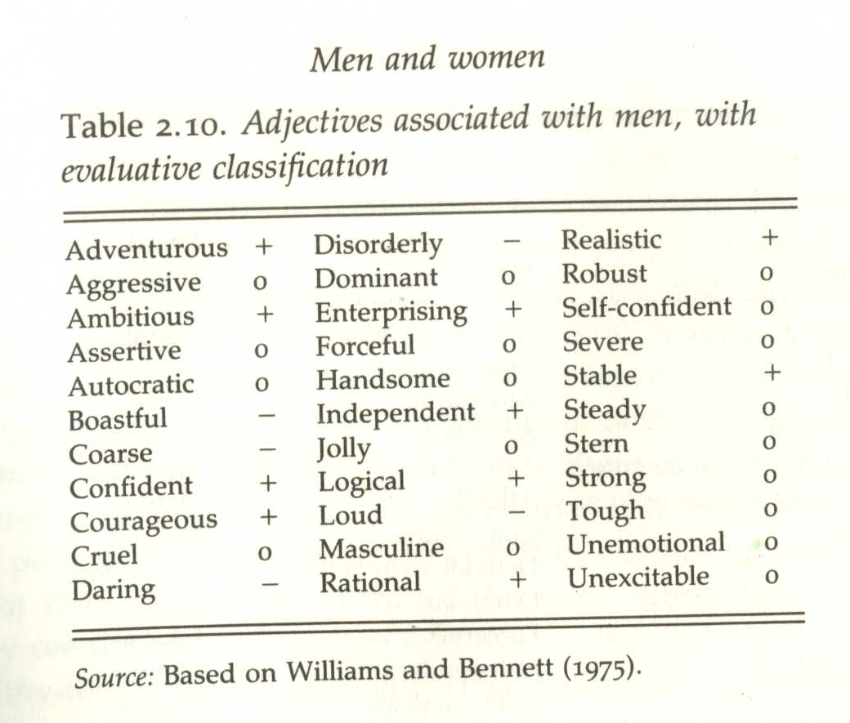
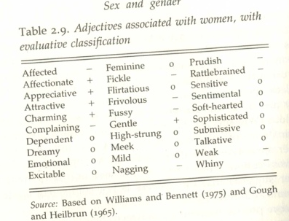

Table 2: Class social experiment female adjectives
Table 1: Class social experiment male adjectives

The images from the book ‘Sex and Gender’ by John Archer and Barbara Lloyd (1996) shows a class experiment conducted in 1975 showing a table and the adjectives associated with gender; next to the adjectives having the symbols (+) indicating positive aspect, negative (-) and zero (0) being neutral; the table summarizes the characteristics desired in both sexes such as the female is valued ‘five are positively valued whilst ten are negative’ (Archer and Lloyd, 1995, p.40) namely ‘Weak’ being deemed negative and ‘sensitive’, ‘talkative’, ‘emotional’ and even ‘feminine’ and ‘masculine’ for the man, were neither desired or undesired in both; does this suggest the latter findings of stereotyping genders show that there isn’t a dire need to tick all the boxes of what ‘traditionally’ is to be a ‘man’ or ‘woman’. When as a society in modern day we still go by these adjectives to describe a ‘man’ or ‘woman’, perhaps it precedes to the origins and evolution as humans; the concept of nature and nurture dynamics possibly having a part in this. In the ‘Sex and Genders’ book, Archer and Lloyd suggests religion being a heavy influence imbedding ideas of gender roles of male and female; in Christianity with the Adam and Eve concept of Adam being created first, therefore men are possibly regarded more superior or important than women (Archer and Lloyd, p4, p48). With religious aspects having a contribution to these notions of gender roles, and a lack of knowledge, instigating potential fear of wrong doing if the way of traditions (being of gender roles) were to be changed, risks punishment. Therefore, abiding to the rules of ‘natural order’ into appeasing their God is a possible theory to why early civilization were so set in their ways of who would be submissive and the weaker sex (being the female), and the dominant stronger sex (being the male) (Archer and Lloyd, p4). These methods of obeying what is ‘taught’ in religion could be argued to be outdated in modern day, especially noting the “religious right” of domestic violence occurring within religious matrimonies of men being superior and stronger to women, a ‘dual standard’ (Archer and Lloyd, p133).

Up until 19th century, predominantly in the Western world, it was a general agreement that society abided by what was taught within their religious faith in terms of the roles of the male and female; until Darwinism and Evolution came into theory (Archer and Lloyd, p48). These new-found discoveries of human biology and mammalian interactions suggests the roles of gender precedes back to archaic human civilization, with ‘sexual selection’ in order to reproduce, conceiving the strongest and healthiest offspring (Archer and Lloyd, p61). Darwin and Triver’s theory of human evolution suggests that ‘sexual selection’ were to involve competition amongst males; being of the largest, strongest, most aggressive and even facial hair to be an intimidation tactic when competing; ‘masculine features (including beards) originated partly through female choice’ (Archer and Lloyd, p61). The advantage of larger and stronger males was again in favor of survival; good stamina for hunting but does not always disregard the females to stay at home or ‘nest’, as cooperative hunting has been shown in ‘present day hunter-gatherer societies’; this perhaps to lessen the competition of gathering food sources (Archer and Lloyd, 62). These patterns of survival not only show up in human interactions but also been evident in other mammals, example being birds; both genders are shown to hunt and gather sources for the offspring as well as competition over certain physical features to attain a mate. In contrast, however, generally differentiating between sexes would typically be decided upon who has the larger or smaller build, differentiating sex organs and who appears to have more ‘rugged’ or ‘refined’ features, this does not apply to all animal species, such as birds due to ‘sexual dimorphism’ (Archer and Lloyd, p58). ‘Sexual Dimorphism’ is an appearance or physical size difference of the animal’s sex despite the sexual organs (Oxford Dictionaries | English, 2018), an example being having a large female and a smaller male within an animal species, or males being more vibrant in colours or distinct markings to the female. This brings on to the topic of the roles being changed in the instance what parent carries the offspring, in humans, females will be the host for the growing baby, who will nurture and care as well. Contrary to what we know as humans, these roles vary within other species such as the male seahorse and male arctic penguin:

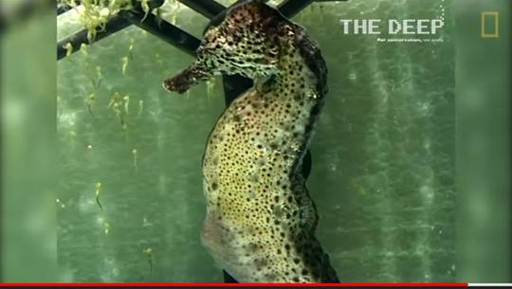

(Figures 3 & 4 Video thumbnails from Youtube, ‘Pregnant Male Seahorses Give Birth’ by National Geographic)
The two images above show the process of the male sea horse giving birth to his offspring, not his female courting partner. The females will also impregnate the male by depositing her own eggs in which the male will fertilize in his brooding pouch. This is the only species in the animal kingdom that males carry their young instead of the females (Nationalgeographic.com, 2018).

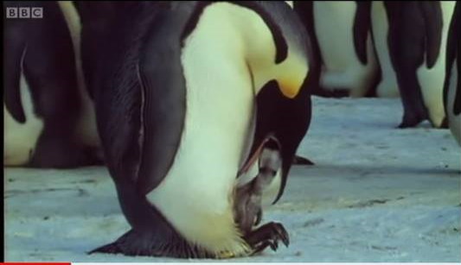
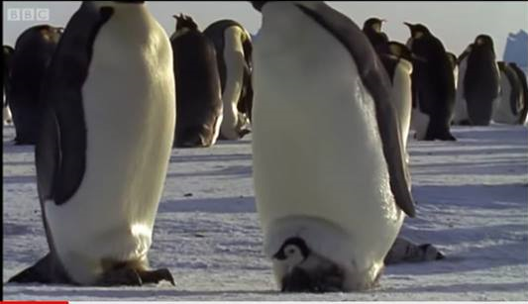

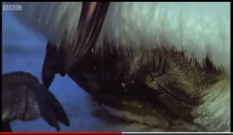

(Figures 5, 6 & 7 from video thumbnails from ‘The Greatest Wildlife Show on Earth’ BBC Earth, 2009)
The thumbnails above are from the BBC British Television documentary of Planet Earth which shows the male Emperor penguins caring for the eggs, even through to hatching whilst the mother ventures out to gather food sources for the baby (BBC Earth, 2009). Once the pair are reunited the males will transfer the baby over to the mother, however in some instances the male is ‘reluctant’ to hand over to the mother, out of fear of abandonment (BBC Earth, 2009). This is evidence of bonding between father and baby, in the both scenarios of the seahorse and penguin it shows males can be nurturing and caring, and not stereotypically to be aggressive or competitive in nature. Even though males can show aggression and competitiveness in an attempt to court, females from different animal species are also capable of taking on a more aggressive role to impress the male or in defense and protect in Triver’s theory (Archer and Lloyd, 1995, p.58).

This therefore brings the question if both male and females in humans as well as other species possess characteristics of both aggression (masculine) and docility (feminine), or is it perhaps taught through nurture and upbringing, such as religious teachings and social groups that imposes the individual’s character and thoughts on gender roles. In the circumstances of child development, whereby the child is influenced by peers (such as parents) and learns through play and interactions (social group) however it is debatable whether personality or character building is the matter of nature vs nurture. According to the ‘Children’s Care, Learning and Development’ book by NVQ Level 3, Child psychologists argue that children’s learning is through nature rather than nurture, in order for the child to ‘progress’ and ‘mature naturally’ (Tassoni, Bulman, and Beith, 2005, p.341). Character development with boy’s play is more ‘vigorous’ and rough ‘such as wrestling’ (Archer and Lloyd, p253) which perhaps is why we associate boys with aggression, dominance and power. Interestingly, studies have found with exposure of the hormone testosterone in the womb to unborn females have shown to grow up with “boy sports” being more appealing to them and showing a disinterest in taking on the role of motherhood and playing with “girl toys” such as dolls or toy babies (Archer and Lloyd, 1995, p.253). It’s not to rule out that children are influenced by their peers in an environment, competitiveness in males is taught or adopted through development in early stages of life. The socialization of the parents to their children or peer groups can dictate or at least influence decisions made for the individual; imitating actions possibly from the same sex parent; ‘imitating activities, performed by a member of their own gender’ (Archer and Lloyd,1995 p.263). Thus, in the instance that a child is brought up a certain way, such as parents having strong views, by this theory it seems that the children will follow their parent or peers and ‘adopt’ mannerisms.

Chapter 2

In continuation to chapter 1, it is noted that individuals are heavily influenced by their parental figures and social peers; traditionally in Western culture it was typical of the daughter taking on the role of house-maker following after her mother, to provide for the family and home, being ‘caregivers’ (Archer and Lloyd, 1995, p.262) whilst the son were to, like his father, be the heavy laborer and ‘bread winner’ of the family providing financial stability (Gauntlett, 2003, p.7). However, gender dynamics changed, especially for women as a result of the World Wars with the absence of men in the workplace (The Second World War, 2015). Although some worked involved going overseas serving as nurses in the military providing for the injured, once again being the caregivers, there was still a need of labour work to run the factories, creating and welding machinery which at the time was considered to be masculine jobs, it perhaps built stronger social communities such as feminism, with team building and bonding amongst the females, being ‘women working behind the lines’ (The Second World War, 2015). This furthers the evidence of women exceeding expectations by being more than capable of doing ‘a man’s job’ with their given biological sex not limiting them as fore thought prior to the economical changes of the time.
This sparked a change in Culture in post war Britain and America; diminishing the preconception of women remaining in the house whilst the men went out to work (Gauntlett, 2006, p.4). being more present in the work place and taking on alternative fashion and media trends, namely so of women and men wearing ‘gender ambiguous clothing’ and the presentation of hairstyle and cosmetics; girls shortening their hair whilst in the latter part of the 1960s early 1970s, boys grew hair. Example of this would be the 1960s model Lesley ‘Twiggy’ Lawson:

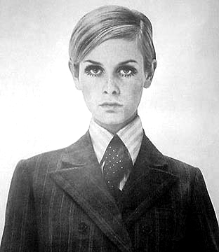

(Figure 8, photographer unknown, Twiggy photographed in business suit, 1969)
The image above portrays Twiggy in a formal suit, her hair is of a short ‘pixie cut’ style, resembling more of a young boy than to a woman. This could perhaps be the turning of androgynous fashion that would follow through the decades into modern day style; as Twiggy still maintains her feminine features with exaggerated eyelashes and eye makeup all the while wearing a what would be considered men’s clothing or fashion choice, could it also suggest a rebellious statement against the binary fashion of men and women (Kirkham, 1999, p.80).
The term Androgyny or androgynous describes the individual of possessing both male and female traits in character or appearance (Collins Dictionary, 2018) and in the case of fashion in post-War west world, it was becoming more popular. Interestingly, despite this new era of style culture, there was still a presence, or an attempt to maintain traditional roles commercially, As Kirkham states in ‘The Gendered Object’ book of the ‘Action Man’ and ‘Barbie Doll’ both brought into commercialization between 1959 and 1966, ‘although intended for children it objectified gender as ‘adult dolls’ in a sense representing the ideal male and female bodies’ (Kirkham, 1999, p.81). Furthermore, reinforcing sexism and binary gender roles in an era of ‘Change’ (Gauntlett, 2006). Kirkham proceeds to suggest that the use of dolls in child’s play imposes gender binaries, subliminally encouraging to follow the binary system and to influence what children should believe to be the ideal role models, through ‘linguistic theory, transforming material objects into images and reads them as a self referential sign system’ (Kirkham, 1999, p.81). this statement suggests that androgyny in the 1960s, though a slow progression into society from an inevitable cultural change of War, was perhaps a very controversial fashion trend; a movement in which not many from the pre-War generation would grasp. By being set in the ways of tradition, with the trend taking off and following into the 1970s. Overtaking other forms of media, to name the music industry; under the guise of Glam rock (Rolling Stone, 2017).
The term ‘Glam Rock’ “glam” being a shortened noun for ‘glamourous’, a genre of rock music with a distinct ‘flamboyant, glittery’ and perhaps theatrical stage presence of ‘androgynous performers’ (Collins English Dictionary, 2018). When Glam rock came to prominence in the 1970s, the iconic figure that gained the most relevancy was David Bowie, being one of the greatest influencers not only music but being a ‘Chameleon’ in fashion, conveying many forms of identity and constantly revolutionizing his style (Rolling Stone, 2017).
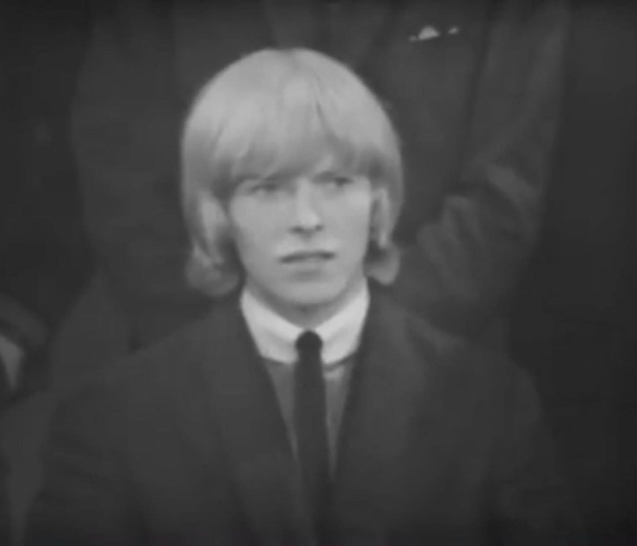

(Figure 9, photographer unknown, David Bowie on BBC ‘Tonight’ (1964) The Society for the Prevention of Cruelty to Long-Haired Men)
Six years Before Bowie rose to fame, he was featured on the BBC Tonight show, representing as a chairman of the ‘Society for the Prevention Of cruelty to Long-Haired Men in 1964 (Bowieforever, 2016). The video shows David Jones, not yet known as Bowie at the time, expressing his concern for the well fair of men being discriminated for their hairstyle. He talks of men teasing or getting ‘harassed on the street’ and calling them ‘darling’ (Bowieforever, 2016). This portrays the discrimination imposed by people, who are not used to the style, by calling them ‘darling’ used generally on women, therefore mis-gendering with the intention to insult. This possibly inspired Bowie to be non conforming as a means to shock and ‘shake’ society’s view on gender roles later in his career. In Mark Paytress’ book ‘Bowiestyle’ (2000), it mentions Bowie’s influencers, notably Bowie’s interest in artists with the likes of Andy Warhol and Salvador Dali, with his surrealist short ‘Un Chien Andalou’ (Dali, 1929) which features a ‘woman dressed in masculine style attire’ and an eye ‘surgically cut open’ (Paytress, 2000, p.24). At the time of the art work being published it was very controversial for the era, and this perhaps took Bowie’s interest in the ‘taboo’ concepts and ‘Avant Garde cinema’ (Paytress, 2000, p.24). Bowie recalls his encounter with Warhol,
“It was fascinating. He has absolutely nothing to say at all, absolutely nothing. And he has this white, pudding face. He looks slightly of this world, really inhuman.” (Bowie, 1966) (Cited by Paytress, 2000, p.58). for Bowie to describe Warhol as ‘out of this world’ and ‘inhuman’ it portrays Bowie’s thoughts and inputs within the art world, to express and liberate, embrace the ‘other worldly’ as it is what makes work ‘fascinating’ (Paytress, 2000, p.58). Along with art movements capturing Bowie’s attention, he sought to look at other alternative media such as acting, interpretive dance and mime to channel his expression as an artist; to which he met Lindsay Kemp in 1967 (Paytress, 2000, p.34).

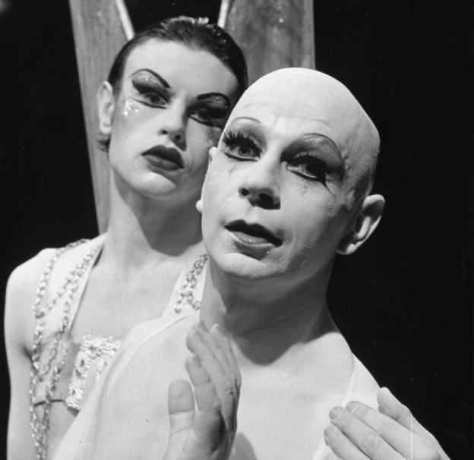

(figure 10, photographer unknown, Lindsay Kemp, date unknown)
Lindsay Kemp a professionally trained mime performer who was a teacher for Bowie, introducing him to a world performance art; to perfecting ‘makeup and stage presence’ (Paytress, 2000, p.34). Mime performance allowed Bowie to experiment with theatrical makeup, and character building;

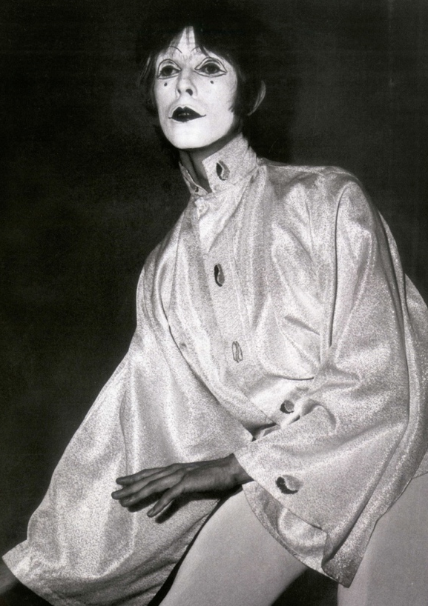

(Figure 11, photographer unknown, David Bowie ‘Threepenny Pierrot’ 1967)

‘Threepenny Pierrot’ was early developments or ‘Genesis’ of what was to become the ‘alter ego Ziggy Stardust’ (Paytress, 2000, p.34). The heavy pigment of white face paint contrasts against the dark line work, which accentuates the ‘feminine’ features of the such as the eyes and lips, it forces perspective of a gender ambiguous face. This could imply the aim to focus on the facial expression during the performance rather than focusing gender on the performer. Kemp left a lasting impression on Bowie, with the teachings of being ‘fluid’ in his performance and to convey curiosity within his work by creating ‘flamboyant characters’ (Paytress, 2000, p.34).

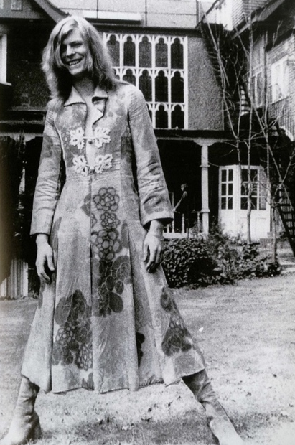

(figure 12, photographer unknowns ‘Man’s Dress’ 1971)
Once Bowie gained recognition in America with ‘The Man Who Sold the World’ album in 1971, in which Bowie wore a long floral dress; ‘parody of a painting by pre-Raphaelite artist Dante Gabriel Rossetti’, the album was too controversial to be released in America as Bowie states
‘I’m not sure if I was trying to be provocative, it was more like a hangover from the Sixties’ (David Bowie, cited by Paytress, 2000, p.62). Paytress further states that Bowie’s ‘unisex fashion’ statements were taken more seriously in America (Paytress, 2000, p.62), possibly due to America’s religious views being strict, especially the fashion style being ‘new’ to society, it was a risky move (Paytress, 2000). Bowie’s provocative fashion style became influential to pop culture, inspiring other artists to modern day, to name artists like Madonna, creating theatrical performance in her music, with sexual orientation being ambiguous (Gauntlett, 2006). For Bowie as a role model, especially with the ‘LGBTQ+ communities’, it was encouragement to be expressive through artistic mediums and the acceptance of expressing personality (Gauntlett, 2006, p.222). This encouragement in media possibly brought out new forms of identity, as people expressing their persona, being sexually ambiguous and not categorizing to specific binaries of ‘male’ and ‘female’ (Gauntlett, 2006). These propositions of new or ‘alternate’ identities resurfacing society sparked studies; as earlier theorists touched upon identification as the self and gender theories.
Chapter 3: Gender Theories
Gender identity as a subject has been theorized widely - whether the identification of gender is determined by environmental factors of the individual, upbringing, or a self-discovered phenomenon. It is suggested that as a society we assume or impose a being’s identity as expressed, “In differentiating infants in the ways that we do, we recapitulate heterosexuality as a precondition” (Salih, 31) implying the identification of sexuality, and in turn can be confused with gender preference, being a cis gendered heterosexual is a general consensus of society by default from birth. “Sex and gender necessarily overlap, sometimes confusingly so” (Glover, xxvi) implies the categorizing of gender to certain sexual orientation, or biological sex, perhaps explains the unwillingness to separate gender from sexuality. Therefore, this breeds a misconception of both terminologies being deemed the same thing. Simone De Beauvoir famously quoted, “One is not born, but rather becomes a woman” (Salih and Butler, 2010) expresses that a person is defined to be a “woman” through development of oneself in contrast to be assigned at birth.

Sigmund Freud theorized gender; “’anatomy’- is destiny” (Freud, cited by Glover and Kaplan, 1998, p.xxvi) which argues regardless of how the individual would change one’s identity physically – they are still considered as “man” or “woman” by their biological sex. This however does not dictate the psychology of the individual, or how they feel what “gender” they categorize themselves in despite their genitalia. Rather, as expression of gender is separate from the physical anatomy or appearance; “Sexual identity is no longer exclusively linked to the anatomical structure of the internal and external organs. It is now a matter of impulses, tastes, aptitudes, satisfactions and psychic traits” (Davidson 1987, cited by Glover and Kaplan, 1998). Freud also stated, “experience of the cases that are considered abnormal has shown us that in them the sexual instinct and the sexual object are merely soldered together” (Freud 1977, cited by Glover and Kaplan, 1998). Does Freud imply the “sexual object”, being the physical metaphor, is associated with orientation “sexual instinct” as a society. Freud continues, “a fact which we have been in danger of overlooking in consequence of the uniformity of the normal picture” (Freud 1977, cited by Glover and Kaplan, 1998). It perhaps suggests as a society, it’s a common assumption of stereotyping the individual’s desires on first impressions. “Uniformity” heavily implies the need of control in society; that everyone is the same, and anything to be other than “uniform” is perceived “abnormal”. It is argued that “Human sexuality cannot in any sense be enclosed within a specific pattern which may be considered ‘normal’” (Torres, 1991, p.73). There isn’t a “specific pattern” to humanity’s characteristics to dictate whether such action is natural or “normal”, possibly as there is lack of research into humanity as a species on regular actions or mannerisms/ traits; as a society we are going by what we are familiar within a social construct. Freud’s other theories, famously noting the Oedipus/Electra Complex; “ideally the developing child will achieve stability by identifying with their same sex parent” (Gauntlett, 2006, p.36) although in theory could be possible, but the outcome variable is heavily dependent on whether said child’s upbringing involves a presence of both sex parents, which, is not always realistic. It implies impressions determined by environmental factors exposed at an early age influences the child’s sexual preference or identification, however theory disregards same sex parents raising a heterosexual child. Gauntlett continues, “(Freudian) discourses, in which sexual urges and conflicts are the driving forces of child development” (Gauntlett, 2006, p. 122) “Sexual urges” if it is in relation to the Oedipus/Electra complex, represents the stereotypical heterosexual upbringing of desiring the opposite sex, which can be in relation to the “heterosexual matrix” theorized by Judith Butler, (Gauntlett, 2006, p.137) a subtopic in ‘Queer Theory’.

‘Queer Theory’ - “is an approach to sexuality and, more generally, identity” (Gauntlett, 136) covers the varying identities which one would present their self, queer and studies of feminism. Particularly expressed in ‘Gender Trouble’ by Judith Butler (DATE) addresses her concerns of women, namely ‘Feminism’, conforming to the idea of “women” being singled off as an unique or superior group in contrast to “men” which in itself is possibly sexist “Creating a binary ‘women’ versus ‘men’“ (Gauntlett, 2006, p.137). “Versus” implies a perhaps negative conflict; a battle of the two sexes and the term “binary” being that the gender nouns are strictly categorized in two boxes of ‘male’ and ‘female’. Butler explains within the ‘Heterosexual Matrix’ that there is a societal expectation as a possible result of cultural traditions, as the diagram shown below:

You have a fixed sex Upon which culture builds Which determines your (male/ female) a stable gender (masc/fem) desire (towards the o opposite sex)

(Diagram from Media, Gender and Identity, An introduction by David Gauntlett, 2006).
The model shows the societal expectation of what the individual’s likes and orientation are based on the ‘fixed’ sex, it was not specifically designed by Butler however it correctly illustrates the theory as a “step-by-step” or “structured” process a person must follow in order to fit in society. This, in theory is inconsiderate of the individual and rather speaks for the generic whole of society, going by traditional heterosexual culture. It is also ignorant to the alternate group of identities other than a cis gendered heterosexual, being the default. This in affect causes inequality and contradicts the aims of feminism; equality. As “Butler notes feminism accepted the ‘heterosexual matrix’” (Gauntlett, 2006, p.137) by liberating femininity with “experiences of childbirth, of menstruation” (Gauntlett, 2006, p. 136) possibly implying what it defines to be a “woman” and to be a feminist, excluding the biological male gender, disregarding male feminists as they have not or will never achieve these experiences. The theory portrays an idealistic way of how humans “should” develop to be as a heterosexual. What Butler believed in order to achieve equality, they would instead adopt a model as shown below:

You have a body You may perform an identity You may have desires

(Diagram from ‘Media, Gender and Identity, An introduction’ by David Gauntlett, 2006)
The second diagram above appears to be more relaxed in a sense that there is less pressure placed on the individual; the word “may” carry a nonchalant approach to what the individual decides to do, more of a choice than force. The arrows are also no longer there so there isn’t a direction one would have to follow; there isn’t a right or wrong way of going about identifying the self. Therefore, this idea by Butler portrays is a more equal or fair way of identification labelling, or no labelling at all, gender is a free expression (Gauntlett, 2006, p.137). The aims of this proposal are for equality by not having strict labelling or come to a set decision; there is freedom. However, similar again to the “Heterosexual Matrix” it may again only work in theory, but perhaps as there is a variety of views, speaking for society, there will be disagreements on both spectrums.

The book ‘Genders’ by Glover and Kaplan describes the misconception of gender fluidity expressed by Butler and Kotz, “The bad reading goes something like this:
‘I can get up in the morning, look in my closet, and decide which gender I want to be today. I can take out a piece of clothing and change my gender, stylize it, and then that evening I can change it again and be something radically other’ (Kotz cited in Glover and Kaplan, 1998, p. xvii).
Liz Kotz states that gender can be easily changed, as easy as stylizing your wardrobe and changing your clothes. This possibly causes the confusion amongst society, as Butler explains, “the flaw in this picture, lies in its failure to take into account the contradictory mode in which we inhabit our sense of gender, not as an identity that we freely embrace, but one that we also struggle against” (Glover and Kaplan, 1998, p.xvii). The statement suggests that it is not just a matter of changing clothing or fashion style so easily, it is a “struggle” with the identity, and a battle of the self, as gender identity is not specifically out of casual choice. This notion suggests feelings of gender dysphoria, or “gender identity disorder” to the individual; a psychological subject that has been researched the past decades.
Gender Dysphoria, a condition which the individual dissociates the given biological sex assigned at birth from their gender identity (National Health Service, 2018). Foucault’s work has touched on social topics and has researched issues of gender identification within social constructs and the outcomes of the individual’s psychological state, “social constructions of sexuality were internalized by people, leading them to see sexuality as the (possibly shameful) truth about themselves at the core of identity” (Gauntlett, 2006, p.116). To be deemed as ‘shameful’ would trigger feelings of guilt and negative thoughts to the individual which in turn creates a negative psychological disorder. The topic of developmental irregularities from birth, an example being hermaphroditism; in which the individual appears having both sets of / or ambiguous genitalia at birth (Collins Dictionary, 2018) can also conjure feelings of distress and confusion. Foucault’s notes on Herculine Barbin; a nineteenth century French intersex individual who eventually committed suicide as a result of rejection from her community (Glover and Kaplan, 1998, p. xiv). Although Barbin primarily associated herself being as a woman, her medical examinations carried out by Dr Chesnet concluded her genitals more to be of “a man” which led to questioning her own identity. This alienated her within society and was “forced to leave town” (Glover, xiv). Her memoirs reveal self-descriptions being of ‘a sad disinherited creature’ whose ‘very life is a scandal’ (Foucault 1980, cited by Glover and Kaplan, 1998, p.xiv). This is evidence of severely emotional distress that was placed upon Barbin, the revelations from her examinations degraded herself from being a regular human and instead a “creature” shows bleak emotions of de-humanization to her character, and that her life being a lie, leading to her death as she felt no sense of “belonging”. In 1960 a research clinic was set up in Los Angeles by Robert Stoller as a means of conducting further research on gender identity and disorders (Glover and Kaplan, 1998).

Conclusion

As expressed in Chapter 3, the purpose to research the psychology and social science of identity was in order to understand the condition in greater depth; to modern day sociology as a society, gender identity is still a current topic and is highly discussed (Gauntlett, 2006). The negative aspect that comes into play of discussing gender topics is the prejudice of mis-gendering; which enters the realm of political correctness. The growing popularity of social media and engaging platforms with forums to discuss topics; creating social groups within the internet, as explained in the YouTube video ‘There Are Only Two Genders change My Mind’ the internet gives ‘free speech’ to an individual. Therefore, freedom of expression can turn into discrimination or ‘hate speech’ (StevenCrowder, 2017). The video covers modern views on gender, whether ‘there are more than two genders’ is a correct statement, or whether it is a ‘radical’ mindset to overcomplicate a ‘simple situation that is a matter of yes or no’ (Stevencrowder, 2017). The video implies that any form of statement can evoke a reaction; whether online or in person, as evident in the video Crowder is approached by a student showing hostility in retaliation to what Crowder’s views are on gender; furthermore, implies regardless what is thrown into the public or society with invitation of discussion, there will always be an opposing view or an ‘inability to please everyone’ (StevenCrowder,2017). From researching each chapter to achieve a more knowledgeable understanding of this vast and ever-expanding topic of identity; it appears that at the core of identity there is need to attain social acceptance but at the same time to rebel against the binary, possibly to show a variety of thoughts and ideas. From researching Bowie, the change of personas was prominent in his work; as a way of conveying a different image in each era, it perhaps portrays a different ‘face’ of his personality each time, in a way to ‘reinvent’ the self. In regard to the question of gender being a performance, is the individual reinventing constantly; as society is not fixed, but rather moving forward and evolving, with new terms created every day. As researched in chapter 1, the terminologies and actions of what was considered ‘feminine’ or ‘masculine’ also changed as society developed to be today. Moreover, is performance and identity also a matter of evolving and growing as a person. Setting aside the term ‘gender’ and focusing specifically on ‘identity’, it seems as a society we ‘perform’ a version of ourselves. Not specifically to ‘performance’ in literary terms, but how we carry ourselves, present ourselves in character to who we interact with. Another example being that being how we perform to our peers, such as creating an online presence, whether be profiles or forums for discussions. Initially, the aim of this research was to find a more concise answer to ‘Gender Merely a Performance’, however given the research and what I’ve learned it appears there is no straight forward answer to the question; as it possibly down the individual’s opinion and how they interpret ‘Gender’ is a matter of the interpreter of the question.

Bibliography

Book Reference
Archer, J. and Lloyd, B. (1995). Sex and gender. Cambridge: Cambridge Univ. Press.
Butler, J. and Salih, S. (2010). The Judith Butler reader. Malden, Mass: Blackwell.
Gauntlett, D. (2006). Media, gender and identity. London: Routledge.
Glover, D. and Kaplan, C. (1998). Gender. London: Routledge.
Kirkham, P. (1999). The gendered object. Manchester: Manchester Univ. Press.
Paytress, M. (2000). Bowiestyle. London: Omnibus.
Woodward, K. (2000). Questioning identity. London: Routledge in association with the Open University.
Tassoni, P., Bulman, K., Beith, K. and Robinson, M. (2005). Children's care, learning and development S/NVQ level 3. [Place of publication not identified]: Heinemann.

Website Reference
Bing.com. (2018). male seahorses - Bing video. [online] Available at: https://www.bing.com/videos/search?q=male+seahorses&&view=detail&mid=B22A12E80F0E0665A196B22A12E80F0E0665A196&&FORM=VRDGAR [Accessed 10 Dec. 2018].
Collinsdictionary.com. (2012). Feminine definition and meaning | Collins English Dictionary. [online] Available at: https://www.collinsdictionary.com/dictionary/english/feminine [Accessed 10 Dec. 2018].
Collinsdictionary.com. (2012). Masculine definition and meaning | Collins English Dictionary. [online] Available at: https://www.collinsdictionary.com/dictionary/english/masculine [Accessed 10 Dec. 2018].
Collinsdictionary.com. (2018). Androgynous definition and meaning | Collins English Dictionary. [online] Available at: https://www.collinsdictionary.com/dictionary/english/androgynous [Accessed 10 Dec. 2018].
Formidablemag.com. (2018). TWIGGY - FORMIDABLE MAG - Best photo collection & short Bio. [online] Available at: https://www.formidablemag.com/twiggy/ [Accessed 10 Dec. 2018].
Nationalgeographic.com. (2018). Seahorses | National Geographic. [online] Available at: https://www.nationalgeographic.com/animals/fish/group/seahorses/ [Accessed 10 Dec. 2018].
Oxford Dictionaries | English. (2018). sexual dimorphism | Definition of sexual dimorphism in US English by Oxford Dictionaries. [online] Available at: https://en.oxforddictionaries.com/definition/us/sexual_dimorphism [Accessed 10 Dec. 2018].
Waheeb, S., Dawoud, N., Waheeb, S., Waheeb, S., Friend, K., Butler, J., Butler, J. and Dundas, D. (2018). 1960s Hairstyles for Men. [online] Stylish Eve. Available at: http://www.stylisheve.com/1960s-hairstyles-for-men/ [Accessed 10 Dec. 2018].

Youtube\Video Reference
YouTube. (2009). Emperor penguins | The Greatest Wildlife Show on Earth | BBC Earth. [online] Available at: https://www.youtube.com/watch?v=MfstYSUscBc [Accessed 10 Dec. 2018].
YouTube. (2015). The Roles of Women Change During World War II. [online] Available at: https://www.youtube.com/watch?v=CRJemr2Wc4s [Accessed 10 Dec. 2018].
YouTube. (2016). Watch a Seahorse Give Birth to 2,000 Babies | National Geographic. [online] Available at: https://www.youtube.com/watch?v=b_nEA3dtOZs [Accessed 10 Dec. 2018].
Youtube. (2016). David Bowie Tonight | 1964 [online]
Available at: https://www.youtube.com/watch?v=w-ShvccGqsw [Accessed 12 Dec. 2018]
Youtube. (2017). There are Only Two Genders| Change My Mind. [online]
Available at: https://www.youtube.com/watch?v=WtftZPL-k7Y&feature=share&fbclid=IwAR0FVyfHeHZ_fCPjUwAEAxTRdiHTh_fLBo073WJgZTyJoSHpKlj9ucIV9OU [Accessed 12 Dec. 2018]

