Year 3 Project
Luke Webb - HND

Introduction

Research title: Ray Tracing for Games

Clearly describe the background to the subject area of study.

Ray tracing is a rendering technique used in computer graphics used for games, animations and other VFX to generated an image lighting by tracking the path of light as pixels in an image plane or 3D scene, using ray tracing you can produce hyper realistic images compared to other rendering techniques as a higher cost of computational power, this has made it mostly unused by studios that wanted to use it, but due to the increase in efficiency in modern hardware we are now seeing the introduction of ray tracing in games some of the latest being call of duty modern warfare, Battlefield V, Metro Exodus and even a remake of Quake 2.

Provide the reader with an understanding of the field in which your study lies and an idea of where and how your study fits into this field.

As a student of Games Development, I am always interested in new technologies and techniques that will make games better, learning algorithms is a big part of developing software and understand them and being able to apply them in different situations gives you a better understanding of how to tackle similar problems in the future, if I want to understand this new techniques then the best way to get a grasp on it would be to implement it.

If relevant, introduce the industry/organisation/context that is being investigated

Games studios are always looking for developers that are able to implement the most advance technologies that are possible as it draws attention the project that they are working on and shows customers that the studio is capable of making interesting games that will keep their eyes entertained.

Define one overarching aim of the study (the research purpose). Construct a series of objectives that specify what you will do to achieve the aim (typically 3 or 4 objectives).

My overarching aim of my study would be as follows
- Implement Ray Tracing using OpenGL
After researching I hope to be able to implement and understand how to create an OpenGL context program that is able to render a scene with at most one simple model like a cube and have it semi-reflective to show off the capability of having a ray-traced lighting.
- Gather a greater understanding of a graphical pipeline using OpenGL
To make my scene I will need to understand how to use OpenGL and make a project that is able to use the computational power of a GPU to help render models and lighting.
- Gather a greater understanding of shading languages to solve problems
Using OpenGL allows me to use GLSL the shading langue for OpenGL this will allow me to use the cores on the GPU to do fast number crunching, the goal is to understand ways that I can use the power of a GPU to solve problems that otherwise would slow down the CPU.
- Create a demo of everything that I study
In the end the main goal is to create a scene using OpenGL to show off a fully ray-trace scene with one or many models having them all lit by ray-tracing lighting and have them be able to reflect that light onto other objects that are also in the scene.

Expected outcomes/deliverables? What will you submit at the end of the study? A set of recommendations based on synthesis of primary and secondary research?

My expected outcomes for my study would be for myself to get a greater understanding of the technologies the revolve around 3D graphics programming, I also expect the development of the project to be quite difficult considering my current knowledge on the topic, however I think that I will be able to create a scene using OpenGL to reflect the knowledge and understanding that I will develop over the coming project.
At the end of the study I hope to submit a 3D application that will demonstrated the implementation of real time ray-tracing for dynamic lighting and reflection with the ability to toggle between both standard lighting and ray-tracing to demonstrated to effects on performance and visual fidelity that comes with using ray-tracing.
Primary Research – The primary research would be to gasp an understanding of how ray-tracing can be implanted and try to develop application using C++ and OpenGL that I’ll be able to use to demonstrate the superior quality it has over other rendering techniques.
Secondary Research – Would be to develop and better understanding of how to use a 3D graphics pine line using OpenGL and its shading language GLSL(OpenGL Shading Language) this will allow me to make hardware accelerated programs to handle more graphical intense programs/scenes in the future.

Research & Development

Identify and justify the research methods that you will use to gather your data and/or evaluate your results. This should include:

Research philosophy and approach (positivism or phenomenology? Induction or deduction?)

The research philosophy that I am going to use is Interpretivism because I intend to take small sample sets of data in the form of benchmarking data to measure the efficiency between standard and ray-traced rendering methods.

Research strategy (software development, experiment, case study, survey, etc.)

My research strategy would software development, I plan to do many rapid proto-types making small improvements on the last iteration this way I’ll be able to focus on the things that might not work as well as I would hope and be able to take small steps the fix issues that might occur when developing my program.

Generalisability, reliability and validity

I will be using Reliability for my research checking the performance of my program as I make small incremental changes over the week of development this way I’ll know what I’m changing affects the program in the greater scope of things.

Identify your data collection methods for each objective (interview, questionnaire, observation, document review, etc.) and explain what data you intend to gather? If you intend to perform a survey then describe the study population and sample (who are they, do you have access?)

The data I plan on collecting would the frames per second that my program will put out rendering both types of lighting and reflection methods multiple times and compare the performance to quality of both methods at multiple times in development making improvements where ever I can to make both methods as efficient as possible, using this data I can then use it to create graphs to display the frames per seconds comparing each benchmark I would like to gather loads of samples from different hardware configuration as well to see what the difference is between configuration this might also show what is the minimum hardware requirements in order to render this programs scene where no matter how much optimization I put into the program it won’t be able to run a ray-traced scene, Id like to layout all of this information into a large excel sheet that will make comparing and creating graphs later on more efficient

If relevant, identify and justify any development methods and techniques that you will use as part of systems development (e.g. feature-driven development, prototyping, UML, storyboards etc.).

Identify risks/limitations/ethical/legal issues and ways that you might deal with those risks

I believe that the main risk to would be not being able to imperilment the algorithm correctly or at all the biggest limitation would be my ability to research the topic and find documentation talking about the process and steps that I would need to take in order to complete the task.
The way I plan on dealing with these issues is by trying to grasp the basic concept of ray-tracing and OpenGL and take small increments in the development of my project this way I’ll be able to build different aspects of the project up using object orientated programming I’ll be able to make my classes interact with each other but also be independent this way development will be able continue and comeback later on in development to finish off and do more research into the topic that I am stuck on.

How will you analyse the data/evaluate your results? (e.g. SPSS, content analysis, compare with user requirements and aims and objectives, software tests, user tests, benchmarks, etc.)

To evaluate my results I will compare my projects development to the user requirements that I have set myself along with testing the software at each gaol that I hit to make sure that there are minimum bugs that will appear later on in development, when the software gets to a point to where it is working correctly I will then take the time to smooth out any bugs and unoptimized part of the project so that it will function better I will test that I have improved the system by doing benchmarks at various parts of development again to test that any changes made will impact proformas positively, The benchmark will consist of checking the frame rate of the program running in a controlled environment and allowing it to run for a length amount of time, running the test for at least 3-5 times to make sure that I get a good average and confirm a base line frames per seconds, the results will be stored in a file to document what changes were maybe to the program in development to accommodate for the positive or negative changes in the frames per second and if or not I am going to justify keeping them in the program or make changes later on in the development and if so how I plan on doing that.

Resources & Planning

Identify any resources required (computer systems, application packages and programming languages, etc. to be used, access to journals).

To be able to conduct the research I will need a computer with a decently modern GPU that will support the newest versions of OpenGL I will be using my own personal computer for this, that is the only hardware requirement as far as software I will be using windows 10 for my OS as it’s the one I’ve used the most, I will need an IDE so that I can write and compile C++ code into an executable for this I would like to use Visual Studio 2019 because it’s the one that I feel most comfortable using as I have the most experience with it, some C++ library such as GLUT, GLEW and of course OpenGL.

Because of how new the technology is I doubt that I’ll be able to find book or journals that will have the information that I will need this is why I will be doing most of the research where I can online as I will be able to find articles, blogs, forums and many more with code snippets with explanations, I will also be able to find better documentations for the libraries that I will be using online on their respected main sites. I will keep track of all the sites that I use and document what information I found useful from them using either a word document or an excel spreadsheet to have a copy of the link and for referencing later on.

Construct a Gantt chart that demonstrates evidence of project planning and management. Identify the timescales for each component of the study.

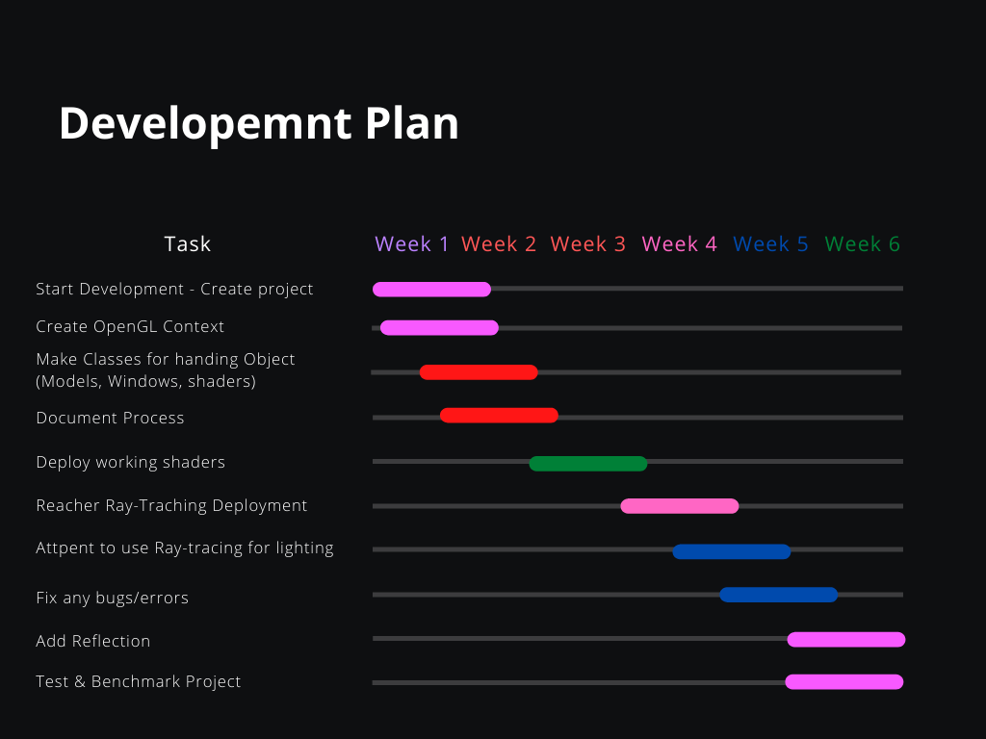

- Week 1

The first week of the project I will layout all the plans for starting development, I will start creating a C++ Project within Visual Studio and gathering resources like GLEW & GLUT for OpenGL and any other libraries that I might want to use to make development easier, I will also create a git repository for version control & back-ups in the event something goes wrong or data lose.

By the end of this week I hope to have a fully working OpenGL based project ready for development to begin

- Week 2

At the start of the second week I will start the foundations of the project make abstract classes to handle things like the Windows, Models, Shaders and Input, this week might be the most important week of development since if everything in this stage goes well it should allow for smooth integration of later classes and tools that I will need to add, this week I’d also like to start documenting progress and any resources that I find for later on in the project, this will help me develop the project in a more efficient manner.

- Week 3

In week three I would like to aim on starting work on the shaders so that I can start to render a modal and start to use basic lighting that will be used as a baseline for later on when I start to implement the ray-tracing lighting.

At the end of the week I hope to have a fully working OpenGL scene with basic lighting and some basic reflection on a simple modal, ready for ray-tracing to be used in my application.

- Week 4

On this week I plan on doing my main research on how I am going to use ray-tracing for my lighting and reflections and start planning out what I will be need add to my program in order to get it working correctly.

At the end of the week I hope to have ability to add this technique to my project and have the implementation ready to be deployed ready for testing.

- Week 5

This week I plan on using the knowledge that I gained in the week before to start developing ray-tracing lighting, this will be my main focus for this week I feel that I might have problems else where in my program and that is way I am also going to spend some of this week fixing and bug or errors that I might find with in my program, getting rid of these error at this point should make it easier for me later on if I need to adjust anything with the ray-tracing later on as well as make adding ray-traced reflection a small amount easier as well.

At the end of the week Id like to have a mostly working lighting system that can use ray-tracing to calculate the lighting and shadows if I am ahead at this point I’d like to keep going and start work on the reflection.

- Week 6

By the last week I’d hope to the parts of development into effect by making sure that there are not bugs/errors in the program that will be able cause the program to crash at this point if I am ahead reflection should be implemented but if not I would use the last of my development time to add this feature or if there was something important that I need to fix before this then I would use the last of my time for that instead.

At the end of the week I’d hope to have all my testing done and to start benchmarking the program to make sure that performance is consistent on both ray-traced and standard lighting and reflection.

