Developing Professional Practice

Name: Jayne O’Sullivan

CIPD Membership Number: 53321739

Date: 14th November 2018

Word count (max: 2500 words)

I declare that this assignment is my own work and that any information obtained from books and other sources have been appropriately referenced.

Signed Jayne O’Sullivan

Table of Contents
What it means to be an HR professional
Fig 1 CIPD Map 3
Self-Assessment, PDP & Reflection
Fig 2 Self-Assessment result 4
Chosen Areas to Develop …………………………………………………………………………………………………………………….5
PDP plan 6
Group Dynamics and Conflict Resolution 6
Fig 4 Group Dynamics Graph 6
Conflict resolution 7,8
Project Management 8,9
Refection 10
References 10

Activity 1:
Understanding what is required to be an effective and efficient HR Profesional
What it means to be an HR professional.
Within the role of HR, you are expected to operate at several different levels and undertake several different tasks, and responsibilities according to your level and status. People in senior roles such as – HR managers or HRBP’s will be involved in departmental management. Those in the middle may specialise in a particular field and have other responsibilities. Other levels such as HR officers and administrators carry out operational level tasks such as administration. Within HR development is key to the role as policy, processes and employment law is regularly being updated. And as professionals, we need to keep developing our knowledge.
The HR map CIPD (2013) a professional map (Fig 1) which has been vastly researched, is an invaluable tool for HR professionals who are looking to develop within their role, it gives you the insight into how you can develop yourself and also gives you the tools to help with this. The areas of the map are split into eight behaviors ten professional areas and four bands. Using the map is a good way of benchmarking yourself. If you want to progress to a different level the map is a good place to start. Once you have completed the self-assessment, you will have an idea of how and where you need to develop your learning. The map can help with the CPD plan, and identify which areas you need to develop and help with continued learning.

Fig 1
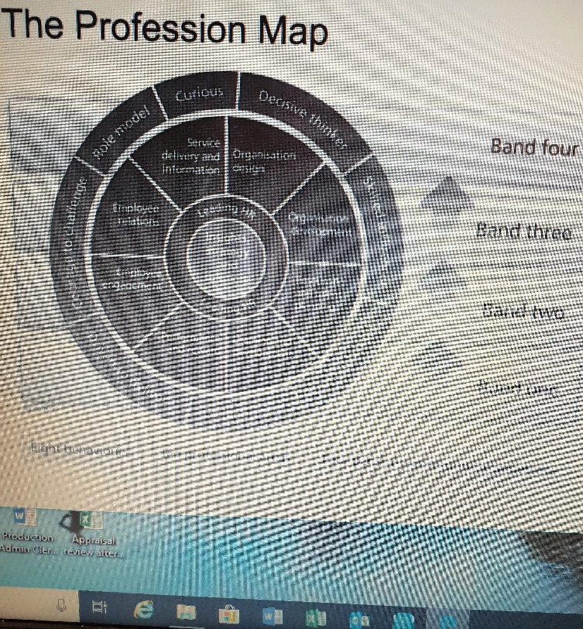

Self-Assessment, PDP & Reflection
While undertaking the self-assessment, (Fig 2) I could see I was in the correct band for the role I am doing now. I have chosen to develop myself within the following areas as listed below, I also completed another self-assessment to see where and how I would manage my learning and development to take me to my next goal. Personal development can be so rewarding and, on many occasions, we surprise ourselves, by how much knowledge we can absorb. While I was completing my PDP plan (in evidence file), I was surprised by how much I wanted to develop myself in my role as an HR assistant. when I first started at Lyte I was part of a team HR Assistant and an HRBP since January I have to take on duties within the Role of HR and start retraining to be able to undertake other responsibilities, I have been calling on HR’s I have worked with in past for support and advice. using others knowledge and expertise is key in developing yourself I have identified that working with a mentor would be very beneficial to my development needs.

Fig 2

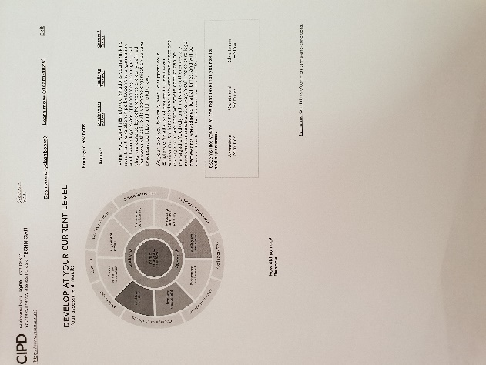

Employee relations.

Policy’ and procedures can change, so it is essential that learning and development are ongoing to be able to support managers as well as employees. Having the correct information is an essential part of the HR role. To get to the next level I have identified that to develop myself in this area I would need to work closely with department managers, and our employment law lawyer. Within this area, you'll make sure that employee relations activities are carried out in line with internal policies and practices, as well as within the law. Maintaining accurate and up-to-date documentation, information and records, in line with legislation is essential. Training and development can be achieved in various ways. I attended a law update course on the 2nd October 2018.

- Online E-learning
- Books
- Mentoring with another HR professional

Employee Engagement:
To be able to develop and learn within this area, you need to able to strengthen the connection I have with all employees I need work closely with colleagues in other departments so that employees are more fulfilled by their work and make a greater contribution towards organisational objectives; give particular attention to good leadership and management. Developing reports on employee engagement and identifying areas that complement the performance. Maintain and share information with colleagues. Working closely with staff to gauge how they feel and understand how and where improvements can be made to make the workplace a healthy environment.

Role model:
Development in this area, I would have to be able to show that I could accept responsibility and take remedial and developmental action when mistakes are made. a You would have responsibility for personal data and information, this would need to dealt I a highly professional manner and within the boundaries of relevant legislation, such as the Data Protection Act. Supporting managers to around the new GDPR rules is important to them to be able to deal with any issues that may arise.

PDP plan
Since January 2018, I have found myself in the HR role alone, since the HRBP left I had to learn more about how HR works, after meeting with the MD it was decided that the company would support me in my development. The first step of my development was to enroll onto the CIPD level 5 course. My PDP plan outlines which areas I needed to work on and how I was going to achieve this and within a realistic time frame. I will be working closely with another HR manager and my manager to adapt my plan and work out which areas I will need to develop to get me to the next level. During my meeting with my manager, we agreed on development activities. I have attended an Excel course on the 5th of November 2018. which will help with spreadsheets and understanding how they help to work out costings, how to display grafts and charts, and any information relating to absence, disciplinary meetings and Labour turnover, which has to be submitted to the Board on the first of the month. I also went onto an employment law update meeting on 2nd October 2018.
(included in evidence file)

Group Dynamics and Conflict Resolution

Fig 4
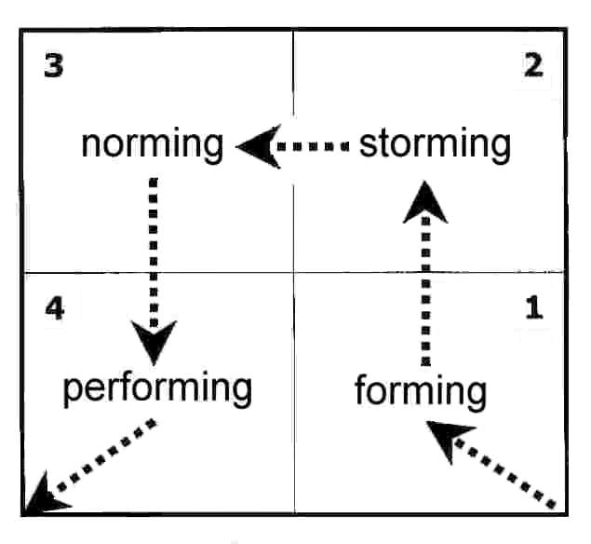

As highlighted above in (Fig 4), there are ways of capturing group dynamics and it works.
Group dynamics is a set of behavioural and psychological process. Understanding the people, you work with and how everyone is different and each can bring valuable ideas to meetings and group sessions using that person strengths will benefit the group. The diagram above can be a great tool to use, below is a breakdown of what each section means. Tuckman (1965).
Forming: this is the first stage, most in this group can be quiet and don’t offer much input, as they don’t yet fully understand the process. As a leader, you will find, that team members' roles and responsibilities have not yet been decided. This part can take some time as people start to work together, as they make an effort to get to know each other they will start to have an input into the group.
Storming: this point, is where the team will start to give some ideas, at this point, many teams might fail as different personalities can start to show. some may ask questions like, ‘why are we doing this’. And they may resist taking on tasks, you need to make sure they are engaged and are enthusiastic and start to take an interest in what you are trying to achieve.
Norming: At the norming stage, the leader, can then start delegating out the work and concentrate on the performance of the team as a whole and work out who fits where. it feels easy to be part of the team and people who decide to join in or leave won’t be able to disrupt the performance of the others. The dynamics of the group will start to come together.
Adjourning: Most teams will eventually get to this stage; project teams will only be together for a short time. Take the time to celebrate your team's achievements, as in the future they will be more likely want to be part of a team if they feel past experiences have been positive, and that their ideas have been taken on board.
While taking part in the Honey and Mumford Questionaire, I found that I was a theorist.
Which highlights that I think problems through step by step. It also showed me that I can sometimes overthink things, and want everything to be correct. I will tend to reject things that don’t fit into my rationale. (Mumford and Honey 1986) Examples of how I deal with the conflict between employees are highlighted below.

Conflict 1 Violent conduct:
1. Speak to all concerned to gather information with regards to what has happened and why.at this stage don’t try to make assumptions on what has happened.
2. Contact the company employment lawyer to check we are following the process correctly.
3. Arrange to see all witnesses and ask for a written statement. Arrange a meeting with both employees and ask for an account of what happened and why. It is important to listen and give each person the chance to give their side of the story. Discuss what the next step will be.
4. Invite both employees to a Disciplinary, allow them time to read all statements and ask questions.
5. The final decision will be made by an Investigating Officer. After listening to the employees and going over all information, The decision was to issue a written warning as this was deemed to be gross misconduct. I (HR) then sent outcome letters and advised the employees that they could appeal and they were given the name of Appeal officer.
The key to any form of Conflict resolution is to listen and use all information that states the facts and not make assumptions.

Conflict 2: Hurtful comments
1.Speak to all concerned to gather information with regards to what has happened and why
2. Speak to any witnesses if there are any.
3. Employee 1 to be spoken to find out the reason for his outburst. Why did he call employee 2 a chav?
4. Speak to Employee 2, why did he decide to take the incident further and carry on outside of work? What did he think would be achieved by his actions.
5. Review all information, arrange meetings with employees. Give decision.
6. The decision was to arrange a Mediation meeting, both were given the opportunity to express how they felt, which worked out really well as both came to understand how the other felt. Both employees listed a few questions they wanted to ask beforehand, which meant they stuck to why we were in this meeting in the first place, my role was to listen and keep the meeting calm and relevant.

Project Management.
Manning meetings:
This project is ongoing, everyone involved with this plays a key part, and participation is vital.as each person has to have input for it to go smoothly as we all know you can’t always plan for all eventualities.
In attendance:

Operations Director
Factory manager
Factory Chargehand
Production Planner.
HR Assistant

1.Operations Director. Starts off the meeting. He will explain what needs to be arranged for the following week, Manning sheets play a vital part, names and who works in each department are given out.
2. The Factory Manager will then inform everyone of any movements or changes within the lines and any issues that have risen in the previous week. He will then inform HR if any workers are needed to help with output.
3. The production Planner details which products are to be prioritised to fulfill orders, and any material issues or any changes that have been made to the planning.
4. HR will arrange for any extra workforce, conduct inductions and Health, and Safety training.
Minutes from the meeting are sent out on an email to all in attendance. Any Fixed-term contracts that are up for renewal will be discussed. Meetings take place with HR and factory chargehand, a scoring system which takes into account Absence, Disciplinary, Skills, and length of service are in place to help the Operations Manager to decide to renew or not. I will (HR) then arrange to meet with employees to either extend their contract or give the reasons for terminating. Persuading employees that this is for business needs can sometimes be difficult, more often than not they will understand.

Project 2

Containers:
As a lot of our materials come from abroad, we use container delivery for this. It is my responsibility to organise the workforce for this. I will liaise with the recruitment agency for this. Each step of this is important as we have a set time of how long the container can be on site once delivered. Any delays can result in the company accruing charges. This can be from the port authorities or the transport departments.

Step 1 Email will be received by the despatch department from the purchasing officer stating how large the container is going to be and how many staff he needs to for this job to be completed safely and on time. Communication is vital at this stage.

Step 2 An email is then sent to me to make arrangements for the staff. (example below)
Hi Jayne
Please, can we book agency workers for the rearranged container on the 25th sept for 7 am?
3 unloaders + 1 forklift driver.
Kind Regards
Darren Price
Deputy Transport Manager
Step 3 I will then raise a purchase requisition for the finance department so they know what the costs will be for the agency workers for that day.
Step 4 Contact agency to supply workers, they will send us the names.
On a few occasions, there might issue with the container being delayed at the port, we then need to arrange to find work for the agency staff until the container turns up, this then has extra cost for the company, the purchasing manager then needs to claim the money back from the shipping company. All delays have an impact, whether it be from the port side or recruitment side, all departments need to work together. On times we may need to use persuasion to work out a compromise with the Agency on the fee they charge us if we need to keep their staff
longer.

Refection

On reflection of my plan, I have identified ongoing training and I have found a mentor in another HR manager, who I will be working closely within the coming months. As I’m now the only HR within our organisation, I need to keep on top of any updates around processes and policy and employment law updates. To be able to support the managers in my workplace, I need to have all the information to hand, CIPD and ACAS have a wealth of information which I will be using to support me. My development with being continuous as my company has put their faith in me by giving me the time to attend this CIPD level 5 course, which is the start of my development.

https://www.cipd.co.uk/learn/cpd/map

https://www.businessballs.com/team-management/forming-storming-norming-performing-model-tuckman-234/

