Introduction
This dissertation asks how the relationship between form and function in Zaha Hadid’s work demonstrates her response to the “challenges and opportunities of the 21st century”? Hadid is a globally renown female architect whose influence can be seen in contemporary cities worldwide. Education was central to her upbringing and her parents, “never made a distinction between science and creativity” (ZHF, n. d). Many of Hadid’s buildings offer visual representations of this inclusive understanding of knowledge, manifest in a luxurious and sometimes fantastical engagement with form and a lesser emphasis on functionality.
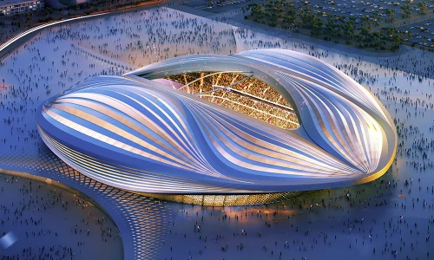

Figure 1: Zaha Hadid’s Qatar 2022 World Cup Stadium, 2015.
By her death in 2016, she was recognised as a seminal influence on the development of architecture, but this recognition came slowly, and at a price. Her innovative and ambitious design drew much criticism some of which was fuelled by the fact that she was an Iraqi female whose primary discipline was mathematics, not architecture. The public response to her work brought some of the twenty first century prejudices around gender and ethnicity to the fore yet her architecture ultimately responded to many of the opportunities that contemporary technology offered architecture.

Methodology
My methodology will include archival and scholarly research. I will use e-journals, and books available in UWTSD library as well as websites such as the Zaha Hadid Foundation archive. I will also take photographic documentation on site at some of Hadid’s London buildings. and refer to photographic material of the Generali building in Milan that I visited during Summer 2022.
Secondary research will focus on designing and distributing questionnaires and I will also survey UK based prominent architectural firms to understand the percentage of male to foreign, female employees and their status.

Aims and objectives.
- Analyse Hadid’s architectural philosophy in the context of some of her iconic buildings
- Evaluate the public response to her work across her career
- Discuss her response to the challenges she faced
- Demonstrate her importance to the development of 21st century architecture
Predictions: Hadid faced ethnic and gender-based challenges but her main challenge and achievement was popularising her efforts to re-ignite the early twentieth century “optimism and belief in new ideas”. (Zaha Hadid. 2005).

Literature review.
These articles and websites discuss racial and gender difficulties encountered by Hadid during her carrier. They analyse her design philosophies and how she developed her unique style and experimented with new technologies over time. See reference list for detail.

Limitations
Many of her buildings are abroad so I won’t be able to visit them. Questionnaire responses may well be a challenge due to the number of social media and email requests received by Joe Public and limited interest. Time management will be challenging because of the need to work on other projects simultaneously. .

Ethical considerations
Questionnaires will need to include detail on participant withdrawal and my approach to GDPR issues when collecting and using the information in my thesis.

Mid August – May submission timeline:
1-4: Establish key questionnaire remit and paperwork for ethics and participation agreements.
4 -10: Compile literature review and collate key academic sources for bibliography.
10-14: Collating and organising data from questionnaires (Excel, graphs etc).
14 - 20: Plan dissertation thesis framework.
20 - 32: Write first draft including referencing and bibliography
32 - 40: Complete final draft responding to supervisor input.

References
Hadid, Z. (2005) ‘Zaha Hadid’, Perspecta,37(famous). pp.130-135. Available at: https://www.jstor.org/stable/40482248

Zaha Hadid Foundation, n.d. About Zaha. Available at: https://www.zhfoundation.com/about-zaha-hadid/ Accessed: 1/5/2026.

Engel&Völkers, n.d. Zaha Hadid’s style and design philosophy. Available at: https://www.engelvoelkers.com/de/en/resources/zaha-hadidas-style-and-design-philosophy Accessed at: 1/5/2026

Hiesinger K. (2010) ‘Form in Motion’, Philadelphia Museum of Art Bulletin, pp.14-60. Available at: https://www.jstor.org/stable/41501092

