Robotics and Automation in Operations

Simulation-Driven Improvement of an Automated Robotic Machine-Tending Cell Using Visual Components

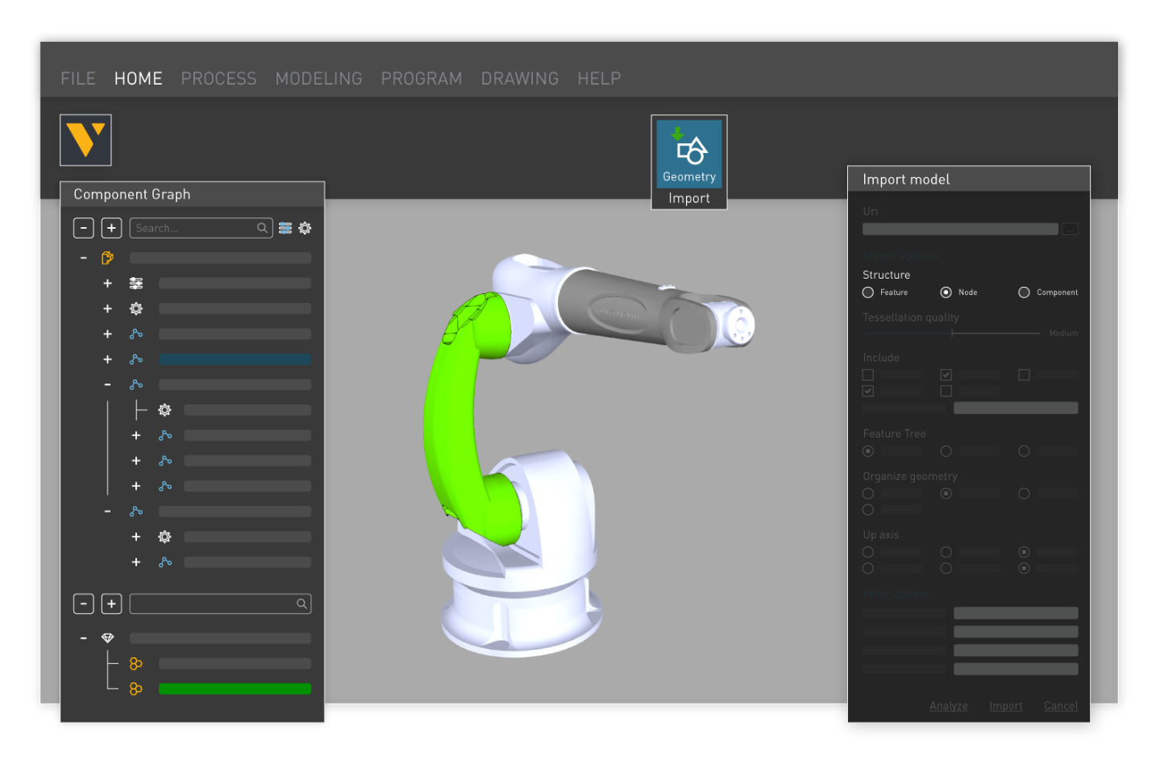

Abstract
This report presents a simulation-driven process design and optimisation study of an automated robotic machine-tending cell developed for Alpha Precision Components (APC), a Tier-1 supplier of high-performance pistons for automotive and motorsport applications. The primary objective of the study was to evaluate an initially underperforming machining system and to develop an optimised configuration through the integrated application of lean manufacturing principles, industrial robotics, and digital simulation.
An initial (“as-is”) digital model was constructed to represent a three-stage CNC machining process comprising turning, vertical milling, five-axis finishing, and manual inspection. Discrete-event simulation was employed to establish baseline performance metrics, including machine utilisation, robot activity, operator value-adding time, work-in-progress (WIP), and overall system flow. Baseline analysis revealed significant inefficiencies, with CNC utilisation below 20%, extensive blocking and starvation between operations, excessive material handling, and minimal operator value-adding activity. Despite the five-axis machining centre exhibiting the longest processing time, it was frequently starved of parts, indicating that overall system performance was constrained primarily by layout and process coordination rather than machining capacity.
A lean-informed optimisation strategy was subsequently implemented using simulation-based experimentation. Key improvements included the adoption of a compact cellular layout, centralised multi-machine robot tending, elimination of intermediate conveyors, relocation of pallet storage and inspection to reduce operator travel, and the introduction of a unified guarded perimeter to enhance safety and compliance. Comparative simulation demonstrated substantial improvements, with CNC utilisation increasing to approximately 94–96%, robot utilisation exceeding 90%, and operator value-adding activity nearly doubling. Blocking and starvation were largely eliminated and system flow was stabilised around the true bottleneck operation.
The study demonstrates the effectiveness of combining lean manufacturing concepts with simulation-driven automation design to optimise complex production systems. It highlights the value of digital modelling for virtual commissioning, risk reduction, and evidence-based decision making, and identifies opportunities for future development through digital twins, predictive maintenance, and adaptive scheduling. The findings confirm that automation alone does not guarantee performance improvement; rather, successful outcomes depend on the integrated application of lean thinking, robotics, and simulation throughout the system design process.

Contents
Abstract 2
Introduction 4
Literature Review 5
Robotics and Flexible Manufacturing Systems 5
Integration of Robots, Machine Tools, and Material Handling 5
Lean Manufacturing in Automated Environments 6
Digital Twins and Simulation 6
Safety Standards and Regulatory Frameworks 6
Methodology and Model Development 7
Case Study Context 7
Process Description 7
Original Layout (“As-Is”) 9
Data Collection, Baseline Validation, and Identification of Inefficiencies 9
Baseline Simulation Data Collection 9
Bottleneck Identification and Flow Disruption 10
Lean Waste Analysis of the Baseline System 11
Validation of Model Assumptions 11
Process Optimisation Through Lean and Simulation 12
Optimisation Strategy 12
Lean-Informed Redesign of the Cell 12
Lean Mapping of Improvements 13
Results and Comparative Analysis 14
Optimised Simulation Results 14
Comparative Performance Summary 15
Interpretation of Results 15
Safety, Ergonomics, and Regulatory Compliance 15
Critical Reflection 16
Conclusion 17
Key Findings 17
Integration of Lean, Automation, and Simulation 18
Human Factors, Safety, and System Sustainability 18
Final Remarks 18
References 20
ISO Standards Referenced 20

Introduction
Manufacturing organisations increasingly operate in environments characterised by global competition, rising customer expectations, shorter product life cycles, and sustained pressure to reduce operational costs while maintaining high levels of quality and delivery performance. These challenges are particularly acute in precision machining sectors supplying automotive and motorsport markets, where dimensional accuracy, surface finish, and repeatability are critical, and where production volumes are often high but subject to frequent design change.
Industrial robotics and automation have become central enablers of productivity and consistency in such environments. Among the most established applications is robotic machine tending, whereby industrial robots are used to load and unload CNC machine tools, transfer parts between operations, and interface with inspection or palletising stations. When effectively implemented, robotic machine tending can increase spindle utilisation, reduce manual handling, improve safety, and provide a foundation for lights-out manufacturing.
However, industrial experience consistently demonstrates that the introduction of automation does not automatically lead to improved system performance. Poorly designed layouts, excessive material handling, fragmented control logic, and weak alignment with lean manufacturing principles often result in underutilised assets, excessive work-in-progress (WIP), and unstable production flow. In many cases, organisations invest heavily in robotics only to discover that bottlenecks persist, operators remain under-utilised, and throughput falls short of expectations.
This report examines such a scenario at Alpha Precision Components (APC), a Tier-1 supplier of high-performance pistons. APC developed an automated machining cell comprising three CNC machines, industrial robots, conveyor-based material handling, and a manual inspection station to support a new turbocharged engine programme. Early simulation results indicated that the original design suffered from low throughput, excessive queuing, and unbalanced utilisation of equipment and labour.
The aim of this assessment is to apply simulation-driven process design to analyse APC’s baseline system, identify sources of inefficiency, and develop an optimised configuration aligned with lean manufacturing and industrial automation best practice. A digital model of the machining cell was constructed using Visual Components, enabling discrete-event simulation of an eight-hour production shift. Baseline performance metrics were established, lean-informed improvements were implemented, and comparative simulations were used to quantify the benefits of the redesigned system.
The objectives of this work are to:
- Critically review literature relating to robotics integration, flexible manufacturing systems, digital twins, and safety frameworks.
- Develop and validate a simulation model of APC’s robotic machine-tending operation.
- Identify bottlenecks, waste, and underutilised resources in the baseline system.
- Apply lean principles to redesign the layout and process logic.
- Quantify improvements in utilisation, flow, and operator value-adding activity.
- Evaluate trade-offs relating to safety, complexity, and operational risk.
- Reflect on the wider role of simulation in commissioning, risk reduction, and continuous improvement.
By addressing these objectives, the study demonstrates how digital simulation can be used not merely as a visualisation tool, but as a rigorous engineering method to support evidence-based decision making in automated manufacturing environments.

Literature Review

Robotics and Flexible Manufacturing Systems
Flexible Manufacturing Systems (FMS) emerged to address the need for high productivity combined with adaptability to product variation. Industrial robots are now integral components of FMS architectures, enabling automated material handling, machine tending, and inspection. Machine tending is particularly suited to robotic automation because it involves structured, repetitive tasks with relatively predictable cycle times and limited product variability (Groover, 2020).
Research consistently indicates that overall system performance in robotic machining cells is governed less by the capabilities of individual machines and more by the interactions between machines, robots, and material-handling systems (Browne et al., 2018). In poorly integrated systems, robots may wait for machines, machines may wait for robots, and parts accumulate in intermediate buffers. This leads to low effective equipment utilisation despite high installed capacity, a phenomenon often described as “hidden capacity loss”.
Multi-machine tending, whereby a single robot services multiple CNC machines, is increasingly adopted to improve capital efficiency and reduce floor-space requirements. However, this approach introduces complex scheduling and path-planning challenges. Without careful balancing of robot service times and machine cycles, multi-machine tending can exacerbate starvation and blocking. Consequently, simulation is widely used to evaluate alternative layouts and servicing strategies prior to physical implementation.

Integration of Robots, Machine Tools, and Material Handling
Modern machining cells integrate industrial robots with CNC machines, conveyors, pallet systems, and human operators. Integration typically relies on discrete I/O or industrial Ethernet networks to coordinate loading, unloading, and machine status.
Banks et al. (2019) emphasise that inadequate integration logic frequently results in excessive waiting and suboptimal sequencing, which can dominate system performance. Conveyor-based buffering is often introduced to provide perceived flexibility; however, this frequently increases transport distances and encourages overproduction in upstream processes. Effective integration therefore requires:
- Clear definition of control logic and signal handshaking.
- Alignment of robot service times with machine cycle times.
- Appropriate buffer sizing to avoid both starvation and excessive WIP.
- Consideration of human interaction for inspection and maintenance.
Simulation environments enable engineers to test these interactions virtually, reducing the risk of costly post-installation modifications.

Lean Manufacturing in Automated Environments
Lean manufacturing seeks to maximise customer value while minimising waste (Ohno, 1988; Womack and Jones, 2003). In automated machining cells, common wastes include transportation, waiting, motion, overproduction (WIP accumulation), and underutilised human capability. A persistent misconception is that automation inherently eliminates waste. In practice, automation can amplify inefficiencies if applied to poorly designed processes.
Lean automation integrates robotics with principles such as flow, line balancing, and cellular manufacturing. Cellular layouts reduce transport distances and improve visibility of bottlenecks, while line balancing aligns cycle times across operations to prevent accumulation of WIP. Standardised work ensures repeatable robot and operator tasks, supporting stability and continuous improvement.
Importantly, lean thinking emphasises designing systems around flow rather than around individual machines. This distinction is critical in robotic machining cells, where local optimisation of machine utilisation can conflict with global system performance.

Digital Twins and Simulation
Digital twins extend traditional simulation by creating virtual representations of physical systems that can be updated with operational data. Simulation platforms such as Visual Components allow engineers to model robot kinematics, material flow, and discrete-event behaviour within a single environment. Negri et al. (2017) highlight the role of digital twins in predictive analysis, virtual commissioning, and lifecycle optimisation.
In machining environments, simulation is widely used to validate robot reach, collision risks, buffer capacity, and throughput sensitivity before equipment is installed. Virtual commissioning reduces technical risk by identifying layout and control issues early, enabling evidence-based design decisions and shortening ramp-up periods.
Simulation also supports continuous improvement by allowing “what-if” experimentation without disrupting production, making it a powerful tool for ongoing operational optimisation.

Safety Standards and Regulatory Frameworks
Robotic machining cells must comply with international safety standards, notably ISO 10218 (industrial robot safety), ISO 12100 (risk assessment and reduction), and ISO 13849 (functional safety of control systems). These standards promote a hierarchy of risk reduction: inherently safe design, safeguarding, and information for use. Typical measures include perimeter guarding, interlocked access doors, emergency stop circuits, and separation of operators from robot operating envelopes.
Ergonomic considerations are also critical, particularly for manual inspection tasks in high-volume environments. Poor workstation positioning and excessive walking distances can contribute to fatigue, reduced quality, and increased risk of musculoskeletal injury. Effective system design must therefore integrate productivity, safety, and ergonomics from the outset.

Methodology and Model Development

Case Study Context
APC manufactures high-performance pistons using a three-stage CNC process supported by industrial robots and manual inspection. The objective of the simulation study was to evaluate the performance of the original proposed layout and to develop an optimised configuration capable of meeting customer demand while minimising waste and ensuring regulatory compliance.
Simulation was selected as the primary analysis tool because it allows complex interactions between machines, robots, conveyors, and operators to be evaluated quantitatively prior to physical implementation.

Process Description
The APC piston manufacturing process is configured as a sequential, multi-stage machining operation comprising three CNC processes followed by manual inspection and palletisation. Each part enters the system as a raw piston blank and progresses through turning, milling, and five-axis finishing before being released for quality inspection and storage. Although conceptually linear, the process exhibits complex interactions between machines, robots, conveyors, and the inspection operator, making it well suited to discrete-event simulation.
Within the Visual Components environment, the manufacturing sequence was modelled to reflect realistic industrial practice, including robot handling delays, material transfer, and operator movement. The process flow is summarised as follows:
Part Arrival and Infeed
Raw piston blanks enter the system via an inlet conveyor at intervals ranging between 200 and 210 seconds. This arrival pattern represents upstream supply variability and prevents the model from behaving as a perfectly deterministic system. Introducing variability at the point of entry is important, as real manufacturing systems rarely experience perfectly regular arrivals, and small fluctuations can propagate downstream to create significant performance effects.
Upon arrival, parts accumulate at the infeed buffer awaiting robot collection. In the baseline configuration, this buffer acts as the first decoupling point between supply and processing capacity.
Operation 1 – Turning (CNC Lathe)
The first machining operation involves external and internal turning on a CNC lathe. The robot assigned to Operation 1 collects a raw blank from the inlet conveyor and loads it into the lathe fixture. Once clamped, the machining cycle commences automatically.
Turning time was modelled using a normal distribution with a mean of 3.5 minutes and a standard deviation of 12 seconds. This reflects realistic variation arising from tool engagement, chip evacuation, and minor control delays. Following completion of the turning cycle, the robot unloads the semi-finished component and places it onto the first transitional conveyor.
This stage establishes the initial geometry of the piston and is critical in determining downstream dimensional accuracy. Any delay at this stage directly affects the availability of parts for subsequent operations.
Intermediate Transfer and Buffering
After turning, parts are transferred via a transitional conveyor to Operation 2. In the original configuration, this conveyor also functions as a buffer, allowing parts to queue when the downstream VMC is unavailable. While buffering provides a degree of decoupling between processes, it also introduces transportation waste and encourages work-in-progress accumulation.
The length and speed of the conveyor were explicitly modelled to account for transfer time (500 mm/s), meaning that parts do not instantaneously appear at the next machine. This transfer delay, although individually small, contributes cumulatively to cycle time and becomes significant when queues form.
Operation 2 – Milling (Vertical Machining Centre)
At the second stage, a dedicated robot collects parts from the transitional conveyor and loads them into the VMC. This operation includes milling of flats, drilling of pin bores, and creation of oil galleries. The VMC cycle time was modelled with a mean of 2.0 minutes and a standard deviation of 6 seconds.
Following completion of milling, the robot unloads the part and places it onto a second transitional conveyor, which again acts as both a transport mechanism and a buffer.
Although the VMC has a shorter average machining time than both the lathe and five-axis machine, its effective utilisation in the baseline system is strongly influenced by upstream delivery delays and downstream congestion.

Operation 3 – Five-Axis Finishing
The third machining stage is performed on a five-axis machining centre responsible for crown profiling and skirt finishing—critical features affecting piston performance and durability. This operation represents the longest processing time in the system, with a mean of 4.0 minutes and a standard deviation of 18 seconds.
A third robot loads parts from the second transitional conveyor into the five-axis machine. Due to its longer cycle time, this operation has the potential to act as the natural bottleneck of the process. However, in the baseline layout, the five-axis machine was frequently starved of parts due to upstream handling inefficiencies, preventing it from operating at its theoretical capacity.
Upon completion, the robot unloads the finished piston and transfers it to the outlet conveyor.

Finished Part Transfer and Manual Inspection
Completed pistons are conveyed to the manual inspection station, where a human operator collects parts for dimensional verification and visual inspection. Inspection time was modelled using a normal distribution with a mean of 2.5 minutes and a standard deviation of 30 seconds, representing variability in measurement activities and operator handling.
Following inspection, acceptable parts are placed onto finished goods pallets. In the original configuration, pallet storage was physically separated from the inspection station, requiring the operator to walk between locations. Operator walking speed was modelled explicitly, distinguishing between loaded and unloaded movement, allowing quantification of non-value-adding travel time.

Operator Interaction and Material Handling
The operator’s role is limited to inspection and palletisation; however, their effectiveness is heavily influenced by layout. In the baseline model, significant walking distances reduced inspection throughput and resulted in long idle periods when parts were unavailable.
By modelling the operator as an active resource with defined movement speed and task logic, the simulation captured the true value-adding ratio of inspection activities, rather than assuming inspection capacity to be infinite.

Original Layout (“As-Is”)

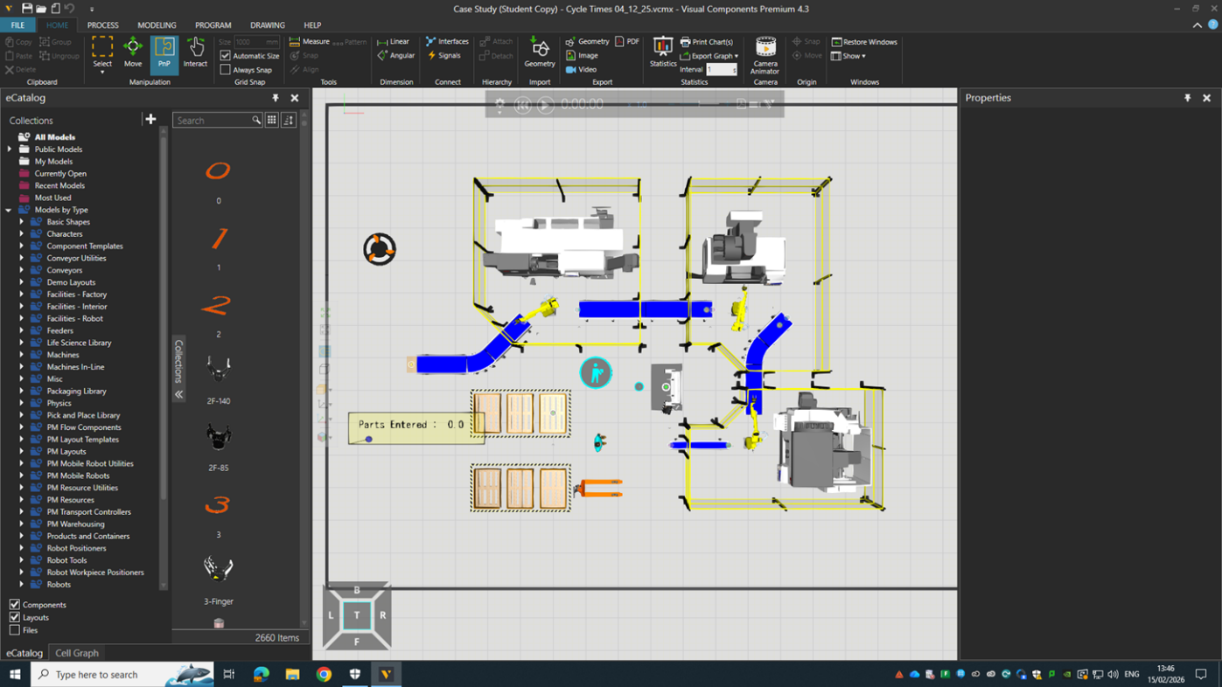
Figure 1 – Original APC machine-tending layout (Visual Components)
The baseline layout employed three industrial robots (one dedicated to each CNC machine), multiple transitional conveyors, and a centrally located manual inspection station.
This configuration reflected a traditional automation approach in which individual machines are automated independently rather than integrated into a coherent production cell.

Data Collection, Baseline Validation, and Identification of Inefficiencies

Baseline Simulation Data Collection
Following construction of the initial (“as-is”) model in Visual Components, the system was simulated over an eight-hour production shift to establish baseline performance metrics. Statistical monitoring components were configured to capture:
- CNC machine utilisation (busy, idle, blocked states)
- Robot utilisation
- Operator activity states
- Work-in-progress (WIP) levels
- Flow interruptions (blocking and starvation)
These outputs provided quantitative insight into how effectively resources were being deployed and how material flowed through the system.

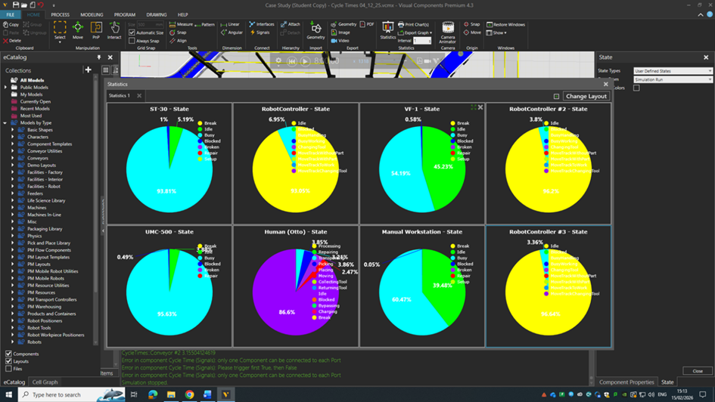
Figure 2 – Baseline system statistics (Visual Components)
The baseline statistics revealed extremely low effective utilisation across most resources. The CNC machines were productive for only approximately 14–16% of the available shift time, while the robots were idle or blocked for over 80% of the simulation period. The manual inspection operator exhibited less than 10% value-adding activity, with the majority of time spent waiting for parts or walking between locations.
Such results clearly indicate that the system was not constrained by machining capacity alone, but by poor coordination between resources and excessive material handling.

Bottleneck Identification and Flow Disruption
Although the five-axis machining centre had the longest individual processing time (mean 4.0 minutes), it was frequently starved of parts in the baseline configuration. This indicates that the dominant constraint was not the machine itself, but the upstream logistics and robot servicing strategy.
This phenomenon is well documented in discrete-event simulation literature, where poor integration between machines and handling systems leads to artificial bottlenecks created by waiting and blocking rather than true capacity limitations (Banks et al., 2019).
In the APC system, several interacting factors contributed to this condition:
- Dedicated robots per machine resulted in poor synchronisation between operations.
- Transitional conveyors introduced significant transport delays and queue formation.
- Parts followed a zig-zag routing path between spatially separated machines.
- The inspection operator was physically remote from finished goods pallet storage, increasing walking time.
These characteristics prevented the establishment of continuous flow and caused significant accumulation of WIP between operations.

Lean Waste Analysis of the Baseline System
Using lean manufacturing terminology, the baseline system exhibited multiple forms of waste:

Transportation Waste
Parts were transferred multiple times via conveyors between machines arranged in a dispersed layout. This resulted in long transfer distances and non-value-adding movement.

Waiting
Machines frequently waited for robots, robots waited for machines, and the inspection operator waited for finished parts. Waiting was the dominant contributor to lost productive time.

Motion
The operator travelled significant distances between the inspection station and pallet storage, increasing fatigue and reducing effective inspection time.

Overproduction (Excess WIP)
Parts accumulated in queues upstream of each CNC machine, particularly before the five-axis centre, masking underlying flow problems.

Underutilised Human Capability
The inspection operator spent most of the shift idle or blocked, indicating poor integration of manual processes within the automated cell.
Collectively, these wastes resulted in a system that appeared automated but performed far below its theoretical capacity.

Validation of Model Assumptions
Model assumptions regarding machining times, robot speeds, and inspection durations were benchmarked against values reported in industrial automation literature and were found to be representative of typical CNC machine-tending applications (Groover, 2020). The observed behaviour of the model—particularly the emergence of starvation and blocking—was consistent with published case studies of poorly integrated robotic cells (Browne et al., 2018).
This provided confidence that the simulation accurately reflected realistic system dynamics and could therefore be used as a basis for optimisation.

Process Optimisation Through Lean and Simulation

Optimisation Strategy
The optimisation approach was guided explicitly by lean manufacturing principles and focused on improving flow rather than maximising individual machine utilisation.
The primary objectives were to:
- Minimise transport distances.
- Reduce WIP and intermediate buffering.
- Balance resource utilisation across the cell.
- Increase operator value-adding time.
- Improve safety and ergonomics.

Rather than incrementally modifying the existing layout, a more radical redesign was adopted, transforming the system into a compact cellular manufacturing arrangement.

Lean-Informed Redesign of the Cell
The redesigned (“to-be”) configuration implemented the following key changes:

Centralised Robot Tending
A single centrally located robot was configured to service all three CNC machines. This enabled true multi-machine tending and eliminated hand-offs between separate robots.

Compact Cellular Layout
The lathe, VMC, and five-axis machine were repositioned in close proximity around the robot, forming a cohesive production cell.

Elimination of Transitional Conveyors
Intermediate conveyors were removed, and parts were transferred directly between machines by the robot, dramatically reducing transport time and WIP.

Relocation of Pallet Storage and Inspection
Finished goods pallets and the inspection station were repositioned adjacent to the cell, significantly reducing operator walking distance.

Unified Safety Enclosure
A single guarded perimeter enclosed the entire machining cell, simplifying safeguarding and improving compliance with ISO 10218 and ISO 12100.

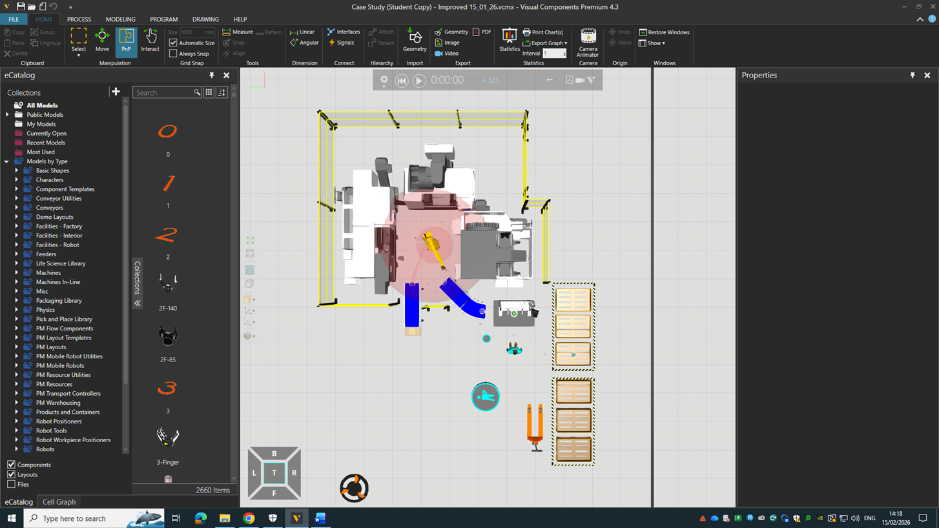
Figure 3 – Optimised APC machining cell (Visual Components)
This redesign reflects the principles of cellular manufacturing and flow, replacing fragmented automation with an integrated production system.

Lean Mapping of Improvements
The design changes can be directly mapped to lean principles as shown below:

Design Change | Lean Principle
Central robot tending three machines | Line balancing
Compact CNC arrangement | Flow
Removal of intermediate conveyors | Transportation waste elimination
Local pallet storage | Motion reduction
Unified safety enclosure | Standardised work

Importantly, these improvements required no additional CNC machines and only reconfigured existing automation assets, demonstrating that substantial performance gains can be achieved through system design rather than capital expansion.

Results and Comparative Analysis

Optimised Simulation Results
Following implementation of the redesigned layout and control logic, the system was re-simulated over an eight-hour shift.
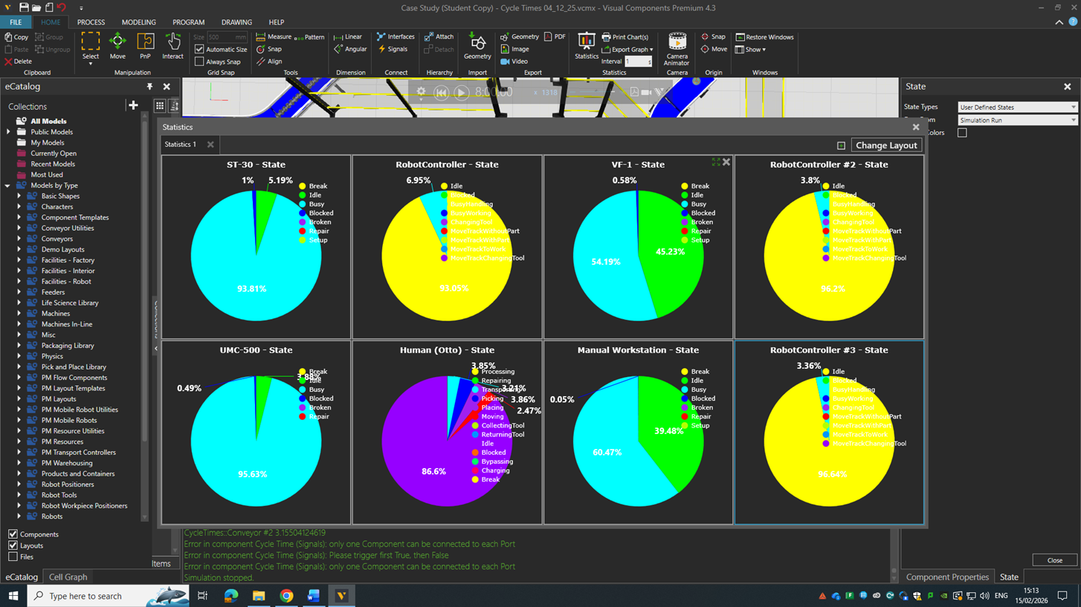
Figure 4 – Optimised system statistics (Visual Components)

The optimised model demonstrated dramatic performance improvements:
- Lathe utilisation increased from approximately 14% to around 94%.
- Five-axis machining centre utilisation increased from approximately 16% to around 96%.
- Robot utilisation exceeded 90%, indicating near-continuous productive activity.
- Operator value-adding time increased from approximately 7% to around 13–14%.
- Blocking and starvation were largely eliminated, and WIP was significantly reduced.
These results represent order-of-magnitude improvements achieved primarily through layout redesign and improved integration, rather than increased machining capacity.

Comparative Performance Summary
A summary comparison between baseline and optimised configurations is shown below:
Metric | Baseline | Optimised | Improvement
ST-30 Utilisation | ~14% | ~94% | +80%
UMC-500 Utilisation | ~16% | ~96% | +80%
Robot Utilisation | ~14% | >90% | +75%
Operator VA Ratio | ~7% | ~13% | +6%
Blocking | High | Minimal | Eliminated

The results confirm that the original system was constrained primarily by layout and coordination rather than machining capacity.

Interpretation of Results
The optimised system achieved continuous flow through the machining cell, with the five-axis centre acting as the true bottleneck. This aligns with lean theory, which emphasises designing systems around the constraint rather than attempting to maximise utilisation everywhere.
By eliminating conveyors and consolidating robot servicing, the redesigned cell synchronised machine cycles and reduced variability in part transfer times. This stabilised production and enabled higher overall equipment effectiveness.
The increase in operator value-adding time demonstrates improved integration of manual inspection within the automated process, rather than treating it as an isolated activity.

Safety, Ergonomics, and Regulatory Compliance
Safety is a fundamental consideration in the design and implementation of automated manufacturing systems, particularly those involving industrial robots and high-speed CNC machinery. In the APC machining cell, the original layout presented several safety and ergonomic concerns, including dispersed robot work envelopes, multiple access points, and significant operator walking between inspection and pallet storage. These conditions increased the potential for human–machine interaction and introduced unnecessary manual handling.
The optimised cell design addressed these concerns through a unified guarded perimeter that encloses the entire machining cell. This approach aligns with ISO 10218 requirements for safeguarding industrial robots by providing physical separation between personnel and moving machinery. Access to the cell is controlled through interlocked gates, ensuring that robot motion is inhibited when operators enter the guarded area.
Ergonomic improvements were realised through relocation of the inspection workstation and finished-goods pallet storage to positions adjacent to the machining cell. In the baseline configuration, the operator was required to traverse significant distances while carrying finished parts, contributing to fatigue and increasing the risk of musculoskeletal injury. The optimised layout substantially reduced walking distances and manual handling, enabling the operator to focus on inspection tasks rather than material transport.
The integration of safety and ergonomics within the optimisation process demonstrates that productivity improvements need not be achieved at the expense of workforce wellbeing. On the contrary, the simulation results show that safety-informed layout design can support both improved operational performance and enhanced working conditions.
In addition, the reduction in WIP and removal of intermediate conveyors simplifies housekeeping and improves visibility across the cell, further contributing to a safer working environment. Fewer accumulation points reduce the likelihood of parts falling, being mishandled, or obstructing walkways. These factors collectively support compliance with broader workplace safety expectations beyond formal robotic standards.
Overall, the optimised design illustrates how safety considerations can be embedded within lean automation initiatives, rather than treated as constraints imposed after productivity decisions have been made. By addressing safety, ergonomics, and flow concurrently, the APC case study demonstrates a holistic approach to system design that is consistent with modern industrial best practice.

Critical Reflection
This study highlights several important lessons regarding the design and optimisation of automated manufacturing systems.
Firstly, it reinforces the principle that automation alone does not guarantee improved performance. In the baseline APC configuration, substantial investment in CNC machines and industrial robots resulted in extremely low utilisation and poor flow due to fragmented layout and rigid control logic. Dedicated robots per machine created localised optimisation but failed to support system-wide performance, illustrating a common pitfall in automation projects where individual assets are prioritised over end-to-end process flow.
Secondly, the work demonstrates the central importance of layout in determining system behaviour. The original dispersed arrangement of machines and conveyors created long transfer paths and multiple buffering points, which amplified variability and obscured the true bottleneck. The lean-informed cellular redesign, by contrast, restored visibility of the constraint and enabled synchronisation of operations around it. This outcome aligns strongly with lean manufacturing theory, which emphasises designing systems around flow rather than isolated processes.
Thirdly, the study illustrates the value of simulation as an engineering decision-support tool. Without Visual Components, APC may have commissioned a system that appeared technically sophisticated but performed poorly in practice. Simulation enabled virtual commissioning of alternative designs, providing quantitative evidence of bottlenecks, waste, and utilisation before physical implementation. This capability is particularly valuable in capital-intensive environments, where post-installation modifications can be costly and disruptive.
The integration of the human operator within the simulation model also proved critical. Treating inspection as a finite-capacity process with explicit walking and handling activities revealed inefficiencies that would have been invisible in a purely machine-focused analysis. This reinforces the importance of socio-technical perspectives in automation design, recognising that people remain integral to production systems even in highly automated environments.
However, the optimisation process also introduced new considerations. Centralising robot tending increased reliance on a single robotic resource, creating a potential single point of failure. While this risk is mitigated by improved maintenance access and clearer safety zoning, it highlights the need for robust preventive maintenance strategies and contingency planning in highly integrated cells.
Finally, the study underscores the complementary relationship between lean manufacturing and digital simulation. Lean provided the conceptual framework for identifying waste and guiding redesign, while simulation supplied the quantitative evidence needed to evaluate design alternatives. Neither approach alone would have been sufficient to achieve the observed performance gains.

Conclusion

Key Findings
This study set out to evaluate and optimise an automated robotic machine-tending cell through the integrated application of lean manufacturing principles and simulation-driven process design. Using Visual Components as a digital modelling platform, both baseline (“as-is”) and optimised (“to-be”) system configurations were developed and analysed to quantify improvements in utilisation, flow, and operator effectiveness.
The baseline simulation revealed severe underutilisation of critical resources, with CNC machines operating at approximately 14–16% utilisation, robots idle or blocked for the majority of the shift, and the inspection operator achieving less than 10% value-adding activity. Despite substantial capital investment in automation, the original system exhibited excessive work-in-progress, fragmented material flow, and artificial bottlenecks created by poor layout and rigid control logic. These findings clearly demonstrated that system performance was constrained primarily by integration and coordination rather than machining capacity.
Application of lean manufacturing principles—specifically flow, cellular layout, line balancing, and waste elimination—enabled a fundamental redesign of the machining cell. The optimised configuration replaced dispersed machines and multiple dedicated robots with a compact cellular layout and centralised multi-machine robot tending. Intermediate conveyors were eliminated, transfer distances were reduced, and inspection and pallet storage were repositioned to minimise operator walking. Safety was simultaneously enhanced through implementation of a unified guarded perimeter.
Comparative simulation demonstrated order-of-magnitude improvements across key performance metrics. CNC utilisation increased to approximately 94–96%, robot utilisation exceeded 90%, operator value-adding activity nearly doubled, and work-in-progress was significantly reduced. Blocking and starvation were largely eliminated, and production flow was stabilised around the five-axis machining centre as the true system constraint. Crucially, these gains were achieved without additional CNC machines, illustrating that substantial productivity improvements can be realised through system redesign rather than capital expansion.

Integration of Lean, Automation, and Simulation
A central contribution of this study is the demonstration of how lean manufacturing, robotics, and digital simulation can be integrated to support evidence-based system design. Lean principles provided the conceptual framework for identifying waste and guiding redesign, while simulation supplied the quantitative evidence needed to evaluate alternative configurations and validate improvement strategies.
The results reinforce the principle that automation alone does not guarantee performance improvement. In the baseline configuration, advanced robotics coexisted with extremely poor utilisation due to fragmented layout and localised optimisation. Only when lean concepts were applied at the system level—prioritising flow over individual machine efficiency—were the benefits of automation fully realised.
Simulation played a critical role in enabling this integration. Visual modelling of resource interactions exposed hidden constraints and emergent behaviours that would have been difficult to predict using traditional static analysis. Virtual commissioning of the optimised layout reduced technical risk and provided confidence in design decisions before physical implementation. This highlights simulation as a powerful enabler of digital engineering and continuous improvement in modern manufacturing environments.

Human Factors, Safety, and System Sustainability
The study also emphasises the importance of incorporating human factors and safety considerations within automated system design. By explicitly modelling the inspection operator and analysing walking distances and task allocation, the optimisation process improved not only machine performance but also operator value-adding activity and ergonomics.
The redesigned cell demonstrates how safety and productivity objectives can be addressed concurrently. Implementation of a unified guarded perimeter improved compliance with international robotic safety standards while simultaneously supporting more compact layout and improved flow. Reduced manual handling and simplified material routes further enhanced workplace safety and sustainability.
These outcomes underline the socio-technical nature of automation: people remain integral to production systems, even in highly automated environments. Effective design therefore requires balanced consideration of machines, robots, material handling, and human operators.

Final Remarks
In conclusion, this study demonstrates the transformative potential of simulation-driven process design when combined with lean manufacturing principles and industrial robotics. By shifting focus from individual machines to system-wide flow, the optimised APC machining cell achieved dramatic improvements in utilisation, stability, and operator effectiveness.
The work confirms that digital simulation is not merely a visualisation tool but a rigorous engineering methodology that supports risk reduction, informed decision making, and sustainable manufacturing system design. As production environments become increasingly automated and complex, such approaches will play an essential role in enabling organisations to achieve operational excellence.

References
Banks, J., Carson, J.S., Nelson, B.L. and Nicol, D.M. (2010) Discrete-Event System Simulation. 5th edn. Harlow: Pearson Education.
Groover, M.P. (2022) Automation, Production Systems, and Computer-Integrated Manufacturing. 5th edn. Harlow: Pearson Education.
Negri, E., Fumagalli, L. and Macchi, M. (2017)
‘A review of the roles of digital twin in CPS-based production systems’, Procedia Manufacturing, 11, pp. 939–948.
Ohno, T. (1988) Toyota Production System: Beyond Large-Scale Production. New York: Productivity Press.
Womack, J.P. and Jones, D.T. (2003)
Lean Thinking: Banish Waste and Create Wealth in Your Corporation. 2nd edn. London: Free Press.
Browne, J., Dubois, D., Rathmill, K., Sethi, S.P. and Stecke, K.E. (2018)
‘Classification of flexible manufacturing systems’, FMS Magazine, 2(2), pp. 114–117.

ISO Standards Referenced
International Organization for Standardization (2010)
ISO 12100: Safety of machinery — General principles for design — Risk assessment and risk reduction.
International Organization for Standardization (2025)
ISO 10218-1: Robotics — Safety requirements — Part 1: Industrial robots.
International Organization for Standardization (2025)
ISO 10218-2: Robotics — Safety requirements — Part 2: Industrial robot applications and robot cells.
International Organization for Standardization (2023)
ISO 13849-1: Safety of machinery — Safety-related parts of control systems — Part 1: General principles for design.

