5/12/2026
Osian Murphy (2405124)

Cyber Assignment

Contents
Identification of Modern Threats 2
RaaS (Ransomware as a Service) 2
Vishing (AI Voice Scams) 2
Supply Chain Attacks 2
Cloud Risks 2
Hybrid Work Risks 2
Modern Security Policies 3
Policy 1 3
Policy 2 3
Policy 3 3
Policy 4 4
Policy 5 4
Conclusion 4
Technical Mitigation Measures 4
MFA (Multi-Factor Authentication) 4
SIEM (Security Information and Event Management) 5
Backup Strategy 5
Cloud Security Posture Management (CSPM) 5
Conclusion 5
Proactive Monitoring and Incident Response 6
Monitoring 6
Automated Incident Response 6
Ransomware Attack Response Example 6
Flow Chart 7
Continuous Training and Awerness 9

Identification of Modern Threats

RaaS (Ransomware as a Service)
RaaS is where a threat actor would purchase/rent a ransomware build from the developers of it, to perform an attack on a company, an example of this would be Lockbit Ransomware. RaaS matters to Vigilant Trust & Asset Management (VTAM) because the threat actor could encrypt and steal financial records, and demand payment. If payment is not received, data loss would occur, aswell as if the ransomware supports file uploading, the financial records would end up on a leak site/available for purchase from the threat actor. This event would cause downtime in the company, financial loss aswell as damage to the companies reputation.

Vishing (AI Voice Scams)
Vishing is the process of using fake emails or AI generated voice calls to socially engineer an employee. Vishing is the process of using an AI generated voice to impersonate someone, whereas phishing is using fake emails to socially engineer employees of a company. This matters because it could lead to infection of a computer or leaking of internal logins. This is important to VTAM because it could lead to unauthorized account access, fraud, or data breaches.

Supply Chain Attacks
A supply chain attack is where a threat actor targets a trusted third party service or software to gain access to companies. A recent example of a supply chain attack would be the Discord Zendesk attack. Zendesk is the support ticket service which was attacked and suffered a data breach. It contained Discord’s users tickets which sometimes contained personal information. Supply chain attacks matter to VTAM because VTAM relies on external software aswell as cloud vendors, which could bring vulnerabilities. The potential impact of a supply chain attack is that an attacker could gain indirect access to internal systems aswell as sensitive internal data.

Cloud Risks
Cloud risks are usually risks which include misconfigured storage, weak access controls and exposed services in cloud platforms. This matters because VTAM likely is storing financial records or customer information in a cloud environment. Misconfigurations in storage and these cloud risks could expose private data to anyone who looks around, or allow unauthorized access to internal systems.

Hybrid Work Risks
Hybrid Work Risks are where there are security risks introduced when working from home and performing remote access, using personal devices and unsecure home networks. This matters because someone working from home could access the company network on an unsecure network, or access the company network on a compromised device, allowing the infection to spread onto company networks. The potential impact of hybrid work is that it can increase opportunities for a threat actor to perform credential theft, infecting the company network with malware, and increase the risk of unauthorized access.

Modern Security Policies
VTAM should implement a few modern security policies based on the Zero Trust model. The Zero Trust model is where no user, nor device is automatically trusted. The policies should align with frameworks like the NIST Cybersecurity Framework and International Organization for Standardization ISO27001 to improve the protection and detection aswell as response abilitys.

Policy 1
The first policy should be MFA (Multifactor Authentication). VTAM should require MFA for every employee account on the network, especially for administrative accounts, cloud services and remote access, as it will support the Zero Trust principle by requiring users to provide multiple forms of authorization before allowing them onto the company network. Implementing MFA will help to reduce the risk of compromised passwords being used by threat actors.

Policy 2

The second policy should be only allowing users to access the data or systems that their job role requires. This is called Least Privilage Access. This policy aligns with the Zero Trust principles by limiting the employees access to unnecessary data that is not required for their job role. This will help to reduce the risk of insider threats aswell as compromised accounts because if an account is compromised while having access to everything, then the threat actor with access to this compromised account, now has access to everything.

Policy 3
The third policy should be that VTAM will ensure that passwords meet a minimum length, complexity and regularly changing the password to login. VTAM should also prevent employees from using the same password across multiple systems. Not allowing employees to use the same password will help with reducing the likelihood that if one password is compromised, then it would prevent the threat actor from accessing other systems with the same password. This policy will help with reducing the risk of credential stuffing attacks and brute forcing.

Policy 4
The fourth policy will be to do with BYOD (Bring Your Own Device). This policy will require employees who are working remotely to use a secure VPN connection, aswell as using company approved devices instead of their own personal devices. If an employee is to use a personal device, then it should comply with the companys security requirements before being allowed to access the network. This will help to secure hybrid working environments, and to reduce the risk of an insecure device accessing the network and spreading malware (if the device has malware).

Policy 5
The fifth policy will be to ensure there is an awerness to security. VTAM should provide the employees with training on common cybersecurity practices, including phishing simulations and provide training for awerness to social engineering. The employees should be trained to be able to recognise suspicious emails, links and phone calls. This will improve the employees security awerness, and will help to reduce how many successful phishing attacks their may be on the company.

Conclusion
In conclusion, these policies support a Zero Trust framework by continuously verifying the employees to ensure they aren’t a threat actor using a compromised account, restricting access to only the requirements of the job role, and improving overall organisational resilience against modern cyber attacks.

Technical Mitigation Measures
VTAM should introduce a multitude of technical aswell as administrative security measures to reduce the likelihood of a cyberattack. The measures that VTAM implements should coincide with the Zero Trust principles, aswell as modern cybersecurity practices.

MFA (Multi-Factor Authentication)
VTAM should implement MFA across their services, including on user accounts, cloud services, administrators accounts and remote access systems. MFA requires users to go through a verification system to prove they really are who they say they are, reducing the likelihood of accounts being compromised by adding multiple layers of security. VTAM should implement this onto accounts with privileged access, and instead of using an SMS number, VTAM should use an authenticator app such as Google Authenticator. Implementing MFA would reduce the risk of accounts being compromised with stolen credentials, as it will require the employee to get a one time code that changes every 30 seconds to verify.

SIEM (Security Information and Event Management)
VTAM should introduce a SIEM platform to collect and analyze security information and logs from servers, endpoints, cloud systems and firewalls. SIEM systems can detect behaviour that is deemed suspicious, such as login failures, malicious activity or unusual network traffic. For implementation, VTAM should centralize the log collection, configure automated alerts and monitor events continuously by employing a security team. This will improve the companies ability to monitor threat detection, and improve the incident response capabilities.

Backup Strategy
VTAM should perform regular encrypted backups of critical data that keeps the business operating, and also sensitive customer information. These backups should be offline to protect against ransomware attacks. Backups should be used as if the company is hit by a ransomware attack, not all data will be lost, critical infrastructure will be able to be restored due to there being a backup. The implementation should be that VTAM should perform daily automated backups of critical company data, store the backups in an offline location or on immutable cloud storage, and VTAM should regularly do test restoration procedures.

Cloud Security Posture Management (CSPM)
VTAM should implement CSPM tools to monitor the configuration of the cloud, and identify any security vulnerabilities to the company. CSPM systems are designed to help detect any misconfiguration in storage, weak permission setups, and any exposed services. The implementation for CSPM would be to continuously scan cloud environments, enforce secure configuration baselines, and also generate alerts for any cloud settings that are deemed risky. This will improve security in hybrid and cloud-based environments.

Conclusion
By VTAM implementing these administrative and technical tools, the company could significantly reduce the chance of a successful cyber attack, while also improving the companies ability to detect, respond and recovery capabilities.

Proactive Monitoring and Incident Response
VTAM should implement continuous monitoring aswell as an structured incident response process. This will allow VTAM to quickly detect, contain and then recover from a cyber attack, for example ransomware attacks.

Monitoring
VTAM should use SIEM platforms to continuously monitor any logs or security events from endpoints, cloud services, firewalls and servers. The system should generate automated alerts whenever it detects suspicious behaviour, an example of such suspicious behaviour would be continuous login failures, network activity which is outside the normal company activity, or any malware execution. Security analysts should monitor any alerts 24/7 to ensure that any threat that may come up, is identified quickly, and a response is deployed.

Automated Incident Response
VTAM should implement an automated incident response (SOAR) technology to automatically complete repetitive security tasks and improve the response times. SOAR systems are able to automatically isolate an infected device, block any malicious IP addresses, and create incident tickets for security teams. Using a SOAR system will reduce the manual workload placed onto the security team, and also improve the efficiency of responses during any cyber incidents.

Ransomware Attack Response Example
If a ransomware attack is detected, any infected devices should be immediately isolated from the network to prevent any further infections. The next step, the security team should then proceed with investigating the affected systems, remove any malicious files, use the data backups to restore functionality, reset any compromised credentials, it would be good practice to reset all credentials of the affected machines, and then notify the management, and any affected stakeholders. Companies are obligated to disclose the attack to the public if any customer data is stolen or accessed.

Flow Chart
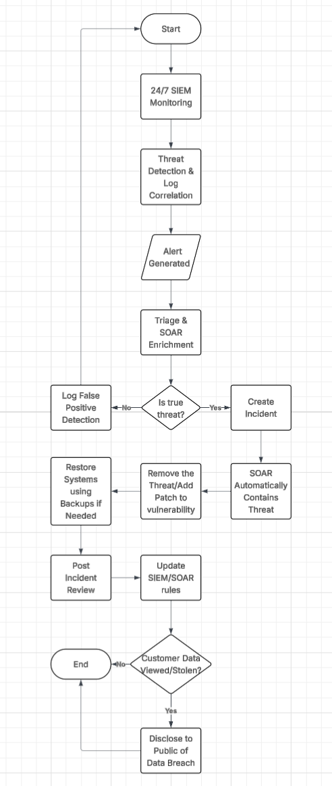

Continuous Training and Awerness
VTAM should introduce a programme that will provide employees continuos training and awareness to help reduce the risk of human related security incidents like phishing, ransomware execution and attacks via social engineering to gain credentials. The programme is created to make sure that all employees of VTAM keep a basic understanding of what the current cyber threats are, and how to respond to a potential attack appropriately.
The programme will be delivered through short regular modules that will take a few minutes of an employees day, rather than a one-off session annually. It will keep the employees engaged by providing multiple choice quizzes, aswell as periodic refresher courses, that will cover topics like keeping passwords secure, recognizing a phishing email, safe use of cloud services and handling sensitive data properly. This approach will ensure that the knowledge necessary is reinforced over time, rather than annually.
The training programme will have simulated attack exercises, to make sure that it is up to date with modern threats. These simulated attacks will include threats such as vishing, where the employees will be tested on their ability to detect if they are being socially engineered and phishing emails, to see if an employee could recognise a malicious email. The results from these simulations will be used to identify the weaker areas, and then provide a more targeted approach on the weaker areas, to reinforce them.
Security awareness will be further reinforced by use of internal communications, like email alerts, posters, and brief updates explaining recent threats in the wider industry. The employees will be encouraged to report any suspicious activity using a clear and simple reporting process.

Zero Trust
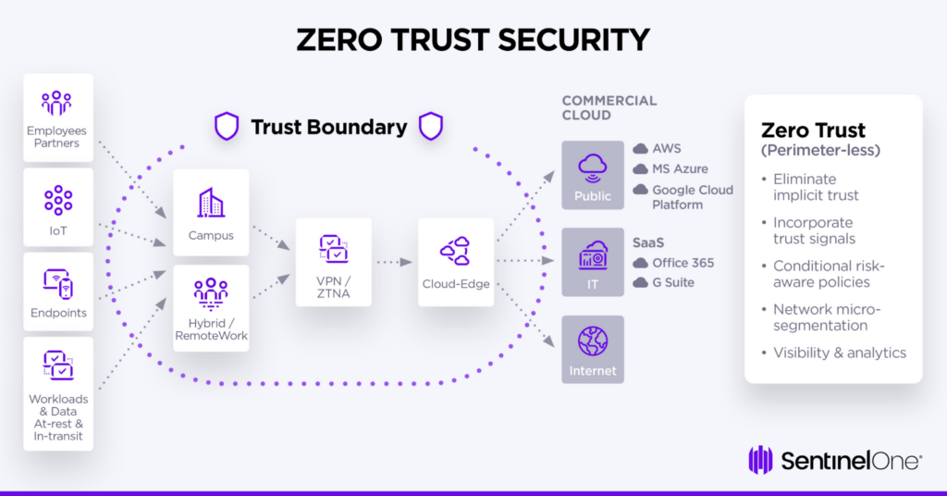
Zero Trust is a rule in cybersecurity, it means to never trust, and to always verify. Instead of blindly trusting anyone within the organizations network, it will treat every user, and device as a potential threat. It will constantly check the identity of employees within the network, and will only give you exact access to do your job. This is used to prevent threat actors from having access to everything if one credential is compromised.

