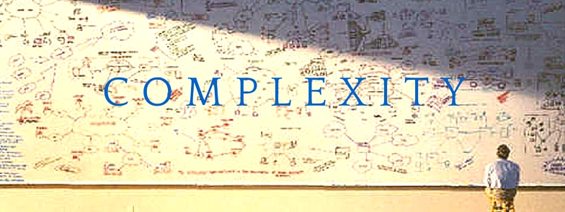
“The art of simplicity is a puzzle of complexity,”
(Douglas Horton)

Managing in Complex Environments
Joel Ramanadhula | Student id: 1712001 | SBPD7006 |12th October 2018

Executive Summary
The report provides an overview on complexity and managing effectively complex environments by outlining terms ‘absolute alignment’ and ‘sophisticated simplicity’ in the context for an aspiring construction company in its mission to become the world leader in innovation and excellence for the construction sector.
Complexity theory as a means of explaining how organisations should view the future and changing circumstances to adapt the style of leadership required in these situations.
Literature review unravels number of leadership skills that are essential in achieving absolute alignment and sophisticated simplicity in a complex environment. Aligning leadership identity, sense of place enables continuous Innovation in leadership skill in managing complex environments.

Contents
Executive Summary 2
1. Introduction 5
o What is complexity 5
o History of Leadership thinking 7
o Leadership in complexity 8
o Leadership in a Complex adaptive system 9
2. Literature Review 12
o Absolute Alignment 13
• Definition of Absolute 14
• Definition of Alignment 14
• Achieving absolute Alignment 15
o Sophisticated Simplicity 17
• Sophisticated Defined 17
• Simplicity Defined 18
• Achieving Sophisticated Simplicity 21
o Sophisticated Simplicity and Absolute Alignment 22
3. Leadership 22
o Structure 23
o Processes and Systems 24
o Foundation 25
o Executive Development 26
o Leadership Framework: 27
• Learning Design Principles 28
• CATWOE analysis 29
o Themes of executive delvelopment programme 32
• Developing Network perspective 32
• Developing Sense making capability 34
• Emotional Intelligence and Social Intelligence 35
• Innovation 37
4. Summary 39
5. Conclusion 40
6. Recommendations 42
5. References 44

Introduction
International engineering enterprise, founded on over a century and a half of experience has an absolute passion to be a world leader in innovation and excellence in Construction sector and offer a single-source solutions addressing complex assignments for some of the world’s most prestigious organisations.
To enable this International engineering enterprise achieve its objective, guiding principles Absolute Alignment and Sophisticated Simplicity have defined. The objective of this report is to define the meaning these guiding principles.
These concepts are defined in the context of leadership in a construction company aspiring to deliver the mission to become the world leader in innovation and excellence for the sector. To enable this enterprise to achieve this objective an approach methodology is also formulated, which support the delivery of these guiding principles. It is important to define the concepts of absolute alignment and sophisticated simplicity in the context of Construction industry to understand how these guiding principles this will support this construction enterprise to become a world leader.

What is complexity
The meaning of complexity is defined differently in various contexts, some of the common meaning of complexity is that it characterises the behaviour of a system or model whose components interact in multiple ways and follow local rules, meaning there is no reasonable higher instruction to define the various possible interactions.
This generally means that this is something with many parts that and those parts interact with each other in many ways, and forming an higher order which is greater than the sum of all the parts. According to Warrant Weaver, 1948 there are two forms of complexity, one is organised complexity and the other is disorganised complexity. The disorganised complicity has large number of parts randomly interacting but the whole systems can be interpreted through probability or statistical methods. The organised complexity has smaller parts whose interactions can be understood by simulations and modelling
In the world of information, processing complexity is s state of measure of propertied transmitted by an observer. The study of these complex linkages at various scales is the main goal of complex systems theory.
There is no agreed upon definition of either complexity or complex adaptive system and the scope of this report does not allow for a detailed discussion of the various possibilities. From a complexity science perspective and in the context of organisations, complexity can be said to have a number of recognisable characteristics. According to Snowden & Boone (2007), characteristics of complexity consist of a large number of interacting elements. They are nonlinear, minor changes can produce disproportionately major consequences. They are dynamic, the whole is greater than the sum of its parts and solutions cannot be imposed: they arise from circumstances, often referred to as emergence. Its system has a memory, the past is integrated with the present and elements evolve with one another and with the environment. The complex systems may appear to be ordered and predictable but hindsight does not lead to foresight because the external conditions and systems constantly change. The agents and the system constrain one another, especially over time; we cannot predict what will happen. A complex adaptive system are characterised by diverse agents that learn and interact with one another in a nonlinear ways, therefore self-organise and emerge and co evolved with the environment.

History of Leadership thinking
The concepts of leadership have evolved over time and it is important to remember the past and analyse how the leadership has changed in due course of time across the decades to draw a parallel to the e new leadership characteristics and style required to address 21st century complexity.
- Initial three decades of 20th century has been mostly of heavy industrial enterprise with command and control oriented centralised leadership
- In the late 1930’s it changed to influence rather than dominance and later moved to persuasive style in the next decade
- later parts of 1950’s the leadership is mostly driven by what people do in groups and later moved in to social movements and shared goals
- The ideas of context and situations came in over 1970’s and early eighties the world has seen growth of multinational corporations with transformation leadership influence.
- A more social responsible tone has been in the nineties and in followed by an ethical becoming a central point

Leadership in complexity
It is commonly accepted the 21st-century economic environment is highly complex, characterised by rapidly evolving demands of globalisation, huge advances in technologies (affecting the quantity and quality of work), shifting customer expectations and new attitudes to work, driven by a multigenerational workforce ( WEF, 2018).
To improve performance in an organisation is always difficult, part of the difficulty is because the organisations were treated like machines and the principles used for improving performance in the machines were being applied to make an organisation run soother faster and better. Organisations as not really machines but are complex adaptive systems beset with uncertainty ( Beinhicker, 2006)
In order to deal with this, organisations oraganisations must learn quickly and adapt rapidly to changing conditions (Marion and Uhl-Bien, 2011; WEF, 2016).
The term complexity refers to the “greater levels of uncertainty, ambiguity, interdependencies and interrelatedness that now characterise the environments in which organisations operate” (Clarke, 2013, p. 135).
Rapid social, economic and technological shifts are taking place as we enter the next decade, producing greater complexity, resulting in increasing dynamics of instability (Uhl-Bien, et al., 2007).
The command and control style of leadership was adopted: the role of executives was to set the direction and managers assumed workers would behave predictably, without deviation from these organisational aims (Jackson, 2003). Today, both scholars and practising managers understand organisations do not behave like machines but are Complex Adaptive Systems (CAS), plagued with uncertainty (Clarke, 2013; Hammer, et al., 2012; Marion & Uhl-Bien, 2011; McDaniel, 2007; Snowdon & Boone, 2007).

Leadership in a Complex adaptive system
Complex adaptive leadership has been quoted as complementary approach to leadership based on assumption leadership of the many by many. The history dates back to the ancient Chinese writings of Tao Te Ching ( C. 5000BC)
Later in early part of 21st century, there has been extensive research on complex adaptive leadership. The points of this were the complex adaptive systems are self-organising with reduced hierarchy, thereby with lesser bureaucracy, which result in higher staff engagement; it is more on distributive approach to leadership.
In a complex adaptive system, leaders have to navigate a rising tide of rapidly emerging circumstances, in addition to dealing with the constant pressure to do more with less, shifting psychological contracts and flexing organisational boundaries (Goh, 2018; Center for Creative Leadership, 2018). When an organisation is viewed as a complex adaptive systems the role of management changes from one of command and control (Griffiths & Inman, 2016) to one of sensemaking, learning and improvisation (McDaniel, 2007).
A type of leadership that can accommodate complexity and interdependence is required (Cameron & Green, 2017), along with the ability to cultivate an environment which allows innovative solutions to emerge from interactions between a variety of agents in the organisation (Griffiths & Inman, 2016; Marion & Uhl-Bien, 2011).
In fact, according to a recent report by Deloitte (2017), only about one-third of executives are considered to have excellent leadership skills and capabilities. The cost of this deficit is estimated by some to be in the millions of dollars (Schyns & J Schilling, 2013).
Today’s executives operate in a Volatile, Uncertain, Complex and Ambiguous world but do not necessarily see themselves as equipped to deal with the levels of complexity they encounter (Kovacs & Corrie, 2017).
Moreover, an absence of appropriate leadership development exists (APQC, 2014; Harvard Business Publishing, 2016; Passmore, 2014). Carefully shaped strategies that account for the changing context of business are required to close this leadership gap (Wilson, et al., 2011).
Developing leaders should be done systemically, not just be seen as a curriculum composed of programmes. Leadership development activities must change the context within which leading takes place, not simply the mind-set and behaviours of individual leaders (Passmore, 2014).
The construction industry consists of a diverse combination of localised needs: various crafts, services products and their professional providers, and many other stakeholders converge together around temporary projects in different stages of development (Kahkonen, 2015). As a result, it is axiomatic that construction projects are one of the most complex operations and as such, an understanding of complexity and how it might be managed is significant (Wood & Gidado, 2008). The industry is also currently facing substantial challenges, including increasing project complexity and scope requirements, economic uncertainty and rising competition with a subsequent squeeze on profit margins (Antunes & Gonzalez, 2015).
The ability of leaders to remain flexible and adaptable in the face of this disruptive business environment will be essential to International construction company maintaining competitive advantage (Goh, 2018). However, if a flexible approach to leadership is expected, this will have implications for leadership development in the industry, as this degree of flexibility does not currently exist (Walker, 2015).
In order for International Construction Company to deliver its mission to become the world leader in innovation and excellence, the leadership of the organisation needs to adopt a complexity approach. Complexity requires leadership to “engage and involve their people, in order to rapidly anticipate sense and respond to ever-increasing changes in the organisation environment” (Griffiths & Inman, 2016, p. 18). Leaders must develop capability in areas such as building and understanding networks (Clarke, 2013), sensemaking, (Ancona, 2012), innovation (Dodge, et al., 2017) and, emotional and social intelligence (Goleman, et al., 2002). With the right leadership development strategy in place to grow these capabilities, there is a far better chance International construction enterprise will attain success in embedding the guiding principles of Absolute Alignment and Sophisticated Simplicity and achieving its mission (Dinwoodie, et al., 2014).

Literature Review
The objective of the following literature review is to understand and define the guiding principles as of absolute alignment and sophisticated simplicity within the context of leadership as set out by the international construction enterprise.
The objective also includes explaining how these principles support the delivery of the company vision to become the world leader in innovation and excellence in the construction sector.
A framework for an executive development programme to support the implementation of these guiding principles will also be outlined using combinations of problem structuring methods like soft systems methodology, Strategic Choice approach and Strategic options development and analysis. This framework will form the basis for recommendations to action.
According to Checkland and Poulter (2010), the concept of worldview is the most important concept in understanding the complexity of human situations and the nature and form of soft systems methodology. Therefore, the principles of absolute alignment and sophisticated simplicity and their necessity in delivering the vision of innovation and excellence is informed by a particular set of worldviews.
As there is no direct access to the organisation, it will be necessary to use worldviews from evidence-based research to inform understanding of what absolute alignment and sophisticated simplicity mean in the context of delivering innovation and excellence at international construction enterprise.

Absolute Alignment
Absolute alignment is a combination of words ‘Absolute’ and ‘Alignment’. This one fundamental guiding principles for supporting international construction enterprise to achieve its mission to become the world leader in innovation and excellence in the sector.
There is no recorded definition of the term absolute alignment in the literature but the term is commonly referred in automotive work for physical calibration; however, Forbes magazines in its journal have used this term for management change describing the need for absolute clarity among leaders for alignment.

Definition of Absolute
The term absolute is defined as “very great or to the largest degree” (Cambridge Dictionary, n.d.) Alternatively, as “not qualified or diminished in any way” (Oxford Dictionary, n.d.). Alternatively “viewed or existing independently and not in relation to other things, not relative or comparative”.
In philosophy, it is referenced for a value or principle which is regarded universally valid or which may be viewed without relation to other things.
There are limitations to the extent to which it can be achieved throughout an organisation (Armstrong & Taylor, 2017) for the reasons outlined below. Therefore, in the context of achieving organisational alignment towards the mission of international construction company , we can assume that ‘absolute’ regards the intention to get the whole organisation aligned behind its purpose to the ‘largest degree’ possible.

Definition of Alignment
The term alignment refers to an arrangement in which two or more things are positioned in straight line or parallel to each other in terms of position and in terms of support, it refers to an agreement between a group of countries, political parties or people who want to work other her because of shared interests (Cambridge Dictionary, n.d.)
Alignment refers to the act of attaining buy-in for the company vision from those who will have a role in making it a reality (Nautin, 2014; Straw, et al., 2013). McCauley (2014, p. 1), defines alignment as the “effective coordination and integration of the different aspects of the work so that it fits together in service of the shared direction.”
Today, most executives are aware that their organisation needs to be aligned. In fact, the failure of an organisations vision can frequently have more to do with lack of alignment than with the strength of the vision or the efficiency of the execution (Straw, et al., 2013). Strategies, organisational capabilities, resources, and management information systems and processes should be arranged to sustain the business purpose (Trevor & Varcoe, 2017).
However, what often happens in organisations is that employee and employer interests become contested terrain (Clutterbuck, 2012). This is described in agency theory as goal conflict, which assumes the pursuit of self-interest at the individual level will misalign with the goals at organisational level and appropriate incentives are required to bring about alignment (Eisenhardt, 1989).
Organisational alignment is an alignment between the an organisations and its employees working together to achieve a strategic objective and it is not natural but have to be built and maintained

Achieving absolute Alignment
It is a process, which results in linking an organisations structure and its resources with its strategy and its environment, be it regulatory or physical environments. Alignment ensures that everyone in the organisation is ‘on the same page’, not just from a task perspective but also an emotional perspective (Straw, et al., 2013). This emotional buy-in is often linked to the purpose of an organisation and people will select into and out of organisations based partially on how aligned they feel with the organisation’s purpose (Clutterbuck, 2012).
To fulfil the purpose to become the world leader in innovation and excellence for the sector, an international construction enterprise must ensure leaders communicate the purpose with clarity, attaching meaning to it, from which individuals can extract concrete goals (Frankl, 2004). However, no matter how clear the purpose, it is reckless to commit to a business strategy without knowing whether you have the capability to achieve it.
Even the best strategy is useless unless supported by appropriate organisational capabilities (Trevor & Varcoe, 2017). Traditionally, businesses organised themselves with those at the top doing the thinking, and everyone else getting on with the job but, as digitisation replaces process-based roles, companies are in need of thinkers not just doers (WEF, 2018). For leadership, this means a different approach to leading than traditional command and control styles, as non-standard, creative, experimental work, in constantly changing environments does not naturally lend itself to management (Benn & Bolton, 2011; Chakhoyan, 2017).
To achieve alignment international Construction enterprise will require management practices, systems and technologies aligned to fulfil the organisation’s purpose. Suitable measures of success, both short and long-term will also need to be defined and communicated (Boss, 2018). Employee would need to align to their role , goal, team and their organisation.
Absolute Alignment can happen where individuals, with the right capabilities, can unite behind a meaningful purpose and when this purpose is supported by the right management systems. Dyson, for example, has an established reputation for creating innovative products. Their innovation strategy is reinforced by sub goals relating to hiring and retaining a highly creative workforce and ensuring the right systems and culture are in place for them to flourish (Clutterbuck, 2012).

Sophisticated Simplicity
Along with absolute alignment, sophisticated simplicity is another guiding principle in the achievement of the International construction enterprise mission to become the world leader in innovation and excellence for the sector.
There is no commonly held definition of sophisticated simplicity, but the combination of words sophistication and simplicity are used in the fields of design and Architecture. Simple and simplicity are often referred to in management and complexity theory literature.

Sophisticated Defined
In the dictionary, the meaning of sophisticated is described as “intelligent or made in a complicated way and therefore able to do complicated tasks” (Cambridge Dictionary, n.d.) and “developed to a high degree of complexity” (Oxford Dictionary, n.d.), so when used in conjunction with the antonym of simplistic would appear to be an oxymoron. However, sophisticated can also mean, “Having, revealing, or involving a great deal of worldly experience and knowledge” (Oxford Dictionary, n.d.), which would appear to be a more apt definition in this context.
In the context of today’s business sophistication refers to a complex and ever changing interaction between units of business environment like an organisation’s leader , employees , technology and the its customer world.

Simplicity Defined
In dictionary, the meaning of simplicity refers to “the fact that something is easy to understand” or the “the fact that something is ordinary, traditional or natural and not complicated” Cambridge Dictionary, n.d.). The fact that something is plain and has no decoration or “the quality or condition of being easy to understand or do” or the quality of condition of being plain or uncomplicated in form of design.” (Oxford Dictionary, n.d.),
The term ‘simplicity’ frequently appears within complexity theory literature (Marion & Uhl-Bien, 2011, Pablo, et al., 2017, Snowdon & Boone, 2007, Stacey, 2004). According to Kerr (2014, p. 2), “To be successful in this extremely complex and unstable business environment, executive leaders must do all that they can to simplify.” However, in their attempts to simplify the complexity of the external environment, organisations are prone to introducing internal complicatedness within their systems and processes (Backx, et al., 2017), making organisations themselves unintentionally complex (e Cunha & Rego, 2010). Ashkenas (2007, p. 102), noted that large organizations are by their very nature complex and this ‘‘complexity is the cumulative by-product of organizational changes, big and small, that over the years weave complications (often invisibly) into the way work is done’’.
Simplicity is not discussed as frequently in mainstream management literature as alignment, but management guru and analyst Josh Bersin (2017) has recently described it as the next big thing in HR and leadership.
The characteristics commonly thought to foster simplicity in a complex environment are:
• Leadership behaviours – Away from command and control towards sensemaking, learning and improvisation (Ashkenas, 2007; Backx, et al., 2017; Chakhoyan, 2017; McDaniel, 2007; Uhl-Bien, et al., 2007).
• Structure – Delayered, a network structure which breaks down silos and facilitates collaboration and innovation (Ashkenas, 2007; Backx, et al., 2017; Highsmith, 2009; Jacobson, 2014; Peters & Waterman, 1982; e Cunha & Rego, 2010).
• Processes and systems - A simple set of organisation-wide processes and employees empowered to use their judgement (Ashkenas, 2007; Backx, et al., 2017; Bekker, 2018; e Cunha & Rego, 2010).

Leadership Behaviours
Performance is driven by behaviour, including the behaviour of leaders. How they lead, whom they promote, what measures they value, how key decisions are made and how they communicate, are just some of the things that determine a leader’s impact on their operating environment (Backx, et al., 2017). Therefore, if leaders are committed to reducing complexity, they must identify how their own patterns of behaviour foster complicatedness and make a personal commitment to simplification (Ashkenas, 2007).
Structure
The overabundance of structure in many organisations gives people an excuse not to think, their contributions are devalued and they lose any sense of accountability and responsibility for results (Ashkenas, 2007; Backx, et al., 2017). A network structure is characterised by open communication (both internal and external), fewer tiers, a wider span of control, and a bottom-up flow of decision-making and ideas (Farnham, 2015). The key resource in a network organisation is knowledge (Kew & Stredwick, 2015); temporary constellations or ‘swarms’ of people come together with the requisite knowledge to solve problems (Griffiths & Inman, 2016). Because of this, it is thought to be more flexible and agile than other structures, with improved collaboration and performance (Brash, et al., 2008).

Processes and Systems
In attempting to reduce uncertainty amid complexity, organisations tend to react by introducing new processes and systems (Backx, et al., 2017). However, when you simplify process by taking out detail you force people to think for themselves and interact (Highsmith, 2009). This is a facet of ‘swarm intelligence’, which assumes the right set of simple rules applied within a group of highly interactive individuals generates innovation and creativity (e Cunha & Rego, 2010; Marion & Uhl-Bien, 2011). According to Highsmith (2009) when intelligent people ‘swarm’ around a problem, they do not need a detailed set of principles describing everything. Instead, what is required to foster agility is a minimum set of “rules that have been shown to work well together” (Highsmith, 2009, p. 74).
Where documentation of policy and process are necessary they should be simple and organisation-wide (Ashkenas, 2007) and employees should be empowered to use their judgment rather than comply with an endless number of rules (Backx, et al., 2017). For example, the expense policy at Netflix reads, Act in Netflix’s best interests (Markovitz, 2015). Such things as detailed job descriptions become obsolete and high levels of formalisation lose their importance, replaced by involvement-oriented mission statements, and a new, adaptive style of leadership (e Cunha & Rego, 2010).

Achieving Sophisticated Simplicity
Sophisticated simplicity can happen where the leadership of the organisation is committed to simplifying structure, processes and systems. Senior executive support is vital, they must role model the leadership behaviours required to adapt to complexity, fostering sensemaking, learning and improvisation as a means to simplify rather than the traditional command and control approach (McDaniel, 2007).

Sophisticated Simplicity and Absolute Alignment
It is clear from the above definitions that Absolute alignment and Sophisticate simplicity have interdependencies. Alignment will be difficult to achieve where there is complicatedness and simplicity is unfeasible unless everyone is aligned. For example, complicatedness can lead to a lack of collaboration among functions and departments (Brash, et al., 2008) and alignment cannot be achieved without collaboration (Pablo, et al., 2017). Both principles are dependent on the effectiveness of leadership and are required to deliver the organisations mission as depicted in
Many factors influence an organisation to achieve its vision, some of the main driving factors that influence are

Leadership
In the dictionary, the meaning of Leadership refers to “the action of leading a group of people or an organisation or an ability to do this” (Oxford Dictionary, n.d.), “the quality or ability that makes a person a leader, or the position of being a leader” (Cambridge Dictionary, n.d.),
Performance is driven by behaviour, including the behaviour of leaders on how they lead, whom they promote, what measures they value, how key decisions are made and how they communicate, are just some of the things that determine a leader’s impact on their operating environment (Backx, et al., 2017). Therefore, if leaders are committed to reducing complexity, they must identify how their own patterns of behaviour foster complicatedness and make a personal commitment to simplification (Ashkenas, 2007). Effective leadership in a complex adaptive systems makes sense making, learning and improvisation central to managerial tasks rather than command, control and planning (McDaniel, 2007; Uhl-Bien, et al., 2007).
If organisations want to simplify in the face of complexity then leaders must learn to deal with ambiguity and tolerate conditions of uncertainty (Jacobson, 2014). This is where sense making comes in. According to Weick (1995, p. 57), “Sense making is a diagnostic process directed at constructing plausible interpretations of ambiguous cues that are sufficient to sustain action.”
Leaders who can make emotional connection and ability to set stretch goals, having clear vision and communication and being innovative, collaborative and initiative taking attitude are critical to inspiring leaders as per (Zenger, Folkman, 2015)

Structure
The overabundance of structure in many organisations gives people an excuse not to think, their contributions are devalued and they lose any sense of accountability and responsibility for results (Ashkenas, 2007; Backx, et al., 2017). To simplify Ashkenas (2007, p105) recommends reduction of levels and layers and increasing span of control and consolidating similar functions.
A network structure is characterised by open communication (both internal and external), fewer tiers, a wider span of control, and a bottom-up flow of decision-making and ideas (Farnham, 2015). The key resource in a network organisation is knowledge (Kew & Stredwick, 2015); temporary constellations or ‘swarms’ of people come together with the requisite knowledge to solve problems (Griffiths & Inman, 2016). Because of this, it is thought to be more flexible and agile than other structures, with improved collaboration and performance (Brash, et al., 2008).

Processes and Systems
In attempting to reduce uncertainty amid complexity, organisations tend to react by introducing new processes and systems (Backx, et al., 2017). However, when you simplify process by taking out detail you force people to think for themselves and interact (Highsmith, 2009). This is a facet of ‘swarm intelligence’, which assumes the right set of simple rules applied within a group of highly interactive individuals generates innovation and creativity (e Cunha & Rego, 2010; Marion & Uhl-Bien, 2011). According to Highsmith (2009) when intelligent people ‘swarm’ around a problem, they do not need a detailed set of principles describing everything. Instead, what is required to foster agility is a minimum set of “rules that have been shown to work well together” (Highsmith, 2009, p. 74).
Absolute alignment and sophisticated simplicity as the guiding principles in the vision of the international construction enterprise. Underpinning these to the core values in the business and keeping emerging opportunities in the horizon in terms of market and technology also a blue-sky thinking is essential for the leader’s construction enterprise to set the direction forward to achieve the vison.

Foundation
The underlying foundation for the core guiding principles for the International construction enterprise are of critical significance to the competitive environment today , and managing with vision can benefit organisation promote a strategic change and foster innovation and employees ( Lipton, 1996, O brien and Medows 200)
Ideology defines the fundamental belief systems and endurance of a character of an organisation and it inspires controls and guides the vision of an organisation. Sound ideology leads to a clear vision. Core values are fundamental to justify the existence of an organisation and is bound by value systems. Leadership influences the direction based on ideology and core values.
Absolute alignment aims to bring uniformity in thoughts and actions among employees and sophisticated simplicity to inspire and appreciate the complexity in simple usage

Executive Development
Leaders are required to be agile and innovative while steadfast and balanced to achieve organisational vision and they need new ways of developing their skills and perspectives. The transition from senior management to enterprise-level leader is more than just a promotion. It requires a step change across all aspects of leadership, from how executives manage themselves to how they interact with others, and ultimately how they engage the broader organization
The executive development program has become an important part of career building for executives who constantly strive to take on new challenges. As the global business environment becomes increasingly complex, the demand for quality programs delivering relevant outcomes has risen. Research and innovation have helped provide deeper insights, better tools and, overall, more sophisticated program design

To deliver the guiding principles of Absolute alignment and Sophisticate simplicity requires plethora of essential leadership skills and behaviours, including but not limited to:
- Ability to communicate effectively with clarity and meaning.
- Awareness on the business process and ability to identify which are effective
- Relationship building to expand the horizon.
- Emotional and social awareness.
- Sensemaking - thinking rationally and intuitively, articulating emerging themes, application of judgement in new and ambiguous situations.

Leadership Framework:
A framework is required to be developed to equip executives towards the developing skills rather than training to deliver the objectives of absolute alignment and sophisticated simplicity
For executives to achieve an oraganisations vision there are three key elements; leading one’s self, leading people and leading organisation.
Figure1: Leadership Framework

The following chapter outlines a framework to inform a development programme in which the below described skills and behaviours will be considered in the following development categories:
- Developing Network Perspective
- Developing Sense making capability
- Leading Innovation
- Developing emotional and social intelligence
Figure 2; Executive Development Framework
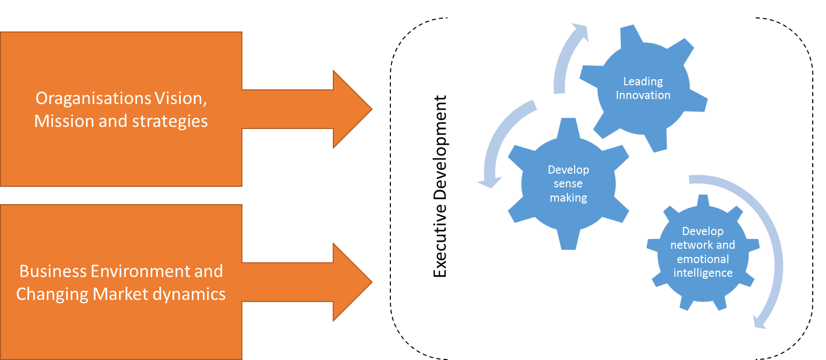

Learning Design Principles
Modern Executive Development must create impact by supplying knowledge and learning just in time to an individual executive’s specific circumstances, making it immediately relevant and inspiring sustainable behavioural change (van Wijk & Anderson, 2012).
In addition to planned formal development more social and informal methods are appropriate (Gentry, et al., 2016), such as action learning, communities of practice, coaching and mentoring, and reflective learning (Beevers & Rea, 2016; Lockhart, et al., 2017; Smith & Sadler-Smith, 2006; Wuestewald, 2016). Starting Conditions
Learning and knowledge creation are themselves inherently complex activities involving the accommodation of a range of individual and contextual variables (Griffiths & Inman, 2017; Smith & Sadler-Smith, 2006; Stewart & Cureton, 2016). It is worth acknowledging that in designing any leadership intervention we are operating in the complex domain as defined by Snowden and Boone (2007), there is no one right answer and the consequences of the intervention cannot be known. Nevertheless, it is still important to understand the context or starting conditions in which the learning will take place to ensure security, depth and completeness of learning (Griffiths & Inman, 2017; Hattie & Yates, 2014). CATWOE model defined by from soft systems methodology is an effective tool to analyse this.

CATWOE analysis
As defined by Peter Checkland It is a simple checklist for thinking and one of the generic techniques that Business Analysis that is used to identify the the business is trying to achieve and the problem areas and how is the solution going to affect the business and people involved in it.
Figure 3: Six elements of CATWOE
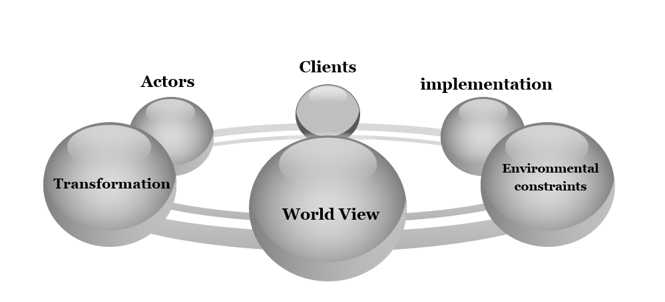
1. Clients: Customers or clients are stakeholders. These are the people who will benefit of suffer due to the change in the system/process. It is important to first identify such customers and understanding how the implementation of the strategy or vision affects them. . The end client will also benefit from any positive outcomes of the development as research tells us the level of dedication a company has to leadership development has a bigger long-term impact on its business performance than anything else (Morgan, 2018).
2. Actors: These are the people involved in the implementation of the changes in the system. In this case, the people who are responsible to delivering the executive development programme
3. Transformation: These are the changes that the system or process brings about. This is the leadership development programme to deliver the vision principles of absolute alignment and sophisticated simplicity
4. Worldview: it is the big picture and the wider impact of the transformation required to achieve the vision, both positive and negative impact on the overall business. This report does not provide the entire worldview as due to the limitation of the author having access to the international construction enterprise.
5. Owner: The leadership team who are the decision makers, who have the authority to make the changes, stop the project, or decide on whether to go ahead with the change. Major stakeholders whose views would normally be sought in this process would include the owners and top management, the learning and development team and the individuals who will participate (Smith & Sadler-Smith, 2006). It is important for the owners and senior leaders at ICC to recognise the value the EDP will deliver, therefore consideration must be given to how the programme will be evaluated at the outset (Beevers & Rea, 2016).
6. Environmental factors: These are the external constraints and limitation affecting the success of the solution. These can be ethical limits, regulations, financial constraints, resource limitations, limitations of project scope, limits set by terms of reference and others.
The process of analysis should start by defining the purposeful activity that will lead to the transformation and the worldviews that influence the process (Checkland & Poulter, 2010).
The approach to executive development programme is summarised along with various design considerations and along with the secondary research conducted over behaviour and skills is required to deliver Absolute alignment and sophisticated simplicity as guiding principles in an executive development programme.
Figure 4: Executive development approach

Themes of executive delvelopment programme
The development categories required for delivering the guiding principles are briefly described below and the delivery methods can be thorough a workshop and executive coaching methods for each development area.
- Developing Network perspective
As organisations strive for effective collaboration across boundaries, leaders must look beyond the organisational chart to the invisible informal networks supporting the organisation (Cross, et al., 2013; Cullen, et al., 2014). Research by MIT found that getting people to collaborate across boundaries was the biggest barrier to collaboration in organisations (Kane, et al., 2018). This is seen as a particular challenge within the deeply fragmented construction sector (Pablo, et al., 2017). Therefore, boundary-spanning skills are of particular interest to International construction enterprise.
Boundary spanners are individuals who are skilled at bridging interests and transferring information from disparate parts of the organisation (Cullen, et al., 2014; Williams, 2002). In reaching across boundaries, leaders learn to broaden their perspectives and generate more diverse and alternative ways of problem solving, fostering cross-organisational innovation and transformation (Clarke, 2013; Ibarra & Hunter, 2007; Yip, et al., 2016).
An Organisation Network Analysis will identify whether executives at International construction enterprise are isolated from the rest of the organisation and where there might be gaps in the boundaries they are spanning. This knowledge will help to accelerate the development of their own social capital. In addition to Organisation network, Analysis a series of workshops, using action-learning techniques to explore the results of the analysis is recommended (Cross, et al., 2013).
Figure 5: organisational Network analysis

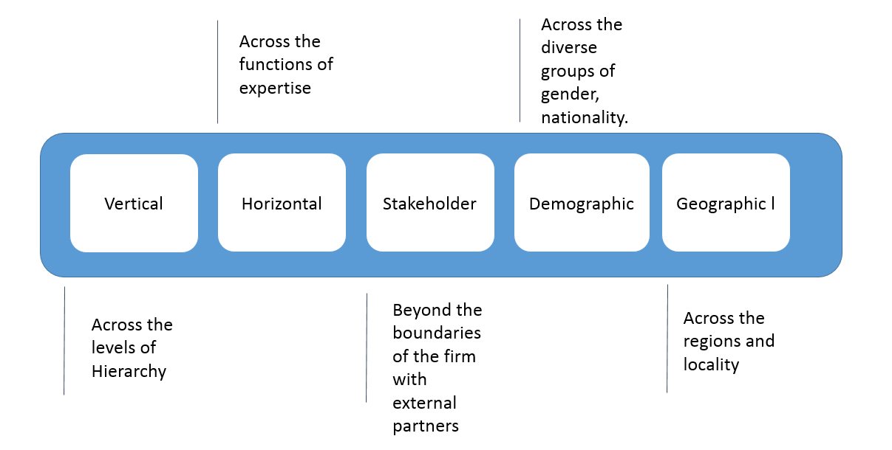

Developing Sense making capability
Sensemaking is highly correlated with leadership effectiveness as it enables leaders to have a better grasp of what is going on in their environments and facilitates other leadership activities such as visioning, relating and inventing (Ancona, 2012). Put simply, sensemaking is “the making of sense” and “structuring the unknown” (Weick, 1995, p. 4); it is developing ideas with explanatory possibilities, rather than a body of knowledge (Weick, 1995).
Sensemaking is not about finding the correct answer but about creating an emerging picture via cues (events, experiences, conversation etc.), enabling people to get some sense of a situation when faced with ambiguity and move to action (Ancona, 2012; Degn, 2013; Weick, 1995).
Development of sensemaking capability relies on leaders themselves being open to continuous learning, which includes self-evaluation and learning from others (Maphinda, 2017). Ancona (2013) recommends combining role models, action learning and feedback in developing sensemaking capability.
Sensemaking also requires that leaders have emotional intelligence (EI) and social intelligence (SI) (Ancona, 2012).
Figure 6: Sensemaking in an Organisation
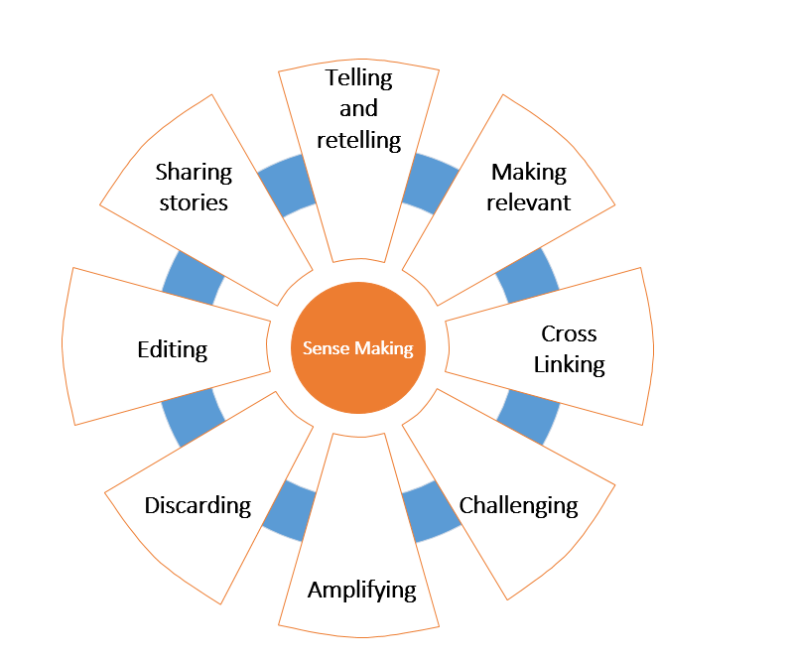

Emotional Intelligence and Social Intelligence
Due to the complexity of organisational change and the role emotions play in change such as global expansion, job reduction, leadership changes, and the stress of everyday responsibilities, the Emotional Intelligence and Social intelligence of leaders and how they interact with multiple stakeholders is something that organisations need to give attention to (Goleman, 1995; Nath, 2013).
It is commonly acknowledged that employee motivation goes beyond the usual monetary reward systems traditionally offered (Njoroge & Yazdanifard, 2014, Pink, 2012). In motivating today’s employees, organisations must engage their minds and captivate their hearts, which can be achieved by incorporating social and emotional intelligence.
Many practitioners and scholars believe that emotional intelligence can be improved upon through development and training programs (Goleman, et al., 2002; Mattingly & Kraiger, 2018; Nath, 2013; Neale, et al., 2009; Rajah, et al., 2011).
Therefore, International construction enterprise should focus on gearing training and development programs targeted at improving levels of existing Emotional intelligence and Social Intelligence. Mattingly and Kraiger (2018) suggest the need to individualise EI training and provide accurate feedback on participants' skills as EI is better trained using an active/experiential approach versus passive methods.
High emotional intelligence is linked to a leader’s ability to build active networks (Cullen, et al., 2014) and to sense making capability (Ancona, 2012) which in turn are linked to effective innovation leadership. Below are the essential competencies for social and emotional intelligence.
Figure 7: Emotional and social intelligence
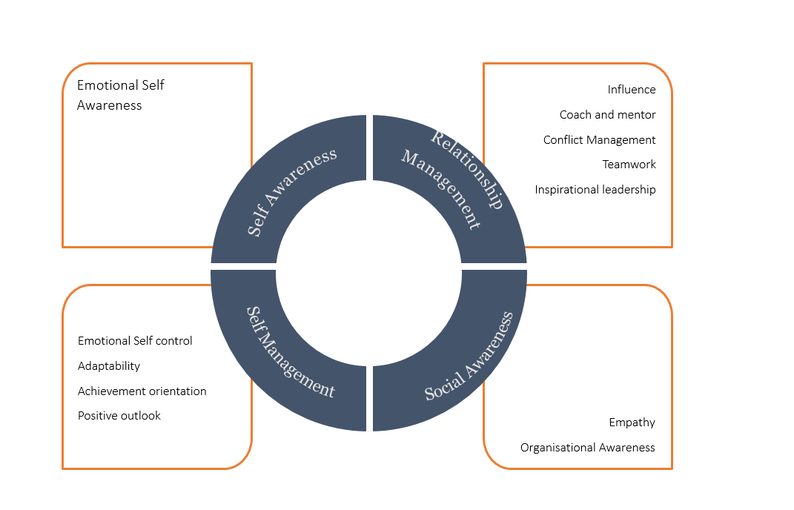

Innovation
Innovation is not just about product and service performance anymore, it also involves business models, company configuration, distribution and customer experience (Brash, et al., 2008; de Coutere & Horth, 2016).
In the face of challenging and unpredictable circumstances, leaders cannot rely on rational decision-making based on previous patterns, as ambiguity cannot be managed away (Horth & Buchner, 2014; Mitchell, 2017). Instead, they must try to make sense of the unfamiliar, which requires innovation leadership. This means bringing new thinking and different actions to how leaders lead (approach to leadership) and how they create a climate for innovative thinking (ibid).
There are a number of parts to the innovation process; clarify, ideate, develop and implement and a different style of leadership may be required at each stage (Kesting, et al., 2015). A number of studies have been conducted in the attempt to establish the impact of leadership approach on the innovation capability of organisations (see Kesting, et al., 2015 for a review and synthesis of the literature).
Innovative leaders would need to have passion for innovation with a long-term perspective. They also should have the courage to fail and learn from failure and deep engagement with innovators and willingness to tolerate mavericks and defend them from middle management.
This requires skill in the areas of networking, sense making, and emotional intelligence and social intelligence previously discussed. Roles vary in leadership at different level in an oraganisations
Figure 8: Levels of innovation leadership

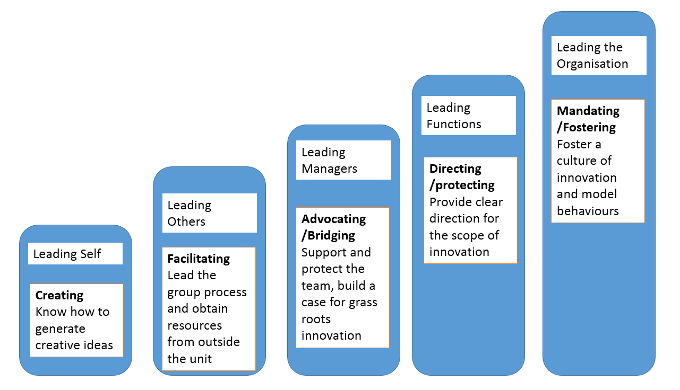
Design Thinking has emerged as a mechanism through which ideation can be encouraged (Liedtka, 2015; van Reine, 2017) and as a best practice through which organisations can influence corporate culture (Mickahail, 2015).
Figure 9: Design thinking process
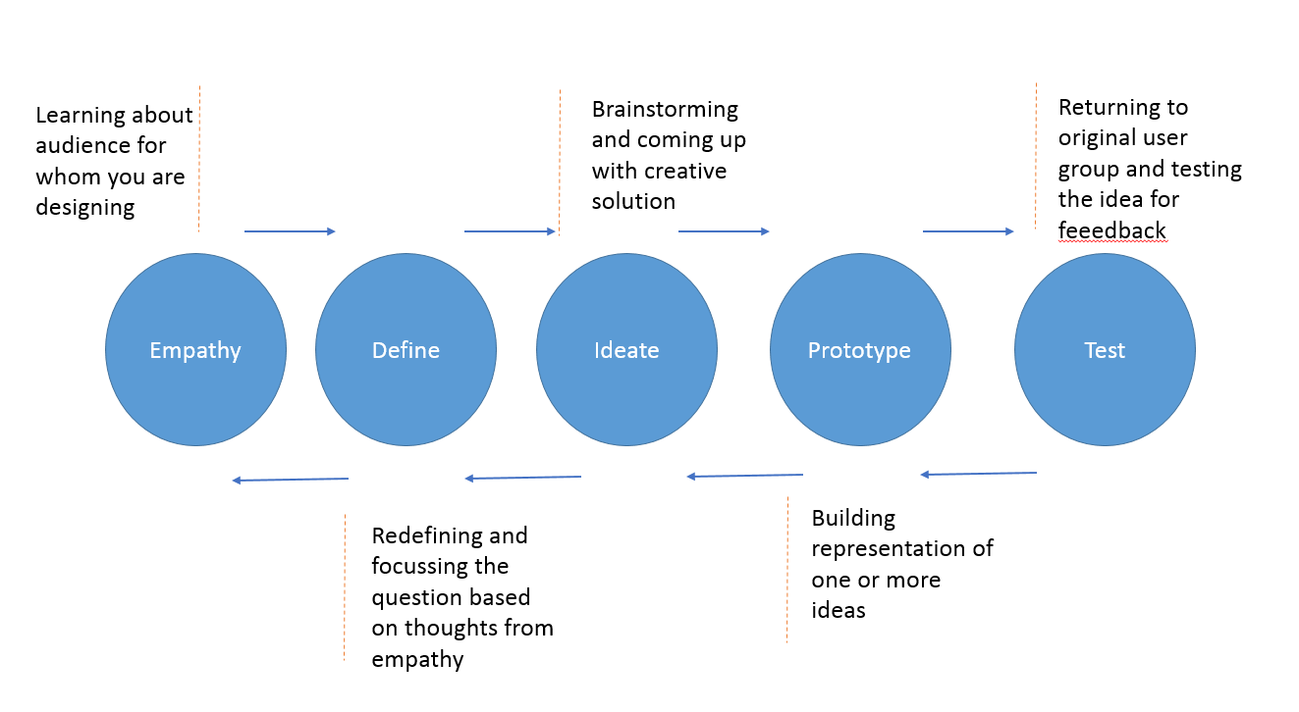

Summary
The proposed framework incorporates the development of some of the skills thought to be fundamental for leading in complexity (Center for Creative Leadership, 2018). It can be seen from the above discussion these skills are interdependent and should form part of a holistic development programme

Conclusion
To understand the concepts of Absolute alignment and sophisticated simplicity and how they can support the delivery of the international construction enterprise mission to become the world leader in innovation and excellence, it is first important to understand the context in which they operate and the skills required of leaders in that context.
It is commonly accepted the 21st-century economic environment is highly complex, characterised by rapidly evolving demands of globalisation, huge advances in technologies, shifting customer expectations and new attitudes to work (CIPD, 2017; Press & Goh, 2018; WEF, 2018).
Advances in the field of complexity science present organisations with opportunities to make sense and gain advantage from these complexities (Snowdon & Boone, 2007).
Organisations can no longer be viewed as ‘machine-like’ systems that act predictably but as CAS, plagued with uncertainty (Clarke, 2013) and therefore a type of leadership that can accommodate complexity and interdependence is required (Cameron & Green, 2017: Griffiths & Inman, 2016; Marion & Uhl-Bien, 2011).
Construction enterprises will require a carefully shaped leadership development strategy which takes account of the changing context of the business especially given the added complexity associated with the construction sector (Walker, 2015). In order for constrcution enterprise to deliver its mission to become the world leader in innovation and excellence, the leadership of the organisation needs to adopt a complexity approach (Griffiths & Inman, 2016).
Absolute Alignment is defined as, Individuals with the right capabilities united behind a meaningful purpose, supported by the right management systems. Absolute alignment requires leaders who can unite individuals behind a meaningful purpose and promote an innovation culture (Clutterbuck, 2012).
Sphisticated Simplicity is defined as, Simplifying structure, process and systems to allow for greater collaboration in a networked system. Spohisticated Simplicity requires leaders who foster sensemaking, learning and improvisation as a means to simplify rather than the traditional command and control approach (McDaniel, 2007).
In defining the above terms and determining what is required of leaders to implement them, some essential leadership skills and behaviours have been unearthed, including but not limited to:
- Skilfully communicating the purpose with clarity and meaning.
- Working across organisational boundaries.
- High capacity for empathy, emotional and social awareness and tolerance for high levels of anxiety and uncertainty.
- Sensemaking - thinking rationally and intuitively, articulating emerging themes, application of judgement in new and ambiguous situations.
- Improvisation - aptitude for spontaneity, imagination and reflection.
These skills can be related to several development themes:
- Developing Network Perspective
- Developing Sensemaking capability
- Leading Innovation
- Developing emotional and social intelligence
It is these themes that are recommended as the focus for an executive development programme for the leaders at construction enterprise.
Based on the above conclusions the following recommendations are made for an Executive development programme aimed at delivering the capabilities to implement the guiding principles of Absolute alignment and sophisticated simplicity.

Recommendations
An executive development programme for the top 50 leaders in International construction enterprise can be delivered adopting development methods that have been selected based on the concepts of constructivism and adult learning theory.
- Organisational Network Analysis
- Sense making leading sessions
- Design thinking workshop
Organisational Network Analysis determines method of communication and social functional networks in an organisation can be determined. This type of analysis will produce statistical and graphical models of people and based on that the construction enterprise can define the task groups. In recent times, many organisations have used these techniques for Network visualisations and most commonly Diversity and inclusivity index. In some cases, this has been extensively used to determine the relationships in a closed task group and understand how they operate as a unit to create psychological safety for its team members. Employee engagement survey and culture survey are some of the other means analyse the organisational network.
Sensemaking as Ancona explained, today’s leaders need the ability to make sense of complex environments. Sensemaking is the ability to make sense of what is going on in a changing and complex environment and is particularly important predictor of leadership effectiveness right now. Sensemaking in business requires executives to unlearn their old mental models and discard some of their core assumptions a. Executives need to take inputs and data from various sources and use the information to construct, a map along with others.
Design thinking workshop can be conducted to harness the principles of design thinking among the executives. Executives would need to facilitate and begin understanding the challenges of emerging world. A workshop would need to detail design-thinking foundations comprising of insights for innovation and methods to generate idea to action followed on by applying the design thinking to construct a new business model or agile way of delivering value in construction business. Lastly, service is the point where organisation meets the world; therefore, the workshop would need to consider human centred service to design moments where people will remember.

5. References
Ancona, D., 2012. Sensemaking: Framing and Acting in the Unknown. In: The Handbook for Teaching Leadership. Thousand Oaks: Sage, pp. 3-18.
Antunes, R. & Gonzalez, V., 2015. A Production Model for Construction: A Theoretical Framework. Buildings, 5(1), pp. 209-228.
APQC, 2014. The Leadership Deficit: Survey Results Brief Synopsis, Houston: APQC.
Armstrong, M. & Taylor, S., 2017. Armstrong's Handbook of Human Resource Management Practice. 14 ed. London: Kogan Page.
Ashby, W. R., 1960. Design for a Brain. 2 ed. New York: Wiley.
Ashkenas, R., 2007. Simplicity-based management. Harvard Business Review, pp. 101-109.
Backx, J. et al., 2017. Mastering Complexity Through Simplicity: Four Steps to Creating Competitive Advantage. [Online]
Available at: http://img-stg.bcg.com/BCG-Mastering-Complexity-Through-Simplification-Feb-2017_tcm9-145559.pdf
[Accessed 20 June 2018].
Balogun, J., Bartunek, J. M. & Do, B., 2015. Senior Mangers' Sensemaking and Responses to Strategic Change. Organization Science, 26(4), pp. 960-979.
Beevers, K. & Rea, A., 2016. Learning and Development Practice in the Workplace. London: Chartered Institute of Personnel and Development.
Bekker, B., 2018. The key to sustainable high performance is “SIMPLICITY”. [Online]
Available at: https://www.linkedin.com/pulse/key-sustainable-high-performance-simplicity-brandon-bekker/
[Accessed 09 August 2018].
Benn, S. & Bolton, D., 2011. Key Concepts in Corporate Social Responsibility. London: Sage.
Bersin, J., 2017. Why Simplicity Is The Next Big Thing In HR And Business. Forbes, 13 June.
Boisot, M. & McKelvey, B., 2011. Complexity and Organisation-Environment Relations - Revisiting Ashby's Law of Requisite Variety. In: S. Maguire, P. Allen & B. McKelvey, eds. The Sage Handbook of Complexity and Management. London: Sage, pp. 279-295.
Boss, J., 2018. A Simple Flow For Thinking About Organizational Alignment. Forbes, 21 January.
Brash, J., Capozzi, M. M. & Davidson, J., 2008. Leadership and Innovation. McKinsey Quarterly, pp. 37-47.
Cambridge Dictionary, n.d. Meaning of “absolute” in the English Dictionary. [Online]
Available at: https://dictionary.cambridge.org/dictionary/english/absolute
[Accessed 09 August 2018].
Cameron, E. & Green, M., 2017. Essential Leadership. London: Kogan Page.
Center for Creative Leadership, 2018. How to Lead Effectively in a Disruptive World. [Online]
Available at: https://www.ccl.org/articles/leading-effectively-articles/lead-effectively-disruptive-world/
[Accessed 31 July 2018].
Chakhoyan, A., 2017. Is the era of management over?. [Online]
Available at: https://www.weforum.org/agenda/2017/12/is-management-era-over/
[Accessed 08 August 2018].
Checkland, P. & Poulter, J., 2010. Soft Systems Methodology. In: M. Reynolds & S. Holwell, eds. Systems Approaches to Managing Change: A Practical Guide. London: The Open University, pp. 191-242.
Child, J., 2015. Organization: Contemporary Principles and Practices. 2 ed. Chichester: John Wiley and Sons Ltd.
Cilliers, P., 2001. Boundaries, hierarchies and networks in complex systems. International Journal of Innovation Management, 5(2), pp. 135-147.
CIPD, 2015. Annual Survey: Learning and Development. [Online]
Available at: https://www.cipd.co.uk/Images/learning-development_2015_tcm18-11298.pdf
[Accessed 31 July 2018].
CIPD, 2017. From ‘inadequate to outstanding’: making the UK’s skills system world class. [Online]
Available at: https://www.cipd.co.uk/knowledge/work/skills/uk-skills-system-report
[Accessed 11 December 2017].
Clarke, N., 2013. Model of complexity leadership development. Human Resource Development International, 16(2), pp. 135-150.
Clutterbuck, D., 2012. The Talent Wave: Why Succession Planning Fails and What To Do About it. London: Kogan Page.
Copeland, M. K., 2014. THE EMERGING SIGNIFICANCE OF VALUES BASED LEADERSHIP: A LITERATURE REVIEW. International Journal of Leadership Studies, 8(2), pp. 105-135.
Cross, R., Ernst, C. & Passmore, B., 2013. A Bridge too Far? How Boundary Spanning Networks Drive Organizational Change and Effectiveness. Organizational Dynamics, 42(2), pp. 81-91.
Cullen, K. L., Palus, C. J. & Appaneal, C., 2014. Developing Network Perspective: Understanding the Basics of Social Networks and Their Role in Leadership, Greensboro: Centre for Creative Leadership.
de Coutere, B. & Horth, D. M., 2016. Innovation Leadership. Training Journal, pp. 12-15.
Degn, L., 2013. Sensegiving and strategic management in HEI's: The sensemaking and sensegiving processes of top-level managers. Higher Education, 69(6), pp. 901-913.
Deloitte, 2017. Global Human Capital Trends, s.l.: Deloitte University Press.
Dinwoodie, D. L., Quinn, L. & McGuire, J. B., 2014. Bridging the Strategy/Performance Gap: How Leadership Strategy Drives Business Results, Greensboro: Center for Creative Leadership.
Dodge, R. et al., 2017. The Role of Leadership in Innovation. Research-Technology Management, May-June, pp. 22-28.
Dwiartama, A. & Rosin, C., 2014. Exploring agency beyond humans: the compatibility of Actor-Network Theory (ANT) and resilience thinking. Ecology and Society, 19(3).
Dyson, R. G., Bryant, J. & O'Brien, F., 2007. The strategic development process. In: F. O'Brien & R. G. Dyson, eds. Support Strategy: Frameworks, Methods and Models. Chichester: John Wiley & Sons Ltd, pp. 3-24.
e Cunha, M. P. & Rego, A., 2010. Complexity, simplicity, simplexity. European Management Journal, 28(2), pp. 85-94.
Eisenhardt, K. M., 1989. Agency Theory: An Assessment and Review. Academy of Management Review, 14(1), pp. 57-74.
Farnham, D., 2015. Human Resource Management in Context. 4 ed. London: Kogan Page.
Frankl, V. E., 2004. Mans Search for Meaning. Reading: CPI Cox & Wyman.
Gentry, W. A., Eckert, R. H., Stawiski, S. A. & Zhao, S., 2016. The Challenges Leaders Face Around the World: More Similar than Different, Greensboro: Center for Creative Leadership.
Goh, T., 2018. What Future Ready Leaders Do Differently [Interview] (01 May 2018).
Goleman, D., 1995. Emotional Intelligence: Why it can matter more than IQ. London: Bloomsbury.
Goleman, D., Boyatzis, R. & McKee, A., 2002. The New Leaders; Transforming the art of leadership into the science of results. London: Sphere.
Griffiths, D. & Inman, M., 2016. Hgh Performance Workplaces: A practical approach to managing complexity and coping with change. South Wales Business Review, 6(4), pp. 18-20.
Griffiths, D. & Inman, M., 2017. Is it time to take learning design to task. Journal of Adult and Continuing, 23(2), pp. 226-249.
Hagemann, B. & Bawany, S., 2016. Enhancing Leadership and Executive Development. Leadership Excellence Essentials, 33(3), pp. 09-11.
Hagemann, B. e. a., 2016. Trends in Executive Development: A Benchmark Report, s.l.: Executive Development Associates.
Hammer, R. J., Edwards, J. S. & Tapinos, E., 2012. Examining the strategy development process through the lens of complex adaptive systems theory. Journal of the Operational Research Society, Volume 63, pp. 909-919.
Harvard Business Publishing, 2016. The State of Leadership Development, Boston: Harvard Business Publishing Corporate Learning.
Hasso Plattner Institute of Design Stanford, 2017. d School Crash Course in Design Thinking. [Online]
Available at: http://www.openculture.com/2017/08/take-a-90-minute-crash-course-in-design-thinking-from-stanfords-design-school.html
[Accessed 13 August 2018].
Hattie, J. & Yates, G., 2014. Visible learning and the science of how we learn. New York: Routledge.
Highsmith, J., 2009. Agile Project Management: Creating Innovative Products. Boston: Pearson Education.
Horth, D. & Buchner, D., 2014. Innovation Leadership, Greensboro: Center for Creative Leadership.
Hughes, M., Thompson, H. L. & Terrell, J. B., 2009. Handbook for developing emotional and social intelligence: Best practices, case studies, and strategies. New York: John Wiley and Sons.
Ibarra, H. & Hunter, M. L., 2007. How Leaders Create and Use Networks. Harvard Business Review, January.
Interaction Design Foundation, 2018. Design Thinking Programs. [Online]
Available at: https://www.interaction-design.org/courses/design-thinking-the-beginner-s-guide?ad-set=design-thinking-programs&gclid=Cj0KCQjwquTbBRCSARIsADzW88xGUlLYNsNfZrMhdubMAHfiP_ihFm9U6Oad_tnFsoiGkFMO3slDcO4aAtFeEALw_wcB
[Accessed 13 August 2018].
Jackson, M. C., 2003. Systems-thinking: Creative holism for managers. Chichester: Wiley.
Jacobson, R., 2014. A More Powerful Leadership Structure for Effecting Change. [Online]
Available at: https://chiefexecutive.net/a-more-powerful-leadership-structure-for-effecting-change/
[Accessed 07 20 2018].
Kahkonen, K., 2015. Role and nature of systemic innovations in construction and real estate sector. Construction Innovation, 15(2), pp. 130-133.
Kane, G. C. et al., 2018. Coming of Age Digitally, s.l.: MIT Sloan Management Review and Deloitte Insights.
Kerr, J., 2013. Legacy. London: Constable.
Kerr, J., 2014. The Executive Checklist. New York: Palgrave Macmillan.
Kesting, P., Ulhøi, J. P., Song, L. J. & Niu, H., 2015. The impact of leadership styles on innovation management - a review and a synthesis. Journal of Innovation Management, 3(4), pp. 22-41.
Kew, J. & Stredwick, J., 2015. Human Resource Management in Context. 3 ed. London: Chartered Institute of Personnel and Development.
Kovacs, L. C. & Corrie, S., 2017. Executive coaching in an era of complexity. Study 1. Does executive coaching work and if so how? A realistic evaluation. 12(2), pp. 74-89.
Kurtz, C. F. & Snowdon, D. J., 2003. The new dynamics of strategy: Sense-making in a complex and complicated world. IBM Systems Journal, 42(3), pp. 462-483.
Liedtka, J., 2015. Perspective: Linking Design Thinking with Innovation Outcomes through Cognitive Bias Reduction. Journal of Product Innovation Management, 32(6), pp. 925-938.
Llopis, G., 2014. Change Management Requires Leadership Clarity and Alignment. Forbes, 30 June.
Lockhart, J., McKee, D. & Donnelly, D., 2017. Leadership Development Within Executive Education: The Elephant in the Room. Utrecht, Academic Conferences and Publishing International Ltd.
Maphinda, H. K., 2017. Leadership and Sensemaking - a conceptual analysis. Unpublished, Stellenbosch: Stellenbosch University.
Marion, R. & Uhl-Bien, M., 2011. Implications of Complexity for the Study of Leadership. In: P. Allen, S. Maguire & B. McKelvey, eds. The Sage Handbook of Complexity and Management. London: Sage, pp. 385-399.
Markovitz, D., 2015. Building the Fit Organization: Six Core Principles for Making Your Company Stronger, Faster, and More Competitive. New York: McGraw-Hill Education.
Mattingly, V. & Kraiger, K., 2018. Can emotional intelligence be trained? A meta-analytical investigation. Human Resource Management Review.
McCauley, C., 2014. Making Leadership Happen, Greensboro: Center for Creative Leadership.
McDaniel, R. R., 2007. Management Strategies for Complex Adaptive Systems. Performance Improvement Quarterly, 20(2), pp. 21-42.
Mickahail, B., 2015. Corporate Implementation of Design Thinking for Innovation and Economic Growth. Journal of Strategic Innovation and Sustainability, 10(2), pp. 76-79.
Mitchell, M. T., 2017. 3 Crucial Behaviors for Successfully Leading Innovation, Greensboro: Center for Creative Leadership.
Morgan, B., 2018. How Leadership Development Impacts Customer Experience. Forbes, 3 April.
Nath, B., 2013. An examination of the relationship between emotional intelligence, leadership styles and leadership effectiveness.. s.l.:s.n.
Nautin, T., 2014. The Aligned Organization. The Lean Management Enterprise, pp. 137-142.
Neale, S., Spencer-Arnell, L. & Wilson, L., 2009. Emotional Intelligence Coaching. London: Kogan Page.
Njoroge, C. N. & Yazdanifard, R., 2014. The impact of social and emotional intelligence on employee motivation in a multigenerational workplace. Global Journal of Management And Business Research., 14(3), pp. 30-36.
Oxford Dictionary, n.d. Definition of 'absolute' in english. [Online]
Available at: https://en.oxforddictionaries.com/definition/absolute
[Accessed 09 August 2018].
Pablo, Z., London, K. & Wong, P., 2017. Adapting Novel Research Techniques to Analyse Collaboration in Offsite Manufacturing Housing Construction Innovations. In: P. W. Chan & C. J. Neilson, eds. Proceeding of the 33rdAnnual ARCOM Conference, 4-6 September 2017. Cambridge: Association of Researchers in Construction Management, pp. 124-133.
Passmore, W., 2014. Developing a Leadership Strategy: A Critical Ingredient for Organizational Success, Greensboro: Center for Creative Leadership.
Peters, T. J. & Waterman, R. H., 1982. In Search of Excellence. New York: Collins.
Pink, D., 2009. Drive. New York: Riverhead Books.
Press, J. & Goh, T., 2018. Leadership, Disrupted: How to Prepare Yourself to Lead in a Disruptive World, Greensboro: Center for Creative Leadership.
Rajah, R., Song, Z. & Arvey, R., 2011. Emotionality and leadership: Taking stock of the past decade of research. The Leadership Quarterly, Volume 22, pp. 1107-1119.
Schreiber, C., 2006. Human and organisational risk modelling: Critical personnel and leadership in network organisations. Unpublished Dissertations. Pittsburgh: Carnegie Mellon.
Schwartz, T., 2016. The Way We're Working Isn't Working. New York: Free Press.
Schyns, B. & J Schilling, 2013. How bad are the effects of bad leaders? A meta-analysis of destructive leadership and its outcomes. The Leadership Quarterly, 24(1), pp. 138-158.
Smith, P. J. & Sadler-Smith, E., 2006. Learning in Organizations: Complexities and Diversities. Abingdon: Routledge.
Snowdon, D. J. & Boone, M. J., 2007. A Leader's Framework for Decision Making. Harvard Business Review, November.
Stacey, R. D., 2004. Strategic Management and Organisational Dynamics: The Challenge of Complexity. 4 ed. Harlow: Pearson Education Limited.
Stewart, J. & Cureton, P., 2016. Designing Delivering and Evaluating Learning and Development. London: Chartered Institute of Personnel and Development.
Straw, J., Scullard, M., Kukkonnen, S. & Davis, B., 2013. The Work of Leaders. San Francisco: John Wiley and Sons Inc.
Taylor, S., 2014. Resourcing and Talent Management. 6 ed. London: CIPD.
The British Psychological Society, n.d. Psychological Testing Centre. [Online]
Available at: https://ptc.bps.org.uk/roles/public
[Accessed 14 November 2017].
Thorsell, J., Bridge, J. & Gardner, F., 2012. Executive Development: Evolutionary Revolution. Global Focus, 63(3), pp. 34-38.
Trevor, J. & Varcoe, B., 2017. How Aligned Is Your Organization?. Harvard Business Review, 07 February.
Uhl-Bien, M., Marion, R. & McKelvey, B., 2007. Complexity Leadership Theory: Shifting leadership from the industrial age to the knowledge era. The Leadership Quarterly, 18(4), pp. 298-318.
van Reine, P. P., 2017. The culture of design thinking for innovation. Journal of Innovation Management, 5(2), pp. 56-80.
van Wijk, G.-J. & Anderson, J., 2012. Customised Executive Learning. Global Focus, 6(1), pp. 12-16.
Walker, A., 2015. Project Management in Construction. 6 ed. Oxford: Wiley Blackwall.
WEF, 2016. The Future of Jobs, Geneva: World Economic Forum.
WEF, 2018. Towards a Reskilling Revolution: A Future of Jobs for All, Geneva: World Economic Forum.
Weick, K. E., 1995. Sensemaking in Organizations. Thousand Oaks: Sage.
Werkman, R., 2010. Reinventing Organization Development: How a sensemaking perspective can enrich OD theories and interventions. Journal of Change Management, 10(4), pp. 421-438.
Willburn, P. & Cullen, K., 2014. A Leader's Network: How to help your talent Invest in the right relationships at the right time, Greensboro: Centre for Creative Leadership.
Williams, P., 2002. The Competent Boundary Spanner. Public Administration, 80(1), pp. 103-124.
Wilson, M. S., Van Velsor, E., Chandrasekar, A. & Criswell, C., 2011. Grooming Top Leaders: Cultural Perspectives from China, India, Singapore, and the United States, Greensboro: Center for Creative Leadership.
Wood, H. L. & Gidado, K., 2008. An overview of complexity theory and its application to the construction industry. In: A. Dainty, ed. Procs 24th Annual ARCOM Conference, 1-3 September, 2008. s.l.:Association of Researchers in Construction Managemen, pp. 677-686.
Wuestewald, T., 2016. Adult Learning in Executive Development Programs. Adult Learning, 27(2), pp. 68-75.
Yip, J., Ernst, C. & Campbell, M., 2016. Boundary Spanning Leadership, Greensboro: Centre for Creative Leadership.

