Construction Materials Assignment

1).
Trellick Tower, located in Kensal Town, North London, is a unique tower block in the UK which was constructed with a concrete frame. It was built between 1968 and 1972. (Notting Hill’s famous Trellick Tower, 2017) It was a residential project commissioned by the Greater London Council, as there was a shortage of residential housing in London at the time, likely due to rises in population following post-war economic and population booms. The architect of Trellick Tower was Ernő Goldfinger, who created a 31-storey design with a separate services tower connected to the residential tower by a series of bridges every three floors. (Brooks, 2020) The design is unique to the London skyline because of the elements Goldfinger incorporated, which have helped give the building iconic status. Trellick Tower became a Grade II listed building in 1998. It is a useful case study in post-war housing because it is equally infamous as it is iconic. Like many projects aimed at supplying social housing, Trellick Tower faced scrutiny during construction and after completion. This was due to public pressure to provide housing at a time when other social housing projects had proved inadequate or had structural issues after completion. Furthermore, Trellick Tower experienced a series of social problems upon completion, such as crime and vandalism. The tower has featured in and inspired popular media, helping to cement it in British popular consciousness. (Richardson, 2021)

The tower block’s design is unique in many ways. It is composed of in-situ exposed concrete, meaning the concrete is poured into the formwork onsite rather than being precast offsite. In-situ concrete contains far fewer joints for this reason. The concrete is reinforced, and one of the challenges during construction would have been reinforcing the suspended walkways. The walkways are integrated into the concrete cores of each unit and reinforced to resist shear forces. The tower is considered Brutalist in style. The separate services tower is also an uncommon design choice. The top of the tower contains boilers and water tanks, which reduces the amount of pipework and the number of pumps needed throughout the building. Staircases are also located in this service tower and connected to the main tower via suspended walkways. There are many different types of dwellings in the tower, with many being duplexes with internal staircases. This reduced the amount of internal corridor space required for a building of this size. (RIBA, 2021)

2).
a. Strength, durability and climatic resistance
Exposed concrete frames are not good insulators. Cavity walls and ceilings were likely not included in Trellick Tower’s design, as this is impractical with concrete frames, especially ones poured and set on site. This is due to the mass of concrete, the labour required, and the fact that concrete does not perform well under tension. However, the concrete frame does have advantages. Concrete is fireproof, so no additional fireproofing is needed. In-situ concrete has far fewer joints than precast concrete because it can be poured into larger moulds without needing transportation. Joints can create natural structural weaknesses because stress may concentrate at these points. Concrete does not have a high strength-to-weight ratio compared to steel. It is also not waterproof, as it is porous, so the frame could experience damp, mould or mildew if not treated during its lifespan. Water seeping into the concrete may reduce its structural integrity over time. Since Trellick Tower is regularly exposed to rainfall, this should be considered by those responsible for maintaining the building.
b. Time, labour, programme and cost compared to steel framing
In-situ concrete can be more labour-intensive than precast concrete or steel framing, and the process takes longer because the concrete must be poured and allowed to set onsite. Concrete is easy to mould onsite as long as the formwork can be built. Construction is less dependent on weather conditions because concrete sets at room temperature and is water-resistant, which is an advantage in the colder and wetter climate of the UK. Concrete can be cheaper than steel because it is more energy-efficient to produce and can include recycled or waste materials, although this was less common when Trellick Tower was built. Concrete mixes must be monitored onsite, which adds tasks for the site team and may cause delays if issues arise. However, if crane access is limited or space for storing steel beams is unavailable, concrete framing can be advantageous because the materials take up less space and may require less plant.
c. Ease of assembly and potential for adaptation
Continuous concrete frames are difficult to adjust after construction because altering the building shape may require large parts of the frame to be modified. In contrast, modular steel frames can often be adjusted more easily. Concrete frames are heavy and have a lower strength-to-weight ratio than steel, so changes to the structure can have a much larger impact on overall stability, meaning structural changes need to be considered very carefully.
d. Integration of services
Trellick Tower has a separate tower dedicated to service provision. This reduced the need for water pumps and limited the amount of pipework required. Concrete frames typically have lower ceilings than steel frames to reduce stress, which leaves less space for services. Services can be cast into the concrete, but this makes future maintenance difficult and may require backup systems, increasing construction costs. (Concrete Society, 2025)

e. Demolition challenges
Since Trellick Tower was built during a period when asbestos was commonly used, asbestos fibres may be present in the concrete, complicating demolition if airborne levels exceed permitted limits. The reinforced concrete frame would need to be broken down so that the embedded steel reinforcement can be removed. This process requires heavy plant and can be time-consuming. The services tower presents additional challenges because heavy equipment like boilers and water tanks at the top must be removed before demolition, often requiring work at height, hot works, or cranes. The services tower may rely on the main tower for stability, so both structures may need to be demolished simultaneously. Due to the tower’s height, explosive demolition would likely be required. This would involve a complex pre-weakening process to ensure the tower falls safely. The resulting debris would need to be processed by heavy plant, creating noise, dust, and vibration that could affect nearby residents.

3). Concrete production significantly impacts the environment. Raw materials such as limestone must be mined and quarried, a process that uses heavy machinery and produces high CO₂ emissions. (UK Green Building Council, n.d.) Quarrying can destroy habitats, disrupt wildlife, and alter the natural landscape. Soil and vegetation may be affected, potentially causing erosion and increasing the risk of polluted water runoff reaching nearby ecosystems. (Bob, 2025)
After extraction, the materials are used to produce cement. Cement production is extremely energy-intensive because the material must be heated in a kiln, producing large amounts of carbon emissions and waste products such as slag. Cooling the cement also requires large quantities of water. Rapid urbanisation driven by concrete construction can further disrupt wildlife that cannot adapt quickly enough to changes in habitat. (Bandera, 2024)
Communities near quarries or cement plants often experience increased traffic, dust and pollution, which can worsen local air and water quality. This may contribute to health issues, including respiratory problems.

4). a.)

Sieve Size (mm) | Mass(g) | % on sieve | % Passing
125 | 0 | 0 | 100
75 | 0 | 0 | 100
63 | 0 | 0 | 100
37.5 | 120 | 9.6 | 90.4
20 | 137 | 10.96 | 79.44
10 | 143 | 11.44 | 68
6.3 | 105 | 8.4 | 59.6
3.35 | 45 | 3.6 | 56
2 | 130 | 10.4 | 45.6
1.18 | 63 | 5.04 | 40.56
0.6 | 105 | 8.4 | 32.16
0.3 | 102 | 8.16 | 24
0.212 | 109 | 8.72 | 15.28
0.15 | 98 | 7.84 | 7.44
0.063 | 55 | 4.4 | 3.04

4). b.)
The percentage of coarse aggregate in the mix is 30.8%. This represents the number of particles that are 20-6.3mm in diameter. The sum of the percentage left on the sieve for the 20mm,10m and 6.3mm sieves gives you this percentage. (10.96% + 11.44% + 8.4%)
The percentage of fine aggregates in the mix is 56.56%. This represents the number of particles that are 3.35-0.15mm in diameter.

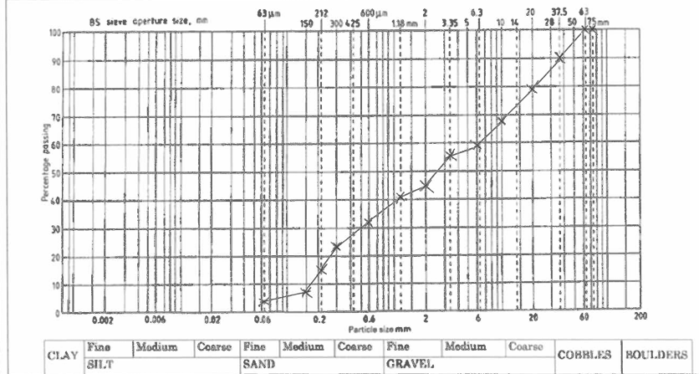
4). c.)

4). d.)
There are no aggregates which we would consider as boulders in the sample. There are very few particles which we would consider to be cobbles. We do not know the consistency of the sample from this data. The particles could be very angular or rounded or a mixture of both. This would affect the quality of the concrete if this is used in the cement because the shape of the grains can affect the strength of the bind due to different porosities and frictions. For concrete that is required to be very strong and dense you want a good function of gradation on this graph. This means that you would see similar amounts of the sample left on the sieve each time. If the sample is missing particles of a certain size, it would limit the utility of the aggregate because there will be voids in the concrete that will not be adequately filled. The sample has a high percentage of fines in comparison to coarse. This means that the sample is more workable as there is a high number of well-rounded particles but its bind strength will be less than other aggregates. Due to the weakness of the bind, I think that backfilling would be the best use of this aggregate so long as the area being backfilled will not be required to bear heavy loads.

Bibiliography
Bandera, G. (2024). Why is Concrete so Damaging to the Environment? [online] FairPlanet. Available at: https://www.fairplanet.org/story/concrete-climate-change-environmental-injustice/.
Bob (2025). Exploring The Disadvantages Of Cement Production: Environmental, Health, And Economic Impacts - ConcreteCaptain.com. [online] ConcreteCaptain.com. Available at: https://concretecaptain.com/disadvantages-of-cement-production/.
Brooks, M. (2020). Trellick Tower. [online] Designingbuildings.co.uk. Available at: https://www.designingbuildings.co.uk/Trellick_Tower.
Concrete Society. (2025). Integration of building services | Concrete Society. [online] Available at: https://www.concrete.org.uk/fingertips/integration-of-building-services/.
Notting Hill’s famous Trellick Tower. (2017). BBC News. [online] 1 Aug. Available at: https://www.bbc.co.uk/news/in-pictures-40728732.
RIBA (2021). A Tale of Two Towers: Trellick Tower turns 50. [online] Riba.org. Available at: https://www.riba.org/explore/riba-collections/inside-our-collections/trellick-tower-turns-50/.
Richardson, P. (2021). Harnessing the Dystopian Dread of the Brutalist Tower Block. [online] Atlas Obscura. Available at: https://www.atlasobscura.com/articles/ballard-high-rise-inspiration.
Team, A. (2025). Trellick Tower by Ernő Goldfinger: A Brutalist Landmark in London | ArchEyes. [online] ArchEyes. Available at: https://archeyes.com/trellick-tower-by-erno-goldfinger-a-brutalist-landmark-in-london/.
UK Green Building Council (n.d.). Environmental & Ecological Impacts of Cement. [online] UKGBC. Available at: https://ukgbc.org/our-work/topics/embodied-ecological-impacts/cement/.
Valle, G. (2021). Concrete vs. Steel: Pros and Cons of Each - BuilderSpace. [online] www.builderspace.com. Available at: https://www.builderspace.com/concrete-vs-steel-which-is-better-for-buildings.
Winstanley, T. (2019). AD Classics: Trellick Tower / Erno Goldfinger. [online] ArchDaily. Available at: https://www.archdaily.com/151227/ad-classics-trellick-tower-erno-goldfinger.
Wolfe, R. (2013). Trellick Tower: The fall and rise of a modern monument. [online] The Charnel-House. Available at: https://thecharnelhouse.org/2013/08/28/trellick-tower-the-fall-and-rise-of-a-modern-monument/.

