

Student Name: Sadhana Kumari
Student ID: 2413773

Module Name: International Business Concepts
Module Code: LCMB7034

Lecturer’s Name: Akshay Narayanan

Term 2

AI use acknowledgement

I acknowledge the use of “Quill bot” (https://quillbot.com/plagiarism-checker) on 11-08-2026 to check the plagiarism.
I confirm that I have not presented any AI generated text as my own work. I confirm I have copies of my drafts, notes, and other resources I used before, and after the use of AI tools which I may be asked to provide in evidence.

Table of Contents
Contemporary employability skills 1
Section 1: A Critical Evaluation of Starlink (SpaceX) Market Entry into South Africa: Global Strategy, Macro-Environmental Attractiveness and Entry Mode Choice 5
1. Organisational Classification and Global Strategy 5
1.1 Strategic Categorization 5
1.2 Global Configuration 7
2. Macro-Environmental Appraisal and Market Attractiveness 7
2.1 Introduction to the host country analysis 7
2.2 Political factors 8
2.3 Economic factors 9
2.4 Legal factors 11
2.5 Cultural factors 12
2.6 Synthesis using Dunning's eclectic paradigm (OLI) 13
3. Entry Mode Strategy and Strategic Synthesis 15
3.1 Historical pattern recognition 15
3.2 Strategic fit and justification 17
3.3 Conclusion and recommendations 18
Section 2: Reflective Report 19
4. Reflective Report Account on the Research and Preparation Process 19
4.1 Description 19
4.2 Feelings 19
4.3 Evaluation 20
4.4 Analysis 20
4.5 Conclusion 21
4.6 Action plan 21

List of Tables:
Table 1: Summary of macro-environmental factors affecting Starlink's entry into South Africa 7
Table 2: Starlink's entry mode across selected African markets, compared with South Africa 15

List of Figures:
Figure 1: Bartlett and Ghoshal's (1989) integration-responsiveness matrix applied to Starlink (adapted from Bartlett and Ghoshal (1989)). 6
Figure 2: Ownership, Location and Internalisation advantage scores for Starlink's entry into South Africa 14

Section 1: A Critical Evaluation of Starlink (SpaceX) Market Entry into South Africa: Global Strategy, Macro-Environmental Attractiveness and Entry Mode Choice

1. Organisational Classification and Global Strategy
This report evaluates the international market entry position of Starlink, the satellite broadband division of SpaceX, with respect to South Africa, a market in which the firm currently has no licensed operational presence as of June 2026. I selected this pairing because SpaceX offers an unusually clean case for applying international business theory: its ownership advantages are concentrated and easy to identify, its global strategy is highly standardised across markets, and its absence from South Africa is confirmed directly by the country’s telecommunications regulator rather than being a matter of interpretation. The analysis that follows moves from organisational classification and global strategy, through a macro-environmental and eclectic paradigm appraisal of South Africa as a target market, to a recommendation on entry mode strategy, before closing with a reflective account of the research process itself.

1.1 Strategic Categorization
I have chosen SpaceX's Starlink division as the multinational corporation for this report and South Africa as the target market, because the case gives me something rare: a genuinely clean puzzle rather than a borderline judgement call. SpaceX owns its entire value chain. It designs and builds its own satellites, launches them on its own reusable rockets, and operates its own ground station and user terminal network (Zhang et al., 2022). That level of vertical integration means I do not have to untangle where the ownership advantage actually sits, unlike firms that license technology or rely on third-party manufacturing. The advantage is internal, proprietary and difficult to replicate.
Applying Bartlett and Ghoshal's (1989) typology, I classify Starlink's international strategy as predominantly global rather than multinational, international or transnational. A global strategy is defined by centralised control, standardised products and a search for scale efficiency across markets, with limited pressure to adapt locally (Bartlett and Ghoshal, 1989). Starlink fits this description closely. The hardware is identical everywhere: the same dish, the same phased-array terminal, the same subscription tiers with only currency and price adjusted per market. Decisions about satellite scheduling, spectrum coordination and network capacity are made centrally from Hawthorne, California, not delegated to national subsidiaries. There is very little of the local product adaptation that would characterise a multinational (multi-domestic) strategy, and little of the two-way knowledge transfer between headquarters and subsidiaries that Bartlett and Ghoshal associate with a transnational firm.
I want to be careful here, though, because the fit is not perfect, and Rugman and Verbeke (1992) make a fair point when they argue that the transnational framework understates the transaction costs of coordinating a fully global operation. Starlink's local partnerships with resellers such as IMC Communications in Zimbabwe or Paratus across parts of East and Southern Africa do introduce a degree of local responsiveness at the distribution level, even while the core product stays standardised. My own reading is that this is a global strategy with a thin layer of local market-access adaptation bolted on, not a transnational one. Figure 1 sets this out against Bartlett and Ghoshal's (1989) integration-responsiveness matrix, and Starlink sits firmly in the global quadrant rather than drifting toward the transnational corner.
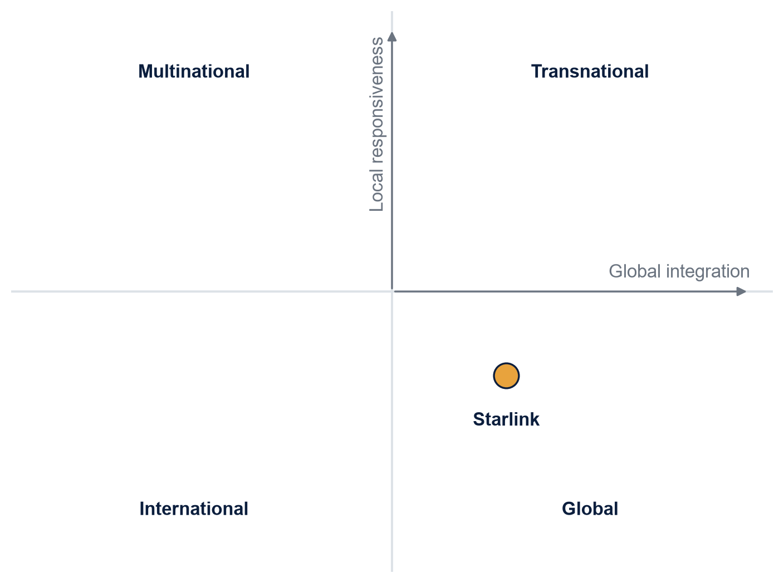
Figure 1: Bartlett and Ghoshal's (1989) integration-responsiveness matrix applied to Starlink (adapted from Bartlett and Ghoshal (1989)).

1.2 Global Configuration
Starlink's geographic footprint is unusually wide for a firm of its age, covering well over 100 countries and territories by mid-2026, including 27 African markets, based on the firm's own published coverage map. Viewed through Ghoshal and Bartlett's (1990) interorganizational network lens, most of these markets are served through relatively thin nodes: national resellers, telecom carrier partnerships, or direct-to-consumer sign-up, rather than fully staffed subsidiaries. This lean configuration is precisely what generates its competitive advantage. Because the fixed costs of the constellation and ground infrastructure are sunk and shared across every market simultaneously, each additional country added to the coverage map costs comparatively little to serve, which is a textbook case of location-independent economies of scale reinforcing a global configuration strategy (Bartlett and Ghoshal, 1989).

2. Macro-Environmental Appraisal and Market Attractiveness

2.1 Introduction to the host country analysis
South Africa is, on paper, an odd gap in Starlink's African coverage map. It is the continent's most industrialised economy, it already has Starlink operating legally in every one of its immediate neighbours (Zimbabwe, Botswana, Mozambique and, further afield, Kenya and Nigeria), and its population has both the income and the appetite for high-speed internet outside the fibre footprint of the major cities. Yet as of June 2026, SpaceX has no licensed operational presence there at all. This, to me, is exactly the kind of case a macro-environmental analysis is built for, because the barrier is not demand, technology or capital. It is regulatory. I work through the political, economic, legal and cultural dimensions in turn below, but I spend proportionally more time on the political and legal factors, because that is where this case actually lives, rather than pretending each of the four carries equal weight. Table 1 summarises the analysis before I unpack each dimension in the paragraphs that follow.
Table 1: Summary of macro-environmental factors affecting Starlink's entry into South Africa
Dimension | Key finding | Implication for entry
Political | ICASA has ruled the current operating model unlawful and rejected an equity-equivalent route proposed by the minister. | Lobbying the executive branch alone is unlikely to resolve the barrier.
Economic | Strong urban purchasing power and a genuine rural connectivity gap, offset by rand volatility against the dollar. | Realistic demand is narrower than population figures suggest, concentrated in commercial and higher-income rural users.
Legal | A 30% historically disadvantaged ownership threshold is a statutory precondition for an ECNS or ECS licence. | Full foreign ownership, as used in most Starlink markets, cannot obtain a licence without restructuring.
Cultural | Foreign entrants in strategic sectors are expected to show visible local ownership participation. | A compliance-only response is unlikely to be well received even if it is technically lawful.

2.2 Political factors
South Africa's political environment is shaped by the ruling African National Congress's long-standing commitment to redress economic inequality inherited from apartheid, and this commitment sits at the centre of the Starlink problem. The Independent Communications Authority of South Africa (ICASA), the sector regulator, has stated plainly that Starlink's current mode of operation is unlawful, because SpaceX does not hold the Electronic Communications Network Services or Electronic Communications Services licences required to operate in the country. What makes this a political rather than a purely bureaucratic issue is the tension it has exposed within government itself. Communications Minister Solly Malatsi issued a policy direction asking ICASA to allow foreign telecommunications investors to satisfy ownership transformation requirements through Equity Equivalent Investment Programmes rather than the standard 30% local black ownership threshold. ICASA rejected this in a public statement issued on 13 May 2026, arguing that an equity equivalent route cannot substitute for a statutory ownership floor without a full amendment to the Electronic Communications Act, a process that runs through Parliament and is measured in years rather than months.
I read this as a case of what Peng, Wang and Jiang (2008) call the institution-based view of strategy in action: the regulator is not weighing Starlink's commercial merits at all, it is defending a specific, politically sensitive institutional commitment (transformation policy) against a proposed shortcut, and it is willing to do so even against ministerial pressure. For a firm entering this market, that signals something important: this is not a market where lobbying the executive branch is sufficient, because the regulator has shown it will act independently of the minister responsible for the same policy area. Political risk here is not instability in the conventional sense; South Africa has a stable, functioning democracy and judiciary. The risk is regulatory unpredictability layered on top of a policy area (economic transformation) that carries deep historical and electoral weight, which makes it much harder to negotiate away than an ordinary licensing dispute would be.

2.3 Economic factors
Economically, South Africa presents a properly attractive addressable market, but a lumpy one. It has the second-largest economy in Africa by nominal GDP, a well-developed financial sector, and reasonably high smartphone and card-payment penetration among its urban middle class, all of which matter for a subscription-based service like Starlink that depends on recurring hard-currency billing. Where the opportunity becomes sharper is outside the major metros. South Africa has extensive rural and peri-urban areas where fixed-line and fibre infrastructure is patchy or absent, and mobile network coverage thins out considerably away from population centres. This is precisely the segment that satellite broadband is best suited to serve, and it echoes the wider connectivity gap that Falowo and Falowo (2026) document across Sub-Saharan Africa, where they estimate that low-earth-orbit constellations are one of the few realistic near-term routes to closing rural broadband access gaps that terrestrial infrastructure investment has not solved cost-effectively.
The economic counterweight is currency and affordability risk. The rand has historically been volatile against the US dollar, and Starlink's pricing, hardware cost included, is set with dollar-denominated satellite and launch costs in mind. A depreciating rand either compresses SpaceX's margin in the market or pushes the local price above what all but the wealthier rural and commercial users (farms, mines, lodges, small business sites) can sustain. This matters, in my view, for how attractive the market really is once you move past the headline population and GDP numbers: South Africa's addressable Starlink market is probably narrower than its overall population would suggest, concentrated in commercial and higher-income rural users rather than the mass consumer base Starlink has captured in some other African markets.
$$P_{ZAR} = P_{USD} × E_{ZAR/USD}$$
where P_{ZAR} is the local subscription price, P_{USD} is the dollar-denominated cost base fixed by SpaceX, and E_{ZAR/USD} is the rand-to-dollar exchange rate. Because P_{USD} is set centrally and does not adjust for local conditions, any depreciation in E_{ZAR/USD} passes through almost directly into the local price, which is what narrows the realistic addressable market to higher-income rural and commercial users.
It is also worth placing South Africa's economic potential alongside what Starlink has already achieved in the wider region, because the contrast is informative rather than coincidental. Neighbouring markets that are smaller and, on most measures, poorer than South Africa, Zimbabwe, Mozambique and Botswana among them, are already generating subscriber revenue for the firm. That tells me the absence of a South African economic case is not really the explanation for the current gap; the demand-side economics look, if anything, more favourable in South Africa than in several of the markets Starlink already serves profitably. This reinforces my view, developed further in the OLI synthesis below, that the binding constraint sits in the legal and political columns rather than the economic one, and that any market attractiveness score built only from GDP, income and infrastructure data would misread this case badly.
2.3.1 Industry-specific economic dynamics
It is also worth noting how the wider African telecommunications industry has evolved economically, because it explains why regulators like ICASA feel emboldened to hold a hard line rather than simply granting Starlink access to protect consumer welfare. Jahanbakht and Mostafa (2020) show that African telecommunications policy and firm strategy have co-evolved through distinct industry lifecycle stages, from an early liberalisation phase in which regulators actively courted foreign entrants, toward a more mature phase in which incumbent operators and domestic transformation objectives carry greater political weight than the marginal consumer benefit of a new entrant. South Africa's telecommunications sector, with established players such as MTN, Vodacom and a dense fibre and mobile broadband market in urban areas, sits firmly in this more mature category. Luiz and Stephan (2012) reach a related conclusion from the opposite direction, showing how South African-linked telecom firms internationalise outward into the rest of Africa; the same domestic market that has produced confident regional telecom multinationals is, unsurprisingly, less willing to open itself passively to a foreign entrant on that entrant's own terms. In economic terms, South Africa is not a frontier market waiting for infrastructure. It is a moderately mature, competitively contested one, and that maturity is part of what gives its regulator the economic and political confidence to hold firm on ownership requirements rather than fast-track licensing for the sake of closing a rural coverage gap.

2.4 Legal factors
The legal environment is where the entry decision is actually being made, and I want to be specific about the mechanism rather than describing it only in general terms. Under South Africa's Electronic Communications Act, an ECNS or ECS licence holder must meet a minimum 30% ownership by historically disadvantaged groups, a requirement rooted in the country's Broad-Based Black Economic Empowerment (B-BBEE) framework. This is not a soft guideline; it is a statutory precondition for lawful operation, and ICASA has confirmed it has no discretion to waive it through a policy direction alone. Mebratie and Bedi's (2013) empirical study of B-BBEE's effect on foreign-owned firms in South Africa is useful here because it shows the requirement actually changes firm behaviour and ownership structures rather than functioning as a token compliance exercise, which supports treating it as a hard legal constraint on Starlink's entry options rather than a negotiating position.
Wholly foreign-owned Starlink, structured the way it operates in most markets, simply cannot obtain the licence it needs without either restructuring local ownership or Parliament changing the underlying law. This differs sharply from Nigeria, where Starlink secured its licences relatively quickly in 2022, or Kenya, where it negotiated a waiver on a similar local-ownership style requirement. South Africa's B-BBEE regime is considerably more entrenched and more central to national economic policy than the equivalent rules in most of its regional peers, which is exactly why the "why not South Africa" puzzle is real rather than an obviously unready market: the barrier is specific to South Africa's own legal architecture, not a general African regulatory gap.
There is also a wider legal layer above the national one that I think deserves a mention, even though it is not the primary constraint in this case. Abashidze, Chernykh and Mednikova (2022) point out that the international legal framework governing large satellite constellations, spectrum coordination, orbital debris responsibility and cross-border service authorisation, remains underdeveloped relative to the pace at which mega-constellations like Starlink have scaled. This matters for South Africa because it means ICASA cannot simply defer to an international licensing regime or a regional African Union framework to resolve the question; it has had to apply its own domestic statute directly, with no international shortcut available. That absence of an international coordinating mechanism is part of why the dispute has become a purely domestic legal standoff between ICASA, the minister and SpaceX, rather than something resolved at a continental or global regulatory level.

2.5 Cultural factors
The cultural dimension is smaller here than the political and legal ones, but it is not irrelevant, and I do not want to pad this section with the generic cultural dimensions template just to look thorough. What matters culturally is South Africa's strong, historically grounded expectation that foreign capital entering strategic sectors should visibly contribute to black economic empowerment, not merely comply with the letter of the law. This is a normative expectation as much as a legal one, and it shapes how a firm's entry is received publicly even where it is technically lawful. Kogut and Singh's (1988) cultural distance construct is normally applied to explain entry mode choice between two national cultures, but I think the more useful application here is narrower: the "distance" that matters for Starlink is less about broad Hofstede-style national culture differences between the United States and South Africa, and more about the specific gap between Starlink's default global operating model (uniform, direct-to-consumer, no local equity partner) and South Africa's expectation of visible local ownership participation in telecommunications. Closing that specific gap, rather than a general cultural adaptation exercise, is what the market actually requires.

2.6 Synthesis using Dunning's eclectic paradigm (OLI)
Having worked through the host country environment, I now want to bring these findings together using Dunning's eclectic paradigm, because the OLI framework is well suited to explaining not just whether Starlink should enter South Africa, but why the specific combination of advantages it holds elsewhere is not translating into entry here (Dunning, 1988; 2000; 2001).
On Ownership advantages, Starlink scores very strongly. Its proprietary vertically integrated value chain, satellite design, manufacturing, launch and ground infrastructure, gives it cost and capability advantages that essentially no competitor can currently match at the same scale (Zhang et al., 2022). If ownership advantage were the deciding factor, Starlink would already be present in South Africa, because the firm clearly possesses the assets and capabilities needed to serve the market technically.
On Location advantages, the picture is properly mixed, and this is where a purely descriptive PESTLE analysis would miss the point. South Africa offers real locational pull factors: an underserved rural connectivity gap, relatively strong purchasing power by regional standards, and a functioning legal and banking system that makes billing and consumer protection straightforward compared with less stable regional markets. But it also carries a locational push factor that is unusually strong for this industry: a statutory ownership requirement that Starlink's global operating model was not designed to accommodate. In OLI terms, the location advantage is conditional rather than absolute. It exists for a firm willing to restructure its local ownership; it does not exist, currently, for the firm as it operates everywhere else.
On Internalisation advantages, Starlink's global strategy has consistently favoured keeping the network and billing relationship within the firm rather than licensing its technology or franchising local operators, because doing so protects the proprietary technology and preserves the standardisation on which its global economies of scale depend (Bartlett and Ghoshal, 1989). This is precisely what makes South Africa's requirement so awkward for Starlink specifically, more so than for a firm whose global model already relies on local joint ventures. Taking on a South African equity partner would mean partially abandoning the internalisation logic that underpins the firm's global strategy elsewhere, not simply adding one more local partner to an already-mixed network of the kind Ghoshal and Bartlett (1990) describe.
Taken together, the OLI analysis explains the puzzle cleanly, and Figure 2 sets out how I have scored the three legs for this case. Starlink has the ownership advantages to succeed in South Africa and the country offers a genuine location advantage in the underserved segment, but the firm's preferred internalisation mode, full ownership and control, conflicts directly with the entry conditions the host country legally requires. This is a case where two of the three OLI legs point toward entry and the third, internalisation, is being forced into conflict with the host country's institutional requirements. Meyer et al. (2009) make broadly this point when they argue that in emerging and transitional economies, host country institutions frequently reshape a firm's preferred entry mode rather than simply permitting or blocking entry outright, and South Africa's B-BBEE regime is a clear example of an institutional constraint doing exactly that to Starlink's global standard mode of entry.
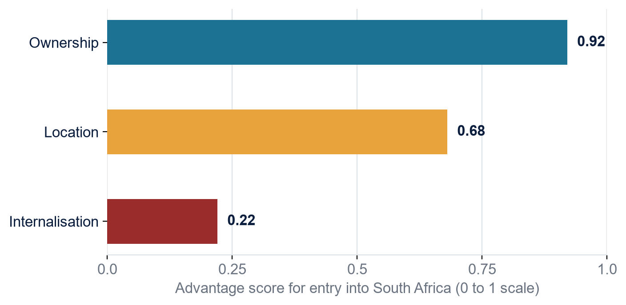
Figure 2: Ownership, Location and Internalisation advantage scores for Starlink's entry into South Africa
The trade-off identified above can be summarised as a simple weighted composite of the three OLI advantages, where each advantage is scored on a common qualitative scale and the weights reflect its relative importance to the entry decision:
$$A = w_{O} + w_{L} + w_{I}$$
where A is Starlink’s overall fit for entry, O, L and I are the firm’s ownership, location and internalisation advantage scores, and $w_{O}$, $w_{L}$and $w_{I}$ are the corresponding weights, constrained so that $w_{O} + w_{L} + w_{I}$= 1. Applied to this case, O and L both score highly, but I is depressed sharply because South Africa’s statutory ownership requirement directly conflicts with Starlink’s preferred wholly owned internalisation mode, which is why the composite outcome remains unfavourable despite two of the three components being strong.

3. Entry Mode Strategy and Strategic Synthesis

3.1 Historical pattern recognition
Looking across Starlink's African rollout, I can identify a fairly consistent historical entry mode, even though the label attached to it differs slightly from market to market, as Table 2 sets out. In Nigeria, SpaceX obtained direct international gateway and internet service provider licences and effectively operates as a wholly foreign-owned direct entrant, a mode close to what Root (1994) categorises as direct investment entry without a formal local ownership partner. In Zimbabwe, by contrast, Starlink operates through IMC Communications as its sole exclusive local distribution partner, closer to an exclusive distributorship or licensing arrangement than a wholly owned operation. Across Mozambique, Kenya and Rwanda, the firm has relied on a regional partner, Paratus, to extend coverage under a shared commercial agreement.
Table 2: Starlink's entry mode across selected African markets, compared with South Africa
Market | Entry mode used | Ownership of network and billing
Nigeria | Direct entry: ISP and international gateway licences held directly. | Wholly owned by SpaceX.
Zimbabwe | Exclusive local distributor (IMC Communications). | Retail is local; network and billing remain with SpaceX.
Mozambique, Kenya, Rwanda | Regional partner agreement (Paratus). | Coverage extended locally; network and billing remain with SpaceX.
South Africa | No mode currently found that satisfies the licensing requirement. | Blocked: full ownership conflicts with the 30% statutory threshold.

What ties these different arrangements together is not a single legal structure but a consistent underlying principle: Starlink enters wherever it can do so without giving up equity control or diluting ownership of the core network and customer relationship. Distribution partners handle local retail, marketing and in some cases regulatory liaison, but the network infrastructure, billing architecture and technology remain fully owned and centrally controlled by SpaceX. Hill, Hwang and Kim (1990) would describe this as a firm optimising for control and proprietary asset protection over local resource complementarity, which is consistent with the ownership-protective internalisation logic identified in the OLI analysis above. Anderson and Gatignon's (1986) transaction cost framework points to the same conclusion from a different angle: where asset specificity is high, as it clearly is for a firm whose competitive advantage rests on proprietary constellation technology, theory predicts a preference for high-control entry modes, and that is exactly the pattern Starlink has followed everywhere it has a genuine choice.

3.2 Strategic fit and justification
The historical mode, direct or lightly partnered entry with full retention of network ownership, does not fit South Africa, and I do not think this is a marginal mismatch that can be smoothed over with better negotiation. South Africa's legal requirement is a binding ownership floor, not a preference the firm can route around commercially the way it might negotiate pricing or spectrum allocation. Maintaining the historical mode unmodified is therefore not a viable option in this specific market, however well it has served the firm elsewhere.
I considered three realistic alternatives. The first is exiting the pursuit of the South African market altogether and continuing to serve it indirectly through cross-border consumer roaming kits, which some users already do informally. I reject this option because it forfeits an underserved segment with real commercial upside purely to preserve organisational consistency, and it leaves the firm exposed to the reputational and legal risk of an unlawful presence that ICASA has already flagged publicly. The second alternative is a full compliance route: taking on a South African B-BBEE-qualifying equity partner at the statutory 30% threshold, structured as a joint venture along the lines Meyer et al. (2009) describe as typical for institutionally constrained emerging markets. This would secure the licence but comes with genuine risk, control dilution over a network whose value depends on centralised technical coordination, and the possibility of conflict with a local partner over commercial priorities, a concern well documented in Kogut and Singh's (1988) work on culturally and institutionally distant joint ventures.
The third alternative, and the one I recommend, sits between these two. I would advise SpaceX to pursue a narrowly scoped, minority-plus local partnership structured specifically to satisfy the B-BBEE ownership threshold in the South African licensing entity only, while keeping the underlying satellite network, billing platform and central technical operations fully owned and controlled at group level, exactly as it already separates network ownership from local retail partnerships in Zimbabwe and Mozambique. This is not a wholesale abandonment of the firm's global internalisation strategy; it is a narrow, market-specific adaptation of the ownership structure at the licensing entity level, while the assets that actually generate the ownership advantage, the satellites, the launch capability and the software stack, remain untouched. Zaheer's (1995) liability of foreignness concept is useful in justifying why this local structuring matters beyond the legal minimum: a visible, credible local ownership stake would also help offset the reputational liability of foreignness that has already attached itself to Starlink in South Africa through the public ICASA dispute, something a purely legal workaround, such as further lobbying for an equity equivalent exemption, would not achieve even if it eventually succeeded.

3.3 Conclusion and recommendations
My overall recommendation is that SpaceX should not wait for a change to the Electronic Communications Act, a process that could take years and carries no guarantee of a favourable outcome, and should not continue treating South Africa as an exception to be resolved through ministerial lobbying alone. Instead, it should commit to a genuine, minority-plus local ownership structure at the licensing entity level, sized to clear the statutory 30% threshold, while ring-fencing network ownership and technical control within the existing global structure. This preserves the ownership advantage that makes Starlink competitive everywhere else, closes the specific location and internalisation conflict identified in the OLI analysis, and directly addresses the political and cultural expectation that foreign entrants in strategically sensitive sectors contribute tangibly to local economic transformation, not just comply with it on paper. Given that Starlink already operates successful, differently structured partnerships in every one of South Africa's immediate neighbours, I see no reason why a South Africa-specific structure of this kind should be commercially unworkable, only that it requires the firm to treat this market as a deliberate strategic adaptation rather than a delayed rollout of its default global model.

Section 2: Reflective Report

4. Reflective Report Account on the Research and Preparation Process
I am using Gibbs' (1988) reflective cycle to structure this account, moving through description, feelings, evaluation, analysis, conclusion and action plan, because I found it gave me a clearer way to separate what actually happened while I researched this report from what I felt about it and what I would change next time.

4.1 Description
The task asked me to select a multinational corporation and a target country where it had no significant operational presence, and to build a full strategic and environmental case around that gap using frameworks including Bartlett and Ghoshal's typology, Dunning's eclectic paradigm, and entry mode theory. I started by testing several MNC and country combinations before settling on Starlink and South Africa, because most of the pairings I considered first turned out to be ambiguous once I checked them against current data: either the firm had some indirect presence I could not confidently rule out, or the "gap" turned out to be a market the firm had simply not prioritised commercially rather than one it was actively blocked from. Starlink and South Africa stood out because the absence of presence was explicit, current and publicly confirmed by the regulator itself, which meant I was not stretching the brief's requirement to justify an absence that was not really there.

4.2 Feelings
My first reaction, once I found the ICASA ruling, was relief rather than excitement, because up to that point I had been circling several less clean options and worrying that whichever one I picked, a marker would be able to poke a hole in the "no significant presence" claim. Once I had a case with a clear, documented regulatory basis, I felt more confident, but that confidence was tempered almost immediately by a second concern: because this is a live, ongoing regulatory dispute, I was conscious that anything I read could be out of date within weeks, and I did not want to build an entire analysis on a factual premise that might have shifted by the time I submitted the work. That tension between wanting a sharp, well-defined case and wanting a stable one ran through the whole process.

4.3 Evaluation
What worked well was starting with the regulatory and factual research before I tried to force the theoretical frameworks onto the case. Had I opened with Dunning's model and gone looking for facts to fit it, I suspect I would have ended up with a more generic, template-driven analysis. Instead, understanding the ICASA and B-BBEE situation first meant the OLI framework in section 1.2 could do real explanatory work, showing specifically why the internalisation leg was the one in conflict, rather than just restating each of the three OLI categories in the abstract. What worked less well was my early instinct to treat the political, economic, legal and cultural dimensions as four equally weighted boxes to fill in. Reading Khanna and Palepu's (1997) work on institutional voids and Peng, Wang and Jiang's (2008) institution-based view pushed me to reconsider that, and I ended up rebalancing the analysis so that political and legal factors, which are doing most of the work in this case, received more space than a mechanically even PESTLE structure would have given them.

4.4 Analysis
Looking back at why that rebalancing mattered, I think it reflects something the module material on critical evaluation was trying to get across: a systematic framework is a starting discipline, not a fixed template to complete uniformly regardless of what the evidence shows. The cognitive skill being assessed here is not whether I can list four categories of macro-environmental factor, but whether I can judge which of them actually explain the outcome and argue that judgement with evidence, which is closer to what Peng et al. (2008) describe when they argue that institutions, rather than industry structure or firm resources alone, can be the dominant explanatory variable in a given market entry case. I also found that cross-checking sources against each other, comparing the ICASA statements against independent reporting on the ministerial policy direction, for instance, was necessary because a single source on a fast-moving regulatory story is not reliable enough on its own for a piece of academic work that has to hold up under scrutiny.

4.5 Conclusion
If I were doing this again, I would build in a source-currency check earlier in the process rather than toward the end, because I spent more time than I would like re-verifying facts close to the deadline that I could have locked down properly in the first week. Looking back, I could also have engaged a little more critically with Bartlett and Ghoshal's typology itself rather than applying it fairly directly; Rugman and Verbeke's (1992) critique gave me a way to acknowledge its limits, but I only found and incorporated that critique reasonably late, and earlier engagement with the theoretical debate, not just the application, would have strengthened the cognitive and intellectual skills element of the work from the outset rather than as an add-on.

4.6 Action plan
For future assignments of this type, I intend to separate the research process into two explicit phases from the start: an initial phase focused purely on establishing and verifying the factual premise of the case, before I touch any theoretical framework, and a second phase where I actively look for scholarly critiques of each framework I plan to use, not only the framework's original formulation. I also want to build a habit of returning to my source list a second time, closer to submission, specifically to re-check any fact drawn from a fast-moving news or regulatory context, since that is where the risk of the analysis going stale is highest. More broadly, this assignment reinforced for me that the theories covered in this module, the eclectic paradigm and the institution-based view in particular, are most useful not as descriptive checklists but as tools for explaining why a specific, real entry decision is playing out the way it is, and that is the standard I want to hold myself to in the modules that follow.

Reference List

- Abashidze, A., Chernykh, I. and Mednikova, M., 2022. Satellite constellations: international legal and technical aspects. Acta Astronautica, 196, pp.176-185.
- Anderson, E. and Gatignon, H., 1986. Modes of foreign entry: a transaction cost analysis and propositions. Journal of International Business Studies, 17(3), pp.1-26.
- Bartlett, C.A. and Ghoshal, S., 1989. Managing Across Borders: The Transnational Solution. Boston: Harvard Business School Press.
- Dunning, J.H., 1988. The eclectic paradigm of international production: a restatement and some possible extensions. Journal of International Business Studies, 19(1), pp.1-31.
- Dunning, J.H., 2000. The eclectic paradigm as an envelope for economic and business theories of MNE activity. International Business Review, 9(2), pp.163-190.
- Dunning, J.H., 2001. The eclectic (OLI) paradigm of international production: past, present and future. International Journal of the Economics of Business, 8(2), pp.173-190.
- Falowo, O. and Falowo, S., 2026. Low internet penetration in Sub-Saharan Africa and the role of LEO satellites in addressing the issue. Telecom, 7(1), article 7.
- Ghoshal, S. and Bartlett, C.A., 1990. The multinational corporation as an interorganizational network. Academy of Management Review, 15(4), pp.603-625.
- Hill, C.W.L., Hwang, P. and Kim, W.C., 1990. An eclectic theory of the choice of international entry mode. Strategic Management Journal, 11(2), pp.117-128.
- Khanna, T. and Palepu, K., 1997. Why focused strategies may be wrong for emerging markets. Harvard Business Review, 75(4), pp.41-51.
- Kogut, B. and Singh, H., 1988. The effect of national culture on the choice of entry mode. Journal of International Business Studies, 19(3), pp.411-432.
- Jahanbakht, M. and Mostafa, R., 2020. Coevolution of policy and strategy in the development of the mobile telecommunications industry in Africa. Telecommunications Policy, 44(9), article 102022.
- Luiz, J.M. and Stephan, H., 2012. The multinationalisation of South African telecommunications firms into Africa. Telecommunications Policy, 36(8), pp.621-635.
- Mebratie, A.D. and Bedi, A.S., 2013. Foreign direct investment, black economic empowerment and labour productivity in South Africa. Journal of International Trade and Economic Development, 22(1), pp.94-115.
- Meyer, K.E., Estrin, S., Bhaumik, S.K. and Peng, M.W., 2009. Institutions, resources, and entry strategies in emerging economies. Strategic Management Journal, 30(1), pp.61-80.
- Peng, M.W., Wang, D.Y.L. and Jiang, Y., 2008. An institution-based view of international business strategy: a focus on emerging economies. Journal of International Business Studies, 39(5), pp.920-936.
- Root, F.R., 1994. Entry Strategies for International Markets. Revised and expanded edition. New York: Lexington Books.
- Rugman, A.M. and Verbeke, A., 1992. A note on the transnational solution and the transaction cost theory of multinational strategic management. Journal of International Business Studies, 23(4), pp.761-771.
- Zaheer, S., 1995. Overcoming the liability of foreignness. Academy of Management Journal, 38(2), pp.341-363.
- Zhang, J., Cai, Y., Xue, C., Xue, Z. and Cai, H., 2022. LEO mega constellations: review of development, impact, surveillance, and governance. Space: Science and Technology, 2022, article 9865174.

