

Student name: Sarder Rahman Maruf
Student ID number: 2311256
Programme: BA Hospitality and Hotel Management
Module: Operating Hotel Facilities
Module code: BMIH5011
Assignment Title: Portfolio 6 elements

Table of Contents Page No
Part 1: Reflective Writing Using Gibbs’ Model 3
1. Description 4
2. Feelings 4
3. Evaluation 5
4. Analysis 5
5. Conclusion 6
6. Action Plan 6
Part 2: Hotel Mentor Feedback 7
Part 3: Academic Tutor Feedback 8
Part 4: Reflection on Hotel and Academic Tutor Feedback 10
4.1 Understanding the Feedback 10
4.2. Impact of the Feedback 11
4.3. Action Steps for Growth 12
Conclusion 14
Part 5: Presentation on Placement Experience 15
Part 6: Questions and Answers Based on the Presentation 18
References 19

Part 1: Reflective Writing Using Gibbs’ Model
Personal reflection is a valuable tool for identifying limitations in one’s skills, professional conduct, and personal attributes. It plays a crucial role in helping individuals either find a suitable career path or bridge skill gaps required for specific roles. Although reflection is highly effective, it can be challenging to practice consistently. To aid this process, several reflective models have been developed over time, such as Gibbs' Reflective Cycle, the ERA cycle, Driscoll's What Model, and Kolb’s Experiential Learning Model (Cambridge Univeristy,2024).
For this particular reflection, I have chosen to apply Gibbs' Reflective Cycle, as recommended in the provided guidance. One of the key advantages of Gibbs’ model is its structured approach, which guides individuals through a comprehensive reflection process using six distinct stages: description, feelings, evaluation, analysis, conclusion, and action plan. This method not only encourages deeper introspection but also supports personal and professional development by linking theory to practice.
The following reflective piece applies Gibbs' model to evaluate my experience and performance during operational activities in the Housekeeping and Maintenance department at the Novotel Hotel in Cardiff.
Figure 1. Gibbs Reflective cycle
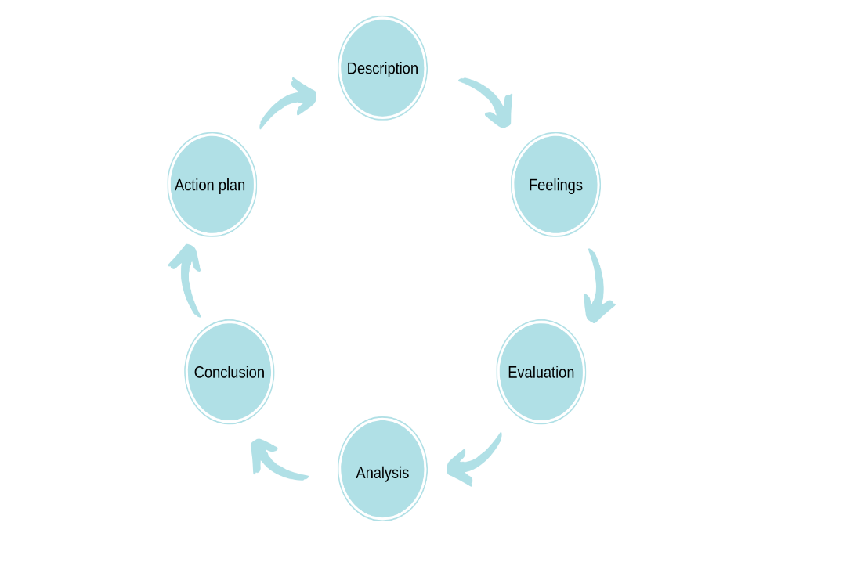
Source: (Model is adopted from Cambridge Univeristy,21024)
1. Description
From 14th January to 30th April 2025, I undertook a placement at the Novotel Hotel in Cardiff (CF10 4RT), where I have completed a 190 hours of work across various operational departments. This was averaging approximately 16 hours per week. My placement was supervised by the Food & Beverage (F&B) Manager, and I rotated between four departments I am including F&B, front desk, housekeeping, and maintenance.
In term of placement at operational facilities of hotel, although, my attendance in Housekeeping was limited, it was a completely new area for me. During my time at the Housekeeping, I was introduced to basic procedures such as room inspection and preparation. I have learned how to assess the overall room condition, paying attention to elements such as lighting, temperature, and ambience. However, I did not receive training on chemical use, linen handling, or laundry systems.
In the maintenance department, I was primarily an observer due to health and safety restrictions. While I was not able to carry out repairs or engineering work, I observed various tasks related to water safety, minor repairs, and general hotel safety protocols. This included exposure to fire safety procedures and an overview of heating and ventilation systems.
2. Feelings
Initially, I felt excited and curious about learning how different hotel departments operate. However, as the weeks progressed, I began to feel slightly disheartened. While I was eager to learn, I often felt sidelined and underutilised. The lack of hands-on training and limited guidance from staff made the experience feel somewhat unstructured. My feeling is not unjustified as (Joy-Matthews et al, 2004, p. 101; Stevenson & Harper (2006), found that in workplace context most frequently reported effect of stress was due to lack of attention to students. the added that such has had direct detrimental effect on student learning experience. However, there were moments of pride when I was able to grasp inspection protocols or observe complex maintenance routines, but overall, I felt the experience lacked depth.
3. Evaluation
One of the strengths of the placement was that it gave me a broad overview of operational hotel functions. At the housekeeping department, observing room inspections and understanding maintenance checks added a new dimension to my understanding of hotel facilities. It also helped me see how different departments contribute to the overall guest experience. Hodges (2007), state that observational learning is one of the effective way to learn tacit knowledge from experts at the work place. based on my experience of learning at the Housekeeping, I am in congruity that I have benefited from observing housekeeping and maintenance works at the hotel.
However, the placement was also marked by several limitations. Staff members often seemed too overwhelmed to offer guidance, and there was a noticeable lack of coordination across departments. The atmosphere suggested a high level of stress due to staff shortages, and this affected the willingness and ability of staff to support trainees. Opportunities for learning were missed because of poor communication and weak leadership structures at both of these housekeeping and maintenance department.
4. Analysis
In analysis of these situation, I can see that from a facilities management perspective, this experience has highlighted the importance of integrated operations and team coordination. According to Total Quality Management (TQM) principles, service quality is best achieved through collaboration, training, and consistent standards (Gillis,2024). This is also aligned with the finding of the study of Bouranta et al. (2019), where it identified organisation with integrated operating system and coordination has higher productivity and employee efficiency compared to the ones without. This clearly highlights that there is need for good coordination between the facilities management and trainees to learn from the team, which in my case was largely absent. Perhaps it was down to me to show proactive effort to engage with the team that could benefit me in learning.

Unfortunately, I have noticed that these were areas where the hotel struggled. The lack of standardised onboarding for trainees, combined with minimal staff support, led to an experience that was more observational than participatory. Here I draw attention to finding of Pretty (1995), experiment where author identified participatory training has higher level of productivity among new employee compared to the one do not take part in activities while learning. This Cleary highlights in my personal weakness of not involving myself into the learning and that I am in agreement that I did not put myself on the front sit of learning in an environment where people are busy with daily routine task and not always have time to teach a trainee carrying out placement.
Moreover, looking from theoretical content, the operational inefficiencies I witnessed especially in communication and teamwork can be linked to systems theory, which suggests that when one part of an organisation is under strain such as staffing shortages, the entire system suffers. That means, from the Novotel Hotel content, a well-managed operational team should function as an interconnected unit to lessen the burden of another unit. This is something that was clearly lacking in this environment.
5. Conclusion
Although there were challenges, this placement at the Novotel Hotel gave me valuable insight into the operational realities of hotel management. I have learned that attention to detail, safety compliance, and room condition assessment are vital element in maintaining service quality. I have also realised how crucial teamwork, leadership, and clear communication are for a smooth running of a hotel.
From my personal context, the placement taught me the value of being proactive, observant, and adaptable, especially when formal guidance is lacking. I also recognised the importance of fostering a positive work culture where staff feel supported and willing to share knowledge.
6. Action Plan
As part of the finding, and to build on this experience, I plan to enhance my practical knowledge of housekeeping and maintenance standards through following action plans:
- I shall undertake additional workshops or online courses, particularly in health & safety, chemical handling, and basic maintenance protocols.
- I also aim to improve my communication and leadership skills, so I can contribute more effectively to future placements.
- In future roles, I will take a more active role in seeking mentorship and clarifying expectations early on.
- I also intend to focus on developing multitasking abilities and building confidence in cross-functional tasks.
- I shall also take training on learning system like CMMS (Computerised Maintenance Management Systems) and SOPs (Standard Operating Procedures), which will help me align more closely with industry best practices.

Part 2: Hotel Mentor Feedback
Marufur demonstrated strong performance in the housekeeping department, consistently following cleaning protocols and maintaining high attention to detail, particularly when working independently or in back-of-house operations. In Maintenance, although his exposure was limited, he showed a good willingness to learn and assisted with basic tasks, adhering to health and safety protocols.
In the Meeting/Events department, Marufur was reliable in the setup and breakdown of events, though he could further develop his proactive engagement with clients. In the Leisure Club, Marufur was helpful with guest inquiries and maintaining cleanliness, but there is room for improvement in guest interaction and proactive service.
Overall, Marufur showed potential and dedication in all areas, with further development needed in guest engagement and proactive task management.

Part 3: Academic Tutor Feedback
- Time Management
Maruf demonstrated a strong and proactive approach to time management throughout his placement. Despite facing a considerable commute, he made an effort to complete his hours quickly and was ahead of schedule within the first two weeks. While this initiative was admirable, it was important for Maruf to pace his experience across the full placement period to fully benefit from all learning opportunities. After this was discussed, he adapted well, maintaining a steady attendance and fulfilling the required weekly hours and overall placement expectations.
From a tutor's perspective, Maruf was reliable in attending scheduled online meetings, where he was usually punctual and prepared. He showed a clear understanding of the placement tasks and requirements outlined in the handbook. His communication through emails and messages was timely and professional, reflecting good organisational skills.
However, Maruf has not yet submitted a draft of his written work; taking advantage of the opportunity for feedback could help strengthen the quality of his final submission.
At the hotel, Maruf completed his assigned tasks in Housekeeping, Front Office, and Food & Beverage within the expected timeframes and to a satisfactory standard.
- Communication
Maruf communicated in a clear and professional manner throughout his placement. During regular online meetings and email correspondence, he remained polite, respectful, and responsive. He was able to express his ideas and concerns thoughtfully when necessary and was open to receiving feedback and advice.
At the hotel, Maruf’s communication style was friendly and engaging. He showed confidence when learning new areas of the hotel. Maruf did appear to be moving through the process to complete it, rather than to gain the most out of this opportunity. This was commented by the hotel. The restaurant area is Maruf’s comfort zone and as such they are not sure that he gained a lot from this time. Maruf could identify his goals after the course and align these with the level 6 placement to gain the most from this and make sure he is not just working through the process.
- Behaviour
Maruf consistently maintained a professional and respectful approach throughout his placement. He adapted well across different departments, worked effectively with both staff and peers, and followed instructions carefully.
During tutor meetings, Maruf showed a positive attitude and a willingness to learn. While he did ask some questions during these sessions, they could have been more detailed and focused. In future, preparing more thoroughly for discussions and asking specific clarifying questions would support both his immediate learning and the quality of his assignment work.
For upcoming placements, Maruf would benefit from taking greater initiative, fully committing to the broader learning experience, and actively seeking out additional development opportunities. This approach will help him continue building confidence and developing stronger leadership capabilities.
- Problem-Solving
Maruf demonstrated good early problem-solving abilities during his placement. He was proactive in asking for clarification when needed and showed sound judgement when addressing tasks such as guest inquiries.
In our discussions, Maruf displayed self-awareness in recognising challenges and was open to feedback, using it constructively to improve his performance.
Looking ahead, further developing his initiative in unfamiliar situations, such as offering solutions independently or stepping forward without direction, will help strengthen his professional skills. Maruf is encouraged to take confidence from his successful placement experience and apply these lessons to enhance his performance during the Level 6 placement.
Tutor: Daniel Payne
Signature: Daniel Payne
Date: 25th April 2025

Part 4: Reflection on Hotel and Academic Tutor Feedback
As per the placement at the operational facilities, I have received feedback from my hotel mentor as well as from my academic tutor who has overseen and organise the placement at the Novotel Hotel in Cardiff central.

4.1 Understanding the Feedback
Looking at the feedback from the hotel mentor, I can see that there are number of area that he pointed out as strength factors. The mentor has appreciated my strong performance in the housekeeping department, mainly in my consistency in following cleaning protocols and giving high attention to detail specially in when I worked independently and in back of the house operation. The mentor pointed out that at the maintenance department although it was my limited exposure but I had showed good willingness to learn and was happy with my assistance with small and basic tasks while maintaining health and safety principles. Moreover, in the meeting and events department, they have found me reliable, with capacity to organise task in braking down into small tasks. However, they have identified some areas that I also need to improve and these are such as I need proactive engagement and guest interaction. Feedback is mainly centred around my practical capacity than my knowledge and understanding.
Following the placement, my academic mentor which is my placement tutor has also offered critical appreciations. My tutor has identified that a significant strength in my ability is time management with efficiency to complete task and hours fast. He further pointed out my reliability in online meeting, punctuality and responsiveness. He also mention that my communication skills was good and professional. However, he also noted that their area some areas that I lack skills and need more improvement. These are my inability in depth of engagement and potential tendency to focus on finishing task rather than maximising learning opportunities. He also pointed out that I have tendency of moving through process fast to complete task rather than gaining most of out of the opportunity. The tutor also mentions there is room for commitment improvement pointing out my lack of interest in submitting a draft of the placement experience.

If I look at common theme that can emerge from both of my mentor’s feedback, I find that there is common theme in “ need for increase in practice engagement”, there is also common theme of lack of focus in learning opportunity than completion of tasks. The hotel mentor was lest critical but encouraging and tutor was constructive in order to help improve personal skills and learn more and utilise the opportunity.

4.2. Impact of the Feedback
In term of the impact of these feedback, I find that these feedback has been highly beneficial for me. It has number of impact on my skills, capacity, understanding and to develop my future action plan to improve the skills and capacity that I have lack during the placement.
One of the impact that I would like to point out is that the feedback has change my understanding in theoretical and practical learning. Because of feedback from both hotel mentor and my tutor, I have realised that practical works outcome and theoretical understanding is largely different. I have also realised that not everyone in a team see thing from same context. Things that was right to me are now evidently wrong to others. For instance, I thought I shall be given instruction to work at the housekeeping and miniatous, but the mentor mention that I was lacking proactive initiatives at work. This clearly justify that might thought was wrong and thus I was unable to edge well during work at the operational department. My understanding align with Bakker (2017), finding where author have identified people in training environment became more effective and productive with working own initiative. There was also evident that people who ask question to have learned more than those who did not. This clearly justify that I should have ask question and took proactive action to improve my learning much more something that my academic tutor has largely pointed out in his feedback.
I have also found that there is new addition which is that my mentor mention about my good attention to details in housekeeping and maintenance work. This is something that was missing in my other works such as in Front office and F&B works. This comment from my mentor shows that I have improve in my limitation following the works at my previous department with the on the job feedback from colleagues. Moreover, my willingness to learn at the maintenance department was also demonstrated by my active observation of water safety checks and fire safety procedures, even though I could not participate hands on. The feedback on proactive engagement resonated with my experience of sometimes feeling sidelined. For instance, during busy periods in housekeeping, I often waited for direction rather than actively seeking opportunities to assist or ask questions about specific procedures like chemical handling. Taking suggestion of Bakker (2017), and feedback back that I have received I have realized that I was perhaps too focused on fulfilling the required hours rather than actively seeking out every possible learning opportunity, especially in areas where I felt less comfortable or where guidance was limited.
Finally, I would like to say that these feedback has significantly shaped my thought process, my practical understanding of professional growth in operational context. in the past I was thinking wrong about every aspects of operating but now I have realised that operational tasks are important and require efficiency and dedication as well as full attention to complete. Feedback has encouraged me to redevelop my skills and improve all the limitation that I have identified. The critical feedback of my teacher has been very helpful in term of understanding of what was good in my skills and ability and what was needed to improve from both personal and professional perspectives. This is something I have found very effective to plan my development goals for professional and academic career.

4.3. Action Steps for Growth
With the feedback from the operational functions, I have found there are number of areas that I will have to work on for certain period of time to improve my skills and capacity to ensure that upon completion of my degree, I can engage in a professional role in hotels or hospitality outlets. I have therefore planned to carryout the following actions for growth.
- Improve knowledge in health and safety area
I have found this is an important area where I was not taking any proactive attempt to work. This is what was pointed out by the hotel mentors during my work at the house keeping and in maintenance operation. However, in order to improve this skills, I shall enrol for an online course where I want to learn chemical handling, basic maintenance of protocols. This course shall therefore help me to understand theoretical perspective of sensitive materials use and legal aspects of it. I shall also learn about CMMS and SOPs that is needed to work in hotel and hospitality industry.
- I shall work on to enhance my communication and leadership skills to address the feedback that I have received.
That means I will be seeking opportunities to practice these skills such as practice action, problem solving, engaging with other to resolve issue, innovate ideas to solve problems. I shall engage in online based leadership short course and practice new skills at my current workplace with the support of my colleagues for next 12 month. I shall also volunteer of task such as interaction with others and consistently make effort to ask questions resolve matter at works. I shall also work closely with my tutors to get feedback on my learning and improvement of the leadership and proactive measure skills.
- I shall improve my observation skills as well as focus my works more on mining benefits.
Through feedback I have learned that I have tendency of going through process fast and not focusing on the actual issues and not looking at the opportunities and solving actual problem. In order to overcome these, I shall continue to practice at my current work to keep my mind to actual problem solving rather than rising to finish task. I shall learn problem solving skills and learn more about critical thinking skills. I shall also practice personal reflaction on each of the task that I do. This way I shall be able to improve my limitation in this area. I shall continue this practice for next 12 month so that I develop the skills and can us it for my next application for a role in hotels around in Cardiff.
- Improve my planning and ordaining skills
I have realised from the feedback that some of the problem that I have faces whether it is rushing to finish the work or lacking observation, was largely poor management and organising skills. I therefore, would take next six moth of my time to develop my planning and organisational skills with further development of skills for use of digital tools to many my task on routine. I shall do it taking own initiative to mange my time well for academic works, personal employment and works in personal life including socialising. I hope to improve these capacity in next six month and use it for my adventage in applying for a job in hotel around Cardiff upon completion of my degree.

Conclusion
The feedback has opened my eyes on the area that I otherwise would not have identified as my weakness. The feedback from operational department along with the feedback from my tutor was highly constructive with critical elements in it. It has helped me to understand my limitation as well as given me an understanding of what I have to do to improve. Based on the finding, I have developed four major action plan with the maximum timeline of 12 month and hope upon improvement and completion of these course, I shall mange to attain my career goal in hotel sector in the UK.

Part 5: Presentation on Placement Experience
The presentation is cross subject presentation and thus full presentation is presented using the presentation submission portal. There shall be a live presentation on 15th of May. However, for this part I have included fragmented slides from the original presentation for the operations department placement.
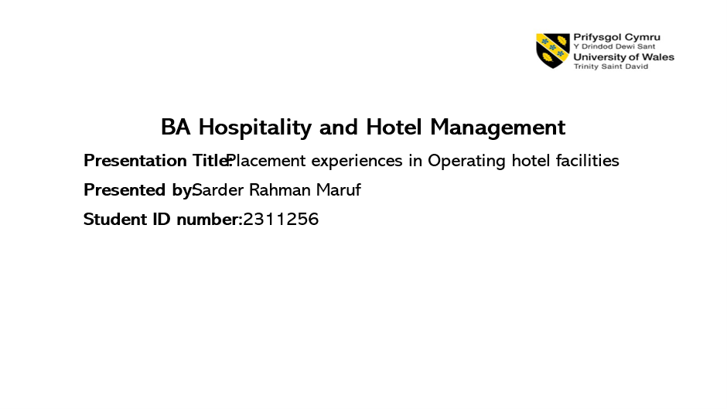
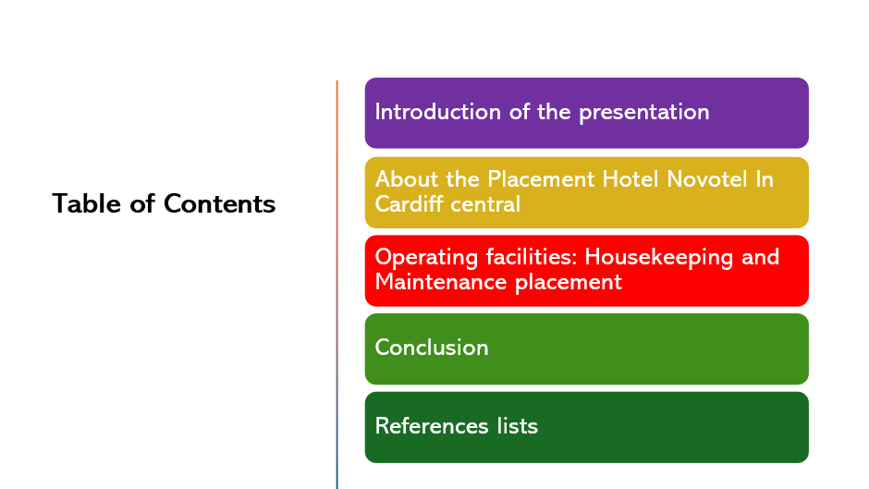

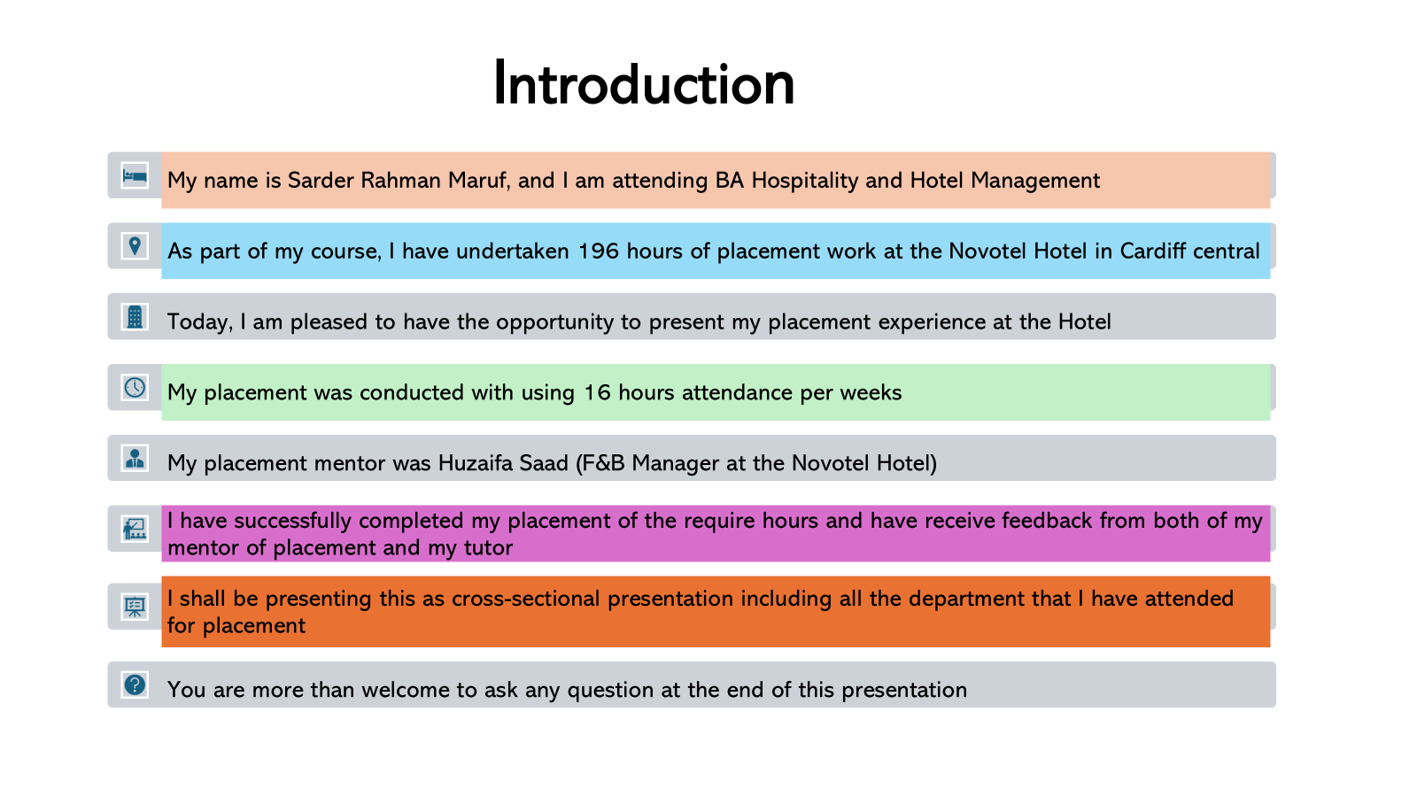

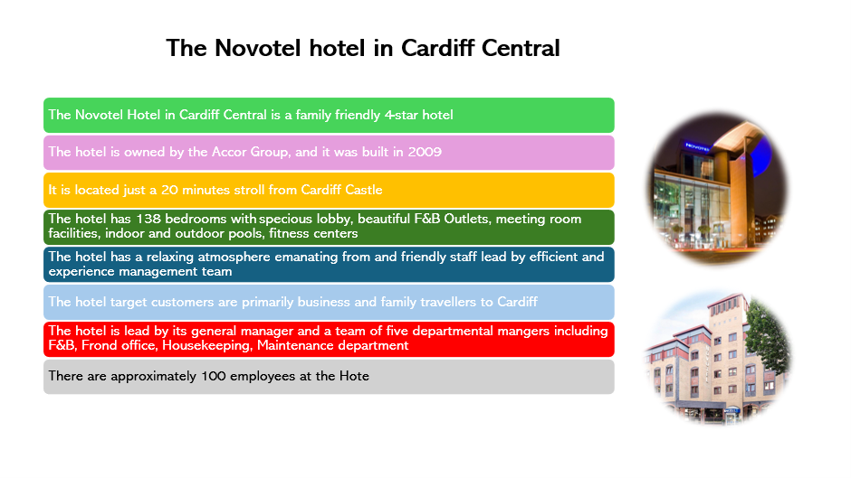

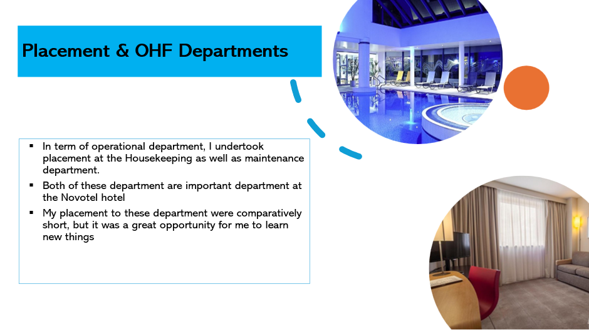
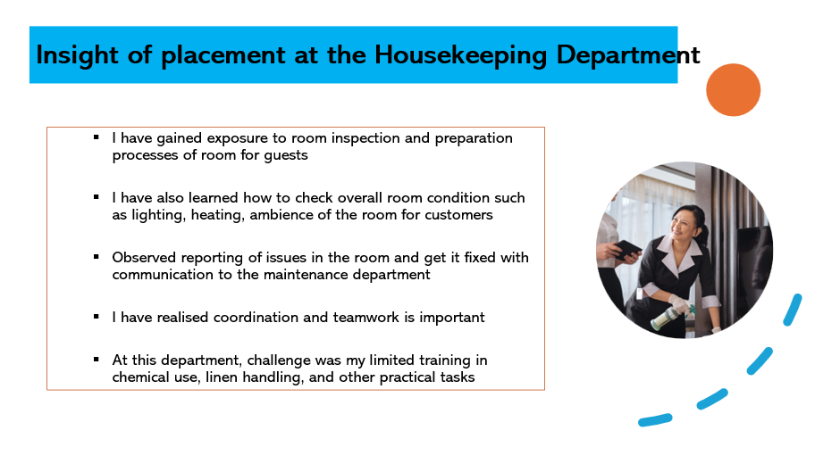

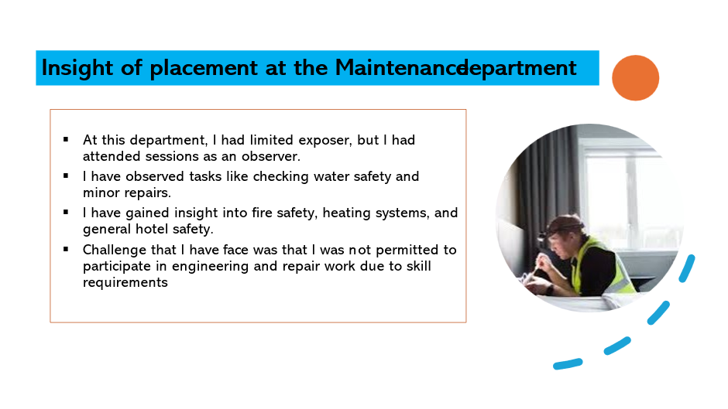
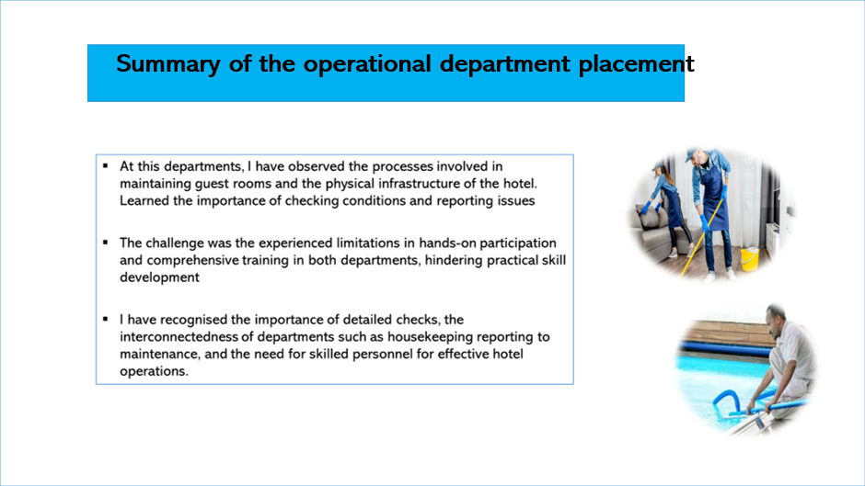

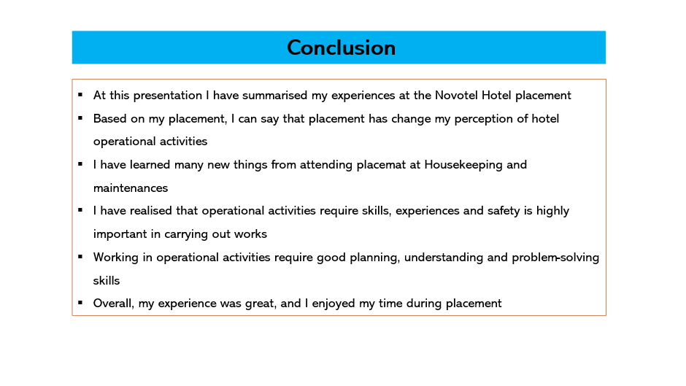


Part 6: Questions and Answers Based on the Presentation
The question and answer session shall be held during live presentation which is scheduled for 15th of May 2025.

References
Bouranta, N, et al. (2019). The key factors of total quality management in the service sector: a cross-cultural study. Benchmarking: An International Journal, Vol. 26. No (3). Pp: 893-92. Available at: https://www.emerald.com/insight/content/doi/10.1108/bij-09-2017-0240/full/html (Accessed: 20th of April 2025).
Bakker, A, B. (2017). Strategic and proactive approaches to work engagement. Journal of organisational Dynamic. Vol 46. No. Pp: 67-75. Available: https://pure.eur.nl/ws/portalfiles/portal/47856542/REPUB_100192.pdf (Accessed: 5th of May 2025).

Cambridge University.(2024). . Reflective Practice Toolkit. Study Skill. Available at: https://libguides.cam.ac.uk/reflectivepracticetoolkit/models
Gillis, A, S. (2024). Total Quality Management (TQM). TechTarget. Available at: https://www.techtarget.com/searchcio/definition/Total-Quality-Management (Accessed: 20th of April 2025).
Hodges, N, J. (2007). What is modelled during observational learning? Journal of Sports Sciences. Vol 25. I (1). Pp: 531-545 Available: https://www.tandfonline.com/doi/abs/10.1080/02640410600946860 (Accessed: 20th of April 2025).
Pretty, J, N. (1995). Participatory learning for sustainable agriculture. World Development. Vol 23, I 8. Pp:1247-1263. Available at: https://www.sciencedirect.com/science/article/abs/pii/0305750X9500046F (Accessed: 20th of April 2025).
Stevenson, A, & Harper, S. (2006). Workplace stress and the student learning experience. Quality Assurance in Education. Vol. 14 No. 2. Pp: 167-178. Available at: https://www.researchgate.net/profile/Sarah-Harper/publication/209835813_Workplace_stress_and_the_student_learning_experience/links/56d5acbe08aee1aa5f7306d7/Workplace-stress-and-the-student-learning-experience.pdf?origin=journalDetail&_tp=eyJwYWdlIjoiam91cm5hbERldGFpbCJ9 (Accessed: 20th of April 2025).

