Setting up Turnitin Assignment Submission Links
Each assignment task requires a set of two links, one for a draft assignment to be uploaded to so the student can view a similarity report for their work before submitting their final version. The second, a link for the final version of their assignment. Each link is set to allow only a single file submission. Files to be submitted must be under 40MB in size and should be in either pdf or .docx (Word) format, preferably the former.

To create these links:
- Turn on editing for the page
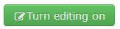
- Using the Add an activity or resource link at the bottom right of the section where your assignment links will be, select Turnitin Assignment 2 from the list of activities & click Add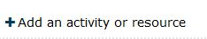 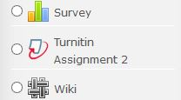
- Give the assignment a title. For this first link ensure it is labelled as ‘Draft’ and in the Summary box place some text informing the students they are allowed to submit one file to this Draft link to check their similarity score and similarity report.
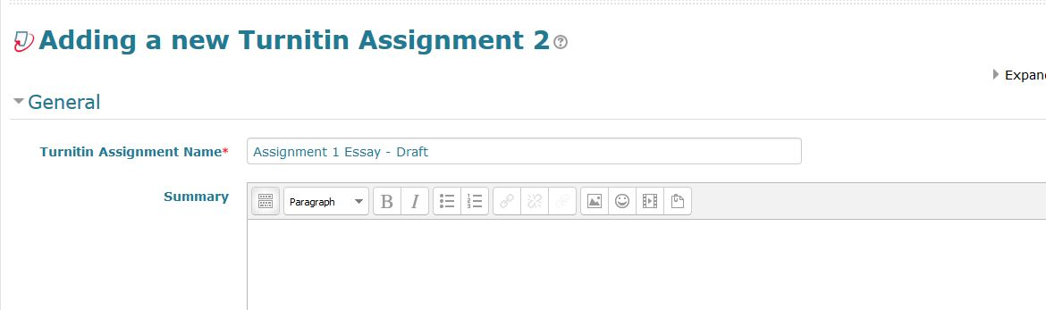
- Scroll down to the section Assignment Part 1 and set the dates:
  - Start Date - the date & time from when the students can start uploading their files.
  - Due Date – the submission deadline for the assignment, set this to be no later than 3pm on a working weekday so there is someone available in the service desk to assist if the student is having difficulties.
  - Post Date – The date from when the feedback will be available for the students to access (for this ‘Draft’ link you won’t be marking or offering feedback, so this date can be set to one sometime in the future, say 2020. This way students are not emailed reminders about viewing feedback for their draft submissions when the Post Date expires).
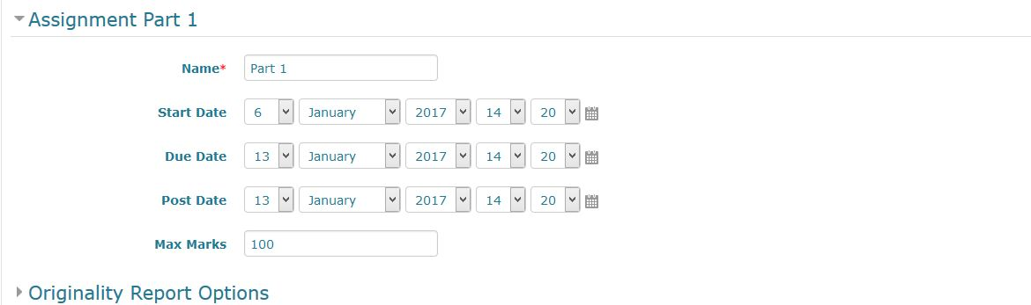
- Expand the section Originality Report Options. Ensure:
  - Allow Submissions after the Due Date = Yes
  - Report Generation Speed = Generate reports immediately (resubmissions are not allowed)
  - For this, the Draft link, Store Student Papers = No Repository
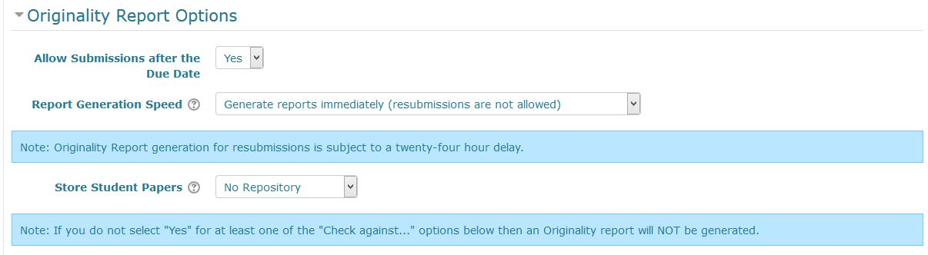
- Once completed, click Save and return to course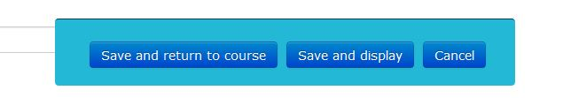
- That is the Draft link complete. You will now duplicate it and change a couple of settings to create the Final link. To duplicate the link, using the Edit menu next to the assignment link select Duplicate:
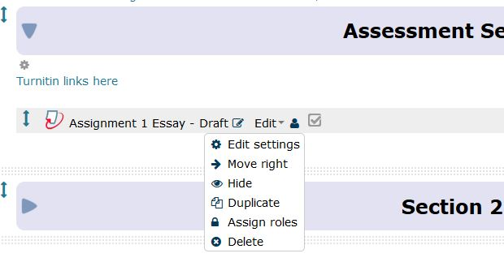

- It will take a few seconds for the duplication process to complete. Once done there will be a second identical link below the one you have just created. Using the Edit menu once more select Edit Settings:
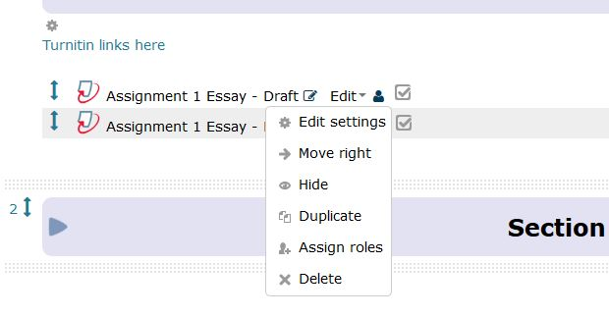
- Most of the settings can stay the same but you need to amend the following:
  - The Turnitin Assignment Name to show as ‘Final’
  - The Summary box to contain all the assignment criteria.
  - The Post Date to reflect the actual date the feedback will be available i.e. 4 working weeks after the Due Date (this can be set to less time but should not be set to more as university policy stipulates feedback must be available after more than 4 weeks from the submission deadline.
  - In the Originality Report Options section change Store Student Papers to be Standard Repository.
- Once the changes have been made click Save and return to course’.

The two links are now ready to be used. If you have more than one assessment period for the module you can use these two links as templates, duplicating each of them again to create a second pair which will just need the titles and dates amending.

This must be done before the links are used and have had files uploaded to them. We suggest you set up any links that will be needed for the academic year before the first assessment period. Any links that will not be needed for a time can be hidden from student view by clicking on the Hide option in the link’s Edit menu, remembering of course to unhide them before they are needed by the students:

