Programme: BA(Hons) Leadership and Management Skills for the Workplace
Module : Knowledge and information Management Skills for the Workplace
Module code : BMSW5106
Student Name : Mr Naeem Ahmed
Student ID : 1810765
Lecturer : Mr Khaza Ahmed
Title : Knowledge and Information Management of Marks & Spencer

Module code:

Executive summary:
At Marks & Spencer, many orders were experiencing lengthy delays, and customer complaints were mounting by the day. Despite its best efforts to stay ahead of the competition, this company will be unable to overcome this issue The goal at the time was to create a customer service purchase information system that could accurately and consistently keep these difficulties at bay, which were a barrier to the long-term viability of a great retail firm. Because the retail market is so competitive, businesses must maintain their information systems up to date to stay up with new delivery alternatives. Marks & Spencer began integrating an up-to-date information management system through its ecommerce platform, which set it apart from its competitors. This information system allows data and information to be easily accessed throughout the company's outlets, including the headquarters

Table of Contents
1. Integrated Customer Ordering Services’ Advantages: 2
1.1. Order Inquiry: 3
1.2. Order Improving and Formatting: 3
1.3. Exceptional Savings: 3
1.4. Order Reports: 3
1.5. Accessibility to Order Displaying: 4
2. Working of ICOS: 4
3. To get Competitive Edge: 5
3.1. Porter’s generic competitive strategy framework: 5
4. Implementations of ERP System: 7
4.1. Challenges while implementing ERP Systems: 8
5 Steps should take: 10
Step 1: Determine the Implementation Scope. 10
Step 2: Select an Enterprise Resource Planning (ERP) System 10
Step 3: Determine the Implementation Stages 11
Step 4: Make a schedule that is both required and achievable: 11
Step 5: Develop a Communication Plan 11
Step 6: Schedule Authorizations During the ERP Implementation Process: 11
Step 7: Create a Test Plan 12
Step 8: During the ERP Implementation Process, Request Approvals: 12
Step 9: Make a test strategy 12
Step 10: Import Corporate Data: 12
Step 11: Prepare yourself for the transformation. 12
Step 12: Arrange for the Go-Live. 12
Step 13: Management and Assistive Technology 12
6. References: 12

Table of Figures:
Figure 1. show Enterprise Resource Planning System (computerhope, 2019) 9
Figure 2: show initial steps for implementing ERP System 14
Figure 3. show steps to implement ERP System 15
Figure 4. show last steps to implement ERP System (hashcodesolutions, 2022) 15

Marks &Spencer benefits by using information systems:

Integrated Customer Ordering Services’ Advantages:
This system is efficient in processing requests, suppliers, and disseminating information to all stakeholders, as well as supervising the delivery of incoming or departing things via a central server, which eliminates any problems associated with the categories (Cannas, 2018). That system was not only created by the process management optimization department, but it was also implemented across all stores who provide in-store ordering. Previously, this information system had to solve challenges such as connecting different stores to a single platform so that all items and administrative data could be communicated. Millions of product details, including purchase content, were impossible to link on the web, in stores, or in organisations (Wirtz, 2022). This system application was created in such a way that data is universally available across all platforms or via the company network, independent of location. The system included order collection, order fulfilment, delivery service, scheduling, stocking, and demand pricing. (Nicholls, 2021).

Order Inquiry:
If a customer wants to enquire about an order they placed earlier, they merely need to offer their unique code to the staff. After entering the code in the inquiring box on the tool’s menu, you will obtain all pertinent information. Shipment or order updates, as well as status notes from the manufacturing department, are all included in the data.

Order Improving and Formatting:
This menu feature allows an operator to modify an order by adding or removing items. However, that programme is used to update client data such as address, shipment dates, and future payments. The operator enters the client code whenever a change or update is required, and the order's information shows on the display. This defines whether a certain order may be cancelled, such as when a product is a bespoke manufacturing order that is already in the works.

Exceptional Savings:
Which are typically exceptional deals for certain things, such as buy one, get the second for 26 percent off. Every one of these transactions has already been recorded in this database, which is updated on a regular basis. Because Marks and Spencer employ a huge number of people and all of them must be educated, using ICOS, which already offers a variety of programmes and promotions, is a more convenient option.

Order Reports:
Each day, requests are stored in systems and can be examined rather than by product type. A dealer or consultant may see how much was supplied and how many requests were received during the day by entering their user ID and then clicking on reports. Users can also request a custom study on the number of Sets supplied if that is all they want. A summary of the complete daily summary and record up to a certain time may be provided using this method.

Accessibility to Order Displaying:
Even if an operator from one Marks and Spencer store wishes to recall when an item is available and shown in another Marks and Spencer store, they may use the taskbar to do a show check or possibly an updated check. This is possible because, as previously stated, all stores are connected, allowing each merchant access to data from all other retailers' products (UKEssays., 2018)
Marks &Spencer's information systems and its working:

Working of ICOS:
Everyone on staff has their own unique ID and passcode, as well as a username, which makes the system incredibly secure and prevents unauthorized access. A worker authorized to take orders enters their Username and password to acquire information and submit orders. When a customer requests a product, an assistant enters its product key, and the whole data, including product specs, availability, and pricing, is displayed to the customer. There appears to be a toolbar panel with numerous options for the assistant to save customer personal information and email addresses. In addition, that tool bar has invoicing or exact findings for every commodity. Some items may not be on display at the shop, while others, such as furniture, may only be available for purchase (Wilson, 2020). The user account is created when the operator enters the client's surname and other information, and a user id is generated or saved in their profile. There is a payment method in the bookmark toolbar once the user's information has been saved. When that option is selected, a menu of payment alternatives, including money, bank card, debit card, and check, displays on the screen. The client is provided a printed confirmation comprising items as well as cash transfer details, as well as a unique customer number, when most of this data has been entered and money has been received.

Marks & Spencer's Information System/Information Technology solutions assist them in gaining a competitive edge.

To get Competitive Edge:
ICOS has shown to be advantageous to enterprises. This replaced a previous technique of shopping throughout the modules via faxes and phone calls, which needed human data entry. This old method was both time-consuming and deceptive. This new e-commerce system was deployed as a cost-effective way to provide exceptional customer service, manage a larger client base, reply to customer queries swiftly, execute orders faster and, most importantly, acquire a competitive advantage. Marks and Spencer built an Integrated Customer Ordering System that established a flow of information throughout all Marks and Spencer shops and headquarters to give exceptional services. While remaining competitive in the market, Marks & Spencer recognised their competitive advantage, which was based on a distinctive strategy. Revenues and development exceeded the competitors on a continual basis. Customers like how promptly their orders are handled, whether picked up in the store or delivered to their homes. Everyone profited from the use of ICOS, from the corporation to the worker to the customer. Because information was readily exchanged among all Marks & Spencer organisations, the assignment could be completed effectively and swiftly. Marks and Spencer have turned its focus to technology and growth to prepare for future advancements, which have been realized owing to its information system, which has relieved them of the bulk of their annoyances. Companies may now aim to grow their businesses with tact. These investments turned out to be quite successful, resulting in higher output and lower costs. ICOS has shown to be an information system that catapulted the company to the next level, resulting in a total change in excellence. This initiative resulted in significant profits from the technology, as well as a shift in the way the company operated and tackled problems.

Porter’s generic competitive strategy framework:

Porter's strategic planning theories include the 5 forces model, generic methods, value chain, diamond systems, and industrial clusters.
- The Five Forces paradigm is a powerful quantitative instrument for evaluating competitiveness, rivalry in linked sectors, and strategy development. According to Porter, there are five sorts of factors that determine the level of competition in any firm. Its market advantage and extensive level of a business generate changes in the economic framework inside the business, deciding the severity of something but also forming internal rivalry within the firm, and so determining the company's final success.
- General Strategies: The key strategy of the company appears to be to choose the right market and the most enticing competition inside it. Five sorts of factors include new rivals, alternatives, consumer capacity to negotiate, quality and cost strength, and present competitive negotiating power.
- The following is the same broad strategy theory: Even in the face of the five forces, Porter believes that every organisation should have two basic types of strategic edge: "reduced as well as goods distinctions," which can be derived from three types of effective strategy formulation: effective competitive strategy, positioning strategies, and centralized corporate strategies.
- Value Chain: The value chain is a useful tool for evaluating sourcing opportunities. This might dissociate a variety of business processes from the importance of communication standards in comprehending how various components of organisational performance, as well as current and future distinguishing factors, impact organisational performance. Retail businesses are self-contained as well as interconnected.
- Diamond System: That country has a big influence on the success of firm rivalries in the diamond system. Therefore, Porter adds to earlier research on global competitiveness. Porter suggests his "Diamond Systems" as a conceptual approach as a response to this topic (diamond theory).
He thinks that fundamentals including manufacturing, market conditions, growth plan, organisation, and competitors, as well as related sectors and performance feedback, may assist their national enterprises obtain competitive advantages.
- Industrial Clusters: Local competition has a considerable impact on business performance in industrial clusters. Porter observes that commercial clustering is a common occurrence in the manufacturing process across all modern nations, and that there are several sorts of industrial domains. A geologically constrained region of individual and collaborative partnerships, interaction significance businesses, specialised distributors, suppliers, investment firms, connected businesses such as vendors, and other competent authorities made up of a collection is defined as a factory cluster. Different tiers of industrial zones offer different levels of complexity and depth (UKEssays., 2018).
Marks &Spencer's problems in installing a new Enterprise Resource Planning (ERP) system are numerous:
Many of the issues that worldwide companies like Marks & Spencer face are getting more severe and sophisticated, and the interdependencies among complications mean that perfect and ideal solutions are hard to attain. On either To improve company performance in this area, many companies, such as M&S, use enterprise resource planning (ERP) systems. The notion of an integrated system encompassing all areas of a firm was first formed in the 1990s, thanks to advances in information and communications. That idea gave rise to the ERP system, which is now considered as one of the world's most advanced strategic planning systems (Mirhosseini, 2021).
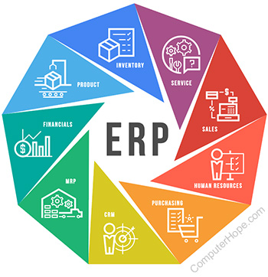
Figure 1. show Enterprise Resource Planning System (computerhope, 2019)

Implementations of ERP System:
An ERP implementation appears to be a multi-phase process that often entails re-engineering workflows to take use of the capabilities of a new system, installing software, transmitting data, and training employees. The process normally takes a few months, but it can take up to a year in large companies. A development team, which includes members from most of the company's organisational activities, is typically in charge of this (Caldwell, 2020).

Challenges while implementing ERP Systems:
ERP can be challenging to implement since it affects a company's operations across the board. Employees must regularly change the way they handle, generally swapping highly productive, automated processes for arduous manual ones, due to the necessity of the new system. One of the most difficult components of ERP implementation is persuading customers, particularly functional groups, that they must change their established behaviors to use the new system. This development will require strong organisational control as well as top staff assistance. To create the new system, that company requires a specialised development team that services all ERP users. It ensures that the software satisfies the goals and commercial objectives of many departments (Lal, 2020).
ERP adoption involves both humans and technology. Therefore, persons and technology challenges, such as resistance to adapt, may be confronted. Some of the most typical ERP implementation problems are as follows:
- Exploration and strategy, planning, programming, data integration, validation, installation, maintenance, and post-launch updates are all phases in the ERP deployment process. As a result, each phase has its own set of crucial operations, the majority of which must be accomplished on time, necessitating meticulous programme management. In addition, successful ERP implementations need collaboration among all stakeholders involved in the system's development and use.
- Companies usually underestimate the amount of money and time necessary for a successful implementation. According to a recent study, scope creep, that occurs when a corporation adds tasks and services to a programme that were not initially anticipated, and misreading staff expectations are two of the most prevalent causes of cost overruns. Making a good and fair approach from the start may be all it takes to alleviate such anxieties.
- Because it provides a uniform, accurate source data across the entire business, data integration has become one of the most significant characteristics of ERP. Data migration, which frequently requires transferring data from a variety of older models to an ERP system, appears to be a vital stage in ERP implementation. However, first and foremost, the company must locate all its data. It might turn out to be significantly more difficult than they expected. Underprioritizing file transmission, on the other side, can lead to issues such as erroneous or duplicated data, as well as schedule delays.
- In an ERP setup, change management refers to a process that entails more than just switching to a new computer system. This generally requires reorganizing company activities to keep up with the new technology, which results in increased performance and productivity. As a result, several employees will need to adapt their mindsets and operating methods, which will result in typical change management challenges.
- Continuous improvement: An ERP implementation is not just a one-time job that ends once the new system is up and running. This system should continue to evolve to match new corporate requirements and technology. Following installation, the development team must learn how to manage the system, resolving conflicts and enabling new rules as they occur. When ERP systems are utilized for more than a generation after deployment, it's vital to monitor and evaluate the system to see if it's still meeting the organization's objectives (UKEssays., 2018.).
A strategy that outlines the measures Marks &Spencer should take to establish a new ERP system:
Most firms overspend on the following three primary aspects:
- Costs of Implementation estimated
- Internal planning for an ERP system has been chosen.
- Future benefits that the system will bring once it is fully implemented.
While Marks and Spencer are a multi-national company, its competition is growing increasingly tough as technology advances (Vadivalu, 2021).

Steps should take:

Step 1: Determine the Implementation Scope.
A. Define the Work Plan; The link between the project's analysis and application is commonly specified in the context of an ERP implementation project. It outlines the goals that must be completed during the adoption process. All the ERP project's queries should be answered by Marks and Spencer.
- What good is it if you don't use it? what they intend to achieve?
- What other business procedures are there?
- What are the main issues that the final version will have to deal with?
B. It is critical to consider the project's objectives: Their purpose is to develop a full set of business skills in deciding from the beginning. This forces them to concentrate on the operational restrictions. What were the regions that are currently experiencing problems? Where does it need to make a difference? As a result, the primary role here should be for workers to be encouraged to set goals that focus solely on the ultimate retailer's benefits to the business, as well as the activities that will be undertaken to accomplish such benefits. This always comes down to reality, because if you don't know how the business functions currently, what modifications they'd want to make, or what long-term goals they'd like to reach, you won't get excellent outcomes from ERP implementation (Belfo, 2021).
C. Be Wary of Potential Threats: Using an ERP deployment, one of the most prevalent risks that firms encounter should not be able to damage the bottom line (Sharma, 2021).

Step 2: Select an Enterprise Resource Planning (ERP) System
However, there are so many ERP Software solutions to choose from that it might be confusing.
- Personal Custom Built ERP Systems: This is the system in which you choose a vendor who will start building a solution from the ground up for you. Another benefit of this approach is that you have complete control over the procedure, which increases relevance and privacy. However, due to the difficulties of ERP implementations and the significant costs connected with them, this is likely to be your least favorite option.
- Cloud-based Sector ERP Services: This would be a significantly preferable alternative for any company when compared to the previous one. Be the ERP solution for your company's operating system. Odoo's Cafe Management Program, for example, is a ready-to-use solution for hoteliers who can just go to their website, schedule the service, and start utilising it right (Aref, 2022).

Step 3: Determine the Implementation Stages
The implementation of Enterprise systems varies greatly from one customer to the next. An important but sometimes forgotten stage is selecting the Erp solution that the employer requires. This stage's main purpose is for the corporation to see the value of mapping business activities. The significance of having a clear declaration explaining all the processes that the organisation follows and, more importantly, why you do them.
Determine whatever ERP alternatives are already available, as well as what adjustments are required to make them fit the company's requirements.

Step 4: Make a schedule that is both required and achievable:
Approximately, 62% of ERP initiatives take longer than expected. Throughout the process, Marks and Spencer should keep a close eye on genuine relevance and performance vs delivery timelines. The programme should be divided into many stages, each of which should be organised into a task list with estimated completion dates.

Step 5: Develop a Communication Plan
- Prepare to meet with your IT coworkers in a systematic way.
- Make frequent get-togethers a priority right away.
- Always keep an eye on what's going on.
- During the project, demonstrations should be organised.
- To avoid misunderstandings, attempt to talk with the same person each time.

Step 6: Schedule Authorizations During the ERP Implementation Process:
One of the most common reasons for project failure is the end product's failure to satisfy the planned outcomes.

Step 7: Create a Test Plan
Testing is one of the most critical components of the deployments.
A. Converting data from previous application business information: Marks and Spencer should be aware that the systems are clearly separate, thus any obsolete data should be deleted before transferring.

Step 8: During the ERP Implementation Process, Request Approvals:
The inability of the end firm to achieve the desired goals is one of the most typical failure reasons.

Step 9: Make a test strategy
Testing is one of the most important aspects of the installation.

Step 10: Import Corporate Data:
Information transduction refers to the process of moving existing firm data to an ERP system. Marks and Spencer should be told that databases are distinct, thus any obsolete data must be erased before transferring.

Step 11: Prepare yourself for the transformation.
As a result, risk mitigation is one of the most prevalent causes of ERP failure.

Step 12: Arrange for the Go-Live.
Make sure the team members have some time set out for it, as it is one of the most time-consuming components of an ERP project.

Step 13: Management and Assistive Technology
Keep in mind that a successful ERP implementation is more of a process than a goal (G., 2017).
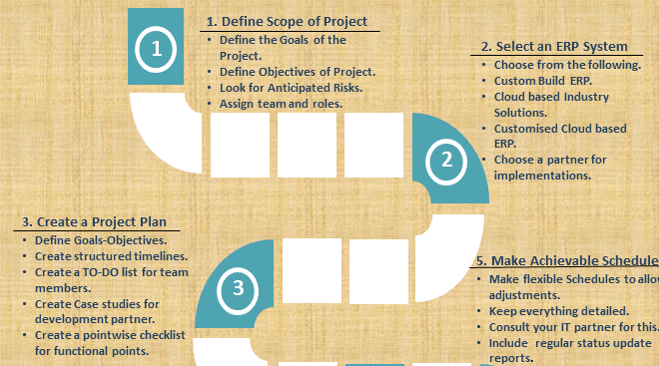
Figure 2: show initial steps for implementing ERP System
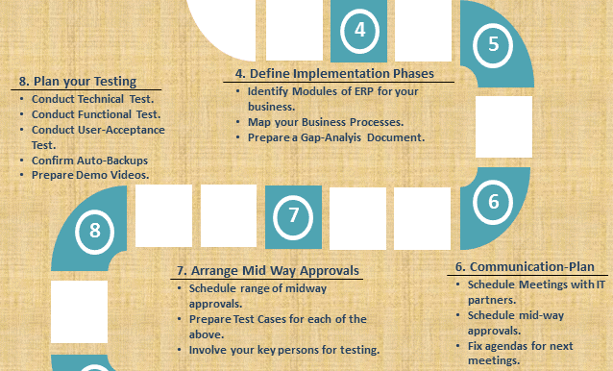
Figure 3. show steps to implement ERP System
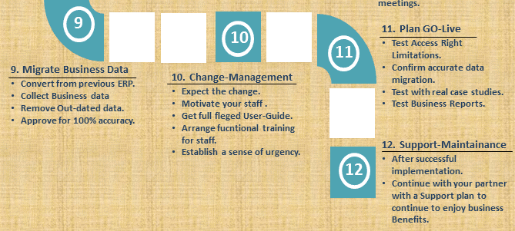
Figure 4. show last steps to implement ERP System (hashcodesolutions, 2022)

References:
Aref, M. M., 2022. Forecasting in Enterprise Resource Planning (ERP) Systems: A Survey. s.l.:In book: Digital Transformation Technology (pp.395-406).
Belfo, F., 2021. Maintenance and Support Model within the ERP Systems Lifecycle: Action Research in an Implementer Company. s.l.:Procedia Computer Science 181(11):580-588.
Caldwell, a. c., 2020. 7 Key ERP Implementation Challenges and Risks. s.l.:https://www.netsuite.com/portal/resource/articles/erp/erp-implementation-challenges.shtml.
G., B. S., 2017. CHALLENGES TO SUCCESSFUL ERP IMPLEMENTATION. s.l.:Institute of Business Management.
hashcodesolutions, 2022. ERP Implementation : 12 Steps to a successful ERP. s.l.:http://www.hashcodesolutions.com/erp-implementation-success/.
Lal, N., 2020. Change Management in ERP Implementation. s.l.:SSRN Electronic Journal.
Mirhosseini, S., 2021. Exploring and analysing the risks and challenges of implementing ERP systems: critical system thinking. s.l.:nternational Journal of Information Systems and Change Management 12(3):234.
Nicholls, B., 2021. Building an Integrated Customer Profile. s.l.:In book: Data Management (pp.63-68).
Sharma, M., 2021. ERP Implementation Barriers. s.l.:In book: Digitising Enterprise (pp.153-159).
UKEssays., 2018.. Marks Spencers Enterprise System. s.l.:[online]. Available from: https://www.ukessays.com/essays/business/marks-spencers-enterprise-system-business-essay.php?vref=1 [Accessed 31 March 2022]..
UKEssays., 2018. Integrated Customer Ordering Service. s.l.:[online]. Available from: https://www.ukessays.com/essays/information-systems/function-of-marks-and-spencer.php?vref=1 [Accessed 30 March 2022]..
Vadivalu, K., 2021. Challenges and Issues in ERP Implementation. s.l.:Project: Challenges and Issues in ERP Implementation.
Wilson, L., 2020. Information Systems Implementation. s.l.:In book: Implementing Information Security in Healthcare (pp.267-276).
Wirtz, J., 2022. Managing People for Service Advantage. s.l.:In book: Services Marketing: People, Technology, Strategy (pp.358-403)Edition: 9Chapter: 11Publisher: World Scientific.

