

Component 1 report

Effective Teamworking for team success
  - Zerron Williams-Hankey
  - lecture, Suzannah Ogwu
| 2028383 | created on 15/10/2021

Contents
Abstract 3
INTRODUCTION 3
How To Develop An Effective Team? 4
The impact of effective teamworking. 5
Barriers to effective teamworking. 5
The types of roles needed to create a cohesive team. 6
References 8

Abstract
This report focuses on how effective team working can be improved in organizations and how to reduce the stress caused to both managers and employees in a diverse environment. The reports also assess the impact of effective teamworking. The literature indicated that effective teamworking improvement is growing rapidly, in addition this report focuses on the method which can be used to overcome obstacles and research shows how best to deal with and improve teamworking, understanding the nature of the common barriers that affect team working.

INTRODUCTION
Teamworking was introduced in America, the early 1900’s experts started experimenting to see if humans have a connection to productivity, TB has developed vastly over the year, expert Edward Bernays founded the public relations industry, he expressed that understanding a person’s emotional state of mind allows businesses to better sell product, by understanding what people will want.

Teamwork is an essential concept to a healthcare organization, having a group of skilled individuals working together, accomplishing tasks to get each required object completed, sharing common goals, having the necessary skills needed to be applied to each job role, shared decision making, having open communication each member adding a new skill. Teamwork provides effective results for health care services internationally (Xyrichis, 2008).

Organizations should be encouraging management to improve team dynamics, creating group activities and refining team building skills, so people feel better motivated to come and when coming into work this way, the workloads become less stressful and team co-ordination has progressed, in 2021
Another reference

How To Develop An Effective Team?
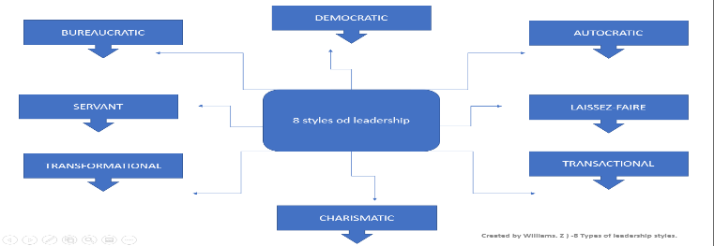
It is important to have an excellent leadership style, with qualities that emphasis an individual’s strengths such as, motivation and enthusiasm, a good leader will have a creative passion with a visual eye for detail. Other skills that a leader should possess is versatility, having the ability to act accordingly with professionalism, through demonstrating significant skills needed to accomplish all goals. Using a democratic leadership style includes all parties to have an informed decision, ensuring everyone is included, this stimulates engagement working towards better job satisfaction, identifying three key skills that’s generates structure and collaboration, explains how groups eventually synchronize. (Coyle,2018)
Figure 1 8 Types of Leadership Styles

Figure 1 8 Types of Leadership Styles
Demonstrated through creating different tests with participants of different age groups and educational background, he found that the younger age group completed each task better because they worked together in a smarter way using the culture code which consists of three key processes, first ‘we are safely connected’ second, ‘we share accurate information’ and third, ‘we know which way to move, meaning as long as everyone communicates effectively and interacts then the development should be easier long-term.

The impact of effective teamworking.
The impact of teamworking in a health care setting can be challenging, hen working effectively in a team allocating tasks to individuals based on their strengths helps a person’s and group complete their task more efficiently this helps boost productivity. In the workplace this also improves communication skills as everyone has their own level of perception, thus makes room for discussions to identify any errors and how best to find the best conflict resolution. One really important factor is to boost the morale when a workload is shared by a group, majority of the time the achievements rate rises higher allowing better results long-term leading to job satisfaction.

Usually in a health care setting the group members relies on the team as a whole, collecting shared information, person centered care plans and patient records when there is a lack of transparency, mistakes and errors are made and sometimes this can be fatal, so it is impeccable (Hansen, et al., 2006) that a person’s skills and knowledge is advancing constantly through training and on-job training, having multi skilled training is essential to ensure if a colleague is stuck, another is able to carry out the job to satisfactory measures , building relationships is very important, trusting and supporting peers with endeavors enables them to complete tasks, this shows team spirt

Barriers to effective teamworking.
The common barriers to effective teamworking firstly would be, lack of trust and respect in the workplace thus having bad interactions with other colleagues, resulting in difficulties when working in a team, due to conflict or not listening to leaders, maybe the leader’s approach isn’t convincing enough to motivate others with contributing similarity which can create more stress and workload for others, and everyone’s actions reflect on the tam as a one. Lack of diversity or cultural differences in languages, people from different countries or background tend to have preferred methods of learning and mind-sets thus creates a communication barrier, when ineffective team dynamics are failing, stopping peers being involved with group discussion or activities. Mental health disorders such as depression and anxiety could be a huge factor in terms of peers not engaging due to being scared/nervous of others, personalities, and there big characteristics (gluyas, 2015)

The types of roles needed to create a cohesive team.
More research (belbin, 2004) he found that creating questionnaires and surveys individuals could take to identify a person’s characteristics to another with this it helps to see the strengths of each party, complementing the progress of the team. Helps to gain self-knowledge being able to deal with conflict resolution as one persons strength applied to one role could be the weakness of another. 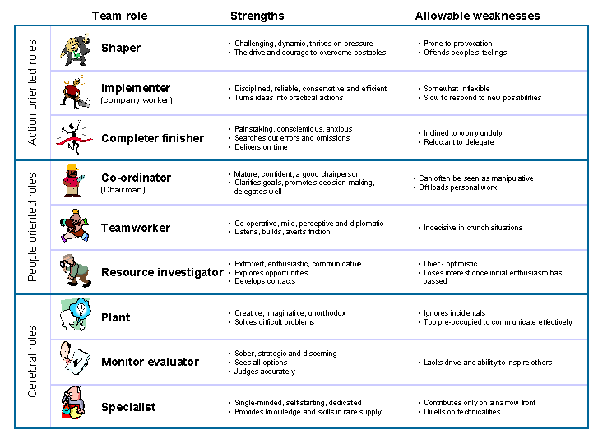
Figure 2 Belbin’s roles

The goal is to contribute to overall success of both managers and employees, (huhman, 2013) states eight ways of how this can be achieved A common goal is established, all factors are considered deciding based on who’s skills are befitting to the task. To create a successful team, it requires diversity having a different range of people with changeable skills, team building exercises are a good strategy for change to see who possesses what skills after a leader takes observations. Communicate with peers to see if they are compliant with the task and shared responsibility, after a job completion a group feedback evaluation should be taken to see what the achievements were and what the improvements could be and where necessary its always ethical to ask for feedback.

,

Conclusion
Teamwork is effective when everyone works together effectively a one, contributing to information, adding ideas, management creating better group activity building a need for improvement by making the staff feel appreciated and supported, this improve personal and professional value and create efficient working environments, both colleagues and mangers can have better working relationships and they can provide better quality care for customers and patients. I agree (Xyrichis, 2008) mangers have a responsibility to employ leaders who’s methods are effective and respected by the company’s policies, but staff have to remain engaged and feel like with the support of the group the workload becomes easier to complete.

Useful links
The Impact of Group Diversity on Performance and Knowledge Spillover (nber.org) (Hansen, et al., 2006)
https://www.ifm.eng.cam.ac.uk/uploads/Research/Design_management/Belbin.gif

References
Anon., n.d.
belbin, r. m., 2004. belbin team roles.
Corrigan, P. W. & Watson, A. C., 2002. Understanding the impact of stigma on people with mental illness.. World Psychiatry, , 1(1), pp. 16-20.
gluyas, h., 2015. effective communication and teamwork promtes paitent safety. 5 august, 29(49).
Hansen, Z. K., Owan, H. & Pan, J., 2006. The Impact of Group Diversity on Performance and Knowledge Spillover -- an Experiment in a College Classroom. National Bureau of Economic Research, , (), p. .
huhman, h., 2013. 8 ways to build a chohesive tam. 5 august.
Leggat, S. G., 2007. Effective healthcare teams require effective team members: defining teamwork competencies. BMC Health Services Research, , 7(1), pp. 17-17.
Maslin-Prothero, S. & Bennion, A. E., 2010. Integrated team working: a literature review. International Journal of Integrated Care, , 10(2), pp. 1-11.
Ream, E. 2., n.d.
Rutter, M., 2005. How the environment affects mental health. British Journal of Psychiatry, , 186(1), pp. 4-6.
Xyrichis, A. a. R. E., 2008. Teamwork: a concept analysis. Journal of advanced nursing,. Issue , pp.232-241., pp. 232-241..

