Academic and Employability Skills

Ransomware report – Cryptowall

Author: Kallum Gordon
Prepared for: Gareth Jones

5th December 2019

1.0 Introduction:
A report that focuses on Cryptowall, but also covers malware in general and prevention methods.

2.0 Abstract:
This report will cover the effects of the ransomware entitled ‘Cryptowall’. A general overview of trojans and viruses will be provided as well as instructions on what to do if infected. Cryptowall will be covered in-depth, and prevention methods and good practice will be expanded upon.
Contents
Academic and Employability Skills 1
1.0 Introduction: 2
2.0 Abstract: 2
3.0 Trojans and viruses 3
3.0.1 General overview. 3
3.0.2 What to do if infected. 4
3.1 Ransomware 4
3.1.1 General overview 4
3.1.2 How you get ransomware. 4
4.0 Cryptowall 4
4.1 Specifics of this threat 4
4.1.1 Infection methods 4
4.1.2 File types affected 5
4.2 Procedures of eradication 6
4.3 Payment? 6
5.0 Prevention methods and good practice 6
5.1 Initial avoidance 6
5.2 Backup Procedures 6
6.0 References 7

3.0 Trojans and viruses

3.0.1 General overview.
A computer virus is a type of computer program that, when executed, replicates itself by modifying other computer programs and inserting its own code. It is aptly named after a real medical issue as it worsens a computers ‘health’, potentially causing issues with the machine.
A trojan borrows the name from a story of a large giant horse being used to trick the defenders of Troy into allowing enemy soldiers into their own city. A trojan hides malware in what looks to be a normal file, tricking the user into allowing the malware onto their own computer and launching it. There are many different types of trojan, and most typical aim at taking control of a victim’s computer and stealing data. The most common types of trojan are as follows:
- A downloader trojan will download additional content onto the infected computer, such as additional malware.
- A backdoor trojan create a ‘backdoor’ on a users’ computer which gives the attacker control of the machine to upload stolen data.
- An infostealer trojan will steal data from an infected computer.
- A distributed denial of service (DDoS) trojan will perform a DDoS attack, which is designed to take down a network by overloading it with too much traffic to handle.
- A remote access trojan will give the attacker full control over a computer. [1]
Spyware is designed to spy on the victim and is secretly implanted on the computer by a hacker. The spyware gathers information and sends it to the hacker.
Adware causes malicious pop-ups and unwanted advertisements on the victim’s computer without their permission. The pop-ups are uncontrollable and tend to behave erratically, they usually appear numerous times on the screen and it can become tedious to close them.
A rootkit assists a perpetrator in remotely accessing or controlling a computer or network without being exposed. They become active before the operating system is booted up, therefore making it hard to detect.
A worm is code that will copy itself and spread to another computer through use of email attachments or sent files. An infected network or system may face slowdowns and other errors while infected.
A keylogger records every keystroke made by a user, this is to steal credentials and confidential data to forward to the hacker.
A botnet is a malware infected computer that acts as a bot created by a cybercriminal to transmit malware, send spam emails, and execute other malicious tasks.
Ransomware is malware that holds your data at ransom, it blocks the user from accessing files or programs present on their computer by encrypting the data and to remove the malware without data being destroyed the user must either use a backup, or pay for a key to decrypt their data that may not work.

3.0.2 What to do if infected.
The first step to take is always generally disconnecting the infected device from the internet, this can help prevent the malware from spreading and/or leaking your private data. After this step is completed the computer should be restarted in safe mode. In this mode only the essential programs and services are loaded. If any malware is set to load automatically when Windows starts, entering in this mode may prevent it from doing so. It is generally easier to remove malware if they’re not running or active.
While in safe mode, a virus scan should be ran by using a malware scanner. You should have only one real-time antivirus program installed at a time, but you can have many on-demand scanners installed to run scans with multiple programs, thereby ensuring that if one program misses something a different one might find it. Running an on-demand scanner should be used first and then followed up by a full scan with a real-time antivirus program.

3.1 Ransomware

3.1.1 General overview
According to Malwarebytes, a trusted anti-virus company, “Ransom malware, or ransomware, is a type of malware that prevents users from accessing their system or personal files and demands ransom payment in order to regain access.” [2] Ransomware creators demand payment via cryptocurrency as this is the safest option to retain their privacy.

3.1.2 How you get ransomware.
Many standard anti-virus programs provide automatic ransomware protection, but it’s not out of the question that new ransomware will slip through the cracks and take advantage of a loophole that has yet to be patched by your OS provider, or the anti-malware software author. “One of the most common methods today is through malicious spam, or malspam, which is unsolicited email that is used to deliver malware. The email might include booby-trapped attachments, such as PDFs or Word documents. It might also contain links to malicious websites.” [2] Malspam also takes advantage of human psychology in order to trick people into opening attachments and well-constructed files by appearing to be real.

4.0 Cryptowall

4.1 Specifics of this threat
Cryptowall is a popular tool used by cybercriminals to receive payments of Bitcoins. As of 2019, ransomware makes up 24% of all reported malware incidents [3] and reports state that Cryptowall 3.0 has caused over $325,000,000 in damages since being introduced. [4] Cryptowall first appeared in 2014, and it has been updated and iterated upon several times to further increase the difficulty of detecting and removing it. Cryptowall is cheap and easy to use, it spreads fast, and many users continue to pay the ransom in the hopes they will get their data back. CryptoWall v5.1 is the latest version based on the HiddenTear malware and uses AES-256 encryption.

4.1.1 Infection methods
Cryptowall dynamically builds an import address table (IAT) using a series of hash representations for both libraries and their associated functions, and prior to loading any functions, Cryptowall must first load their libraries. Once the library address has been obtained, Cryptowall proceeds to load any functions that will be needed for the remainder of its operation. [4] Strong RSA-2048 encryption is used to lock files in an attempt to receive the ransom payment. It attempts to hide inside the OS and adds itself to the start-up folder, it will also delete volume shadow copies, which makes it difficult or impossible to restore data without a decryption key.
Cryptowall can infect a device by being spread through a phishing email, which tricks the user into clicking a link which then downloads Cryptowall onto their computer. Exploit kits are also used and take advantage of security vulnerabilities to deploy the malware. Malicious ads are another way to become infected as cybercriminals purchase or hack internet advertisements to deliver the malware through a browser. Hacked ads often try to run javascript in a browser to download the malware without the user noticing.

4.1.2 File types affected
Varonis created a table that includes every file-type Cryptowall can affect [5] , this is shown below:
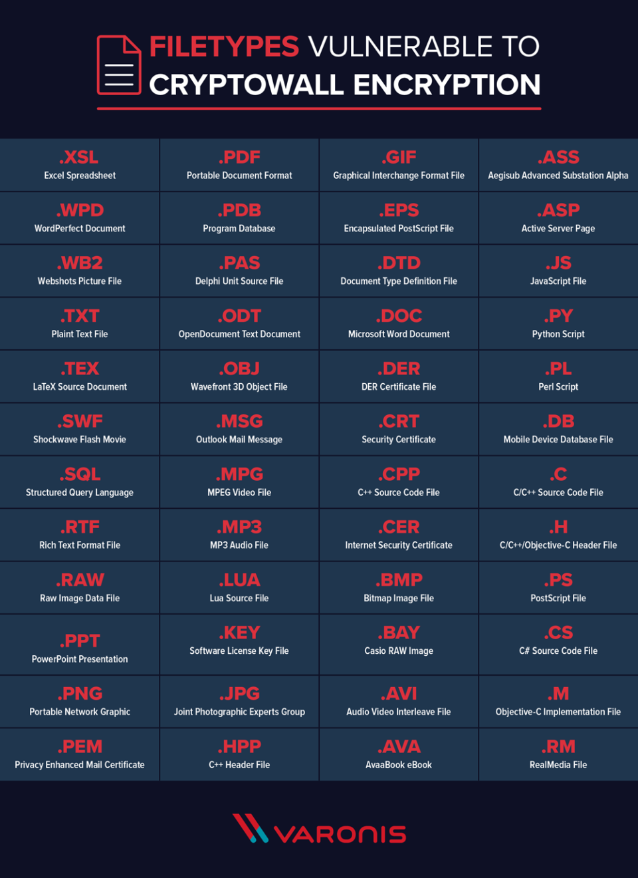

4.2 Procedures of eradication
Cryptowall can be removed by booting the infected computer in safe mode, and restoring from a clean restore point. If a recent restore point has not been created, a malware removal application can be opened via USB, and can scan all files and remove Cryptowall.

4.3 Payment?
After paying the fee of around $1,000 in bitcoins, the malware should delete itself. But a recent report by CyberEdge revealed that only 19% of users that pay the ransom of general ransomware get their files back. [6] Therefore payment should not be offered, and prevention methods should be invested in instead.

5.0 Prevention methods and good practice

5.1 Initial avoidance
It is recommended that the user keeps their computer patched and up to date as malware uses known vulnerabilities in software and operating systems to move to new computers. Leaving those vulnerabilities unpatched effectively leaves an open door for hackers to enter. Keeping the OS and all applications updated gives the user a better chance of avoiding malware infections.
Using a well-known anti-virus scanner such as Malwarebytes can protect from several kinds of malware attacks, it quarantines known malware programs and prevent them from executing. Reputable anti-virus scanners will always scan your computer automatically in the background and block anything malicious, and manual scans can be performed too.
Using a firewall can protect the user from dangerous connections that can send malicious files to a computer. The Cryptowall ransomware depends on a connection to the cybercriminal to continue the attack. A firewall may be able to prevent the connection, preventing the attack.
Avoiding clicking links that look suspicious can save a computer from becoming infected, only open links from emails that are trusted.
Making sure your browser is up to date can patch critical security flaws, and using ad-block can block potentially malicious ads.

5.2 Backup Procedures
Keeping a backup copy of files can protect from hard drive failure or ransomware. The rule of three should be followed to ensure that data can be restored, such as storing the data on hard drives, storing the data on a USB, and storing the backup on the Cloud.
Maintaining a least privileged model can also help, as users will only have access to the files needed to do their job, so if they are hit by Cyptowall, it will only encrypt those files. This limits the scope of a ransomware attack, and with a sufficient backup plan, the recovery process is simple.

6.0 References

[1] | Norton, "What is a Trojan?," Norton, [Online]. Available: https://uk.norton.com/internetsecurity-malware-what-is-a-trojan.html. [Accessed 13 November 2019].
[2] | Malwarebytes, "Ransomware," Malwarebytes, [Online]. Available: https://www.malwarebytes.com/ransomware/. [Accessed 20 November 2019].
[3] | Verizon, "2019 Data BreachInvestigationsReport," Verizon, New York, 2019.
[4] | Cyber Threat Alliance, "Lucrative Ransomware Attacks: Analysis of the CryptoWall Version 3 Threat," Cyber Threat Alliance.
[5] | J. Petters, "Varonis," 6 1 2018. [Online]. [Accessed 13 11 2019].
[6] | Cyberedge group, "2019 CYBERTHREAT DEFENSE REPORT," Cyberedge group, 2019. [Online]. Available: http://cyber-edge.com/cdr/#about-this-report. [Accessed 13 11 2019].

