

Student Name:Tanvir ahmed tipu

Student ID:2504655

Module Name: Marketing Management

Module Code: LCMB7024

Lecturer’s Name:Dr Laila Maazouz

Work Count: 2593

Term 1

Table of Contents
1. Introduction 3
2. Critical Analysis of the Macro Marketing Environment 4
2.1 Overview of the Macro Marketing Environment 4
2.2 Selection of Two External Macro Marketing Actors 4
2.3 Critical Analysis of Each Actor 5
2.3.1 Technological Forces 5
2.3.2 Environmental / Climate Regulation 6
3. Strategic Responses of Pioneering and Follower Organisations 8
3.1 Pioneering Organisations’ Strategic Responses 8
3.2 Follower Organisations’ Strategic Responses 11
4. Conclusion 13
5. References 14

1. Introduction
The strategic marketing management necessitates organisations to continuously read the changes in the external environment and make market decisions based on them (Kotler et al., 2020). The global electric vehicle (EV) industry is among the most dynamic markets where scanning the macro marketing environment is significant because of the advancement of technological innovation (Hertzke, Müller and Schenk, 2022). The report discusses Macro-environmental influences on strategic marketing within the EV market, with references to the development of new global products of Tesla’s (Pioneer) Robotaxi and BYD’s (follower) Shark PHEV as examples to illustrate differences in reaction to environmental changes.
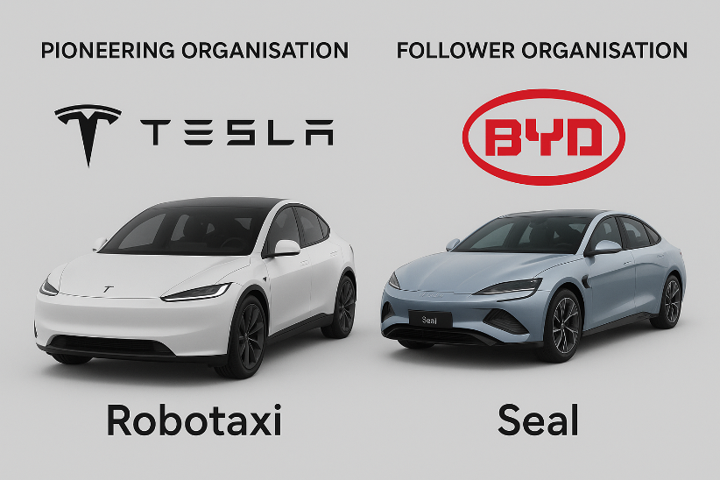
Figure 01: Pioneering and Follower Organisation with Products (Source: Self-made)
The knowledge of the macro marketing environment helps companies to establish trends that can drive the company to grow, as well as recognise the threats that can disrupt business (Whittington et al., 2017). To support strategic decision-making, organisations must thus incorporate strategic decisions in the processes of planning to enhance resilience, predict changes and maintain a competitive edge. The report examines the differences in the effects of global EV trends, such as technology and climate regulations, on Tesla and BYD. It then evaluates their strategic reactions in accordance with the Growth Matrix provided by Ansoff, as well as discusses the potential market growth of each.

2. Critical Analysis of the Macro Marketing Environment

2.1 Overview of the Macro Marketing Environment
The macro marketing environment covers the wider external forces in which the strategies of firms are created and opportunities, threats, and long-term feasibility are influenced (Hague, 2019). Strategic marketing management analysing such an environment is imperative because it enables organisations to foresee and adjust to trends.
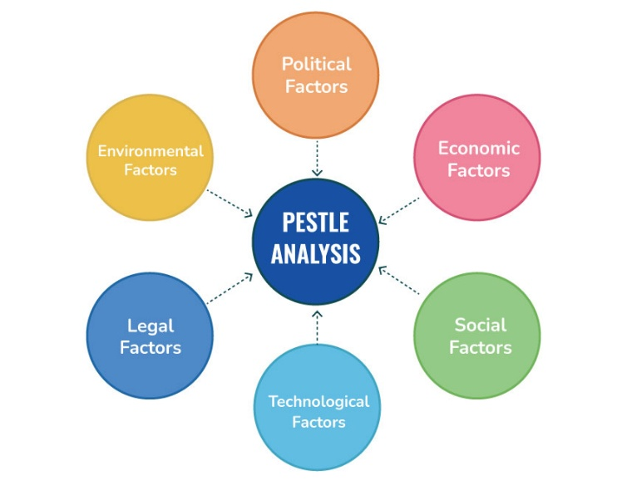
Figure 02: PESTEL Analysis Model Framework (Source: Speaking Nerd, 2021)
A theoretical framework that is often applied in the organisation of this environmental scan is PESTEL, which classifies the forces in the environment into six groups: Political, Economic, Social, Technological, Environmental and Legal (Speaking Nerd, 2021). The EV market is characterised by a high rate of technological advancement, high environmental demands, and the presence of the global market that is not limited by borders. To both companies, such as Tesla and BYD, competitive advantage can be transformed at a structural level due to shifts in battery technology, infrastructure and environmental policies.

2.2 Selection of Two External Macro Marketing Actors
This paper will focus on two macro-environmental actors that are particularly relevant to the global EV industry:
- Technological forces are selected since the EV business, such as Robotaxi and Shark PHEV, is essentially based on innovation - battery chemistry and energy density, charging infrastructure, software, and autonomy. These innovations do not just influence consumer value propositions (cost, convenience), but also define the manufacturing economics, supply chains and distinctions among competitors.
- Environmental/climate regulation is chosen since all governments in the world are using regulatory instruments (emissions standards, ZEV mandates, carbon pricing) to hasten decarbonisation, and these measures have a significant impact on EV demand and supply.

2.3 Critical Analysis of Each Actor

2.3.1 Technological Forces
Impact on the EV Industry
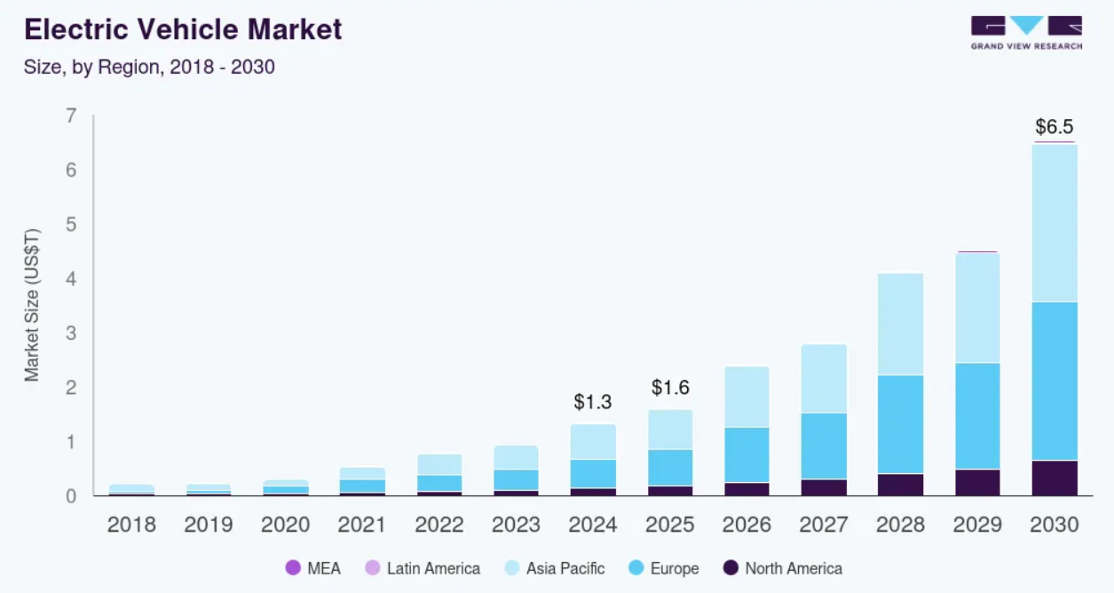
Figure 03: Electric VehiclesMarket Size & Forecast (Source: Grand View Research, 2024)
The electric revolution is based on technological innovation. The global electric vehicle market size was estimated at USD 1,328.08 billion in 2024 and is projected to reach USD 6,523.97 billion by 2030, growing at a CAGR of 32.5% from 2025 to 2030 (Grand View Research, 2024). Thus, this industry has the potential to grow significantly in future.

Pioneers (Tesla)
- Opportunities: Tesla, being an innovator, is getting an advantage from the fast technological development. Also, according to BloombergNEF, the average battery pack price dropped 20% in 2024, reaching US$115 per kilowatt-hour (kWh) (Europa.eu, 2025). With Robotaxi, its high investment in its battery R&D, autonomous driving, and its Supercharger network is a solid competitive advantage. Moreover, Tesla has a significant infrastructure and resources that will always lead them to being innovative.
- Threats: Nonetheless, Tesla can also lose its position due to technological disruption. When a competitor, like any other OEM, commercialises a next-generation battery or charger solution more effectively or at a lower price, the cost leadership of Tesla might shrink (The Observatory of Economic Complexity, 2022). Additionally, alternative technology innovation potentially changes consumer demand.
Followers (BYD)
- Opportunities: With regulation pushing toward 100% ZEV, BYD’s broad portfolio (including PHEVs) can help it navigate transitional demand (ICCT, 2025). The high domestic presence in China, which has a high adoption of EVs, provides BYD with the benefits of scale and cost-efficiency.
- Threats: Conversely, BYD can be left behind in case technological propensity shifts at a significant rate. The cost of the R&D necessary to keep up with the innovations demonstrated by BYD may also be a burden. Moreover, in the case of changing global supply chains (materials, such as lithium, cobalt, or silicon), BYD can suffer an input limitation or a rise in costs.
Strategic Implications
For the development of new products, Tesla will need to keep spending a lot on R&D and keep its innovation running. On the other hand, BYD can take advantage of its scale and verticalization (manufacture of batteries, assembling EVs) to introduce new technologies on a cost-effective basis. It can also engage in partnerships, joint ventures or licensing where it obtains the emerging technologies without necessarily incurring the entire expense of research and development.

2.3.2 Environmental / Climate Regulation
Impact on the EV Industry
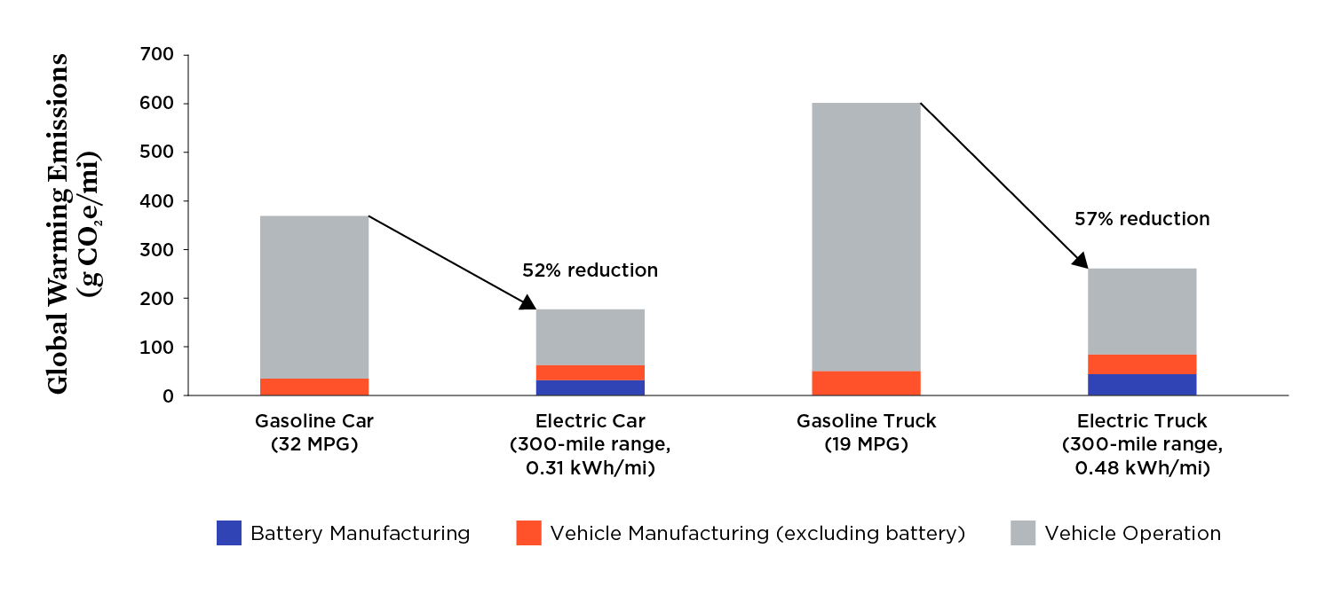
Figure 04: Lify Cycle Global Warning Emissions: EVs vs Gasoline Cars and Trucks (Source: Union of Concerned Scientists, 2025)
One of the strongest macro forces that impacts EV adoption is environmental regulation. During the last several years, most governments have come up with strict emissions limits, zero-emission-vehicle (ZEV) requirements, and incentives. EVs produce 52% less impact on the environment. Also, EVs almost 20% of all light-duty vehicle (LDV) sales in the world was a record high due to climate policies (Union of Concerned Scientists, 2025). Als
Pioneers (Tesla)
- Opportunities: Global mandates for EV adoption (100% ZEV by 2035 in major markets) increase demand for Tesla’s zero-emissions products (ICCT, 2025). Being a pure-play EV company, Tesla has the whole product segment matching the zero-emission vehicle requirements. The Tesla Company can sell its Robotaxi in markets with a ZEV credit, occasionally even auctioning the surplus credits to other car manufacturers.
- Threats: Regulation, however, presents risk too. Tesla needs to produce according to the regulations of the government to minimise environmental impact. Also, Tesla is currently up against stiff competition from alternative fuel vehicles and self-driving technology. Many luxury automakers, such as Mercedes-Benz, BMW, Audi, and Lexus, are bracing for fierce competition. Therefore, understanding the regulation requirements can help Tesla to stay ahead of its competitors when introducing Robotaxi.
Followers (BYD)
- Opportunities: In the case of climate control is a growth driver. BYD always emphasises environmental sustainability. BYD has committed to achieving net-zero carbon emissions by 2050, with an interim target to reduce carbon emissions across its operations by 50% by 2030 (Pirmana et al., 2023). Since the government provide various benefits to organisations which up for mass production and those that produce within the environmental sustainability guidelines, the new product of BYD can be easily produced and delivered to end users.
- Threats: In the case of BYD’s Shark PHEV, excessive dependence on Chinese subsidies can work against it in the case of the withdrawal of policies. Further, as regulations get more complex (like lifecycle emissions, recycling requirements, battery removal) BYD will have compliance costs that may squeeze margins, especially in export markets where standards differ.
Strategic Implications
Tesla needs to develop a strong compliance framework (recycling, battery end-of-life, circular value chains) to reduce the risk of regulation. On the other hand, BYD must spread its regulatory risk by not only diversifying its market to those that offer heavy subsidies but also matching the international regulatory standards. Sustainability capabilities (battery recycling, low-carbon manufacturing) will allow BYD Shark PHEV to meet more complex requirements and make it appear a socially responsible manufacturer of EVs on a global scale.

3. Strategic Responses of Pioneering and Follower Organisations

3.1 Pioneering Organisations’ Strategic Responses
Innovative companies, such as Tesla, are typically at the forefront of innovation and market development. Their strategic reactions seek to maintain a first-mover advantage, support differentiation, and capitalise on new opportunities (Hooley et al., 2020).
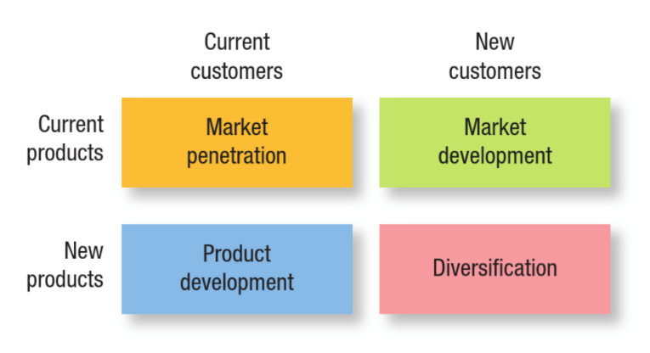
Figure 05: The Ansoff’s Growth Matrix (Source: Hooley et al., 2020)
Based on the Growth Matrix developed by Ansoff, the reactions of Tesla can be analysed along four strategic directions, including market penetration, product development, market development, and diversification (Quantive, 2024). This matrix will be used to analyse and plan their strategies for the growth of Robotaxi for Tesla.
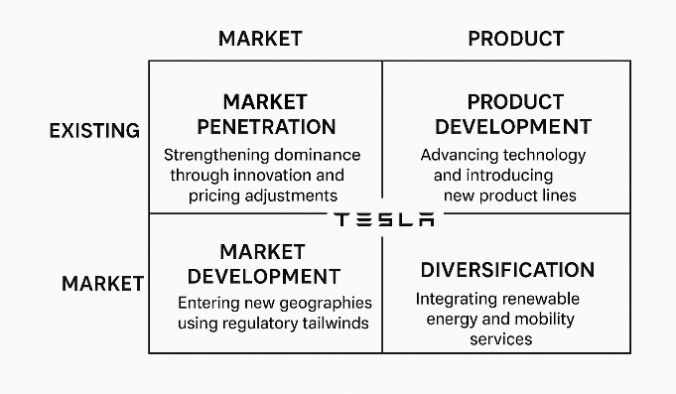
Figure 06: Pioneering Organisation’s Strategic Response (Source: Self-made)
1. Market Penetration
Strengthening Dominance Through Innovation and Pricing Adjustments
With the changing nature of technology and the strictness of the environmental policies, Tesla has amplified its market penetration mode of defence to maintain leadership. Declining battery prices and increasing economies of scale have allowed Tesla to periodically cut the prices of their vehicles to spur demand. In 2023-24, Tesla announced a global price cut of 5-20% on selected models in response to increased competition with BYD and other Chinese EV brands (Cheng, 2023). This enabled Tesla to retain sales volumes even in the face of economic uncertainty and decelerating demand in developed markets.
2. Product Development
Advancing Technology and Introducing New Product Lines
The product development strategy of Tesla is a direct reaction to the outside influences like high-speed battery development, software and regulatory incentives of low-emission technologies. Tesla has spent more than USD 3 billion annually to invest in next-generation batteries, autonomous driving systems, and AI-based automobile intelligence (Lesjak, 2024). An illustrative case is the release of Tesla Robotaxi, a new product in particular reaction to technological changes in full self-driving (FSD) algorithms and regulatory policies in favour of technologically-enabled low-emission transport.
3. Market Development
Entering New Geographies
Climate regulation and technological preparedness in all markets are significant influences on Tesla's global expansion strategy. Areas that have strict emissions standards, like the EU, UK, Canada, and in Asia, give good market grounds to develop. Tesla is also building more plants near regulatory-oriented markets, including the Gigafactory in Germany, which ensures environmental regulations (Tesla, 2022).
4. Diversification
Integrating Renewable Energy and Mobility Services
The diversification of Tesla is very consistent with the trends of environmental regulation and sustainability. In addition to consumer EVs, Tesla also incorporates the Tesla automotive business with energy storage, solar solutions, and digital services. The products like Powerwall, Megapack, and solar roofs are based on the climate policies (TESMAG, 2020). The new Robotaxi platform is also a diversification into autonomous ride-hailing - a high-growth and data-intensive mobility service.
Evaluation of Tesla’s Strategic Effectiveness
Tesla has an innovative position that enables it to be at the forefront of technological progress, impact standards of regulation, as well as consumer expectations. Nevertheless, the increasing competition with agile followers like BYD and regulatory challenges with regard to autonomy and battery sourcing remain challenges. To remain on top, Tesla shall have to strike a balance between innovation, operational efficiency and cost competitiveness.

3.2 Follower Organisations’ Strategic Responses
BYD is an organisation that is led by followers and thus develops competitiveness through scale, manufacturing efficiency and strategies that are adaptable. The reactionary strategies of BYD to external technological forces and environmental regulation can be contrasted with the reactions of Tesla (Cheng, 2023). The company is taking advantage of already developed technologies and regulatory incentives instead of innovation on the edge. The strategies of BYD’s Shark PHEV are observed using the Growth Matrix by Ansoff.
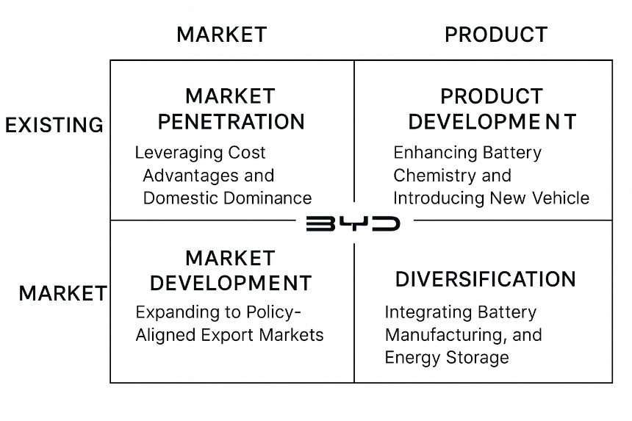
Figure 07: Follower Organisation’s Strategic Response (Source: Self-made)
1. Market Penetration
Leveraging Cost Advantages and Domestic Dominance
Cost leadership is the strongest strategic response that BYD can have in the market through penetration. Due to vertical integration, such as production of in-house batteries and semiconductors, BYD can sell vehicles at a 13% lower price than most of the global competitors (Dixit, 2025). This approach is effective in markets where the regulation is stimulating the use of EVs fast and customers are price-sensitive. As of 2023-24, BYD had become the largest volume EV salesman, in part due to high penetration in the mass-market segment of the Chinese market.
2. Product Development
Enhancing Battery Chemistry and Introducing New Vehicle Lines
Despite being a follower company in general, BYD practices selective innovation in order to be competitive. The strategic reaction to the technological changes and world attention to battery safety standards was the evolution of the Blade Battery, a Lithium iron phosphate (LFP) battery that provides a better safety level and longer life of battery cells, designed by BYD (Hasan et al., 2023). The product development, like the introduction of the BYD Shark PHEV truck, is consistent with regulatory requirements for more environmentally friendly commercial vehicles.
3. Market Development
Expanding to Policy-Aligned Export Markets
The external environmental regulation within China has significant prospects for the market development strategy of BYD. BYD has gone on to grow quickly in Europe, Southeast Asia, the Middle East and Latin America into markets that have favourable incentives in the importation of EVs or have a robust decarbonisation agenda. As an illustration, Thailand and Brazil are two countries that have added tax credits and industrial policies to the assembly of EVs (Sundararjun and Wongbandit, 2021).
4. Diversification
Integrating Battery Manufacturing, Semiconductors, and Energy Storage
Compared to the diversification at Tesla, which is technological in nature, the diversification of BYD is efficiency in nature and is mostly oriented towards building core competencies. BYD produces batteries, chips and electric powertrains via its subsidiaries, and this ensures that the company has stability in its supply chain even in the face of global supply shortages (Hertzke, Müller and Schenk, 2022). This vertical integration will enable BYD to be quicker to climate regulations demanding lifecycle emissions transparency and ethical sourcing.
Evaluation of BYD’s Strategic Effectiveness
The philosophy of BYD’s Shark PHEV is based on policy alignment, affordability, and scale, but not a frontier innovation. This solution has been very effective in the subsidy-based markets and areas in which there is a need to electrify with low-cost solutions. The strategic weaknesses of BYD are, however, as follows: trade restrictions between countries, reliance on the LFP battery technology, and less powerful brand recognition in the competitive marketplace.

4. Conclusion
In conclusion, the report has discussed the way the macro-environmental forces affect the global industry of electric vehicles (EVs). It has also been shown that the pioneer and follower companies act strategically in response to these forces for their respective new products. The analysis established that the macro marketing environment, especially the technological forces and environmental/climate regulation, is a very important factor that determines the strategic marketing decisions. The findings show that technological innovation can speed up transformation in the market by allowing cost savings, enhancing vehicle performance, and developing of new models. The second section emphasised the strategy of response of each company based on the Growth Matrix developed by Ansoff. To maintain its technological leadership, Tesla focuses on product development, diversification, and market development, but also employs market penetration strategies to address the threat of competition. The cost-led penetration, selective product development, and aggressive international expansion are the three strategic follower approaches adopted by BYD, which focus on policy-favoured areas. Collectively, these reactions demonstrate that winning in the EV sector requires the capacity to understand the transformations in the environment, particularly for new product development. Therefore, their respective new products’ success depends on various macro environmental factors, and they need to make strategic decisions in order to stay competitive in their respective field.

5. References
Cheng, E. (2023). Tesla cut EV prices in China more than BYD did for its flagship Han sedan this year, a study finds. [online] CNBC. Available at: https://www.cnbc.com/2023/12/20/tesla-cut-china-ev-prices-more-than-byd-did-for-its-flagship-han-sedan.html [Accessed 19 Nov. 2025].
Dixit, A. (2025). BYD’s strategy to overtake Tesla in EV production globally. [online] Available at: https://www.automotivemanufacturingsolutions.com/electrification/how-chinas-byd-surpassed-tesla-with-production-and-battery-tech-reshaping-the-global-ev-market/304649 [Accessed 19 Nov. 2025].
Europa.eu. (2025). Electric Vehicle Battery Packs Experience Record Price Drop in 2024. [online] Available at: https://alternative-fuels-observatory.ec.europa.eu/general-information/news/electric-vehicle-battery-packs-experience-record-price-drop-2024.
Grand View Research (2024). EV Market Size & Share | Global Electric Vehicles Industry Report, 2020. [online] Grandviewresearch.com. Available at: https://www.grandviewresearch.com/industry-analysis/electric-vehicles-ev-market [Accessed 18 Nov. 2025].
Hague, P.N. (2019). The business models handbook: templates, theory and case studies. London, United Kingdom: Kogan Page Limited.
Hasan, S., Islam, M.S., Bashar, S.A., Noman, A., Hossain, R.B., Haque, M.A. and Faishal, R. (2023). Beyond lithium-ion: the promise and pitfalls of BYD’s blade batteries for electric vehicles. In: E3S Web of Conferences. EDP Sciences, p.00005.
Hertzke, P., Müller, N. and Schenk, S. (2022). Dynamics in the global electric vehicle market. McKinsey Centre for Future Mobility.
Hooley, G.J., Nicoulaud, B., Rudd, J.M. and Lee, N. (2020). Marketing strategy & competitive positioning. 7th ed. Harlow; New York: Pearson.
ICCT (2025). Electric Vehicle Battery Packs Experience Record Price Drop in 2024 | European Alternative Fuels Observatory. [online] Europa.eu. Available at: https://alternative-fuels-observatory.ec.europa.eu/general-information/news/electric-vehicle-battery-packs-experience-record-price-drop-2024? [Accessed 19 Nov. 2025].
International Council on Clean Transportation. (2025). The EV Transition Check - International Council on Clean Transportation. [online] Available at: https://theicct.org/ev-transition-check-2025/ [Accessed 19 Nov. 2025].
Kotler, P., Armstrong, G., Harris, L.C. and He, H. (2020). Principles of Marketing. 8th ed. Hoboken: Pearson.
Lesjak, Z. (2024). Tesla Sales Statistics in 2022: Production, Revenue and Superchargers. [online] Tridens. Available at: https://tridenstechnology.com/tesla-sales-statistics/.
Pirmana, V., Alisjahbana, A., Yusuf, A., Hoekstra, R. and Tukker, A. (2023). Economic and environmental impact of electric vehicle production. Clean Technologies and Environmental Policy, 25, pp.1–15. doi: https://doi.org/10.1007/s10098023024756.
Quantive (2024). What Is the Ansoff Matrix: Definition, Steps & Examples. [online] Quantive.com. Available at: https://quantive.com/resources/articles/ansoff-matrix [Accessed 18 Nov. 2025].
Speaking Nerd (2021). Investigative Study of PESTLE Analysis Model. [online] SpeakingNerd. Available at: https://speakingnerd.com/strategy/strategy-models/pestel-analysis [Accessed 18 Nov. 2025].
Sundararjun, J. and Wongbandit, A. (2021). Policies and regulations to promote electric vehicles in Thailand.
Tesla (2022). Gigafactory Berlin-Brandenburg. [online] Tesla. Available at: https://www.tesla.com/giga-berlin [Accessed 19 Nov. 2025].
TESMAG. (2020). Tesla Energy Business: Powerwall and Solar Roof Expansion in Europe. [online] Available at: https://www.teslaacessories.com/nb/blogs/news/tesla-energy-business-powerwall-and-solar-roof-expansion-in-europe [Accessed 19 Nov. 2025].
The Observatory of Economic Complexity. (2022). Tesla | The Observatory of Economic Complexity. [online] Available at: https://oec.world/en/profile/company/tesla [Accessed 19 Nov. 2025].
Union of Concerned Scientists. (2025). Driving Cleaner. [online] Available at: https://www.ucs.org/resources/driving-cleaner#ucs-report-downloads [Accessed 19 Nov. 2025].
Whittington, R., Scholes, K., Angwin, D., Regner, P. and Johnson, G. (2017). Exploring Strategy: Text and Cases. 11th ed. Harlow, England: Pearson.

