Structural and Fluid Analysis
Designing a butterfly valve Fluid Flow assessment
Discuss Reynolds number. Why is this important, how does it influence the flow around the butterfly valve and estimate what the Reynolds number is of the fluid flowing around the butterfly valve?

Reynolds numbers were named after an English scientist and describe the viscosity of the flow of the liquid or air. When we write Reynolds numbers in class, we abbreviate it as RE; it is also considered a unitless number.

The main reason why Reynolds numbers are important is that they tell us if the flow is laminar or turbulent. The exact figure of when Reynolds number changes the flow from laminar to turbulent is not exactly clear; however, for the sake of this assignment, we can take that if the Reynolds number is less than 2300, then the flow will be in straight lines and considered laminar. If we imagine that the flow was in lines for a moment, we would see long straight lines heading towards the butterfly valve. If the Reynolds number is over 4000, then we would consider the flow turbulent. When the Reynolds number is over 4000, the lines would not be straight, and the flow would undergo irregular fluctuations and mixing. Turbulent flow is different from laminar flow as laminar flow is effectively layered and moves in straight paths. The best way of describing turbulent flow is that the speed of the fluid at a given point will constantly be changing in its magnitude and direction.

The area between this is a bit of a blur, and we would consider this area the transient area. The transient flow is where the laminar flow would transition to a turbulent flow. To define the transient flow, we can say it is when the viscous and Reynolds stresses are of equal magnitude.

To further break this down, the internal force is the liquid's density (Kg/m^3) times by the velocity (m/s) times by the length (m). The previous sentence is then divided by the viscosity of the fluid (kg/ms). If the inertia forces increase, then we will also see an increase in the Reynolds number. An increase in inertia forces leading to an increase in Reynolds number makes sense from a practical point of view as an increase in pressure, velocity and length are factors that will create more turbulence. If the inertia forces are decreased, then it will lead to more laminar flow. If the viscous forces increase then, it will mean the flow will stay laminar. Again, if the number decreases, it will lead to the opposite.

“Flow behaviour in natural or artificial systems depends on which forces (inertia, viscous, gravity, surface tension, etc.) predominate. In slow-moving laminar flows, viscous forces are dominant, and the fluid behaves as if the layers are sliding over each other. In turbulent flows, the flow behaviour is chaotic and changes dramatically, since the inertial forces are more significant than the viscous forces.” (Osborne Reynolds Demonstration)

The example's factors that will be considered are that the flow will split because the valve permanently blocks part of the flow. As the valve is closed, the area will decrease, which I predict will cause the Reynolds number to increase. However, the pressure and the viscosity will remain constant throughout.

I want to give a practical example of what I have previously discussed above. As the question tells us, the petrol starts in a tank before going through a pipe to a butterfly valve. The density for this is 800kg/m^3, the viscosity for this is 6x10^-3. I am presuming that the temperature holds at a steady rate of 20 degrees Celsius. The calculations have been taken mainly from Bernoulli’s equations. As pipes and valves are made to a good finish, it is unlikely that rough services need to be considered.
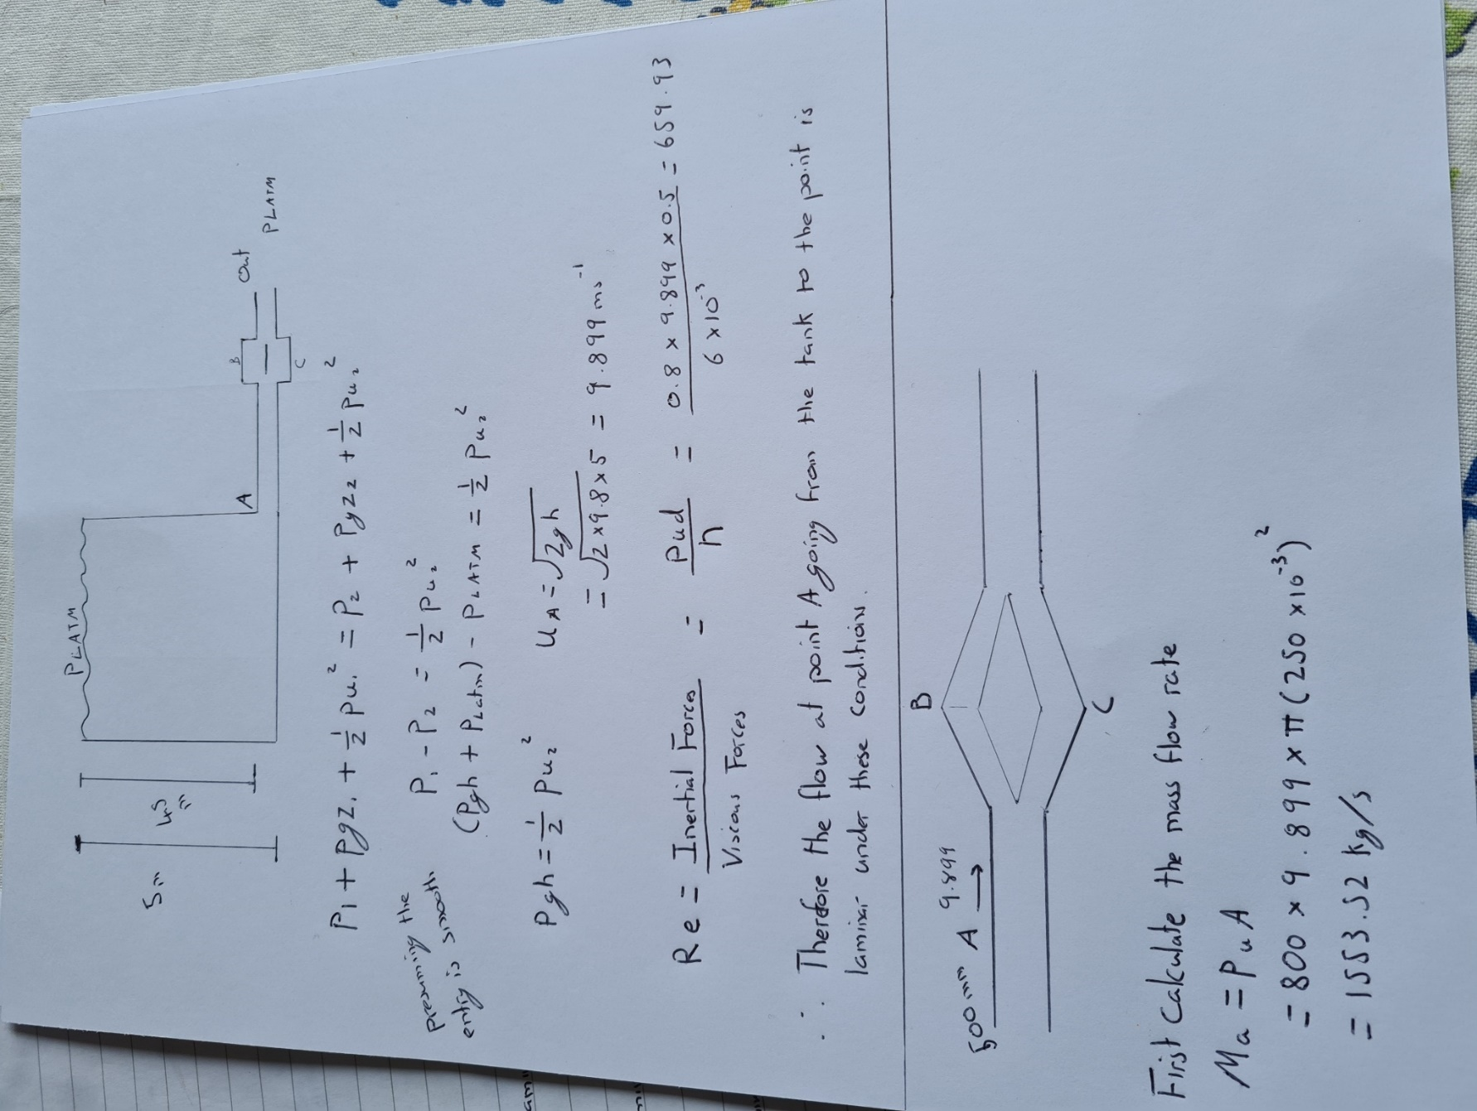

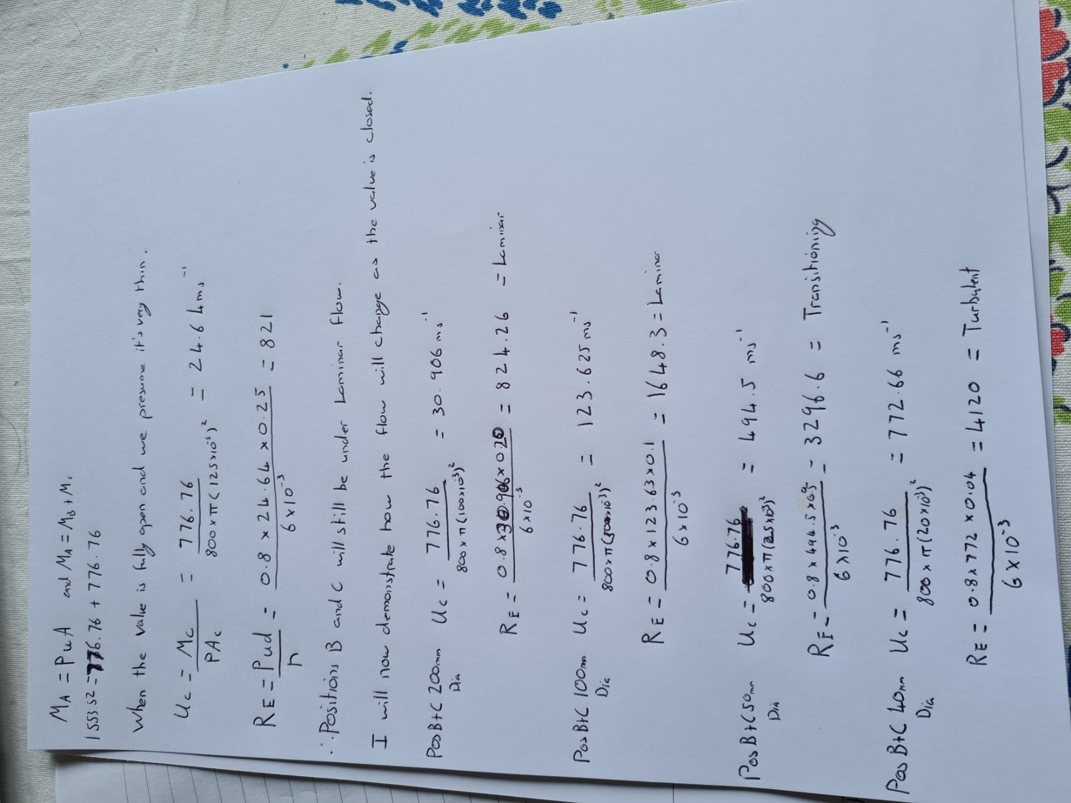
The above work proves that as the area decreases, we begin a transition from laminar flow to turbulent flow. The good news is that when fully open under atmospheric pressure conditions, we can expect laminar flow. To criticise my own work, when the valve is fully open the distance won’t ever be 250mm as the size of the valve itself needs to be taken into account. This is mostly just an example.

Discuss boundary flow around the butterfly valve and relate this to the separation and the turbulence around the valve, particularly the rivets that hold the valve onto the central shaft. Discuss why you think that valve has been designed like this and the cost implications of such a design.
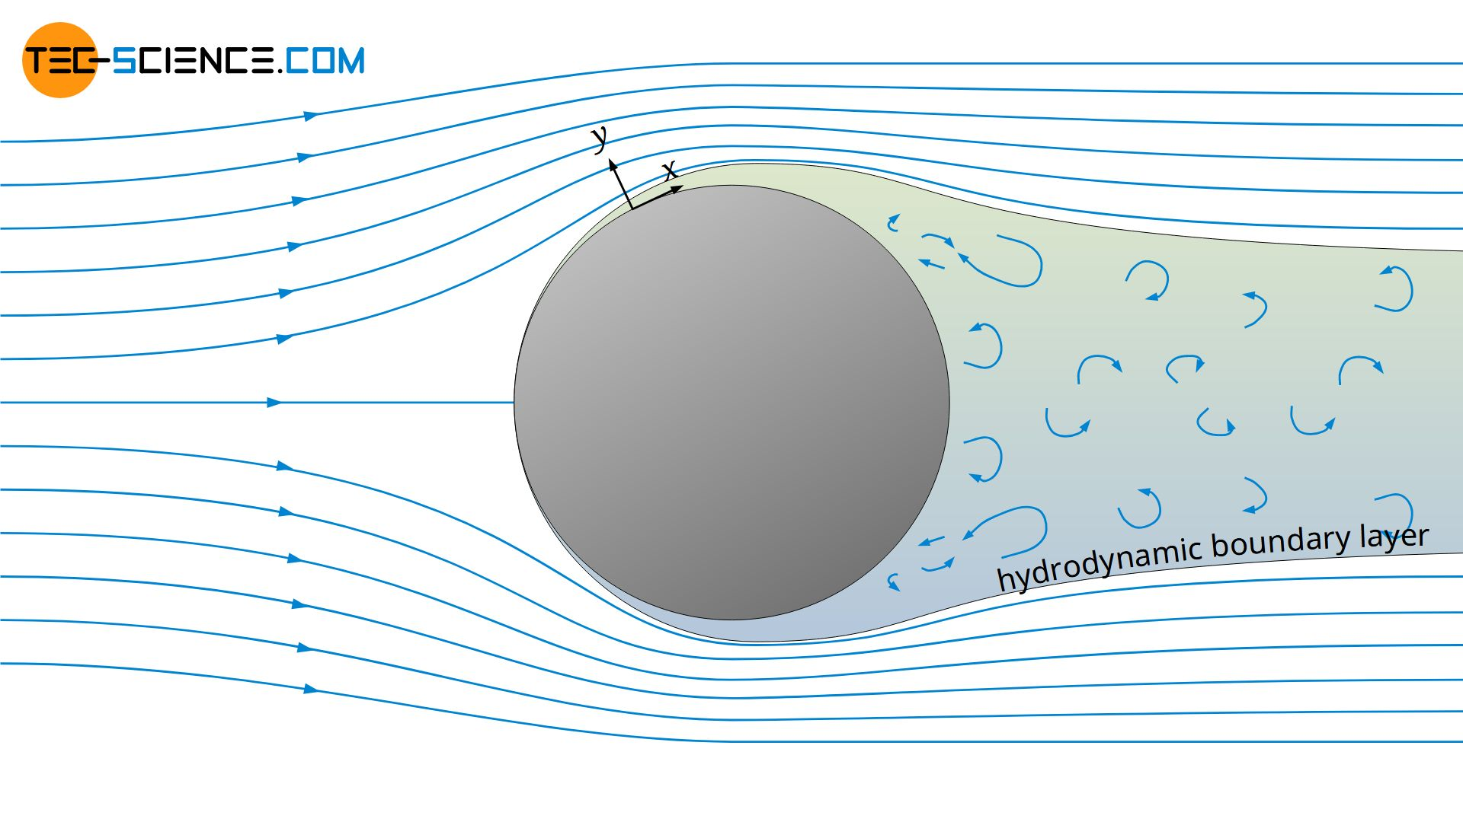
The above picture is taken from tech science. The picture is an extreme but worthwhile picture of what happens to the flow as the valve begins to close. First, the straight-line laminar flow that is heading towards it will be disrupted. Furthermore, the flow lines are forced to go around the blocking object. The lines transition from laminar to turbulent due to filling the space where the valve is now blocking.
Around the valve itself, we can expect that the long straight lines heading towards it will be disrupted somehow. The flow has to go somewhere, and it will be forced to go around the valve in any way necessary. As the handle slowly turns, the valve will begin to close; as proven in the previous equation, this will significantly disrupt the liquid flow. As a result of the rivets on the valve, the above equations have to be criticized as Bernoulli’s can only truly be applied when all surfaces are smooth, with no lumps and dips.
The picture below perfectly shows what happens to the liquid around the valve. The picture is from the 25th IAHR Symposium on Hydraulic machinery and systems. The valves on the right are free from the rivets and sharp edges, and it shows how the boundary flow flows smoother due to fewer interruptions when fully open. However, the valve on the left has clear hinges, which means that as the boundary flow is passing, it leads to greater disruption around the raised areas. So, the valve on the left clearly shows us that while the overall flow of the system can still be laminar, the flow specifically around the rivet will be more turbulent.

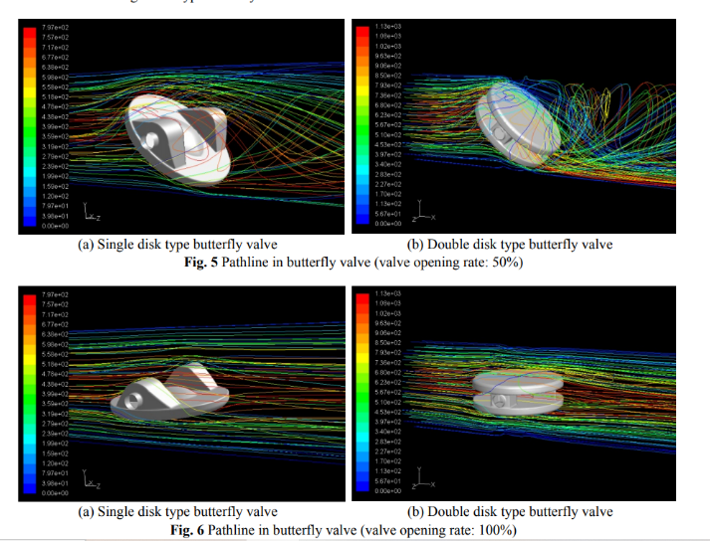

Kim and Wu studied the flow pattern, velocity distribution, and flow coefficient of butterfly valves through two-dimensional numerical analysis. Huang and Kim studied the velocity field and pressure distribution for three-dimensional incompressible flow in butterfly valves. They also reported the optimum design of the butterfly valve disk for stable flow regulation, smooth opening and shutting ability, and decrease of cavitation.
From work done by Kim and Wu and taking notes from Bernoulli’s theory, it seems that the butterfly valve given to us in the question has been designed to be as thin as possible while also having the valve itself be as smooth as possible. The thinner the valve is, the less it will cause issues for the laminar flow. Obviously, the less material that is used altogether will mean the overall cost will be reduced.
This butterfly valve is to be manufactured from glass fibre reinforced plastic. Discuss the implications of this in terms of the performance of the valve. Relate this to the historical, current and future developments of such components. You should include reference to technical literature, industry standards and codes of practice.
Glass Fibre Reinforced Plastic is a material with high mechanical strength, is lightweight, and has high corrosion and temperature resistant properties. From what has previously been discussed about smooth surfaces being critical when we deal with Bernoulli’s equation. GFRP also has an excellent resistance to corrosion and temperature, which if this were being used in a hot country or near a hot area, it would still function. GFRP is also easier to repair compared to some of the other metal-based products on the market.

Further explanation of the benefits of using GFRP can be seen below. In the numbers below, a list of advantages of GFRP will be found. The information below is from Materials Science and Engineering ninth edition, page 558.

- It is easily drawn into high-strength fibres from the molten state.
- It is readily available and may be fabricated into glass-reinforced plastic economically using a wide variety of composite-manufacturing techniques.
- As a fibre it is relatively strong, and when embedded in a plastic matrix, it produces a composite having a very high specific strength.
- When coupled with the various plastics, it possesses a chemical inertness that renders the composite useful in a variety of corrosive environments.
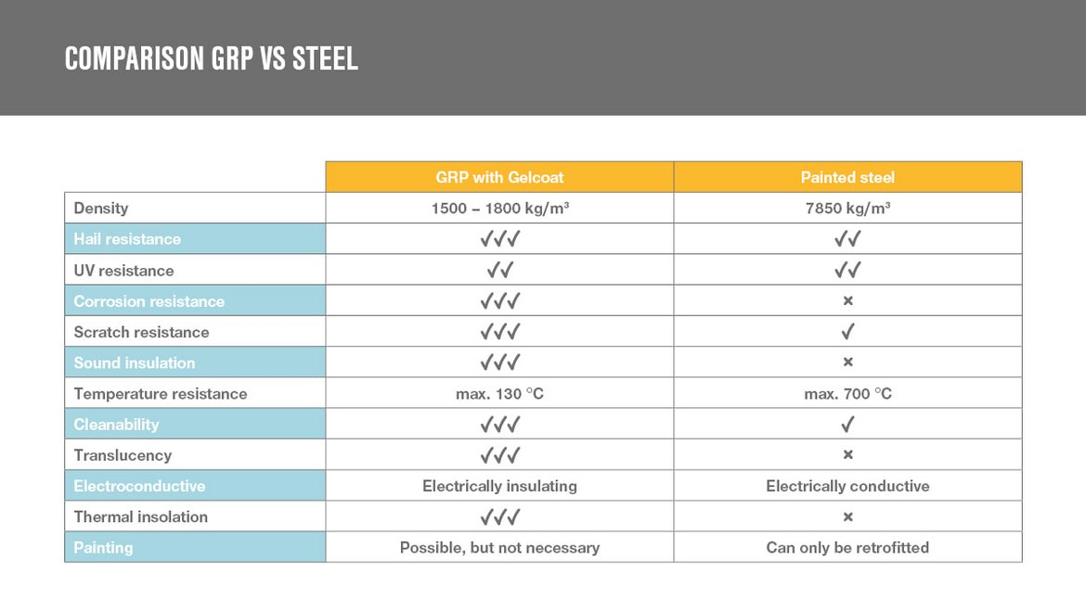
The picture above was sourced from Lamilux, which is a company that deals with high-tech materials. GFRP is a fibre plastic composite. GFRP has high elongation at break, good electrical current resistance, and excellent corrosion resistance. Steel's advantage is that it is easily recyclable; however, it is also a very limited resource. At some point, we will need to find other resources to replace it. The most significant issue steel has even for this application is its weight. So far, there is no practical way to reduce steels weight. GFRP, on the other hand, is extremely strong and dimensionally stable. Again, this will depend on GFRP's overall structure, like is it a moulded part, for example. Steel can withstand much higher temperatures than GFRP. Steel can withstand up to 700 degrees Celsius. GFRP, on the other hand, cannot go above 130 degrees Celsius. There should not be a need to go that high on this specific application; however, this valve would need changing if the need does arrive.
From the book Understanding How Components Fail page 203, on steel components, cavitation fatigue can occur, forming clusters of many pits in metal surfaces vibrating or moving rapidly in a liquid. By using glass fibre reinforced plastics, we can eliminate this failure mode.
ISO 16136:2006 is the latest international standard developed for industrial valves, including butterfly valves. The ISO is a relatively recent update as this lets us know what standards we need to comply with. It should be noted that this is specifically for thermoplastics, whereas GFRP is more specific than that. I can find no specific ISO specification for GFRP. The temperature range that this ISO states the valve should perform in is between minus -40 - +120 degrees Celsius for a lifetime of 125 years.
I have attempted to get as much information from this research from MSS-SP 67 and MSS-SP 68. These are standard codes of practice. These are specific codes of practice for butterfly valves. SP 67 is for general butterfly valves, and SP68 is more specially for high-pressure systems that use butterfly valves.
For a brief history of the butterfly valve, they were initially produced as they were easy to install, maintain, and very simple in their function. However, even in the early days, the valves did suffer from interrupting the flow and were not used for high differential pressures.
Since they were first used way back in the 1800s, innovations include analogue signals to tell us if the valve is open or closed. Improvements in the rubber seals so that they do not wear out as often and have a better sealing factor. As materials have improved over the years, they have been able to create thinner valves. One of the critical areas that have seen the most innovations is how individuals open and close the valves. This can be achieved in many ways, but the traditional approach is to manually turn the wheel that opens and closes the valves. Since then, for very high-pressure loads, there are Hydraulic pistons that can be used. Electrical-operated valves can be used to put them in the open and the closed positions. Pneumatically operated valves can also be used but, these are mainly for pneumatic pipelines and are rarely used in hydraulics systems.
Discuss what modelling techniques could be used to simulate the fluid flow though this valve. Discuss the advantages and the disadvantages of the tools highlighted?
The first tool that comes to mind is using CFD, which is Computational Fluid Dynamics. CFD is a tool that uses basic equations that can simulate and model the fluid's movements. This software can be used in seakeeping, resistance and propulsion, and also other applications such as piping. The advantages of CFD are simple and that they are a great way of saving time in order to come up with new designs. In this case, we could try experiments that could take a long time to set up and then an even longer time running them to get the correct results. For example, when dealing with petroleum, we do not want to spill any of it as it is not a chemical we want to go into the environment. By simulating, we can analyse the results in an easy and non-dangerous manner.
By using CFD, we can also study the system under conditions that are far above the limits of what we practically have available. It may not be crucial now, but as time goes on and the needs for the system change, we would then be able to know what the system can cope with. CFD will also provide us with more detail that we can not achieve using a more traditional technique. For example, when we make a small change to a process, all calculations will have to be repeated. With CFD, the small changes can be calculated in minutes. The software will also automatically generate graphs and other tools that would take time if individuals did it by hand.
Some of the disadvantages of CFD are that anyone can use them but, that does not mean they should. Results generated using CFD should always roughly equal what the individual thought. Other errors that can occur include errors due to simple flow models or simple boundary conditions. Also, the time it takes for large models to be tested, the costs may grow if the wrong equipment is initially used and there needs to be enough computing power per cell.
Another technique that can be used is the use of small-scale models to see the effects. Small-scale models are used more often than not in the aeronautical and automotive industries. Small simulation trials can be used by individual companies and do not rely on water tunnel centres. These can be great for early demonstrations, testing theories, and not dedicating to many resources initially.
The last technique I would like to review is water tunnels, which are very similar to wind tunnels. It is unknown how old this practice is, but we know that wind tunnels were used by the Wright brothers, which immensely helped them discover flight. Water Tunnels are used for submarines for measuring the forces acting upon the unit, lifts, and drags for hydrofoils. In this case, we could test different types of butterfly valves to measure the Reynolds numbers, flow analyse, and potential failure modes. Not all at the time, but sometimes we have to scale down the size of the component to fit it inside of a water tunnel. A water tunnel cannot be made for every experiment the individual wants to do, and therefore models of the components the individual wants to produce need to be made rescaled.
For this reason, the Reynolds numbers need to be recalculated and then scaled up or down depending on the actual size of the component. We also need to consider the cost and availability of water tunnels. From research done on Wikipedia, there is only one water tunnel in the UK, and the maximum per country that I have found at the moment is in Germany that has five. The finite number means that everyone who wants their parts tested must compete with other companies who want their work completed. Even if there is excess demand, businesses cannot just make a new water tunnels centre overnight. Building it is one thing but populating it with engineers who understand the technology is something else.
During the development of this component, it is proposed that a prototype is produced and tested in a laboratory to understand the fluid flow through this valve and also to correlate it to the simulation carried out in task 4. Discuss how you think this experiment should be carried out and how the acquisition of data should be obtained and compared to the simulation.
When developing new products, we must test them in the real world. Often a procedure for this could be, make a small model and test it at a minimal cost. Does the theory seem correct? Next, the business could simulate the part in different conditions. Simulating could be completed using CFD software. Finally, as a final test, it could be sent to a water tunnel for further testing, where the best real-world experience can be found.

Viscosity

For this specific component, a few things need to be considered. The first point to look at is the liquid. We need to ask ourselves what grade of this fuel is going to be used. This will affect the viscosity. This could make the difference of when the flow is laminar, transitional, or turbulent. For this experiment, it would be worth testing several liquids. Below, several liquids have been written that could be tested to determine the effect of the flow around the valve depending on the flow.

Liquid | Viscosity | CFD Simulation Result | Water Tunnel Result | Percentage Difference
Pentane | 0.224
Hexane | 0.295
Heptane | 0.389
Octane | 0.509
Nonane | 0.665
Decane | 0.85
Undecane | 1.098
Dodecane | 1.359
Tridecane | 1.724
Tetradecane | 2.078
Pentadecane | 2.82
Hexadecane | 3.03
Heptadecane | 4.21

The reason for completing this experiment is to compile a document that would tell future engineers or maintenance staff about what acceptable liquids could be used in the process. For the current fuel, it might be ok, but if the liquid is changed and the viscosity increases, we might face a situation where we are no longer getting the smooth laminar flow that we once were getting. What also needs to be completed when this part of the experiment is concluded, is that we compare our results to the results we were getting while using the CFD. In an ideal world, we would hope that the results would be similar; otherwise, there may be factors that have not been considered. Before moving on, further CFD studies should take place.

Pressure

Another factor that I would be keen to look at is the effect of pressure on the flow around the valve and in the system in general. For this assignment, I have assumed local atmospheric pressure to be used; however, I also have to consider what if, in the future, the pressure acting on the liquid on the tank is increased, for whatever reason it would need to be. Therefore, I would have to create again a graph stating the maximum pressures that should be allowed with every given liquid that can be used.

Temperature range

The temperature of the room will affect the viscosity, as stated earlier in the assignment. For this reason, we need to know the minimum temperature that the system could work at. Reference “Iso 16136:2006, the valve itself should be able to operate in -40 – 120 degrees Celsius over 25 years without breaking. This is specifically for the valve itself and not the liquid. Tests should be completed throughout this temperature range so that we can sell the valve after the testing has finished.

Monitoring between cycles

Something else that needs to be considered with this is the monitoring between cycles. For example, the ideal scenario is that each liquid and pressure is tested for a certain amount of time. After this, the part is taken to a lab for a complete analysis to see if any failures are likely to occur. In general, cracks and strain should be measured repeatedly. If the change in length increases as the cycles continue, then documentation should be written about maximum forces that should be allowed to be applied to the component. While this work is being completed, it might be necessary to increase the width of the valve to cope with the amount of force required.

Overall, the reason for testing is simply to find out if the valve can withstand the loads that the ISO demand from it and to work out at what parameters the part will fail at. Other conditions that could be considered are, if the valve is left half open/ half closed, what is the effect on the valve’s overall life. How quickly can the valve be removed and refitted? What are the consequences of fitting this part incorrectly? The point of testing is to prove that the component you want to sell will complete its function, I believe the tests I have suggest and the ISO to back them up would allow sales of this globally.

Assignment word count minus question = 3242

Bibliography
Data for viscosity and density can be found here:-
Average Viscosities of Miscellaneous Liquids (geotechenv.com)
Experiment #7: Osborne Reynolds’ Demonstration – Applied Fluid Mechanics Lab Manual (pressbooks.pub)
Flow separation (boundary layer separation) - tec-science
Microsoft Word - 099_IAHRXXV.doc (iop.org)
Glass Fibre-Reinforced Plastic - an overview | ScienceDirect Topics
Review on glass fiber reinforced polymer composites - ScienceDirect
Glass reinforced plastic (GRP) or FRP from Plasticon UK
MSS SP 67 - Butterfly Valves | Engineering360 (globalspec.com)
MSS SP 68 - High Pressure Butterfly Valves with Offset Design | Engineering360 (globalspec.com)
GRP and steel: Comparison of two materials | insights by LAMILUX
Understand how components fail – Donald J Wulpi
4 Advantages and Disadvantages of CFD | CFD Modeling Services (wordpress.com)
Water tunnel (hydrodynamic) - Wikipedia
ISO 16136:2006(en), Industrial valves — Butterfly valves of thermoplastics materials

