
Programme | MSc Public Health and Social Care in Practice
Module | Practice-Based Research
Module code | LCHS7008
Lecturer | Oluwadamilola Tayo
Assignment Title | Component 2 Written Research Proposal
Student Name | Zakiyabanu Zakirhusen Malek
Student ID | 2531983
Word Count | 2719

Research Title: Factors Influencing the Uptake of Breast Cancer Screening and Its Impact on Early Detection Among Eligible Women in the UK: A Systematic Review.

Table of Contents
Introduction and background 5
Prevalence 5
Explaining the consequences 6
Narrowing the focus 6
Research Problem, Rationale and Evidence Gap 6
Research problem 6
Research rationale 7
Evidence Gap 7
Literature Review 7
Barriers and facilitators to screening uptake of breast cancer among women 7
Impact of early detection on health outcomes 8
Literature gap 8
Research Aim, objectives and question 9
Research Question 9
Aim 9
Objectives 9
Methodology 9
Research design 9
Question framework 9
Database and Search strategy 10
Inclusion and exclusion criteria 11
Study screening and selection 11
Quality appraisal and risk of bias 12
Data extraction and synthesis 12
Ethical Considerations 12
Limitations 13
Timeline Expected Contribution 13
References 15

Introduction and background
The breast cancer is a fatal disease where abnormal growth of cells forms tumours. Leaving it unchecked can be fatal, as it can spread throughout the whole body and damage the body critically (WHO, 2026). In today's era, Breast Cancer survival rates are increasing, and death rates are going down, due to support for awareness. Advancements in Breast Cancer treatment allow healthcare experts to diagnose Cancer earlier. The symptoms of this issue can be identified by the colour change of the breast skin, including changes in size, appearance and shape (Mayo Clinic, 2026).
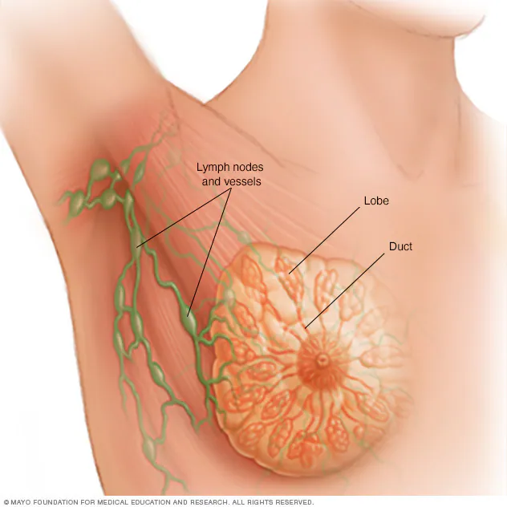
Figure 1: Breast Anatomy
(Source: Mayo Clinic, 2026)

Prevalence
In the UK, the prevalence of Breast Cancer is 2.11% for females and 0.009% for males (Barclay et al., 2024). Correspondingly, every year around 59,400 diagnoses happen in the UK; among them, around 59,000 people are women, and 420 are men (Cancer Research UK, 2026). Correspondingly, it is found that around 6, 94,000 deaths are caused by Breast Cancer in 2024 (WHO, 2026). The economic burden of this is significant, as Jalali et al. (2023), identified that because of the significant prevalence of this, its medical expenses can force a major financial strain on patients, as the study indicated each patient has an annual cost of 11,979.09 USD. In the UK mortality rates are increasing and almost 11,200 women’s were died in every year (Cancer research UK, 2026).

Explaining the consequences
Breast Cancer heavily affects mental and physical health, family roles and the economic condition of the patients. In this context, Namoos et al. (2025), highlighted that Breast Cancer patients tackle a multifaceted strain of psychological and physical challenges, where major physical challenges include unsteadiness on the feet and sudden falls. Similarly, the psychological burdens include stress-related disorders anxiety and depression, often due to the fear of cancer. These often lead to economic challenges for employees due to work issues, despite the medical burdens also being found significant, where Jalali et al. (2023), identified the cost of radiography among major medical economic burdens. In 2024-25, around 1.94 million women went to the NHS for screening, indicating the pressure on the NHS regarding Breast Cancer cases (NHS England, 2026).

Narrowing the focus
The inability of UK-based women to attend the doctors for the screening of Breast Cancer is backed by several reasons. These include language issues, cultural or religious beliefs about body privacy and fear of finding cancer (Bolarinwa and Holt, 2023). It matters as going to the appointments helps to find cancer early, and it helps to save lives and lower the treatment costs. From this perspective, Thomas and Norris (2025), identified that in stage III or IV, 60% of Breast Cancer cases were diagnosed, as most of the women go to doctors when they see a perceptible alteration. Hence, understanding its importance is essential, which is explored by this study to find the importance of screening in the early detection of Breast Cancer in UK-based women patients. The main purpose of this report is to identify the factors that Influencing the Uptake of Breast Cancer Screening and Its Impact on UK women.

Research Problem, Rationale and Evidence Gap

Research problem
The problem behind cancer-related death is none other than the lack of screening of Breast Cancer in UK-based women. The lack of knowledge about Breast Cancer and cultural factors are the pivotal reasons behind the lack of early screening (Zha et al., 2019). It leads to around 11,1200 deaths every year, due to the lack of screening (Cancer Research UK, 2026a). In the UK, only 63.6 % of the total invited women came for the diagnosis of Breast Cancer due to a lack of knowledge and trust in healthcare; this indicates the higher possibility of breast cancer mortality in the UK (Breast Cancer Now, 2026).

Research rationale
The lack of early breast cancer screening can lead to cancer progression to the advanced stages and lower success of the treatment, ultimately leading to increased mortality (Ginsburg et al., 2020). Costa et al. (2024), highlighted two major reasons behind the diagnosis delays of the women, which are the lack of general awareness and the dismissing of suspicious signs as unimportant. It is essential to shed light on the fast recognition of breast cancer, as the lack of early detection can even lead to death. Hence, this study intends to delve into the process of gaps in the screening of breast cancer in UK-based women.

Evidence Gap
The lack of knowledge about the significance of screening for breast cancer has led to around 31 deaths per day in the UK and has limited the ability of medical experts to identify the disease in the earlier stages (Cancer Research UK, 2026a). Thus, this study will fill this gap by finding the appropriate reasons behind the negligence of UK-based women in the screening of Breast Cancer.

Literature Review

Barriers and facilitators to screening uptake of breast cancer among women
Barriers to breast cancer screening include financial costs, low awareness and fear of a cancer diagnosis. In this context, Ponce-Chazarri et al. (2023), found that low educational and socioeconomic levels, race or ethnicity and medical mistrust are the most common barriers to screening uptake of breast cancer. In the UK, mainly the asian or black women have faced worse experiences in healthcare than white women, which increased distrust in healthcare systems.
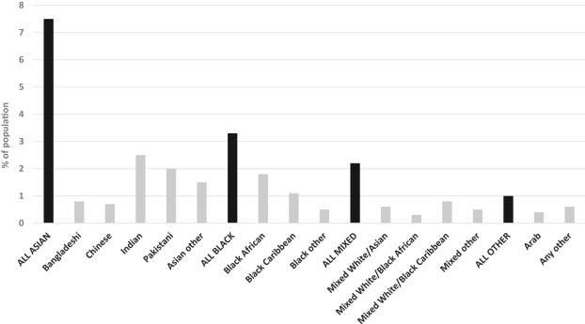
Figure 2: Non-white ethnic minority groups in the UK with percentage and distribution
(Source: Gathani et al., 2021)
This figure suggest that in the UK multiple ethnic minority group are present in the UK who faces barriers to adopt any kind of health services (Gathani et al., 2021). Similarly, Zha et al. (2019), found that unawareness about breast cancer, language barriers, difficulties securing child care and time away from work prevent the earlier screening of patients. Correspondingly, Sanaullah et al. (2025), highlighted that screening utilisation is hindered due to several factors such as financial constraints, cultural factors and low health-related awareness. Therefore, it can be summarised that the barriers and facilitators totally diminish the chances of screening for patients.

Impact of early detection on health outcomes
Early detection of Breast Cancer drastically improves clinical outcomes, which helps improve the health of patients. Munir et al. (2025), found that earlier detection of Breast Cancer is helpful in leading to a better prognosis in comparison to later diagnosis, which improves treatment success and survival rates. Similarly, Khan et al. (2025), cited that early detection of Breast Cancer is helpful in enhancing the overall long-term results by increasing the chances of successful treatment. Similarly, patients diagnosed at an early stage have greater survival rates than who are diagnosed in advanced stages.

Literature gap
Although previous studies have explored a range of individual, socioeconomic, cultural and healthcare related facilitators and barriers influencing breast cancer screening uptake, the evidence remains fragmented in relation to how these factors collectively influence participants among women in the UK. As an example, Ponce-Chazarri et al. (2023), only highlighted the socioeconomic, educational barriers and facilitators on the uptake of Breast Cancer screening among women while Bolarinwa and Holt (2023), highlighted cultural factors on the screening uptake of Breast Cancer among women. However, these researches are focused on only barriers and facilitators rather than evaluating their implication for early detection. Conversely, Munir et al. (2025), highlighted the impact of the lack of early screening on the health of Breast Cancer patients but did not highlight the impact of missed screening on the early detection of that Cancer. Hence, there is a need to synthesise the existing UK evidence by examining the factors influencing breast cancer screening uptake along with their implications for early detection among women. This systematic review will address this gap by integrating evidence on screening participation, its determinants and its relationship with early detection.

Research Aim, objectives and question

Research Question
What factors influence the uptake of breast cancer screening and early detection of breast cancer among eligible women in the UK?

Aim
To critically evaluate the influence of the factors in the uptake of breast cancer screening among women eligible for the breast cancer screening programme in the UK and their impact on the early detection of breast cancer.

Objectives
•To examine the uptake of breast cancer screening among women eligible for the breast cancer screening programme in the UK.
•To evaluate the individual, socioeconomic, cultural and healthcare-related factors influencing participation in breast cancer screening.
•To examine the impact of breast cancer screening uptake on the early detection of breast cancer.
•To identify evidence-based strategies to improve breast cancer screening uptake and promote earlier detection among eligible women in the UK.

Methodology

Research design
The research design helps to provide a structured roadmap for accurately accomplishing a study. In this research, a systematic literature review (SLR) will be embedded for the secondary qualitative research. It will be beneficial to capture the effectiveness of factors influencing the uptake of Breast Cancer screening and its impact on early detection among women in the UK. In this regard, Azarian et al. (2023), highlighted that SLR is helpful in synthesising previous works for strengthening a specific topic’s foundation. It is helpful in providing a holistic overview of the existing knowledge about a specific topic and reflecting a comprehensive representation of the topic. In this research, SLR will be used to highlight the effectiveness factors that influence uptake of Breast Cancer and its impact in the early detection through exploring the existing sources of information.

Question framework
The question will be created by using the PICO Framework that consists of four factors like population, intervention, comparison, and outcome. The PICO framework is highly used in healthcare research because it is helpful to define the research question clearly and ensure the development of a structured search strategy. This PICO framework is appropriate for this research because it aims to recognise factors influencing breast cancer screening uptake and evaluate its impact on early detection of breast cancer among women in the UK.
PICO Element | Description
Population (P) | Women who are eligible for breast cancer screening programmes in the UK.
Intervention (I) | Participants in the breast cancer screening and factors that influence screening uptake.
Comparison (C) | Women with lower screening uptake and those who do not participate in screening activities.
Outcome (O) | Improved diagnosis rate, early detection of breast cancer, and better health outcomes.
Table 1: PICO Framework
(Source: Self-created)

Database and Search strategy
The different electronic databases will be used to conduct a detailed search of the literature. The selected databases for article selection for this research include Google Scholar, Scorpus, PubMed, ScienceDirect, Web of Science, CINAHL. These databases consist of a large number of peer-reviewed journal articles related to cancer screening, healthcare, public health, health behavior, and women’s health (Haroen et al., 2025). Also, the supplementary searching will be conducted that is helpful to identify relevant information through database searching. The search will also focus on the peer-reviewed articles which consist of knowledge about factors influencing breast cancer screening uptake and evaluate its impact on early detection among women in the UK.
The search terms will be developed from the key concepts of the research questions and combined using the Boolean operators such as ‘OR’, ‘AND’.
Concept | Search terms
Breast Cancer | "Breast neoplasm" OR "Breast cancer" OR "Breast tumour"
Screening Uptake | "Screening participation" OR "Screening uptake" OR "Screening utilisation" OR "Screening attendance"
Breast Cancer Screening | "Breast screening" OR “Breast cancer screening" OR "Mammography screening"
Early Detection | "Early diagnosis" OR "Early detection" OR "Cancer detection"
Location | “UK” OR “United Kingdom” OR “Wales” OR “Scotland” OR “Northern Ireland”
Table 2: Boolean Operators
(Source: Self-created)

Inclusion and exclusion criteria
The eligibility criteria will be established before the screening process that is helpful to ensure the consistent selection of study which is aligned with the research question.
Criteria | Inclusion | Exclusion
Publication type | Peer-reviewed journal articles | Non peer-reviewed sources (Blogs, unpublished manuscripts)
Text Availability | Full-text article | Only Abstract
Language | English | Non-english
Credibility | All articles must be collected from credible sources. | Unreliable sources
Timeframe | 2019-2026 | Before 2019
Table 3: Inclusion and Exclusion criteria
(Source: Self-created)

Study screening and selection
The collected records will be uploaded to the reference management software where the duplicate will be identified and deleted firstly. After that, collected papers will be screened based on the above-mentioned inclusion and exclusion criteria. The PRISMA 2020 guidelines will be followed for the complete selection process. This PRISMA provides a transparent and structured approach for recognising, screening, and selecting studies for systematic reviews (Martinez et al., 2023). In the identification stage, relevant studies will be gathered from different electronic databases. In the screening stage, the duplicate articles will be removed after accessing their relevance if it belongs to exclusion criteria. The eligibility of the research papers will be assessed by reviewing it based on the inclusion and exclusion criteria.

Quality appraisal and risk of bias
The collected studies will be accessed for assessing the methodological quality using the appropriate validate appraisal tools which are based on the study design. As an example, randomised control trials could be asessed through the Cochrane Risk of Bias tool and the mixed methods study with the help of Mixed Method Appraisal Tool (MMAT). This appraisal will also help to identify different methodological limitations such as selection bias, outcome measurement, incomplete reporting, and other potential sources of bias.

Data extraction and synthesis
A structured table of data extraction will be created to gather important information from each selected study. The extracted information will consist of author, publication year, country, sample characteristics, research design, main findings. The collected data will be analysed by using the thematic synthesis. The approach is appropriate because this study includes different research design and outcome measures. Thematic synthesis allows findings obtained from different sources to group into the common themes and compare structurally. The findings will be organised under different themes such as:
- Cultural and socio-economic factors influencing participation.
- Impact of screening uptakes on early detection outcomes.
- Individual factors that influence screening uptake.
This synthesis will enable vast understanding of factors that identify different factors influencing breast cancer and their impact in early detection among women in the UK.

Ethical Considerations
Although this systematic review will not involve participant recruitment or primary data collection, ethical standards will be maintained throughout the review. In this context, accurate Harvard referencing and appropriate acknowledgement of resources will also prevent plagiarism, while transparent reporting will reduce selective reporting and misrepresentation of the findings (Ramesh, 2024). These ethical procedures and approval reported by including studies will also be considered. Additionally, findings will be presented fairly and without any distortion. As this study will utilise published literature and involve no direct human participants, formal ethical approval will not be expected to be required. However, institutional requirements will be checked thoroughly before commencement.

Limitations
This review can be impacted by publication bias, as studies with noteworthy insights have more probability to be published. Furthermore, limiting the review only to English-language, full-text papers can exclude relevant evidence. Also, differences in study designs, populations and definitions of screening uptake can restrict comparison and synthesis and researcher judgement during screening, quality appraisal and interpretation can introduce subjectivity (Johnson et al., 2022). These limitations can be addressed through predefined eligibility criteria, systematic screening, quality appraisal and transparent reporting, also by consistent with systematic-review reporting guidance (Taylor et al., 2023). Therefore, findings will be interpreted cautiously and not generalised beyond the available evidence.

Timeline Expected Contribution
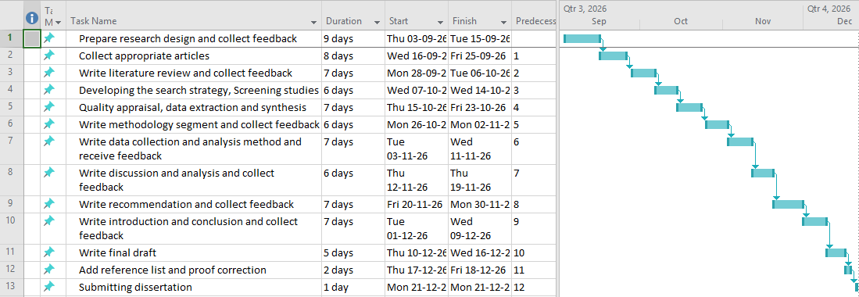
Figure 3: Gantt-chart
(Source: Self-created)
The review will be completed over eight weeks in six stages. Week 1 will involve refining the research question, establishing and testing the search strategy and finalising eligibility criteria. Week 2-3 will cover database searching, removal of duplicates and screening titles/abstracts. Weeks 4-5 will involve full-text screening and quality appraisal of eligible studies. Week 6 will concentrate on data extraction while Week 7 will involve thematic synthesis and interpretation of findings. Week 8 will be dedicated to final writing, proofreading, editing and submission. PRISMA 2020 will guide transparent reporting throughout the review process. The review is expected to recognise evidence on individual, socioeconomic, cultural and healthcare-related barriers to screening uptake and their implications for early detection. Findings may support targeted screening practice, inform UK healthcare practice and identify priorities for future UK research. This may also strengthen evidence-based decision-making and promote equitable access to screening services.

References
Bolarinwa, O.A. and Holt, N. (2023) ‘Barriers to breast and cervical cancer screening uptake among Black, Asian, and Minority Ethnic women in the United Kingdom: evidence from a mixed-methods systematic review’, BMC Health Services Research, 23(1), p.390. Available at: https://doi.org/10.1186/s12913-023-09410-x
Breast Cancer Now (2026) Women not taking up first invitation to breast screening is a decades long crisis, warns leading breast cancer charity. Available at: https://breastcancernow.org/about-us/media/press-releases/women-not-taking-up-first-invitation-to-breast-screening-is-a-decades-long-crisis-warns-leading-breast-cancer-charity
Cancer research UK (2026a) Breast cancer mortality statistics. Available at: https://www.cancerresearchuk.org/health-professional/cancer-statistics/statistics-by-cancer-type/breast-cancer/mortality (Accessed: 6 August 2026).
Cancer research UK (2026a) Breast cancer mortality statistics. Available at: https://www.cancerresearchuk.org/health-professional/cancer-statistics/statistics-by-cancer-type/breast-cancer/mortality (Accessed: 1 August 2026).
Costa, L., Kumar, R., Villarreal-Garza, C., Sinha, S., Saini, S., Semwal, J., Saxsena, V., Zamre, V., Chintamani, C., Ray, M. and Shimizu, C. (2024) ‘Diagnostic delays in breast cancer among young women: An emphasis on healthcare providers’, The Breast, 73, p.103623. Available at: https://doi.org/10.1016/j.breast.2023.103623
Gathani, T., Chaudhry, A., Chagla, L., Chopra, S., Copson, E., Purushotham, A., Vidya, R. and Cutress, R. (2021) ‘Ethnicity and breast cancer in the UK: Where are we now?’, European Journal of Surgical Oncology, 47(12), pp.2978-2981. Available at: https://doi.org/10.1016/j.ejso.2021.08.025
Ginsburg, O., Yip, C.H., Brooks, A., Cabanes, A., Caleffi, M., Dunstan Yataco, J.A., Gyawali, B., McCormack, V., McLaughlin de Anderson, M., Mehrotra, R. and Mohar, A. (2020) ‘Breast cancer early detection: A phased approach to implementation’, Cancer, 126, pp.2379-2393. Available at: https://doi.org/10.1002/cncr.32887
Haroen, H., Agustina, H.R., Pahria, T., Mambang Sari, C.W., Adhipurnawan Winarno, G.N., Bangun, A.V., Pardosi, J.F. and Akuoko, C.P., (2025). A scoping review of patient navigation in the continuity of cancer care for women. International Journal of Women's Health, pp.4779-4798. https://www.tandfonline.com/doi/pdf/10.2147/IJWH.S558219
Jalali, F.S., Keshavarz, K., Seif, M., Akrami, M., Jafari, A. and Ravangard, R. (2023) ‘Economic burden of breast cancer: a case of Southern Iran’, Cost Effectiveness and Resource Allocation, 21(1), p.58. Available at: https://doi.org/10.1186/s12962-023-00470-8
Johnson, F., Ulph, F., MacLeod, R., and Southern, K. W. (2022). Receiving results of uncertain clinical relevance from population genetic screening: systematic review & meta-synthesis of qualitative research. European journal of human genetics, 30(5), 520-531. https://www.nature.com/articles/s41431-022-01054-5.pdf
Khan, A.Q., Touseeq, M., Rehman, S., Tahir, M., Ashfaq, M., Jaffar, E. and Abbasi, S.F. (2025) ‘Advances in breast cancer diagnosis: a comprehensive review of imaging, biosensors, and emerging wearable technologies’, Frontiers in Oncology, 15, p.1587517. Available at: https://doi.org/10.3389/fonc.2025.1587517
Martinez, E.C., Valdés, J.R.F., Castillo, J.L., Castillo, J.V., Montecino, R.M.B., Jimenez, J.E.M., Escamilla, D.A. and Diarte, E., (2023). Ten steps to conduct a systematic review. Cureus, 15(12). https://www.cureus.com/articles/217671-10-steps-to-conduct-a-systematic-review.pdf
Mayo Clinic (2026) Breast cancer. Available at: https://www.mayoclinic.org/diseases-conditions/breast-cancer/symptoms-causes/syc-20352470 (Accessed: 6 August 2026).
Munir, J., Nisha, Y., Islam, N., Bissell, M.B., Schwarz, B.A., Cordeiro, E. and Seely, J.M. (2025) ‘Impact of method of detection of breast cancer on clinical outcomes in individuals aged 40 years or older’, Radiology: Imaging Cancer, 7(3), p.e240046. Available at: https://doi.org/10.1148/rycan.240046
Namoos, A., Thomson, N., Olson, C., Sheppard, V. and Aboutanos, M. (2025) ‘Physical and Psychological Burdens Among Breast Cancer Survivors: Evaluating Post‐Treatment Gait Impairment, Falls, and Depression Using Real‐World Data’, European journal of cancer care, 2025(1), p.5558563. Available at: https://doi.org/10.1155/ecc/5558563
NHS England (2026) Women attending first NHS mammogram hits 10-year high as thousands more cancers found. Available at: https://www.england.nhs.uk/2026/02/women-attending-first-nhs-mammogram-hits-10-year-high-as-thousands-more-cancers-found/
Ponce-Chazarri, L., Ponce-Blandón, J.A., Immordino, P., Giordano, A. and Morales, F. (2023) ‘Barriers to breast cancer-screening adherence in vulnerable populations. Cancers, 15(3), p.604. Available at: https://doi.org/10.3390/cancers15030604
Ramesh, M. R. (2024). Ethical publication and dissemination of research: principles and practices. Ethical Frameworks in Special Education: A Guide for Researchers, 29. https://www.researchgate.net/profile/Ravindra-Kushwaha-2/publication/382887467_Ethical_Frameworks_in_Special_Education/links/66b1c2e12361f42f23b572d9/Ethical-Frameworks-in-Special-Education.pdf#page=40
Sanaullah, A.A.R., Nandagopal, S., Wazil, S.M., Abdulla, R.A., Kareem, N.A., Assadi, R.A. and Muttappallymyalil, J. (2025) ‘Perceived Barriers to Breast Cancer Screening Utilization among Women in the United Arab Emirates: A Cross-Sectional Study: Perceived breast screening barriers. Archives of Breast Cancer, 12(4). Available at: https://doi.org/10.32768/abc.7219648053-176
Taylor, L. C., Law, K., Hutchinson, A., Dennison, R. A., and Usher-Smith, J. A. (2023). Acceptability of risk stratification within population-based cancer screening from the perspective of healthcare professionals: A mixed methods systematic review and recommendations to support implementation. PLoS One, 18(2), e0279201. https://onlinelibrary.wiley.com/doi/pdfdirect/10.1111/hex.13739
Thomas, N.S. and Norris, E. (2025) ‘Understanding the delays in diagnosis of breast cancer in India using blogs and YouTube videos’, BMC Public Health, 25(1), p.2792. Available at: https://doi.org/10.1186/s12889-025-24132-x
WHO (2026) Breast cancer. Available at: https://www.who.int/news-room/fact-sheets/detail/breast-cancer (Accessed: 6 August 2026).
Zha, N., Alabousi, M., Patel, B.K. and Patlas, M.N. (2019) ‘Beyond universal health care: barriers to breast cancer screening participation in Canada’, Journal of the American College of Radiology, 16(4), pp.570-579. Available at: https://doi.org/10.1016/j.jacr.2019.02.044
Cancer research UK, (2026) Breast cancer mortality statistics, available at: https://www.cancerresearchuk.org/health-professional/cancer-statistics/statistics-by-cancer-type/breast-cancer/mortality

