

Martins Uwugiaruoyi UWTSD BMSW5101_London
Developing workplace critical thinking
Assessment: Level 5 TERM 2 GROUP 1
Lecturer: Yajesh Kumar

Table of Contents
Executive Summary 2
Introduction 3
Amazon’s Believe, attitude and Values (Culture) 4
Key Management Theory 6
Taylor’s Scientific Theory 6
Contingency Theory 7
Human relations theory 8
Bureaucratic Theory 10
Application of Key Theories in Amazon’s social distancing 11
Critical Evaluation of the Theory 12
Recommendations for Amazon 14
Conclusion 16
References 17

Executive Summary

The research examines how Amazon interacts with their consumers, staff, and third-party collaborators, as well as how they engage with one else and go about their daily tasks during this challenging and unexpected time owing to Covid 19. If the employees consistently demonstrate exemplary behaviour, their client devotion, happiness, and sense of society will all improve. In the workforce, there is a new mood and a distinct mindset. The way certain individuals operate in the company is largely designed to foster a pleasant and efficient environment. This includes, to some extent, the behaviour of employees and clientele. The corporation Amazon will be the subject of the article, which will be devoted to discussing the concepts. The paper will also discuss major theories for social distancing, as well as Taylorism's critical examination and its lack of significance for Amazon. The research will also examine Amazon's working ethos to assess the atmosphere. It will also make suggestions that will help to comprehend social distancing throughout the coronavirus epidemic.

.

Introduction

Amazon.com, Inc. provides straight shopping solutions to customers. The primary business segments are served by Amazon Web Services (AWS), North America and Global. Websites established in North America comprise, among others, www.amazon.com and www.amazon.ca, which allow customers to buy commodities and solutions via the computer. The International Division provides online commerce purchases of consumable commodities and parcels to customers all over the globe. Amazon Web Division sells computers, memory, websites, and AWS services to start-ups, enterprises, government’s entities, and educational institutions all across the globe. Jeffrey P. Bezos formed the company in July 1994 and is based in Seattle, WA (CNN, 2020). Jeffery P. Bezos started Amazon from his garage, initially, J Bezos has chosen the name for the company as Cadabra or Relentless, and however through persuasion by lawyers Amazon was chosen which represented the biggest river in the world (Businessinsider, 2017). As of 2019 Amazon has over 647500 employees and has also launched other products such as Digital streaming, Amazon TV and films. The purpose of this paper is to describe how organisational views, opinions, and faiths influence professional behaviour. It also has implications for the COVID, which is concerned with addressing the difficulties that will arise in the foreseeable period. As a result of the impact of COVID 19, Amazon shares increased by 2% in August 2020, adding $4.9 billion to Jeff Bezos' total wealth, giving him the first individual to have a value of more than $200 billion and more than $90 billion than someone other (Forbes, 2020).

Amazon’s Believe, attitude and Values (Culture)
Very particularly, Amazon's atmosphere in operations cannot be integrated since its staff' standards and beliefs are not similar, causing conflict. In unstructured organizations, there will be customs, and regulating the cultural impact of gathering employees' admiration will be triggered. Perhaps be especially applicable to the Amazon issue, the environment emphasizes on Management Values," as stated on his homepage and maybe applied to any function inside his organisation. Such traits are preferred for leaders since leaders are company entrepreneurs who have excellent company judgement and expertise. Amazon's culture overall, as well as Amazon's facilities, appear to be administrative. Clear directives from supervisors or employees with a solid organisational framework to act on are prevalent across this industry. For example, a manager's job is to define goals, and employees must strictly adhere to them. Individuals do not, nevertheless, receive a premium, and they may wish to devote ten hours of their free moment to their job. Rather, they must work mandatory extra hours. The multiple societal impacts on individuals are sometimes generated by stringent rules that may not be flexible in specific instances, such as a pregnant lady who still wishes to perform constantly to sustain production while experiencing unhappiness with a chore. This may be one of the reasons why Amazon's group is so distinct, resulting in problems of desire between management and staff (Murninghan, 2018). Amazon is committed to creating the best customer-centric company, as evidenced by its distinctive organisational design that may not match everybody. Individuals who can thrive in a fast-paced culture and develop under intense stress will be able to succeed in the company. All prospective workers are exposed to Amazon's basic principles and aims, which assists to determine whether or not they can fit within the company’s atmosphere. First and foremost, these cultures are compatible.
Customer’s obsession—this is Amazon's major goal, and users should come first, neither rivals nor other businesses. The primary emphasis is on client interaction, and user loyalty is the most important moto.
Invent and simplify- they are constantly willing to consider and execute fresh concepts, and those who come up with the finest ones are recognized. They make every effort to make operations as easy as feasible for their clients.
Ownership-Really no such as management; it is simply their job, and all personnel are liable for the organization's growth. Amazon strives to build long-term relationships with its suppliers, consumers, workers, and businesses.
Highest standard- Amazon's objectives are to provide great client service and sell the quality ones possible.
Frugality- Amazon claims that all can be accomplished with little time and funds, and staff are taught the principle of minimalism, which entails less input and more benefit.
Earn consumers' trust- earning clients' faith is a top concern for Amazon, as are personnel who work to realise the company's objective and goal.
Deliver result- Deliver the best possible outcome for all at Amazon, including their clients and entrepreneurs.
Amazon's ethos is made up of these principles, beliefs, and attitudes, which all personnel must adhere to and operate with (sellers Nexus, 2019).
During the epidemic, Amazon's corporate culture has aided the firm's success, with the corporation reporting a 37 percent increase in earnings for the third quarter. The enterprise also observed an increase in the cost of delivering items to clients, which increased by 57 percent year over year and resulted in a $15 billion increase. Amazon anticipates higher business over the Christmas and festival seasons. The company's workforce has increased to 1.2 million individuals globally, up from 1.1 million the prior year. The corporation's stock has risen dramatically, with shares up by 74 percent at one stage this year. Amazon's stock has risen dramatically over the field, and their market capitalization is now the highest of the five greatest important internet corporations in the United States (CNBC, 2020)

Key Management Theory

Taylor’s Scientific Theory
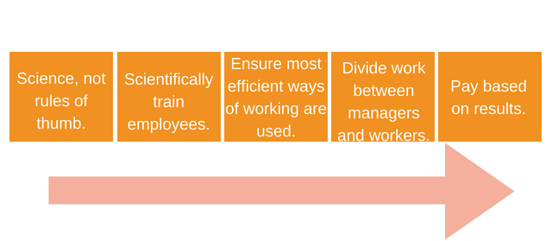
Taylorism was presented against the backdrop of the Economic Transformation that started in the United Kingdom in the seventeenth century and eventually expanded to a greater level. With the invention of a technology that could eventually replace personal employees, industries became more efficient. Taylor realized those superfluous country facilities needed to be eliminated to optimize productivity. Every working motion is intended to maximize the capacity of people to generate significant revenues for businesses through coaching. In respect of scientific administration, Taylor has created four philosophies: There are four steps to the management process. -
Figure –Frederick W Taylor Scientific Theory
Sources – (Schou, 2020)

- Employment research is used by the administration to complement the obsolete thumb rule.
- Management select, train, and train employees based on empirical criteria to improve communication skills for tasks.
- The management collaborates with employees to guarantee that the research is conducted following methodological techniques.
- • Administration and execution are common responsibilities, and if executives and personnel are competent in their roles, disputes will be minimized.
- Taylor asserts that scientific administration, which can be observed in part at Amazon, was created largely for factory line tasks using such ideas. (Uddin & Hossain, 2015).
In Amazon's investigation analysis, the primary element of Taylorism is staff incentive, which is part of managerial techniques. "The most important thing individuals want from their managers is a raise in income. Businesses primarily seek cheap economic labour expenses from employees. Moreover, there are additional significant and unique characteristics that can be used to measure employees' attitudes in terms of people or positions. According to Taylor's work, the ultimate approach to encourage individuals is to give them money. Assume Taylorism's thesis holds true at Amazon facilities, where standardised activities are classified as hazardous. Amazon unveiled a unique bracelet that can capture and monitor staff' hand motions in full detail; some have compared this innovation to a futuristic monitoring system. Amazon can use this kind of technology to track employee behavior and abilities, as well as decide who is highly efficient and who fewer efficient is. (Jacobin, 2018)

Contingency Theory
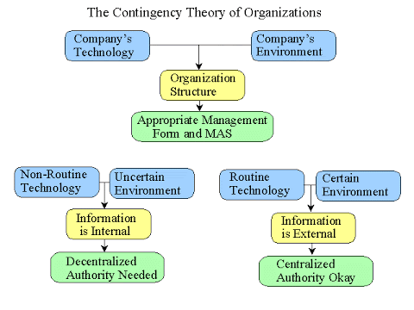

Figure: Contingency Theory
Source (Lee, 2011)
Contingency theory might be the earliest proven logical approach to investigate a leader's manner and pertinent circumstances in any scenario. The contingency concept was created by Fred Fiedler. The contingency concept is an organisational idea that claims there is no better way to create a corporation, run a firm, or execute choices. Because of the criteria, the concept has been thoroughly explored. With the "thumb-in-the-wind" technique of determining the leader, the contingency principle can be extremely useful. Contingency theory has provided realistic, excellently ways to reflect broader broadly regarding executive success than prior leader-only arguments. (Vidai, et al., 2017). The essence of leadership structures is often overlooked in some categorisations, and contingency is neither different. It is necessary to develop appropriate leader connections, a purpose with well-stated objectives and procedures, and a leader's power to enforce incentives and penalties. A lack of such things in the correct combination and context might result in a leadership catastrophe. If a leader has power and has influence over the actions to be accomplished, he or she can create a conducive climate for leadership. Since it is hard to change an ingrained condition, the use of contingency theory in organisations could be troublesome. There is very no guidance on how to train leaders so that they can flourish in a range of scenarios. While contingency plans aren't always precise or thorough, they do provide significant leadership style indicators that can be valuable in a lot of circumstances. Easy indicators are also provided by the contingency theory.

Human relations theory
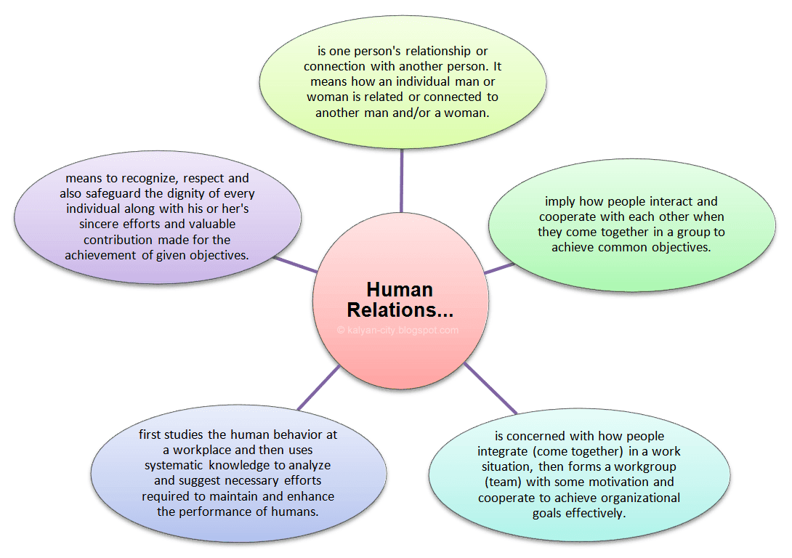

Figure: Human Relations Theory
Source (Akrani, 2015)
Starting on the initial morning of income, Bezos will continue to work to improve social competency and build more needs. Amazon's tactical aim is to prevent short-term gains while gaining a long-term competitive advantage. Although Amazon is merely a corporation, its layout is both adaptable and complicated. To encourage Amazon's organisational culture, a special two-pizza law was devised, which states that groups can be minimal since they simply need two meal pizzas. Small groups ensure high levels of attention and dedication. In contrast, Amazon's business culture pushes employees to think outside the box to come up with fresh ideas and alternatives. Amazon has a well-developed training programme for its employees. Professionals are seen as an effective strategy to expand their experience and competencies by the organisation, which perceives every individual as a significant area. For instance, Bezos has stated that the employees' identity will be considered in the same light as the Amazon brand.
Amazon's learning programme enables employees to engage in the corporation's social and traditional life. The mindset and competence will improve until they had a thorough understanding of Amazon's commercial model. These operations in the Amazon will be viewed through the lens of the Strategic Human Resources Management theory (SHRM). According to SHRM, a company should develop a mechanism to link HR decisions to organizational aims or rely on good practices to improve functional success. Amazon's HR practises are, to a large degree, consistent with the finest nine practises. To remove rank inequalities, the corporation establishes modest groups, supports individual self, and spends substantially on staff training and growth. Amazon also makes it easier for regions and organizations to share their original thinking. The SHRM Competency Set differentiates what it takes to be a successful HR practitioner throughout the performance span, globally, throughout all job levels, working divisions, and job capabilities. Describes the skills and knowledge required for a successful career as an HR professional. SHRM is divided into nine categories.
Leadership and Navigation: The capacity to coordinate and contribute to activities and forms inside the organization
Ethical Practice: The capacity to coordinated centre values, astuteness, and responsibility all through all organizational and commerce hones.
Business Acumen: The capacity to get it and apply data that contribute to the organization's key arrange.
Relationship Management: The capacity to oversee intelligence to supply benefit and bolster the organization.
Consultation: The capacity to supply direction to organizational partners.
Critical Evaluation: The capacity to decipher data with which to form commerce choices and suggestions.
Global & Cultural Effectiveness: The capacity to esteem and consider their viewpoints and foundations for all parties.
Communication: The capacity to successfully trade data with partners.
HR Expertise (HR Knowledge): The information of standards, hones, and capacities of successful human asset administration. (SHRM, 2020)
The "ideal match" To transform Amazon into a lucrative e-commerce powerhouse, the SHRM model illustrates how executive management choices properly connect with staff activities. Staff will be encouraged to bring new ideas and improve their productivity if they fully comprehend and know the company ethos and function in a flexible, team-based manner (Demir, 2017).

Bureaucratic Theory
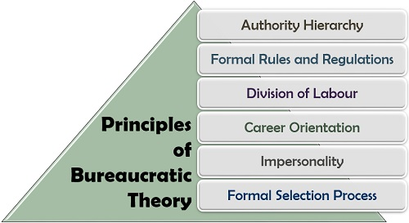

Figure: Bureaucratic Theory
Source (Prachi, 2019)
Weber considered that regulation might help individuals achieve the maximum levels of efficiency, rationality, and pleasure. He genuinely believed that bureaucracy was so sensible that it would revolutionise the entire society. Unfortunately, Weber did not anticipate that all bureaucratic elements would have a detrimental impact. Structured rules promote security and consistency, but they can also lead to over-regulation. Considering its inherent drawbacks, the administration is nonetheless prevalent in organizations. The pyramid's organisational design is based on operational concepts, with authority divided into segments, groups, and sections. Almost every significant business makes use of it. Weber's idea is that recruiting and progress should be based on abilities (Idrus, 2015). The bureaucracy idea can be found in Amazon's organizational system and staff guidelines. Around the spectrum, just very top executives are authorised to talk in favour of the corporation and its staff, making facts tougher to obtain and staff' points tough to communicate. Bureaucracy is demonstrated by employees who are subjected to regular inspection owing to inadequate work; such types of actions might have a bad influence on Amazon. It has the potential to lower the expectations of their clients. If Amazon uses the bureaucracy concept throughout COVID-19, it may experience a decrease in staff and consumer engagement.

Application of Key Theories in Amazon’s social distancing

These issues are being addressed by researchers, statistical researchers, scientists, and medical associations all across the globe. While engineering perspectives are uncommon in epidemiology models, we believe that one would strongly assist government employees in this scenario. Of course, the COVID-19 outbreak isn't a visible or widespread technical problem. However, its essential behaviour is that of an unexpected, open-loop machine. We've all been taught that if it's left unchecked, it'll grow enormously. There is also some positive stuff to report. It can, though, be stabilised fast and reliably, just like any other structure, by adhering to management system fundamentals, particularly the usage of responses. Motivated by epidemiologists' and others' vital efforts on the main lines of such a nationwide outbreak, they've explored how input might help stabilise and slow the development of this deadly epidemic that is currently afflicting us. They developed an approach based on established engineering concepts that supply real direction to policymakers, taking into consideration both health and economic problems. They employed feedback-based ways to keep check of the pandemic and limit how long it lasted (Pearson, 2020).
The power of a regulatory response lies in the ultimate relaxation of a geographical barrier requisite for a cohesive society over such prolonged timeframes. They tested our idea and discovered that authorities might use one of the disease's widely accessible software simulations to deal with the enormous difficulties of bargaining and uncertainties, perhaps saving lots of lives (Abosag, et al., 2020).
A surprisingly high percentage of people who contract the illness develop a type of bacterial meningitis that is typically lethal. Most of these individuals require external respiration, but some, perhaps the plurality, will die if the quantity of sufferers exceeds the capacity of critical treatment facilities to handle people (Appel, et al., 2020). For that purpose, the "flattening of the curve" of diseases toward time has been the subject of enormous global efforts. As in China, Italy, Spain, and other nations, in just a short time, a wide sharp curve suggests that a surge of diseases may be seen to flood hospitals and lead to mass casualties.
The outbreak initiatives have helped to clear up these misunderstandings. Human relations theory has the potential to implicate social distancing. Individuals want a feeling of connection and admiration, as per human relations theory, therefore keeping track of social alienation or exclusion in the workplace can be difficult. As a result, Amazon must run a strategy to encourage remoteness within the company. Given the remoteness, the group's head must handle people with dignity. Clients and staff should receive excellent solutions. The spread of the virus, the chance of certain strategies succeeding, and the extent to which individuals automatically pursue risk-reducing behaviour are all fascinating topics. They take into account the long incubation period and the perceived propagation of the illness before signs appear. It was most likely that infections seemed to connect with individuals unaware of realising what they were performing and then spread it to others. R0 most likely made a significant difference. This latency till the beginning causes a latency timing in the influence concept. It's notorious for bringing oscillations into access networks, particularly when there's a lot of ambiguity in the architecture. The argument is that an epidemic is a complicated, fast-moving scenario that can be disastrous if regional attempts to identify and handle it are inadequate. During the Spanish flu epidemic of 1918, cities used a variety of tactics to shut down and return their citizens, with dramatically diverse results. Many rebounded rapidly, while others experienced comeback surges that were bigger than the primary epidemic, and some experienced many outbreaks following the primary shutdown (Stewart, 2020).

Critical Evaluation of the Theory
Although Taylorism can describe the majority of the major aspects, actual management actions in Amazon are extremely complicated, and Taylorism struggles to describe them since some key components have been overlooked. There is no fairness among personnel and supervisors in industrial procedures where personnel are treated like computers or robots rather than individuals. It was probably another of Taylorism's flaws, as he claimed that human workers can perform as well as a machine if it was "designed" to do so. Amazon claims that its human-robot no intervals are the best workforce or most efficient staff in the company. They don't have time to go to the restroom because they're worried about meeting output targets. They devote the majority of their free hour in queue studying for rigorous inspection and are worried by mishaps at a workplace where they are required to research. As Amazon deploys machines in fulfilment centres (Florence warehouses), the labour completed also isn't eased, but rather transforms humans into machines by giving them a place to rest (independent, 2019).
Second, criticising most companies' conduct of paying workers a unit price of payment is a tough way to live up to Taylorism beliefs. Fewer administrators in Taylor's organization likely think about compensating for performance. They would like to track fractions and performance, and not rewards based on the piece-rate assessment of hours. Logistics staff at Amazon are required to perform in inconvenient locations. Ambulances were called 600 times at a British factory over three years for employees who were subjected to industrial harassment, while personnel in an east Pennsylvania business where centralized warming was unavailable got ill (Gschwantner & Hiebl, 2016). Some local factories, for example, Lexington County, South Carolina (over 30 percent decrease), Chesterfield, Virginia (17 percent), and Tracy, California (16 percent), are seeking to cut wages. In addition, Amazon also reported that workers could obtain an ambassador's name advancement, but there is no extra payment for this rank.
Furthermore, this can be explained in effect by the decline of America's traditional retailing and severe competition between international competitors, which drives Amazon to influence personnel. To summarise, Taylorism's detractors have largely recognized such two elements while looking at leadership and stockroom operations. More especially, there's a chance that the Taylorism concept or premise won't hold in the instance of Amazon. A dispute is minimized seeing as to the discrepancy between Amazon's reality and Taylorism's Concept of Management, which argues that executives and staff communicate regularly. Nevertheless, on November 24, 2018, many Amazon logistics staff across Europe decided to take protest about risky job conditions on the busiest shopping day of the season in Germany, Spain, Italy, Poland, France, the United Kingdom, and Poland. Some of the assaults are based on a Taylorism premise that may or may not be relevant in the Amazon context. Although Amazon has traditionally consented to give up unfair behaviour in hiring in Italy after protests, the action is usually the principal mechanism of resolving unfair prejudice for the company (Gschwantner & Hiebl, 2016). Individuals may embrace fresh working adjustments as a result of COVID 19 rather than anything individual, as per contingency theory. Contingency theory also applies to Amazon's artefacts, such as logistic operational procedures and how employees are compensated through assessment ratings. However, there are some misgivings that contingency theory may not be totally appropriate to understand Amazonian administration and culture, especially motive and past.

Recommendations for Amazon

PESTEL assessment should be undertaken to assess the influence of Amazon's exterior surroundings on workforce behaviour as a result of Covid19.
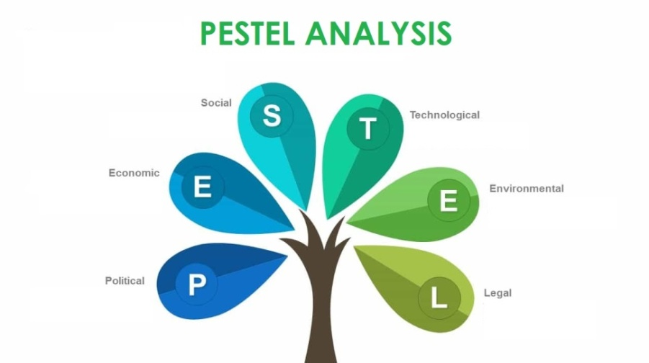

Figure: PESTEL Analysis
Source-(Engelseth and Kritchanchai, 2018)
Political Factors - Amazon might have to deal with political issues including tariffs, licenses, and royalties. With Covid 19, certain federal laws and standards will have to be implemented, including the UK furlong plan for staff, their premises are always made Covid protected and suitable for personnel to operate, and all staff members must be taught and provided the appropriate PPE to safeguard themselves.
Economics Factors- Prices, market prices, and joblessness prices are all financial variables that Amazon must cope with. Joblessness levels have risen as a result of the Covid 19 outbreak, causing unpredictability. This can alter staff behaviour and mood at work, resulting in a reduction in output and a waste of revenue (Engelseth and Kritchanchai, 2018).
Social Factors- The concept of social distance is introduced. Amazon ought to consider fewer individuals operating overly near together, as well as changes in client behaviour that require greater digital transactions. Amazon will have to adjust to the emerging standard by offering electronic purchasing easier and more accessible to users. A company must also require to interact with its third-party team to develop that stock levels, client support, and shipping of items aren't impacted.
Technology Factors- Amazon would have to focus on new technology, innovation, and a fresh and simple method to buy websites. More payment options and, above significantly, technologies like the modern drom that can carry items safely.
Environmental Factors- Amazon would have to focus on its environmental impact, comply with environmental changing requirements, spend, and demonstrate that it is at the forefront of the emerging universe system. Polymer and electrical vehicles must be prioritised.
Legal Factors- Amazon must need to remain to observe all applicable laws, including those concerning healthcare and security, bias, and customer welfare. Companies can strive to provide greater care for their employees.
These considerations will be examined and addressed when entering the job, following provincial and city health officials. Staff' condition and fever checking,
- Owing to Covid 19, Amazon must keep in mind that unwell personnel are informed and that they are in compliance with health care requirements.
- Due to closing schools and day-care, Amazon must implement variable labour arrangements that enable staff to perform while remaining at a house to look for family or kids.
- Amazon must keep it simple for staff who have to self-isolate for COVID-19 to do so without having to certify their illness, ask for medical leave, or risk any regulatory penalty as a result of their absence.
- Amazon must guarantee that all rules and practices for COVID 19 are implemented and adhered to by the workers following public-health principles and present provincial and national statutes.
- Amazon must set up hotlines and a help desk to assist staff who have been impacted by COVID 19 or who are grappling with the altered standard.

Conclusion
Finally, Amazon's researcher analysis re-examines the value of empirical administration to the delivery platform, providing causes and data to evaluate administration and processes in its logistics. Prior research and analyses have found that the scientific administration of Amazon logistics can help to understand how the corporation specialises, evaluates its output, and pays its employees based on output. Scientific administration, as a result of Amazon's superior managing approaches, does not appear to accurately reflect the company's real situations, notably in terms of competition and labour ethic. There are yet numerous concerns with the report, like executives' uneven authority to receive wages in portion, the unjust faith in Taylorism in the mood of the corporation's executives, and numerous ideas that are meant to clarify the situation. This question essentially revolves around if or not representational management should be humanised. High labour loads and extended operating hours ensure the organisation’s ultimate success, but they aren't always good for lowering turnover because employees aren't looked for. There are a couple causes why this problem should be addressed. To advance job efficiency, the primary strategy is to employ other advances. Amazon, as a technology business, should invest further in the development of produced knowledge, so that the task of a select computer can be divided by the types of machinery, instead of the people having to shoulder the entire workload. The second strategy is to change the corporate ethos. The present criticism from the business is that the job load is too great, and the employees are uncared for. Amazon's environment is centred on giving concern and respect to consumers while dismissing its staff, therefore if Amazon can try to increase staff caring, it will be a huge help to Amazon in keeping its workers.

References

Abosag, I. B.Ramadan, Z. Baker, T. & Jin, Z. (2020) Customers' need for uniqueness theory versus brand congruence theory: The impact on satisfaction with social network sites. Journal of Business Research, Volume 117, pp. 862-872.
Appel, G. Grewal, L. Hadi, R. & Stephen, A. T. (2020) The future of social media in marketing. Journal of the Academy of Marketing Science, Volume 48, p. 79–95.
Businessinsider, (2017) Jeff Bezos Amazon history facts. Available at: https://www.businessinsider.com/jeff-bezos-amazon-history-facts-2017-4?r=US&IR=T#amazon-wasnt-the-companys-original-name-1. Accessed:1 December 2020
CNBC, (2020) Amazon earning. Available at: https://www.cnbc.com/2020/10/29/amazon-amzn-earnings-q3-2020.html. Accessed December 3, 2020
CNN, (2020) Amazon.com Inc. (Online)
Available at: https://money.cnn.com/quote/profile/profile.html?symb=AMZN
Demir, A. (2017) Management Information System: Case Study of Amazon.Com. Journal of Research in Business and Management, 4(11), pp. 11-17.
Engelseth, P. and Kritchanchai, D. (2018) Innovation in healthcare services–creating a Combined Contingency Theory and Ecosystems Approach. MS&E, 337(1), p.012022.
Forbes, (2020) World richest billionaire. Jeff Bezos first 200 billion. Available at: https://www.forbes.com/sites/jonathanponciano/2020/08/26/worlds-richest-billionaire-jeff-bezos-first-200-billion/?sh=f98a3444db7b. Accessed: 1 December 2020
Gaurav, A. (2015) Human Relation.
Gschwantner, S. & Hiebl, M. R. W.(2016) Management Control Systems and Organizational Ambidexterity. Journal of management control, 27(4), pp. 371-404.
Idrus, A. (2015) The Role of Bureaucratic Leadership, Organizational Culture, and
Independent, (2019) Business, robots. Amazon delivery artificial intelligent technology. Available at: https://www.independent.co.uk/news/business/robots-amazon-delivery-artificial-intelligence-technology-a9264036.html. Accessed on December 3, 2020
Organizational Commitment on Organizational Performance (Study on the Local Government Task Force/ SKPD’s Financial Administration Officials in Jayapura City Government). European Journal of Business and Management, 7(19), pp. 8-16.
Jacobin, mag. (2018) Amazon wristband surveillance scientific management. Available at:https://www.jacobinmag.com/2018/02/amazon-wristband-surveillance-scientific-management. Accessed: 2 December 2020
Toward a Construct-Valid Measure. Journal of Managerial Issues, 20(2), pp. 256-270.
Murninghan, M. (2018) Equity Culture and Decent Work: The Case of Amazon (2017). New England Journal of Public Policy, 30(1), pp. 1-15.
Pearson, C. (2020) The first data on covid-19 and teens' mental health is here — and it's not good. [Online]
Available at: https://www.huffingtonpost.ca/entry/the-first-data-on-covid-19-and-teens-mental-health-is-here-and-its-not-good_l_5ee96d22c5b650b4255d3fe4?guccounter=1&guce_referrer=aHR0cHM6Ly93d3cuZmFjZWJvb2suY29tLw&guce_referrer_sig=AQAAALvfjDWSG5asywBaTbqaywr_G4JWibcd
Prachi, M. (2019) Max Weber bureaucracy theory. https://theinvestorsbook.com/max-webers-bureaucracy-theory.html
Rich, L. (2019) Management information system. https://sites.google.com/site/misresearch001/home/contingency-theory.
Schou, P.K. (2020) Towards a Contingency Theory of How Network Structures Influence the Entrepreneurial Process. In Academy of Management Proceedings (Vol. 2020, No. 1, p. 13165). Briarcliff Manor, NY 10510: Academy of Management.
Seller Nexus, (2019) Amazon mission statement. Available at: https://sellernexus.com/amazon-mission-statement#:~:text=As%20Amazon%20says%2C%20their%20vision,they%20need%20to%20purchase%20online.&text=This%20is%20one%20of%20largest,1%20among%20other%20eCommerce%20resources. Accessed December 2, 2020
SHRM, (2020) Certification about the body of competence and knowledge. Available at https://www.shrm.org/certification/about/body-of-competency-and-knowledge/Pages/Competencies-Overview.aspx. Accessed 7 December 2020
Stewart, G. (2020) How Control Theory Can Help Us Control COVID-19, s.l.: IEEE Spectrum.
Uddin, N. & Hossain, F. (2015) Evolution of Modern Management through Taylorism: An Adjustment of Scientific Management Comprising Behavioral Science. Procedia Computer Science, Volume 62, pp. 578-584.
Vidai, G. G. Campdesuñer, R. P. & Rodríguez, A. S. (2017). Contingency theory to study leadership styles of small business owner-managers at Santo Domingo, Ecuador. International Journal of Engineering Business Management.

