Motion Simulation and FEA
CAD & FEA (M6X02210)

Liam Paul Standing
P150310

University of Wales Trinity Saint David
School of Engineering
Automotive Engineering BSc

19/01/2020

Contents

Contents 2
1. Introduction 4
2. Research 5
3. Methodology 6
4. Results 10
5. Modifications 11
5.1 N1 Modifications 11
5.2 N2 Modifications 14
6. Conclusion 15
7. References 16
8. Appendix 17

Figure 1.1, CAD of Formula Ford. Standing, 2020. | 4
Figure 1.2, Formula Ford Suspension in Workshop during measuring. Standing 2020. | 4
Figure 2.1, CAD modelling flowchart, Sourced Fleche. et al., 2014. | 5
Figure 3.1, Example of measurements taken. Shown measurements drawings for upper wishbone. Standing, 2019. | 6
Figure 3.2, Importing Equations from Wheel rim part to Tyre part. Standing, 2020. | 7
Figure 3.3, Using Equations on Wheel rim sketch denoted by Σ. Standing, 2020. | 7
Figure 3.4, Exploded view of Parts view 1. Standing, 2020. | 7
Figure 3.5, Exploded view of Parts view 2. Standing, 2020 | 8
Figure 3.6, Mate redundancies and degrees of freedom. Standing, 2020 | 8
Figure 3.7, Upper Wishbone motion study import. Standing, 2020 | 9
Figure 4.1, FEA contour plot for N. Standing, 2020. | 10
Figure 4.2, Von Mises Stress on N. Standing, 2020. | 10
Figure 4.3, Von Mises Stress on N and N-s. Standing 2020. | 10
Figure 5.1, Changed fillet to end of upper wishbone N1. Standing, 2020. | 12
Figure 5.2, N1 in Assembly prior to Motion study. Standing, 2020. | 12
Figure 5.3, N1.1 modification with increased thickness and fillet. Standing, 2020. | 12
Figure 5.4, N1.2 load bearing ready for FEA. Standing, 2020. | 13
Figure 5.5, N compared to N1 modification Von Mises stress, Standing, 2020 | 13
Figure 5.6, FEA of N1.1. Standing, 2020 | 14
Figure 5.7, FEA of N1.2. Standing, 2020. | 14
Figure 5.8, FEA of N1.2. Standing, 2020. | 14
Figure 5.9, N2 modification changing Von Mises Stress in wishbone. Standing, 2020 | 15
Figure 5.10, N2 with load bearings for FEA. Standing 2020. | 15

Table 1, Abbreviations 3
Table 2.1, Component reference to the modification. Standing, 2020 5
Table 5.1, Comparison of stress limits for components N and N1. Standing, 2020 ………………….13
Table 5.2, Comparison of stress limits for components N and N2. Standing, 2020…………………..15

Table 1, Abbreviations
Abbreviation | Meaning
CAD | Computer Aided Design
CAE | Computer Aided Engineering
FEA | Finite Element Analysis
HRA | Hot Rolled Asphalt

Introduction

In this assignment the creation of a real-world suspension system as a digital model was investigated using CAE, CAD and FEA to improve a component in the model. The investigation would analyze the suspension system going over a road bump.
A Formula Ford chassis and suspension has been selected to be modelled and accurate measurements of the vehicle were taken in a workshop to model it in to a CAD program, Solidworks 2019. Once all the parts were modelled and an assembly created a motion study was carried out with the suspension going over a road bump. Using this motion study, the loading forces could be transferred over to a FEA analysis. In which the upper wishbone was decided upon for the further development and improvements based on the possibility of failure due to exceeding Von mises stress limit shown from a FEA analysis. Once this was decided upon the upper wishbone had two main separate types of alternatives made for FEA analysis. A set of alternatives with additional material and another with a change of material. The results of each of the alternatives against the original wishbone show the extent of the possible improvements that could be made, and the subsequent drawback to each alternative.
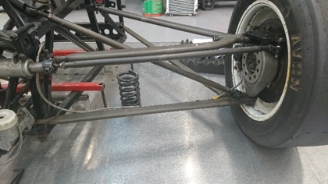
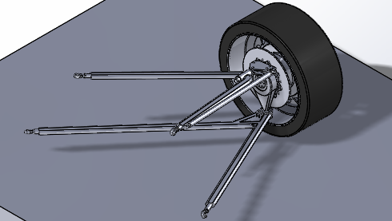
Figure 1.2, Formula Ford Suspension in Workshop during measuring. Standing 2020.
Figure 1.1, CAD of Formula Ford. Standing, 2020.

Research

CAD packages such as Solidworks among others are helpful tools in the automotive and motorsport industries, allowing companies to design and analyze components with a reduced cost in materials and timing in testing. These packages allow components to be easily modified to adapt the results to get the desired characteristics. In the case of this assignment the model of a formula Ford suspension has been created and tested in solidworks. After the FEA testing the decided component then goes through the flowchart pathway of objective modification as expressed in Figure 2.1.
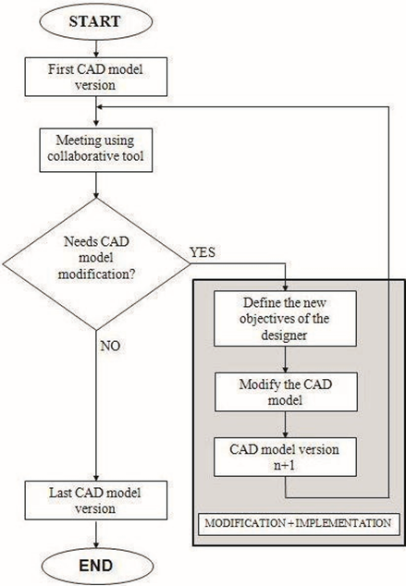
Figure 2.1, CAD modelling flowchart, Sourced Fleche. et al., 2014.
Table 2.1, Component reference to the modification. Standing, 2020
Component Reference | Design Objective and Modifications
N | Original Component.
N1 | Material Reduction.
N2 | Alternative Materials.
In this assessment there will be two main modifications of the component selected. These are referenced in Table 2.1. This table has been derived from the pathway of Figure 2.1 and the nature of vehicles in some cases requiring these changes. Such as racing vehicles where N1 and N2 can have an impact on the speed due to weight reduction being linked to F=MA and decreasing the mass would result in a lower amount of force required to achieve the same acceleration. (Milliken, et al., 2002)

Methodology

Taking Measurements
Taking measurements of the formula Ford was undertaken in workshop conditions using dedicated precision measuring equipment. This process included sketching the component out and adding annotated measurements akin to a technical drawing as well as weighing each component.
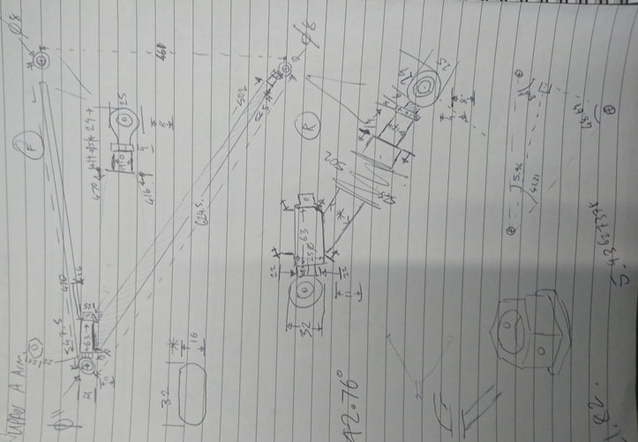
Figure 3.1, Example of measurements taken. Shown measurements drawings for upper wishbone. Standing, 2019.

Solidworks modeling
The creation of the components in Solidworks was made using the example drawings above (Figure 3.1) using modeling techniques such as “Equations”. Equations are a helpful way to define measurements when modeling parts by using a formula. For example if required to change the dimensions of the wheel rim the tyre dimension would have to change to follow suit.
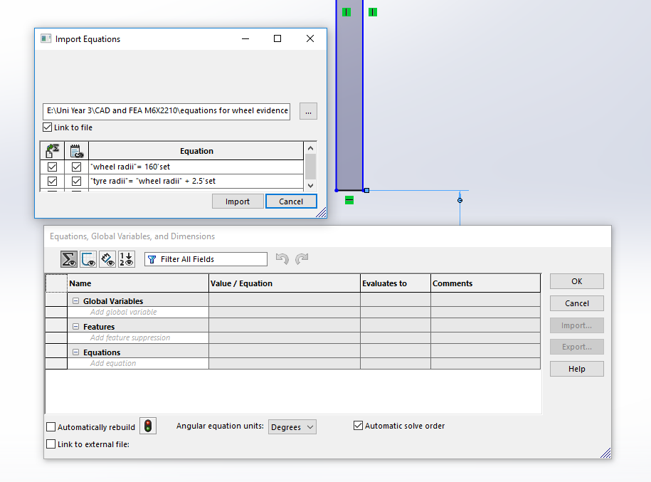
Figure 3.2, Importing Equations from Wheel rim part to Tyre part. Standing, 2020.
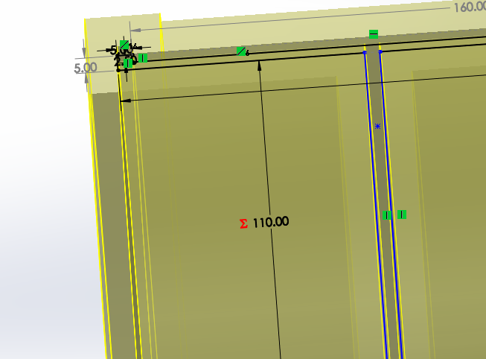
Figure 3.3, Using Equations on Wheel rim sketch denoted by Σ. Standing, 2020.

Using this equation shown above (Figure 3.2 and 3.3) the diameter of the wheel rim has a direct effect of the diameter of the tyre by a set ratio. Hence if the rim size was changed to tyre would follow suit and remain the same aspect ratio, or alternatively the aspect ratio could be changed changing the tyre size but not the wheel rim.
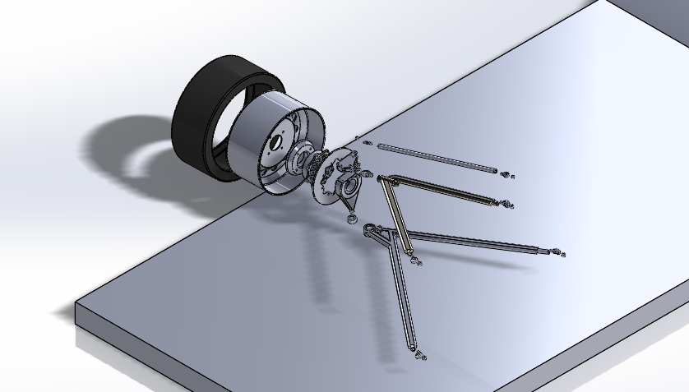
Figure 3.4, Exploded view of Parts view 1. Standing, 2020.
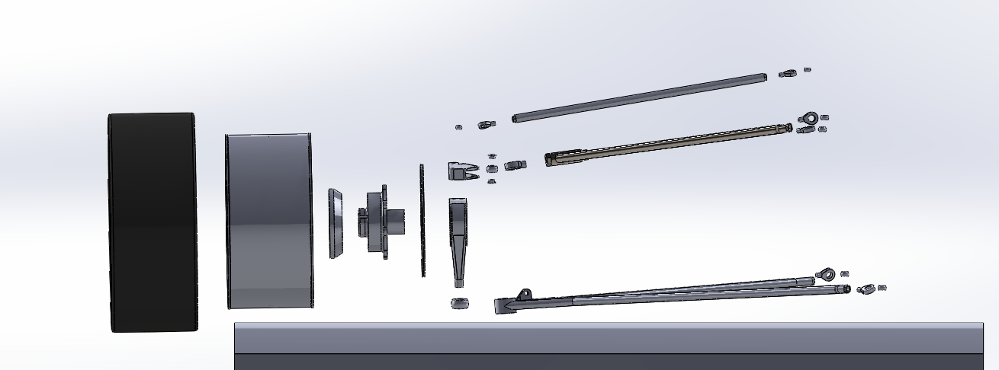
Figure 3.5, Exploded view of Parts view 2. Standing, 2020.

Completed parts were assigned a material in the case of all components were assigned AISI 321 annealed stainless steel apart from the tyre, brake disk and road (McHone Industries, 2018). The tyre was assigned SBR (Sae-oui, et al., 2017), the brake disk AISI 4130 (Maleque, et al., 2010) (Mohammed, et al., 2018) and the road was assigned cast carbon steel as asphalt (HRA). These components then have a weight based on the material selected which could be compared and edited to the measured weight of the component. Once all the components had been modelled assembly was undertaken using mates. These mates were added to reduce the degrees of freedom each component had, which is 6 degrees per component. If a component was over constrained it would have mate redundancies when it came to motion analysis, this could affect the way in which the assembly performed in the motion analysis and would affect the results. Hence any mate redundancies would be aimed to be reduced as much as possible, ideally 0. This is done by using a mixture of standard, advanced and mechanical mates. (Ghozlane, W. & Knani, J. 2016)
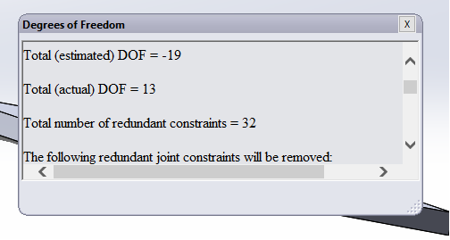
Figure 3.6, Mate redundancies and degrees of freedom. Standing, 2020.

Motion study
The simplest motion study can be performed to an assembly by adding gravity. By doing this the mate redundancies as previously mentioned can be displayed. This assignment requires two additional inputs for a basic analysis, these being a solid body contact between the road bump surface and the tyre in conjunction with a linear motor for the road to move relative to how the suspension system would encounter a bump in reality. In addition, an advanced model would have a spring and damper input.
The motion analysis is used to give results of how the assembly performs a designated action, by giving results of either force, displacement, velocity or acceleration in both linear and angular forms among other resulting quantities. In the case of this assignment the action of the suspension is going over a road bump. Once all parameters met the results can be calculated and imported as motion loads in to any component to carry out a FEA study. In the case of this assignment this is the upper wishbone as seen in figure 3.7.
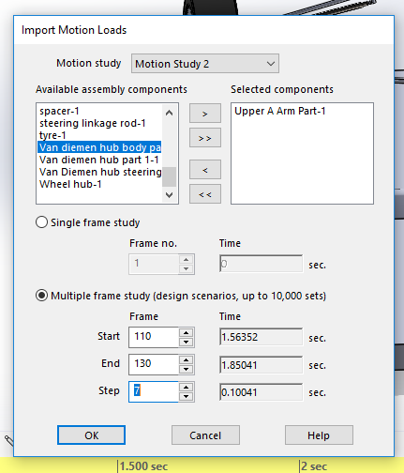
Figure 3.7, Upper Wishbone motion study import. Standing, 2020

Results
The FEA of the upper wishbone was run from exported motion study data. Once the FEA was complete the results of the analysis would come in the form of an Excel spreadsheet and a contour plot on the part for each frame that the motion study was run for.
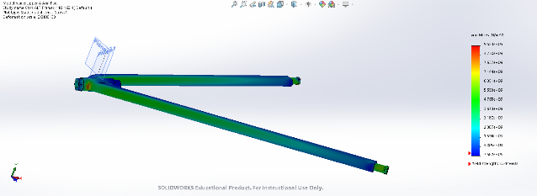
Figure 4.1, FEA contour plot for N. Standing, 2020.
The results of the FEA would give an Excel spreadsheet with a breakdown of all the loads and inputs for each frame of the motion study. Hence in this spreadsheet the data can be used to create graph such as the Von Mises Stress over time as expressed below.
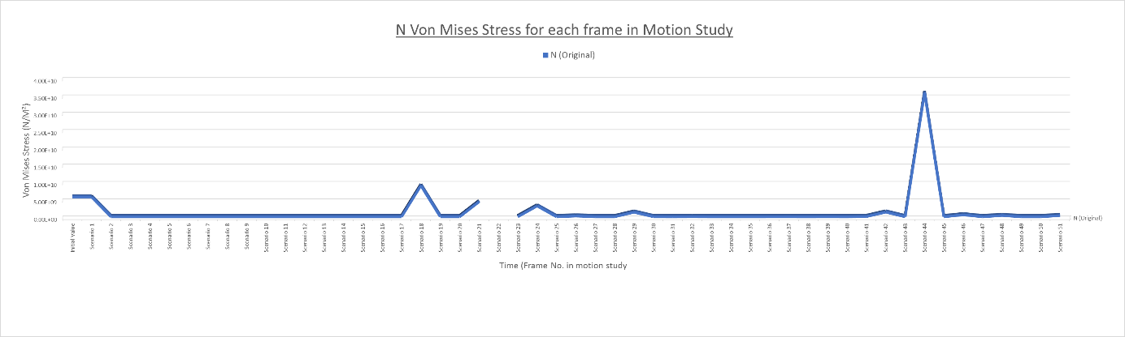
Figure 4.2, Von Mises Stress on N. Standing, 2020.
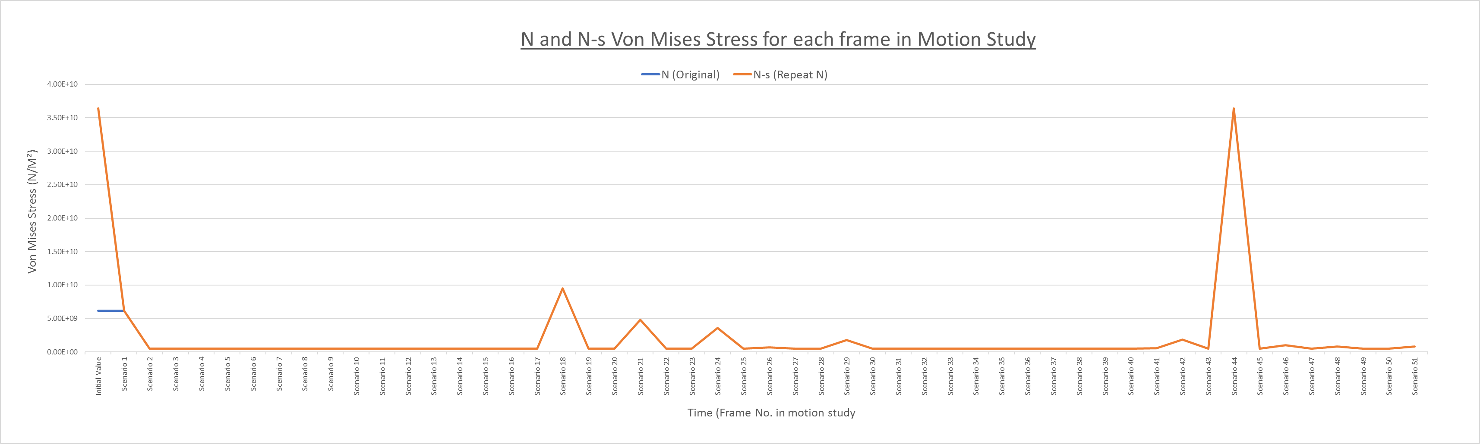
Figure 4.3, Von Mises Stress on N and N-s. Standing 2020.
Figure 4.2 shows the Von Mises Stress during testing including an issue where some of the data didn’t appear due to failing during the FEA. Due to this the test was re-run and resulted in the creation of figure 4.3 where N-s is a repeat of the test where the scenario 22 didn’t fail. The overlay also shows that the data matches apart from the initial stress. In these figures (4.2 and 4.3) we can see the moment the wheel first touches the road surface at the beginning. The moment it first touches the road bump at scenario 18. And the returns to the road surface at scenario 41.

Modifications
As expressed in Table 2.1, there are two main modifications being undertaken. The first being changing the design parameters of the wishbone by either adding or removing of material (N1). Areas where material was added or removed depended upon the N (original) part contour plot in the frame where the most and least stress respectively.

5.1 N1 Modifications
Modification N1
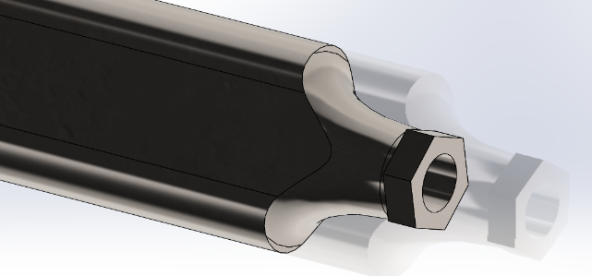
Figure 5.1, Changed fillet to end of upper wishbone N1. Standing, 2020.
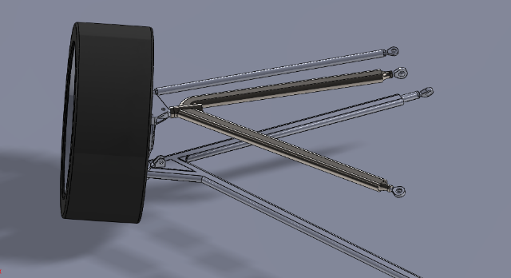
Figure 5.2, N1 in Assembly prior to Motion study. Standing, 2020.
From the results of N in the previous section the ends of the wishbone in which the rose joints attach appeared as the weakest points in the FEA contour plot. For this reason more material was added to distribute the loading and hence reduce the stress. In addition the thickness of the wishbone was in increased by 2mm.

Modification N1.1
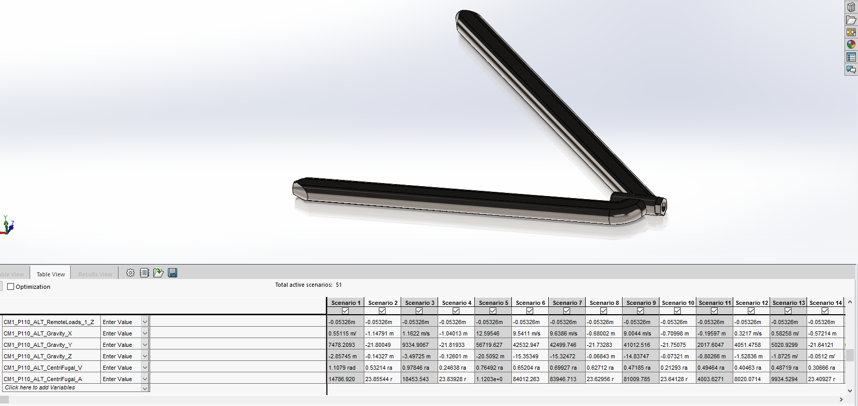
Figure 5.3, N1.1 modification with increased thickness and fillet. Standing, 2020.
The second iteration of the N1 modification was N1.1 with increased thickness of 4mm compared to N (Original) and more robust fillets at ends. Like the N1 modification the weight of the wishbone overall would increase by the additional material however would provide a reduction in stress.

Modification N1.2
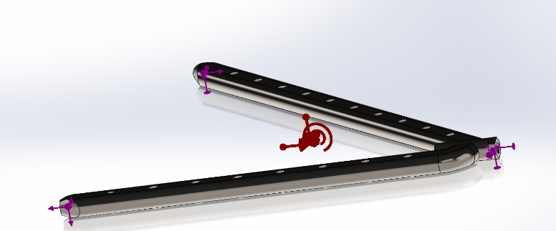
Figure 5.4, N1.2 load bearing ready for FEA. Standing, 2020.
The last modification follows suit with the previous modification of N1.1 however in addition has drilled holes along the wishbone. This was designed to merge the benefits of increased material distributing Von Mises stress, in conjunction with removing material from areas with predictably low stress to reduce the weight of the wishbone compensating for the increased thickness.

N1 modifications Results
Table 5.1, Comparison of stress limits for components N and N1. Standing, 2020

Table 5.1 outlines the changes in the stress levels of the different wishbones in the same road bump scenario. Modification N1 reduces the Minimum stress however N1.1 and N1.2 both significantly improve the compared to the original (N). Conversely these same components experience the highest maximum stress however from Figure 5.7 and 5.8 this can be seen to not peak the yield strength.
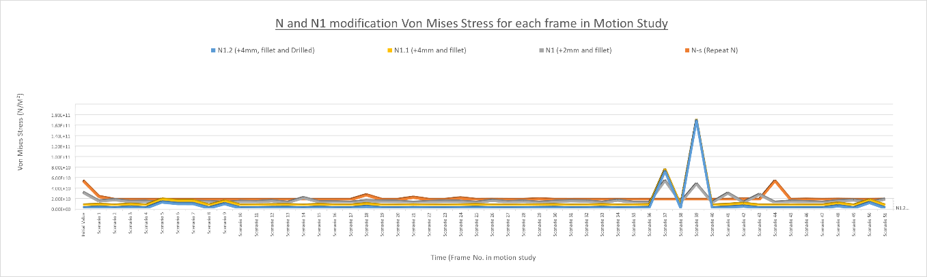
Figure 5.5, N compared to N1 modification Von Mises stress, Standing, 2020.

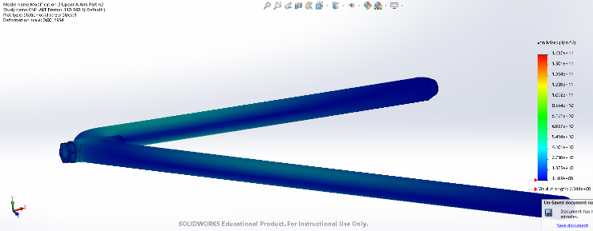
Figure 5.6, FEA of N1.1. Standing, 2020.

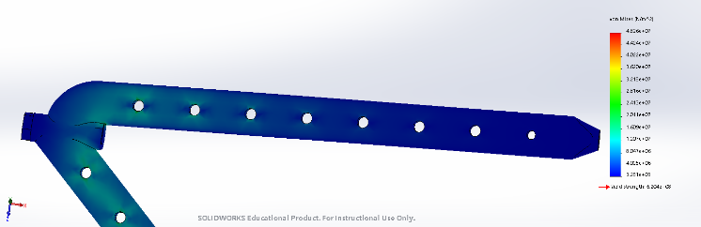
Figure 5.7, FEA of N1.2. Standing, 2020.

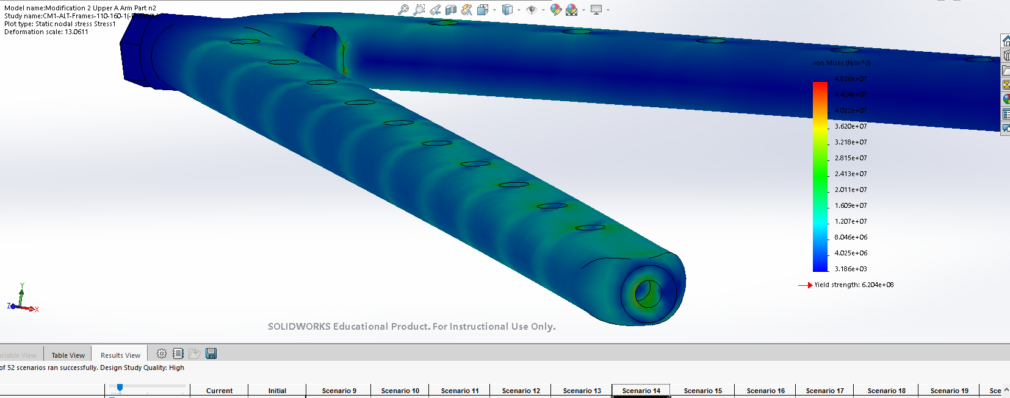
Figure 5.8, FEA of N1.2. Standing, 2020.

5.2 N2 Modifications
The second modification aimed to improve the wishbone is the change of the wishbone material. This modification as expressed in Tables 2.1 in referred to as modification N2. Table 5.3 outlines the different outcomes of running the motion study of the wishbone with alternative materials than the AISI 321.

Table 5.2, Comparison of stress limits for components N and N2. Standing, 2020
The first changed material was to alloy steel (N2) in which seen in table 5.2 had no effect to the minimum or maximum Von Mises stress. However the average stress over the whole duration was slightly lower showing that the alloy steel has a small improvement compared to the original (N). N2.1 uses an aluminum alloy 3003 (Aalco, 2018) which is an aircraft grade material. This has lowered weight in conjunction with decreased minimum, maximum and average stress.
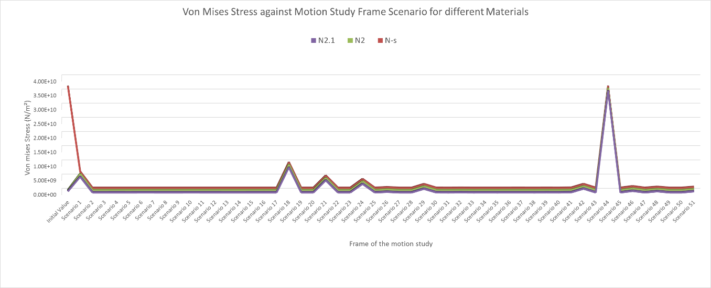
Figure 5.9, N2 modification changing Von Mises Stress in wishbone. Standing, 2020.
Seen in figure 5.9 above the trend of the stress always follows the same principal pathway to the original.
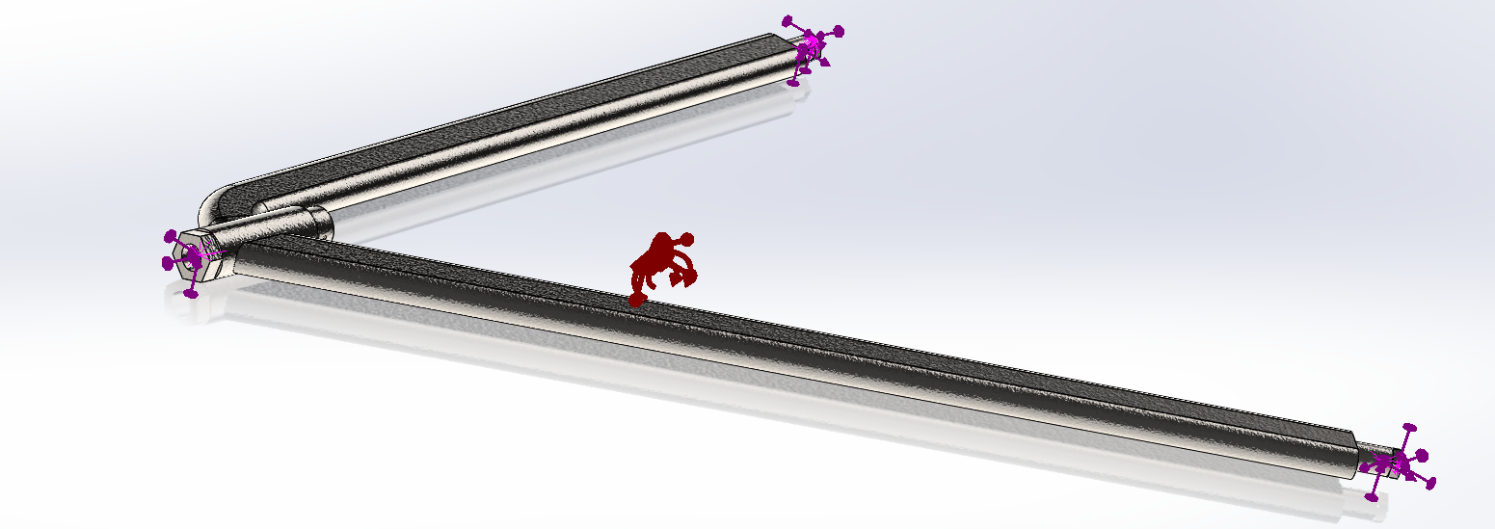
Figure 5.10, N2 with load bearings for FEA. Standing 2020.

Conclusion

Looking at the results of both N1 and N2 modifications of the wishbone there are certainly distinct improvements to be made in certain areas created as compared to the standard component. Minimal improvements can be seen in N2 overall, however the general consensus shows that the material of the wishbone has impact on the maximum, minimum and average stress just not as significant as the design. Comparing figure 5.5 to 5.9 of all the modifications the N1 modification to increase the thickness by 2mm has a good compromise of increasing areas that suffered weakness in N and not deodorizing the weight by increasing the thickness to far as seen in N1.1. The combination of both an Aluminum 3003 alloy wishbone and the increased thickness would show potential for further improvements. In addition the use of the solidworks features such as a topology study could be used to further reduce the weight of the wishbone without compromising the failure point of the wishbone.
Other points to consider is that the real world implications of running the CAD are that some accuracy is lost in the simulation in various areas. Such as the meshing process where the size of the nodes is directly proportional to the precision of the results and the time in calculating the results. In other areas the motion study has limitations to the forming of contacts such as between the road and tyre but can be extended for any motion study scenario. The materials in which the contacts can be assigned are very slim further deceasing the likelihood of an accurate final result.
In conclusion the use of simulations in CAD and CAE software has shown to display areas of improvement to a specified component in a suspension system. This improvement being the changing of the material and mapping of materials to the weakest contours of a FEA plot.

References

Fleche, D. et al., 2014. First Step Toward a Quantitative Approach to Evaluate Collaborative Tools. Procedia CIRP, 21(C), pp.288–293. https://doi.org/10.1016/j.procir.2014.03.160
Milliken, W.F., Olley, D.L. & Olley, Maurice, 2002. Chassis design : principles and analysis : based on previously unpublished technical notes by Maurice Olley. ISBN 0768008263
McHone Industries, 2018. Stainless Steel Grades Chart. [Online] https://blog.mchoneind.com/hubfs/MCHONE%20stainless%20grades%20chart%20downloadable%20(1).pdf?hsCtaTracking=3d1d22ba-ac44-4362-903a-90afc7fa9341%7C3122bf89-177e-4e5c-9a62-d150c578f4ed
Sae-oui, P. et al., 2017. Effects of Blend Ratio and SBR Type on Properties of Carbon Black-Filled and Silica-Filled SBR/BR Tire Tread Compounds. Advances in Materials Science and Engineering, 2017, pp.1–8. https://pdfs.semanticscholar.org/07db/3ce72df7396cb621c5cf63d66b6dbbd9d1db.pdf?_ga=2.47290660.2039932500.1579470410-69089508.1579470410
Mohammed, N.A. et al., 2018. Design, Analysis, Fabrication and Testing of a Formula Car Chassis. Materials Today: Proceedings, 5(11), pp.24944–24953. https://reader.elsevier.com/reader/sd/pii/S2214785318325951?token=6F9DD4F8C179348B1CA4361A6CC638C091AF90AEF8CBA1AD3F41CFA89302EE51111DE0936DE363E0E7B8487054CD28BF
Maleque, M.A. et al., 2010. Material Selection Method in Design of Automotive Brake Disc. World Congress on Engineering 2010 Vol III WCE 2010, June 30 - July 2, 2010, London, U.K. ISBN: 978-988-18210-8-9. http://www.iaeng.org/publication/WCE2010/WCE2010_pp2322-2326.pdf
Ghozlane, W., & Knani, J. (2016). Modelling and simulation using mathematical and CAD model of a robot with six degrees of freedom. 2016 4th International Conference on Control Engineering & Information Technology (CEIT). doi:10.1109/ceit.2016.7929054
Aalco, 2018. Aluminum Alloy 3003 '0' Sheet. Aalco Metals Ltd. http://www.aalco.co.uk/datasheets/Aalco-Metals-Ltd_Aluminium-Alloy-3003-0-Sheet_59.pdf.ashx

Appendix
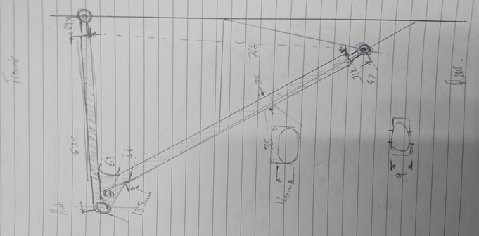

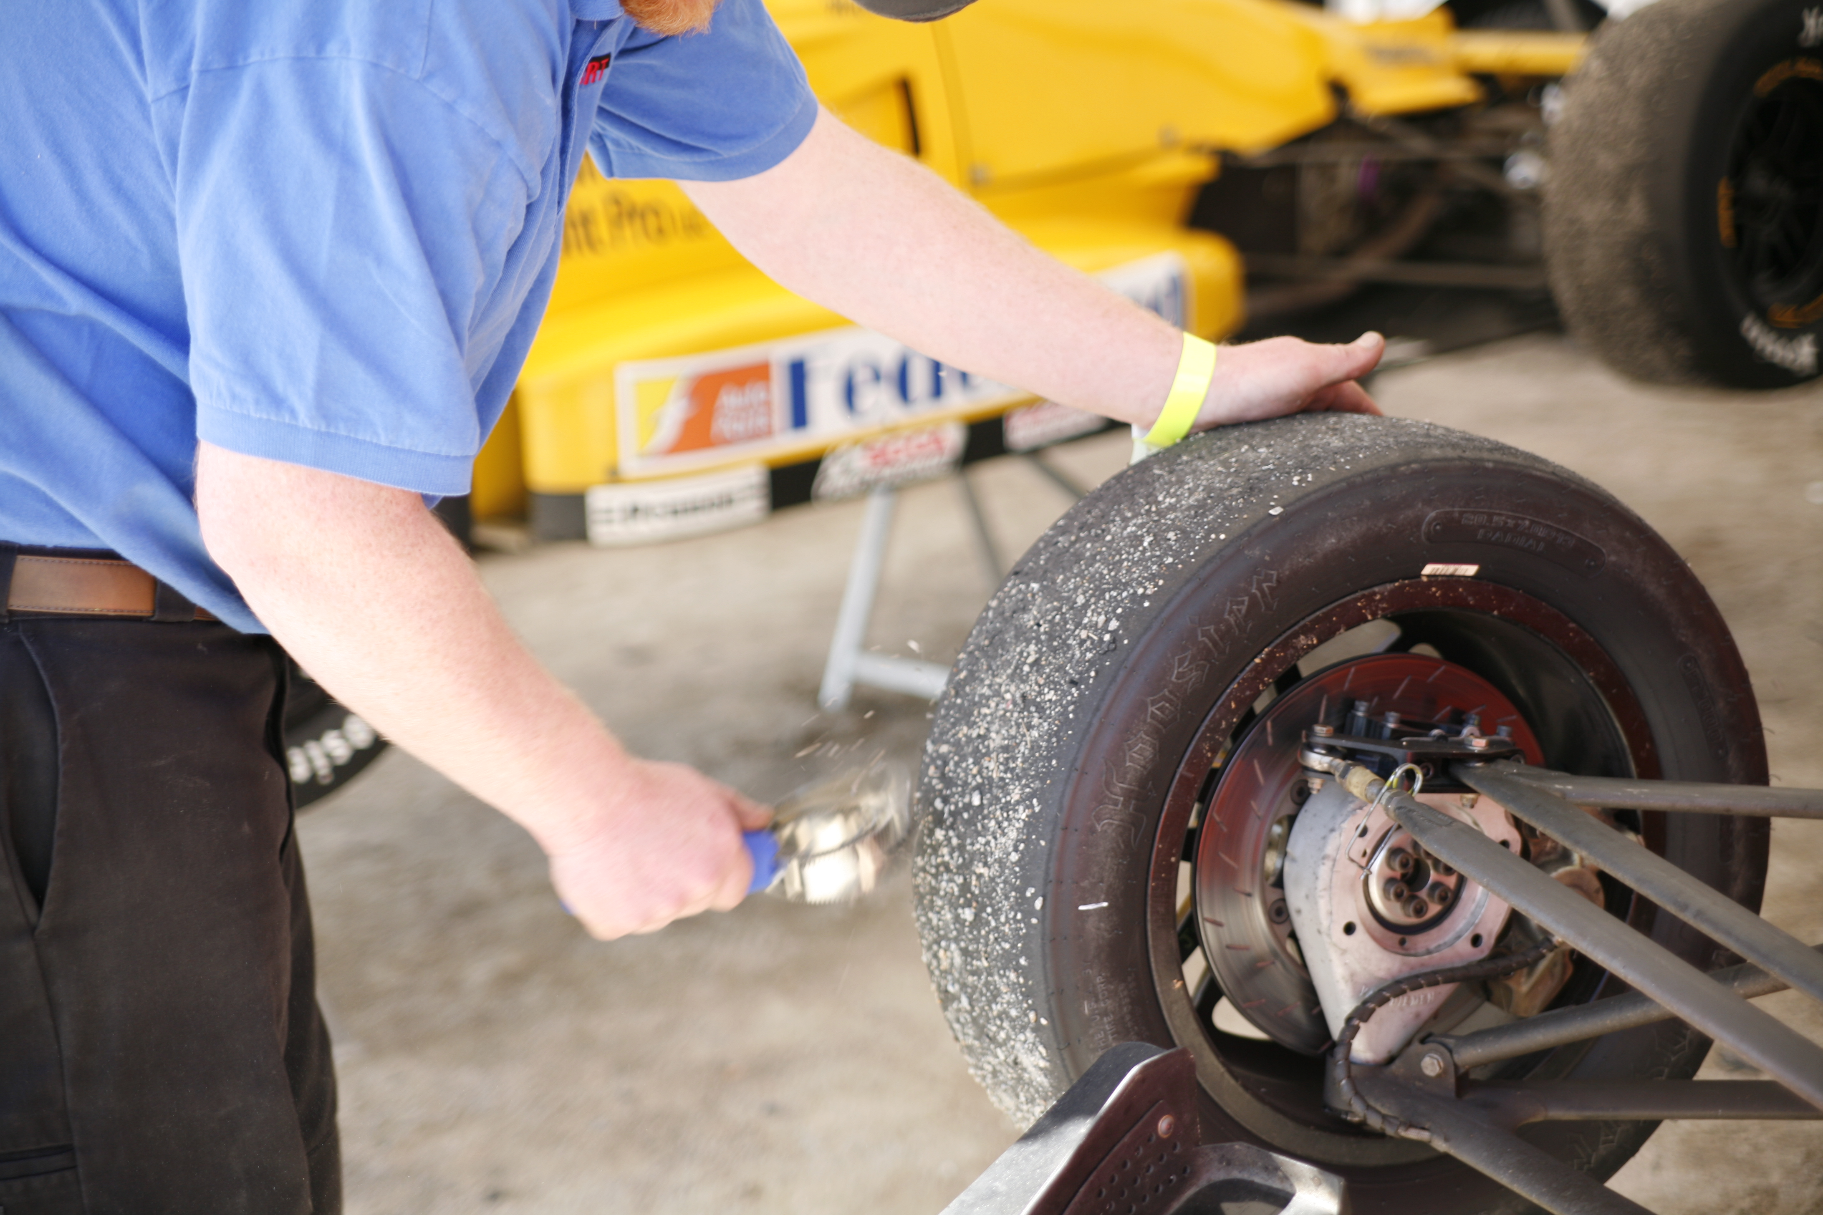

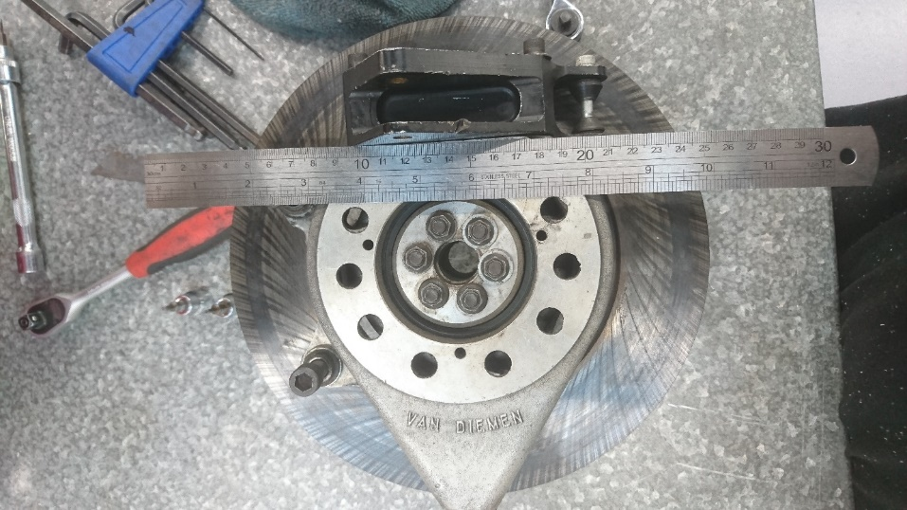
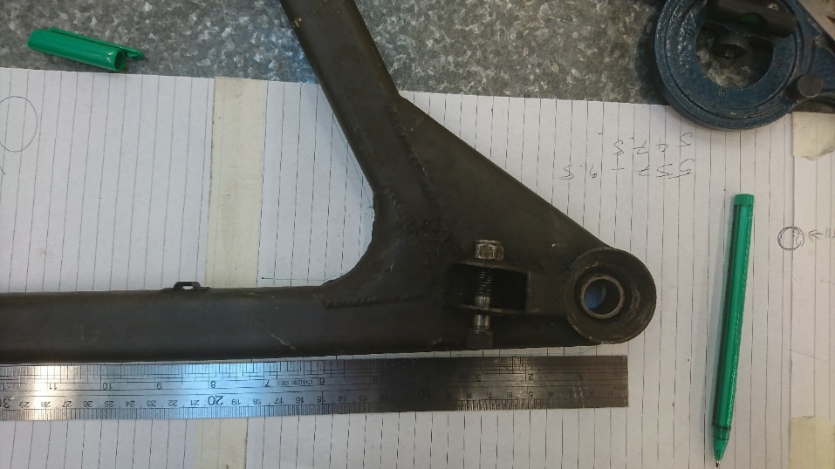

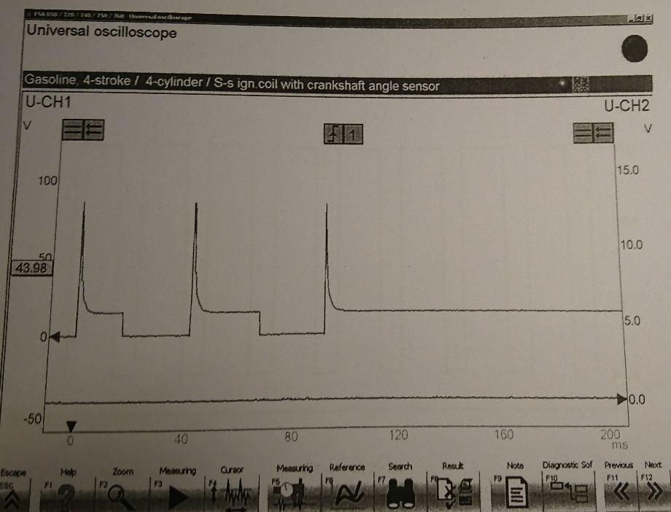
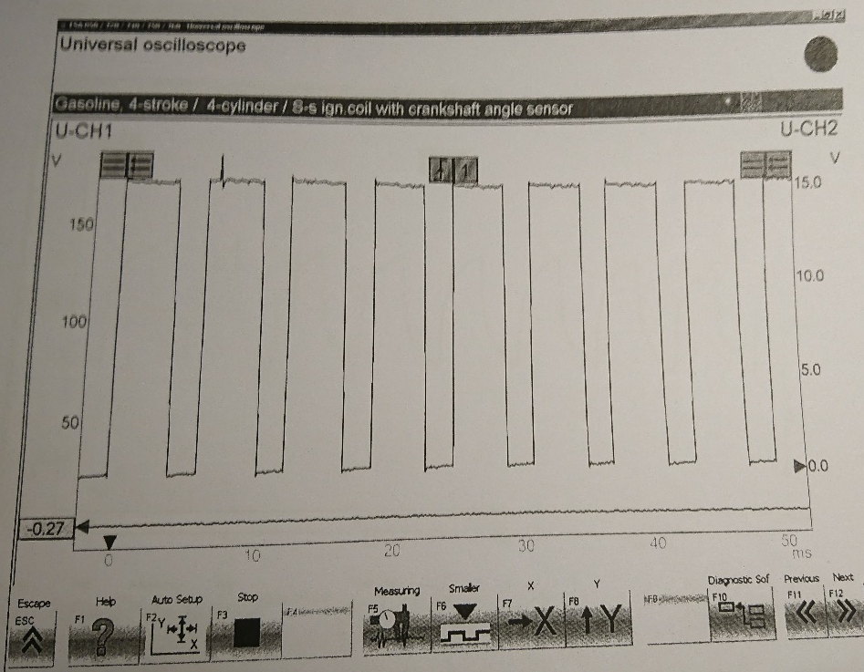
Word count = 262

