Please delete the box below and replace it with an “appropriate” passport style photograph that clearly shows your face. Your photo should be roughly the same size as the box:

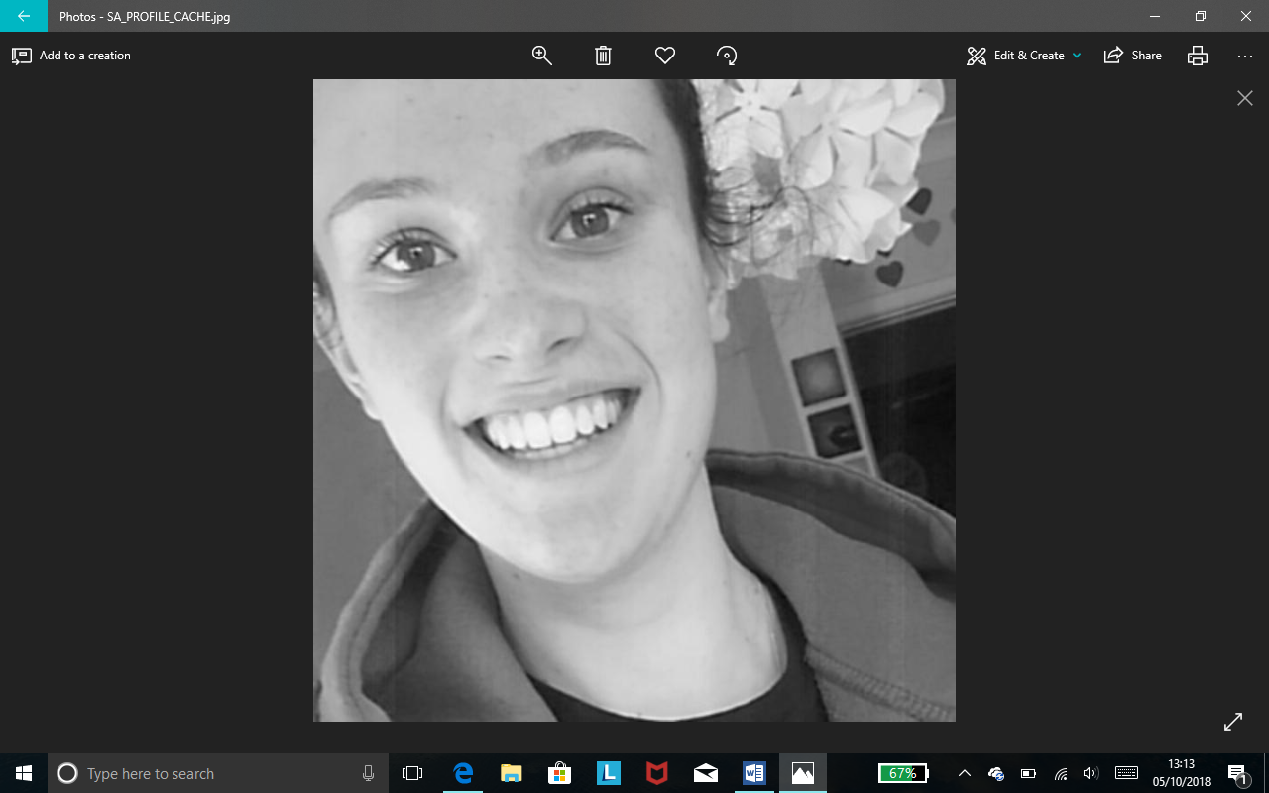

Name: Erin Smith

Student number: 1803017

Student email address: 1803017@student.uwtsd.ac.uk

Contact number: 07401961970

Please use the remaining space to give a brief outline of why you have chosen your course of study and any relevant special interests or experiences:

I have chosen Outdoor Education because I wanted to try something new, I’m always up for a challenge and I thought outdoor education would be perfect for that. I don’t really know much about Outdoor Education and I think these 3 years will help me have a bit more of an understanding. I did NCS which is a outdoorsy kind of programme where we were able to do land and water sports and I seemed to really enjoy it.

