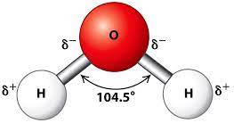
Figure 1- Water molecule structure [11]

Water – The main culprit behind many OME problems
  - the detrimental effect of water on Explosive materials and OME articles and processes
Christopher Belton (2021887) | L4 HNC OME (Chemistry) | July 4, 2022

Table of Contents
Introduction 2
Physical and chemical properties of water and chemical behaviour related to them 2
Physical properties 2
Chemical Properties and behaviour 3
Water in the atmosphere and relative humidity 3
Atmosphere 3
Relative Humidity 3
The role of water in various chemical processes 4
Acid/ Base Chemistry 4
Redox Reactions 5
The adverse effect of water on various OME related materials, articles and processes 6
Pink Water 6
Munition 6
Pyrotechnic 6
Outgassing 6
Polymerisation Reactions (Binders) 7
High/Low explosive filling 7
Possible solutions to prevent the performance issues associated with moisture ingress (described in point 4). 7
Facility/ storage parameters 7
munition design 7
Manufacturing 8
Conclusion 8
References 9
Figures 10

Introduction
This report will cover the detrimental effect of water on explosive material, OME articles and the various process undertaken by explosive engineers. This is split into 5 main areas Physical and chemical properties of water including chemical behavior. Water in the atmosphere and relative humidity. The role of water in various chemical processes. The adverse effect of water on various OME related materials, articles and processes and the possible solutions to prevent performance issues with moisture ingress. Where possible the author will link this to the workplace.

Physical and chemical properties of water and chemical behaviour related to them

Physical properties
Water is special due to the fact it is the only substance that can exist in all three states. Solid, Liquid and gas. As stated in the table below water has a high melting and boiling point compared to other liquids and despite it’s small molecular weight. For example the boiling point of Acetone is 50.5 ̊C.
Liquid- Water flows with very little resistance due to very low viscosity. In turn when removed from the container rapidly undergoes deformation. Water is classed as a liquid between the temperatures of 0̊C - 100̊C.
Ice- Water turns into ice at 0̊C. At this point water turns from a liquid into a solid. Ice is unable to conform to a set shape whilst in this state. The density is lower compared to liquid water due to the fixed intermolecular distance whilst in the solid state.
Gas- When water is it’s gaseous state it is often called water vapour or steam. The chemical properties do not change when altering the state. As the water boils the hydrogen bonds are broken.

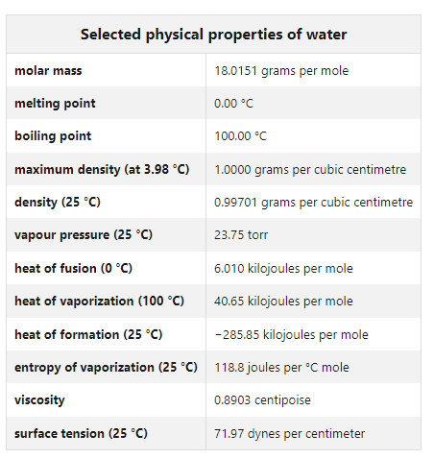
Figure 2- Physical properties of water [12]

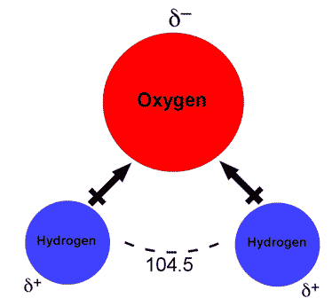
Chemical Properties and behaviour
Figure 3- Water chemical compound
The chemical formula of water is H2O. This is formed by the covalent bond of hydrogen and oxygen atoms. Each hydrogen atom is bound to the central oxygen at0m along with the oxygen also has two pairs of unshared electrons. Water is known for its ability to dissolve many substances hence the name “universal solvent”.
H2O is a large part of chemical reactions in the lab and occur naturally in nature due to water being an amphoteric compound. This means that it can be either an acid or a base in the chemical reaction. This is due to its ability to donate and accept protons.

Water in the atmosphere and relative humidity

Atmosphere
Water in the atmosphere is generally between 0% - 4%. This is a continues exchange between the atmosphere, ocean and the continents through the following four processes. Evaporation, transpiration, condensation and precipitation. Water exists as a gas through water vapor, liquid through rain and solid as snow and ice. “The formation of these complexes can dramatically affect the chemistry in the atmosphere, including heterogeneous removal and alteration of the photochemical properties of the atmospheric species, the formation of water droplets and aerosol particles, as well as the participation of these complexes in chemical reactions.” [1]

Relative Humidity
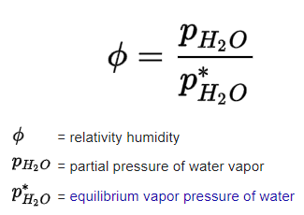
Humidity is the amount of water vapor present in the air. This is normally given as a percentage. You need the temperature as well as the relative humidity as 65% humidity at 25̊C has a different amount of water vapour to 65% humidity at 10̊C.
Figure 4- RH formula
Relative humidity when working with explosives is dependent on the type of work undertaken. When working on primary explosives the humidity in the explosive facility must be above 65% for standard work this is 45%. This varies dependent on facility/ company.

The role of water in various chemical processes

Acid/ Base Chemistry
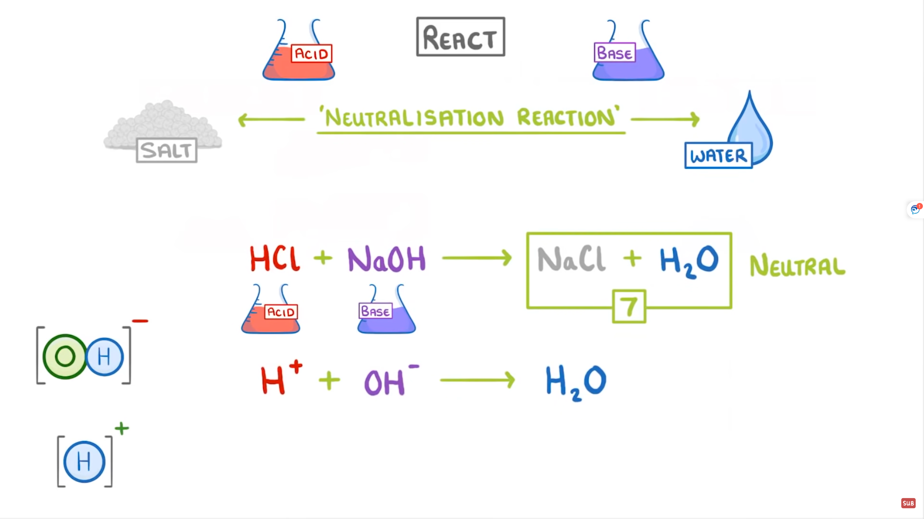
One of the most important chemical properties of water is that is amphoteric. This means that it has the ability to be an acid or a base in a chemical reaction.

Figure 5 Acid/Base reaction

Acid definition- “An acid is a chemical species that donates protons or hydrogen ions and/or accepts electrons. Most acids contain a hydrogen atom bonded that can release (dissociate) to yield a cation and an anion in water. The higher the concentration of hydrogen ions produced by an acid, the higher its acidity and the lower the pH of the solution” [2]
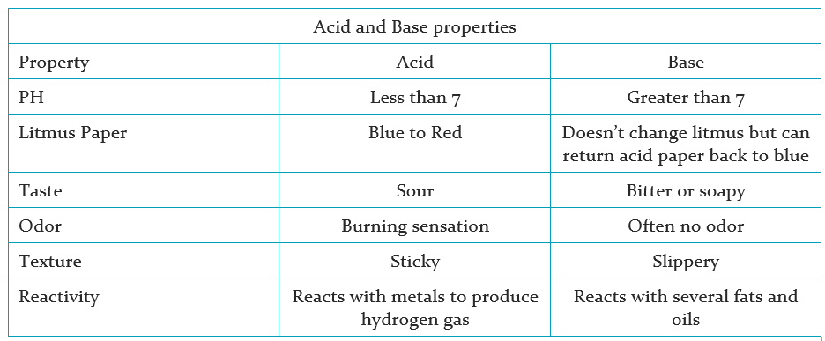
Base definition- “A base is a chemical species that donates electrons, accepts protons, or releases hydroxide (OH-) ions in aqueous solution. Bases display certain characteristic properties that can be used to help identify them. They tend to be slippery to the touch (e.g., soap), can taste bitter, react with acids to form salts, and catalyze certain reactions. Types of bases include Arrhenius base, Bronsted-Lowry base, and Lewis base. Examples of bases include alkali metal hydroxides, alkaline earth metal hydroxides, and soap.” [3]
Figure 6- Acid and Base properties

Redox Reactions
Redox reactions are commonly referred to as oxidation reduction reactions. This is because it involves the transfer of electrons from one species to another. When a species loses an electron it is being oxidized and when it gains an electron it is being reduced. Five main types of redox reactions are combinations, decompositions, displacements, combustions and disproportionations.
Common redox reactions include the transfer of oxygen atoms, hydrogen atoms or electrons. In the explosives industry corrosion on munition components can be serious safety concern especially when it involves the fusing system. Corrosion is a redox reaction along with the ignition of AN/FO (figure 6). Combustion which is another redox reaction “is the formal terms for "burning" and typically involves a substance reacts with oxygen to transfer energy to the surroundings as light and heat. Hence, combustion reactions are almost always exothermic.” [4]
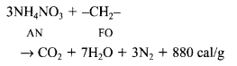

Figure 7- AN/FO Redox reaction

The adverse effect of water on various OME related materials, articles and processes

Pink Water
Pink water is explosively contaminated waste water most commonly produced by washing/ steaming out munitions and cleaning down explosive facilities. Water is required for the task however becomes very difficult to dispose of due to classification issues especially explosives substances such as TNT and RDX are mixed in the solution. Whilst the explosive is in solution it is safe. As the solution evaporates explosive crystals form on the container and any piping which can be easily ignited and very difficult to certify free from explosives.
“The principal contaminants in pinkwater are trinitrotoluene (TNT) and cyclo trimethylene trinitramine (RDX); they are transferred to water in washdown operations, and washout and steamout of old munitions.” [5]

Munition
As stated previously corrosion is a redox reaction. When a material corrodes/ rusts this can cause safety concerns. For example when disassembling an item that has corrosion you will need to use more force that the designers intended to take apart the item, if the corrosion affects the thread then this could cause friction/ heat and initiate the munition.

Pyrotechnic
It is of vital importance that any pyrotechnic mixture is free from water contamination. If the pyrotechnic mixture is contaminated this can be catastrophic. This could be for two main reasons. For example the pyrotechnic is fitted to an aircraft and the aircraft is required to fire flares. If the flare then fails the aircraft could be destroyed by the incoming threat/ missile. Or the flare could cause unintentional ignition on the aircraft causing damage or sympathetic detonation of the other pyrotechnics or payload.

Outgassing
Outgassing is often called off gassing which is when trapped gas is released from materials. Some of these gasses can be extremely harmful to humans such as ammonia and gases such as methane are extremely flammable.
“It has been established that the presence of air bubbles in a liquid explosive such as nitroglycerine renders it peculiarly susceptible to initiation by mechanical shock, that such ignitions start at or in the bubble, and that certain organic vapours like carbon tetrachloride, ether and pentane tend to suppress this type of ignition” [6]
Outgassing can occur in the explosive fill dependent on how the fill is manufactured. Air pockets in the fill when detonated will cause an uneven reaction causing sub optimal performance. Additional cracks in the main fill can form and propagate to other gaps. This then causes safety issues due to being unable to provide safe storage reassurance mandated by JSP482. The addition of water increases the exothermic hazard in pyrotechnics. A 2014 article in the journal of loss prevention in the process industry states that “The water in the mixture slowly dries; the exothermic activity induced during drying of water appears to be responsible for accidents.” [7]

Polymerisation Reactions (Binders)
Binders are essential in explosive and propellant formulations for increased performance. Previously inert binders had been used but this is now been replaced with energetic binders such as hydroxy-terminated polybutadiene (HTPB) and hydroxy-terminated polyethers (HTPE). Binders work by producing cross linked polymers which allows the ingredients to be bound strongly together. HTPE is being used as the chosen binder over HTPB in many applications. Water effects these binders negatively as it weakens the cross linked polymer bonds which the propellant relies upon for increased performance. “It is indicated that HTPE propellants can be used as alternative to HTPB propellants due to its remarkable insensitive property and perfect mechanics performance.” [8]

High/Low explosive filling
TNT, dynamite, RDX and PETN are all high explosive fills used in conventional munitions. Water ingress to the main fill during the manufacturing stage, storage phase or pre use phase can have detrimental effect on the effectiveness and safety of the munition. This is also the same for low explosives such as black powder, safety fuze and ignitors. When these items are contaminated they normally fail to function as intended rather than cause safety issues.

Possible solutions to prevent the performance issues associated with moisture ingress (described in point 4).

Facility/ storage parameters
Facilities must be designed to protect the munition from all types of threats and hazards. In MOD JSP482 (explosive regulations) which is the overarching guidance on how the MOD stores explosives and what standards the facility must meet both in the UK and abroad on operations. This details the building design, temperature requirements, drainage requirements and where the storage house is located. This is also similar to process room requirements. Only fit for purpose “UN” marked containers which have gone through all the appropriate tests can be used. [9]

munition design
Munitions should be designed from the outset to have superior protection from water ingress. Material selection is also extremely important as choosing a material that doesn’t react with water reduces the number of possible issues throughout the life of the item. Environmental seals must also be used on joins between different components and a silicon compound/ putty over screw holes as this seals the munition preventing water ingress. Malleable material should be used where possible to stop cracking when parts of the munition move. This is very evident on MANPADS (man portable air defense system).

Manufacturing
Manufacturing facilities must be built to a high standard in accordance with JSP482 as described under “facility/ storage parameters”. Training for employees in the importance of contamination and the detrimental effect water has in the manufacturing process is very important. The HSE states that “Manufacturing includes processes where explosive articles or explosive substances are made or assembled, or unmade or disassembled. For example, gunpowder manufacture, filling or fusing of fireworks, assembling fireworks displays from components, breaking down jet perforating guns, removing fuses from artillery shells and filling shotgun cartridges and other cartridges for small arms)” [10]

Conclusion
In conclusion water is composed of two parts of hydrogen and one part oxygen. The hydrogen atoms are positively charged and the oxygen atom is negatively charged and exists in three states. Solid, liquid and gas. Water in the atmosphere sits between 0%-4% and this has an impact on the relative humidity along with the temperature. One of the most important chemical properties of water is that is amphoteric which means it can be both a base and an acid. Corrosion and combustion are two common redox reactions that occur within OME. Water has an adverse impact on a variety of articles, materials and process. This can be performance and safety based. The user/designer must be aware as all three states will have an effect with varying repercussions an example of this would be ice when the munition is at altitude on an aircraft. Conforming to the law, legislation and best practice will prevent issues associated with moisture ingress. Research and development is a massive part of this and unfortunately legislation sometimes takes slightly longer to catch up.

References

[1] | J. S. F. J. M. A. Robert J. Buszek, "Water effects on atmospheric reactions," International Reviews in Physical Chemistry , no. 3, pp. 335-369, 2011.
[2] | D. A. M. Helmenstine, "Acid Definition and examples," 13 January 2022. [Online]. Available: https://www.thoughtco.com/definition-of-acid-and-examples-604358. [Accessed July 2022].
[3] | D. A. M. Helmenstine, "Base Definition in Chemistry," 06 November 2019. [Online]. Available: https://www.thoughtco.com/definition-of-base-604382. [Accessed July 2022].
[4] | LibreTexts, "Oxidation- Reduction reactions," 01 April 2021. [Online]. Available: https://chem.libretexts.org/Bookshelves/Analytical_Chemistry/Supplemental_Modules_(Analytical_Chemistry)/Electrochemistry/Redox_Chemistry/Oxidation-Reduction_Reactions#:~:text=An%20oxidation%2Dreduction%20(redox),gaining%20or%20losing%20an%20electron.. [Accessed July 2022].
[5] | Global Security, "Explosives and the Environment," 2022. [Online]. Available: https://www.globalsecurity.org/military/systems/munitions/explosives-env.htm. [Accessed July 2022].
[6] | E. Jones, "Suppression of Bubble Initiation of Liquid Explosives," NATURE 173, vol. 173, pp. 77-78.
[7] | S. P. P. Barana, "Water induced thermal decomposition of pyrotechnic mixtures – Thermo kinetics and explosion pathway," Journal of Loss Prevention in the Process Industries, vol. 30, pp. 275-281, 2014.
[8] | W. -H. W. J. -Y. Z. X. -H. L. X. -Q Song, "Review on HTPE propellants," Review on HTPE propellants, 2008.
[9] | MOD, JSP482.
[10] | HSE, "Manufacturing Explosives," 2022. [Online]. Available: https://www.hse.gov.uk/explosives/manufacturing.htm. [Accessed July 2022].
[11] | "Water Structure Properties," [Online]. Available: https://alevelbiology.co.uk/notes/water-structure-properties/.
[12] | S. S. Zumdahl, "Britanica.com," [Online]. Available: https://www.britannica.com/science/water/Physical-properties. [Accessed July 2022].

Figures
Figure 1- Water molecule structure [11] 0
Figure 2- Physical properties of water [12] 2
Figure 3- Water chemical compound 3
Figure 4- RH formula 3
Figure 5 Acid/Base reaction 4
Figure 6- Acid and Base properties 5
Figure 7- AN/FO Redox reaction 5

