ACCA4023-Introduction to Web & Database Concepts

Assignment 2: HTML & CSS Web Development

Name: Jay L Boodhun
Student no: 2531572

Lecturer: Dr Anum Paracha

8/14/2026


UNiversity of Wales Trinity ST. DAVID
Introduction 2
1. HTML Website 3
2. Website Implementation 4
3.HTML & CSS Validation 9
Error Validation and fixes 9
3. Evaluation of Professional Website 16
4. Evaluation of Home-made Website 16
5. Website Comparison 16
6. Using Inspect to Analyze website 18
7.Conclusion 20
8. References 21
9. Appendices 22

Introduction

For this project, the aim is to construct a website. The purpose is to demonstrate the use of Hypertext Mark Up Language (HTML) via the Visual Studio Code platform (VSC). Using HTML a website demonstrating the effects of “Diabetes.” To highlight this topic, 5 webpages were developed which were as follows: -
For the Home page, the purpose of this page is to give a simple awareness of the importance of Diabetes as a serious ailment. In this case, the user of the website is captured by simple images that highlight the importance of dealing with it as a serious matter.
About- Here this page goes into greater detail of the effects if diabetes is not treated. Unlike the 1st page which shows the effect of diabetes, this page encourages the user to be curious if they are experiencing such symptoms?
Services- This is the important page as it encourages the user to seek help if diabetes has been recognized through both the home and about page.
Contact- Following the services page, again it encourages the user to sign up and seek professional advice. This page portrays a strong understanding that help is available if the user is concerned about the effects of diabetes. This is reliant of how successful the previous pages have educated the user?
Welcome- This is the ONLY page that it not highlighted on any of the 4 pages. The reason is that it is only for serious users who have pinpointed that this service is really needed. In this page the user is assured that their details have been passed on and that they will be contacted.
In term s of the highlighting the importance of Diabetes it is essential to refer to a report of MASLD for type 2 diabetes. Just like everything mentioned here, it points out increased risk of obesity etc..., [1] This is particularly common in people with type 2 diabetes, especially when obesity (despite not being mentioned in this assignment is still one of the symptoms) is present, and that it increases the risk of serious liver disease.

HTML Website

The website is developed to induce curiosity from any demographic of people who identify the symptoms of Diabetes, and not specifically anyone who is suffering from type 1 or 2 diabetes.
To enable the website to come into effect, there are 2 requirements involved. Firstly, to make these pages appealing to the audience/ user, it was essential to use graphical images to hold the user’s attention. These images were also accompanied by their related explanation. Both images and explanation work in tandem to educate the user and encourage them to seek the website for further explanation. For the images, it was necessary to use image platforms like Shutterstock.com, Pexels.com, pixabay.com, and Canva (using mainly free royalty images).
Secondly, using coding with HTML tags on the VSC platform was used to generate information on the website. The pages were accompanied by the .html (notifying the personal computer that it is a website hyperlink). [2]
“The webpage source code is the programming behind any webpage, or software. In case of websites, this code can be viewed by anyone using various tools, even in the web browser itself. In this section, we extract the textual and hyperlink features existing in the HTML source code of the webpage.”

Website Implementation
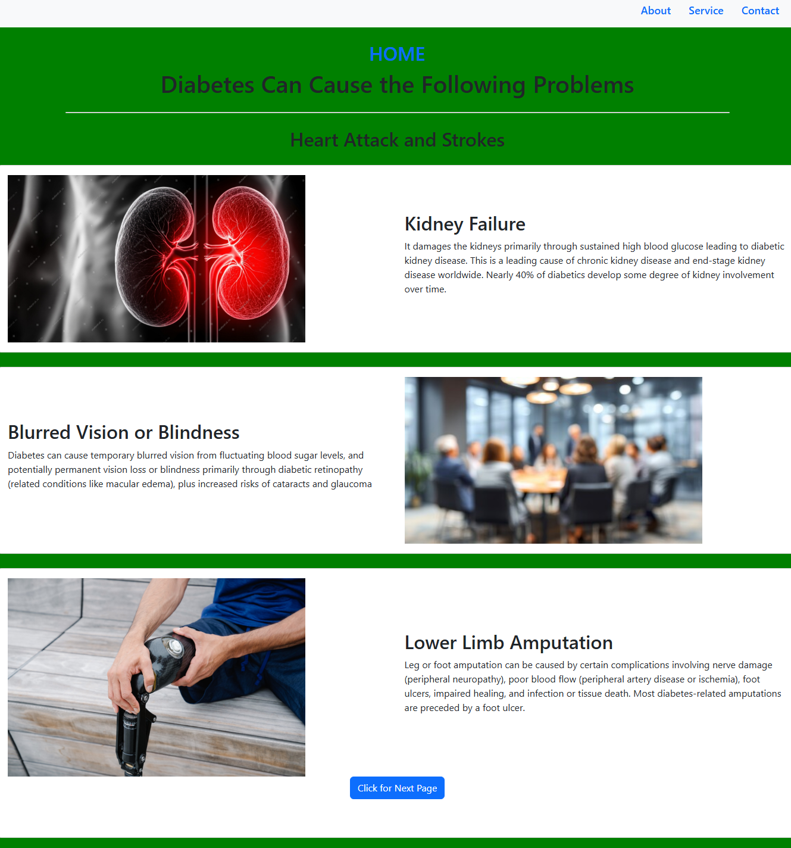

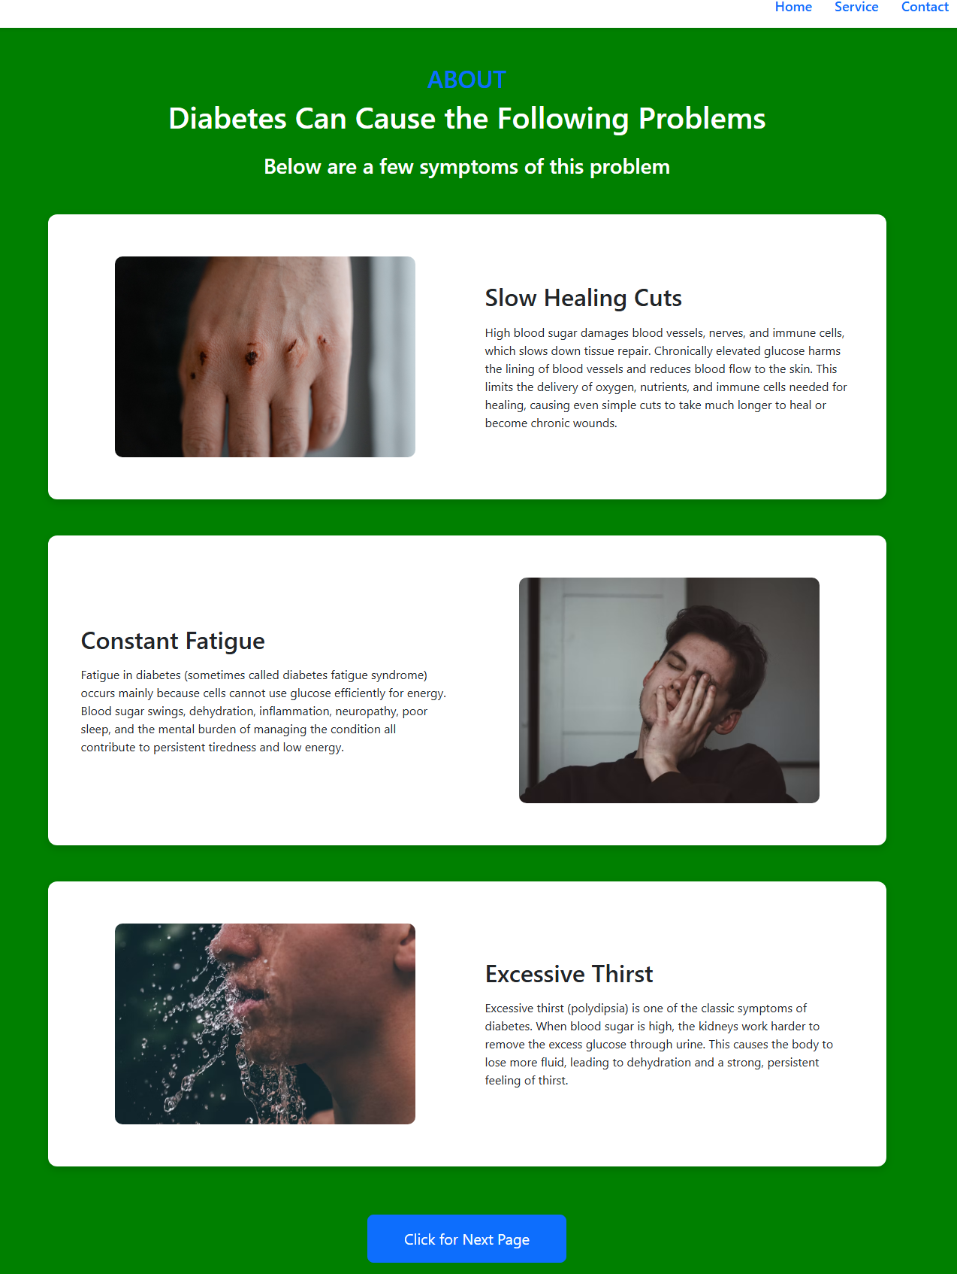
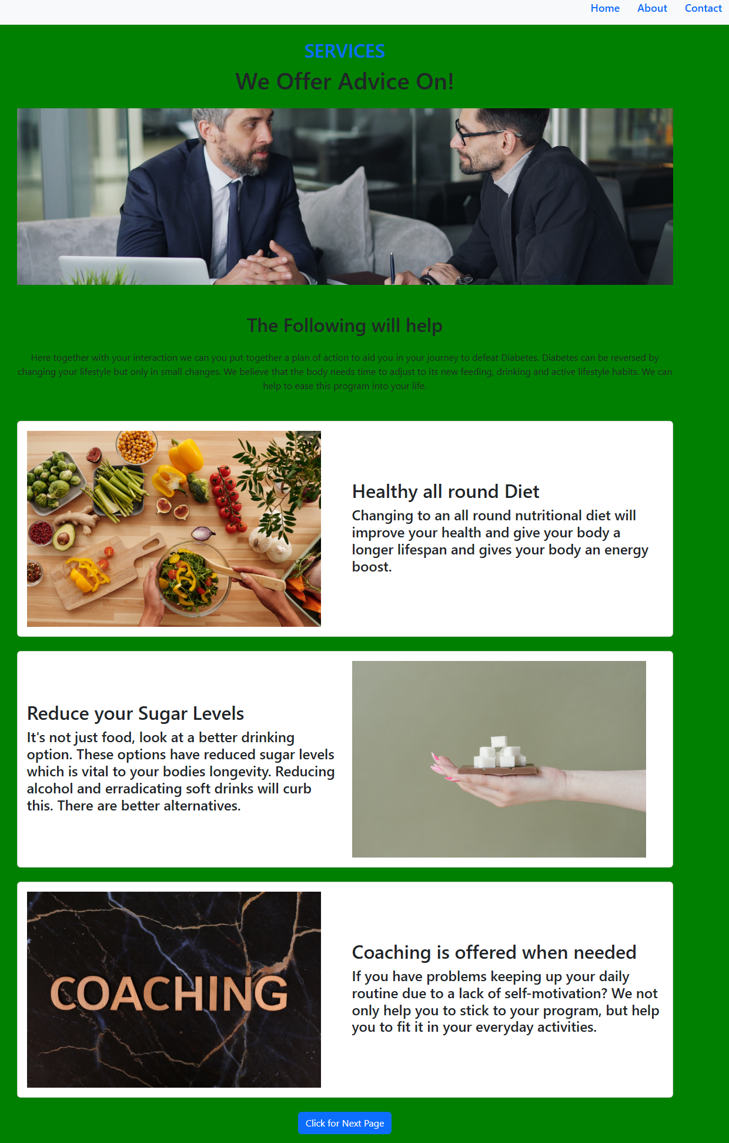

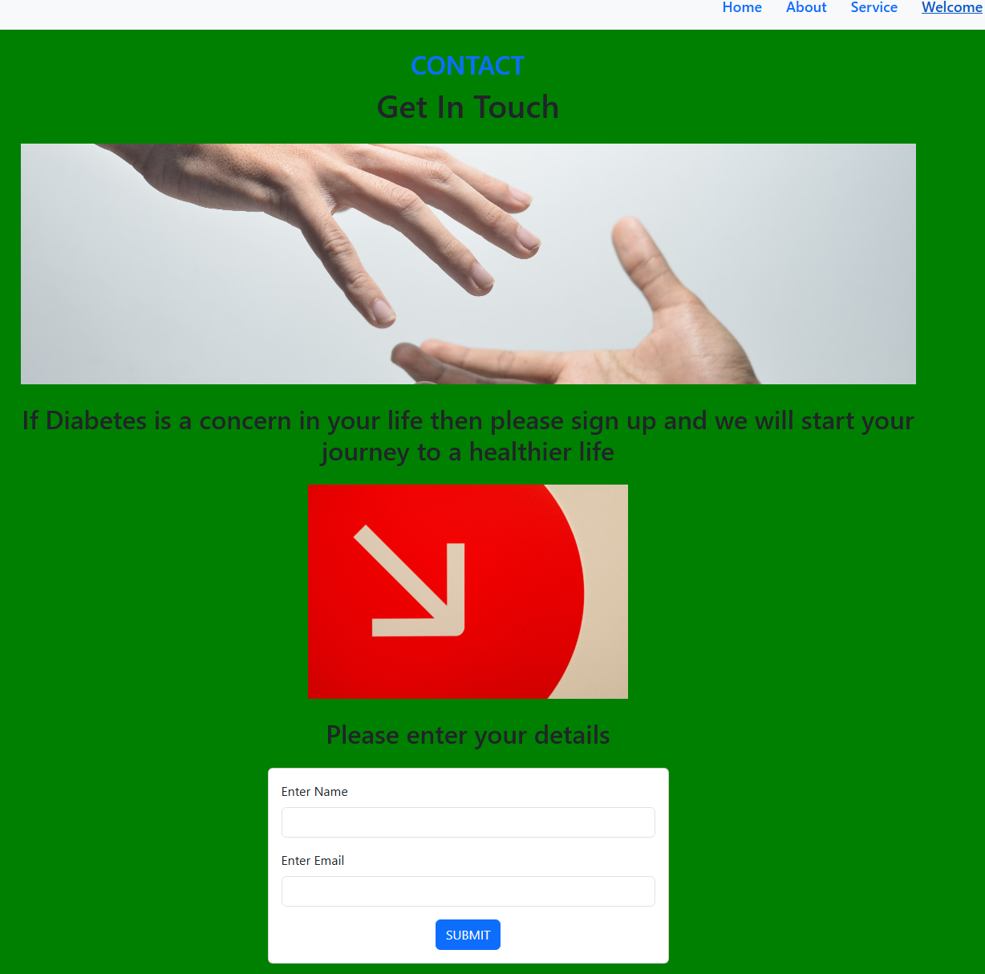

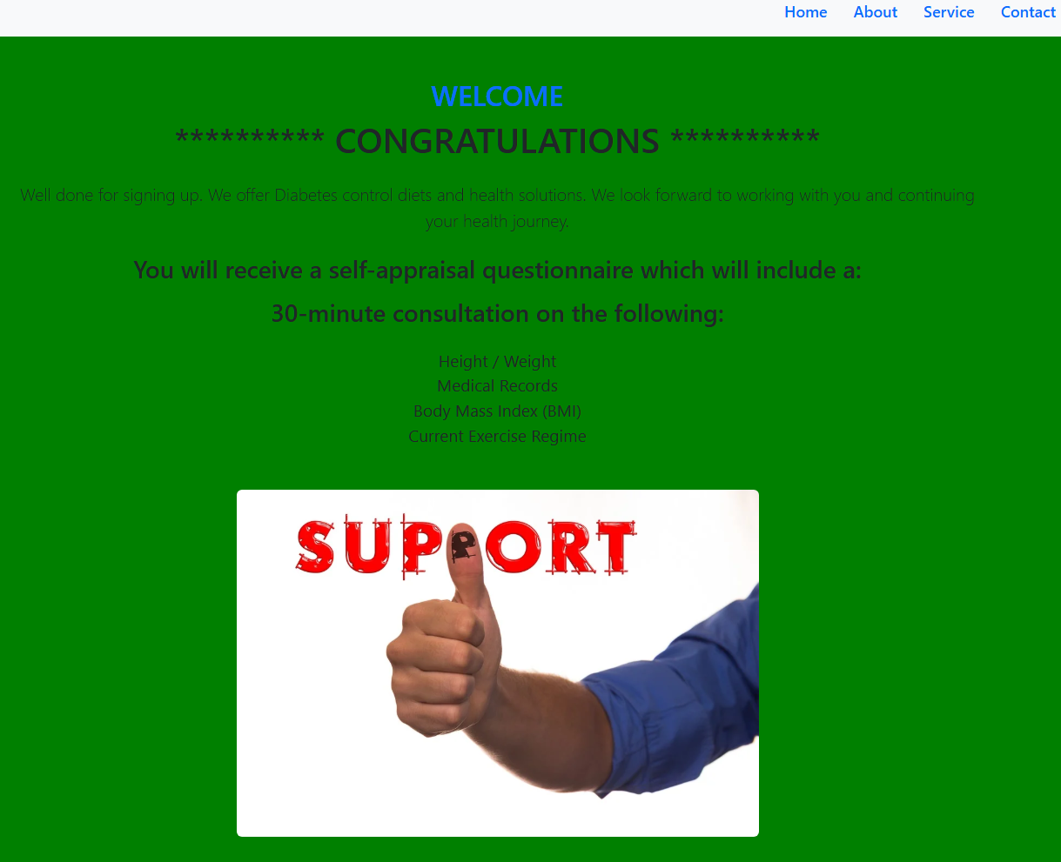

- HTML & CSS Validation.
During the development of the diabetes awareness website, all pages were validated using the official W3C Markup Validation Service. This step was essential because as demonstrated on a study on validating problems on HTML many webpages on the internet contain validation errors that can cause inconsistent rendering across browsers, accessibility problems, and difficulties for automated tools. In this project, common issues such as unclosed tags and incorrect heading hierarchy were identified and corrected, ensuring that the final pages conform to HTML standards and provide a more reliable user experience. [3]
Error Validation and fixes. To test the validity of the Diabetes website in terms of is use there were 2 websites that were used firstly https://validator.w3.org/. Following the Home page of the website using cross check through this link, the following changes were completed. Firstly, the validator confirms that there are stray tags namely </div> tags. This has highlighted the tags that have not closed. Below are 4 screenshots from the VSC platform. The amendments include amending the "Card body" in both rows and columns. In doing this, it fixes any unclosed elements that the validator website highlighted
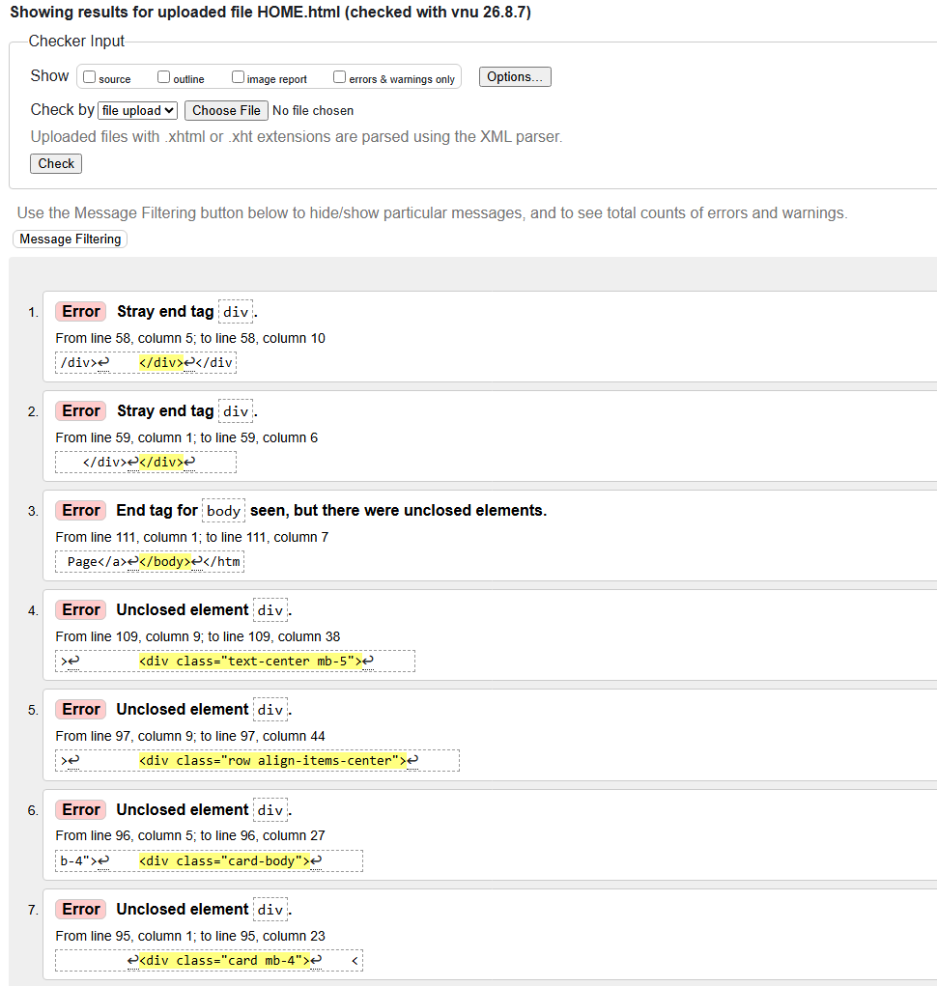
.
For HTML Errors
Screenshot 1 (see appendix 1)-The elements show the "nav" links show that there are gap spaces, font spaces, and font sizes.
Home –Screen 2 (see appendix 1)-shows the padding of the width requirements together with the blocks that define the text size.
Home-Screen 3 (see appendix 1)-Shows the division of each division of each screen tab of images and text.

About page- The heading has skipped heading 2 (h2). This was a simple adjustment and so was not included in the appendix.
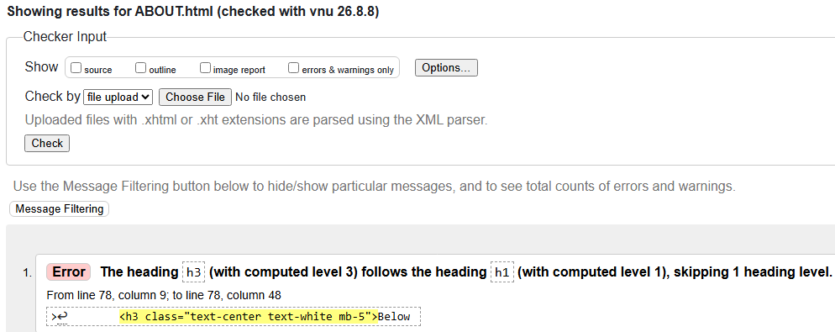
.

Services page-Just like the ABOUT page, this was an easy to rectify adjustment. The main issue that the validator points out is the Hierarchical heading mainly skipping from heading 2 (h2) to head 4 (h4).
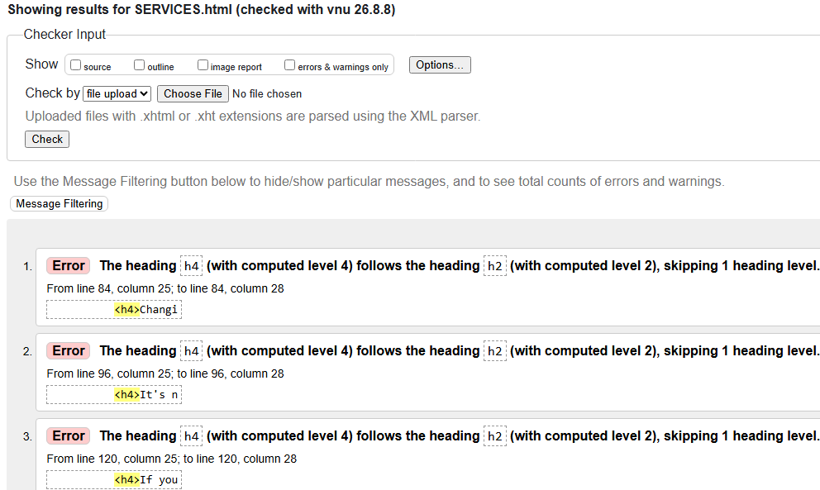
Contact page- The validator shows that there are NO ERRORS, and so no changes were needed.
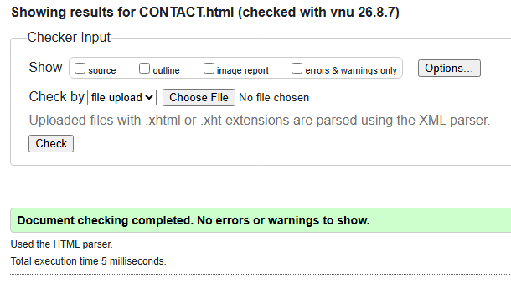
Welcome page-It mirrored the same ERRORS as the "About" and "Services" pages skipping the heading (missing a Hierchary structure).
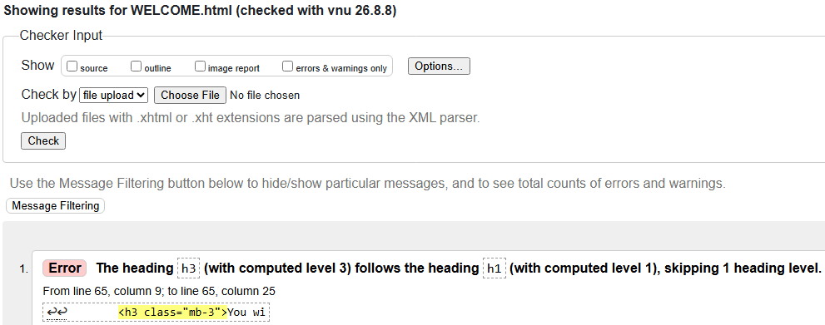

The second part of the testing process includes https://jigsaw.w3.org/css-validator this website was used to test of the Cascading Style Sheets (CSS), This measures the validation of style sheets,
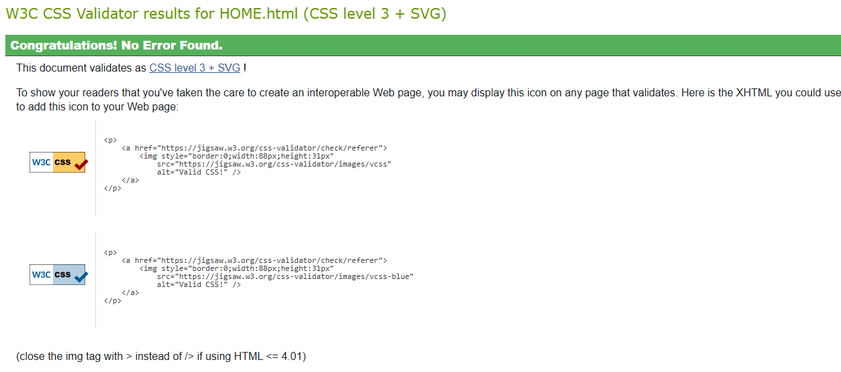
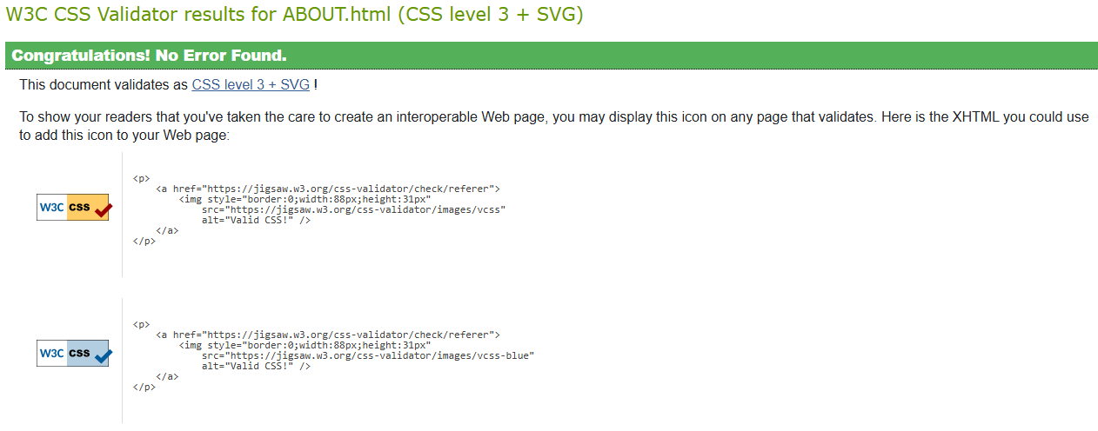

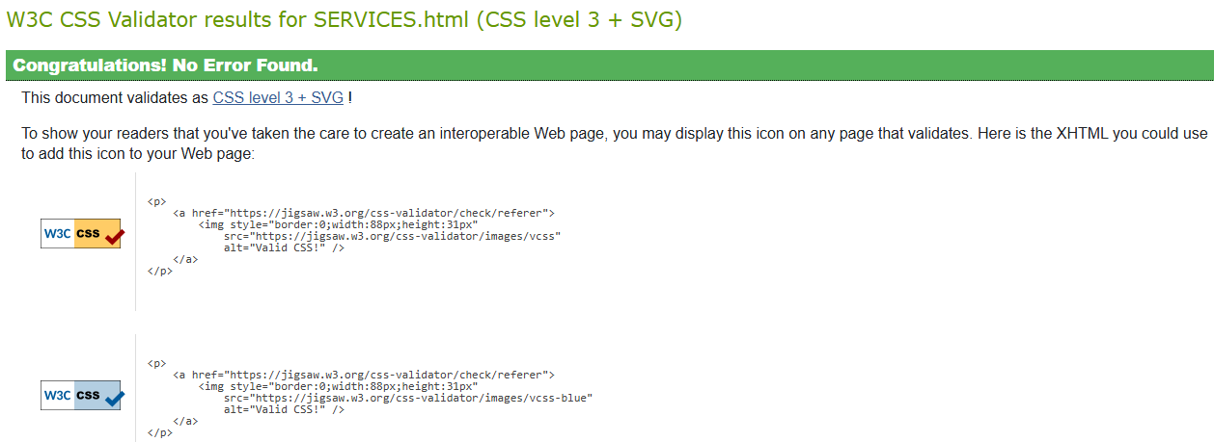

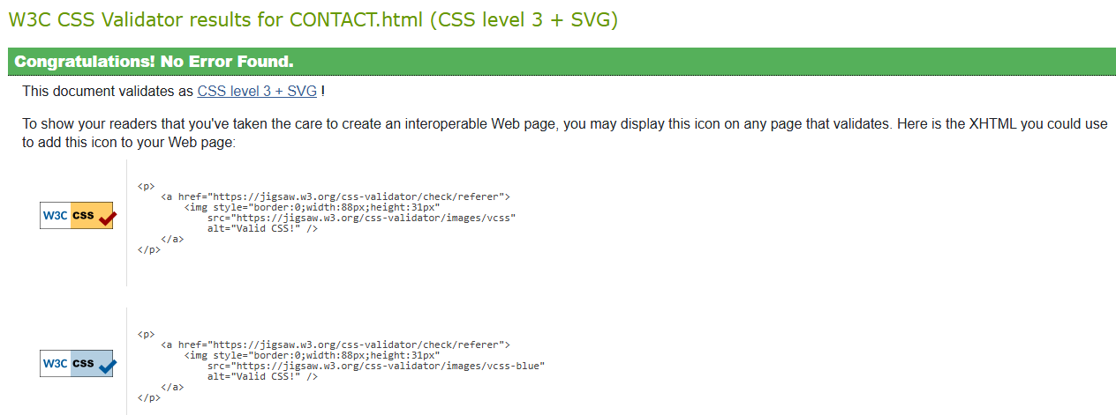
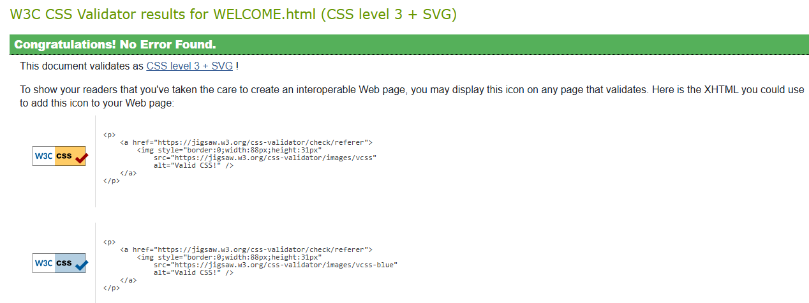
All 5 pages passed the CSS validation test!

Evaluation of Professional Website
Using the website https://www.diabetes.org.uk (appendix 2)
In terms of Researching a similar diabetes website, the weblink is a UK national diabetes information line addressing huge variation of problems relating to diabetes. It offers hyperlinks that can easily be accessible to the user’s Usability is exceptional, offering an expanded listing of problems relating to type 1 & 2 diabetes. Each heading has its own hyperlink to other pages, which is a huge advantage to its user. Being a UK national website, its Accessibility is phenomenal as diabetes is a national concern and so there were no problems finding this as a service. Its SEO is phenomenal, having all the necessary services to deal with this concern. The website has a login for Professions to investigate further to become a member and informs them of the latest developments and conferences,

Evaluation of Home-made Website

For the Home-made Website a candidate tested it for its usability, and accessibility (no research and SEO was needed as it was already in front of them) highlighted the following:
The website was easy to use and there was no confusion as to what the website was about. The main issue was the tabs on the website (e.g. Images and the text explanation were positioned to the left of the page). This was prior to making improvements as seen in this assignment. This feedback was very useful as the webpages were basic and needed plenty of work to make it look like a professional website. The result of the feedback resulted in the final website displays (see pages 3-8).

The candidate found it easy to navigate from page to page because they had to read the page and scroll down when they had finished and then clicked the link for next page. The same routine happened for each page was designed to read and click to the next page.
There were two drawbacks. Firstly the webpages did not contain headings on the top right. This meant that the candidate only got access to the proceeding page via the link. Secondly the graphics were based on the left side the pages. Which was later corrected by using Bootstrap command, which the webpages a clear website framework.
- Website Comparison:
The UK website has far more options for the user in terms of information due to its helpful list of concerns. It has a distinct advantage as it channels decades of knowledge and as such is a trusted national website.
The contrasts with the home-made website being as assignment project. (as mentioned in page 3) is primarily for curious observers who simply may be interested in casually identifying this problem. One clear advantage that the website has is the simplicity of the graphics, and its easy-to-read script. It does not bombard the user with too much information. The website is designed for the user to investigate as to whether diabetes may be an issue in the future?
However, the Profession website in does emphasize best practice like colour contrast checkers (Web AIM) and automated auditors (Wave, aXe), but for the home-made website the aligned top right headings are justified (with amendment) but does need improvements [4]

Using Inspect to Analyze website
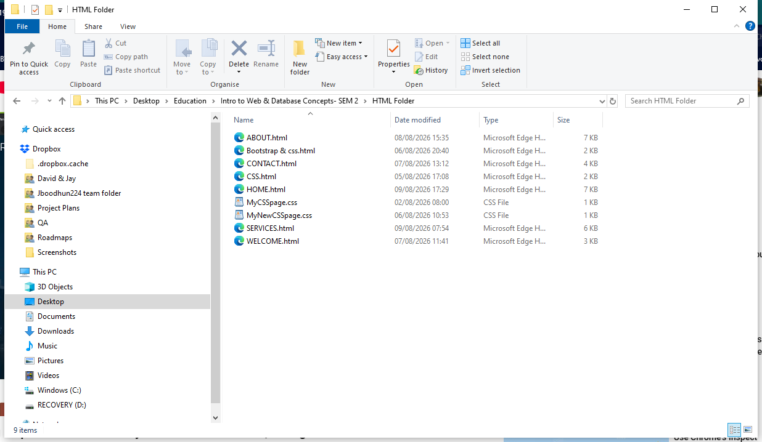
To check to see if home-websites can be viewed on a mobile phone. The HOME.html page was saved on Microsoft Edge

Having opened the html page, the display was as follows with the inspection HTML codes presented on the right-hand side (see below). To view the website on mobile APP. The mobile inspect feature has a mobile view feature
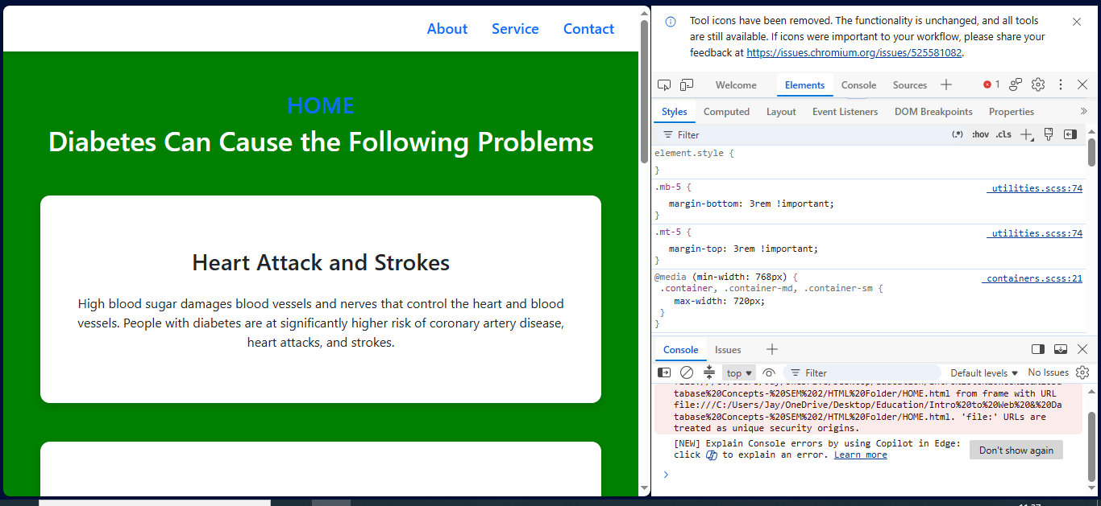
If we see the next proceeding screenshots below we have top have of the website and the middle part of the website as proof.
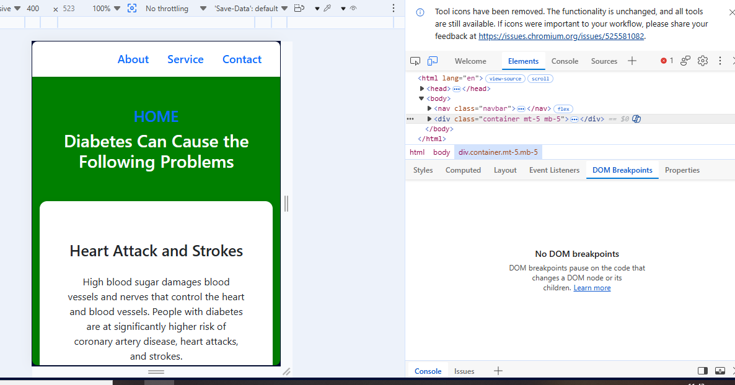

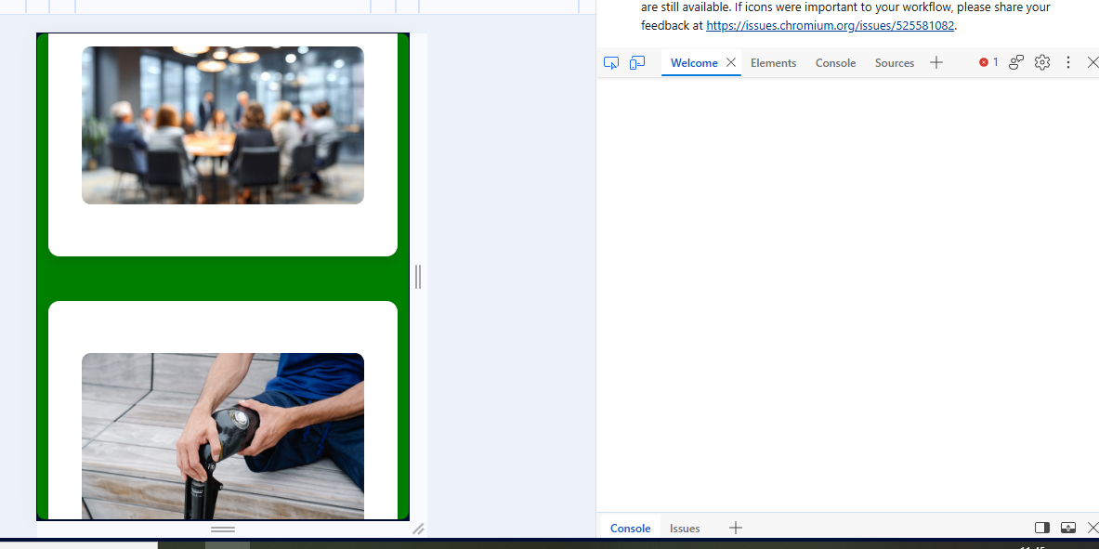

7.Conclusion
The assignment for the development of the Homepage has gone through a journey of improvement through HTML and CSS coding. As seen through the initial candidate testing phase. This was eye opening as Candidate testing was an essential part of website improvement functionality of the website. Following its basic coding the pages were restricted to left hand side of the page and as such needed more advanced coding through implementing borders, padding and a colour scheme which added continuity of all 5 pages. These were corrected by implementing further CSS codes and Bootstrap. What this improvement highlights in the strength of “multi code operations” [5] using highly needed CSS coding to improve webpages adding new features if needed. The HTML and CSS validators are a clear indication that proper coding methods need to be adhered to.
When developing a website there were 2 main areas of thought, the topic of diabetes is a major UK health concern and so the home-made page was competing against a well-founded, well researched medically established website which adhered to CSS (Web rules etc..,). In this matter the Home-made website had to take a different approach, mainly that of not necessarily looking for users who are type 1 & 2 suffers of diabetes but was to attract attention of avid users who would like to browse and investigate further if this was a relevant medical matter in their lives.

8. References
[1] | Abdelmalek,M; Apovian,C; Balapattabi,K; Bannuru,R; Barb,D; Bardsley,J; Beverly,E, “Metabolic Dysfunction-Associated Steatotic Liver Disease (MASLD) in People With Diabetes:,” Diabetes Care, vol. 48, pp. 1057-1082, 2025.
[2] | Aljofey,A; Jiang,Q; Rasool,A; Chen,H; Liu,W; Ou,Q; Wang, Y, “An effective detection approach for phishing websites using URL and HTML features,” Scientific Report, 2022.
[3] | Chen,S; Hong,D; Shen,V, “An Experimental Study on Validation Problems with Existing HTML Webpages,” Chiba, 2005.
[4] | H. Shah, “Harnessing Web Accessibility Tools for WCAG 2.1 Migration of a Design System,” in Conference on Computing, Networking, Telecommunications & Engineering Sciences Applications, Zagreb, 2023.
[5] | Huang,S; Wu,X; Li,Y; Chen, Zhang,D; Wei,F, “VisCodex: Unified Multimodal Code Generation via Model Merging,” in ICLR, Rio de Janeiro, 2026.

9. Appendices

Screenshot 1
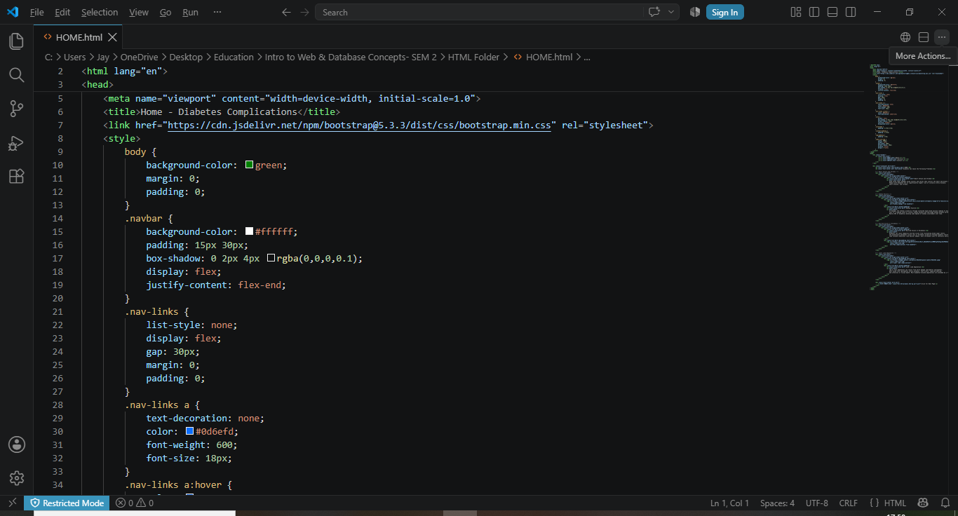

Screenshot 2
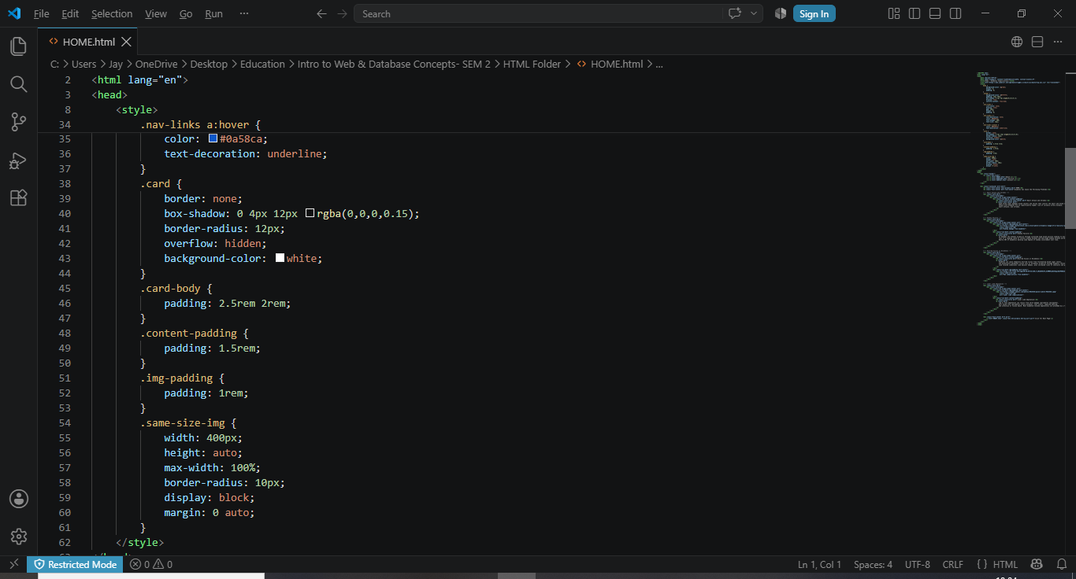

Screenshot 3
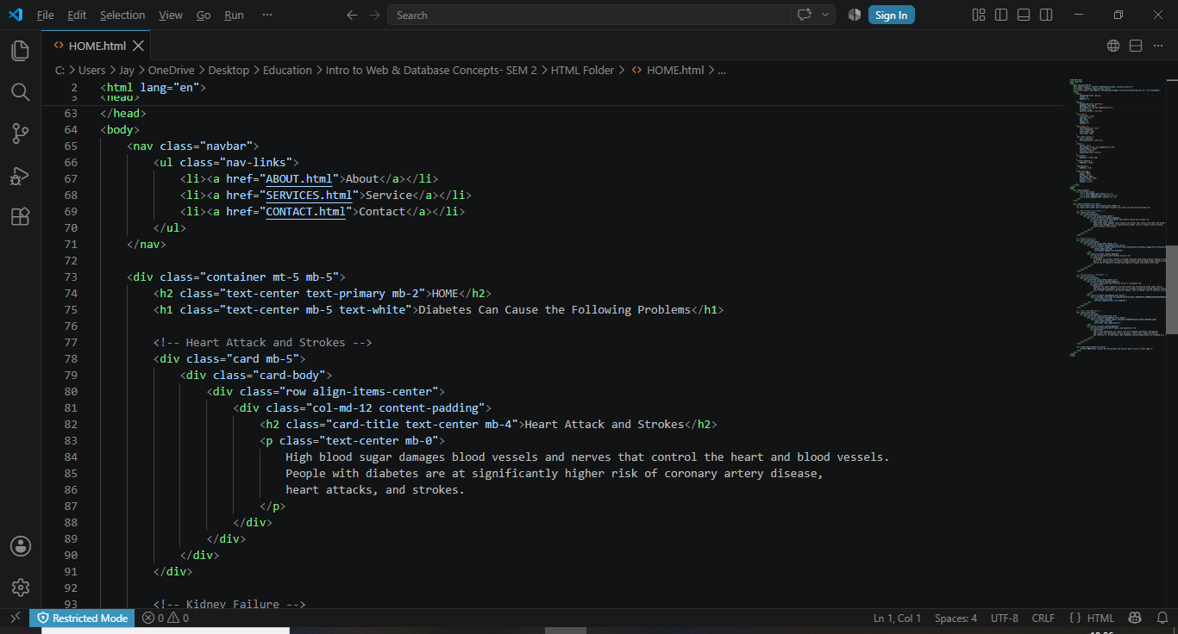
Screenshot 4
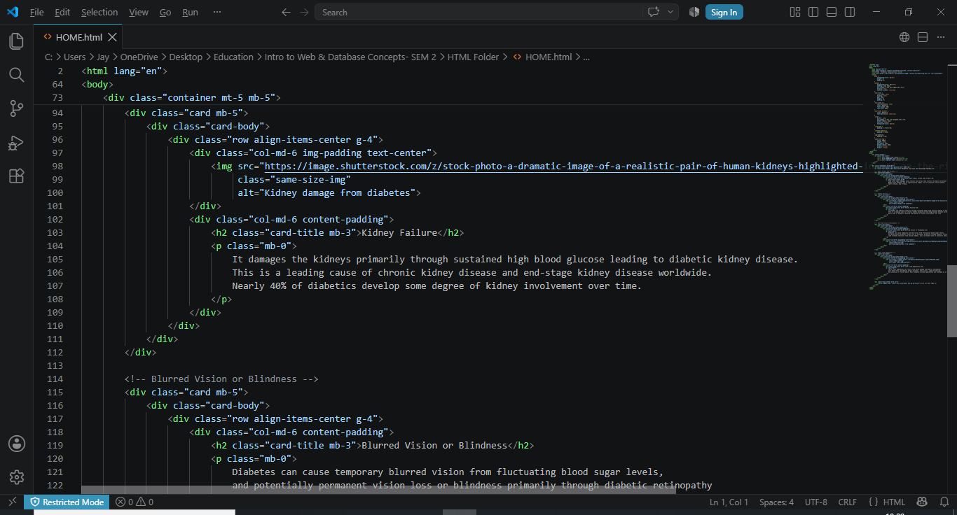

SERVICES
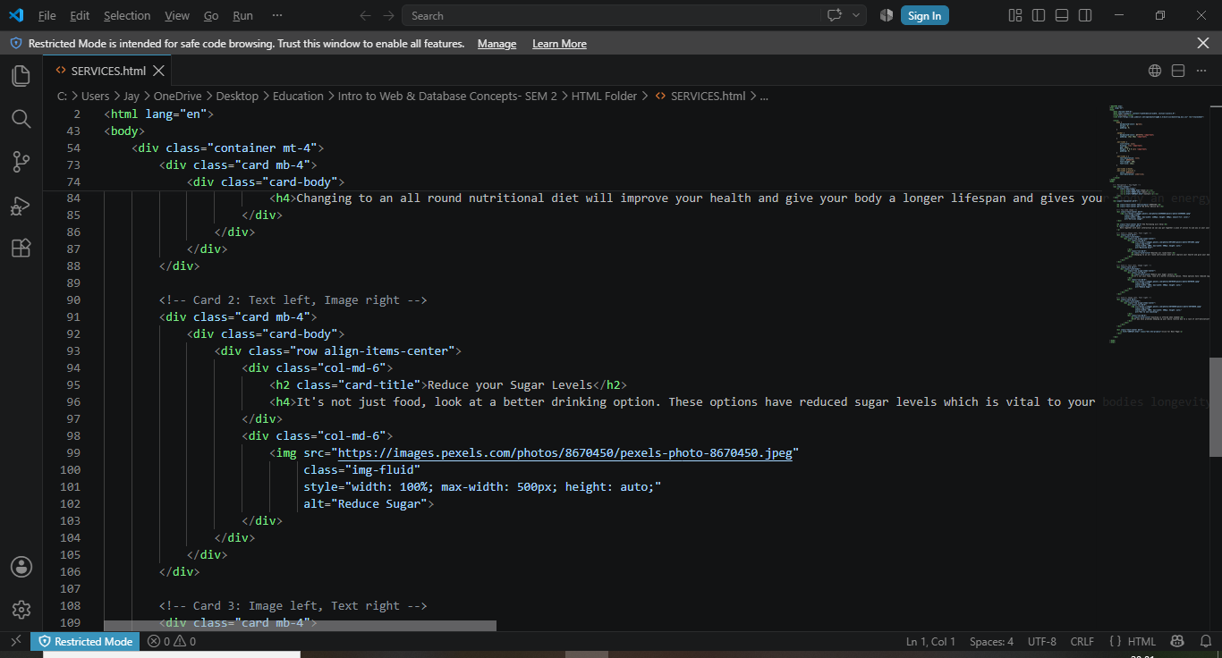
Appendix 2


