Umar Shah (1706987)

Internet Protocol

BSc Cloud Computing

Part 1

Table of Content
Title | Page Number
1.1 Introduction | 03
2.1 Basics of IPv6 | 03
3.1 Addressing method of IPv6 | 03
3.1.1 Unicast addressing | 03
3.1.2 Multicast addressing | 06
3.1.3 Anycast addressing | 06
4.1 Differences between IPv4 and IPv6 | 06
Part 2 | 08
6.1 Conclusion | 09

Introduction:

The technological development and due to higher internet traffic it is very much needed to think about new IP addressing system that will reduce the limitations of IPv4 addressing system. In that occasion IPv6 is an effective solution. This report is prepared to understand the concept of IPv6 addressing.

2.1 Basics of IPv6:
IPv6 is an addressing system where the new and existing IPs are addressed more accurately using the 128 bit hexadecimal numbering system. As the IPv4 addressing is facing saturation problem that can be realized after 10-15 years s later IPV6 addressing system is developed. So this addressing system is actually replacing the existing and mostly used IPv4 addressing system. The limitations of IPv4 addressing is identified ad tried to remove in IPv6 addressing where creating huge space focusing the future demand is one of the main problem.
3.1 Addressing method of IPv6:
The IPv6 Addressing is classified into three main categories and has some sub categories as discussed below-
3.1.1 Unicast addressing:
An interface on an IPv6 device is uniquely addressed where A IPv6 packet is sent to a unicast address and received by the assigned interface to that address. In unicast addressing the address can be either link-local scope, global scope or site-local scope. The unicast addresses are also divided into three categories-
- Global unicast address
- Link-local addresses
- Site-local addresses

Global unicast address:

The IPv6 global unicast addresses are similar to IPv4 public addresses since they are routable on the internet network. Internet Assigned Numbers Authority only assigned 2000::/3 addresses to the global pool. All global unicast addresses have a 64-bit interface ID field (that is, n + m = 64) except those that start with B'000'. On the other hand, the global unicast addresses starts with B’000’ have no such constraint on structure of the interface ID field. The part of global unicast address is as below-

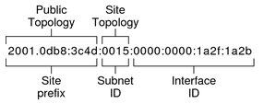

Link-Local Address: According to Loshi, P. (2012), Link-Local Address is only valid for the communication process within the network segment and with the broadcast domain where the host is connected with. Link-Local Address is not considered as unique outside the single network segment and the data packets do not get forwarded in this process from the router. The Link-Local Address in IPv4defined with the address block of 169.254.0.0/16. In IPv6 it assigned as FE80::/10. The local addresses assigned in this process manually.
Figure 2: Link-local address scope zones
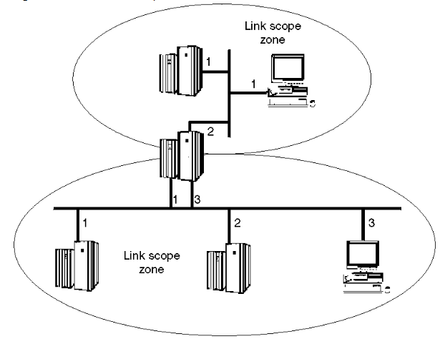
Loopback address: The unicast address also known as loopback address and it represent as 0:0:0:0:0:0:0:1. This address assigned in the physical interface to get communicated with the other end of the interfaces. The unicast address gets engaged with the target interface by using the link-local unicast addresses to ensure the virtual interfaces. This address is not being applied for the information transformation through IPV6 as it unable to communicate outside the node. The sources addresses send on this process from the outside of the node. The IPV6 addressed could not able to transfer the information’s which contain the loopback addresses.
Unspecified Address: 0:0:0:0:0:0:0:0 these types of IP addressed are known as unspecified address and do not assign in any node. Such combination reveals that there is absent the location of the data transfer. The data transferred from the IPV6 protocol indicate that the source addresses included but the host before identifying its own information and created such information. In case of IPv6 the routing headers indicate that the destination address remains suspicious in this process.
IPv4 compatible IPv6 address: in this process that IPv4 address being mapped with IPv6 address and embraced the global address with it. These information basically used the IPv6 tunnel dynamically. In this process the IPV6 unicast address assigned in 32 bit
80 bits | 16 | 32 bit16s
000…000 | 0000 | IPV4

IPv4 mapped IPv6 address: In this process the IPv4 address being used to represent the IPv4 node address and node address considered as IPv6 so it could be enable for IPv6. The application deal with IP address in IPv6 format The dual node TCP/IP performed on the transformation of IPv4 mapped address in the format of IPv4. The mapped address of IPv4 is as below:
80 bits | 16 | 32 bit16s
000…000 | FFFF | IPV4

Examples
The example of IPV6 – IPv4 address is as below
::FFFF:129:144:65:37
The compressed form of IPv6 address is as below
::FFFF:8190:3425

3.1.2 MULTICAST ADDRESSING
This form of address starts with FF and the prefix is FF00::8. The target interfaces located in several other devices and in this process the information that has been transferred could use by all devices and in this process it perform like the IPv4. In this process any device could joint in network any time it want and also could leave. Ff02::1 represents that the broadcast performed in all nodes and IPV6 do not support such type of communication.Ff02::2 represents that the information share in all routes in a particular segment. It is a source of address for a multicast group. Basically the data transformed from the IPV6 to the multiple destination where it belongs to different multicast group.
The addressing format of multicast group is as below
8 | 4 | 4 | 112 bits
11111111 | Flags | Scope | Group ID

3.1.3 Anvcast Addressing
It is a king of addressing which is assigned for more than one interface. Basically in IPV4 the data transferred get received by different nodes but in this process of IPV6 the data received from the closest node. The address used in this process as a part of route sequence. The anycast addressing uses the same addressing formatting that has been used by the unicast addressing. So it become very difficult to make distinguished between the anycast and unicast by evaluating the addressing only. To distinguish the any cast addressing from the unicast addressing process the administrative support is required. Anycast addressing format is presented below in a table:
n bits | 128-n bits
Subnet prefix | 000….000

4.1 The differences between the IPV4 and IPV6
Factors | IPV4 | IPV6
Address Size | 32 bit | 128 bit
Address Format | Dotted decimal like, 192.149.252.76 | Hexadecimal notation used 3FFE:F200:0234:AB00:0123:4567:8901:ABCD
Numbers of address | 2²³ | 2¹²⁸
Exchange of Packets | The host fragmented the packet at the time of sending and receiving the information | In this process the routers do not fragmented the packets but the fragmentation process supported at the time of sending information’s.
Configuration | In this process addresses configured either using DHCP or manually | In this process manual consideration is not applicable

5.1 Security vulnerability of IPV6
The Security architecture has developed the security strategies for the IPV6 internet protocol. There are various options that provide security for transferring the safe data packages. The company and board ID design uniquely to ensure the security of the 48 bit addresses.
Basically in IPV4 the connectivity used different IP address for different users so it gets difficult to find out the users from the trafficking (Loshin, 2011). So the attackers do not get easy to attack to gain access in this process but in IPV6 the users could easily identify from the trafficking so the chances of attacking is higher in this process. The IPV6 used Mac address for different users and there are several devices that also uses their own Mac address which create complexity and make the total process vulnerable for being attack by the attackers. Again the hackers also gain able to easily bypass the firewall that has been developed by the IPV6 and there are several software’s that has developed by the hackers and used for bypassing the firewall like Hackers’ Choice, Scapy6 etc. Again the multiple addressing used by the IPV6 has also enhanced its vulnerability which makes hackers easily hacked data sharing in IPV6.

Part 2
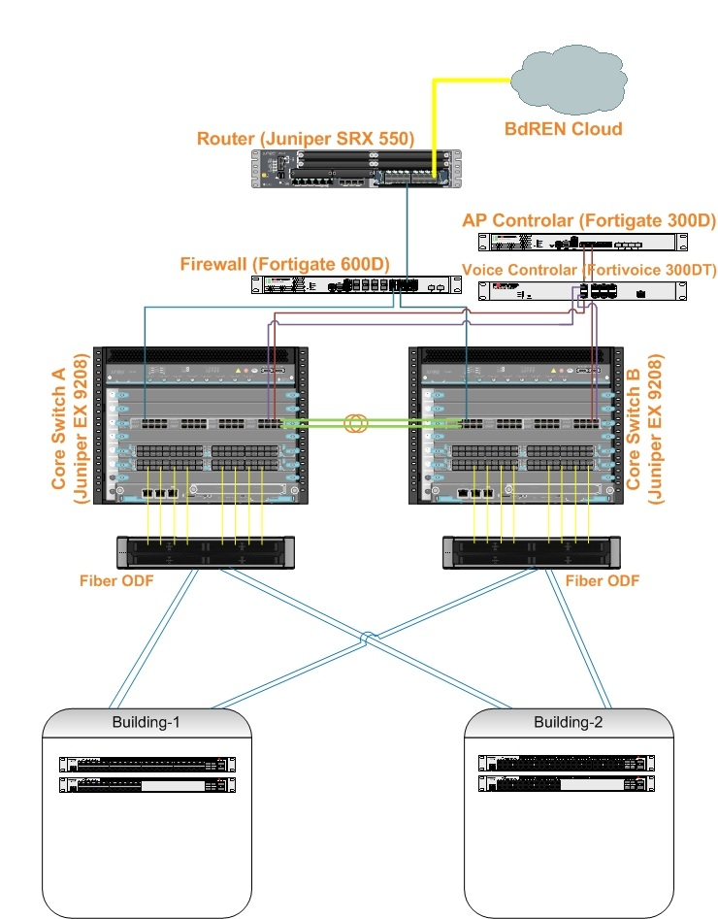
6.1 Conclusion
The IPV6 has successfully developed on the limitation of the IPV4 and its trafficking is increasing very rapidly since 2015. IPV6 considered providing solution in the process of future communication. The IPV6 has gain able to enhance the performance ability in communication technology.

References:

Loshin, P. (2012) IPv6: Theory, Protocol, and Practice. Elsevier.

Loshin, P. (2011) IPv6 Clearly Explained. Morgan Kaufmann.

Shima, K. (2013) IPv6 Core Protocols Implementation.

DeNardis, Laura E. (2015) IPv6: Politics of the Next Generation Internet. Virginia Polytechnic Institute and State University.

Qing Li, Q. (2015) IPv6 Socket API Extensions: Programmer's Guide. Morgan Kaufmann.

Miller, Mark A. (2012) Internet Technologies Handbook: Optimizing the IP Network. John Wiley & Sons.

Part 2 - IP addressing scheme for school of management and engineering

Whole Subnetting

Subnet | Host | Network ID | Broadcast ID | First Usable | Last Usable | Subnet mask
0 | School of applied computing | 172.16.32.0/20 | 172.16.47.255 | 172.16.32.1 | 172.16.47.254 | 255.255.255.240
1 | School of automotive engineering | 172.16.0.0/20 | 172.16.15.255 | 172.16.0.1 | 172.16.15.254 | 255.255.255.240
2 | School of Engineering | 172.16.16.0/20 | 172.16.31.255 | 172.16.16.1 | 172.16.31.254 | 255.255.255.240

School of applied Computing
Subnet | PC | Host | Network ID | Broadcast ID | First usable | Last usable | Subnet mask
0 | 142 | Lab 308 | 172.16.32.0/22 | 172.16.35.255 | 172.16.32.1 | 172.16.35.254 | 255.255.252.0
1 | 62 | Lab 301 | 172.16.36.0/23 | 172.16.37.255 | 172.16.36.1 | 172.16.35.254 | 255.255.254.0
2 | 52 | Lab 309 | 172.16.38.0/23 | 172.16.39.255 | 172.16.38.1 | 170.16.39.254 | 255.255.254.0
3 | 47 | Lab 304 | 172.16.40.0/24 | 172.16.40.255 | 172.16.40.1 | 172.16.40.254 | 255.255.255.0
4 | 42 | Lab 306 | 172.16.41.0/24 | 172.16.41.255 | 172.16.41.1 | 172.16.41.254 | 255.255.255.0
5 | 38 | Lab 303 | 172.16.42.0/24 | 172.16.42.255 | 172.16.42.1 | 172.16.42.254 | 255.255.255.0
6 | 32 | Lab 302 | 172.16.43.0/24 | 172.16.43.255 | 172.16.43.1 | 172.16.42.254 | 255.255.255.0
7 | 22 | Staff | 172.16.44.0/25 | 172.16.44.127 | 172.16.44.1 | 172.16.44.126 | 255.255.255.125
8 | 20 | Lab 310 | 172.16.44.128/25 | 172.16.44.255 | 172.16.44.129 | 172.16.44.254 | 255.255.255.128
School of Automotive Engineering

Subnet | PC | Host | Network ID | Broadcast Id | First usable | Last usable | Subnet Mask
0 | 52 | Lab 301 | 172.16.0.0/23 | 172.16.1.255 | 172.16.0.1 | 172.16.1.254 | 172.16.1.255
1 | 50 | Lab 206 | 172.16.2.0/23 | 172.16.3.255 | 172.16.2.1 | 172.16.3.254 | 172.16.3.255
2 | 42 | Lab 205 | 172.16.4.0/23 | 172.16.5.255 | 172.16.4.1 | 172.16.5.254 | 172.16.5.255
3 | 42 | Lab 101 | 172.16.6.0/23 | 172.16.7.255 | 172.16.6.1 | 172.16.7.254 | 172.16.7.255
4 | 37 | Lab 103 | 172.16.8.0/24 | 172.16.8.255 | 172.16.8.1 | 172.16.8.254 | 172.16.8.255
5 | 27 | Lab 102 | 172.16.9.0/24 | 172.16.9.255 | 172.16.9.1 | 172.16.9.254 | 172.16.9.255
6 | 22 | Staff | 172.16.10.0/24 | 172.16.10.255 | 172.16.10.1 | 172.16.10.254 | 172.16.10.255
7 | 22 | Cad Lab | 172.16.11.0/24 | 172.16.11.255 | 172.16.11.1 | 172.16.11.254 | 172.16.11.255

School of Engineering
Subnet | PC | Host | Network ID | Broadcast ID | First Usable | Last Usable | Subnet Mask
0 | 250 | An Open Access Lab | 172.16.0.0 | 172.16.3.255 | 172.16.0.1 | 172.16.3.254 | 255.255.252.0
1 | 82 | Lab 202 | 172.16.4.0 | 172.16.4.255 | 172.16.4.1 | 172.16.4.254 | 255.255.255.0
2 | 82 | Lab 409 | 172.16.5.0 | 172.16.5.255 | 172.16.5.1 | 172.16.5.254 | 255.255.255.0
3 | 67 | Lab 203 | 172.16.6.0 | 172.16.6.127 | 172.16.6.1 | 172.16.6.126 | 255.255.255.128
4 | 47 | Lab 404 | 172.16.6.128 | 172.16.6.255 | 172.16.6.129 | 172.16.6.254 | 255.255.255.128
5 | 47 | Lab 410 | 172.16.7.0 | 172.16.7.127 | 172.16.7.1 | 172.16.7.126 | 255.255.255.128
6 | 30 | Lab 408 | 172.16.7.128 | 172.16.7.255 | 172.16.7.129 | 172.16.7.254 | 255.255.255.128
7 | 27 | Lab 205 | 172.16.8.0 | 172.16.8.63 | 172.16.8.1 | 172.16.8.62 | 255.255.255.192
8 | 24 | Test Centre | 172.16.8.64 | 172.16.8.127 | 17.16.8.65 | 172.16.8.126 | 255.255.255.192
9 | 22 | Lab 201 | 172.16.8.28 | 172.16.8.191 | 172.16.8.129 | 172.16.8.190 | 255.255.255.192
10 | 20 | Staff | 172.16.8.192 | 172.16.8.255 | 172.16.8.193 | 172.16.8.254 | 255.255.255.192

IPv6 Address for Six Servers
DNS | 2001:0DB8:85A3:0000:0000:8A2E:0370:7334
Email | 2001:DB8:A::123/64
Finance | 2001:DB8:0:0:1:0:0:1
Registry | 2001:0DB8::0001
File server | 2001:DB8:A0B12F0::1
Print server | 2001:0000:6DCD:8C74:76CC:63BF:AC32:6A1/64
Mp | FD79:FADB:564F:D2A1::/64

