

Osvaldas Stanelis

1802408

Computing (Data and Information systems)

Software Development

(ACCA4017)

30.04.2020
Exercise 1
Code:
#include "pch.h"
#include <iostream>
#include <sstream>
#include <string>
#include <math.h>
#include <iomanip>
using namespace std;
// exercise 1
int main(int argc, char** argv)
{
string input;
stringstream stream;

float number, lenght;
string book;

cout << "Please enter book title: " << endl;
getline(cin, input);
stream.str(input);
stream >> book;
stream.clear();

cout << "Please enter book lenght: " << endl;
getline(cin, input);
stream.str(input);
stream >> lenght;
stream.clear();

cout << "Please enter quantity: " << endl;
getline(cin, input);
stream.str(input);
stream >> number;
stream.clear();

if (number <= 0 || lenght <= 0)
{
cout << "Invalid quantity or lenght !!!" << endl;

exit(EXIT_FAILURE);
}

cout << "Book title is: " << book << " Book lenght is: " << lenght << " Your quantity is: " << number << endl;
}

Pictures: 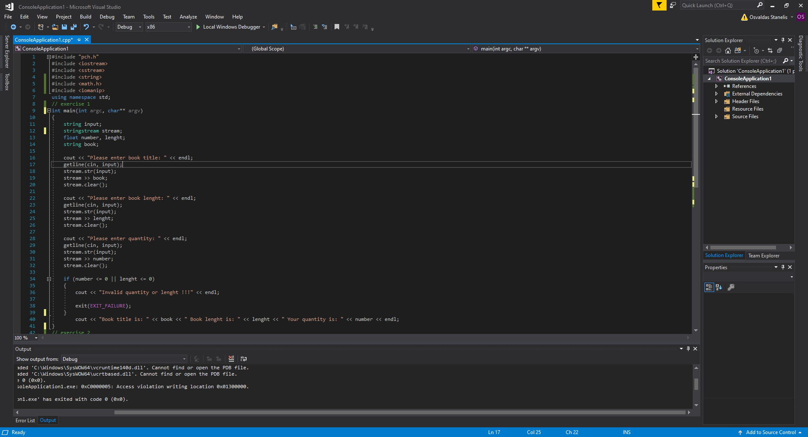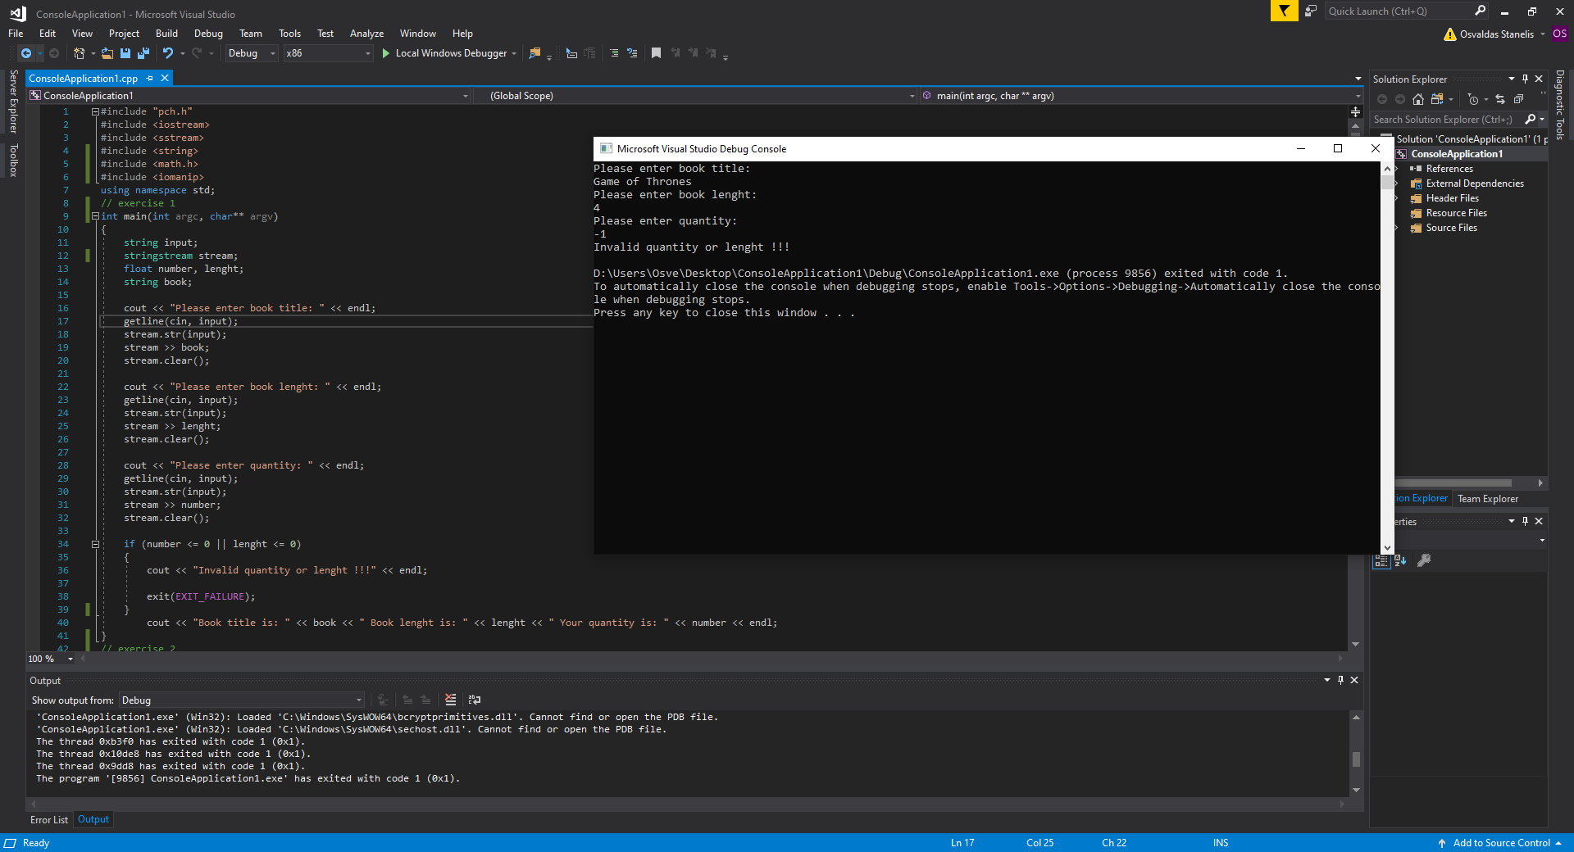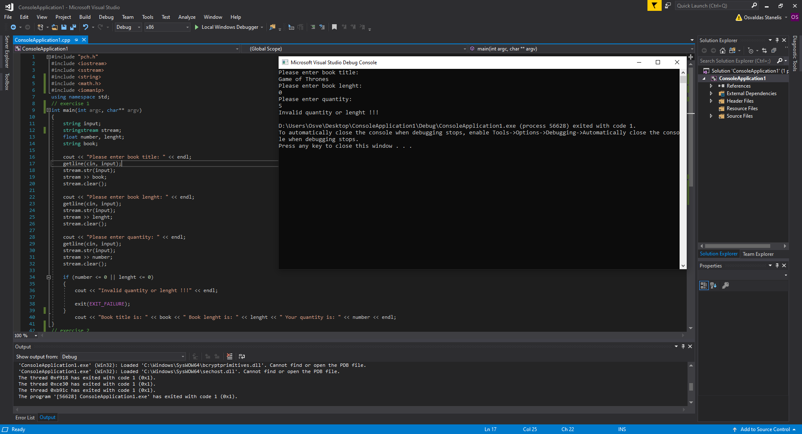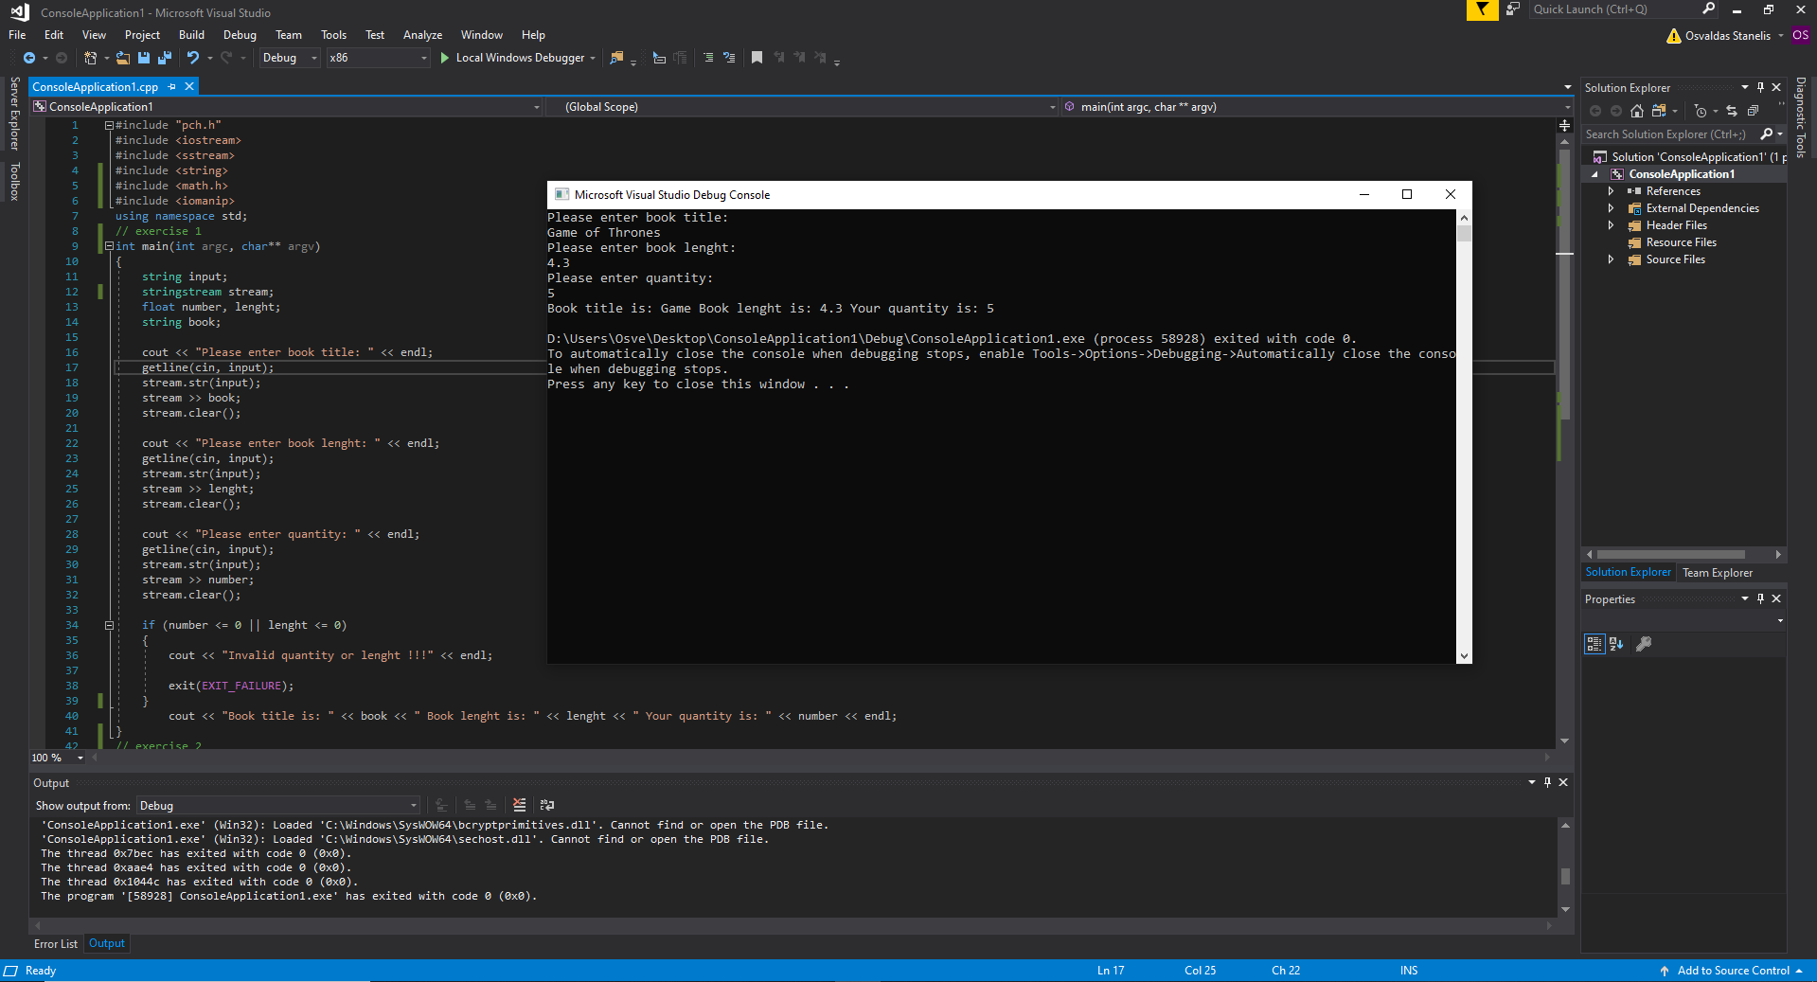

Exercise 2
Code:
int main(int argc, char** argv)
{
float boxHeight;
float boxWidht;
float BoxHeightInside;
float boxWidhtInside;
float circleRadius;
float circleRadiusCalculation(float);
float boxAreaCalculation(float, float);
// Main box size
cout << "Type height of box: " << endl;
cin >> boxHeight;
cout << "Type a width of box: " << endl;
cin >> boxWidht;
cout << "Main figure size is: " << boxWidht << " x " << boxHeight << endl;
// Circle radius
cout << "Enter circle radius: " << endl;
cin >> circleRadius;
// Inside box size
cout << "Type inside height of box: " << endl;
cin >> BoxHeightInside;
cout << "Type inside width of box: " << endl;
cin >> boxWidhtInside;
cout << "Inside figure size is: " << boxWidht << " x " << boxHeight << endl;
// Circle radius
circleRadiusCalculation(circleRadius);
float finalCircleArea = circleRadiusCalculation(circleRadius);
float finalBoxArea = boxAreaCalculation(boxHeight, boxWidht);
float finalInsideBoxArea = boxAreaCalculation(BoxHeightInside, boxWidhtInside);

cout << "Final figure area is: " << endl;
cout << finalBoxArea - finalCircleArea - finalInsideBoxArea << endl;
return 0;
}
float circleRadiusCalculation(float circleRadius)
{

float circleArea;
cout << "Calculating circle area (A = 3.14 * (r * r))" << endl;
cout << "With formula of 3.14 * " << circleRadius << " * " << circleRadius << endl;
circleArea = 3.14 * circleRadius * circleRadius;
cout << "Circle area is: " << circleArea << endl;
return (circleArea);
}

float boxAreaCalculation(float h, float w)
{

float BoxArea;
cout << "Calculating box area (S = a * b)" << endl;
cout << "With formula of S = " << h << " * " << w << endl;
BoxArea = h * w;
cout << "Box area is: " << BoxArea << endl;
return (BoxArea);
}
Pictures: 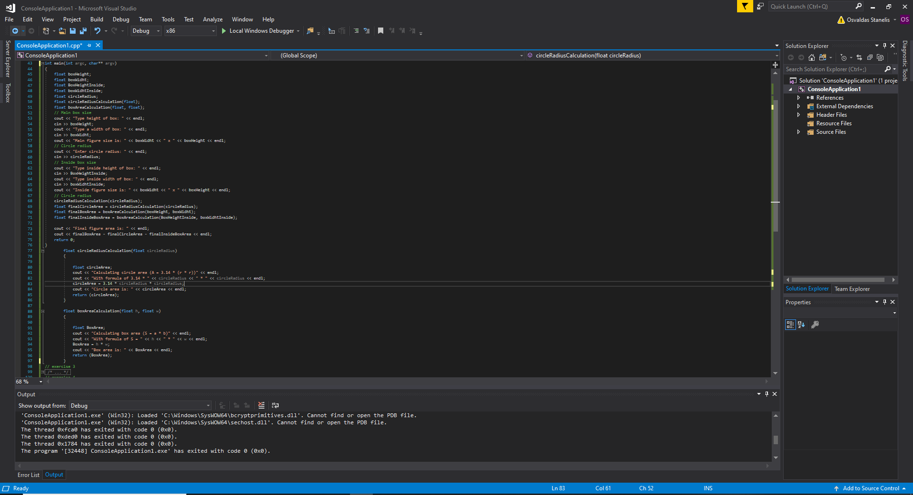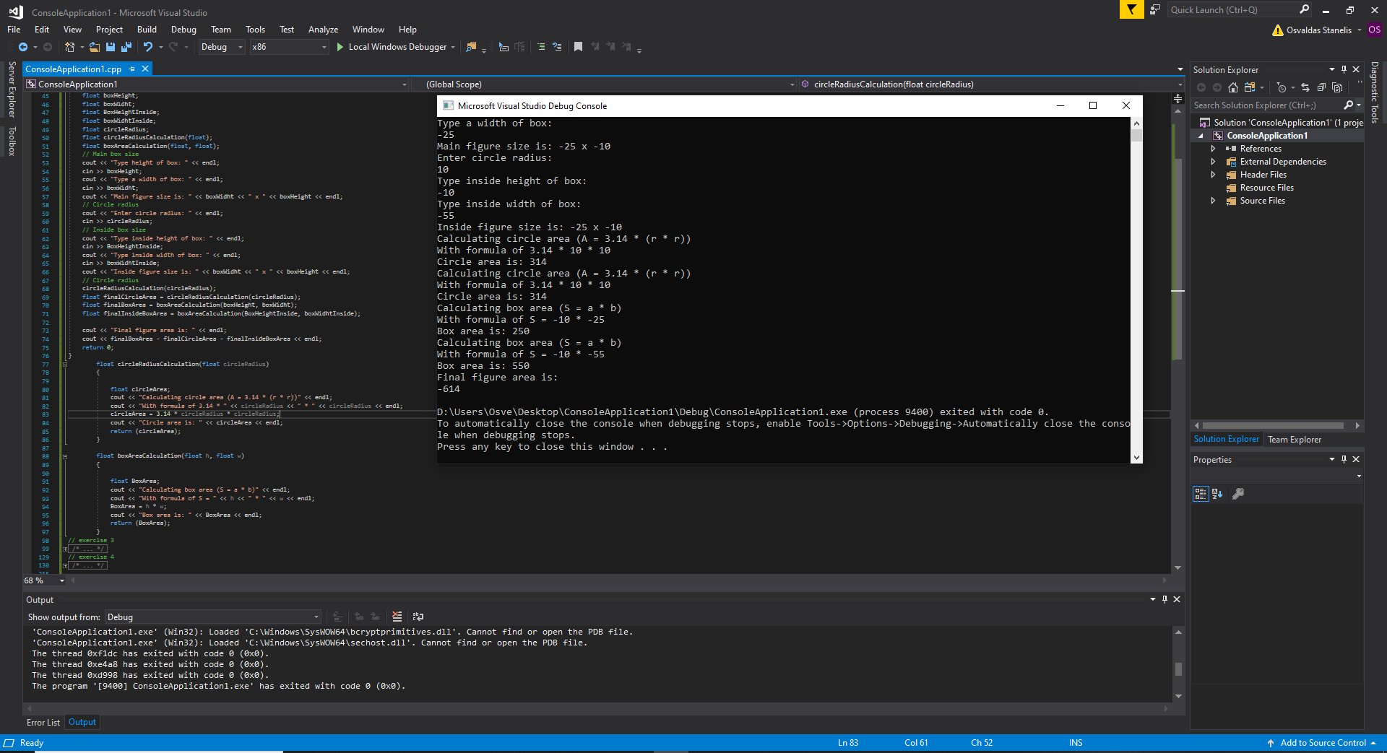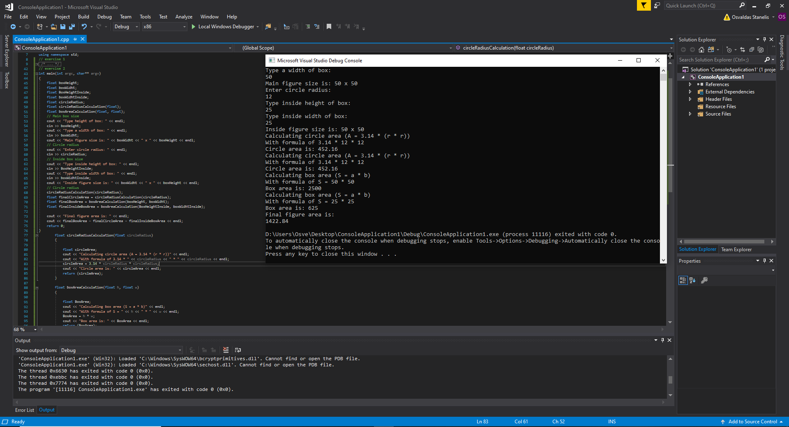 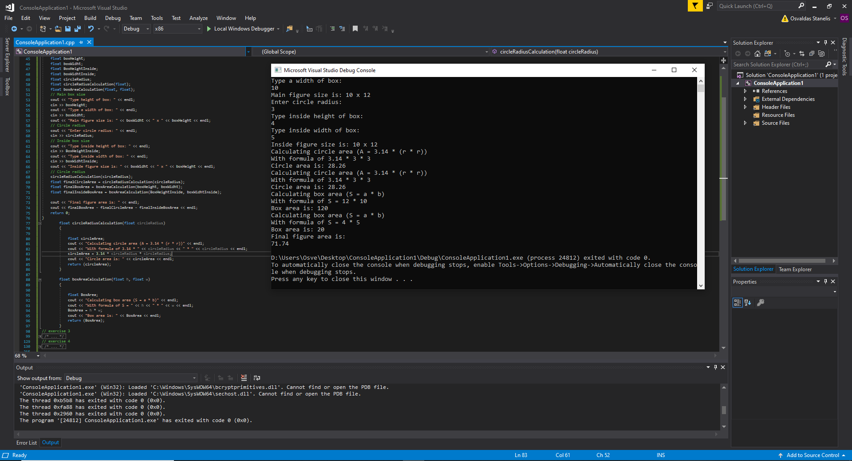

Exercise 3
Code:
int main(int argc, char** argv)
{
string input;
stringstream stream;

int sizeA;
int j = 1;
int sum = 0;
double* prices;
cout << "How many prices are you going to enter? " << endl;
cin >> sizeA;
cout << "Your price is: " << sizeA << endl;
prices = new double[sizeA];

for (int i = 1; i <= sizeA; ++i)
{
cout << "Enter prices: " << endl;
cin >> prices[i];
cout << "Your price is: " << prices[i] << endl;
}
while (j<=sizeA)
{
cout << "Product price is " << prices[j] << endl;
sum = sum + prices[j];
j = j + 1;
}
cout << "Total sum of GBP is " << sum << endl;
cout << "Total sum of EUR is " << sum * 1.14 << endl;
}

Pictures: 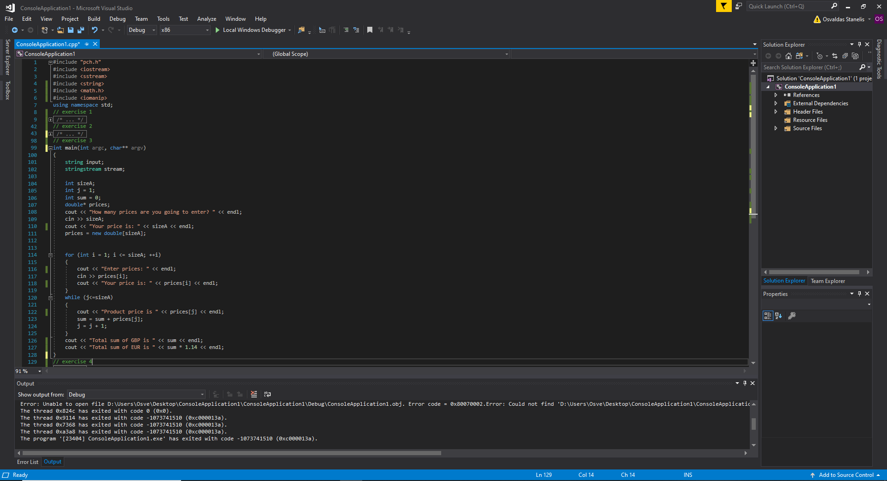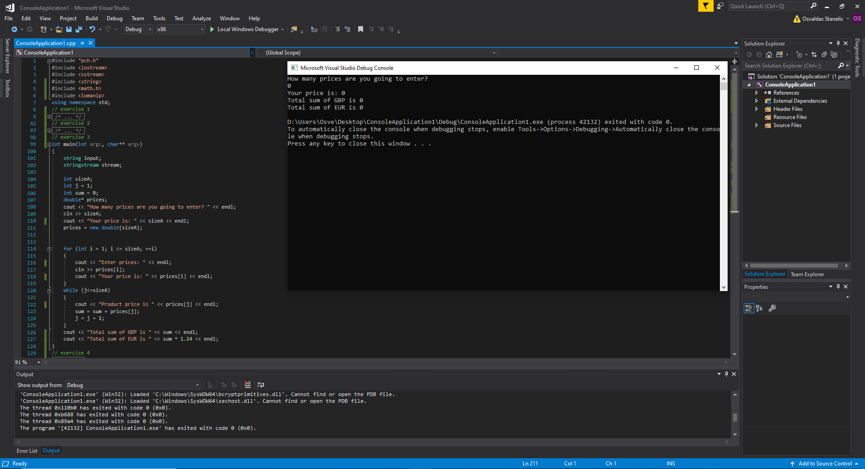 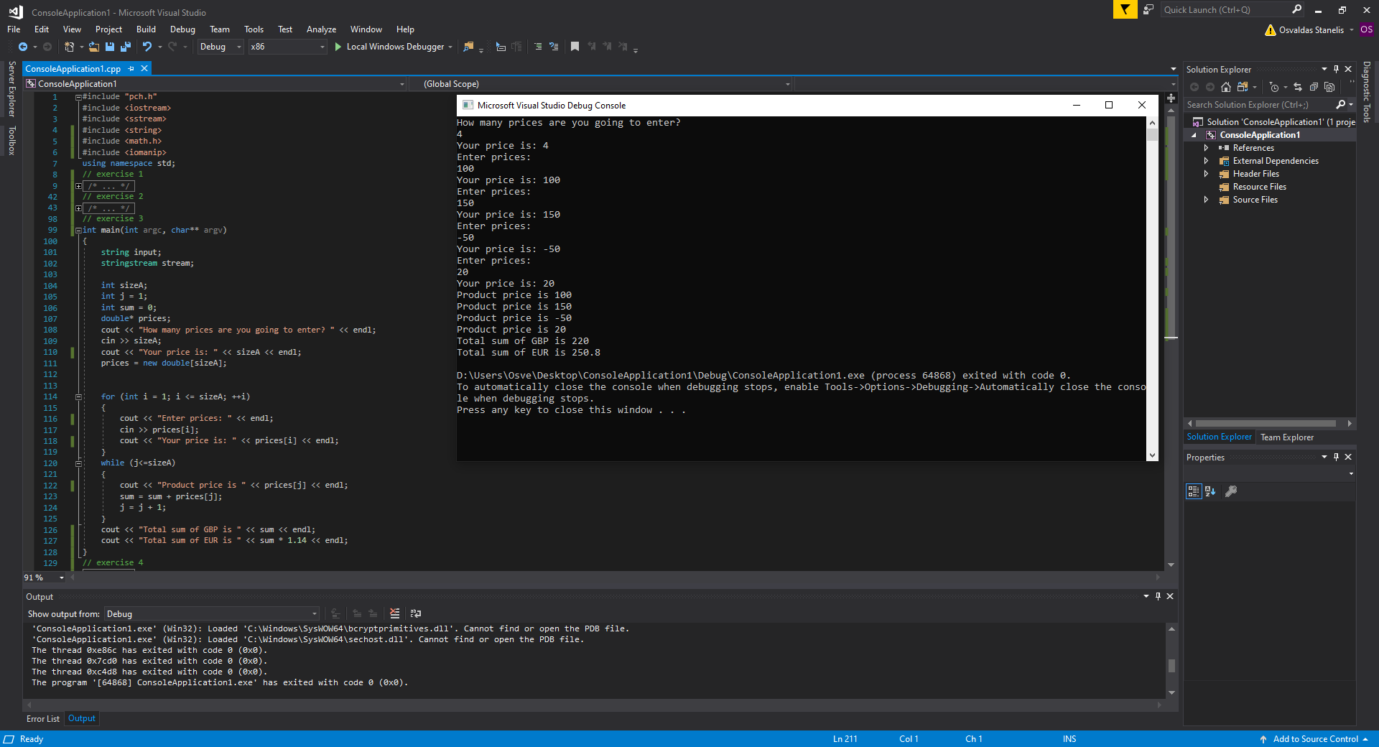 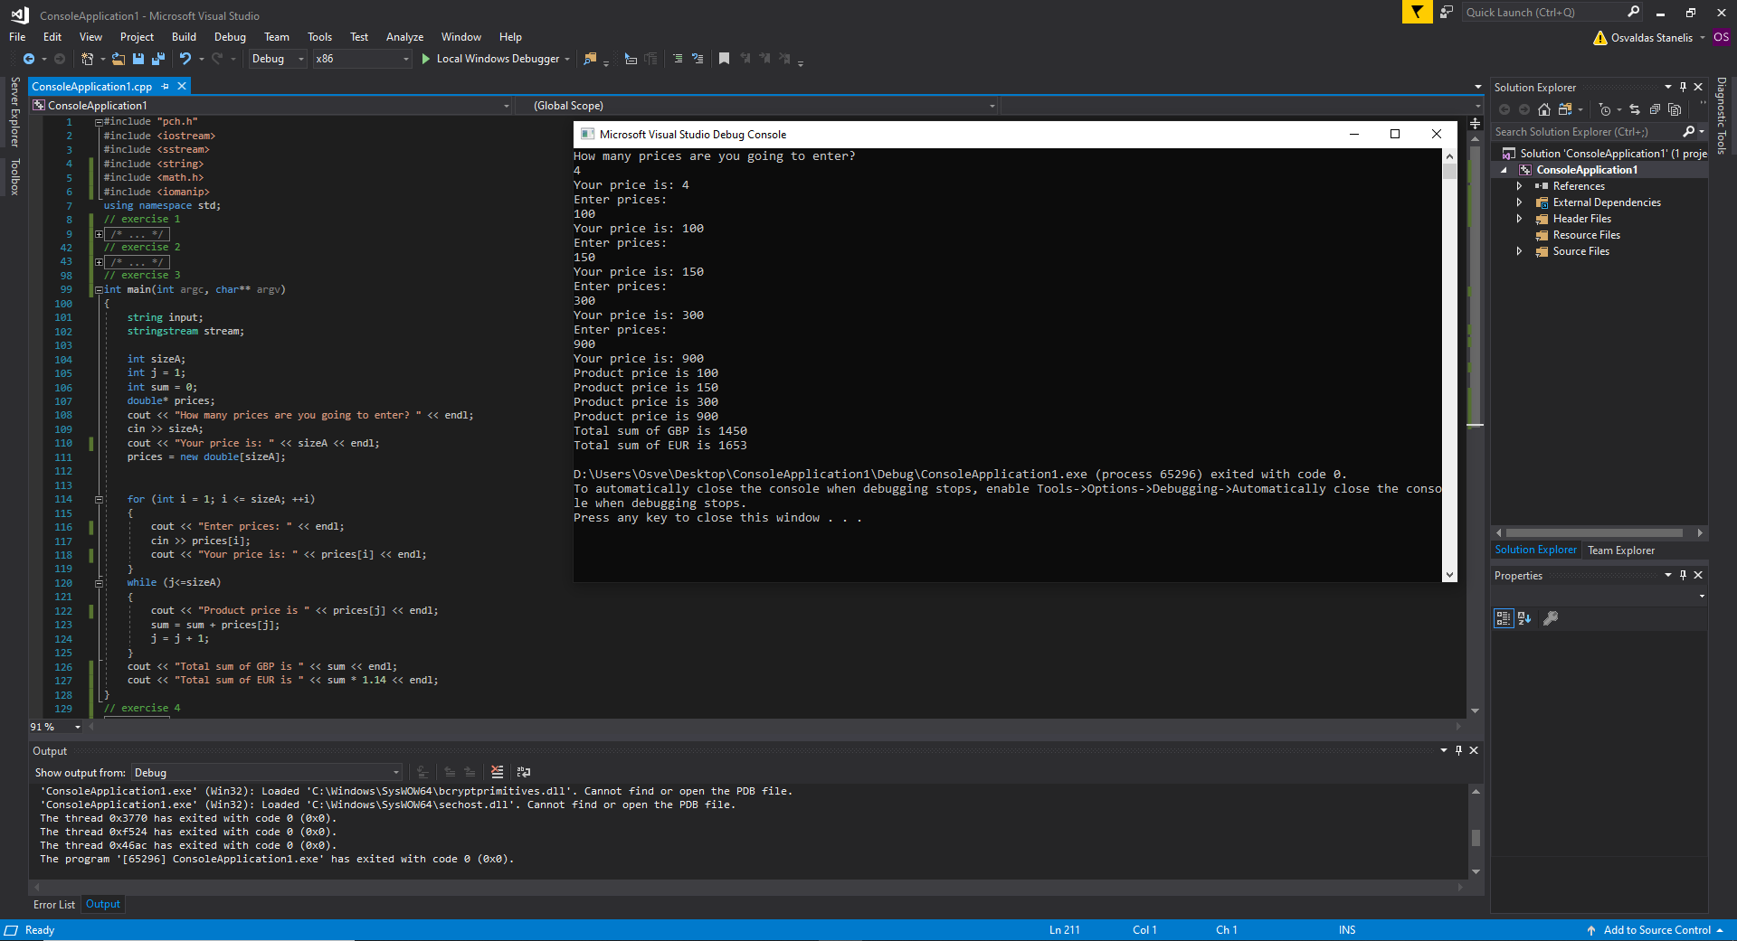

Exercise 4
Code:
int main(int argc, char** argv)
{
int x1, y1;
int x, y;
int x1guess, y1guess;
int lifeCounter = 3;
int placementIterations = 1;
int succesfullShots = 0;
char treaseCoords[8][8] = { '-' };
char shootingCoords[8][8] = { '-' };
void draTableOfTreasures(char);

cout << "Player 1 turn " << endl;

// fill all table with -
int filli, fillj;
filli = 0;
while (filli < 8)
{
fillj = 0;
while(fillj < 8)
{
treaseCoords[filli][fillj] = '-';
fillj++;
}
filli++;
}

// Enter Treasure coordinates for game
for (int i = 0; i < placementIterations; i++)
{
cout << "Player 1 place treasures now: " << endl;
cout << "X ";
cin >> x;
cout << "Y ";
cin >> y;
treaseCoords[x][y] = 'x';
}

// Draw auto table via loop where treasure have been placed for debuging
int i,j;
i=0;
while(i<8)
{
j=0;
while(j<8)
{
cout << "\t" << treaseCoords[i][j];
j++;
}
i++;
cout<<"\n";
}

cout << "Player 2 turn: " << endl;
for (int i = 0; i < placementIterations; i++)
{
cout << "Player 2 chose coordinates: " << endl;
cout << "X ";
cin >> x;
cout << "Y ";
cin >> y;
shootingCoords[x][y] = 'x';
if (shootingCoords[x][y] == 'x' && treaseCoords[x][y] == 'x')
{
cout << "Successfull guess" << endl;
succesfullShots = succesfullShots + 1;
}
else
{
cout << "Sorry there is nothing" << endl;
lifeCounter = lifeCounter - 1;
}
}
// Print final game status
if (lifeCounter <= 0 || succesfullShots == 3)
{
cout << "!!! Player 2 won !!!" << endl;
}
else
{
cout << "Sorry !!! Player 1 won !!!" << endl;
}
}
Pictures:

