Academic and Employability Skill

Table of Contents
Task No. | Task Title | Page No
1.1 | Personal Overview | 03
1.2 | Self-introduction | 04
1.3 | Key learning during preparing and delivering PowerPoint presentation | 04
2.1 | Required level of skill for higher educational learning | 05
2.2 | Required employability skills | 06
2.3 | Self-evaluation | 07
2.4 | Compare and contrast the skills | 08
3.1 | Action plan | 09
4.1 | Look after personal data | 10
4.2 | The possible disasters for data damage | 10
4.3 | Potential threats of Cryptowall virus | 11
 | Conclusion | 11
 | Appendices | 12
 | References | 13

Section 1:
1.1 Personal Overview:
Moij Gugarman
07459300580
moijgugarman@outlook.com
Objective
Look for a suitable position in an organization where I can execute my capabilities and skills to meet the professional demands. I want to demonstrate my theoretical knowledge in an encouraging work environment when working in the organization and learning continuously.
Education
2014-2015 English course Level 1
2012-2014 Higher secondary-Gujarat Board
Subject English, Math, Computer, Physics, Chemistry.
2011-2012 Secondary school-Gujarat Board
Subject English, Math, Computer, Hindi, Gujarati
Internship experience

Work experience:
October 2017-to date
Co-operative (Customer Assistant)
Job Duties:-
· Providing information about products to customers
· Giving best service to customers
· Ensuring that customer get what they want to know
· Helping customer to decide what type of product they need

June 2015-September 2017
Roman Scrap Traders
Behind Central Ware House, Marida Crossing, Nadiad, Gujarat, 387001.
Job duties:-
• Analyze end of the day report
• manage the accounting department
• Deal with customers
• Explain in deep about the product
• Handle the labor department
Skills
· Hardworking and enthusiastic
· Team player but can work independently
· Strong interpersonal communication skills
Language: English
Hobbies
Reading Books, Playing Cricket, Ilike to meet new people occasionally

1.2 Self-introduction
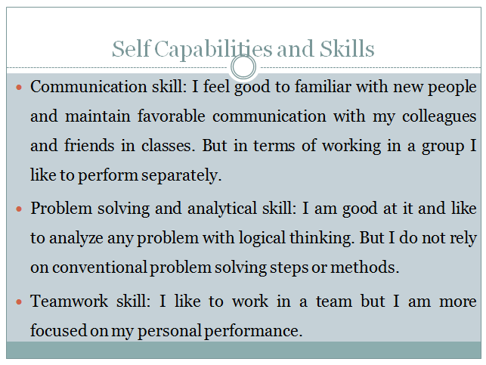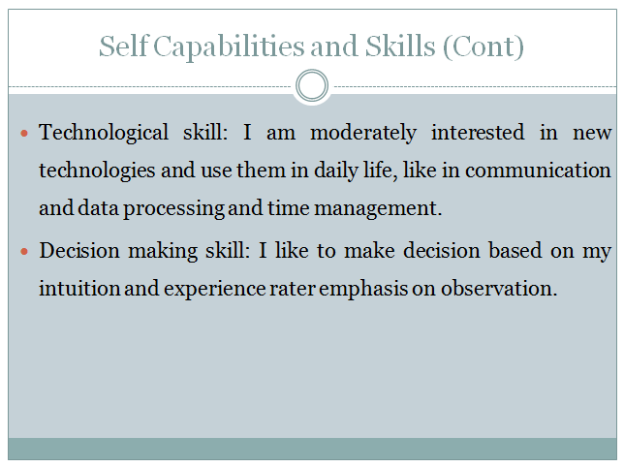
1.3 Key learning during preparing and delivering PowerPoint presentation
In different courses in this university and in my professional life I had to prepare and deliver PowerPoint presentation many times and each time I have learnt something new. This time some of my lessons are listed below-
- The content of the presentation should be specific and as simple as possible so that audience can relate them easily with the presentation.
- The key points should be highlighted properly in the slides so that the audience can easily grab the concept and also in question session it becomes easy to focus on specific topic.
- The question session should be arranged after delivering the presentation and that should be mentioned before the presentation.
- In group presentation the topic should be distributed according to the knowledge and expertise of the team members.
- Additional animation and videos should be avoided that help to save time during presentation.
- Related pictures and graphs should be included in the slides that enhance the attractiveness of the presentation.
- Simple PowerPoint design should be used that make the audience comfortable to read the contents.
- During presentation it is better to use any presentation note rather reading from the slides.
- It’s important to choose suitable gesture and posture used during presentation that should carry confidence of the presenter.
- The number of slides should be standard so that audience doesn’t feel boring before starting the presentation.
Section 2: Skill Evaluation
2.1 Required level of skill for higher educational learning
The level of learning style gets varied in the different stage of life so it finds that the earlier stage of life the strategies undertaken differently with the change of the individual’s age. The basic demands of the employee’s services are it link up with the individuals demand in workplace and the service provided by the adults. Basically the individuals have to meet with the needs and meet with their professional demand from the level of the education. Some skills that is very crucial for the study of the higher educational knowledge is given below:
Adaptive thinking skill: due to the fast changing of the technologies the communication process is also changing very effectively and creating very significant impact on the businesses (Finch and Fafinski, 2014). It is becoming very crucial for the management and the education institution to make the employees always get able to communicate from the high technological devices to ensure that the communication has properly been made.
Collaborative skill: the working is a team or in a group is very important for the students and the professionals of the company. the businesses are highly focused on performing all activities in a group as it successfully enhance the quality of the services delivery and make the individuals get able to achieve success by supporting one another. The collaborative working of the employees share common values and common goal that needs to achieve.
Problem solving skill: According to Zaki (2013), the problem solving ability of the employees are also very significant for the companies to ensure the achievement of organizational goal appropriately. The educational content develop in this process in a way that the individuals get able to find out issues of problem solving and get practice from the real world perspective.
Innovation and creativity: the educational institute is very much concern to make the individuals to enhance their creativity and develop new ideas in a way that they get able to remain competitive in business environment. The innovative ideas are very much important for the companies to make its distinguished from other companies in business environment. So the management always remains concern to ensure that the employees are highly focused to develop innovative strategies.
Self – learning ability: The self-management learning ability of the individuals also play a crucial role for the employees of the organization as they get able to find out a sense of competition among the employees who are more willing to take challenged and learn issues that has been developed by their self-ability. The performance of the employees gets significantly varied from the self-management skills.

2.2 Required Employability Skill
According to Zaki (2013), the employability skills of the individuals are very supportive for them to make individuals get properly able to engage in professional work. There are several employability skills that developed at the time when individuals gain knowledge from the higher educational studies. The employability skills of the employees are presented below:
Communication: According to Spaaij (2011), the communication skill is very important for the workplace as its directly impact on the service ability of the employees and also create impact on the service delivery to the customers. There are different types of communication that employees have to perform like face to face communication and over phone communication. There are several factors like body movement; voice etc. significantly contributes of the communication level of the employees.
Team Work: the companies are highly focused to make all employees get engage to perform all activities in a team so that the overall qualification of the companies get enhanced. The team effort makes the employees to receive support from other individuals and perform all activities appropriately. The total performance of the organization get improved when all employees engage to work in a team
Problem Solving: the ability of the employees for solving the problem makes them able to perform all activities appropriately and enhance the effectiveness of the organizational performance. In this process the innovative ideas generate by the employees to ensure that the employees get able to resolve the problems that has been generated in workplace.
Technology: According to Gravells (2010), the technology is very significant for the employees to get able to perform all activities appropriately. It makes the employees to significantly enhance the overall performance of the organization. The company gets able to enhance the effectiveness of the service delivery ensuring the appropriate time.
Initiative and enterprise: the initiatives are very important and crucial for the companies as the initiatives taken by the employees make them able to perform better in workplace. Their initiatives make them get able to adopt the changes appropriately and perform accordingly with the organizational demand and remain competitive.

2.3 Self-evaluation
Self-evaluation is required to find out self-strengths and weaknesses that are helpful to prepare an action plan to achieve proper learning objectives within a specific time period. My strengths and weaknesses are identified below-
Strengths:
- I don’t hesitate to learn new things rather have interest in new study materials.
- I have the ability to learn anything fast.
- I have capacity to motivate people.
- I am good in time management that helps me to make thinks ready within time.
Weaknesses:
- In crucial situation I can’t take decision fast.
- I usually fell interrupted if anyone criticizes my work.
- I am not highly active in social media communication that is essential in digital age communication in academic and professional life.
2.3.1 Personality type
Based on a wed based personality test I have evaluated my personality and found the personality I have. There are some factors considered here to portrait my personality as discussed below-
Mind: This personality trait states hoe much open-minded a person is when he communicate or interact with other people. From this point of view I am proved more introvert minded person. So, this is sometimes hinder in favorable communication. In teams of team building and working in a team introvert nature make hindrance.
Energy: This is another personality trait that indicates how an individual uses his mental energy to think about anything. According got the test I am more focused to use more mental energy on my instinct that means I take decisions based on natural instinct rather observing.
Nature: This personality trait evaluates the nature of decision making whether the decision is taken based on logic or emotions. From that perspective I am more logical in terms of making any decision.
Tactics: In terms of decision-making and planning how tactically sound a individual is that is evaluated this personality trait. Based on the test I am less judgmental and more prospectus in terms of making decision and planning.
Identity: This personality trait evaluates an individual’s identity in self-confidence for making decision and taking any initiative. I found me as less confident from this perspective.
2.4 Compare and contrast the skills
The compare and contrast is conducted to between my skills mentioned initially in the PowerPoint presentation. I have selected those skills where I need to improve myself-
Communication skill: I need to develop my communication skills as I found that what I think about my communication that is not actually right because of my more introverted mind-set. So, I need to develop extroversion communication skills.
Team working skill: I like to work in a team but that is not effective as I mainly focus on my personal performance. So, it is very important to team working skill right now that will be very useful in my professional career.
Decision making skill: In terms of my decision making skills I have found similarities between my personal view and tested result. But this is not good for me to take decision based on intuition that actually makes confusion. So, I have to improve this skill by taking decision based on proper analysis and observation.
2.4.1 Learning from the exercise
Through the self-evaluation process and comparing my personal thoughts about my learning skills with tested results in this exercise I have learnt many things as listed below-
- Individual performance and effort is less important than performing as a team that is also helpful in professional life.
- What skills I need to develop that can be identified when others like team members and my teachers notice them rather I notice them.
- Leadership skills development is good for working in an organization but dominance attitude should be avoided that enhance the acceptance in a team.
- Criticism is good that helps to sort out the weak points in learning skills.
Section3: Action plan
An action plan is essential for me to develop my learning and employability skills to achieve my goals in academic and professional life. An action plan is developed below with short-term and long-term goals-

 | Short-term time frame | Long-term time frame
My Goals: I want to be the university’s student president | In my upcoming courses I want to work in teams and try to involve me in tem building activities. | I want to represent my department as student’s representative as a president.
Skills and knowledge to be learned | - Collaborative skills need to develop  - Communication skills need to develop specially the social media communication | - Leadership skills need to develop along with the capability of managing diversified people  - Decision making skills must be developed to make decision in crucial situations
Process to acquire the skills | - More team engagement and sharing ideas with team members  - Be more familiar with social media communication and try to cope up with the latest communication systems | - Try to help own team members and other team members in a friendly way that will help to convince others and make more popularity
Resources | Enough time to spend with the team | Support from friends, own team and own class
Time schedule | I want to start implementing my action plan by this semester and it will end in next semester. | I want to start this process by this semester and want to complete until I become a student president.

Section 4: Application
4.1 Look after personal data
This is a digital age and data is stored in digital form and exchanged through digital medias. So, there is safety and risks both to handle these kinds of data. The personal and official data carries most confidential value compared to other kind of data. So, it is important to ensure highest level of security where backup is a technique to protect the data. It is better to backup the important data in 3 different places as discussed below-
1st place: PC or laptop: This is the first place where data can be stored in separate drive with proper management and following an order. In this case it is very important to use trustworthy and strong anti-virus software. If the PC or laptop is connected to the internet it’s very important to do to ensure primary level data protection.
2nd place: External storage devise: This is an onsite data backup place where an external storage device can be used to backup the exact data stored in the PC or laptop. In that case it is very important to remember that keep update the data regularly.
3rd place: Cloud storage: This is an offsite data storage system where a user can backup his data automatically when it is updated and added new data in his/her PC and laptop. In case of damaging of other tow places data this backup can help to get the data back.
4.2 The possible disasters for data damage
Data can be damaged in different way and for digital data this is a very common but highest risk for users. Due to data damage the possible disaster are listed below-
- If data is damaged during or end of the organizing or preparing any data or project it becomes a disaster for the user to rearrange all the information and also give same level of dedication to prepare the project within deadline. As a result a student can lose grades and for a job holder it may hamper his performance and even can be a valid cause to fire from his job.
- If data is damaged that and that is confidential or very important for an organization that company can suffer significant loss in monetary value.
4.3 Potential threats of Cryptowall virus
Cryptowall virus is also known as Ransomware that is automatically downloaded into user’s computer device and start to encrypt files which is not controlled by the user. The potential threats of this virus is given below-
- It takes control of user’s PC and starts remove files that can be a huge loss for user.
- It creates encryption of the files and locks the PC that is not possible for the user to access his PC again.
- The Cryptowall hackers demand highest amount of money from users and in return theyr provides the access. They can blackmail the user for his personal and confidential data.

Section 5: Conclusion

There is a link between the skills of higher study and the employability skills because during the higher education the students become prepare for their professional life. This is the best time to prepare for that professional life and make prepare for desired job. For those who are dong job and also doing higher study they can compare their skills and find out proper way to develop specific set of skills useful for their existing and future job position.

Section 6: Appendices:
Appendices 1: Sample questionnaire of personality test
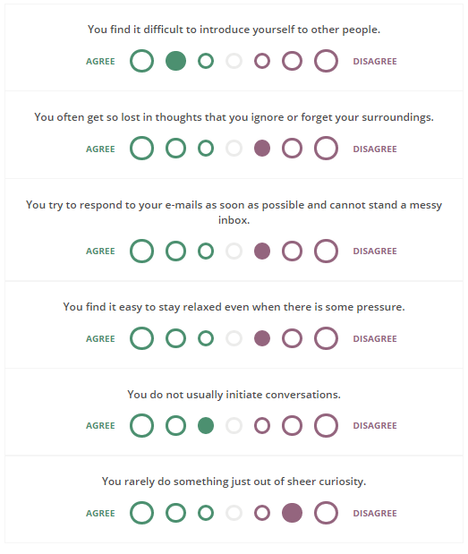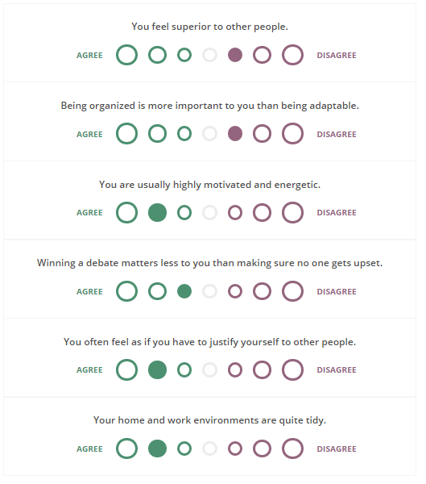

Appendices 2: Personality test result
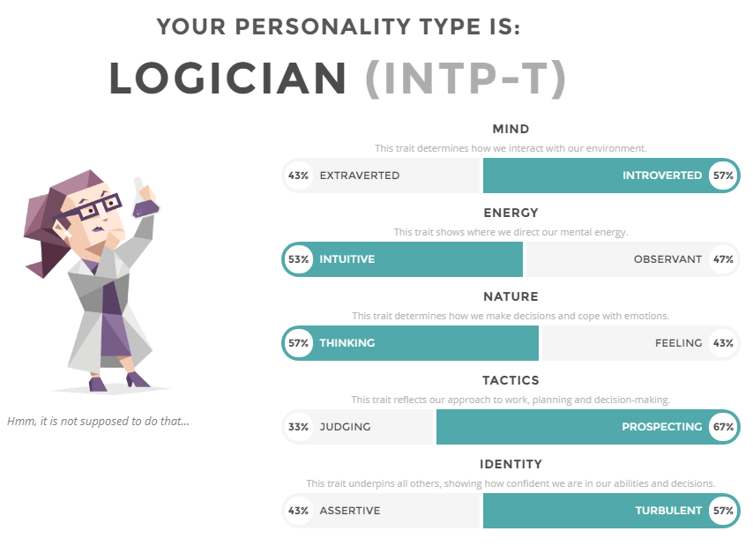

References
- Finch, E., Fafinski, S., (2014) Employability Skills for Law Students: OUP Oxford
- Gravells, A., (2010) Delivering Employability Skills in the Lifelong Learning Sector: SAGE
- Spaaij, R., (2011) Sport and Social Mobility: Crossing Boundaries: Taylor & Francis
- Zaki, S. A., (2013) Development of Employability Skill Profile for Construction Skilled Workers: Universiti Teknologi Malaysia
- Mehmood, M. F., Ali, J. A., Saim, H. M., (2014) An assessment of industrial employment skill gaps among university graduates: Intl Food Policy Res Inst
- Rao, M. S., (2015) Soft Skills - Enhancing Employability: Connecting Campus with Corporate. I. K. International Pvt. Ltd.
- Holmes, K. (2017) What Employers Want: The Employability Skills Handbook. Trotman Education.
- Marsh, R., (2016) Skills for Employability Part One: Pre-Employment. Christal Publishing.
- Susskind, L., Moomaw, W. and Gallagher, K., (2016) Transboundary Environmental Negotiation: New Approaches to Global Cooperation. John Wiley & Sons.
- Hager, P. and Holland, S., (2014) Graduate Attributes, Learning and Employability. Springer Science & Business Media.

