
Living with Chronic Heart
Disease: Long-Term

Management of Coronary Artery Disease
Name: Jaiminkumar Amrutbhai Limbachia
Student Id: 2527056
Instructor: Dr. Raheela Shaikh
Course: Master in Public Health And Social
Care In Practice
Module Code: LCHS7003
Date: 27/02/2026

Living with Chronic Heart Disease:
Long-Term Management of Coronary Artery Disease
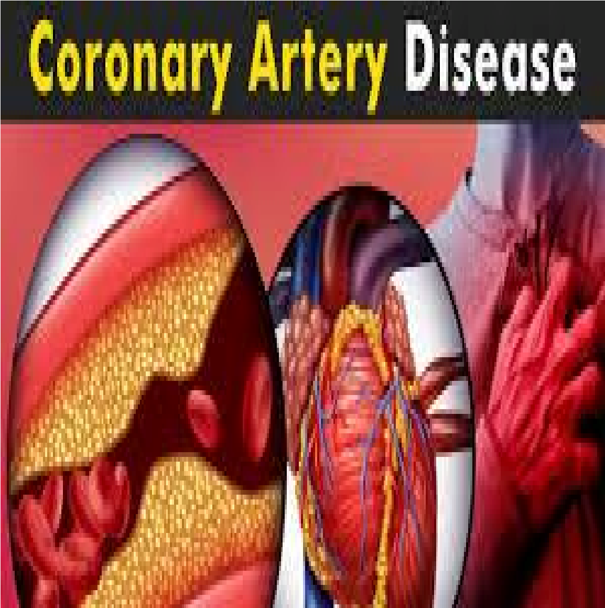

Contents
Living with Chronic Heart Disease: Long-Term
Management of Coronary Artery Disease 4
Introduction 4
Definition and Prevalence of CAD 8
Symptoms of CAD 10
Risk Factors and Aetiology of CAD 12
Non-Modifiable Risk Factors: 12
Modifiable Risk Factors: 15
CAD impacts their families and personal lives 16
Evidence-based interventions, UK 19
Pharmacological Treatments: 20
Invasive Procedures: ...................................... 22
CAD Management Theoretical Model 24
Social Care and Health Agendas-Political 25
Recommendations on how to Improve Person-Centred
Care 27
Summary 29
Reference list ...................................................... 33

Living with Chronic Heart
Disease: Long-Term
Management of Coronary Artery
Disease

Introduction
Coronary artery disease (CAD) is a prevalent and life-threatening health risks in millions of people worldwide (Bansal & Hiwale, 2023; Bottardi et al., 2024).
As the primary cause of deaths due to cardiovascular complications, CAD is a constriction or obstruction of the coronary arteries supplying oxygenated blood to the heart muscle because of deposition of the plaque (atherosclerosis) (Cacciatore et al., 2023).
It is the reduction of blood flow to the heart and, consequently, the development of heart pain (angina), heart attack, and heart failure eventually (Bottardi et al., 2024).
Usually, CAD is a chronic progression, a chronic disease, and the quality of life of the representatives of the population in question improves or deteriorates depending on the success of the management (Bahit et al., 2023).
The impact that CAD has had is not simple when it comes to the physical well-being of the individuals, as well as with regard to their mental health and social interactions (Dabek et al., 2024).
The consequences of the symptoms of chest pains, fatigue, and shortness of breath may lead to extreme quality of life and functional disability in performing the functions of life (Dabek et al., 2024).
In addition, the moral stress of living with the chronic illness and being stressed about the illness can also cause anxiety and depression (Bucciarelli et al., 2020).
This effects further exacerbated for the families and the caregivers, who are emotionally and financially strained by taking care of their loved ones (Bucciarelli et al., 2020).
This booklet critical examines of pathophysiology, risk factors, and general management of CAD with particular emphasis on the existing evidence-based treatment options in the UK (Bansal & Hiwale, 2023).
It also explains what happens to patients and their families, both tangible and intangible, due to CAD and comments on the existing models of care, and offers suggestions on how person-centred methods can be improved (Cacciatore et al., 2023).
These points contribute to the fact that this booklet should have awareness raising due to the necessity to adopt a holistic and integrated approach to CAD management, which will eventually result in improved health outcomes and quality of life of people affected by the condition (Bottardi et al., 2024).
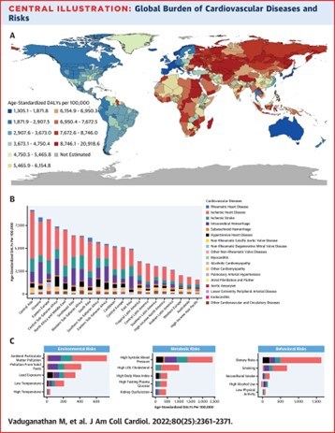
(Vaduganathan et al. 2022)

(Wong 2012)

Definition and Prevalence of CAD
The constriction of coronary arteries, which may occur due to atherosclerosis, where the coronary artery walls are covered with a plaque of cholesterol, fats, and other substances, is a primary symptom of coronary artery disease (Sciahbasi et al., 2024).
The presence of the plaque blocks the blood supply to the heart and can lead to angina, heart attack (myocardial infarction), and heart failure (Bansal & Hiwale, 2023).
Incidence in the globe: CAD is at the forefront in the number of conditions, which are deadly and kill millions of individuals every year worldwide.
According to the WHO, 17 million people die each year because of cardiovascular diseases (CVD), and cardiovascular disease (CAD) is estimated to be 32% of all deaths globally (WHO, 2023).
The older age group and the middle-aged are susceptible to CAD (Bottardi et al., 2024).
UK Prevalence: CAD is a public health problem that is of consequence in the UK.
The figures given by the British Heart Foundation show that there are over 2.3 million patients of CAD in the UK (BHF, 2023).
Moreover, one out of every 26% of all the national deaths is caused by CAD (BHF, 2023). With the aging population, lifestyle changes, and the rise of risk factors in the population, e.g., obesity, smoking, poor diet, etc. (Cacciatore et al., 2023), CAD is becoming more prevalent.

Symptoms of CAD
Chest pain (Angina): The symptoms are usually the feeling of pressure or a squeeze in the chest (Bansal & Hiwale, 2023).
May radiate to the arms, neck, jaw, back, or stomach (Bottardi et al., 2024). Result of a physical activity, stress, or emotional distress (Cacciatore et al., 2023).
Can be relieved by rest or nitro-glycerine (when it is stable angina) (Bansal & Hiwale, 2023) Shortness of breath: hypertension is a common comorbid condition in CAD patients.
It leads to additional destruction of the arteries (Sciahbasi et al., 2024).
Abnormal heart sounds:
The Presence of murmurs or abnormal heart sounds can also give some hints about the problems with the heart functions (Jung et al., 2023).
Ankle, foot, leg swelling: This may be due to heart failure (complication of CAD) in the region where the heart fails to pump blood (Ciuca-Pana et al., 2025).
Cold, clammy skin: It may be a symptom of a heart attack or the insufficiency of circulation due to CAD (Golukhova et al., 2023).
Cyanosis (bluish color of the skin): The deficiency of oxygen in blood may change the skin, lips, or nails to blue, in the most extreme cases (Golukhova et al., 2023).
Reduced exercise capacity: the inability to perform previous tasks without difficulty due to the poor functioning of the heart (Ciuca-Pana et al., 2025). The symptoms and signs do not always manifest themselves identically in all patients with CAD (Jung et al., 2023).

Risk Factors and Aetiology of CAD
Risk factors leading to CAD and prevent and curb them (Fuchs & Whelton, 2019).
These risk factors are either modifiable or non-modifiable to determine (Giubilato et al., 2023).

Non-Modifiable Risk Factors:
Age: Age is a risk factor of CAD, particularly after the age of 45 years in men and 55 years in women (Fuchs & Whelton, 2019).
Gender: Men are more susceptible to it at a younger age, and women are more susceptible to it at an older age due to the absence of estrogen, which protects the cardiovascular system (Grande et al., 2020).
Genetic Factors: The prevalence of CAD is influenced by several modified or non-modifiable risk factors (Bansal & Hiwale, 2023). Age, gender, and family history are examples of non-modifiable risk factors (Bottardi et al., 2024). Age is considered the most likely risk factor for CAD, with the most precise numbers being estimates at 45 (men) and 55 (women) .
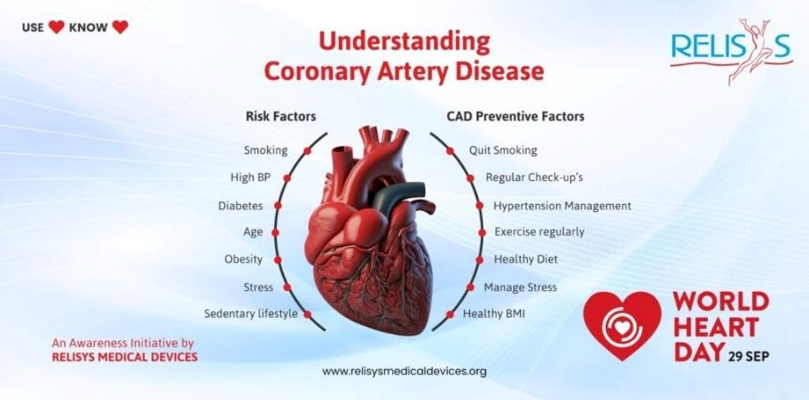

( Risk factors of CAD )

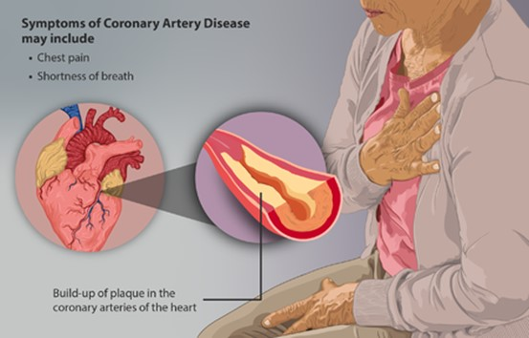
( Acute Coronary Syndrome 2021)
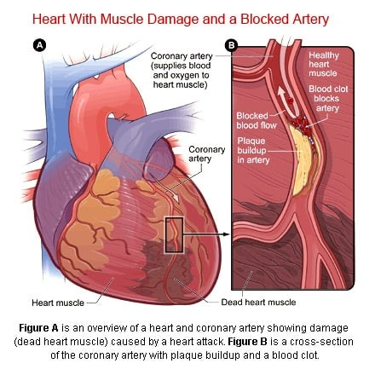
( COR Medical Group, Inc. 2025)

Modifiable Risk Factors:
Hypertension (High Blood Pressure): High blood pressure causes the walls of the arteries to become susceptible to the deposits of plaque (Fuchs & Whelton, 2019).
Dyslipidemia: abnormal concentration of low-density lipoprotein cholesterol (LDL-C) and triglycerides, and normal levels of the high-density lipoprotein cholesterol (HDL-C) significantly contribute to the atherosclerotic process (Giubilato et al., 2023).
Smoking: With the use of tobacco, the number of blood clots is increased, and the plaque in the arteries grows at a faster rate (Giubilato et al., 2023).
Physical Inactivity: Exercise is among the main risks of obesity, Hypertension, and diabetes, which lead to CAD (Grande et al., 2020).
Obesity: Obesity and overweight conditions put the heart load higher and pressure, cholesterol, and glucose higher, which elevates the risk of CAD (Colhoun et al., 2024).
Diabetes Mellitus: Diabetes predisposes atherosclerosis to harm the blood vessels and promote the growth of plaque (Colhoun et al., 2024).

CAD impacts their families and personal lives
The impact of CAD on the physical health of individuals is both complicated and negative, not to mention that it also affects mental and social health (Grande et al., 2020).
In addition to that, the effects of the disease on the families and the caregivers of the individuals with CAD are extensive domains (Giubilato et al., 2023).
Physical Impact: CAD has the following main physical issues: chest pain (angina), fatigue, and loss of exercise tolerance due to the insufficiency of blood supply to the heart (Golukhova et al., 2023).
According to the research literature available, the pathophysiology of the disease development of CAD is associated with the fact that a heart attack, arrhythmias
(irregular heartbeats), and heart failure can occur (Ciuca-Pana et al., 2025).
Chronic CAD might lead to the inability to perform daily activities and, in the long run, might result in disability (Golukhova et al., 2023).
Psychological Effect: CAD can have far-reaching psychological effects (Grande et al., 2020).
The majority of individuals with CAD become anxious, depressed, and fearful of a heart attack (Grande et al., 2020).
The need to receive medical attention, lifestyle modifications, the uncertainty of the outcome of the further evolution of the health condition, etc., may cause the emergence of chronic stress (Giubilato et al., 2023).
In fact, in the study, depressed and anxious patients with CAD tend to escalate the progression of the illness (Grande et al., 2020).
Social Impact: CAD does not affect a person only, but also the family members and caregivers (Giubilato et al., 2023).
The disease may be related to a long-term course, the constant appearance of the doctor, and certain lifestyle changes, and all these points may turn into an acute load on the relations in the family (Ciuca-Pana et al., 2025).
It can lead to physical, emotional, and financial stress among the caregivers, especially when they have to help the patient overcome the condition (Giubilato et al., 2023).
The relatives may experience burnout and lower quality of life due to this load of care (Grande et al., 2020).

Evidence-based interventions, UK
CAD treatment is a complicated procedure that requires modifications in lifestyle, drugs, and, in severe instances, the use of instruments (Krittanawong et al., 2024).
The following are the treatments that are also common in the UK and other developed nations (Giubilato et al., 2023).

Pharmacological Treatments:
Statins: Statins are the initial treatment for LDL-C level reduction (Giubilato et al., 2023).
They are working by inhibiting HMG-CoA reductase, which is one of the essential enzymes in the liver that forms cholesterol (Farmakis et al., 2021).
Additionally, statins have been reported to be highly effective in reducing the chances of heart attacks and strokes among other cardiovascular diseases (Giubilato et al., 2023).

Statin as first-line treatment of CAD.
Antiplatelet Drugs: CAD patients are administered antiplatelet drugs like aspirin and clopidogrel to clear their blood clots that cause heart attacks (Golukhova et al., 2023).

(Austin 2019)
Beta-Blockers: The medications reduce the heart output by slowing the heartbeat and lowering blood pressure, and thus reduce the CAD symptoms, such as angina (Farmakis et al., 2021).
Angiotensin-Converting Enzyme (ACE) Inhibitors ACE inhibitors refer to medications that are used to widen the blood vessels and lower the blood pressure of individuals with CAD, besides boosting the general heart functioning of the individuals (Ciuca-Pana et al., 2025).
Calcium Channel Blockers: It is a kind of drug that helps to relax and dilate blood vessels and, therefore, pump the heart's blood more easily (Farmakis et al., 2021).

Invasive Procedures :
Percutaneous Coronary Intervention (PCI): PCI is a kind of intervention that implies the insertion of a catheter to recanalize the blocked blood vessels and insert a stent to maintain their openness (Nemeth et al., 2025; Lugo-Gavidia et al., 2024).
Coronary Artery Bypass Grafting (CABG): CABG is a surgery that involves the replacement of a blocked artery in the heart with a normal blood vessel (Kohsaka et al., 2023; Pagliaro et al., 2019).

CAD Management Theoretical Model
The theoretical models are valuable to comprehend and apply to improve the long-term outcomes of CAD patients (Agamy et al., 2025).
The National Institute for Health and Care Excellence guidelines on CAD management in the UK provide a platform to resolve the issues with the latest evidence (Sciahbasi et al., 2024).
Such principles are concerned with the stratification of risks, the early detection of the latter, and the creation of a certain treatment plan according to the needs specific to the individual patients (Ciuca-Pana et al., 2025).
The Framingham Risk Score (FRS) is one of the most widespread tools for assessing the risk of developing CAD in 10 years in other parts of the world (Kohsaka et al., 2023).
It is inclusive of multiple variables, including age, sex, cholesterol, blood pressure, smoking, and diabetes (Sciahbasi et al., 2024).
Both models, the NICE guidelines and the FRS, provide structured frameworks that guide clinical practice and decision-making, ultimately improving the long-term health outcomes for CAD patients.

Percutaneous coronary intervention (pci) procedure and
Cardiac Catheterization and Percutaneous Coronary
Intervention (PCI) image

Social Care and Health Agendas-Political
CAD management is the area where the local and national health policies play an important role (Oancea et al., 2025).
NHS Health Check is a program that entails offering free check-ups to individuals between the ages of 40-74 years of age to ascertain their risk of heart disease, stroke, kidney disease, and diabetes in the UK (Bentzel et al., 2024).
This will be to provide early interventions to high-risk individuals with CAD (Tecson et al., 2022).
Furthermore, national campaigns like One You are supposed to make people adopt healthier lifestyles, helping to achieve this by being physically active, eating healthily, and stopping smoking (Bentzel et al., 2024).
These programs need to be utilized in the prevention of CAD, as well as in the management of the risk factors of the disease at the population level (Ullah et al., 2023).

Recommendations on how to Improve Person-Centred Care:
Self-Management: Self-care is considered one of the best ways of CAD management (Tecson et al., 2022).
It includes lifestyle modifications, such as eating heart-healthy foods, having more physical activity, and quitting smoking (Savarese et al., 2023).
The healthcare practitioners play a part in instructing and directing the patients to implement these changes (Oancea et al., 2025).
The self-management instruments will be personalized, depending on socioeconomic differences, mental illness, and culture (Ullah et al., 2023).
End-of-Life Care: End-of-life care is needed by individuals with high-level CAD and heart failure (Savarese et al., 2023).
The focus should be on the palliative care that can regulate such symptoms as Pain, shortness of breath, and Fatigue; to enhance the quality of life (Ciuca-Pana et al., 2025).
Patient preferences are to be discussed, and advance care planning is a must in these cases (Pfisterer, 2009).
Multidisciplinary Care: CAD management is to be multidisciplinary, where cardiologists, nurses, dietitians, and mental health professionals are engaged (Agamy et al., 2025).
It is a group-oriented initiative that makes sure that every requirement of the patient, including physical, emotional, and social requirements, is fulfilled (Oancea et al., 2025).

Summary
In summary, coronary artery disease (CAD) management requires a holistic and multifaceted approach, which does not just involve treatment of the symptoms.
Being a chronic progressive condition, CAD influences several aspects of an individual's life, physical, psychological, and social, and thus requires a complex approach that will include pharmacological treatment, invasive one when needed, and long-term changes in the lifestyle of an individual (Bansal & Hiwale, 2023; Bottardi et al., 2024).
Antiplatelets, statins, beta-blockers, and ACE inhibitors are some of the pharmacological therapies that are strongly indicated to stabilize the progression of the disease, minimize the risk of cardiovascular issues, and prevent such complications as myocardial infarction (Cacciatore et al., 2023).
In cases where medical treatment cannot be used because it does not provide sufficient rehabilitation, invasive interventions such as angioplasty or cardiac artery bypass graft can be employed to establish appropriate blood circulation and functional reserve (Krittanawong et al., 2024).
However, a combination of clinical interventions cannot be solely effective in guaranteeing maximum long-term outcomes.
There is growing evidence of the significance of making person-centred care the central focus of medical care, in which the lived experience, values, and preferences of the individual are the main priorities (Bahit et al., 2023).
This approach helps patients to be empowered to take charge of their condition instead of being mere subjects of care.
Self-management interventions include medication adherence, dietary changes, smoking cessation, stress management, and regular physical activities as imperative in decreasing disease progression and minimizing the recurring cardiac events (Ciuca-Pană et al., 2025).
Helping people gain the knowledge, skills, and confidence to manage their own health is one factors that lead to autonomy and positively impacts clinical outcomes and the quality of life.
In addition, it is required to work with multidisciplinary teams to support the needs of individuals with CAD that may be rather complicated.
The nurses, physiotherapists, dietitians, cardiologists, psychologists, and primary care providers might be required to collaborate and provide adequate care interdisciplinarity (Bucciarelli et al., 2020).
Such cooperation will make the treatment plans not just safe in terms of medicine but also socially and psychologically amiable.
Indicatively, education and emotional support regarding physical training of cardiac rehabilitation programmes have been evidenced to have a significant impact on the recovery and lessening hospital readmissions (Ciuca-Pană et al., 2025).
Lastly, the most probable effective intervention in the improvement of the prognosis is a healthy approach in which the medical treatment, lifestyle change, and psychosocial support are included.
Paying special attention to the person-centred care, self-management, and multidisciplinary support mechanisms, healthcare professionals will surely make a positive contribution to the quality of patient life and introduce long-term behavioural change (Sciahbasi et al., 2024).
This form of combined model not only enhances the clinical outcomes but also the overall health condition, enabling CAD patients to live healthy and more productive lives despite the healthcare costs of having a chronic heart condition (Colhoun et al., 2024).
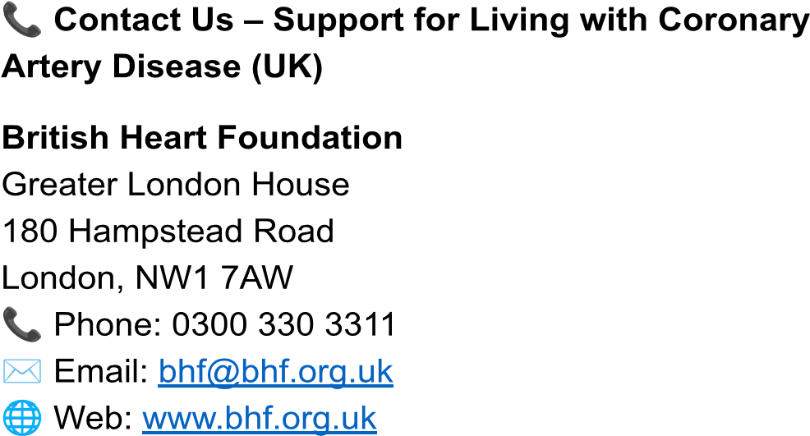


Reference list:

Alessandro Sciahbasi, Russo, P, Michela Zuccanti,
Chiorazzo, L, Castelli, FM & Granatelli, A 2024, ‘Management of Hypercholesterolemia in Patients with Coronary Artery Disease: A Glimpse into the Future’, Journal of Clinical Medicine, vol. 13, Multidisciplinary Digital Publishing Institute, no. 23, pp. 7420–7420, viewed 18 February 2026 https://www.mdpi.com/2077-0383/13/23/7420 .
Bahit, MC, Korjian, S, Daaboul, Y, Baron, S, Bhatt,
DL, Kalayci, A, Chi, G, Nara, P, Shaunik, A &
Gibson, CM 2023, ‘Patient Adherence to Secondary
Prevention Therapies After an Acute Coronary
Syndrome: A Scoping Review’, Clinical
Therapeutics , vol. 45, no. 11, pp. 1119–1126.
Bansal, A & Kishore Hiwale 2023, ‘Updates in the
Management of Coronary Artery Disease: A Review Article’, Cureus , vol. 15, Cureus, Inc., no. 12, pp. e50644–e50644, viewed 18 February 2026, https://pmc.ncbi.nlm.nih.gov/articles/PMC10790113
/ .
Bottardi, A, Prado, GFA, Lunardi, M, Fezzi, S,
Pesarini, G, Tavella, D, Scarsini, R & Ribichini, F 2024, ‘Clinical Updates in Coronary Artery Disease:
A Comprehensive Review’, Journal of Clinical Medicine, vol. 13, MDPI AG, no. 16, p. 4600, viewed 18 February 2026, https://www.mdpi.com/2077-0383/13/16/4600 .
Bucciarelli, V., Caterino, A.L., Bianco, F., Caputi,
C.G., Salerni, S., Sciomer, S., Maffei, S. and Gallina, S., 2020. Depression and cardiovascular disease: The deep blue sea of women's heart. Trends in cardiovascular medicine , 30 (3), pp.170-176.
Cacciatore, S, Spadafora, L, Bernardi, M, Galli, M,
Betti, M, Perone, F, Nicolaio, G, Marzetti, E,
Martone, AM, Landi, F, Asher, E, Banach, M,
Hanon, O, Biondi-Zoccai, G & Sabouret, P 2023,
‘Management of Coronary Artery Disease in Older
Adults: Recent Advances and Gaps in Evidence’,
Journal of Clinical Medicine, vol. 12, MDPI AG, no. 16, p. 5233, viewed 18 February 2026, https://www.mdpi.com/2077-0383/12/16/5233.
Chayakrit Krittanawong, Khawaja, M, Virk, H,
Escobar, J, Khalid, U, Birnbaum, Y, Lavie, CJ,
Sharma, S, Hani Jneid, Rao, S & Virani, SS 2024, ‘Strategies for chronic coronary disease: A brief guide for clinicians’, npj Cardiovascular Health , vol.
1, no. 1, viewed 18 February 2026, https://www.nature.com/articles/s44325-024-00006- w .
Ciuca-Pană, M-A, Boulmpou, A, Ileri, C, Manzi, G,
Golino, M, Ostojic, M, Galimzhanov, A, Busnatu, S, Mega, S & Perone, F 2025, ‘Chronic Heart Failure and Coronary Artery Disease: Pharmacological Treatment and Cardiac Rehabilitation’, Medicina, vol. 61, MDPI AG, no. 2, p. 211, viewed 18 February 2026, https://www.mdpi.com/1648-9144/61/2/211.
Colhoun, H.M., Lingvay, I., Brown, P.M., Deanfield,
J., Brown-Frandsen, K., Kahn, S.E., Plutzky, J.,
Node, K., Parkhomenko, A., Rydén, L. and Wilding, J.P., 2024. Long-term kidney outcomes of semaglutide in obesity and cardiovascular disease in the SELECT trial. Nature medicine, 30 (7), pp.2058-2066.
Dąbek, J, Styczkiewicz, M, Kamiński, K, Kubica, A,
Kosior, DA, Wolfshaut-Wolak, R, Rajzer, M, Szynal,
M, Jankowski, P & Gąsior, Z 2024, ‘Quality of Life in
Patients with Coronary Artery Disease—Multicenter POLASPIRE II Study’, Journal of Clinical Medicine , vol. 13, MDPI AG, no. 13, p. 3630, viewed 18 February 2026, https://www.mdpi.com/2077-0383/13/13/3630 .
Farmakis, D, Xanthopoulos, A & Triposkiadis, F 2021, ‘A critical appraisal of the pharmacological management of stable angina’, Hellenic Journal of Cardiology, vol. 62, no. 2, pp. 135–138.
Golukhova, EZ, Slivneva, IV, Kozlova, OS,
Berdibekov, BS, Skopin, II, Merzlyakov, VY,
Baichurin, RK, Sigaev, IY, Keren, MA, Alshibaya,
MD, Marapov, DI & Arzumanyan, MA 2023,
‘Treatment Strategies for Chronic Coronary Heart Disease with Left Ventricular Systolic Dysfunction or Preserved Ejection Fraction—A Systematic
Review and Meta-Analysis’, Pathophysiology , vol.
30, MDPI AG, no. 4, pp. 640–658, viewed 18 February 2026, https://www.mdpi.com/1873-149X/30/4/46.
Grande, G., Ljungman, P.L., Eneroth, K., Bellander, T. and Rizzuto, D., 2020. Association between cardiovascular disease and long-term exposure to air pollution with the risk of dementia. JAMA neurology , 77 (7).
Giubilato, S, Lucà, F, Abrignani, MG, Gatto, L, Rao,
CM, Ingianni, N, Amico, F, Rossini, R, Caretta, G,
Cornara, S, Di Matteo, I, Di Nora, C, Favilli, S,
Pilleri, A, Pozzi, A, Temporelli, PL, Zuin, M, Amico, AF, Riccio, C & Grimaldi, M 2023, ‘Management of Residual Risk in Chronic Coronary Syndromes.
Clinical Pathways for a Quality-Based Secondary
Prevention’, Journal of Clinical Medicine , vol. 12,
MDPI AG, no. 18, p. 5989, viewed 18 February
2026, https://www.mdpi.com/2077-0383/12/18/5989 .
Fuchs, FD & Whelton, PK 2019, ‘High Blood
Pressure and Cardiovascular
Disease’, Hypertension , vol. 75, no. 2, pp. 285–292.
Heart & Circulatory Disease Statistics 2023 — British Heart Foundation https://www.bhf.org.uk/what-we-do/our-research/he art-statistics/heart-statistics-publications/cardiovasc ular-disease-statistics-2023
Jung, J, Lee, S-N, Her, S-H, Yoo, K-D, Moon, K-W,
Moon, D & Jang, W-Y 2023, ‘Long-Term Clinical
Impact of Patients with Multi-Vessel
Non-Obstructive Coronary Artery Disease’, Life , vol.
13, Multidisciplinary Digital Publishing Institute, no. 11, pp. 2119–2119, viewed 18 February 2026, https://www.mdpi.com/2075-1729/13/11/2119.
Kohsaka, S, Ejiri, K, Takagi, H, Watanabe, I,
Gatate, Y, Fukushima, K, Nakano, S & Hirai, T
2023, ‘Diagnostic and Therapeutic Strategies for
Stable Coronary Artery Disease Following the ISCHEMIA Trial’, JACC. Asia, vol. 3, no. 1, pp.
15–30, viewed 5 April 2023, https://pubmed.ncbi.nlm.nih.gov/36873769/.
Lugo-Gavidia, LM, Alcocer-Gamba, MA &
Martinez-Cervantes, A 2024, ‘Challenges and
Advances in Interventional Cardiology for Coronary
Artery Disease Management’, Medicina, vol. 60,
MDPI AG, no. 8, p. 1323, viewed 18 February
2026, https://www.mdpi.com/1648-9144/60/8/1323 .
Maria-Alexandra Ciuca-Pană, Aristi Boulmpou,
Cigdem Ileri, Manzi, G, Golino, M, Ostojic, M,
Akhmetzhan Galimzhanov, Busnatu, S, Mega, S &
Perone, F 2025, ‘Chronic Heart Failure and
Coronary Artery Disease: Pharmacological Treatment and Cardiac Rehabilitation’, Medicina, vol. 61, Multidisciplinary Digital Publishing Institute, no. 2, pp. 211–211, viewed 18 February 2026, https://www.mdpi.com/1648-9144/61/2/211.
Nemeth, O, Tamas Ferenci, Tibor Szonyi, Szoke, S,
Fulop, G, Pinter, T, Geza Fontos, Andreka, P &
Zsolt Piroth 2025, ‘Long-Term Outcome of
Unprotected Left Main Percutaneous Coronary
Interventions—An 8-Year
Single-Tertiary-Care-Center Experience’, Journal of
Personalized Medicine , vol. 15, Multidisciplinary Digital Publishing Institute, no. 7, pp. 316–316, viewed 18 February 2026, https://www.mdpi.com/2075-4426/15/7/316.
Oancea, C, Gherman, DM, Capraru, RS, Aurelian,
SM, Nedelescu, MM & Popescu, FG 2025, ‘Factors
Affecting Return to Work of Patients with Chronic
Coronary Syndrome: A Prospective
Study’, Healthcare , vol. 13, MDPI AG, no. 18, p.
2368, viewed 18 February 2026, https://www.mdpi.com/2227-9032/13/18/2368 .
Pagliaro, BR, Cannata, F, Stefanini, GG & Bolognese, L 2019, ‘Myocardial ischemia and coronary disease in heart failure’, Heart Failure Reviews , vol. 25, Springer Science and Business
Media LLC, no. 1, pp. 53–65, viewed 18 February
2026, https://link.springer.com/article/10.1007/s10741-019 -09831-z .
Pfisterer, M. (2009). Management of Chronic Heart Disease in the Elderly. Cardiovascular Medicine , 12 (12), 321. https://doi.org/10.4414/cvm.2009.01463
Salaheldin Agamy, Zaghloul, S, Khan, Z, Shahin,
A, Ramy Kishk, Smman, A & Candilio, L 2025,
‘Innovations in Diagnosis and Treatment of
Coronary Artery Disease’, Diagnostics , vol. 16, Multidisciplinary Digital Publishing Institute, no. 1, pp. 98–98, viewed 18 February 2026, https://www.mdpi.com/2075-4418/16/1/98.
Savarese, G., von Haehling, S., Butler, J., Cleland, J.G., Ponikowski, P. and Anker, S.D., 2023. Iron deficiency and cardiovascular disease. European heart journal, 44 (1), pp.14-2
Sara Bentzel, Charlotta Ljungman, Per Hjerpe,
Linus Schiöler, Karin Manhem, Kristina Bengtsson
Boström, Thomas Kahan, Georgios Mourtzinis, Long-term secondary prevention and outcome following acute coronary syndrome: real-world results from the Swedish Primary Care Cardiovascular Database, European Journal of
Preventive Cardiology , Volume 31, Issue 7, May
2024, Pages
812–821, https://doi.org/10.1093/eurjpc/zwad389 Sciahbasi, A, Russo, P, Zuccanti, M, Chiorazzo, L,
Castelli, FM & Granatelli, A 2024, ‘Management of
Hypercholesterolemia in Patients with Coronary Artery Disease: A Glimpse into the Future’, Journal of Clinical Medicine, vol. 13, MDPI AG, no. 23, p.
7420, viewed 18 February 2026, https://www.mdpi.com/2077-0383/13/23/7420.
Tecson, KM, Kluger, AY, Cassidy-Bushrow, AE, Liu,
B, Coleman, CM, Jones, LK, Jefferson, CR,
VanWormer, JJ & McCullough, PA 2022,
‘Usefulness of Statins as Secondary Prevention
Against Recurrent and Terminal Major Adverse Cardiovascular Events’, The American Journal of Cardiology , vol. 176, pp. 37–42.
Ullah, M, Shah Hamayun, Wahab, A, Khan, SU,
Rehman, MU, Haq, ZU, Rehman, KU, Ullah, A,
Aqsa Mehreen, Awan, UA, Mughal Qayum &
Naeem, M 2023, ‘Smart Technologies used as
Smart Tools in the Management of Cardiovascular
Disease and their Future Perspective’, Current Problems in Cardiology , vol. 48, Elsevier BV, no. 11, pp. 101922–101922, viewed 18 February 2026, https://www.sciencedirect.com/science/article/abs/pi i/S0146280623003390 .
Wang, Z, Zhu, S, Zhu, J, Jiang, Z & Ren, Y 2025,
‘Comparison of P2Y12 inhibitors and aspirin in secondary prevention of coronary events: a meta-analysis of RCTs’, BMC Cardiovascular Disorders , vol. 25, BioMed Central, no. 1, pp. 207–207, viewed 18 February 2026, https://link.springer.com/article/10.1186/s12872-025 -04668-x .
Zemaitis, MR, Boll, JM, Kato, M & Golla, G
2025, Peripheral Arterial Disease , Nih.gov,
StatPearls Publishing, viewed 18 February 2026, https://www.ncbi.nlm.nih.gov/sites/books/NBK4307
45/ .

