

Programme: | MSc Public Health and Social Care in Practice
Module: | Population Health and Digital Health Promotion
Module code: | LCHS7009
Lecturer: | Diola Bijlhout`  Dr Ping Wu
Assignment Title: | Component 1  2 Blogs
Student Name: | Tufel Tajuddin Arab
Student ID: | 2530247

Table of Contents
Blog 1 3
Title: Can Generative AI-integrated FreeStyle Libre Continuous Glucose Monitoring (CGM) change Diabetes care? 3
Introduce the public health issue 3
Description of the technology 5
How it promotes health 6
Critical evaluation 7
Recommendations 7
References 8
Blog 2 9
Title: Designing the improved AI-powered tool, DiaLife AI to transform diabetes self-management 9
Public health problem 9
Introducing the technology 9
Evidence of potential impact 10
Critical discussion 11
Conclusion and future improvement 11
References 12

Blog 1

Title: Can Generative AI-integrated FreeStyle Libre Continuous Glucose Monitoring (CGM) change Diabetes care?

Introduce the public health issue
Diabetes is a metabolic and chronic disease, which is characterised by high blood glucose levels that create a major global health emergency (WHO, 2024).

Symptoms
- Blurred vision
- Losing weight unintentionally
- Feeling very thirsty
- Feeling tired (WHO, 2024)
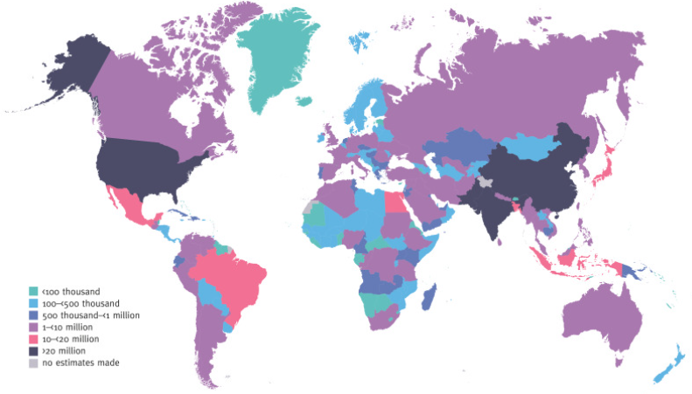
Figure 1: Global diabetes in 2021
(Source: NIH.GOV, 2021)
As per the evidence of NIH.GOV (2021), 537 million adults who age between 20 to 79 years are mainly facing diabetes across the world, indicating the global burden.
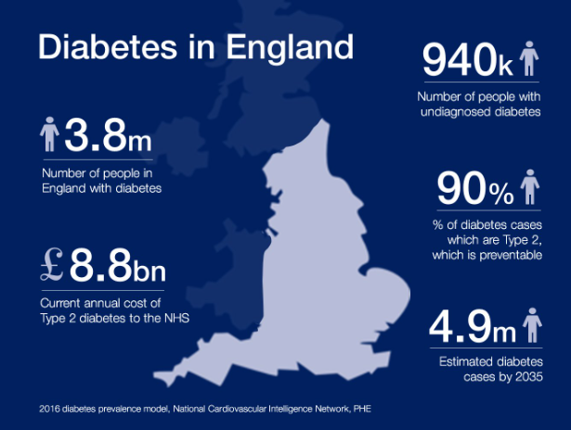
Figure 2: Diabetes data
(Source: GOV.UK, 2018)
As of 2018, in the UK, 3.8 million people are living their lives with diabetes, where 940k people in this country live with undiagnosed diabetes (GOV.UK, 2018). Thus, the evidence highlights a strong public health burden of diabetes in the UK. As a healthcare organisation, the NHS has invested £1.92 billion in 2025 for enhancing the treatment budget for diabetes patients (NHS, 2025). Therefore, the global and the UK’s increasing burden of diabetes demonstrates the significance of diabetes prevalence through implementing effective technology.

Description of the technology
FreeStyle Libre CGM is a Generative AI-integrated system, which is developed and manufactured by Abbott Diabetes Care, helps to track glucose level by eliminating painful finger-prick blood tests (Blum, 2018).
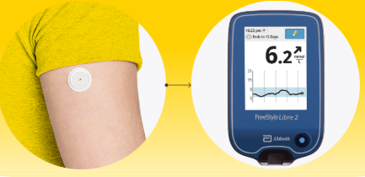
It also directly integrates with smartphones via the FreeStyle Libre Link app, which automatically streams minute-to-minute glucose readings (Reddy, Verma and Dungan, 2023). It monitors diabetes and alerts patients by using a water-resistant and small sensor on the upper arm, measuring glucose in each minute in the interstitial fluid (Blum, 2018).

How it promotes health
FreeStyle Libre promotes health by introducing better diabetes management through offering continuous and real-time glucose monitoring. It helps users understand how daily habits affect their glucose levels and supports informed self-management (FreeStyle Libre, 2026). Around 85% of people comfortably use FreeStyle Libre (Al Hayek, Robert and Al Dawish, 2020). Sharing glucose data with healthcare professionals enables more personalised care. The system's alerts also encourage timely action and better treatment adherence.
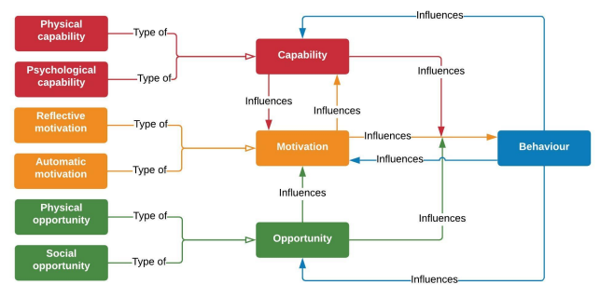
Figure 3: COM-B Model
(Source: West and Michie, 2020)
Using the COM-B model as the behavioural change theory, the technology increases Capability through greater knowledge, Motivation by offering immediate feedback, and Opportunity by clinical support, which strengthens healthier behaviours (West and Michie, 2020).

Critical evaluation
Advantages
- Continuous real-time glucose monitoring.
- Early detection of hypo and hyperglycemia.
- Supports clinical interventions (Blum, 2018).
- Improving patient engagement and self-management (Blum, 2018).
Disadvantages
- High device costs
- Unequal digital access
- Over-dependency on digital technology (Blum, 2018).

Recommendations
The disadvantages of FreeStyle Libre can be reduced by integrating multilingual chatbot support, AI-driven personalised coaching, and digital literacy training for vulnerable populations. Enhanced interoperability with NHS systems and stronger data privacy safeguards would further improve accessibility and equitable diabetes self-management, informing the design of a more inclusive digital intervention.

References
Al Hayek, A.A., Robert, A.A. and Al Dawish, M.A. (2020) ‘Acceptability of the FreeStyle Libre flash glucose monitoring system: the experience of young patients with type 1 diabetes’, Clinical Medicine Insights: Endocrinology and Diabetes, 13, p.1179551420910122. Available at: https://doi.org/10.1177/1179551420910122
Blum, A. (2018) ‘Freestyle libre glucose monitoring system’, Clinical diabetes, 36(2), pp.203-204. Available at: https://doi.org/10.2337/cd17-0130
GOV.UK (2018) UK Health Security Agency. Available at: https://ukhsa.blog.gov.uk/2016/09/18/the-week-at-phe-online-highlights-and-national-conference-wc-12-sep/ (Accessed: 15 July 2026).
NHS (2025) NHS diabetes treatment spending reaches £1.92 billion as new medications become available. Available at: https://media.nhsbsa.nhs.uk/press-releases/e29454d6-7346-4183-b9fe-57a31a04ce1e/nhs-diabetes-treatment-spending-reaches-1-92-billion-as-new-medications-become-available (Accessed: 15 July 2026).
NIH.GOV (2021) Chapter 3Global picture. Available at: https://www.ncbi.nlm.nih.gov/books/NBK581940/ (Accessed: 15 July 2026).
Reddy, N., Verma, N. and Dungan, K. (2023) ‘Monitoring technologies-continuous glucose monitoring, mobile technology, biomarkers of glycemic control’, Endotext [internet]. Available at: https://www.ncbi.nlm.nih.gov/sites/books/NBK279046/ (Accessed: 15 July 2026).
West, R. and Michie, S. (2020) ‘A brief introduction to the COM-B Model of behaviour and the PRIME Theory of motivation [v1]’, Qeios. Available at: https://discovery.ucl.ac.uk/id/eprint/10095640/1/WW04E6.pdf (Accessed: 15 July 2026).
WHO (2024) Diabetes. Available at: https://www.who.int/news-room/fact-sheets/detail/diabetes (Accessed: 15 July 2026).

Blog 2

Title: Designing the improved AI-powered tool, DiaLife AI to transform diabetes self-management

Public health problem
Diabetes is a leading global public health issue, where 9.2% of people in the UK suffer from this disease (Stewart, 2025).
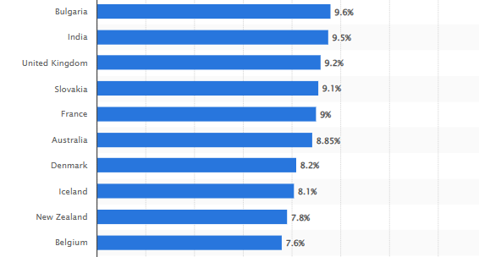
Figure 1: Diabetes prevalence among adults in selected countries 2024
(Source: Stewart, 2025)
It remains a major public health issue, as it is driven by a combination of an ageing population, global obesity rates, and a sedentary lifestyle (Goyal, Singhal and Jialal, 2023). Although existing technologies, such as FreeStyle Libre CGM improves diabetes monitoring, it still has disadvantages in behaviour change, where introducing AI-powered solutions through DiaLife AI can mitigate this limitation.

Introducing the technology
DiaLife AI is an AI-powered digital health platform for the self-management of diabetes. It integrates some core features:
- 24/7 conversational chatbot
- AI meal recognition
- Activity tracking
- Smartwatch connectivity
- AI-powered personalised health coach

It will deliver a personalised, proactive, and connected approach by integrating AI and a chatbot into diabetes self-management.

Evidence of potential impact
AI-integrated digital health platforms transform the healthcare quality of diabetes care by shifting the trend from reactive to proactive and personalised management. It also diminishes the increase in diabetes-related healthcare expenditure by promoting personalised management (Guan et al., 2023).
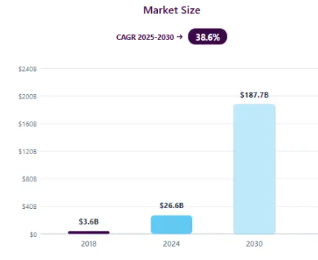
Figure 2: AI market size in the UK healthcare industry
(Source: Grand View Research, 2026)
The AI market size will be increased by $187.7 billion by 2030, indicating high adoption growth, which can decrease the burden of diabetes among adult patients (Grand View Research, 2026). Thus, by considering the positive impact, DiaLife AI will also actively track diabetes among people. Considering the Theory of Planned Behaviour, it will reinforce positive attitudes through enhancing perceived behavioural control and personalised feedback via a self-management tool, strengthening clinical and family engagement (Gross and Christian, 2017).

Critical discussion
Advantages
- Provides highly personalised recommendations (Yin, Qiu and Wang, 2025).
- Chatbots offer continuous support outside clinic hours.
- Remote monitoring can reduce unnecessary appointments (Yin, Qiu and Wang, 2025).
- Multilingual support can minimise health inequalities.
- Easily accessible.
- Low implementation cost.
Disadvantages
- AI algorithms may introduce bias (Jada and Mayayise, 2024).
- Cybersecurity and data privacy concerns (Jada and Mayayise, 2024).

Conclusion and future improvement
Following compliance with the UK GDPR and NHS Digital data security standards can mitigate the disadvantages by enforcing accountability and transparency (Miller, Lukic and Skiera, 2025). Therefore, DiaLife AI highlights how integrating AI-driven technologies can help to provide more personalised and proactive, along with equitable diabetes management by supporting sustainable behaviour change and improved long-term health outcomes.

References
Goyal, R., Singhal, M. and Jialal, I. (2023) ‘Type 2 diabetes’, StatPearls [Internet]. Available at: https://www.ncbi.nlm.nih.gov/books/NBK513253/ (Accessed: 15 July 2026).
Grand View Research (2026) Artificial Intelligence In Healthcare Market (2026 - 2033). Available at: https://www.grandviewresearch.com/industry-analysis/artificial-intelligence-ai-healthcare-market (Accessed: 15 July 2026).
Gross, M. and Christian, J. (2017) Planned behavior: The relationship between human thought and action. Routledge.
Guan, Z., Li, H., Liu, R., Cai, C., Liu, Y., Li, J., Wang, X., Huang, S., Wu, L., Liu, D. and Yu, S. (2023) ‘’Artificial intelligence in diabetes management: advancements, opportunities, and challenges’, Cell Reports Medicine, 4(10). Available at: https://doi.org/10.1016/j.xcrm.2023.101213
Jada, I. and Mayayise, T.O. (2024) ‘The impact of artificial intelligence on organisational cyber security: An outcome of a systematic literature review’, Data and Information Management, 8(2), p.100063. Available at: https://doi.org/10.1016/j.dim.2023.100063
Miller, K.M., Lukic, K. and Skiera, B. (2025) ‘The impact of the General Data Protection Regulation (GDPR) on online tracking’, International Journal of Research in Marketing. Available at:
Stewart, C. (2025) Prevalence of diabetes among adults in selected countries as of 2024. Statista. Available at: https://www.statista.com/statistics/236764/prevalence-of-diabetes-in-selected-countries/?srsltid=AfmBOopn5X9cp-RBgbBpcz9parhMqFHvnQjgYVFwmBRk3NTuCpwtPXHX (Accessed: 15 July 2026).
Yin, J., Qiu, X. and Wang, Y. (2025) ‘The impact of AI-personalized recommendations on clicking intentions: Evidence from Chinese e-commerce’, Journal of Theoretical and Applied Electronic Commerce Research, 20(1), p.21. Available at: https://doi.org/10.3390/jtaer20010021

