Marketing plan written for

______________________________ (Travel Lodge) ______________________________

Student Name

___________Florin Vasilica Mecic___________

Student ID number
___2215417___

Marketing Essentials BMIH4005

Lecturer

___Chris Wilkin___

Table of Contents
1 Introduction 3
2 Situation Analysis 5 'C's 3
2.1 Company: SWOT analysis 3
2.2 Customers: Segmentation and Targeting 3
2.3 Competitors: Porter’s five forces 4
2.4 Perceptual positioning maps 5
2.5 Collaborators 5
2.6 Climate 6
3 Objectives 6
4 Strategy 7
5 Tactics 7
5.1 Marketing mix 7
6 Action 9
7 Control 9
8 Conclusion 10
9 References 11
10 Appendix 13

Introduction
The Purpose of the marketing plan is to identify the target audience of a firm and ensure at ensuring that they are effectively engaged and aligned with the marketing objectives. This will help an organisation attain a competitive advantage and will enhance profits (Stevens et al., 2021). Therefore, the report is being prepared for Travel Lodge to analyse the changing external and internal environment of business and prepare an appropriate marketing plan to target a new set of customers. For conducting situational analysis, SWOT, PESTLE, and Porter Five Forces will be conducted. In addition, for marketing tactics, a marketing mix will be used.

Situation Analysis 5 'C's

Company: SWOT analysis
Strengths  -Travel Lodge is marked as UK’s first value-brand hotel.  -It comprises 590 hotels across UK, Spain and Ireland.  -The hotel is set in a prime location like the seaside and roadsides. | Weakness  -A lack of focus on advanced technology.  -Strong brand with limited market share.  -Marketing activities are restricted.  -Lack of engagement
Opportunity  -Adherence to new technology.  -Focusing on digital marketing tactics.  -Targeting a new set of customers.  -Change with changing consumer trends. | Threats  -Increasing competition.  -Consumer awareness.  -Knowledge available on the internet

Customers: Segmentation and Targeting
Segmentation | -The marketing plan will target customers of Luton.  -Both males and females will be targeted.  -Leisure and business traveller.  -The consumer looking for luxury and comfort
Targeting | Group of friends, business travellers and families.
Positioning | -The brand is positioned as a luxury brand in the UK.

Competitors: Porter’s five forces
Buyer Power | The buyer power is relatively high due to the consumer’s ability to compare and contrast different hotels (Nobar and Rostamzadeh 2018).
Supplier Power | Many suppliers for hotel resources are available. Thus, the power is low.
Threat of Substitute | The threat is moderate due to the availability of cottages at a reasonable price (Simpson and Nevell, 2022).
The threat of New Entrant | The threat is low due to the adequate investment required to manage the hotel (Hoang et al. 2021).
Competitive Rivalry | High competition exists in the market.  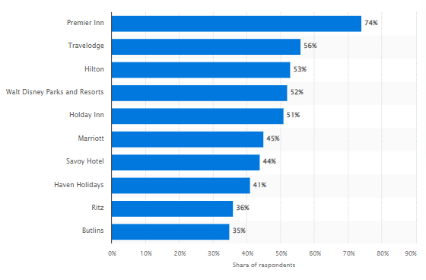  Figure 1: Hotel Brands in the UK  (Source: Statista 2022)

Perceptual positioning maps
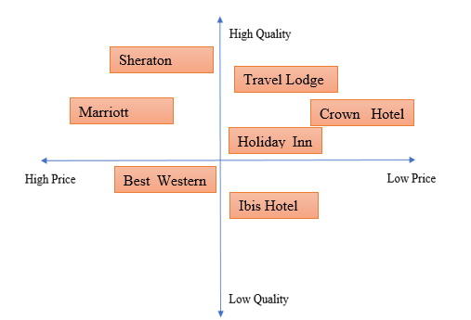

Collaborators
The Hotel works with partners to ensure that customers are provided with great services. The hotel maintains a good relationship with franchisees and other businesses and provides full responsibility to the partner to maintain business needs. In 2018, the hotel partnered with Itsu to allow customers to enjoy delicious meals (H&C News 2018).

Climate
Political | -Laws and regulations are favourable for the Hotels.  -After Brexit, Hotel suffered from staff shortages (Tiwasing 2021).
Economical | -UK GDP increase by 2% in 2022 (ONS UK 2022).  -UK economic situation is now stable.
Social | -The pandemic changed people’s preferences.  -Use of social media has also elevated.
Technological | -Technology used has enhanced the hotel industry (Mellian-Alzola et al. 2020).  -AI, Big Data and blockchain technology are common.
Legal | -Consumer protection law.  -Employee safety law.
Environmental | -Increasing focus on sustainability.  -Hotel needs to adapt to clean practices.

Objectives
SMART target:
The aim of the marketing plan is to attract a new set of customers using social media and other digital media initiatives. To achieve this, SMART Targets are set to grab customer attention.
- To focus on an influencer marketing strategy to create awareness about the brand by 30% within 3 months target period.
- To enhance consumer engagement activities within the first quarter of 2023 by focusing on Giveaways and other promotional activities.
- To market sustainable initiative taken by the hotel to create a responsible brand image and enhance sales by 10% by the 3rd quarter of 2023.

Strategy
The focus of Travel Lodge is to provide value to the services extended to the customer. They consider customers as value seekers and therefore pay attention to minor details. The brand has positioned itself as a luxury yet affordable brand to provide a delightful experience to customers. The brand differentiates itself from the competitors based on the focus on aspiration and ensuring that the hotel suits every pocket. The consumer always seeks value for money, and therefore, the hotel will target friends, family and business travellers who are seeking to grab an affordable yet cosy experience. The value proposition of the company has enabled them to achieve a distinctive position in the market.
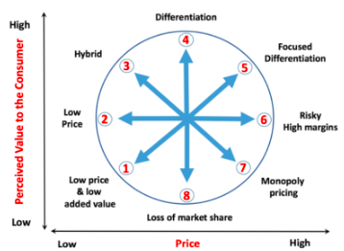
However, based on Bowman’s strategy, clock Travel Lodge focuses on low prices but with high-added value services. This ensures that the hotel will target its consumers with low prices, but the quality will not be compromised.

Tactics

Marketing mix
-Product
Travel Lodge offers all the great value that customers seek during travelling. Its remarkable interior is suitable for modern business travellers. Every room at Travel Lodge comprises of Dreamer Bed, en-suite bathroom, large desk areas, and phone charging sockets. For families with children, pull-out beds are also available. For added comfort, super rooms are also established, with TV, ironing board, hair dryer and all premium facilities. In addition, Travel Lodge Plus is thoughtfully designed for leisure and business traveller to meet their comfort needs (Gennie and Sulistyani 2019).
-Place
To ensure that customers are able to reach out to the hotel easily, the brand has positioned itself in some major towns and city centres alongside roadside stops and seaside locations. The brand is constantly looking for expansion in the UK and beyond, providing added value to the customers. Besides this, about 200 of the hotels of Travel Lodge comprise on-site Bar Cafe Restaurants, and other hotels also comprise a coffee house nearby to further serve as an ideal base for the hotel. Consumers can easily locate the hotel due to its availability on Google Maps and the popularity of the location. Furthermore, social media channels and official websites also provide information about the location (Ulfa et al., 2020).
-Price
Based on the marketing environmental analysis, the majority of the brands focus on a competitive pricing strategy. Gupta et al. (2021) provided that competitive pricing allows businesses to choose price points based on competitors’ pricing. However, at Travel Lodge, revolutionary pricing is offered. Rooms are offered cheaper if booked earlier. This provides an opportunity for people to take advantage of low-cost accommodation facilities. The price can be seen on booking websites or the official website of Travel Lodge (Travel Lodge 2022b).
Promotion
Travel Lodge has also focused on advertising using various channels. However, the brand needs to change its marketing approach and emphasise new trends and marketing patterns. This means that the use of social media channels needs to be focused on communicating with the target audience. The Hotel will make use of the RACE marketing framework to focus on marketing activities. The first stage is to plan the overall transformation plan or digital marketing strategy. For Travel Lodge, focusing on branded content is planned. Reach focus on enhancing website visits and increasing awareness. This will be achieved using paid, earned and owned media touchpoints. The consumer will Act by interacting with the brand. Social media presence must be enhanced to achieve this. The interaction will convert to sales, and to achieve long-term engagement, building customer loyalty will be the focus.
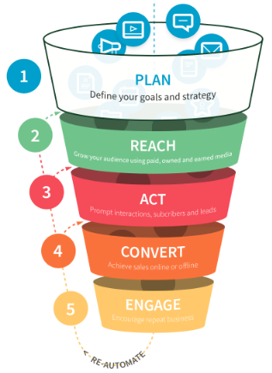

Action
Travel Lodge will formulate a separate marketing team that will focus on developing relevant content to keep the audience engaged. Innovative and creative measures are supposed to be taken using social media channels to enhance customer traffic.
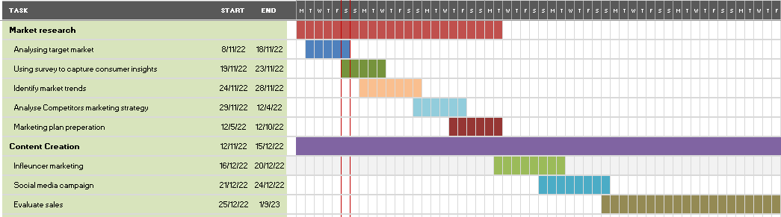

Control
The Unique Selling Proposition for Travel Lodge is the low-cost choice provided to the customer, especially business and leisure travellers. It serves as an ideal location to stay and suits an individual travel budget and needs. Furthermore, the effective services of the hotel brand are exceptional. However, to increase profits and ensure that customer forms a positive brand image, a promotional strategy such as discount and loyalty programs must be offered. In addition, to measure the success of the marketing strategy, the number of clicks on a website, likes, shares, comments and the increasing number of followers must be evaluated (Li et al. 2021).

Conclusion
Based on the overall analysis, it is evident that the marketing plan for Travel Lodge will envision success and will be able to acquire new customers post-pandemic and Brexit situation. Though many challenges are liable to be faced by the brand in terms of competitors’ strategies, fostering differentiation and innovativeness will serve as the key to success. It will also ensure that audience is constantly engaged with the brand. Therefore, a team will be formed to ensure regular efforts are made to enhance the digital marketing strategy.

References
Gennie, T.A. and Sulistyani, A., 2019. Faktor-Faktor Yang Mempengaruhi Loyalitas Pelanggan Di Hotel Travelodge Batam. Jom Fisip, 6(1), pp.1-13.
Gupta, V., Ivanov, D. and Choi, T.M., 2021. Competitive pricing of substitute products under supply disruption. Omega, 101, p.102279.
H&C News 2018. UK first: Travelodge partners up with itsu. [Online] Available at https://www.hospitalityandcateringnews.com/2018/05/uk-first-travelodge-partners-itsu/ [Accessed on 26 November 2022].
Hoang, T.G., Truong, N.T. and Nguyen, T.M., 2021. The survival of hotels during the COVID-19 pandemic: a critical case study in Vietnam. Service Business, 15(2), pp.209-229.
Li, F., Larimo, J. and Leonidou, L.C., 2021. Social media marketing strategy: definition, conceptualisation, taxonomy, validation, and future agenda. Journal of the Academy of Marketing Science, 49(1), pp.51-70.
Melián-Alzola, L., Fernández-Monroy, M. and Hidalgo-Peñate, M., 2020. Information technology capability and organisational agility: A study in the Canary Islands hotel industry. Tourism Management Perspectives, 33, p.100606.
Nobar, H.B.K. and Rostamzadeh, R., 2018. The impact of customer satisfaction, customer experience and customer loyalty on brand power: empirical evidence from the hotel industry. Journal of Business Economics and Management, 19(2), pp.417-430.
ONS UK 2022. Gross Domestic Product (GDP). [Online] Available at https://www.ons.gov.uk/economy/grossdomesticproductgdp#:~:text=GDP%20monthly%20estimate%2C%20UK%3A%20September%202022&text=Gross%20domestic%20product%20(GDP)%20is,fall%20in%20the%20services%20sector. [Accessed on 26 November 2022].
Simpson, A. and Nevell, M., 2022. Thermographic detection of hidden archaeological features in a Cheshire thatched cottage, and related aspects of thermal performance: case study at Roadside Cottage. The Historic Environment: Policy & Practice, 13(2), pp.196-215.
Statista 2022. Most popular hotel brands in the United Kingdom (UK) as of the second quarter of 2022. [Online] Available at https://www.statista.com/statistics/951262/most-popular-hotel-brands-uk/ [Accessed on 26 November 2022].
Stevens, R.E., Loudon, D.L., Wrenn, B. and Warren, W.E., 2021. Marketing planning guide. CRC Press.
Tiwasing, P., 2021. Brexit and skill shortages: An empirical analysis of UK SMEs. 739898418.
Travel Lodge 2022a. Our Company. [Online] Available at https://www.travelodge.co.uk/about/our-company/ [Accessed on 26 November 2022].
Travel Lodge 2022b. Where would you like to go? [Online] Available at https://www.travelodge.co.uk/hotel-deals [Accessed on 26 November 2022].
Ulfa, U., Abrian, Y. and Adrian, A., 2020. Analysis of The Factors that Affect Employee Turnover Intention at Travelodge Hotel Batam. JURNAL PENDIDIKAN TEKNOLOGI KEJURUAN, 3(4), pp.216-220.

Appendix


