World of Animation: The Complete Phantasmagoria Chronicles
Introduction
A myriad of intriguing and unusual parallel worlds, including the entrancing world known as the Illusory Realm, are located within the great and endless universe. This Mirage Realm is a globe defined by the five fundamental elements- Fire, Water, Earth, Wind, and Air- which serve as the foundation of the natural world and perform a vital role in maintaining the equilibrium and tranquillity of the Mirage Realm. A tower of dreams serves as a bridge between reality and fiction, and it is the source of all spiritual strength at the centre of this fantastical area. Ancient and fierce magic can be found within the building's confines, giving its defender incredible power. A powerful black pressure led by a group of optimistic and evil black sorcerers who want to engulf the whole Age of Dreams in eternal darkness has been an unanticipated catastrophe that has broken the peace of this land.

Background and Main Characters
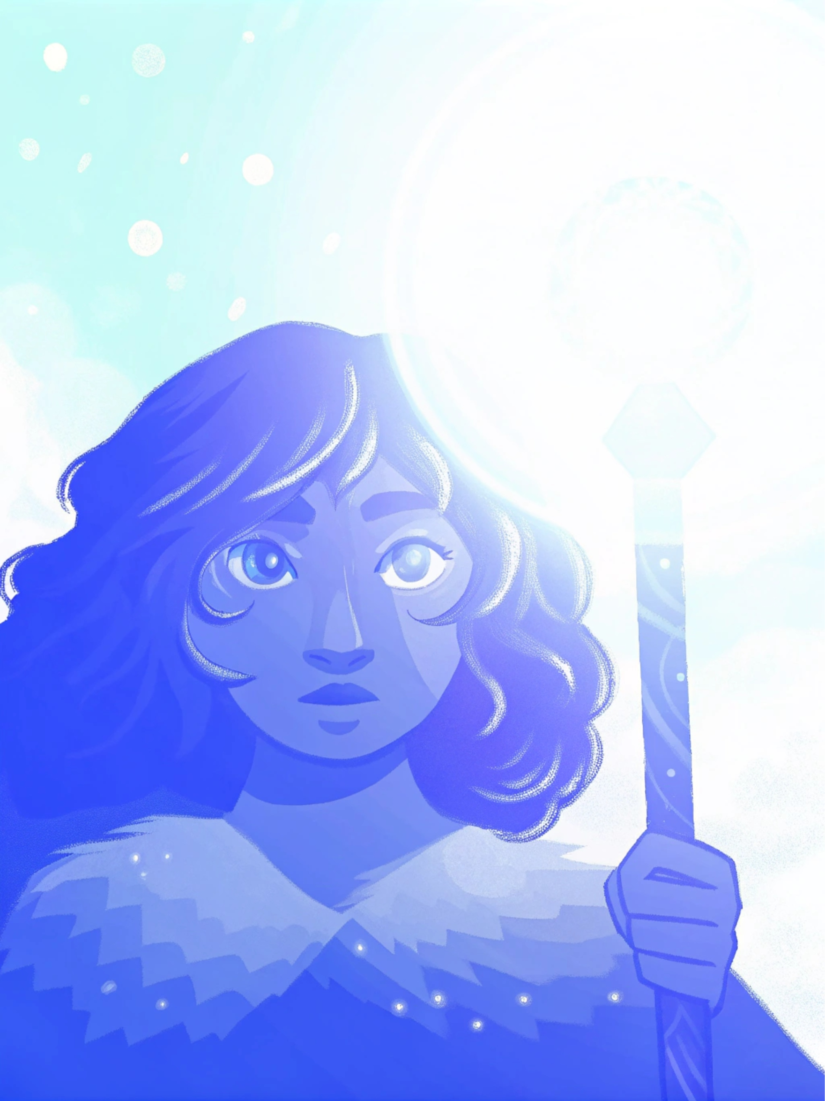
Erin: A younger woman endowed with wind's elemental power, she is soft and tough. By effectively utilizing water tides for defence and recovery, Erin has mental clarity akin to moving water. She has often cherished the idea of meeting with her kids, famous adventurers from the Illusory Realm who had vanished while searching for the treasures of the Tower of Dreams. She was orphaned when she was a young child. Erin embarks on a quest to discover the Phantasmal Dream Era, eventually aiming to get them with the fortitude and intelligence of her kids.
She can control snow and water tides. Her tool is a beautifully made ice crystal staff made of ice, decorated with a sparkling blue jewel that creates dazzling brightness. Erin, you summon animated water snakes and separate strong frost fragments that strike her enemy with deadly accuracy when she uses the Ice Crystal Staff. Additionally, she can activate the" Frozen Field" skill by using the Ice Crystal Staff, which covers everything in her immediate area with ice and makes her allies a safe haven.

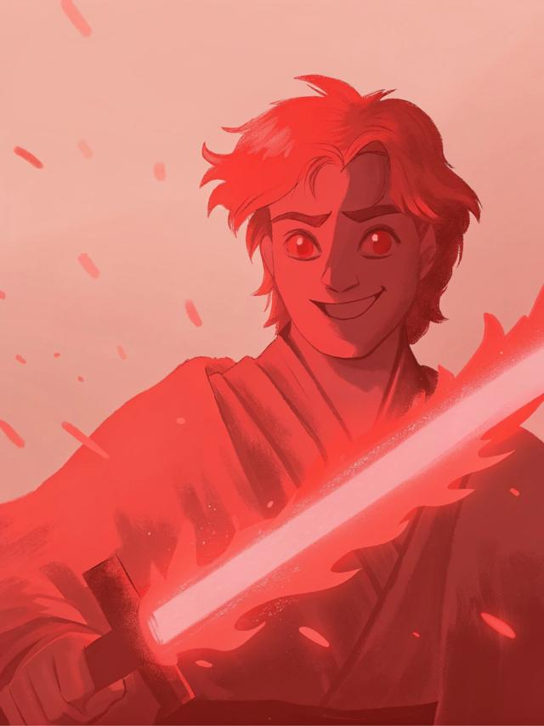
Kyle: A brave hero of fire, Kyle is an enthusiastic young man known for his bold heart and sincere convictions. He uses unpleasant light magic and embodies a flaming spirit. Kyle aspires to be the most powerful warrior of the Phantom Era, protecting his country from evil forces and living up to the noble dreams in his brain. He is a member of a respected heritage of warriors dedicated to preserving the peace of the Phantom Realm for generations.
His fiery sword, known as" Breath of the Dragon," emits a radiant glow that resembles moving lights. He can easily destroy fire bombs with his dagger or summon the' Flame Storm ' skill, conjuring a torrent of flames that engulfs his enemies, inflicting steady fire damage. He can summon the" Inferno Dragon Breath" ability at crucial moments to ignite a massive blaze that wreaks havoc on his foes.

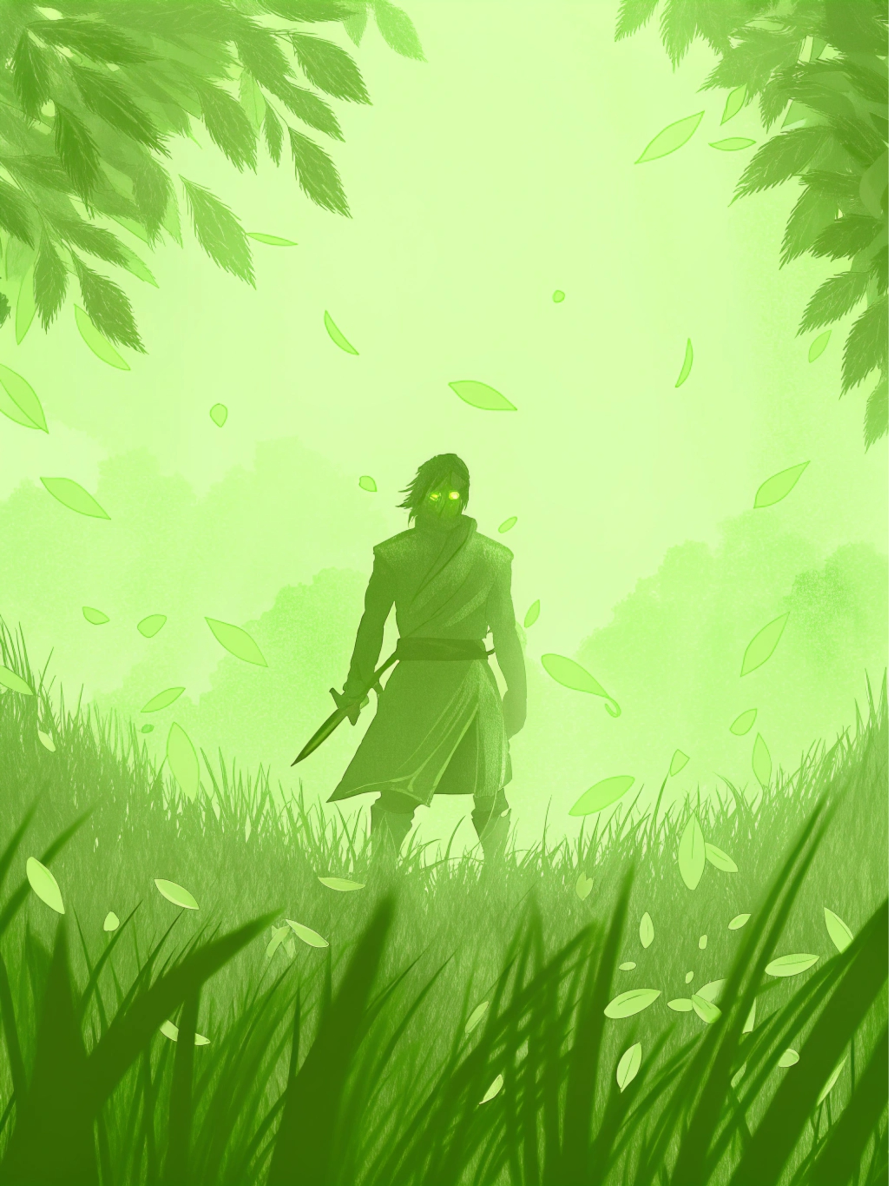
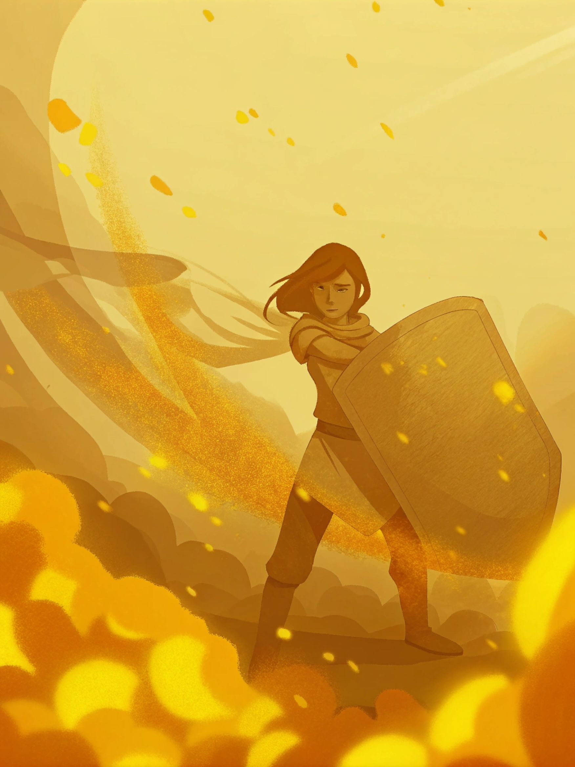
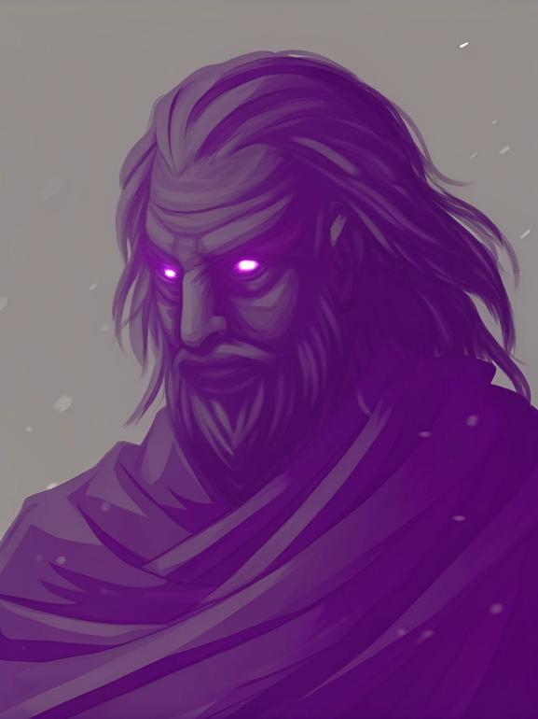
Leia:An Earth Elemental Mage of extraordinary intellect and devious, Leia excels in obscure art. Her sharp intellect complements her composed demeanour, allowing her to change the earth and rock for good and evil purposes. She aspires to discover the ancient mysteries of the Illusory Dream Era and become the greatest magic of her time because of her excitement about the Illusory Realm's history and mythology. Leia is adept at fusing miracles and her understanding to produce incredible, beautiful phenomena. She is very experienced in different forms of earth miracles.
Her powerful weapon, the" Rock Wall Guardian," has a surface of strong rock that can withstand abuse. She can use her" Seismic Wave" talent, which causes the earth to tremble and displace or stun enemy foes while using the shield to protect her colleagues from damage. Additionally, she can summon a massive rock giant to give significant defensive and offensive help to her crew using the" Rock Giant" ability.
A young person with a lean frame and a desire for freedom is Windwalker: The Elemental Ranger of Wind. He can use wind energy for the quick action and unpleasant manoeuvres because his heart is as unrestrained and free-flowing as the wind. Windwalker travels through the Illusory Realm in search of unique experiences and difficulties. His profound admiration for the natural world and its people inspires his desire to communicate with close friends as he explores this extraordinary earth.
He is equipped with a compact set of war shields and wields a small knife, aptly named' Windwalker', imbued with the substance of wind. Utilizing his knife and wind energy for smooth flying navigation and his "Eye of the Storm" ability, which ensnares adversaries, causes conflict, and inflicts damage, he uses his fierce tempest. He can stimulate his" Wind Wings" ability in times of need, allowing himself or his allies to ascend briefly to avoid angry assaults.
A mysterious force that can control space and time, Noah: The Elemental Emissary of Air. Erin and her colleagues are mentored by him, who protects the Phantom Dream Era. As Erin and the others search for a way to restore balance to the earth by embracing deep wisdom and extraordinary power, Noah guides them through the mysteries of the Tower of Dreams. His appearance illuminates the way forward for Irene and her contemporaries, making him appear like a brilliant lighthouse in the dream world.

Synopsis
Chapter 1: The Journey
A quiet village surrounded by mountains and a gurgling stream. Irene strolled along the riverbank, enjoying the tranquility, the sunlight dappled the water, just like a painting. At this moment, an ancient parchment map came into view, with yellowed edges and flashing runes, marking the mysterious path to the Tower of Dreams.
Irene's heart raced, her eyes locked onto the map. The Tower of Dreams, the land of legends, hides endless secrets and power. After her parents disappeared on an expedition, this place became a pain in her heart. The appearance of the map seemed to point out the way to find her father.
Irene decides to embark on a journey, saying goodbye to her village and friends, with longing and longing, she embarks on a path of challenges and opportunities. Through the forest, over the mountains, across the river, through the hardships, the faith is stronger. On the way, they met Kyle, a brave warrior, Leah, an earth witch, and Windwalker, an agile ranger.
The four of them share the same vision and explore the mysteries of the Phantom Era. They support each other, face challenges, share stories, and build deep friendship and trust. As night falls, they sit around the campfire and talk about their hopes for the future.

Chapter 2: Elemental Trials
Under Noah's wise and mysterious guidance, Erin, Kyle, Leia, and Windy, with a desire for the unknown and a quest for power, arrive at an ancient relic known as the ‘Elemental Trials’. This relic is hidden in the depths of a dense forest, surrounded by dense fog, as if isolated from the world, revealing an ancient and mysterious atmosphere.
The Elemental Trial Ground, as its name suggested, was a holy place where tests and challenges coexisted. The power of the four major elements - water, fire, earth and wind - were gathered here, and only those who possessed enough courage and strength to successfully pass the trial were qualified to continue on the journey of exploring the Tower of Dreams.

It is a vast space made up of a clear lake, and in the middle of the lake stands an ancient altar with a blue glow in the middle, symbolizing the power of the water element. In the trial, Erin will not only have to face a powerful water monster condensed from the lake, but he will also have to overcome his fear of deep water. With a deep understanding of water and ice, she gradually mastered the essence of controlling the power of the water element, and finally succeeded in defeating the water monster and passing the water trial.

Immediately afterward, Kyle stepped into the scene of the fiery trial. The place is a burning crater with magma tumbling and flames burning in the sky. Faced with a formidable foe condensed by flames and suffocating heat, Kyle's courage and resolve were greatly honed in the trial. He wielded the longsword in his hand and fought fiercely against the flaming enemies, and eventually managed to pass the Trial of Fire by virtue of his firm will and excellent fighting skills.

Leah, on the other hand, stepped into the grounds of the Trial of Earth. This place is a labyrinth of hard rocks, in which there are all sorts of hidden traps. Not only did Leia have to face enemies coalesced from the rocks, but she also had to carefully avoid the deadly traps. With her profound attainments in earth magic, she gradually mastered the skill of controlling rocks and soil, and eventually succeeded in cracking the labyrinth and passing the Trial of Earth.

Finally, Feng Xing stepped into the grounds of the Trial of Wind. Here was a vast and boundless sky, in which floated all kinds of obstacles condensed by the power of wind. With his excellent speed and agility, Wind Walker freely travelled through the air, dodging those obstacles. Not only did he have to face enemies condensed by the power of wind, he also had to overcome his fear of heights. In the end, with his excellent flying skills and keen insight, he successfully passed the Wind Trial.

Through this series of trials, Erin and the others not only honed their elemental powers, but also learnt how to better collaborate and cooperate. The friendship and trust between them was further deepened during the trials, laying a solid foundation for the next adventure.

Chapter 3: The Shadow of Darkness
In the vast lands of the Phantom Era, there exists a kingdom led by a wise monarch with a solid and complex political system and an economy centred on the miracle industry, which places equal emphasis on magic and technology. The upper class of the kingdom consists of nobles and high-ranking magicians, who hold the decision-making power and most of the wealth of the country; while the commoners, through hard labour and affinity for the elements, maintain the functioning and balance of society. However, underneath this seemingly orderly social hierarchy, a discontent was quietly growing, especially for those who were unable to reach the peak of power due to their birth or limited abilities.

Just as Erin and the others, as the most outstanding young magicians in the kingdom, were confidently preparing to move on and explore the unknown, an unprecedentedly powerful dark force came barreling in like a dark cloud. The source of this force is a dark magician known as the ‘Lord of Shadows’, who not only possesses powerful darkness, but is also a hidden force in the political conflict of the kingdom, attempting to subvert the existing rule, and with the legendary supreme power of the Tower of Dreams, will bring the entire Phantasmal Dream Era under his dark rule.

The Lord of Shadows is clad in a deep black robe, his face hidden in the shadows of his hood, revealing only a pair of eyes that shimmer with an ethereal green light, as if he can see into the deepest fears of the human heart. He launched a surprise attack on the eve of the kingdom's traditional festival, the Elemental Celebration. This festival was an event that celebrated the harmonious coexistence of the elements, and people would wear colourful costumes, hold grand ceremonies, and chant ancient songs to express their awe and gratitude for nature. However, the arrival of the Lord of Shadows overshadowed all of this.

He gently waved the dark staff in his hand, and in an instant, the air around him seemed to freeze, and a palpitating dark energy surged out from the tip of the staff, transforming into a dark creature of various shapes and forms, which either hissed or laughed, launching a fierce attack on Irene and the others. At the same time, the Lord of Shadows also dispatched a group of magicians who were also proficient in dark magic, holding their wands and chanting under their breath, a black magical light pierced through the night sky, striking directly at Ayrin and the others' defensive formation. Among these magicians, there was no lack of traitors from the noble class, who had betrayed the kingdom and its people for their personal ambitions and interests.

Although Irene and the others each mastered different elemental powers, such as the fiery heat of the fire element, the agility of the water element, the swiftness of the wind element, and the steadiness of the earth element, they appeared to be unusually overwhelmed in front of the dark power of the Lord of Shadows, which was capable of devouring almost everything, and their defences gradually became shaky. During the intense battle, Ayrin and the others witnessed the shocking abilities of the Lord of Shadows - not only was he able to manipulate dark creatures, he was also able to distort space, causing Ayrin and the others' attacks to repeatedly fall short. What was even more terrifying was that he was also able to spy on the fears and weaknesses within Irene and the others through his dark magic, so that he could formulate even more deadly attack strategies.

However, at this juncture of life and death, Irene and the others did not choose to give up. They clung to each other tightly, conveying their trust and encouragement to each other with firm eyes. In the ancient language of the kingdom, there was a proverb: ‘A united heart is better than ten thousand armies.’ It was this unity and indomitable will that allowed them to make clever use of the terrain and the principle of phasing between elements to gradually stabilise their position. In between battles, they also boosted their morale with the kingdom's traditional music and poetry, using the power of art to inspire courage and hope within.

Eventually, Irene and the others found a chance to escape, but it was this first encounter with the Lord of Shadows that made Irene and the others realise even more deeply that only by uniting as one can they overcome their inner fears and defeat this seemingly invincible enemy.

Chapter 4: The Labyrinth of the Tower of Dreams
With Noah's help, Erin and the others finally made their way to the Tower of Dreams. However, they discovered that dark forces had turned the mansion into a complicated labyrinth. In order to reach the top, they must solve a number of puzzles and traps.
In the process, they never merely encountered violent criminals and complicated mechanisms but also discovered several secrets about the history and future of the Phantom Era. Through wisdom, courage and teamwork, they essentially cracked one puzzle after another and gradually approached the lower surface of the Tower of Dreams. As a result of this creation of understanding and trust in one another, they gained wisdom and resilience. Under Noah's manner, the four of them, Erin, Kyle, Leah, and Windy, arrived in front of the famous Tower of Dreams with an unrelenting need for the mysterious world and a never-ending desire for power. The picture before them, which resembled a dark cloud, did cast an ominous dark over their emotions, though. This recently stunning and wonderful building is now firmly under their command thanks to the dark forces ' silent transformation into a complicated labyrinth like a massive internet.
Due to the thick layer of black fog that covered the exterior walls, The Tower of Dreams appeared even more intriguing and challenging. Erin and the others stubbornly took a heavy breath, gathered their courage, and took a deep breath through the windows of this labyrinth. They were informed that solving a number of puzzles and traps would merely reveal the peculiar face from the Tower of Dreams.
The inside was distorted and the lines in the labyrinth were while complex as a labyrinth as if they were never-ending. They moved their way along narrow glaciers, afraid to touch any unexplained mechanism as they advanced. A vicious creature immediately launched an intense assault on them, far like black lightning in the evening when it suddenly burst out of the shadows. The creature's heavy black level weapons, heart-stopping colored lights on its eyes, and its mouth spew out using flames, like those from heaven, scalding the air around it.
Ayrin and the others ' quick actions led to a great fight. With their extraordinary combat skills and silent teamwork, they bravely fought the dragon. In the shadow of arms, they sought counterattacking possibilities while avoiding the monster's problems with talent. After a protracted struggle, they finally prevailed over the monster thanks to their perseverance and excellent cooperation.
However, this was only the launch of their adventurous journey. As they advanced further into the labyrinth, they realized that the puzzles and mechanisms in this intricate were getting more and more challenging. Some mechanisms require them to precisely click specific icons when they are n't attentive, which is occasionally result in traps. Some puzzles require them to cause according to the hints, which, if left unchecked, can cause misery. They even learned how to work off and collaborate more effectively in order to solve problems up, displaying their wisdom and courage in the process.
In the process of investigation, they also discovered several secrets about the history and future of the Phantom Era. Some of these secrets were unexpected, while others appeared to be instigating. They learnt that the Illusory Dream Era was once an era full of peace and joy, but, the era eventually became disorganized and revolution with the fall of the dark forces. The Tower of Illusory Goals, on the other hand, contained unending power and wisdom available for those who were destined to arise. It was also the last remnant of that era.
As each puzzle was solved and each tool passed, they began to resemble the top of the Tower of Dreams. As a result of this creation of understanding and trust in one another, they gained wisdom and resilience. They were taught how to get the pull in a situation and how to keep a great head during a crisis.
After some obstacles and exams, they immediately came to a key node in the Tower of Dreams. An ancient altar stood in the center of a large, circular room. The altar, which was only illuminated by beautiful light, served as the only passageway leading to the top surface. However, around the altar were all sorts of traps and mechanisms, like an unknown web searching for them. By solving the riddles here, they were aware of how to successfully fly to the altar and carry on their adventurous journey.

Chapter 5: The Duel between Light and Darkness
After enduring countless hardships and dangers, Irene and her group finally set foot on the top floor of the Tower of Dreams, ushering in a fated duel with the enemy that had always loomed over them like a shadow, the Lord of Shadows. The space at the top of the tower seemed to be compressed, and the air was so heavy that it was suffocating, and a fateful battle was about to begin.

Erin, as the leader of the team, she clutched the ice crystal mace that was carved out of cold ice. The blue gem at the top of the staff shone with an icy light, as if it contained endless ice power. Facing the Lord of Shadows, she took a deep breath and swung the Ice Crystal Staff, instantly summoning countless agile water snakes, which surrounded the Lord of Shadows in an attempt to restrict his movements. Immediately after, Eileen unleashed her ‘Frozen Field’ skill, the temperature around her plummeted, the air condensed into ice, and the Shadow Lord was trapped by a thick layer of ice crystals. However, the Lord of Shadows was not an ordinary person, he struggled hard, and the ice crystals gradually cracked. Without flinching, Eileen waved her staff again and condensed sharp ice crystal fragments, which flew towards the Shadow Lord like razor-sharp blades, attempting to seriously injure him.

The Flame Elementalist wielded the ‘Breath of the Inferno Dragon’, and his longsword's body was like a flowing flame, emitting a fiery glow. He swung his sword to release flame bombs, and a fireball cut through the darkness like a meteor, striking directly at the Shadow Lord. However, the Shadow Lord was surrounded by a dark magic barrier, and the flame projectiles were devoured the moment they touched the barrier. The Flame Elementalist was not discouraged, he took a deep breath and unleashed his ‘Flame Storm’ skill, a sea of fire instantly enveloped the Shadow Lord. The flames raged in the darkness, attempting to devour everything. However, the Lord of Shadows used the power of darkness to gradually devour the flames and transform them into his own energy. At the critical moment, the Flame Elementalist unleashed his ‘Dragon's Breath’, and a huge flaming dragon's breath erupted from his long sword, striking the Shadow Lord directly. Flame and darkness collided in the air, emitting a deafening roar.

The Rock Elementalist gripped his ‘Rock Wall Guardian’, and the surface of his shield was covered with hard rock, as if it could withstand all the attacks in the world. He stepped forward to defend his team from the Shadow Lord's attack. The Lord of Shadows wielded dark magic in an attempt to knock the Rock Elementalist down. However, Rock Elementalist was as steady as a rock. He used his ‘Seismic Wave’ skill to cause the ground to shake, sending Shadow Lord flying. Immediately after, he unleashed his ‘Rock Giant’ skill, and a huge Rock Giant emerged from the ground and pounced on the Shadow Lord. The Rock Giant's fists were as heavy as mountains, and every attack made the Shadow Lord feel overwhelmed.

The Wind Elementalist wore lightweight battle armour and a Wind Walker around his waist. He used his short blades combined with the power of the wind to move freely through the air, attempting to disrupt the rhythm of the Shadow Lord's attacks. He unleashed his ‘Eye of the Storm’ skill, and a powerful storm swept out of the sky and caught the Shadow Lord in it. The Wind Elementalist in the storm was like an eagle flying with its wings spread out, wielding his Wind Walker and releasing countless wind blades in an attempt to cut the Shadow Lord into pieces. However, the Shadow Lord used the power of darkness to gradually devour the storm. At the critical moment, the Wind Elementalist releases the ‘Wind Wings’ skill, providing himself and his teammates with the ability to fly for a short period of time to avoid the Shadow Lord's fatal blow.

Noah, as the spiritual pillar of the team, put his hands together and closed his eyes. Under his guidance, the elemental powers of Irene and the others were perfectly fused. He unleashed the ‘Elemental Resonance’ skill, bringing together the elemental powers of the team members to form a brilliant light. This light was like a bolt of lightning that instantly penetrated the Shadow Lord's dark magic barrier, hitting him directly in the vitals. The Lord of Shadows let out a mournful wail as his body gradually became transparent under the illumination of the light, eventually turning into nothingness and dissipating into the air.

The Lord of Shadows wailed, and his body gradually became transparent in the light of the light, and finally dissolved into nothingness, dissipating into the air.

With the disappearance of the Shadow Lord, the dark forces disintegrate. The Tower of Dreams is once again bathed in warm sunlight and restored to its former tranquility and beauty. Erin and the others hugged each other tightly, their faces beaming with the joy of victory and the celebration of the consequences. With unity and courage, they proved themselves and the truth that light will eventually triumph over darkness.

Chapter 6: Fusion of Elements and Victory
After defeating the Lord of Shadows, Erin and the others finally mastered elemental fusion. They all realize that connecting their efforts is likely to generate the most powerful energy. They decided to perpetuate this energy so that more people could benefit from it. Under Noah's guidance, Erin and others began to think about how to connect the power of the five factors. They overcame a lot of difficulties and problems, but they didn't give up. Eventually, they completely fused these five parts of the problem into a brand new magic formation. This circle has a strong attack power, and heals the wounded and can teleport to any location.
Erin and the others ' activities demonstrated that the Illusory Domain had the undeveloped possibility for elemental fusion. The people who lived in the illusory domain revered and admired them. Their story spread throughout the Illusory Domain, helping more people pursue their dreams and courage.

Chapter 7: The Dawn of Peace
The Illusory Dream Era slowly regained its peculiar tranquillity and prosperity by fighting the dark forces. Irene and the others finally realized their dreams and missions after having some problems and concerns. They showed more bravery and strength by continuing to follow the Fantasy Dream Era.
Erin and the others celebrated in the Tower of Dreams treasures. They thanked Noah for his guidance and support, as well as for their kindness and support. They knew this glory was not easy to come by and resulted from their joint efforts. They decided to move on, see more uncharted territories, and read their favorite accounts.
After the celebration, Irene and the others returned to their cities. They could distribute the need and courage by handling those around them through their actions. They became legends in want, and their accounts inspired more people to pursue their dreams and courage.

