An Analysis of The Impact of E-commerce on Consumer Buying Behaviour and it’s Contribution to the Demise of the High Street



Name: Alicia Graham-Evans
School: Swansea Business School, UWTSD
Degree: Business Management
Due Date : 12th May 2020
Word Count:

Coronavirus (COVID-19) Pandemic
Taking into consideration the ongoing impact of the global COVID-19 Pandemic, it is important include a statement at the beginning of my dissertation that acknowledges the effects that COVID-19 has had on the research that I have undertaken towards my undergraduate degree in BA Hons Business Management.

The University of Wales Trinity Saint David recognises that the COVID-19 Pandemic, national lockdowns and campus closures has directly or indirectly impacted the work of many undergraduate researchers. Through the turbulent time and circumstances of closures and openings within the university, some research has and continues to be disrupted, including personal circumstances that have proven difficult to manage. Teaching was arranged and coordinated virtually throughout the pandemic. All research data collection was designed to utilise digital data collection.

The inclusion of this statement is necessary for the reader’s awareness, both presently and for future reference. It is important to recognise that the pandemic may have had an effect on the scope, direction and presentation of the research. However, both the academic standards and quality threshold for the award remains unchanged. I wish to reassure readers that this statement is not evidencing a lack of original research nor quality.

Declaration

Acknowledgements

I would like to thank my Dissertation Co-ordinator, Dr Caroline Jawad for her continued support and patience throughout my dissertation process. I would also like to express my gratitude to all of my lecturers that have guided me through my three years at UWTSD, especially Gareth Hughes and Julie Haywood.
Ultimately, I would like to thank my fiancé and my family for their endless support throughout the entirety of my time at University. I would like to give special thanks to my grandmother, Wendy Graham, who has been a pillar of support and kindness for me. Without her, I would not be the person I am today, nor would I have excelled so far in my education. For this, I am eternally grateful.

Abstract
The rapid growth of e-commerce has had a significant impact upon both consumer behaviour and the high street. E-commerce has enabled consumers to shop from anywhere in the world, providing a convenient benefit compared to that of instore shopping. Research has shown that, as a result, e-commerce has also affected the high street, and continues to do so as more and more people participate in online shopping. Although extensive previous research has been conducted regarding the associations between e-commerce and consumer behaviour, the current Coronavirus pandemic has considerably changed the way e-commerce operates and the changing behaviour of consumers, possibly making previous research outdated. This study aims to explore how COVID-19 has affected e-commerce and consumer behaviour, as well as analyse whether these factors have contributed to the demise of the high street. This research analysed secondary data and collected primary data in the form of a voluntary, anonymous questionnaire with a sample of 107 participants to gain a better understanding of consumers’ views on e-commerce and physical stores. The study particularly focussed on the gender and age-ranges of participants to explore whether these factors presented any significant associations or differences in responses. Once data was collected, results underwent further extensive analysing using Chi-Square tests. The majority of results supported existing literature and found that men and women were equally as likely to participate in online shopping. However, this study did identify that people over 65 years of age were more likely to shop online than instore. This finding differs greatly from previous research, however it can be concluded that this comes as a direct result of the COVID-19 Pandemic and various UK Lockdown restrictions. Following these results, the research has recommended a strong need for more research to be carried out on e-commerce and consumer behaviour in the aftermath of COVID-19. It is also recommended that further research is conducted in regards to how the high street can recover after the pandemic. The limitations of this research included the inability to incorporate a mixed methods research approach (to the COVID-19 restrictions) and also a lack of previous research on the topic. In order for researchers to acquire a deeper understanding in regards to how e-commerce has affected both consumer behaviour and the high street, future studies should aim to focus on the impact of COVID-19. The researcher anticipates that this research will contribute to the better understanding of how e-commerce has affected consumer behaviour, as well as its contribution to the demise of the high street.

Table of Contents
1. Introduction 1
1.1. Introduction 1
1.2. Background and Rationale 1
1.3. Aims and Objectives 2
1.3.1. Aim: 2
1.3.2. Objectives: 2
1.4. Research Structure 2
1.5. Conclusion 3
2. Chapter Two: Literature Review 3
2.1. Introduction 4
2.2. Consumer Buying Behaviour 4
2.3. The Impact of E-commerce on Consumer Behaviour 5
2.4. The Effects of Covid-19 on Online Consumer Behaviour and it’s Contribution to the Demise of the High Street 6
2.5. CHAPTER SUMMARY 6
Chapter 3 – Research Method 7
3.0. Introduction 7
3.1. The Research Onion (Saunders et al, 2016) 7
3.2. Research Approaches 8
3.3. Research Strategies 8
3.4. Time Horizon 8
3.4. Questionnaire 8
3.5. Data Analysis 12
3.6. Sample 12
3.7. Reliability and Validity 12
3.8. Pilot Study 13
3.9. Ethical Considerations 13
3.10. Chapter Summary 13
4.0. Chapter Four: Data Analysis 13
4.1. Introduction 13
4.2. Data Analysis 14
4.3. Methods 14
4.4. Demographics and Descriptive Statistics 14
4.5. Chi-Square Analysis 14
4.5.1. Chi-Square Analysis for Gender Association 15
4.5.2. Chi-Square Analyses for Age Associations 18
4.6. Discussion 21
4.7. Conclusion 22
5. Chapter Five: Conclusion and Recommendations 22
5.1. Introduction 22
5.2. Main Findings 23
5.3. Implications 23
5.4. Recommendations 24
5.5. Limitations 24
5.6. Further Research 25
5.7. The Achievement of Objectives 25
5.8. Self-Reflection 27
5.9. Conclusion 27
6. References 29

Table of Figures
Figure 1: Consumer Behaviour as an Evolutionary Process (Foxall, 1992) 5

Figure 2: The Research Onion (Saunders et al, 2016) 7

Figure 3: Gender Association and recent online purchases: Showing a significant association between gender and question 4 15

Figure 4: Gender Association and COVID-19 impacts. Showing a significant association between gender and question 8 16

Figure 5: Gender Association and Personal Shopping Preference. Showing a significant association between gender and question 11. 16

Figure 6: Gender Association and Customer Review Influence. Showing a significant association between gender and responses to question 13. 17

Figure 7: Age Association and Recent Online Purchase. Showing a significant association between age range and responses to question 3 18

Figure 8: Age Association and Recent Instore Purchases. Showing a significant difference between age range and responses to question 4 19

Figure 9: Age Association and Online Shopping Frequency. Showing a significant difference between age range and responses to question 6 20

Figure 10: Age Association and Instore Shopping Frequency. Showing a significant difference between age range and responses to question 7 20

List of Tables
Table 1: Research Questionnaire 12

Table 2: Showing significant associations and differences between gender and responses to questions 3,4, 8, 11 and 13 17

Table 3: Showing significant associations and differences between age and responses to questions 3,4, 6 and 7 18

List of Abbreviations

COVID-19: Coronavirus
UWTSD: University of Wales Trinity Saint David
E-commerce: Electronic Commerce
SPSS: Statistical Package for the Social Sciences

Appendices

Introduction

Introduction

This research aims to analyse the impact that e-commerce has had on consumer buying behaviour, and to explore whether it is at all responsible for the demise of the high street and other physical stores. Previous research suggests that online shopping behaviour is influenced by several factors, with the most popular being technical accessibility, price and convenience (Constantinides, 2004; Rahman et al, 2018; Rigby, 2020; Boice, 2021). However, the recent COVID-19 Pandemic has resulted in consumers increasing their online shopping frequency. A recent study shows that 41% of consumers shopped online for items that they would usually purchase in-store (Wold, 2020). Meanwhile, instore sales have declined by 10% compared to before the Pandemic began (Dalgleish, 2020). As the COVID-19 Pandemic is such a recent event, this research will also analyse how consumer behaviour has been influenced as a direct result of the Pandemic.

Background and Rationale
The invention of the internet has transformed the lives of consumers. It has altered how consumers communicate, work, learn, and most significantly, how they shop. Electric Commerce (E-Commerce) refers to the online purchase of goods or services (Mann et al, 2000). Online shopping has resulted in increased convenience for consumers, offering them more variety, better prices and easier accessibility to research and make purchases anywhere in the world. E-commerce also offers a more attractive alternative to traditional shopping as it removes factors such as sales pressure and large crowds from the consumers experience. The amount of UK citizens that use the internet daily steadily increases each year. However, 2020 saw the largest internet-use increase in decades, surging from 45.1 million users in 2019, to 46.6 in 2020 (Johnson, 2020). This could mainly be a direct result of the COVID-19 Pandemic. As the UK faced several national lockdowns, people turned to the internet to stay in touch with friends and family, to work and, as a result of the closure of all non-essential stores, to purchase online. Throughout the Pandemic, online shopping rates rose by 129% in the UK and Europe (Skeldon, 2020). Although e-commerce was already growing rapidly before the COVID-19 Pandemic, figures suggest that lockdowns and closures accelerated the shift to online shopping, but was not the sole reason for the demise of the high street.

Although previous research has analysed how e-commerce has affected consumer buying behaviour, the purpose of this research is to identify how these changes have lead to the collapse of the high street and other physical stores. This research aims to provide a further, in-depth assessment regarding how consumer’s behaviours have changed and how they are influenced by online shopping. This study will also evaluate the impact that COVID-19 has had on consumer behaviour, as well as find associations between the Pandemic and it’s contribution to the demise of the high street. This research will explore whether the deterioration of physical stores was inevitable, or whether factors such as increased online shopping and the COVID-19 Pandemic are entirely to blame for its downfall. Lastly, the purpose of this research is to contribute a further understanding regarding this topic, and to make appropriate recommendations going forward.

Aims and Objectives

Aim:

To analyse the impact that e-commerce has had on consumer buying behaviour and to investigate whether this has contributed to the demise of the high street.

Objectives:

- To critically analyse existing academic literature on the impact that online shopping has had on consumer behaviour and its contribution to the demise of the high street

- To determine an appropriate research approach to investigate public views on the impact online shopping has had on consumer behaviour and whether they believe it has contributed to the demise of high street stores.

- To collect, organise and analyse data responses to examine public views on the impact of e-commerce on consumer behaviour and its contribution to the demise of the high street.

- To recognise the practical implications within the research study and make appropriate recommendations for practice going forward.

- To explore possible approaches for additional investigation, whilst referencing the limitations experienced throughout the present study.

Research Structure
In order to effectively meet the objectives of this study, this research will be made up of five chapters.

Chapter one has introduced the research topic by providing an in-depth background and rationale as well as setting clear aims and objectives that explains how the researcher aims to conduct a successful study. A research structure has also been outlined to show the structure of the research.

Chapter two provides an extensive literature review. This literature review analyses previous research and data that has been conducted in regards to the impact e-commerce has had on consumer buying behaviour, including its contribution to the demise of the high street. This chapter provides a deeper understanding of the topic and highlights any gaps that have been found within the topic.

Chapter three presents the research methods and methodology. This section seeks to identify a suitable research technique that is appropriate for the topic. This then allows the research to begin the data analysis process.

Chapter four continues to analyse the collected primary data using the method that was selected in chapter three. Data analysis will be carried out using Statistical Package for the Social Sciences (SPSS) which will allow findings and results to be presented.

Lastly, chapter five will consider and discuss the initial aim and objectives of the research. The chapter will discuss main findings, appropriate recommendations and any limitations that came to light throughout the research.

Conclusion
Chapter one has successfully introduced an outline for the research study by providing a clear background on consumer behaviour in relation to online shopping, and it’s contribution to the demise of the high street. Chapter one has also clearly outlined the goal of this research, by the use of aims and objectives that will be followed throughout the research process. As previously discussed, the following chapter will provide a critical analysis of literature regarding the research topic.

2. Chapter Two: Literature Review

2.1. Introduction

The purpose of this chapter is to review both current and previous academic literature and secondary data to gain a deeper understanding of the effects that e-commerce has had on consumer buying behaviour and its contribution to the demise of the high street. This chapter aims to complete this dissertations first objective:

“To critically analyse existing academic literature on the impact that online shopping has had on consumer behaviour and its contribution to the demise of the high street”

The literature review is comprised of sources obtained from Journals, Books, Articles, Textbooks, Google Scholar, reliable website entries and Academic Research Studies in order to gain knowledge regarding how ecommerce has impacted consumer buying behaviour,
as well as analysing the contribution that e-commerce has had on the demise of the high street and other retail stores.

2.2. Consumer Buying Behaviour
Consumer behaviour reflects the totality of consumers’ decisions (MachInnis et al, 2020). This can be in regards to the products or services that consumers choose to purchase or participate in. Due to the increasing popularity of the internet, researchers have had to update the way in which they study and predict consumer behaviours. Hoyer et al (2012) suggested that there were several factors that held the ability to affect consumer behaviour, including situational, social, cultural and personal factors.
Factors such as location, environment and timing may influence consumer behaviour (Hoyer et al, 2012). Simple yet effective techniques such as ensuring stores have an aesthetically pleasing layout and a nice aroma can motivate potential consumers to make a purchase. Personal factors, on the other hand, include taste preferences, personal financial circumstances and related factors (Dudovskiy, 2015). Hoyer et al (2012) suggests that an effective strategy in regards to social factors is to target popular members of society. When other members of society see that a popular member of society is interested in the product or service in question, it will influence them to also make a purchase. Finally, Hoyer et al suggest that cultural factors that affect consumer buying behaviour are related to cultural differences amongst consumers. Studying consumer behaviour is important for marketers as it allows them to understand what their customers expect from them. Furthermore, consumer behaviour is constantly changing and evolving and so it is important for marketers to keep updated on current trends. Consumer Behaviour as an Evolutionary Process, featured in the European Journal of Marketing in 1992 and was written by Gordon Foxall. To better understand consumer behaviour, Foxall introduced the behavioural perspective model (BPM). The BPM portrays the rate at which consumer behaviours take place (Foxall, 1992).

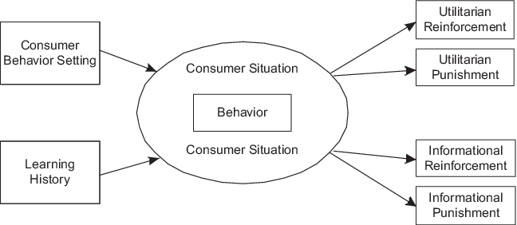
Figure 1: Consumer Behaviour as an Evolutionary Process (Foxall, 1992)

Foxall suggests that consumer behaviour can be understood with this straight-forward model that shows how consumers’ choices are impacted by the consequences of consumption. The model can be used to interpret consumer behaviour as a choice that is linked with managerial concerns. Behaviour settings are proposed establishments that provide an explanation of the relationship between individuals and the environment, particularly the social environment. Different settings allow consumers different levels of control over their behaviour. The learning history is another element of the consumer situation that refers to consumers’ similar experiences that have taken place before the current behaviour setting (Foxall et al, 2012). This previous experience allows consumers to understand the behaviour setting by predicting how their behaviour in this situation will incur. Utilitarian reinforcement mediates the benefits that come as a direct result of the product or service. Secondly, Foxall et al (2012) describes informational reinforcement as the more indirect consequences of behaviour, such as social consequences. Therefore, all products and services contain an element of utilitarian, informational and aversive reinforcement. Additionally, the reinforcement patterns of the BPM are assembled as a continuum from high to low utilitarian reinforcement and from high to low informational reinforcement (Foxall et al, 2012).

2.3. The Impact of E-commerce on Consumer Behaviour
Electronic commerce, also referred to as e-commerce, refers to the buying and selling of goods and services on the Internet (Khan, 2016). The internet has allowed businesses to make changes in the way they operate. For example, the internet enables organisations to generate revenue and gain new customers (Reynolds, 2004). A large amount of research has been conducted in regards to the factors that influence and determine consumer buying behaviour (Rungsrisawat, et al, 2019; Panda et al, 2014; Limayem et al, 2000; Pouraseedi et al, 2012). Research into the global success of online shopping conducted by Jiang et al (2013) suggested that the time, effort and costs that come with visiting a physical store contribute to the way that consumers measure convenience. Similarly, this point was also suggested by Beauchamp and Ponder (2010) who suggested that consumers chose to shop online to save time compared to visiting physical stores.

2.4. The Effects of Covid-19 on Online Consumer Behaviour and it’s Contribution to the Demise of the High Street
Whilst the topic of e-commerce and consumer behaviour has been widely researched, a limited amount of research has been carried out following the recent worldwide COVID-19 Pandemic, a factor that has and will continue to have a lasting impact on both online and in-store shopping. Much of the research that has been conducted has found that the COVID-19 crisis will have a lasting long-term effect on how consumers shop (Morgan, 2020; UNCTAD, 2020; Lowe, 2020; Choudhury, 2020). However, some research suggests that the Coronavirus Pandemic simply accelerated the inevitable shift from in-store to online shopping, and is not entirely responsible for the change (Dagleish, 2021; UK Parliament, 2020; Corfe, 2020). However, with the ongoing development of online shopping services and the lasting impact of the COVID-19 pandemic, UK High Streets have faced major changes. Previous research conducted by The Office of National Statistics found that 25% of UK businesses closed due to lockdown restrictions (Thangarajah, 2020). As a direct result of this, consumers turned to online shopping platforms. However, the COVID-19 pandemic may have simply accelerated the inevitable outcome for many High Street stores, rather than being the sole reason for its closures. The high street has been left with the highest number of empty outlets in five years after 25,700 shops closed their doors in the past year (Ashford, 2019). Research conducted before the COVID-19 Pandemic began came to similar conclusions with that of recent studies. A significant amount of pre-COVID research suggested that the high street would inevitably fail due to the success of online shopping (Maat and Konings, 2018; Cui, 2016; Sanderson, 2019; Rigby, 2011; Office for National Statistics, 2019). With this being said, a vast amount of research has analysed the effect that COVID-19 has had upon physical stores, compared to pre-covid statistics (Office for National Statistics, 2021; Gilliland, 2021; Bai, 2020). These studies indicated that the COVID-19 Pandemic was a detrimental factor contributing to the demise of the high street. Not only were consumers demanded to shop online due to government ‘Stay at Home’ restrictions, but non-essential businesses were forced to close their doors for unknown periods of time. This resulted in the highest record of high street job losses in over 25 years (Haigh, 2021). It has been suggested that, had the COVID-19 Pandemic not occurred, certain high street shops may have been able to recover from the damaging effects of e-commerce. However, these retailers faced no chance, ultimately due to the coronavirus global pandemic.

2.5. CHAPTER SUMMARY
This chapter achieved the first objective:

“To critically analyse academic literature on the effects that ecommerce has had on consumer buying behaviour and its contribution to the demise of the high street”

To summarize, this chapter has reviewed a wide range of literature that describes how much of an impact e-commerce has had on consumer buying behaviour whilst also examining how this has lead to the demise, or at least the decrease in revenue, for the high street. A wide range of sources were used throughout the literature review in the form of reports, book, journals and academic research studies that have helped to explain how e-commerce has changed consumer habits and led to the high street decreasing in popularity for many.

Chapter 3 – Research Method

3.0. Introduction
Chapter three aims to fulfil the second objective of this research study:
“To determine an appropriate research method to explore how e-commerce has affected consumer buying behaviour, and also its contribution to the demise of the high street”.
In order to complete this objective, the researcher will be guided by the research onion model (Saunders et al, 2016).

3.1. The Research Onion (Saunders et al, 2016)
In order to analyse the primary research, the researcher will use the Research Onion proposed by Saunders et al (2016). The Research Onion helps to describe the stages that a researcher must consider when developing an effective methodology (Stainton, 2020). Using the Research Onion to choose data collection and analysis techniques allows the researcher to better understand the justification and identification of research methods that are relevant for this dissertation. Saunders et al (2016, p. 6) defines research as ‘the process that people undertake in a systematic way in order to find out things, thereby increasing their knowledge’. This definition acknowledges that the main aim of research is to better understand a certain topic and, by doing so, increasing the researchers knowledge on said subject. In this case, the researcher aims to analyse the impact that social media has had on consumer buying behaviour, as well as evaluate the impact this had had on the high street.

Figure 2: The Research Onion (Saunders et al, 2016)

3.2. Research Approaches
In order to conduct the appropriate research throughout this study, a quantitative approach will be used to collect data. To effectively evaluate the research question, a questionnaire was conducted. The purpose of quantitative research is to generate knowledge and create understanding (Allen, 2017). Quantitative research methods, such as questionnaires allow researchers to easily and effective analyse data that has been collected. As a result, the researcher will be able to draw conclusions and form appropriate recommendations based on the analysis of the results obtained. Questionnaires also offer participant anonymity, therefore it is more likely that responses will be honest and relevant to the study. It can also be stated that questionnaires pose a more accurate method of data collection compared to other methods. Questionnaires can automatically transfer data to spreadsheets and other software’s, therefore reducing the risk of human error and enabling automatic validation of the data (Cleave, 2018).

3.3. Research Strategies
A Research Strategy is a plan of action that allows researchers to conduct research systematically to produce quality results and detailed reporting (Dinnen, 2014). To collect primary data for this study, the researcher conducted a questionnaire. Bell (as cited by Beiske 2002) noted that questionnaires are an “excellent method to obtain quantitative data about people’s attitudes, values, experiences, and past behaviour”.

3.4. Time Horizon
Time horizon refers to the amount of time it takes for research to be conducted. In this study, the appropriate time horizon for this research was a cross-sectional study. Cross-sectional studies refers to data that is gathered only once in order to answer a research question (Chat, 2016). This is instead of undertaking longitudinal studies, that requires the collection of certain data more than once.

3.4. Questionnaire
The questionnaire for this study was created using the Google Forms platform before being published on social media platforms including Facebook, Instagram and Twitter. These platforms were chosen specifically to reach participants that would provide the researcher with a wider age range. Using only one social media platform to collect data would result in many individuals close in age participating in the questionnaire, therefore it would not provide reliable results. By using different social media platforms, the researcher is able to target a wider audience, and therefore can expect more detailed answers from a wider sample group.
QUESTIONS | RELATION TO CHAPTER TWO
Question 1. What is your gender?  Question 2. What is your age range? | Both questions 1 and 2 are general, demographic questions that will provide the researcher with background information for data analysis and comparisons.
Question 3. When was the last time you made an online purchase? | This question provides information regarding the last time participants made an online purchase.  Previous researcher conducted by the University of Business and Economics (2017) found that 15% of people made online purchases every two months.
Question 4. When was the last time you made an in-store purchase? | This question provides information regarding the last time participants made a purchase in-store.  A previous study conducted by YouGov (2021) found that the most popular frequency for in-store shopping was weekly.
Question 5. What industry is your career/study in? | This is a general, demographic question that will provide the researcher with background information for data analysis and comparisons.
Question 6. How often do you make purchases online? | This question aims to understand the frequency in which consumers purchase online. This question is similar to question 3, but was included so the researcher could compare participants online shopping frequency with the last time they made an online purchase.  Previous research conducted by the University of Business and Economics (2017) found that the majority of consumers purchase online every 2 months on average.
Question 7. How often do you make in-store purchases? | This question allows the researcher to understand the frequency in which consumers purchase in-store. This question is similar to that of question 4, but was included so the researcher could compare participants instore shopping frequency with the last time they made a purchase instore.  A previous study by YouGov (2021) found that the minority of participants made an instore purchase daily.
Question 8. How has the COVID-19 Pandemic affected your online shopping habits? | Question 8 was included so the researcher could understand how the COVID-19 Pandemic has affected e-commerce.  Rigby (2020) found that e-commerce sales increased by 70% during the COVID-19 Pandemic.
Question 9. When the COVID-19 Pandemic is over, how will this influence your future shopping habits? | This question was put in place to understand how the COVID-19 Pandemic will influence consumers future shopping habits.  A survey conducted by Unctad (2020) states that changes in consumer behaviour are likely to outlast the Covid-19 Pandemic.
Question 10. What is the main reason you shop online?  Question 11. What is your personal preference? (Please answer without regarding the COVID-19 Pandemic) | Questions 10 and 11 allow the researcher to better understand why consumers shop online.  A study conducted by Boice (2021) found that the main reason for shopping online is convenience.
Question 12. Have you made an online purchase as a result of a recommendation or 'post' that you've seen on social media platforms such as Facebook, Instagram or Twitter? | Question 12 aims to find a correlation between social media’s influence on consumer purchases.  A study conducted by the University of Oxford (2019) shows a strong association between these factors.
Question 13. Do customer reviews influence your decision when choosing to buy products both online and instore? | This questions aims to find a correlation between customer reviews influence on consumer purchases.  Helversen et al (2018) finds that customer reviews have a significant impact on consumer purchases.
Question 14. Do you anticipate that online shopping will have a negative effect on physical stores? | Question 14 aims to understand how consumers anticipate e-commerce will affect physical stores.  A study carried out by Linzbach (2019) concluded that the growing increase of online shopping will have a negative impact on physical stores.
Question 15. What is your reason for choosing your answer to question No.14? | This question was included so the researcher could better understand why participants believe online shopping will negatively affect physical stores.
Question 16. Have you made a purchase a direct result of a celebrity/influencer sharing a product on social media? | This question highlights any pressures that participants feel/have felt that have led to purchases.  Othman et al (2017) found a significant association between influencers and consumer buying intent.
Question 17. Do you believe that social media contributes to an increased amount of people online shopping? | This question was included to view the opinions of participants regarding social media’s contribution to online shopping.  A previous study by the University of Oxford (2017) found that social media contributes significantly to online shopping.
Question 18. Do you believe that there is a pressure to stay up-to-date with the latest trends due to social media? | This question was included to see whether participants felt pressure due to social media trends.  A previous study conducted by Hampton (2015) found that consumers felt pressure by social media to stay on trend, especially in females under 30 years of age.
Question 19. Have you ever made a purchase as a result of social media to stay on trend, even if you did not particularly want or need said item? | Question 19 was included to see if participants have made an impulse purchase in order to stay on trend.  The University of Oxford (2017) found that younger people are more inclined to make impulse buys to stay on trend.
Table 1: Research Questionnaire

3.5. Data Analysis
The data collected within this study will be analysed using speciality software, Statistical Package for the Social Sciences (SPSS). The data will then undergo a further statistical analyses in the form of Chi-Square Tests. SPSS offers fast and reliable data analysis (Sharief, 2019) and also minimises mistakes and errors within the data conclusions.

3.6. Sample
When conducting research, it is unfeasible to research the whole population. Instead, researchers must construct a smaller amount of participants, known as a sample. The results from this sample are then used to make statements that apply to a broader group or population (Salkind, 2010). Convenience sampling is a type of sampling where people are sampled due to being convenient sources of data for researchers (Lavrakas, 2008). In this case, the questionnaire was aimed at individuals who have shopped online in the past. This will allow the researcher to obtain the most accurate and valid results. The sample group obtained is valid as the researcher targeted individuals with internet access, and those who had previous experience with online shopping. Due to the COVID-19 pandemic, the researcher was confident that this questionnaire would be appropriate for a considerable amount of people across the United Kingdom.

3.7. Reliability and Validity
In any research study, it is important to consider factors such as reliability and validity. The term reliability refers to the consistency of a research study (Mcleod, 2013). The questionnaire will offer the option for participants to hide their identity. Anonymity throughout the questionnaire will allow participants to feel more comfortable and confident with their answers, therefore increasing the probability of collecting honest answers. It is also important that the research ensures the study remains valid. Validity is defined as the extent to which a concept is accurately measured in a quantitative study (Heale and Twycross, 2015). In order to ensure the study is valid, questions will be selected carefully with deep consideration. This is to ensure that all questions asked are relevant to the study, therefore producing the most accurate results.

3.8. Pilot Study
A questionnaire was conducted before the official questionnaire for this study was published. This is known as a pilot study. A pilot study is a small study to test research protocols and data collection strategies (Hassan and Mazza, 2006). Pilot Studies allow researchers to gain knowledge from their first questionnaire to implement in their official research. Researches are able to determine what questions are relevant to the study and what questions aren’t. Therefore, ensuring only the most relevant questions are included, to ensure the study is conducted properly, and to ensure accurate results are obtained.

3.9. Ethical Considerations
Throughout the data collection process, the researcher must take ethical considerations into account. Ethical considerations are guidelines that researchers must follow in order to protect participants. For example, participants in this study have the right to remain anonymous and keep their information confidential. Therefore, it is the researchers responsibility to keep this information secure in order to adhere to ethical considerations. In order to comply with UWTSD’s ethical standards, the researcher was required to submit an ‘Ethics Approval Form’ to their research supervisor. The researcher also ensured that participants confidentiality and data remained secure for the entirety of the research study by storing all collected data on a password protected device.

3.10. Chapter Summary
This chapter has successfully met the second objective of this research study:
“To determine an appropriate research approach to investigate public views on the impact online shopping has had on consumer behaviour and whether they believe it has contributed to the demise of high street stores.”

In summary, this chapter has confirmed the research design of this study and has provided detailed steps that have outlined measures to ensure this study is successful. This chapter has reviewed how the study will remain valid and reliable, as well as acknowledging ethical considerations that must be adhered to.

4.0. Chapter Four: Data Analysis

4.1. Introduction

The previous chapter recognised the methods and methodology that were relevant for this research. Chapter four aims to achieve the third objective:

“To collect, organise and analyse data responses to examine public views on the impact of e-commerce on consumer behaviour and its contribution to the demise of the high street”.

This chapter will display and analyse the data that has been collected as part of this research. 107 respondents participated voluntarily in this study, which was utilised as an online questionnaire and explored the impact that e-commerce has had on consumer behaviour, as well as exploring how this has affected the UK high street.

4.2. Data Analysis
Data analysis is the process of collecting, modelling, and analysing data to extract insights that support decision-making (Calzon, 2021). The data collected from the questionnaire study was transformed into an excel spreadsheet before being uploaded to the IBM SPSS Statistics Software package for further analysis. Further analysis was achieved by SPSS features such as cross-tabulations and Chi-Square tests of association. Differences between two independent variables were examined within these tests. For example, variables such as the gender and age of participants were analysed to find any associations within the data.

4.3. Methods
The genders and ages of individuals who participated in the research questionnaire were categorised in order to highlight significant associations and differences in respondents opinions. Respondents were given the option to identify as “non binary”, “other” or prefer not the answer the question altogether, however all participants identified as either “male” or “female”. Similarly, participants were provided four age ranges to choose from, as well as an option not to disclose their age for the study.

4.4. Demographics and Descriptive Statistics
The study collected responses from a total of 107 participants, all of which were aged over 18 years old and took part in the questionnaire voluntarily. Recruitment was carried out with the use of online social media platforms such as Facebook and Instagram. This allowed the target audience to be reached effectively as participants must have had access to the internet, meaning their responses would be relevant when being questioned about online shopping. Of the 107 participants, 86 were female, whilst 21 were male. 62 of these participants were under the age of 45, whilst 42 participants were over 45 years of age. 3 participants chose not to disclose their age.

4.5. Chi-Square Analysis
The chi-square test is a statistical hypothesis test widely used to test relationships between separate variables in order to identify any associations or differences in collected data. The ultimate goal of the chi-square test is to better interpret relationships between two categorial variables (University of Southampton, 2017).

4.5.1. Chi-Square Analysis for Gender Association
Chi-Square analyses were carried out to examine associations and differences between the responses of male and female participants in the data that was collected from the research questionnaire.

Figure 3 below displays a significant association between males and females and their responses to question 4 of the research questionnaire.

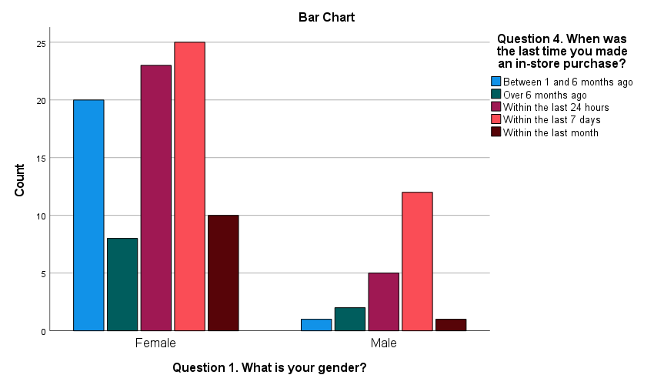
Figure 3: Gender Association and recent online purchases: Showing a significant association between gender and question 4

Figure 4 shows a significant association between the respondents of males and females to question 8 of the research questionnaire.

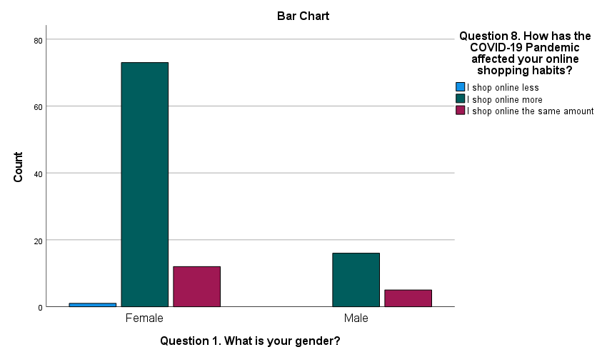
Figure 4: Gender Association and COVID-19 impacts. Showing a significant association between gender and question 8

Figure 5 displays a significant association between male and female views to the responses of question 11.
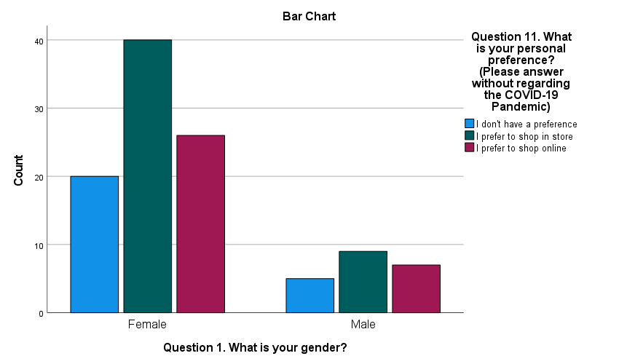
Figure 5: Gender Association and Personal Shopping Preference. Showing a significant association between gender and question 11.

Figure 6 shows a significant association between male and female responses in reference to question 13 of the questionnaire.
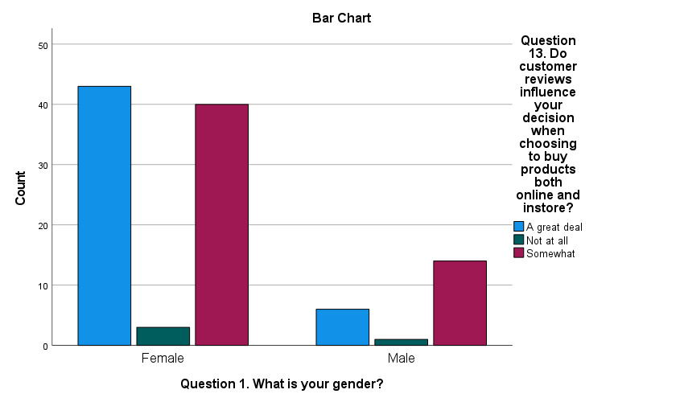
Figure 6: Gender Association and Customer Review Influence. Showing a significant association between gender and responses to question 13.

Table 2: Showing significant associations and differences between gender and responses to questions 3,4, 8, 11 and 13
Question Number | Question | Significance (p-value)
3 | When was the last time you made an online purchase? | .125
4 | When was the last time you made an instore purchase? | .107
8 | How has the COVID-19 Pandemic affected your online shopping habits? | .489
11 | What is your personal shopping preference? | .949
13 | Do customer reviews influence your decision when choosing to buy products both online and instore? | .210

4.5.2. Chi-Square Analyses for Age Associations
Further chi-square tests were carried out to examine any associations between participants responses in regard to their age. The responses focussed on both online and instore shopping habits of consumers. Only questions which included nominal data were selected in order to ensure the accuracy of the Chi-Square tests. In this case, questions 3, 4, 6 and 7 were analysed.

Figure 7 below shows a significant association between age range and responses to question 3 of the questionnaire.

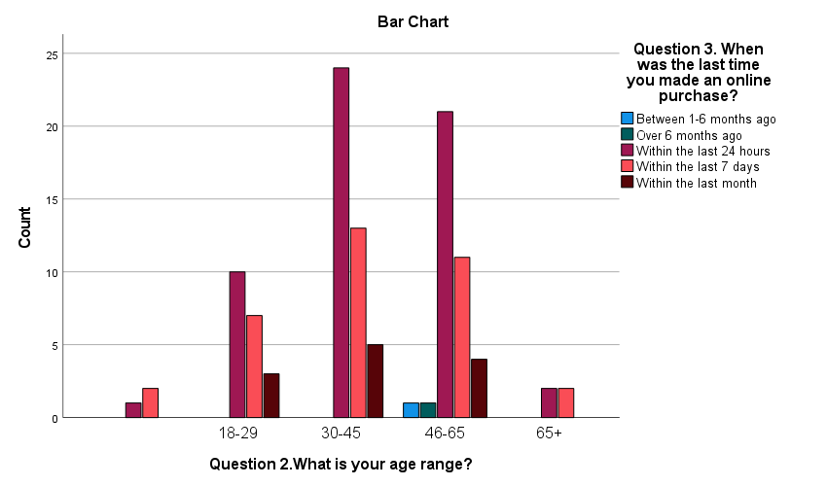
Figure 7: Age Association and Recent Online Purchase. Showing a significant association between age range and responses to question 3

Table 3: Showing significant associations and differences between age and responses to questions 3,4, 6 and 7
Question Number | Question | Significance (p-value)
3 | When was the last time you made an online purchase? | .969
4 | When was the last time you made an instore purchase? | .001
6 | How often do you make purchases online? | .010
7 | How often do you make purchases instore? | .343

Figure 8 displays a significant difference between age and the responses for question 4. Figure 8 shows that individuals aged between 30 and 65 are more likely to make in-store purchases at least once in a seven day period. However, the majority of those aged between 18-29 either made a purchase within the 24 hours before they completed the questionnaire, or between 1 and 6 months before. These results show a notable difference between responses in the youngest age range that were questioned, and therefore no associations can be made. Figure 8 participants aged over 65 years old had made an instore purchase in the previous 1 to 6 months of participating in the questionnaire. This could be a result of the COVID-19 restrictions that were heavily focused on the isolation of elderly people.

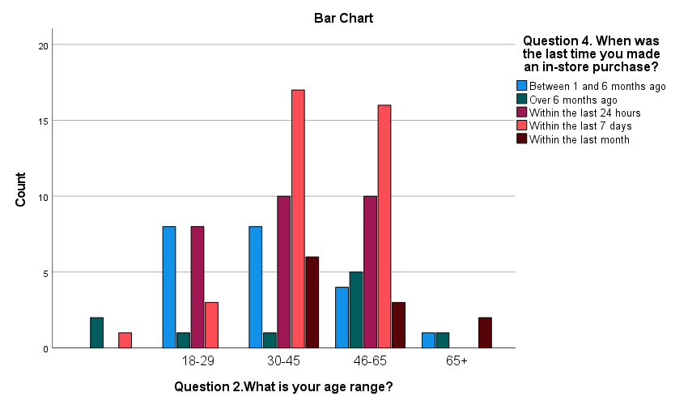
Figure 8: Age Association and Recent Instore Purchases. Showing a significant difference between age range and responses to question 4

Figure 9 shows a significant difference between age and responses to question 6.

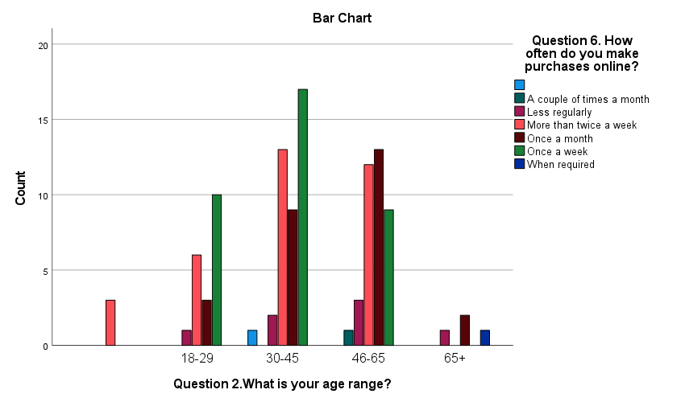
Figure 9: Age Association and Online Shopping Frequency. Showing a significant difference between age range and responses to question 6

Figure 10 below shows a significant difference between age and the participant responses to question 7.

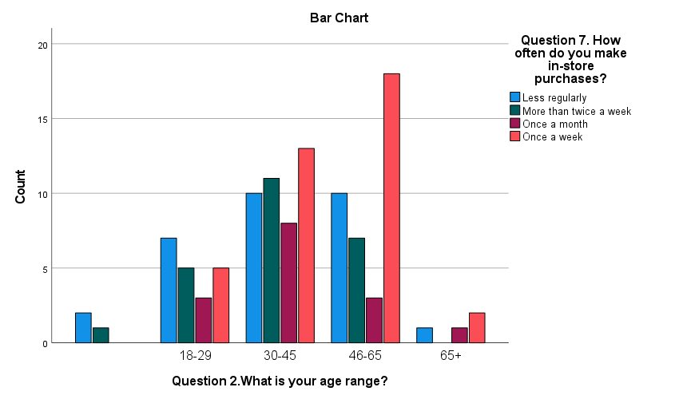
Figure 10: Age Association and Instore Shopping Frequency. Showing a significant difference between age range and responses to question 7

4.6. Discussion
The study aimed to investigate the impact that e-commerce has had on consumer buying behaviour, and also e-commerce’s contribution to the demise of the high street and retail stores in the United Kingdom. Similar to previous, established research (Rahman et al, 2018), the present study confirms that e-commerce has had a profound impact on consumer buying behaviours and habits. Furthermore, the study has highlighted that many participants believe that e-commerce will (if it has not done so already) lead to the inevitable demise of the high street.

When analysing age ranges and responses to the study’s questionnaire, it was found that significant associations were found in only question 3. Figure 4.2 shows that the majority of all age ranges (between 18 and 60+ years old) had made an online purchases within 24 hours of participating in the questionnaire. However, significant differences between age ranges and responses to the questionnaire were highlighted in questions 3, 6 and 7. It was found that individuals aged between 18 and 29 were more than half less likely to make in-store purchases than those aged 30 and over. Furthermore, figure 4.7 analyses associations between gender and instore shopping frequency (again, analysing question 4 of the questionnaire). This found that females are more likely to make instore purchases compared to males. Figure 4.4 shows that, while the majority of people in age groups 18-29 and 30-45 make online purchases at least once a week, those whose ages range between 46-65 and 65+ are more likely to only purchase online once a month. However, several participants of all age ranges admitted to making online purchases more than twice weekly. Figure 4.5 studies association between age ranges and in-store shopping frequency. Whilst ages from 30-65+ are more likely to make instore purchases once a week, data shows that 18-29 year olds make in-store purchases less than once per month.
When analysing gender and responses to the study’s questionnaire, significant associations were found in regards to questions 3, 4, 8 and 11. Figure 4.6 shows a significant association between gender and the individuals’ latest online shopping history. The data shows that the majority of both men and women had made an online purchase in the 24 hours of participating in the questionnaire. Similarly, Figure 4.8 shows a significant association between gender and how the COVID-19 pandemic affected their personal online shopping habits, with both the majority of men and women stating that they shop online more as a direct result of the pandemic. Figure 4.9 also shows a significant association between gender and question 11, which asked participants what their personal shopping preference was. Participants were asked to answer without regarding the COVID-19 pandemic. Data shows that the majority of both male and females prefer to shop in-store. The data found a significant difference when analysing the association between gender and the impact that consumer reviews had on purchasing items. It was found that customer reviews influenced female’s decision when choosing to buy products (both online and in-store) “a great deal”, however this only influenced male participants “somewhat”.

4.7. Conclusion
Chapter 4 has achieved the study’s third objective:

To collect, organise and analyse data responses to examine public views on the impact of e-commerce on consumer behaviour and its contribution to the demise of the high street.

To conclude, this research supports that of previous reported research as it suggests that the younger generation are more included to participate in online shopping compared to individuals aged over 40 years old. Previous research (Dang et al, 2020; Kruh, 2017, Wan et al, 2012) suggests this may be due to younger people having more access and knowledge around technology, and also their increased usage of social media platforms. However, unlike previous research, the present study found that participants aged over 65 years old were more likely to shop online, rather than shop instore. This differs greatly compared to previous research (Lian, 2014; Iyer and Eastman, 2006; Smith, 2018), however this contrast may be a direct result of the COVID-19 Pandemic, which urged elderly members of the population to stay at home as much as necessary. The majority of previous research on this topic was conducted before the coronavirus crisis, therefore explaining the difference in results. The present study further supports previous research in regards to gender and online consumer buying behaviour. Previous literature (Coppola, 2020; Macklin, 2006; Dwight, 2016) found that there is no significant difference between gender and e-commerce, and that both male and female consumers are equally as likely to participate in online shopping. Overall, the present research has found similar results as that of previous studies. However, some results have differed as a direct result of the COVID-19 Pandemic, such as an increase in the elderly population using e-commerce services.

This chapter has effectively analysed the primary data that was collected from the researchers questionnaire and investigated public views regarding the impact of e-commerce on consumer behaviour, as well as its contribution to the demise of the high street. Chapter five will seek to complete the final objectives of this research by recognising the implications and limitations that the researcher has faced during this study. The research will continue to make appropriate recommendations and discuss further avenues for future research possibilities.

5. Chapter Five: Conclusion and Recommendations

5.1. Introduction

The previous chapter successfully achieved the third objective of this research study by analysing the primary data that was collected and highlighting main findings. This chapter seeks to achieve the remaining two objectives:

“To recognise the practical implications within the research study and make appropriate recommendations for practice going forward”

And

“To explore possible approaches for additional investigation, whilst referencing the limitations experienced throughout the present study”

5.2. Main Findings
The main findings in this research project found that online shopping has had a significant impact on consumer buying behaviour, and the research suggests that these changes have contributed to the demise of the high street as a whole. When evaluating associations and differences between genders, it was found that women’s purchase decisions are greater influenced by factors such as consumer reviews. For example, the primary research of this study showed that women are more influenced by consumer reviews compared to men. Whilst both male and female participants admitted that they shop online a great deal more as a direct result of the Coronavirus pandemic, research found that the preference amongst both genders was in-store shopping.

When analysing associations and differences between age ranges, the research concluded that individuals within all ranges were more than likely to make an online purchase within a 24 hour period. However, individuals aged between 30 and 65 were more likely to make a greater amount of in-store purchases compared to age ranges between 18 and 29 and 65 and over. Previous research suggests that younger adults (aged between 18 and 29) are more frequent internet users (Olson et al, 2010). This could assist in the explanation of why the younger generation are less likely to participate in in-store shopping. Similarly, participants aged 65 and over may have refrained from visiting physical stores due government ‘Stay at Home’ restrictions throughout the COVID-19 Pandemic.

5.3. Implications
The present study has highlighted that, although the general population prefer to participate in instore shopping, the vast majority of them are more likely to shop online. This could be a direct result of the current climate that is focussed on the COVID-19 pandemic, which has urged individuals to stay at home as much as possible.

5.4. Recommendations
A number of recommendations can be made as a result of this study. Predominantly, it is important to highlight the jeopardy that faces the high street, and the extent in which its future is uncertain. It is also important to specify that that the Coronavirus pandemic is not the solitary factor that has contributed to the failure of the high street. For the high street to recover from both pre and post-COVID struggles, it is important for them to vastly focus on their customer service to ensure that the human-element of an instore experience outweighs the convenient benefits of online shopping (Sheppard, 2020).

It was also be beneficial for the government to work closely with local authorities across the United Kingdom to offer financial help and resources to aid in the recovery of the high street. It would be helpful if local authorities and councils reassessed car parking charges, especially in busy cities. Previous research suggests that expensive parking costs have remarkably contributed to the demise of the high street (Benson, 2013). Although the complete abolishment of parking charges may prove to be unrealistic, a reduction in parking costs may appeal to consumers, therefore encouraging them to visit high streets more frequently. Similarly, the government could review business tax rates. Presently, physical shops acquire extra charges for their ‘bricks and mortar’, whilst online stores have no such charge. By either reducing the tax for physical stores, or introducing a similar tax to online retailers, the government would be ensuring that the high street receives fair treatment within the retail industry.

5.5. Limitations
When conducting a study, researchers will be faced with influences that are out of their control. These influences are referred to as limitations (Bradford, 2017). Reporting research’s limitations is fundamental to ensure readers can evaluate the credibility of the study (Ross and Zaidi, 2019). Since the research was conducted in the course of the Coronavirus Pandemic, the researcher wasn’t able to complete the collection of primary data through a mixed methods approach like originally planned. A questionnaire was successfully utilised to form a quantitative data approach, however initial plans to collect qualitive data in the form of structured surveys were unable to go ahead. It is important to note that this limitation could have impacted the data that was collected, however this factor was out of the researchers control.

Another limitation also arose due to the lack of previous research available on the impact that COVID-19 has had on e-commerce and consumer buying behaviour, as well as it’s contribution to the failure of the high street. Whilst a significant amount of previous research has been conducted without regards to COVID-19, it is important to realise the profound impact that the pandemic has had on the topic, possibly making certain pre-COVID research completely void. As a result, the researcher faced difficulties in writing the study’s literature review. However, this limitation did provide the researcher with an opportunity gaps in previous literature and recommend areas in need of further research (Lee, 2015).

5.6. Further Research
It could prove to be beneficial for further research to incorporate a mixed methods approach. The addition of utilising qualitative data as well as quantitative could provide more accurate results and provide a deeper insight into how e-commerce has affected consumer behaviour, as well as its contribution to the demise of the high street. This may also be useful for predicting future consumer trends that come as a result of developments in technology.

Further research could also investigate the lasting impact that COVID-19 has had on consumer behaviour as a result of e-commerce. Previous studies and this current research have analysed the impact of e-commerce on consumer behaviour pre-COVID or during COVID. The lasting impacts of the COVID-19 Pandemic are currently unknown. It cannot yet be concluded whether the COVID-19 pandemic will only pose short-term challenges in regards to consumer behaviour and e-commerce. Therefore, further research may be required to better understand the implications that the coronavirus pandemic has caused.

5.7. The Achievement of Objectives
This research has successfully completed its initial objectives:

- To critically analyse existing academic literature on the impact that online shopping has had on consumer behaviour and its contribution to the demise of the high street

This objective was achieved by providing extensive literature review that focused on existing secondary research relating to the topic of changing consumer behaviour as a result of e-commerce. The literature review also analysed the factors that have contributed to the failure of the high street. This research aimed to explore e-commerce’s effect on consumer behaviour and the high street throughout the continuation of the COVID-19 Pandemic, a topic that has minimum existing research.

- To determine an appropriate research approach to investigate public views on the impact online shopping has had on consumer behaviour and whether they believe it has contributed to the demise of high street stores.

This objective was met by recognising a suitable research method for the study, whilst being mindful of the COVID-19 restrictions. As a result, a questionnaire was conducted to investigate the impact that e-commerce has had on consumer behaviour, and to explore public views on whether this has contributed to the demise of the high street.

- To collect, organise and analyse data responses to examine public views on the impact of e-commerce on consumer behaviour and its contribution to the demise of the high street.

Objective 3 was accomplished by the utilisation of the SPSS Software Package. Crosstabulations supplied descriptive statistics which aided the researcher with the completion of Chapter 4. Further analysis was carried out by the use of chi-square tests, which evaluated any significant associations and differences within the data. Data analysing found that both males and females across a wide range of age groups preferred instore shopping, however have most recently participated in frequent online shopping as a result of the COVID-19 Pandemic.

- To recognise the practical implications within the research study and make appropriate recommendations for practice going forward.

Objective 4 was achieved by recognising the practical implications within the research study. To an extent, the research supported previous research, implying that e-commerce has had a profound impact upon consumer behaviour, and has contributed somewhat to the demise of the high street. However, this research identified a gap in previous literature and further focussed on the topic whilst acknowledging the COVID-19 Pandemic. The research was then able to make further recommendations. For example, it is important for more extensive research to be conducted in regards to e-commerce’s affect on consumer behaviour in the aftermath of the Coronavirus Pandemic. It will also be beneficial for further research to explore the ultimate factor that has contributed to the demise of the high street, and also if the high street can ever fully recover.

- To explore possible approaches for additional investigation, whilst referencing the limitations experienced throughout the present study.

Objective 5 was completed by exploring possible avenues for additional investigation, whilst also referencing the limitations experienced by the researcher throughout the present study. Limitations of the present research included the lack of previous research available to the researcher, as well as the restrictions that were in place due to the COVID-19 Pandemic. It was recommended that further research is carried out to gain a better understanding of the research topic in the aftermath of the coronavirus crisis.

5.8. Self-Reflection
The researcher of this study sought to investigate e-commerce’s effect on consumer behaviour, as well as its contribution to the downfall of the high street and other physical stores. The researcher was particularly interested in exploring this topic during the COVID-19 Pandemic to better understand how e-commerce has changed consumer behaviour in light of the coronavirus crisis, a subject with minimum existing research. This research has proved successful in meeting the study’s initial aims as it found that the COVID-19 Pandemic has had a profound impact upon consumer buying behaviour due to the increased amount of people purchasing online. Therefore, this research has been able to fill a gap that previous research has been unable to do, as the COVID-19 Pandemic is such a recent phenomenon.

The researchers interest in ever-changing consumer behaviour has stemmed from the completion of several modules in the BA (Hons) Business Management course provided by UWTSD.

This project has enabled the researcher to develop an abundance of new skills, as well as to focus and develop existing skills. The researcher practiced independent learning for the duration of this study. Whilst virtual help and advice was readily available through the use of email and Team meetings, face-to-face meetings and lectures remained unavailable due to government restrictions. This proved challenging at times, however this provided the researcher with beneficial experience of independent learning, a skill that will remain useful throughout the researchers future education and career.

5.9. Conclusion
This chapter has successfully fulfilled the fourth and fifth objectives:

“To recognise the practical implications within the research study and make appropriate recommendations for practice going forward.”

And

“To explore possible approaches for additional investigation, whilst referencing the limitations experienced throughout the present study.”

This research aimed to critically analyse the effect that e-commerce has had on consumer behaviour, and explore its contribution to the demise of the high street. This research has successfully achieved its initial aim and has found that e-commerce has had a dramatic impact on consumer behaviour, and has significantly contributed to the failure of the high street and other physical stores. The research also found that the COVID-19 Pandemic led to a global increase in the amount of people who participate in online shopping, and as a result further affected consumer behaviour. However, research shows no indication that the COVID-19 Pandemic is solely responsible for the demise of the high street. This is in accordance to previous research (Ashford, 2019; Maat and Konings, 2018; Cui, 2016; Sanderson, 2019; Rigby, 2011) that suggests that the high streets downfall began long before the COVID-19 Pandemic.

This study was also successful in completing the initial objectives that were proposed in Chapter one, which also introduced the overall aim of the research as well as a rationale. Chapter two presented an in-depth literature review that analysed the impact of e-commerce on consumer behaviour and its contribution to the demise of the high street. This completed the researches first objective. Chapter three went on to achieve the second objective of the research, exploring suitable research methods and deciding that a quantitative approach in the form of an online questionnaire was an appropriate selection. Chapter four included an analysis of the primary data that was collected and evaluated participant views on the impact e-commerce has had on consumer behaviour, and its contribution to the failure of the high street. This achieved the research’s third objective. Lastly, chapter five achieved the fourth and fifth objectives of the research and completed the aim of exploring views regarding the impact of e-commerce on consumer behaviour and its contribution to the disintegration of the high street. Chapter five also included implications, recommendations, limitations and potential future research that is relevant to this study. This research has successfully analysed how online shopping has changed and affected the consumer, and also evaluated how this has and has not contribution to the demise of the high street.

References
Allen, M., 2017. The SAGE encyclopedia of communication research methods. 1st ed. SAGE Publications, p.12.
Ashford, J., 2019. What is driving the collapse of high street shops?. The Week, [online] p.2. Available at: <https://www.theweek.co.uk/104224/what-is-driving-the-collapse-of-high-street-shops> [Accessed 4 February 2021].
Bai, H., 2020. The Socio-Economic Implications of the Coronavirus Pandemic (COVID-19): A Review. ComFin Research, 8(4), pp.8-17.
Beauchamp and Ponder, 2010. PERCEPTIONS OF RETAIL CONVENIENCE FOR IN-STORE AND ONLINE SHOPPERS. Marketing Management Journal, 159(3), p.34.
Beiske, B., 2002. GRIN - Research methods. Uses and limitations of questionnaires, interviews, and case studies. [online] Grin.com. Available at: <https://www.grin.com/document/15458> [Accessed 7 March 2021].
Benson, K., 2013. Are parking charges killing our high streets? – Which? Conversation – Which? Conversation. [online] Which? Conversation. Available at: <https://conversation.which.co.uk/money/your-view-are-parking-charges-killing-our-high-streets/> [Accessed 4 May 2021].
Boice, M., 2021. Top Reasons Consumers Shop Online - Why Online Shopping is Popular. [online] Jungle Scout. Available at: <https://www.junglescout.com/blog/reasons-consumers-shop-online/> [Accessed 26 April 2021].
Bradford, R., 2017. limitations and delimitations in research. [Blog] St. Cloud State University,.
Calzon, B., 2021. Your Modern Business Guide To Data Analysis Methods And Techniques. [Blog] Data Pine, Available at: <https://www.datapine.com/blog/data-analysis-methods-and-techniques/> [Accessed 12 April 2021].
Chat, L., 2016. Time horizon: cross-sectional versus longitudinal studies. [online] Le Petite Chat. Available at: <https://kalyaneynath.wordpress.com/2016/06/02/time-horizon-cross-sectional-versus-longitudinal-studies/> [Accessed 7 March 2021].
Choudhury, S., 2020. More people are doing their holiday shopping online and this trend is here to stay. [online] CNBC. Available at: <https://www.cnbc.com/2020/12/15/coronavirus-pandemic-has-pushed-shoppers-to-e-commerce-sites.html> [Accessed 3 May 2021].
Cleave, P., 2018. Advantages Of Questionnaires In Online Research | SmartSurvey. [online] SmartSurvey. Available at: <https://www.smartsurvey.co.uk/blog/advantages-of-questionnaires-in-online-research> [Accessed 23 April 2021].
Constantinides, E., 2004. Influencing the online consumer's behavior: the Web experience. Internet Research, [online] 14(2), pp.111-126. Available at: <https://www.researchgate.net/publication/220146932_Influencing_the_online_consumer%27s_behavior_The_Web_experience>.
Coppola, D., 2020. Online purchasing penetration in Great Britain by gender 2020 | Statista. [online] Statista. Available at: <https://www.statista.com/statistics/276076/online-purchasing-penetration-in-great-britain-by-gender/> [Accessed 5 May 2021].
Corfe, S., 2020. Coronavirus has accelerated the demise of our high streets - here's why we should just let them die. [online] The Telegraph. Available at: <https://www.telegraph.co.uk/news/2020/07/21/coronavirus-has-accelerated-demise-high-streets-should-just/> [Accessed 3 May 2021].
Cui, H., 2016. Online Shopping Behavior and Impacts on the Physical Store. International Journal of Education and Human Developments, 2(3), p.21.
Dalgleish, R., 2020. How the COVID-19 Pandemic has accelerated the shift to online spending. [Blog] Office for National Statistics, Available at: <https://blog.ons.gov.uk/2020/09/18/how-the-covid-19-pandemic-has-accelerated-the-shift-to-online-spending/> [Accessed 27 April 2021].
Dang, V., Wang, J. and Vu, T., 2020. An integrated model of the younger generation’s online shopping behavior based on empirical evidence gathered from an emerging economy. PLOS ONE, 15(5), p.e0232213.
Dinnen, J., 2014. Phase #2: Clearly Define Your Research Strategy | MacKenzie Corporation. [online] Mackenziecorp.com. Available at: <https://www.mackenziecorp.com/phase-2-clearly-define-research-strategy/#:~:text=A%20Research%20Strategy%20is%20a,quality%20results%20and%20detailed%20reporting.> [Accessed 7 March 2021].
Dudovskiy, J., 2015. A Brief Literature Review on Consumer Buying Behaviour. [online] Business Research Methodology. Available at: <https://research-methodology.net/a-brief-literature-review-on-consumer-buying-behaviour/> [Accessed 4 February 2021].
Dwight, R., 2016. Differences between how men and women do online shopping. [Blog] Crobox, Available at: <https://medium.com/crobox/differences-between-how-men-and-women-do-online-shopping-6e590e54d06f> [Accessed 5 May 2021].
Foxall, G., 1992. The behavioral perspective model of purchase and consumption: From consumer theory to marketing practice. 1st ed. Cardiff: Taylor & Francis, p.48.
Foxall, G., Oliveira-Castro, J., James, V. and Schrezenmaier, T., 2011. Consumer Behaviour Analysis : The Behavioural Perspective Model. 1, 1(1), p.3.
Gilliland, N., 2021. Covid-19 impact on retail: What trends are emerging in 2021? | Econsultancy. [online] Econsultancy. Available at: <https://econsultancy.com/how-is-coronavirus-impacting-the-retail-industry/> [Accessed 3 May 2021].
Haigh, J., 2021. 'Worst year for High Street job losses in 25 years'. [online] BBC News. Available at: <https://www.bbc.co.uk/news/business-55501049> [Accessed 3 May 2021].
Hampton, K., 2015. Psychological Stress and Social Media Use. [online] Pew Research Center: Internet, Science & Tech. Available at: <https://www.pewresearch.org/internet/2015/01/15/psychological-stress-and-social-media-use-2/> [Accessed 27 April 2021].
Heale, R. and Twycross, A., 2015. Validity and reliability in quantitative studies. Evidence Based Nursing, 18(3), pp.66-67.
Hoyer, W., MacInnis, D. and Pieters, R., 2012. Consumer Behavior. 6th ed. Indianopolis: Cengage Learning, p.64.
Iyer, R. and Eastman, J., 2006. The Elderly and Their Attitudes Toward the Internet: The Impact on Internet Use, Purchase, and Comparison Shopping. Journal of Marketing Theory and Practice, 14(1), pp.57-67.
Jiang, L., Yang, Z. and Jun, M., 2013. Measuring consumer perceptions of online shopping convenience. Journal of Service Management, [online] 24(2), pp.191-214. Available at: <https://www.researchgate.net/publication/240917798_Measuring_consumer_perceptions_of_online_shopping_convenience> [Accessed 4 February 2021].
Johnson, J., 2020. Topic: Internet usage in the UK. [online] Statista. Available at: <https://www.statista.com/topics/3246/internet-usage-in-the-uk/> [Accessed 29 April 2021].
Khan, A., 2016. Electronic Commerce: A Study on Benefits and Challenges in an Emerging Economy. Global Journal of Management and Business Research, 16(1), p.19.
Kruh, W., 2017. The truth about online consumers. [online] New York: KPMG, pp.22-37. Available at: <https://assets.kpmg/content/dam/kpmg/xx/pdf/2017/01/the-truth-about-online-consumers.pdf> [Accessed 5 May 2021].
Lee, J., 2015. How To Present Study Limitations and Alternatives. [online] Wordvice. Available at: <https://wordvice.com/how-to-present-study-limitations-and-alternatives/> [Accessed 4 May 2021].
Lian, J., 2014. Online shopping drivers and barriers for older adults: Age and gender differences. Computers in Human Behaviour, 37, pp.133-143.
Limayem, M., Khalifa, M. and Frini, A., 2000. What makes consumers buy from Internet? A longitudinal study of online shopping. IEEE Transactions on Systems, Man, and Cybernetics - Part A: Systems and Humans, [online] 30(4), pp.421-432. [Accessed 3 May 2021].
Linzbach, P., Inman, J. and Nikolova, H., 2019. E-Commerce in a Physical Store: Which Retailing Technologies Add Real Value?. NIM Marketing Intelligence Review, [online] 11(1), pp.42-47. Available at: https://www.nim.org/sites/default/files/medien/2327/dokumente/linzbach_ea_vol_11_no_1_eng.pdf
Lowe, S., 2020. How Covid-19 will change our shopping habits. [online] Bbc.com. Available at: <https://www.bbc.com/worklife/article/20200630-how-covid-19-will-change-our-shopping-habits> [Accessed 3 May 2021].
Maat, K. and Konings, R., 2018. Accessibility or Innovation? Store Shopping Trips versus Online Shopping. Sage Journals, 2672(50), p.1.
MacInnis, D., Chan, E., Northey, G., Hoyer, W. and Pieters, R., 2020. Consumer Behaviour. 2nd ed. London: Cengage Learning Australia, p.36.
Macklin, B., 2006. Gender and Online Shopping - eMarketer. [online] Emarketer.com. Available at: <https://www.emarketer.com/Article/Gender-Online-Shopping/1004178> [Accessed 5 May 2021].
Mann, C., Eckert, S. and Knight, S., 2000. Global electronic commerce. 1st ed. Washington: Institute for International Economics, p.24.
Mcleod, S., 2013. What is Reliability? | Simply Psychology. [online] Simplypsychology.org. Available at: <https://www.simplypsychology.org/reliability.html#:~:text=The%20term%20reliability%20in%20psychological,to%20see%20a%20similar%20reading.&text=If%20findings%20from%20research%20are%20replicated%20consistently%20they%20are%20reliable.> [Accessed 7 March 2021].
Morgan, B., 2020. 50 Statistics Showing The Lasting Impact Of COVID-19 On Consumers. [online] Forbes. Available at: <https://www.forbes.com/sites/blakemorgan/2020/10/19/50-statistics-showing-the-lasting-impact-of-covid-19-on-consumers/?sh=743eaabc261f> [Accessed 3 May 2021].
Office for National Statistics, 2021. Impact of the coronavirus (COVID-19) pandemic on retail sales in 2020 - Office for National Statistics. [online] Ons.gov.uk. Available at: <https://www.ons.gov.uk/economy/grossdomesticproductgdp/articles/impactofthecoronaviruscovid19pandemiconretailsalesin2020/2021-01-28#:~:text=1.-,Main%20points,remain%20below%20pre%2Dpandemic%20levels.> [Accessed 3 May 2021].
Office for National Statistics, 2021. Internet sales as a percentage of total retail sales (ratio) (%) - Office for National Statistics. [online] Ons.gov.uk. Available at: <https://www.ons.gov.uk/businessindustryandtrade/retailindustry/timeseries/j4mc/drsi> [Accessed 4 February 2021].
Olson, K., O’Brien, M., Rogers, W. and Charness, N., 2010. Diffusion of Technology: Frequency of use for Younger and Older Adults. Ageing International, [online] 36(1), pp.123-145. Available at: <https://www.ncbi.nlm.nih.gov/pmc/articles/PMC3370300/> [Accessed 4 May 2021].
Othman, Z. and Lisichkova, N., 2017. The Impact of Influencers on Online Purchase Intent. Masters. School of Business, Society and Engineering, Mälardalen University.
Panda, 2014. Online Shopping: An Exploratory Study to Identify the Determinants of Shopper Buying Behaviour. International Journal of Business Insights & Transformation, [online] 7(1), pp.52-59. [Accessed 3 May 2021].
PCMH, 2013. Mixed Methods: Integrating Quantitative and Qualitative Data Collection and Analysis While Studying Patient-Centered Medical Home Models. Rockville: DFH, p.12.
Poursaeedi, A., 2012. An Analysis of Factors Affecting on Online Shopping Behavior of Consumers. International Journal of Marketing Studies, [online] 4(5), pp.81-98. [Accessed 3 May 2021].
Rahman, M., Islam, M., Esha, B., Sultana, N. and Chakravorty, S., 2018. Consumer buying behavior towards online shopping: An empirical study on Dhaka city, Bangladesh. Cogent Business & Management, 5(1), p.1514940.
Rahman, M., Islam, M., Esha, B., Sultana, N. and Chakravorty, S., 2018. Consumer buying behavior towards online shopping: An empirical study on Dhaka city, Bangladesh. Cogent Business & Management, [online] 5(1), p.1514940. Available at: <https://www.tandfonline.com/doi/full/10.1080/23311975.2018.1514940>.
Reynolds, J., 2004. The Complete E-Commerce Book. 2nd ed. New York City: CRC Press, p.11.
Rigby, C., 2020. How the Covid-19 pandemic has changed the way UK shoppers buy – and how retailers have responded. [online] InternetRetailing. Available at: <https://internetretailing.net/covid-19/covid-19/how-the-covid-19-pandemic-has-changed-the-way-uk-shoppers-buy--and-how-retailers-have-responded-22350> [Accessed 26 April 2021].
Rigby, D., 2011. The Future of Shopping. Harvard Business Review, 259(16), p.18.
Ross, P. and Zaidi, N., 2019. Limited by our limitations. Perspectives on Medical Education, 8(4), pp.261-264.
Rungsrisawat, S., 2019. Factors Determining Consumer Buying Behaviour in Online Shopping. International Journal of Innovation, Creativity and Change, [online] 8(8), pp.222-237. Available at: <https://www.ijicc.net/images/vol8iss8/8814_R1ungsrisawat_2019_E_R.pdf> [Accessed 3 May 2021].
Salkind, N., 2010. Encyclopedia of research design. 1st ed. Los Angeles: SAGE reference, p.44.
Sanderson, 2019. The Death of the High Street?. 1st ed. [ebook] Atlanta: IT Software and Services, p.3. Available at: <https://www.sanderson.com/hs-fs/hub/164674/file-337659615.pdf/the-death-of-the-high-street.pdf> [Accessed 4 February 2021].
Saunders, M., Lewis, P. and Thornhill, A., 2016. Research methods for business students. 7th ed. London: Pearson Education Limited, 2016, p.17.
Sharief, K., 2019. SPSS Statistics – Definition, Benefits, Types, Tutorials & Downloads. [online] Computer Tech Reviews. Available at: <https://www.computertechreviews.com/definition/spss-statistics/> [Accessed 26 April 2021].
Sheppard, K., 2020. Trade thoughts: Can the high street ever fully recover from the coronavirus lockdown? • THIIS Magazine. [online] THIIS Magazine. Available at: <https://thiis.co.uk/trade-thoughts-can-the-high-street-ever-fully-recover-from-the-coronavirus-lockdown/> [Accessed 4 May 2021].
Skeldon, P., 2020. Online shopping surges by 129% across UK and Europe and ushers in new customer expectations of retail. [online] InternetRetailing. Available at: <https://internetretailing.net/covid-19/covid-19/online-shopping-surges-by-129-across-uk-and-europe-and-ushers-in-new-customer-expectations-of-etail-21286> [Accessed 29 April 2021].
Smith, C., 2018. Senior Citizen Ecommerce Habits in 2018 - Trinity Insight. [online] Trinity. Available at: <https://trinity.one/insights/digital-marketing/senior-citizen-ecommerce-habits-2018/> [Accessed 5 May 2021].
Thangarajah, S., 2020. Will Covid-19 be the death or rebirth of the high street? | Roman Road LDN. [online] Roman Road LDN. Available at: <https://romanroadlondon.com/high-street-coronavirus-impact/> [Accessed 2 April 2021].
UK Parliament, 2020. The Future of the High Street. London: House of Commons, p.685.
UNCTAD, 2020. COVID-19 and e-commerce: a global review. 1st ed. [ebook] Geneva: UNCTAD United Nations, p.14. Available at: <https://unctad.org/system/files/official-document/dtlstictinf2020d1_en.pdf> [Accessed 26 April 2021].
University of Economics & Business, 2017. 1st ed. [ebook] Wordpress, p.1. Available at: <https://ecr-community.org/wp-content/uploads/2017/03/ECR_Greece_Blog_ecommerce_logistics_survey.pdf> [Accessed 26 April 2021].
University of Oxford, 2019. The real relationship between social media and shopping | Saïd Business School. [online] Sbs.ox.ac.uk. Available at: <https://www.sbs.ox.ac.uk/research/research-showcase/real-relationship-between-social-media-and-shopping> [Accessed 26 April 2021].
University of Southampton, 2017. Chi Square | Practical Applications of Statistics in the Social Sciences | University of Southampton. [online] Southampton.ac.uk. Available at: <https://www.southampton.ac.uk/passs/full_time_education/bivariate_analysis/chi_square.page> [Accessed 3 May 2021].
Wan, Y., Nakayama, M. and Sutcliffe, N., 2010. The impact of age and shopping experiences on the classification of search, experience, and credence goods in online shopping. Information Systems and e-Business Management, 10(1), pp.135-148.
Wisker, G., 2008. The postgraduate research handbook. 2nd ed. Basingstoke: Palgrave Macmillan, p.33.
Wold, S., 2020. How Covid-19 has changed shopper behaviour – Marketing Week. [online] Marketing Week. Available at: <https://www.marketingweek.com/how-covid-19-has-changed-shopper-behaviour/> [Accessed 27 April 2021].
YouGov, 2021. How often are British and American shoppers visiting the grocery store? | YouGov. [online] Yougov.co.uk. Available at: <https://yougov.co.uk/topics/food/articles-reports/2021/01/28/grocery-store-frequency-us-gb-poll#:~:text=In%20the%20UK%2C%20the%20most,%25)%20purchase%20groceries%20this%20way.> [Accessed 26 April 2021].

