  RECOMMENDATION OF A MACHINE LEARNING MODEL |   Module: L7 – Application  of Machine Learning  Module code: ACCA7025  Lecturer: Dr Aliyu Sambo  Student name: Nadejda Toma  Student ID number: 2232920  Submission deadline: 25 June 2026

Table of Contents

Abstract 2
Introduction 2
Literature Review 3
1.1 Machine Learning for Predictive Maintenance 3
1.2 Comparative Analysis of Machine Learning Algorithms 4
1.3 Data Quality and Preprocessing 5
1.4 Model Evaluation, Explainability and Research Gap 6
Proposed Workflow Methodology 8
2.1 Workflow Overview 8
2.2 Data Preparation 8
2.3 Model Development 10
2.4 Model Evaluation and Explainability 11
2.5 Proposed Workflow Summary 13
Discussion and Recommendation 13

Abstract

Machine failures are expensive, but replacing parts too early is not an efficient solution either. This report examines how traditional machine learning can help manufacturing companies predict equipment failures before they occur while working within limited computational resources. Recent research is reviewed to compare commonly used algorithms, data preparation techniques and evaluation methods. Based on the findings, a practical workflow is proposed, followed by a recommendation of Random Forest as the most suitable algorithm for the scenario described. The recommendation considers not only predictive performance but also computational efficiency, model transparency and the practical requirements of industrial implementation.

Introduction

Keeping production running smoothly is a constant challenge in manufacturing. A single unexpected machine failure can interrupt operations, increase maintenance costs and delay customer orders. At the same time, replacing components too early wastes both time and money. Because of this, many manufacturers now monitor equipment using sensors that continuously record values such as vibration, temperature and pressure, allowing maintenance decisions to be based on the actual condition of the machine rather than fixed service schedules [1], [2], [3].
Turning this data into reliable maintenance decisions is where machine learning becomes valuable. Different algorithms offer different strengths, but selecting the most suitable one is not simply a question of achieving the highest accuracy. Factors such as computational cost, interpretability and practical deployment are equally important, particularly for organisations with limited computing resources [1], [3]. This report reviews current literature, proposes a practical predictive maintenance workflow and provides a justified recommendation for the most appropriate machine learning model based on the requirements of the given manufacturing scenario [4].

Literature Review

1.1 Machine Learning for Predictive Maintenance

Predictive maintenance is built around a simple idea: machines should not be repaired only after they fail, nor serviced blindly just because a scheduled date has arrived. The better approach is to read the condition of the machine itself and act only when the data calls for it. In manufacturing, this usually means using sensor signals such as vibration, temperature, pressure, speed, current or position to detect early signs of wear or abnormal behaviour (see Figure 1). Machine learning is valuable here because it can learn patterns in these signals that manual inspection would miss [1], [3], [5].
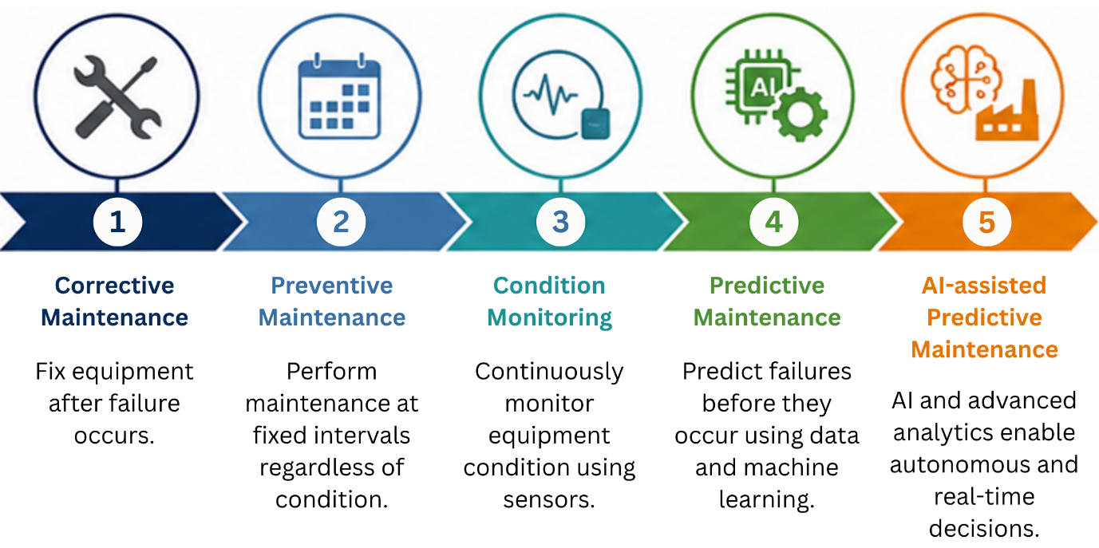
Figure 1. Evolution of Maintenance Strategies (Corrective to AI-assisted Predictive Maintenance)

Looking across the studies reviewed for this report, predictive maintenance is no longer only a theoretical idea. It is now used in manufacturing, energy, transport and healthcare to detect faults, estimate remaining useful life and reduce unplanned downtime [5]. Real-time IoT systems have made this easier, since data can be collected continuously while machines are running [1], [2].
Shahin et al. further demonstrate that machine learning-based early failure detection services can significantly reduce equipment downtime by identifying developing faults before breakdown occurs, reinforcing the practical value of predictive maintenance in modern manufacturing environments [6]. This matters for the present report because the problem is not whether data exists, but how to turn it into a reliable and affordable prediction system.
There is still a gap between research results and factory reality. Many studies report high accuracy, but they often rely on laboratory datasets, simulated failures or carefully prepared data. Factory data is rarely that clean: it contains missing values, noisy readings, sensor faults, transmission errors and very few real failure examples. Elkateb et al. show that IoT-based predictive maintenance can work in industrial settings, but also that practical deployment takes more than a model which performs well in experiments [2]. This is why the algorithm choice in this report must weigh accuracy, interpretability and computational cost together, as the brief requires.

1.2 Comparative Analysis of Machine Learning Algorithms

Choosing a model for predictive maintenance is not simply a matter of picking the algorithm with the highest accuracy in one paper. Different studies use different datasets, machines and fault types, so their results are not directly comparable. As a result, headline accuracy figures should be interpreted carefully rather than compared directly. Ouadah et al. make this point by treating algorithm selection as a practical decision rather than a purely mathematical one: their comparison of Decision Tree, Random Forest and K-Nearest Neighbour shows that the best choice depends on dataset size, the type of prediction problem, and the balance between performance and simplicity [3].
The Decision Tree algorithm is often used as a starting point because it is easy to understand. The decision path can be followed and linked to specific sensor variables, which helps maintenance engineers. Its weakness is instability: a single tree can change sharply when the training data shifts, and it tends to overfit when the data is noisy, or the machine runs under varying conditions [3], [7]. This makes it a useful baseline, but a risky main recommendation for a real plant.
Support Vector Machine can perform well, especially on smaller, cleaner datasets. Brusa et al. used SVM successfully for fault diagnosis, reaching very high accuracy when combined with suitable feature selection and explanation methods [8]. The limitation is practical: SVM needs careful tuning, and its computational cost rises as the dataset grows. For a company with limited resources and continuous sensor data, that makes deployment harder than the headline results suggest [2], [5].
Simpler models such as Logistic Regression, Naive Bayes and K-Nearest Neighbour remain useful because they are easy to implement and cheap to train, but their assumptions fit industrial sensor data poorly. Logistic Regression expects mainly linear relationships, Naive Bayes assumes independent features when sensor readings are clearly connected, and KNN slows at prediction time because each new case is compared against the stored data [3], [9]. They are helpful for comparison but unconvincing as the main model for the brief.
A clearer trend emerges when ensemble methods are compared with single classifiers. These combine several weak learners and handle non-linear sensor patterns better than single classifiers. Random Forest is particularly relevant: it is less sensitive to noise than a single tree, reduces overfitting through bagging, and provides feature-importance information that helps engineers see which variables drive a prediction [3]. Yang and Wang found Random Forest to be the best performer in their comparison, with strong accuracy and balanced precision and recall on manufacturing data [10], and Ayvaz and Alpay likewise found that ensembles such as Random Forest and XGBoost outperformed individual algorithms in a real production-line system [1].
Ignoring XGBoost would be difficult because several recent studies report excellent results. Even so, the improvement over Random Forest is often relatively small, while the additional tuning effort can be considerable [1], [9]. But better accuracy does not automatically mean better suitability. Boosting models usually need more careful hyperparameter tuning and are harder to explain to maintenance staff, and in a resource-limited plant, that extra complexity is not worth it if the gain is small. The "best" model on paper is not always the best model to deploy.

1.3 Data Quality and Preprocessing

One issue appears in almost every study, regardless of the algorithm being tested: data quality. Wanyonyi and Masinde found that preprocessing alone can significantly affect accuracy, precision, recall and F1-score across models [11]. This matters because raw industrial data is rarely ready for modelling: missing values, outliers, duplicate records and inconsistent readings can mislead a model before algorithm choice even becomes relevant (see Figure 2).
Class imbalance is especially important here. Most records describe normal behaviour, while real failures are rare, so a model can look accurate by predicting "normal" most of the time while missing the minority class that matters most. De Vargas et al. show that oversampling, undersampling and hybrid sampling are widely used to reduce this, with ensemble learning often performing strongly on imbalanced data [12]. Züfle et al. add that useful anomaly detection is possible with limited signals and modest data when preprocessing and resampling are handled carefully [13].
Feature selection is a further practical concern. Too many irrelevant or unstable features slow training, raise computational cost and make a model harder to explain. Buyukkececi and Okur argue that feature selection improves efficiency by removing redundant variables and improves interpretability when the chosen features stay stable as the data changes [4]. For this report that is important because the company needs a workflow that is accurate, understandable and affordable at once.
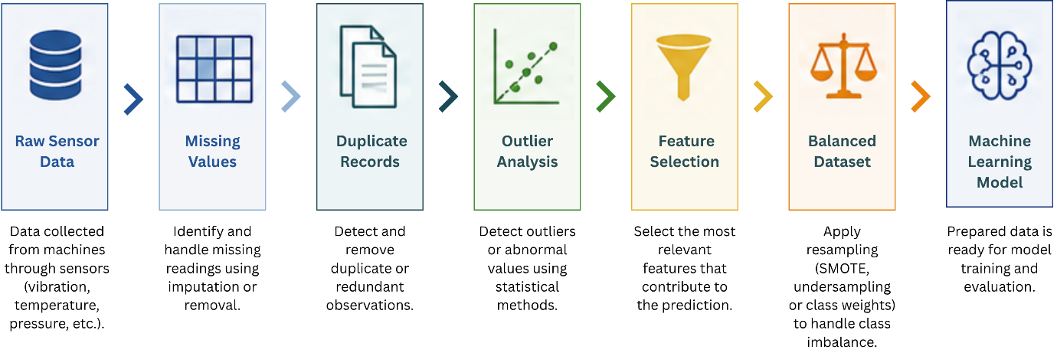
Figure 2. Typical Data Preprocessing Pipeline for Predictive Maintenance.

1.4 Model Evaluation, Explainability and Research Gap

Accuracy alone is not enough to evaluate a predictive maintenance model. In failure prediction, missing a real fault is usually worse than raising a false alarm, so precision, recall, F1-score, ROC-AUC and the confusion matrix should be read together [14]. Recall matters most where a false negative could let a machine break down, while precision matters because too many false alarms erode trust in the system (see Figure 3).
Interpretability is a practical requirement, not just an academic preference. Engineers need to know why a model predicts failure, especially when that prediction triggers downtime or a part replacement. Tree-based models support this better than most black-box methods, since they show which features influence the outcome, and Brusa et al. show that SHAP can explain feature contribution in fault diagnosis without weakening predictive performance [8].
The main conclusion from the reviewed literature is clear: predictive maintenance works best when the model is chosen with the industrial context in mind. For an organisation operating under limited resources, this trade-off may outweigh the relatively small improvements in accuracy reported by some studies. Random Forest and other tree-based ensembles repeatedly perform strongly on structured sensor data while staying practical for limited-resource environments [1], [3], [10], [15]. Taken together, these findings provide a clear justification for the workflow proposed in the next section, where data preparation, model selection and evaluation are treated as equally important stages rather than independent tasks.

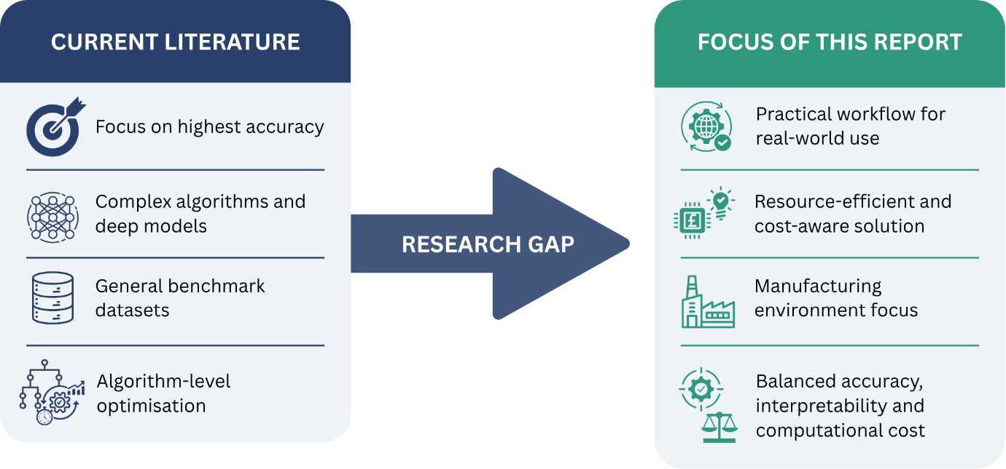

Figure 3. Research Gap Identified in the Literature.

Proposed Workflow Methodology

2.1 Workflow Overview

The workflow proposed in this report (see Figure 4) is to recommend a predictive maintenance process that is realistic for the manufacturing company. Rather than chasing the highest accuracy reported in research papers, the proposed solution focuses on something that engineers could realistically use in everyday operations. The workflow therefore balances three equally important priorities: predictive performance, model transparency and computational efficiency. This approach reflects the evidence presented in the literature review, where the strongest-performing solution is not always the one best suited for practical deployment [4], [5].
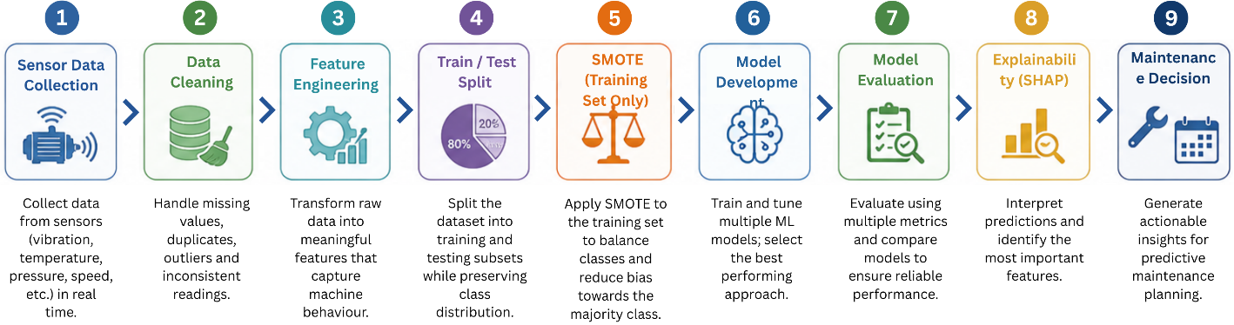
Figure 4. Proposed Predictive Maintenance Workflow

The process begins with preparing the available sensor data, followed by model development, evaluation and interpretation of the results. Each stage supports the next, meaning that reliable predictions depend not only on the machine learning algorithm itself but also on the quality of the data, the way the model is trained and the ability of engineers to understand its decisions. For this reason, the workflow is presented as one connected process rather than a series of independent technical steps.

2.2 Data Preparation

The company already collects sensor information such as temperature, vibration and pressure, providing a suitable starting point for predictive maintenance [2]. Before these measurements can be used for model development, they need to be organised and linked with maintenance records showing when failures occurred and what caused them. Reviewing the data at this stage is valuable because it quickly reveals whether enough failure examples exist to support supervised learning and whether the sensor readings contain patterns that are likely to distinguish healthy equipment from developing faults [1].
Industrial data is rarely clean. Missing values, duplicated observations, sensor interruptions and abnormal readings are common, and each of these can influence model performance if ignored. Wanyonyi and Masinde demonstrate that preprocessing alone can noticeably change accuracy, precision and recall, highlighting that data preparation is far more than a routine cleaning exercise [11]. The proposed workflow therefore begins by removing duplicate records, handling missing values, synchronising sensor timestamps and investigating unusual observations before deciding whether they represent genuine faults or simple measurement errors.
Outliers require particular attention. An unusually high vibration value may indicate a faulty sensor, but it may also be the earliest sign of bearing failure. Automatically removing every extreme observation could therefore eliminate valuable maintenance information. Instead, suspicious readings should be compared with maintenance logs and neighbouring sensor values before any decision is made [11].
Another important consideration is class imbalance. In most manufacturing environments, examples of normal operation greatly outnumber machine failures. If this imbalance is ignored, the model may achieve high overall accuracy while failing to detect the minority class that matters most [12]. To reduce this risk, the class distribution should first be examined after splitting the dataset into training and testing subsets. Where necessary, balancing techniques such as oversampling, undersampling or synthetic approaches like SMOTE can be applied, but only to the training data. Applying these techniques before the split would introduce data leakage and produce overly optimistic evaluation results. Keeping the test data untouched ensures that the final performance reflects realistic operating conditions [12], [13].
The final part of data preparation focuses on feature engineering and feature selection. Raw sensor streams often become much more informative after being converted into statistical indicators such as mean values, standard deviation, RMS and selected frequency-based vibration features [14]. Not every variable contributes equally to prediction, however. Removing weak or redundant features reduces computational cost, improves interpretability and often increases model stability. As Buyukkececi and Okur argue, selecting stable features is just as important as improving predictive performance because the model must continue to perform reliably when operating conditions change [4].

2.3 Model Development

With the data prepared, attention turns to the prediction model itself. The first design decision concerns the type of learning problem. Although some studies estimate Remaining Useful Life (RUL), this usually requires long run-to-failure histories that many manufacturers do not possess [5]. For the company described in the brief, a supervised classification approach is more practical because it predicts whether equipment is operating normally or showing signs of an approaching failure using maintenance records that already exist [3].
Only classical machine learning algorithms are considered (see Table 1), as neural networks fall outside the scope, because they will increase computational requirements unnecessarily.
ALGORITHM | ADVANTAGES | LIMITATIONS | SUITABLE FOR THIS PROJECT
Decision Tree | Easy to interpret | Overfitting | Medium
Logistic Regression | Simple | Linear only | Low
KNN | Simple | Slow prediction | Medium
SVM | High accuracy | Expensive | Medium
Random Forest | Accurate + interpretable | Slightly larger model | High
XGBoost | Highest performance | Higher complexity | Medium/High
Table 1. Comparison of Classical Machine Learning Algorithms Considered in This Study

Decision Tree provides a simple and interpretable baseline, while Logistic Regression, K-Nearest Neighbour and Support Vector Machine offer useful comparisons. Ensemble methods, particularly Random Forest and Gradient Boosting, are included because they consistently performed well throughout the reviewed literature [3], [7], [9].
Rather than relying on a single training run, each model should be evaluated under several parameter settings using stratified k-fold cross-validation. Hyperparameter optimisation through grid search or random search allows each algorithm to perform under fair conditions before comparisons are made [2]. Performance alone should not determine the final recommendation. Training time, model complexity and computational requirements should also be recorded because a small improvement in accuracy may not justify substantially greater processing costs in a factory operating with limited hardware [1], [16].
Based on the reviewed evidence, Random Forest represents the strongest overall candidate. It handles noisy industrial data well, reduces overfitting through ensemble learning and provides feature importance information that engineers can interpret without specialist knowledge [3], [10]. Gradient Boosting remains a valuable benchmark and may outperform Random Forest in some situations, but it should only replace the proposed model if its performance improvement clearly outweighs the additional computational and implementation costs.

2.4 Model Evaluation and Explainability

Model performance should be assessed using several complementary evaluation measures rather than relying on overall accuracy alone (see Figure 5). Since machine failures are relatively rare, precision, recall, F1-score, ROC-AUC and the confusion matrix together provide a more balanced picture of predictive performance [14]. Recall deserves particular attention because failing to identify a genuine fault may lead directly to unexpected equipment failure. Precision is equally important because excessive false alarms increase maintenance costs and reduce confidence in the system. Considering these metrics together provides a more realistic assessment than accuracy on its own.
Evaluation should also include a statistical comparison between competing models whenever possible. As highlighted by Rainio et al., small numerical differences do not always represent meaningful improvements, making statistical validation an important part of model selection [14].
Interpretability is another essential requirement. Engineers are far more likely to trust recommendations when they understand why the model predicts an approaching failure. Tree-based algorithms naturally provide feature importance rankings, while SHAP can explain individual predictions by showing how each sensor contributed to the final decision [8]. This additional transparency supports maintenance planning without sacrificing predictive performance.
Computational efficiency remains closely linked to explainability. A lightweight model with a carefully selected feature set requires less processing power during both training and prediction, making deployment possible on existing factory hardware. Previous research has demonstrated that Random Forest-based predictive maintenance systems can operate successfully in real-time industrial environments and even on resource-constrained edge devices, showing that practical implementation is achievable without expensive computing infrastructure [1], [15].
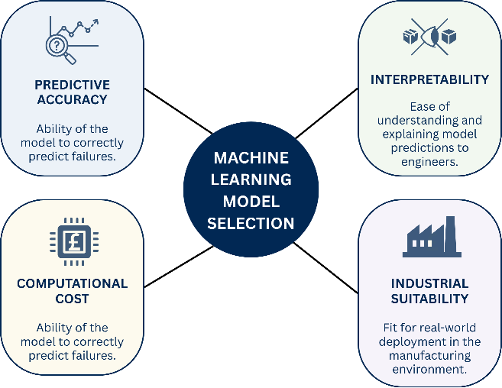
Figure 5. Model Evaluation and Explainability

2.5 Proposed Workflow Summary

The proposed methodology follows a straightforward sequence. Sensor data is first collected, examined and prepared before feature engineering and feature selection reduce unnecessary complexity. The prepared data is then divided into training and testing subsets, with any balancing techniques such as SMOTE applied only to the training data to prevent data leakage. Classical machine learning algorithms are compared under consistent validation procedures, after which their performance is assessed using multiple evaluation metrics rather than accuracy alone. Finally, feature importance and SHAP explanations provide transparency, allowing maintenance engineers to understand and trust the model's recommendations.
This workflow reflects the main conclusion reached throughout the literature review. Successful predictive maintenance depends on much more than selecting an accurate algorithm. Reliable data preparation, balanced model evaluation, practical computational requirements and explainable predictions all contribute to a solution that is suitable for real industrial deployment. Taken together, these stages provide a clear foundation for the final recommendation presented in the next section [3], [10].

Discussion and Recommendation

By this point, the choice of algorithm is no longer based on individual accuracy scores. The literature review showed that several machine learning models can predict equipment failures, while the proposed workflow demonstrated that model performance depends just as much on data quality, preprocessing and evaluation as it does on the algorithm itself. The final recommendation, therefore, comes from looking at the complete picture rather than focusing on one performance metric.
Random Forest emerged as the most suitable solution for this manufacturing company, not because it achieved the highest result in every study, but because it repeatedly offered the best balance between performance and practicality. Across the reviewed research, it consistently produced reliable predictions, handled noisy industrial data well and remained easier to interpret than many competing models [1], [3], [10]. For a company planning to introduce predictive maintenance into daily operations, those qualities are likely to have greater long-term value than achieving a small increase in accuracy at the expense of additional complexity.
Some alternative models clearly deserve consideration. Decision Tree remains one of the easiest algorithms to understand, making it useful during the early stages of model comparison. Even so, its tendency to overfit means that good performance on one dataset does not always translate into stable behaviour when production conditions change [3], [7]. Logistic Regression offers a lightweight solution, but industrial sensor data rarely follows simple linear relationships, limiting its ability to capture the behaviour of developing faults. K-Nearest Neighbour is equally straightforward to implement, although prediction becomes increasingly expensive as more historical data is stored. Support Vector Machine has shown strong classification performance in several industrial studies, yet this often comes with greater computational cost and more demanding parameter optimisation [8], [9].
Gradient Boosting proved to be the only model that genuinely challenged Random Forest. Some studies reported slightly stronger predictive performance, making it a reasonable benchmark during model comparison [1], [9]. That might seem enough to recommend it, at first sight. Looking beyond the published accuracy values tells a different story. The improvement was often relatively small, while the additional tuning effort, longer training times and lower interpretability remained. From a practical point of view, recommending a more complex solution simply because it performs marginally better would be difficult to justify. The objective of this consultancy report is not to identify the most sophisticated model available, but the one most likely to deliver dependable results within the company's technical and financial constraints.
The same argument applies to the overall workflow. One lesson appeared repeatedly throughout the literature: changing the algorithm alone rarely transforms predictive performance. Data preparation, handling class imbalance, selecting stable features and evaluating models with appropriate metrics all influence the outcome [4], [11], [12]. This is exactly why the proposed workflow presented in the previous chapter gives equal attention to each stage instead of treating algorithm selection as the single deciding factor. A well-prepared dataset combined with a reliable model is far more valuable than an advanced algorithm trained on poorly prepared data.
Evaluation should also reflect the realities of predictive maintenance rather than relying on accuracy alone. Missing a genuine failure may lead to unexpected downtime, while excessive false alarms reduce confidence in the system and increase unnecessary maintenance costs. For that reason, the recommendation developed in this report favours models capable of maintaining a strong balance between precision and recall instead of simply maximising one metric. The consistent performance of Random Forest across these measures further strengthens its suitability for this application [3], [10], [14].
One final point is worth considering. Predictive maintenance is not intended to replace maintenance engineers. It is designed to give them better information before making decisions. For this reason, the proposed solution follows a human-in-the-loop approach, where model predictions act as decision-support rather than automatic instructions. Engineers remain responsible for validating, questioning or overriding recommendations using their operational experience, recent maintenance history and knowledge of current production conditions. Combining machine learning with engineering expertise is likely to produce more reliable decisions than relying entirely on either one.
Based on the evidence reviewed and the workflow proposed throughout this report, Random Forest is recommended as the primary predictive maintenance model for the manufacturing company. The recommendation reflects much more than predictive accuracy. It considers implementation effort, computational efficiency, model transparency and the practical realities of deploying machine learning within an industrial environment. Gradient Boosting should still be included during comparative testing, but unless it demonstrates a clear and consistent advantage on the company's own data, Random Forest remains the option that offers the strongest overall value and the lowest implementation risk [1], [3], [6], [10].

References
[1] S. Ayvaz and K. Alpay, "Predictive maintenance system for production lines in manufacturing: A machine learning approach using IoT data in real-time," Expert Syst.Appl., vol. 173, pp.114598, 2021,
[2] S. Elkateb, A. Métwalli, A. Shendy and A. E. Abu-Elanien, "Machine learning and IoT–Based predictive maintenance approach for industrial applications," vol. 88, pp.298–309, 2024,
[3] A. Ouadah, L. Zemmouchi-Ghomari and N. Salhi, "Selecting an appropriate supervised machine learning algorithm for predictive maintenance," vol. 119, no. 7, pp.4277–4301, 2022,
[4] M. Büyükkeçeci and M. C. Okur, "A comprehensive review of feature selection and feature selection stability in machine learning," vol. 36, no. 4, pp.1506–1520, 2023,
[5] C. Tsallis, P. Papageorgas, D. Piromalis and R. A. Munteanu, "Application-wise review of Machine Learning-based predictive maintenance: Trends, challenges, and future directions," vol. 15, no. 9, pp.4898, 2025,
[6] M. Shahin, F. F. Chen, A. Hosseinzadeh and N. Zand, "Using machine learning and deep learning algorithms for downtime minimization in manufacturing systems: An early failure detection diagnostic service," vol. 128, no. 9, pp.3857–3883, 2023,
[7] D. Dhanraj, A. Sharma, G. Kaur, S. Mishra, P. Naik and A. Singh, "Comparison of different machine learning algorithms for predictive maintenance", in 2023 International Conference for Advancement in Technology (ICONAT), pp. 1–7.
[8] E. Brusa, L. Cibrario, C. Delprete and L. G. Di Maggio, "Explainable AI for machine fault diagnosis: understanding features’ contribution in machine learning models for industrial condition monitoring," vol. 13, no. 4, pp.2038, 2023,
[9] M. Er-Ratby, A. Kobi, Y. Sadraoui and M. S. Kadiri, "Predictive maintenance: a comparative study of machine learning algorithms in industrial applications", in 2025 33rd Mediterranean Conference on Control and Automation (MED), pp. 239–244.
[10] Y. Yang and H. Wang, "Random forest-based machine failure prediction: A performance comparison," vol. 15, no. 16, pp.8841, 2025,
[11] E. Wanyonyi and N. Masinde, "The impact of data preprocessing on machine learning model performance: A comprehensive examination," 2025,
[12] V. Werner de Vargas, J. A. Schneider Aranda, R. dos Santos Costa, P. R. da Silva Pereira and J. L. Victória Barbosa, "Imbalanced data preprocessing techniques for machine learning: a systematic mapping study," vol. 65, no. 1, pp.31–57, 2023,
[13] M. Züfle, F. Moog, V. Lesch, C. Krupitzer and S. Kounev, "A machine learning-based workflow for automatic detection of anomalies in machine tools," ISA Trans., vol. 125, pp.445–458, 2022,
[14] O. Rainio, J. Teuho and R. Klén, "Evaluation metrics and statistical tests for machine learning," vol. 14, no. 1, pp.6086, 2024,
[15] V. Artiushenko, S. Lang, C. Lerez, T. Reggelin and M. Hackert-Oschätzchen, "Resource-efficient Edge AI solution for predictive maintenance," vol. 232, pp.348–357, 2024,
[16] D. K. Yadav, A. Kaushik and N. Yadav, "Predicting machine failures using machine learning and deep learning algorithms," vol. 3, pp.100029, 2024,

