Level 5 Associate Diploma
in People Management

5CO03
Professional behaviours
and valuing people

- AC1.1

A professional could be identified in a number of ways, for example someone who carries out their job in a professional manner and to a high standard, (Taylor, S. and Woodhams, 2022) or a medical professional who is required to be registered with a professional body as part of their licence to practice and then there are people professionals and school business leaders where registration to a professional body is not mandatory but provides a set of standards that they can measure their professional competency to.

CIPD, the professional body that ‘governs HR and people development’ promises to provide a career that’ champions better work and working lives’ so when people become members of a professional body such as CIPD, they are expected to meet the professional standards and be able to align their practices to the Professional standard and code of practice (CIPD, 2023).

Launched in 2018, the CIPD profession map is a benchmark for people professionals around the world who work at any level (student to Chartered) to continually learn and improve practice. It is intended to support professionals in making confident decisions based on ‘purpose, values, core knowledge and behaviours’ (CIPD, 2023)

The profession map allows professionals to identify gaps in their skillset and identify development opportunities including creating a personal development plan, an opportunity to reflect on practice maximise impact in the workplace and the personally review membership levels.

While nursing did not not become a regulated body, the Nursing and Midwifery Council. until the 1990s, it now exists to maintain a register of nursing professionals who practice at a required standard. (Nursing and Midwifery Council, 2009) Similarly to other professionals such as people professionals or school business leaders, when a professionals join a recognised professional body, individuals are gaining a network of like minded community support that offers relevant training, credentials and advocates for the chosen career with a set of standards or code of conduct that safeguards not just the individual, but also stakeholders and the organisations.
The downside is when professions such as nursing where equal pay is constantly being raised there is a cost of the membership, time required to invest in additional / ongoing training, where nurses are required on the front line and leads to other front line pressures.

In conclusion, when a professional join a recognised professional body with its own values and code of conduct, they are gaining a network of like minded community support that offers relevant training, appropriate credentials and support for the chosen career with a set of standards or code of conduct that safeguards individuals, stakeholders and the organsiation and inturn and over time could also lead to a profession that allows for greater remuneration for the chosen career

- AC1.2

According to CIPD, ethical values ‘provide the moral compass by which we live our lives and make decisions – “doing the right thing” because it’s the right thing to do’. (Taylor, S. and Woodhams, C, 2022))

As the link between managers and employees, people are likely to see unethical decisions being made, when individuals may be under pressure (CIPD Podcast, Kate Griffiths Lambert).

Public sector workers follow the Nolan Principles, which include selflessness, integrity, objectivity, accountability, openness, honesty, and leadership. These principles guide how we perform duties. These are embedded in the way I carry out my role, in particular Integrity and within Appendix A, my 360 feedback supports this. I build relationships with colleagues as well as personal relationships I am respectful of all positions, and in my role, I ensure confidential information remains confidential to ensure there is the trust of employees, I am open and honest, and will admit any mistakes I may make and ensure fair treatment of others, which is acknowledged by peers and managers.

When carrying out the role of school business manager in advising staff or senior leadership team, I continually aim to ensure transparency and trust in my practice by following the appropriate policies and procedures.

Figure 1 gives a visual of what people see in our behaviour but is underpinned by our beliefs, values and attitudes. ‌
Figure 1
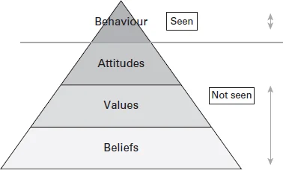
Utilitarianism, is a theory that a moral and political theory whose actions and institutions are designed to promote human wellbeing, a strong work ethic that I apply in my role as a School Business Manager, by being accountable for my actions, fostering a working environment that is fair and equitable and taking into account people’s personal situations while following policies and procedures and by consistently doing the right thing to be able to make the best decision with the best intentions.

This is also demonstrated in my approach to work as it has opened new opportunities for me, for example, having recently been approached to support other schools in establishing clear procedures and policies to address a unfavourable audit report and by the 360 feedback received from colleagues, (Appendix A)

- AC1.3

According to the CIPD Chief Executive, Peter Cheese, people professionals are quickly adapting more than ever to understand the benefits and risks for both employees and organisations alike when driving changes forward. He continues with explaining how the role is pivotal within organisations when navigating the changing world of work. Rapidly evolving technology and adoption of hybrid and flexible working are critical priorities, recognising the profession to be at the heart of business and change. (Cheese, P. 2023)

Being able to influence and professionally challenge decisions of others is a key behaviour of a people professional. Pressures of innovative ways of working, change in practice or staff carrying unethical or illegal behaviour, managers can need support of people professional to ensure stakeholders buy in, support and speak up when something isn’t right and also influence managers in making sure decisions are fair and appropriate to safeguard employees at the time, but also the organisation avoid employment tribunals, this makes the role of a people professional from recruitment roles to strategic and policy writing crucial to organisations.

One of the Profesional Maps core behaviour of a people professional is professional courage and influence. We are required to maintain ethics on being fair, confident in our decisions to be able to influence stakeholders.

CIPD Professional Courage and Influence short course identifies key aspects of how we as professionals can be strong on this core behaviour. (Perry Trimms, 2023)
- Constructive and confident in how challenge oppositions
- Clear communication
- Proactive in building relationships with stakeholders to build trust
- Engaging and tailor influence style for buy-in
- If anything in our remit goes wrong, take responsibility and reflective on our practice

A relevant example of the importance of professional influence occurred in my previous educational setting. The HR department advised the headteacher against hiring someone who had recently left the school as the headteacher's PA. However, the then headteacher and governing body ignored this advice, which led to an investigation years later over accusations of inappropriate contact by this former student. The investigator questioned why the local authority allowed such a critical appointment, raising concerns about the headteacher and governing body for disregarding HR’s guidance. Later, with a new headteacher, I, as the business manager, worked closely with the HR business partner to ensure careful consideration of any decisions that could raise doubts. The collaboration was valued, particularly as we carried out a teaching and support staff restructure, made significant savings but also did not have any strike action from unions
.
4. AC1.4

As a people professional who has a strong work ethic to ensure my following moral compass and ensure we as an organisation are “doing the right thing” because it’s the right thing to do, I have come across both unethical and illegal practice (Russell & Weeks, 2024)

Local Authority audits team carry out periodic audits to examine and evaluate financial and administrative controls in schools, the examples of both unethical and illegal practice in this AC is where I have been asked to go in and address the concerns, that led to Significant gaps, weaknesses or non-compliance were identified ensuring processes and procedures are addressed.

The CIPD ‘Rotten apples, bad barrels and sticky situations’ report states that ‘just under a third (31%) of people professionals say that managers in their organisations often demonstrate unethical behaviour’ There are various reasons people may act unethical in their work, this could be because people find their role monotonous, personality traits and passive moods as well as those who feel like they do not have control of their actions. (Gifford et al, 2019)

In Wales, teaching staff must register with the Education Workforce Council (EWC), which establishes essential principles for professional conduct and practice. Registrants are expected to act with honesty and integrity, one being financial matters. The Governing body must set financial spending and commitment limits for headteachers to prevent unauthorised budget alterations and ensure the detection of any financial misconduct. ‌(Code of Professional Conduct and Practice) Should I have been aware of this process not being carried out or incorrectly communicated, I would raise my concerns with the Chair of Governors and would ensure clear communication of these financial limits and why this is needed, to ensure all parties understood.

An example of illegal behavior in the workplace involves unauthorised payments made to an employee, processed by an individual benefiting from the funds. This situation could be classified as theft. If I were informed of such conduct, I would verify the facts and raise my concerns with the appropriate senior leader or a senior council member. An independent investigation would follow, leading to a potential suspension of duties and, depending on the findings, possibly resulting in a criminal investigation if upheld by the Governing Body's disciplinary committee.

5. AC2,1

A core psychological need is to feel accepted by people, according to Harvard Business Review in 2019, 40% of people feel isolated in the workplace, since then, Jessica Brown from People Management, says two thirds of employees feel less connected working from home (Brown, 2021)

To ensure employees feel valued and treated fairly, organisations should support equality, diversity, and inclusion in the workplace. This creates a sense of belonging and empowerment, which can help with recruitment and retention. It also addresses workplace behaviors and reduces unplanned absences, positively impacting business performance.

There are a number of theories that explore how an employee feeling included, valued and fairly treated in turns impacts the business.
Figure 2.
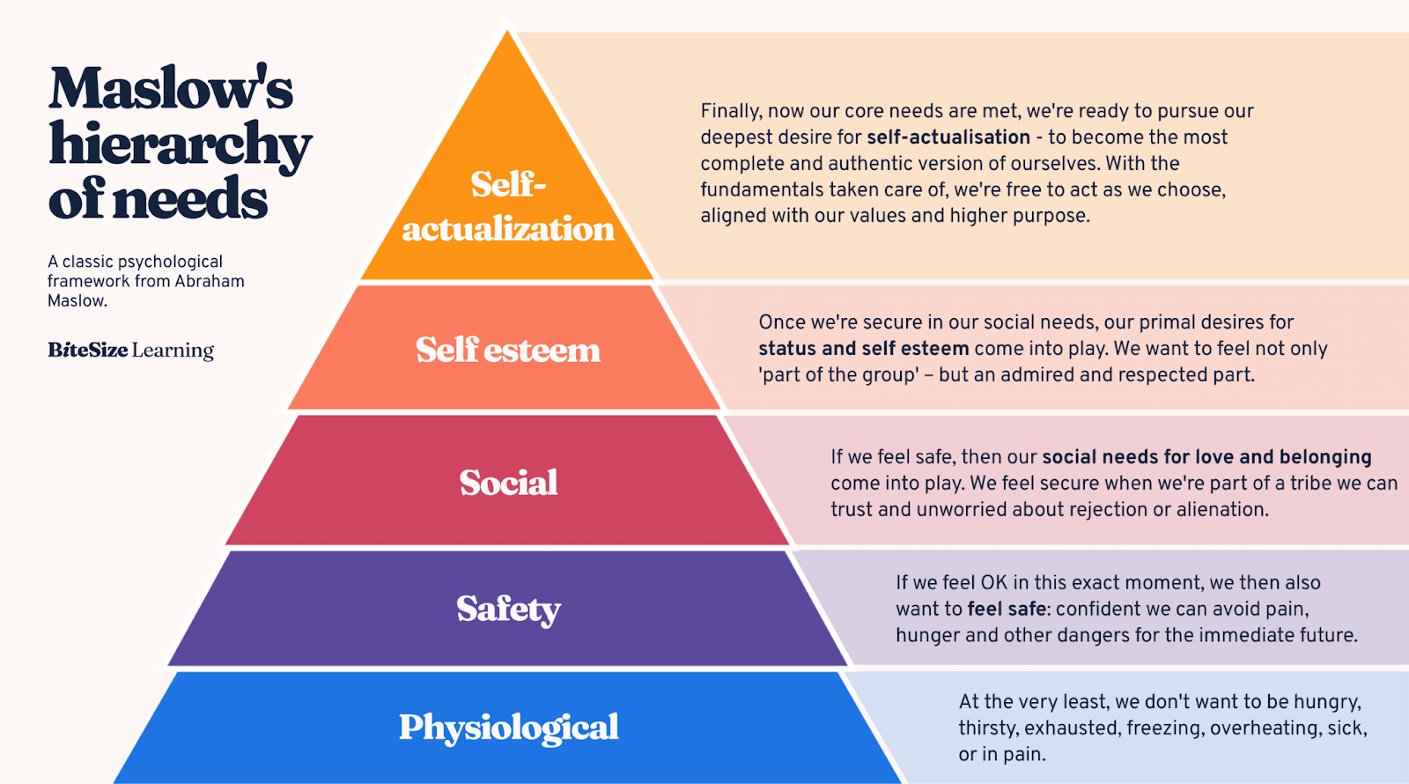
Maslow's Hierarchy of Needs (Figure 2) is often used to understand what motivates people in
the workplace. The theory suggests that if basic needs like food are not met, individuals will not focus on gaining recognition at work. However, despite its popularity, recent reports from HBR indicate that there is little data supporting this theory. (Fowler, 2014)

Herzberg (Figure 3) two factor theory is another theory that there are two hygiene factors that can drive job satisfaction and performance. (Nickerson, 2025)

Hygiene factors, also called dissatisfiers, must meet a certain standard for employees to feel valued. Examples include a sense of achievement, acknowledgment of contributions, finding work interesting, and having autonomy. Motivators, or satisfiers, include clear policies, competitive pay, and positive relationships. Herzberg explains that both satisfiers and dissatisfiers should be addressed together to create an environment where employees feel included, valued, and treated fairly.

Figure 3 is an illustrative example of how hygiene and motivational factors influences someone's overall work experience
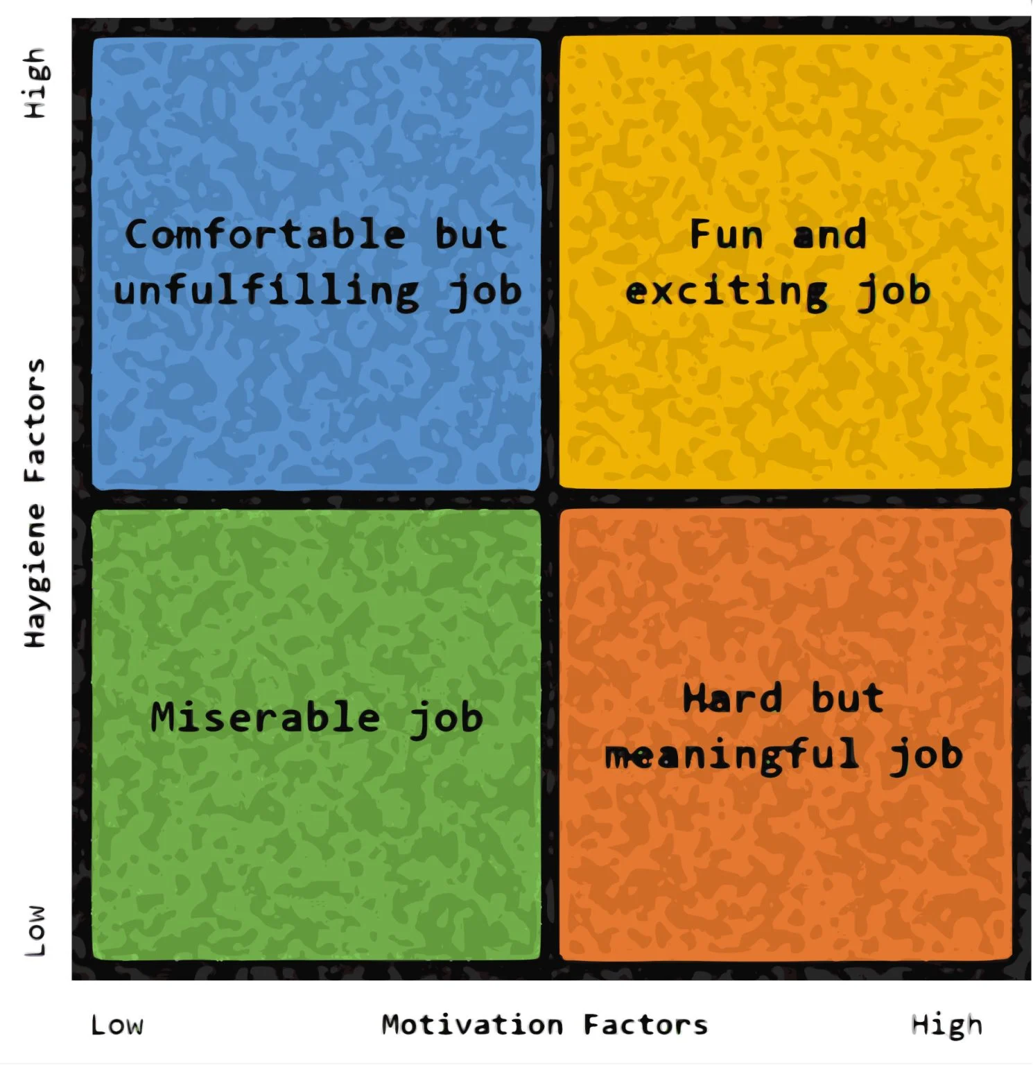
Figure 3

Before starting the CIPD course, I talked with colleagues and friends about work. As a school business manager responsible for finance, HR, and operations, I realised my motivation in work comes from contributing to the organisation and making others feel valued. (Carr et al., 2019). I treat everyone, from the Cleaning team to the Office Manager, with respect and kindness, remembering personal details and offering support. I believe in following policies to protect individuals, which aligns with the Herzberg model.

- AC2,2

Currently looking at the school’s leave of absence/special leave policy and in order to ensure I am being inclusive for the different types of contracts (ie Teaching, Support Staff term time only and Support Staff all year round contracts) I intend to look at the policy and come up with some guidance that is in the ‘spirit of the policy and recognising the goodwill that runs in schools’ to review the current numbers and reasons for Leave of Absences, the policy recognises that unplanned eventuality arise and that time is needed at short notice, however, some staff see this as an entitlement in addition to their 13 weeks holiday (teaching and Support term time staff and the contractual annual leave entitlement which is part of Working Time Regulations 1998 (WTR) and should not be classed the same as flexible working (Ayling and Suff, 2024)

As schools and some other employers may state that any holidays should be taken outside of the school term time, it would be unfair for them potentially to have to take unpaid LOA when they could use some of their annual leave entitlement.

There is a lot of ambiguity around ‘Headteacher’s discretion’ so in order to gauge people’s interpretation of the policy and ensure equity and fairness across all types of contracts I would ask for representatives from each employment type and of those at different levels, including Senior and Middle Leadership on both Teaching and Support Staff as well as other employees with no ‘responsibility’ to gain insights to why staff would need time off at short notice while also ensuring that voices can be heard as well as Trade Union representatives. As part of the process I will be looking at other school environments to see what works well and how we can support employees well being with a coordinated approach to Leave of absences while also meeting the needs of the business.

This would then be presented to Governors and then after a period of time, review the guidance’ to see what the impact ahs been for the employer and the employees ensuring all staff feel values, that they are

- AC2,3

First impressions count! So when recruiting members of staff, to ensure that we have a balanced and measured approach to the process, while a range of stakeholders will be included on the official panels, such as Governors, line managers and Senior Leadership Team, I also include an informal ‘panel’ and give them an opportunity to give feedback.

For example, the reception team has the skills of being very personable and sees a range of people every day, they are also able to gauge a person on their first visit, when they sign in, how they speak to them and how they speak to other candidates while waiting in reception. When the formal interview is over and the panel has their preferred candidate, I will ask the Reception team to come in and give us their feedback on each of the candidates. I do not know of a time that the panel and the reception staff have disagreed and every appointment that they have been part of has been successful. I also think it makes the admin team/reception staff feel valued (Carr, 2019) and included in decisions of people that they are going to be working alongside.

Upon reflection of my 360 review (Appendix A) that I sent out to colleagues this has also been recognised.

- AC3.1

Technology and AI is rapidly evolving within today’s society and according to guest speakers on CIPD Podcast episode 195, this includes the HR role,‌(CIPD | Is your organisation ready for the ChatGPT of things?, 2023) although, in my opinion, while there are people in jobs, there will always be an element of need for a ‘human/ people professional too but to then use AI as a ‘tool’ to maximise technological resources to be able support recruitment and data analytics, (Adams, 2025)

.In the role of a school business manager (Esta, 2025) I have not had much use of AI, however, the results of employee surveys have used AI package to pick up common ‘themes‘, while this was seen as an efficient way to pick up keywords people use, it did still need human interface as was not 100% accurate because if someone said ‘I have not encountered stress in the workplace’ and someone else has said ‘I am continually stress about work ‘ the focus has been on the word ‘stress’ and may be picked out as ‘stress’ being a negative and a bigger concern than what is actually is.

Bridgette Phillipson, Education secretary has called for ‘a digital revolution ‘ involving AI within schools (Adams, 2025) and Schools are having to address students' potential use of AI in coursework and in order to remain current in my role, this is a key area I need to develop my understanding. I pride myself on working ethically, and as a people professional, with a wide remit of responsibilities of HR and Finance, making the most of AI could support my role and may improve productivity so I need to understand how the use of AI can support my working to enhance the capabilities within my role including business leadership. As a starting point, my CPD plan includes using the CIPD resources and online course as starter, there are also other courses that are also available through School Business Manager networks such as ASCL.

However much uptake of AI is within society, I would not see this taking me away from that ‘human touch’ in supporting and interacting with individuals, such as in wellbeing meetings, AI can not replace empathy and the personal touch so while human’s are in jobs there will always be the need for human people professionals, just upskilled People Professionals who understand the capabilities and AI being use ethically in the workplace.

- AC3,2

Using the CIPD Profession Map, and 360 Feedback (Appendix A) from colleagues, I have been able to reflect on my strengths and areas for improvement.

Strengths - Integrity
CIPD says that at an associate level, a professional should be able to demonstrate professionalism and consistency in what is said and done to build trust. However, reviewing the levels and the feedback received from colleagues, I would consider myself as operating between a Charter Member and Fellow level. I am visible in how I role model this value both professionally and personally.
Ingriety is a core value in the way I work and a personal value. As C.S. Lewis said "Integrity is doing the right thing, even when no one is watching.” In my 360 feedback three different people recognised this value and highlighted it as a strength of mine.

Strengths -Valuing People
In order to be an effective leader, I strive to ensure people feel genuinely valued. The profession map says the key to valuing people is to create a shared purpose and enable people development. I was pleased to see that my efforts in ensuring people are valued featured throughout the 360 feedback, and includes recognition of building a sense of team spirit, treating people fairly, enabling others to develop their skills and taking into account wellbeing of others, all of which I would say I confidently work at Associate level.

Areas for improvement - Personal resilience
While I am motivated to carry out my job, taking on board responses from the 360 feedback (Appendix A) and referring to Commercial Drive behaviours, I need to improve my personal resilience while maintaining motivation through self care and personal responsibility. One anonymous colleague says an area for improvement for me is to ‘Not take adverse reactions to heart’. This has been an area of improvement for me, and I feel I have improved slightly after reading ‘the Chimp paradox’ following a previous colleague's recommendation, but recognise that this and taking care of my own self care is still an area I need to improve.

Areas for improvement - Conflict resolution
I would also say I need to improve conflict resolution. While I will tread carefully and be empathetic to people’s situations, I am not confident in dealing with conflict and could not coach people to resolve conflict within a team.

In conclusion, to improve my personal resilience and conflict management, Harvard Business Review suggests compartmentalizing cognitive load and taking detachment breaks. I will also work on personal development and self learning on how to problem solve and take a constructive approach to conflict.

- AC3.3

Appendix B is a table that contains my personal development plan based on the self-assessment above. This includes what I need to improve on, what I will do to achieve this, the resources I will need, the success criteria and the target dates.

- AC3.4

Appendix C (below) is a reflective record of my learning over the last 12 months, and how this has impacted my performance at work and/or my behaviour in my current role.

Name | Date | Profession Map Area | Type of Learning | What is the learning experience you're reflecting on | What did you learn from this experience? | How does this change the way you'll work in the future? | What else have you done - or what will you do
LJ Williams - Business Management | 10/01/2024 | Passion for learning | Listened to a podcast | LJ Williams is a School Business Leader that has recorded podcasts and has discusses with other School Business Leaders about a range of topics such as Line Management, Premises, ICT, Financials, review of a year in the role | Reaffirming what I believe in, aligning my goals, sharing top tips and advice to help SBLs gather all the information, evidence and intelligence they need to get to grips with the role quickly, reflecting on the role, pointers for consideration | Take on people's advice and top tips, firms up my knowledge and keeps me on track | Further reading from books recommended by the professionals on podcasts
Chimp Paradox | 29/03/2024 | Culture and behaviour | Read an article/blog/book etc | Helps people to manage their mind more effectively, with an approach grounded in neuroscience. Through the Chimp model,&nbsp; help people understand how the mind functions can develop the insight and skills needed to get the best out of themselves and others. The approach can help people to improve success in both personal and professional settings | The book offers a simplified way of understanding our two thinking brains and how we can learn to use them to the best of our ability.  It is a simple representation to aid understanding and help us to use science. It may also help us to make sense of how we have been in the past, how we are now, and how we can manage ourselves better in the future. In our mind management model, the inner Chimp is the emotional team within the brain that thinks and acts for us without our permission. The logical team is the real person, it is rational, compassionate and humane, and the Humanwithin. The memory banks for reference are the Computer. | When meeting with staff to return to work, carry out wellbeing visits with staff who perhaps think everyone is against them, feels that they are not doing a good enough job, I try to explain how reading this book made me realise how powerful our mind is. Sometimes I react to things and let my emotions run away with me, but having read this book meant that I try and stop and think of my 'chimp' | Continue to read and develop my personal skills, and when I feel overwhelmed, pick the book up and read again
HR in Practice | 29/05/2024 | Other | Attended an event | HR fundamentals to give an overview of HR in practice  how to prioritise HR work, risk assess an HR situation, and recognise where immediate and longer-term attention is appropriate. overview of recruitment techniques and learn how to maintain good employee relations and identify where relationships can break down and how to support high morale and productivity while recognising the different types of underperformance and how and when to intervene. Introduction to UK employment law, including basic contractual and HR policy issues. | How good HR practice contributes towards achieving company objectives, apply good recruitment and selection practices to support organisation/wider HR department  develop; performance and personal effectiveness in handling a range of HR issues, increase confidence in your work as an HR professional. | This was a brief 2 day course that allowed me to have confidence in areas I was familiar in from working practice, while also allowing me to explore other areas such as employment law and gave be a brief insight | Follow up with a more detailed course that would develop my skills and understanding.
School Business Management | 18/06/2024 | Passion for learning | Something I'm doing/I've done at work | Having been new to the role of school business management, I didn't realise what I did naturally when it comes to processes, policies and procedures has had so much impact on the organisations that I have worked for.&; Schools are like their own entity and unless a headteacher has come from an academy where they have experience of spending the budget correctly, managing HR processes then I have learnt things can go wrong, From my experience, I have been asked twice to help a school with incorrect processes including not contracts for teaching and support staff not being equitable and taking into account the different terms and conditions. Through my own interest I listen to podcasts about school business management, leadership as well as always looking for continued ways to improve and streamline processes - having completed an Agile Project Management course has allowed this | I have to have more confidence in what I do and what I know. Having carried out a reflective reflection of what has my Impact been in the role proved beneficial and gave me a time of reflection on my practice and also what the next steps are. | Not to take things for granted, to continue learning, and recognise that every school is different, I like to think I have benefitted not just the school when it comes to financial management but also ensured HR processes are followed and employees are supported to make their working time enjoyable | Share best practice within; others, contribute to informal discussions on X and SBM forums. Support Cluster schools and look to develop myself
EWC Code of Professional Conduct and Practice and using social media responsibly professional responsibilities and ethics | 03/09/2024 | Ethical practice | Attended/completed a course | Professional Code of Conduct - What is EWC Code of Conduct, What can happen if not abide by Code of Conduct. Understanding of Good Practice guides | Examples of behaviour that go against code of conduct, real life examples, Importance of social media posts and privacy settings. | While I am not EWC registered in my role, I would consider the code of conduct as professional integrity and should be abided to whether registered or not registered; But also supports me in my role as HR within the school, as part of safer recruitment checks | Ensure that importance of the risks are included as part of staff induction process, and to being in the experts for other staff on INSET days too

Bibliography - Professional behaviours and valuing people

Adams, R. (2025) The English schools looking to dispel ‘doom and gloom’ around AI, the Guardian. The Guardian. Available at: https://www.theguardian.com/education/2025/mar/06/the-english-schools-looking-to-dispel-doom-and-gloom-around-ai

Alarcon, S.M. (2024) That’s the question: Belonging to a professional association can offer numerous benefits, but it also comes with its challenges. For business leaders keen on expanding their market reach and fostering growth, here are some of the key advantages and drawbacks you should consider: Pros - Networking Opp, Linkedin.com. Available at: https://www.linkedin.com/pulse/understanding-pros-cons-professional-association-sergio-m-alarcon-dwucc/

Armstrong, M. (2014), Armstrong’s Handbook of Human Resource management, Kogan Page ISBN 9780749469658

Armstrong, M. (2024). Armstrong's Essential Skills for People Professionals: Kogan Page.

Ayling, L. and Suff, R. (2024) Working Hours & Time Off Work | Factsheets, CIPD. Available at: https://www.cipd.org/uk/knowledge/factsheets/working-time-factsheet/.

Boyles, M. (2023) What Are Business Ethics & Why Are They important?, Business Insights Blog. Harvard Business School. Available at: https://online.hbs.edu/blog/post/business-ethics

Brown, J. (2021) Two-thirds of employees feel less connected working from home, survey finds, 90313. Available at: https://www.peoplemanagement.co.uk/article/1742971/two-thirds-of-employees-feel-less-connected-working-from-home (Accessed: 25 February 2025).

Carr, E.W. et al. (2019) The Value of Belonging at Work, Harvard Business Review. Available at: https://hbr.org/2019/12/the-value-of-belonging-at-work

CGA / EWC. Available at: https://www.ewc.wales/site/index.php/en/ (Accessed: 9 March 2025).

CIPD (2023) Code of Conduct and Ethics, CIPD. CIPD. Available at: https://www.cipd.org/globalassets/media/comms/code-of-conduct/2023-cipd-code-of-conduct-and-ethics.pdf
CIPD | Is your organisation ready for the ChatGPT of things? (2023) CIPD. Available at: https://www.cipd.org/uk/knowledge/podcasts/ai-and-organisational-change/.

‌CIPD (2023) Code of Conduct and Ethics, CIPD. CIPD. Available at: https://www.cipd.org/globalassets/media/comms/code-of-conduct/2023-cipd-code-of-conduct-and-ethics.pdf.

CIPD (2023) HR Professionals Are Key to Implementing New Ways of Working and Should Be at the Heart of Driving Change, Says a New CIPD Report, CIPD. Available at: https://www.cipd.org/uk/about/news/hr-professionals-pivotal-implementing-change/.

‌CIPD (2024) Ethics at work: an Employer’s Guide, CIPD. CIPD. Available at: https://www.cipd.org/uk/knowledge/guides/ethics-work-guide/

Clark, S. (2015) Ethical decision-making: Eight Perspectives on Workplace Dilemmas. Available at: https://www.cipd.org/globalassets/media/comms/the-people-profession/profession-map-pdfs/ethical-decision-making-2015-eight-perspectives-on-workplace-dilemmas_tcm29-9564.pdf.

Code of Professional Conduct and Practice (no date) www.ewc.wales. Available at: https://www.ewc.wales/site/index.php/en/fitness-to-practise/code-of-professional-conduct-and-practice/the-code.

Esta (2025) NEWS: AI Brings Fresh Creativity to Classrooms | Edexec, Edexec | Supporting
business and financial excellence in schools and academies. Available at: https://edexec.co.uk/news-ai-brings-fresh-creativity-to-classrooms/ (Accessed: 25 February 2025).

Fowler, S. (2014) What Maslow’s Hierarchy Won’t Tell You About Motivation, Harvard Business Review. Available at: https://hbr.org/2014/11/what-maslows-hierarchy-wont-tell-you-about-motivation .

Mohdzaini, H. (2019) CIPD | Briefing | AI in focus: Role of people professionals, regulation and the CIPD, CIPD. Available at: https://www.cipd.org/uk/views-and-insights/thought-leadership/insight/ai-people-professionals-cipd/.

Nickerson, C. (2025) Herzberg’s two-factor Theory of motivation-hygiene, Simply Psychology. Available at: https://www.simplypsychology.org/herzbergs-two-factor-theory.html.
Nursing and Midwifery Council (2009) Standards for pre-registration Midwifery Education, Nursing and Midwifery Council. Available at: https://www.nmc.org.uk/globalassets/sitedocuments/standards/nmc-standards-for-preregistration-midwifery-education.pdf

Rob Walker01 (2025) CIPD Professional courage and influence, Scribd. Available at: https://www.scribd.com/document/791712482/CIPD-Professional-courage-and-influence (Accessed: 12 February 2025)

Taylor, S. and Woodhams, C. (Eds) (2022) Studying Human Resource Management, A Guide to the Study, Context and Practice of HR, 3rd Ed, CIPD: Kogan Page

Taylor, S. and Woodhams, C. (Eds) (2022) Human Resource Management, People and Organisations, 3rd Ed, CIPD: Kogan Page

Unethical workplace behaviour: Rotten Apples, bad barrels and sticky ... Available at: https://www.cipd.co.uk/Images/unethical-behaviour-in-the-workplace_report-2_tcm18-57022

Waite, K., Beevers, K., Small, N., Tomlinson, K. and Hussain, S. (2021) People Practice. Kogan Page

APPENDICES

APPENDIX A - 360 Feedback

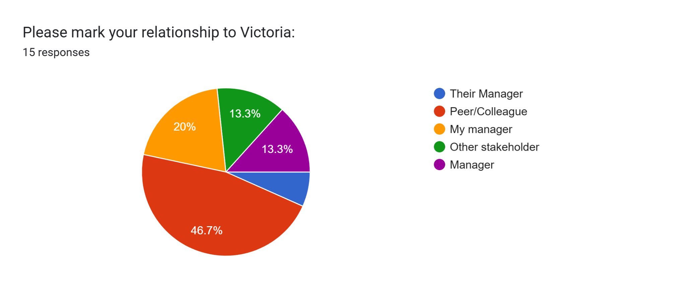
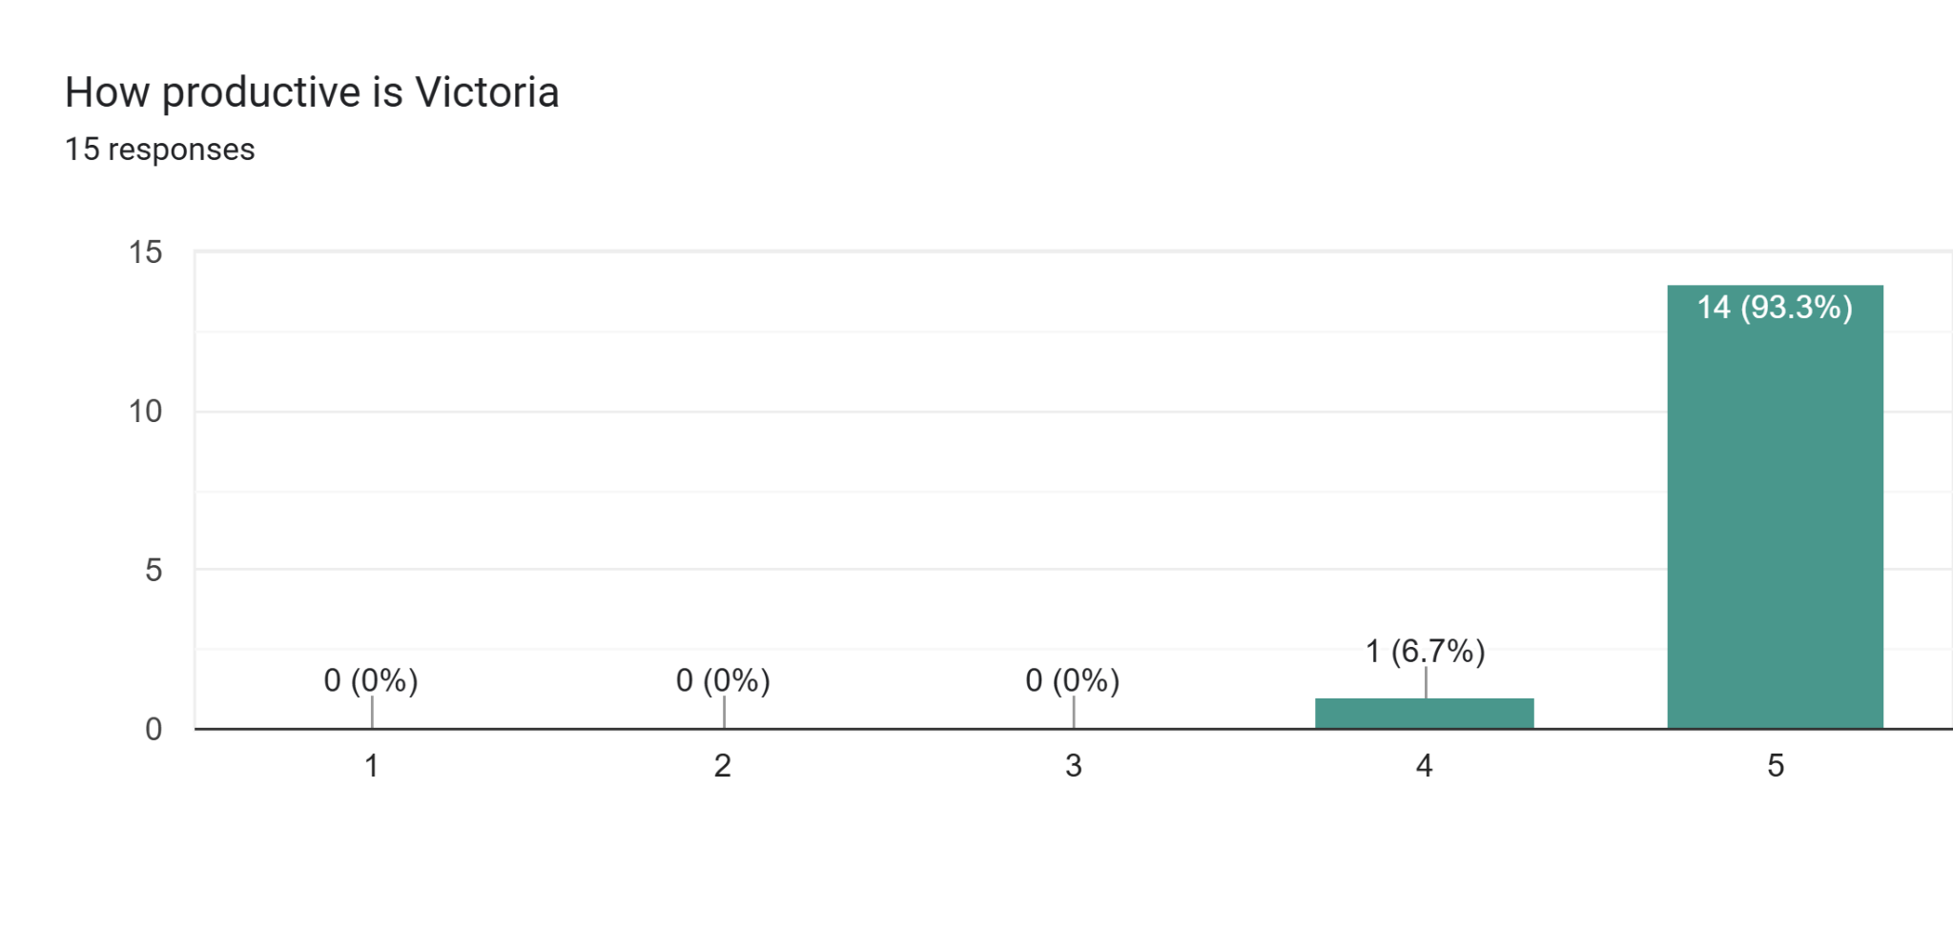
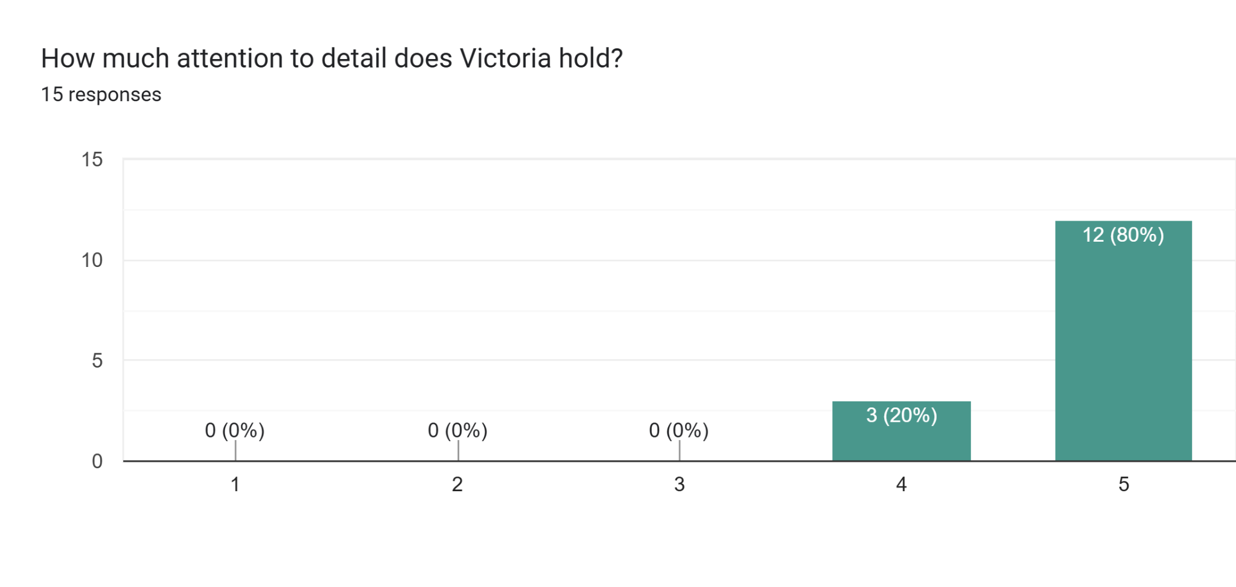
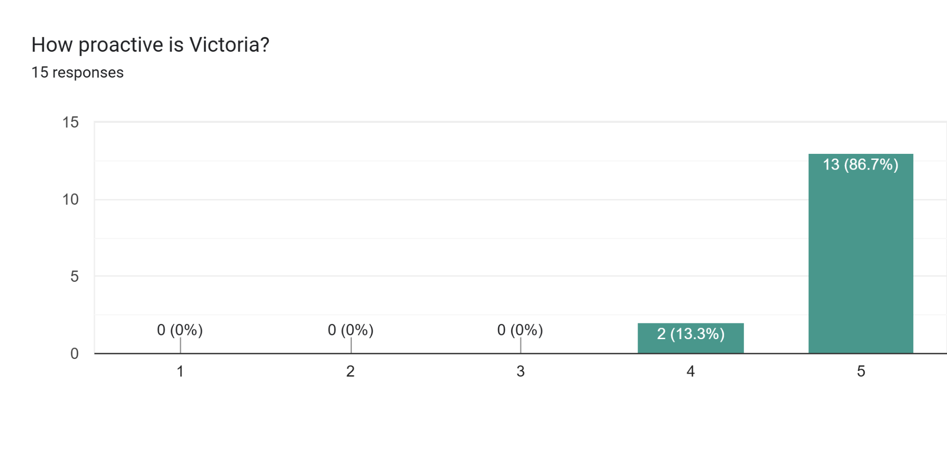
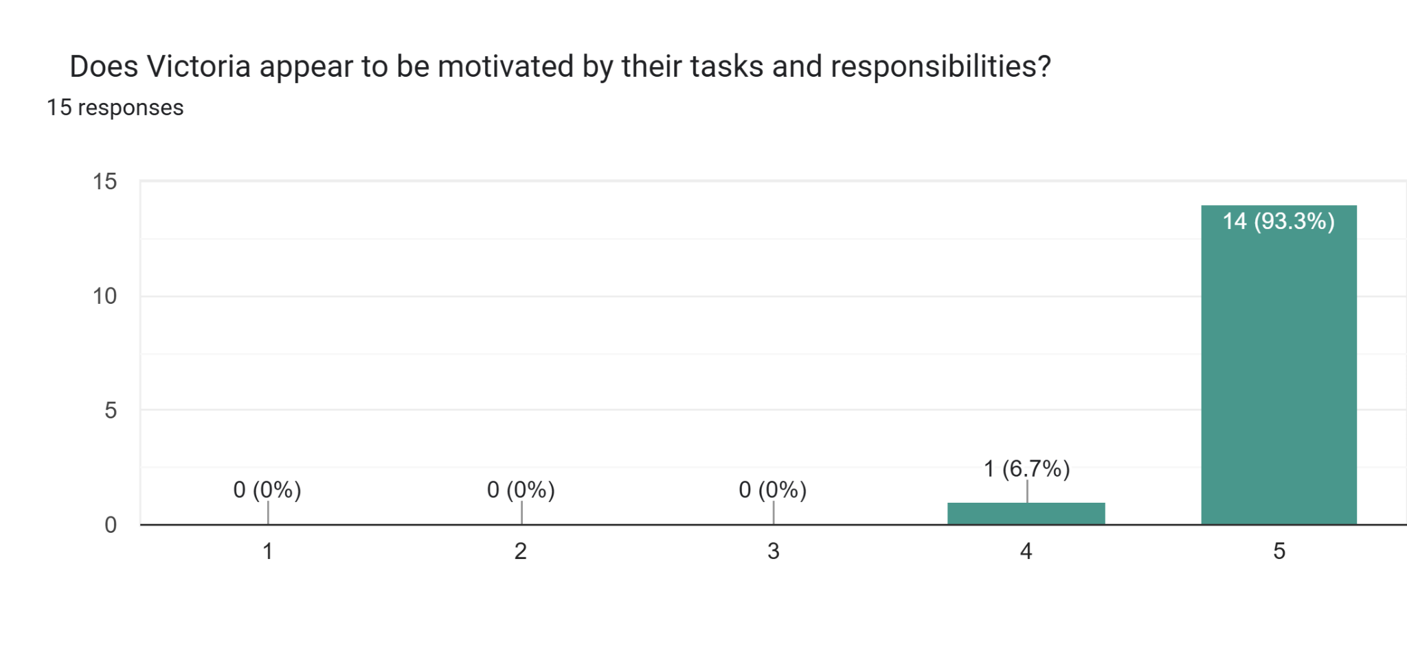
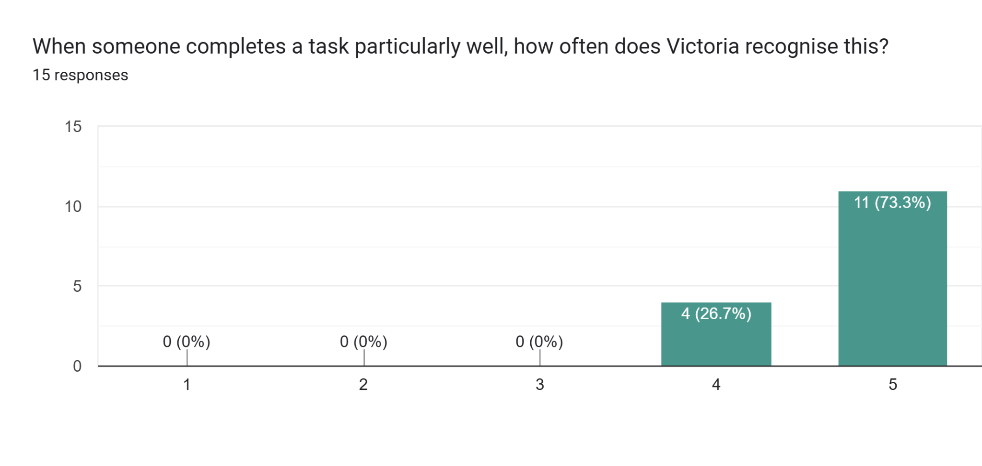
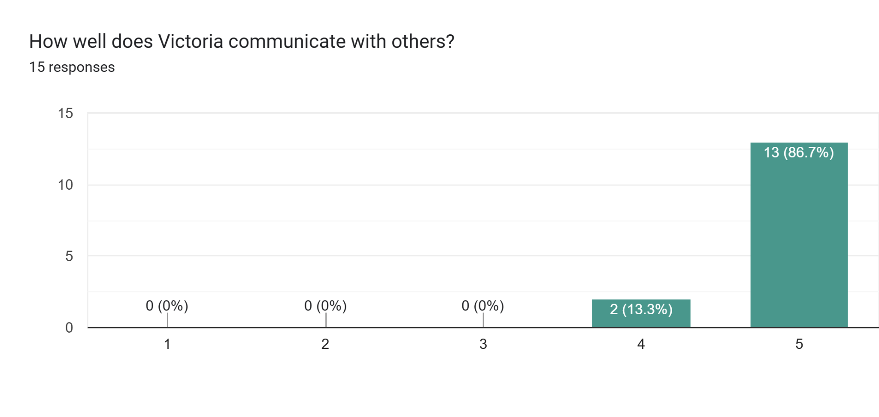
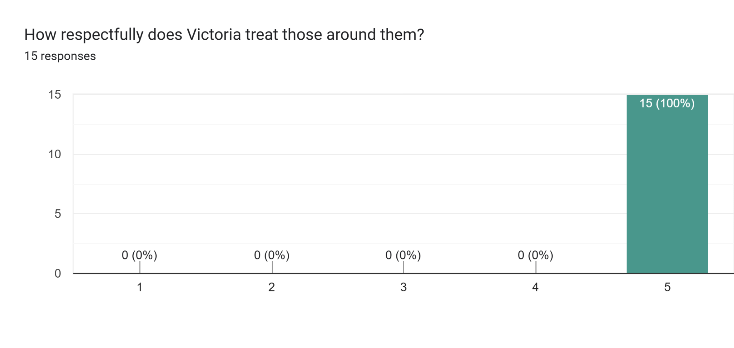
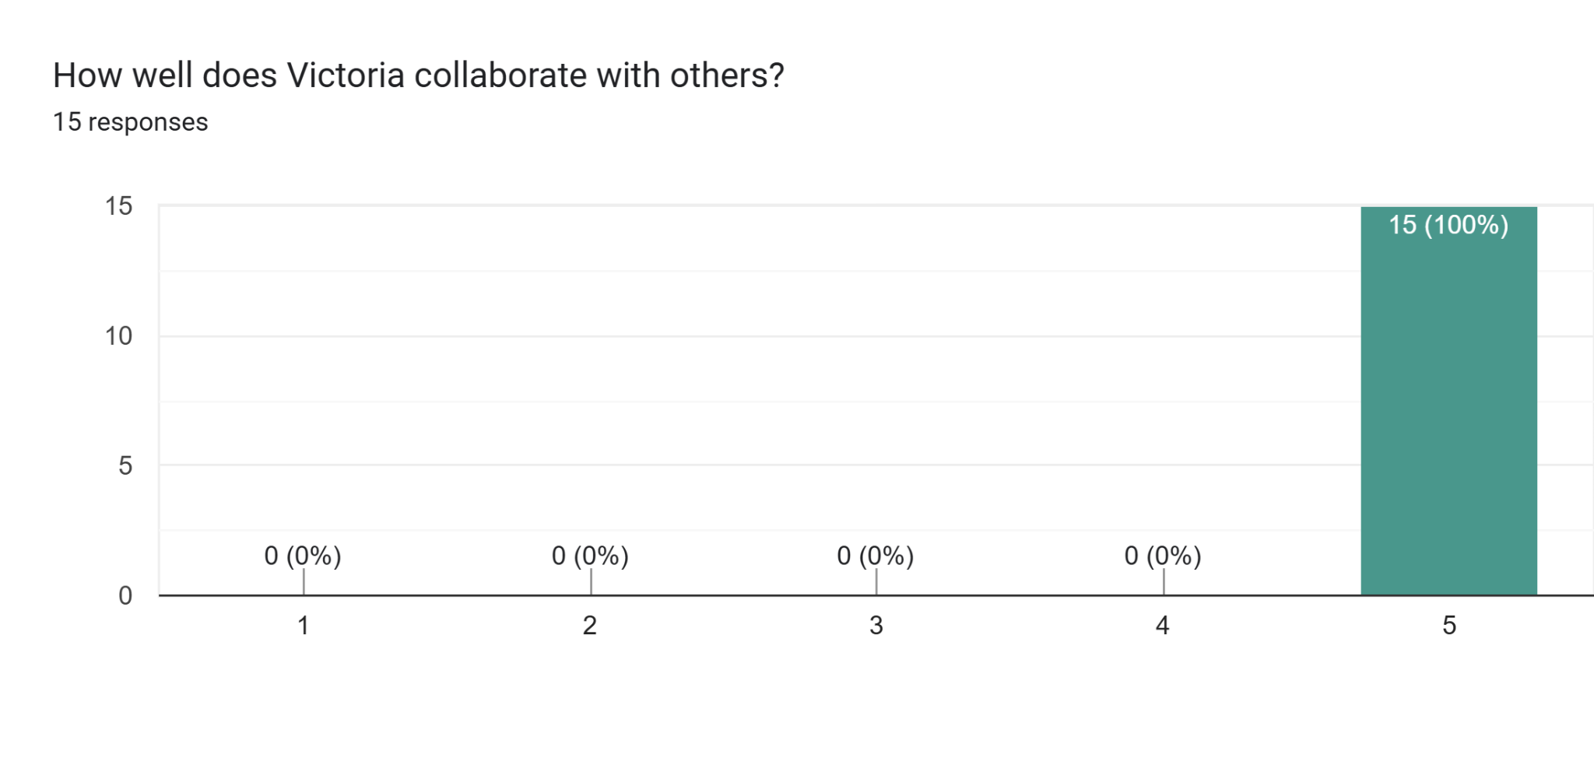
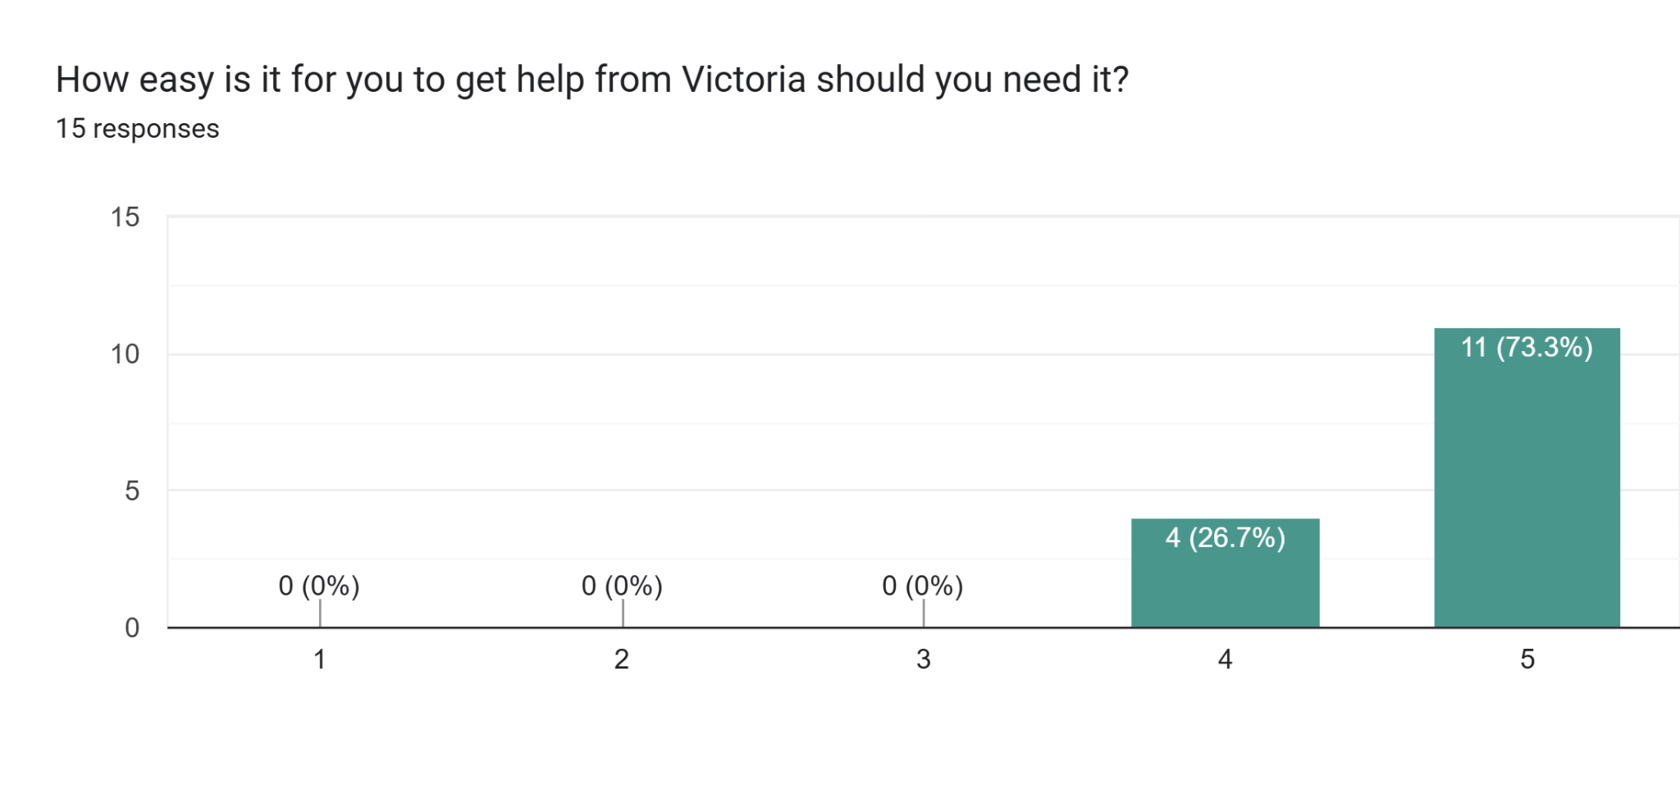
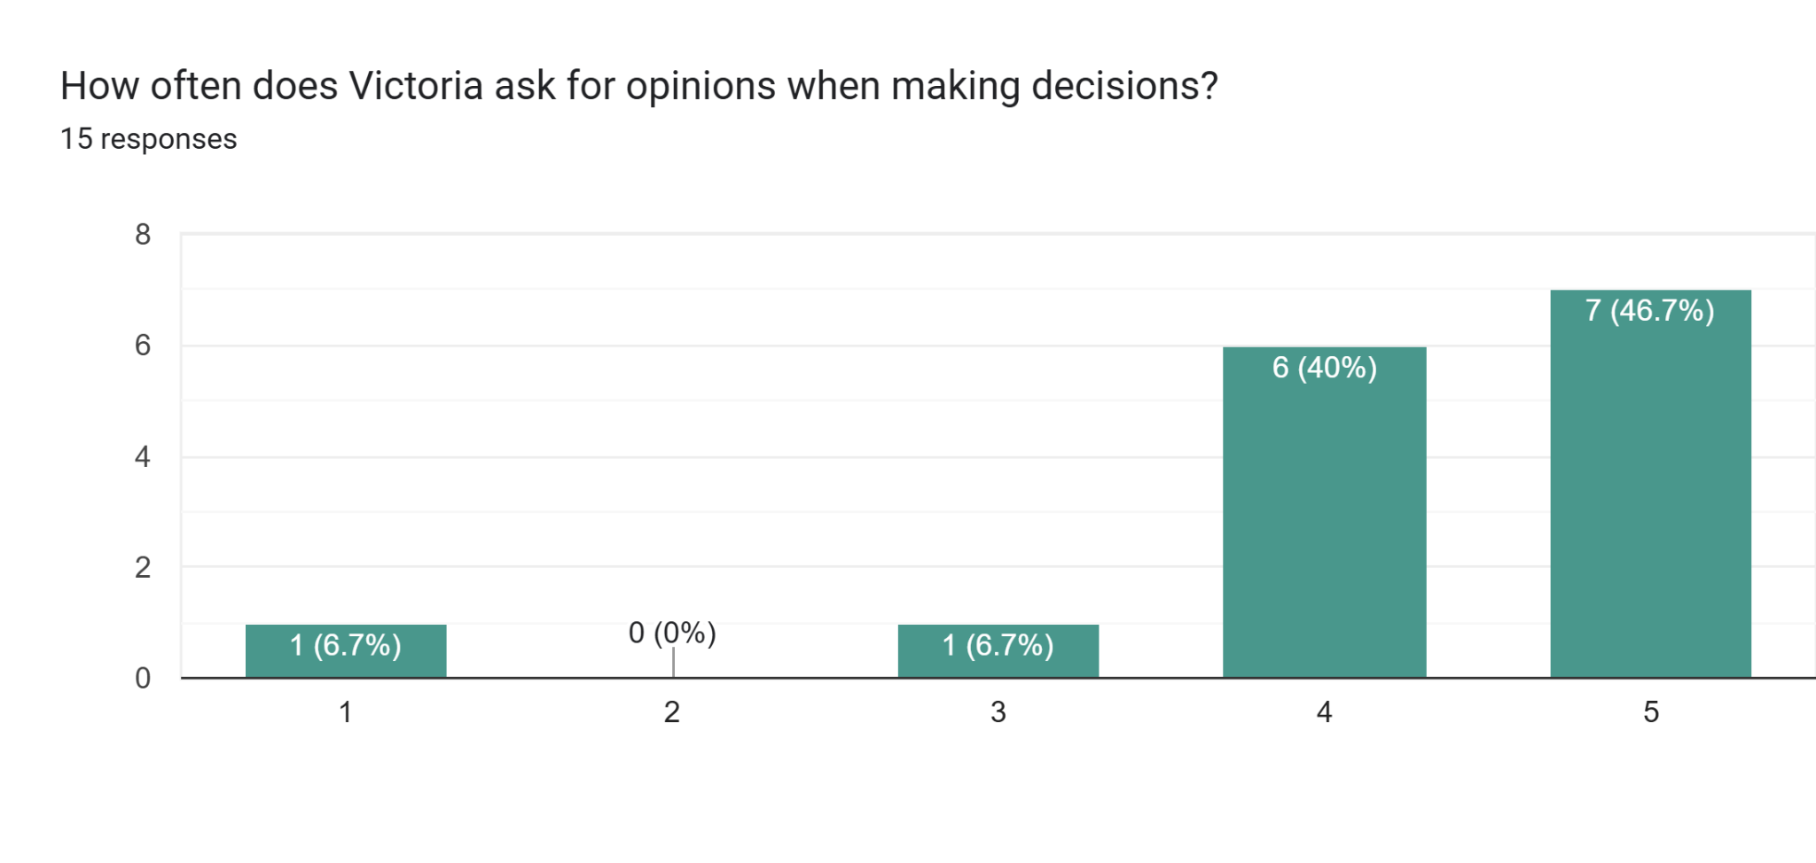
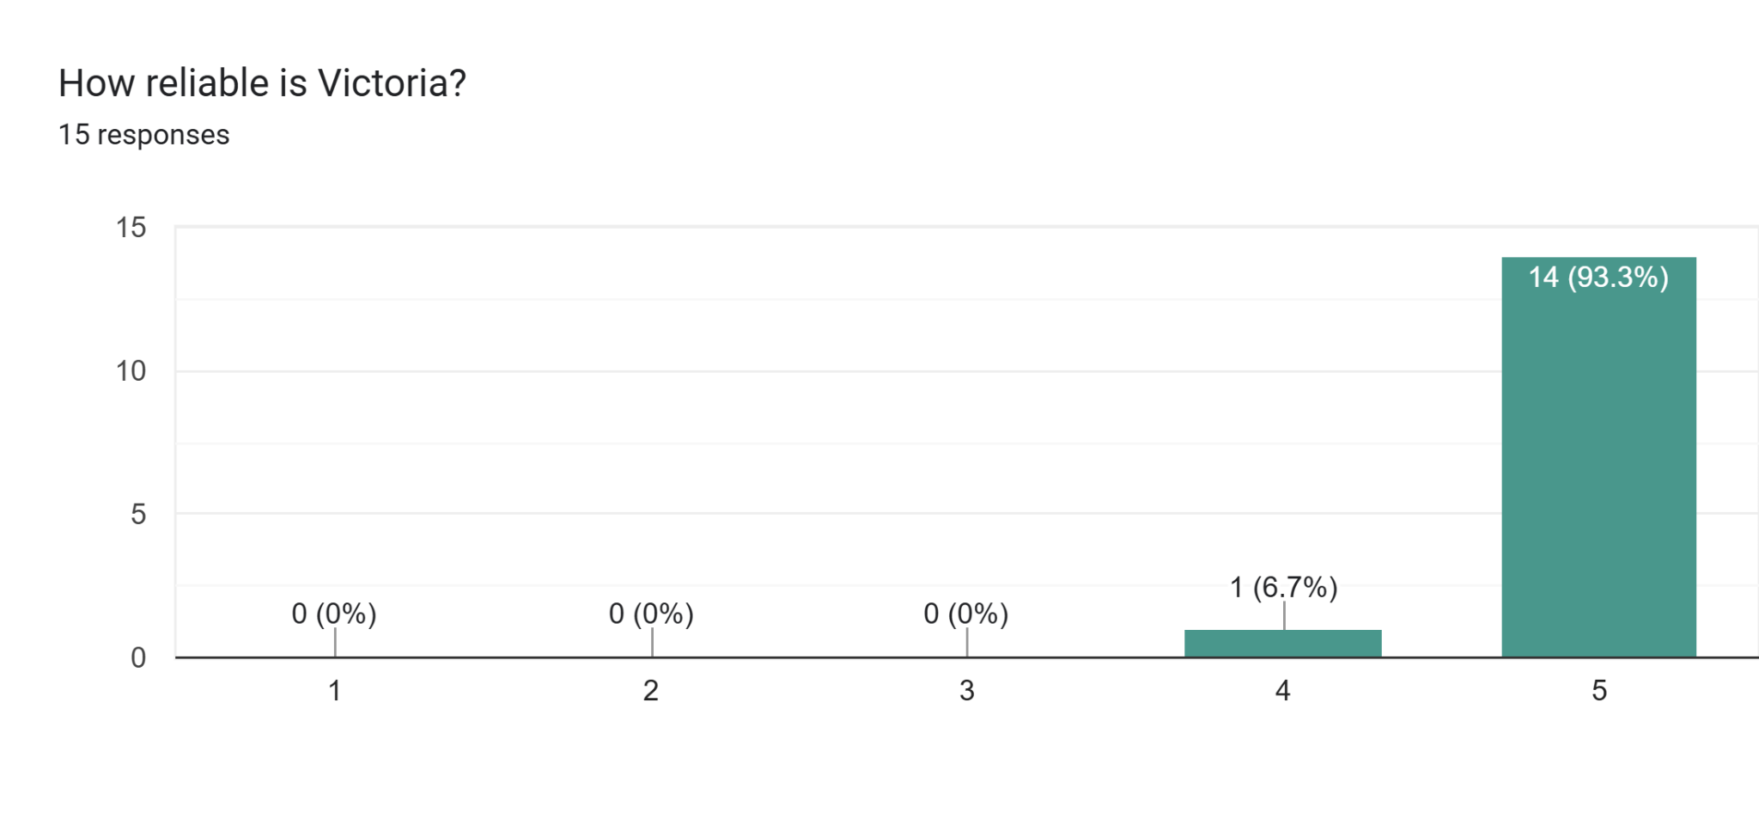
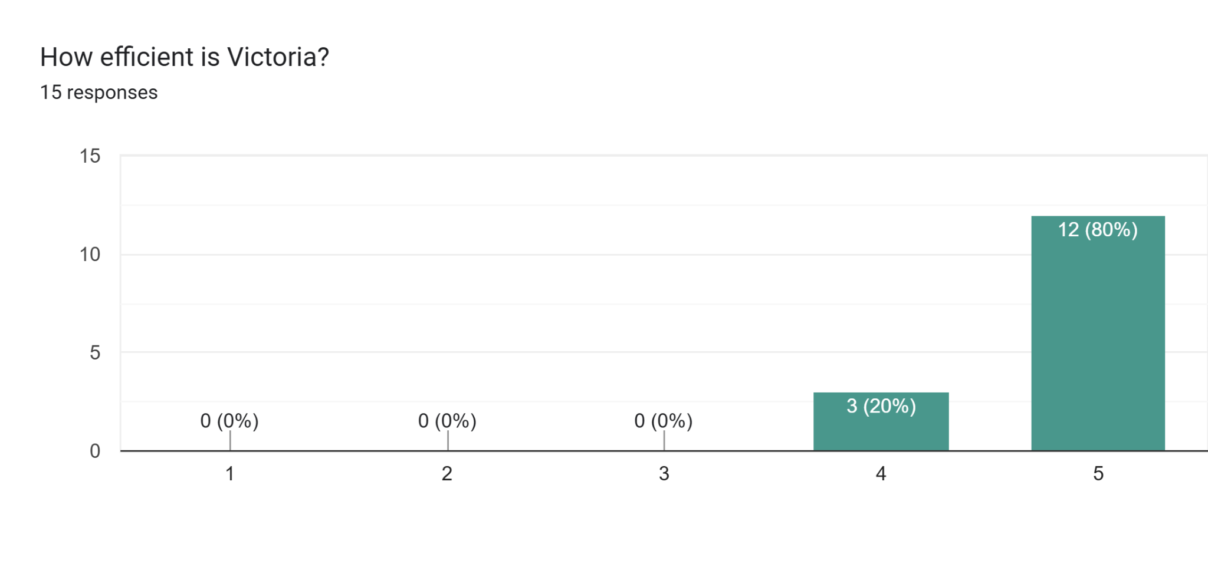
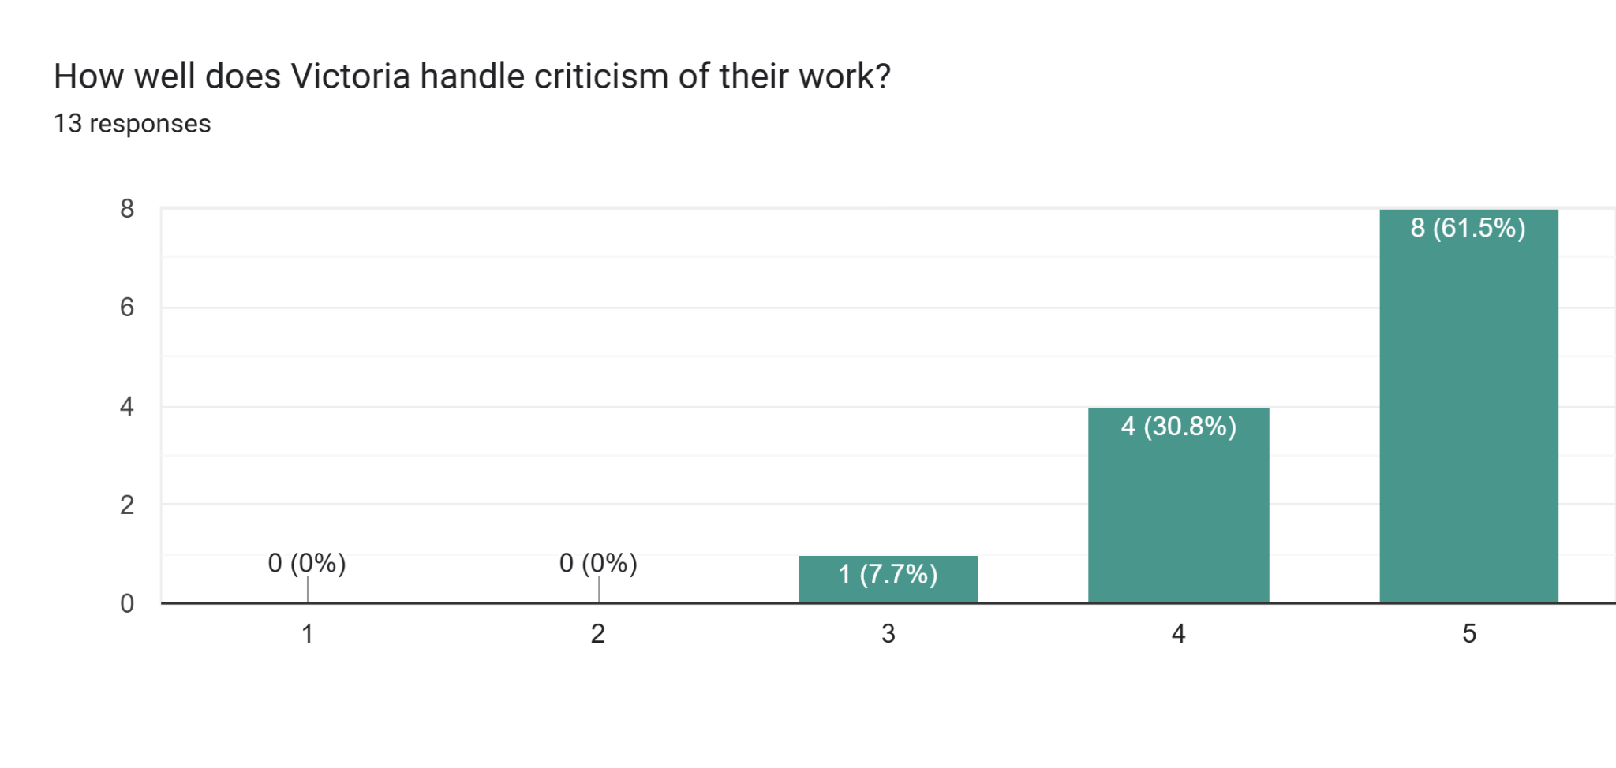
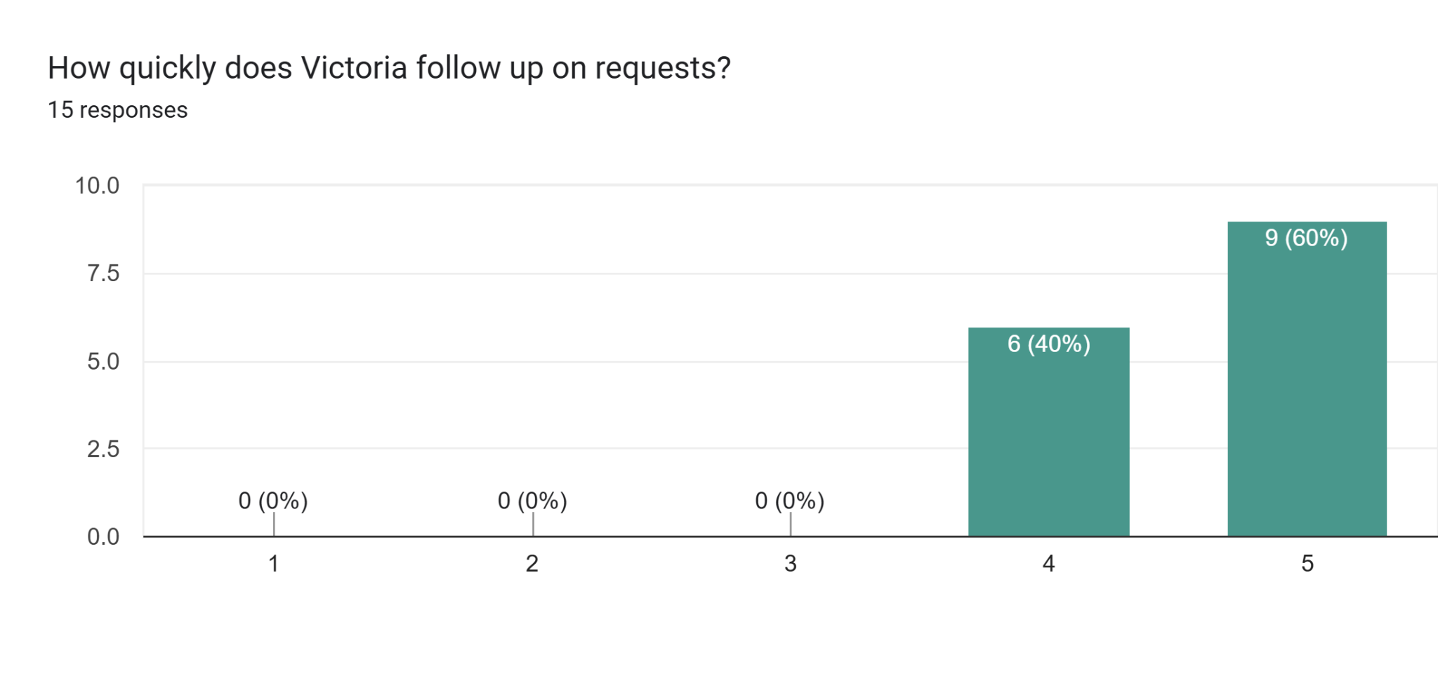
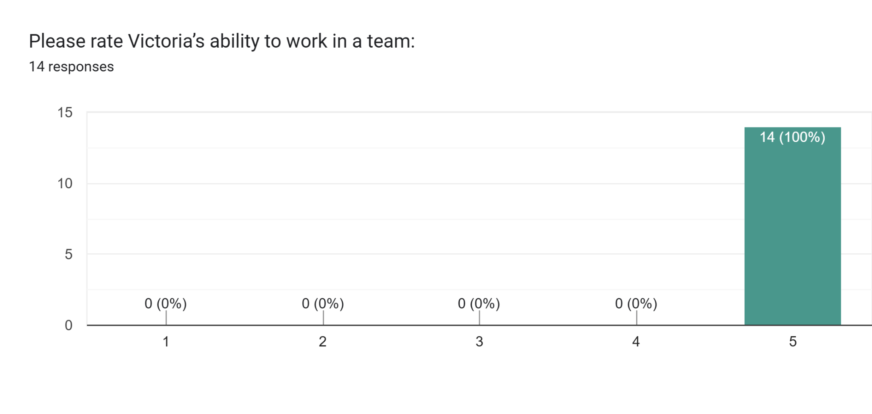
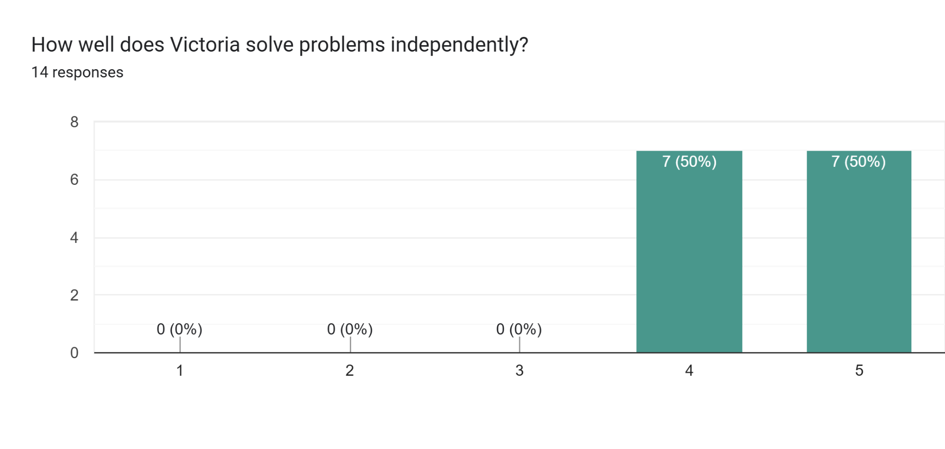

What does Victoria excel at and should continue to demonstrate? Please provide examples: | How might Victoria be able to improve on their performance? Please include examples: | How does Victoria help you and your team to succeed? | Does Victoria exhibit any leadership qualities in the role they play in the company? Please provide examples:
Excellent Team Leader |  | Always works towards the organisation and team goals and always willing to guide and mentor her team members to get the best out of them | Yes always
Victoria is excellent at streamlining processes & also looking at how as a school we can work smarter & more efficiently.  For example:-  School Productions - the ticket sales & seating plan was a manual process, Victoria implemented Ticketsource which is far smarter  Victoria suggested a weekly meeting with the Operations Manager. Support Officer & Caretaking staff to discuss the visitors, fixtures, trips and internal events for the following week. This has helped the Operations Manager check whether supply staff is needed, the caretaking team can prepare in advance and the Support Officer knows in advance of events. This is something that we all find so beneficial.  Also, Victoria is approachable and has been a wonderful Manager who is supportive and offers advice when needed. |  | Victoria is extremely supportive and when she joined the school she looked at all our processes and has suggested ways we can improve areas.
Communication and organisation
Organisational skills. Streamlining processes. She’s also fantastic at line managing staff in a supportive way. | Try not to overcomplicate things. | She is a fantastic team player. She is very good at her job. | Yes, many. She works extremely collaboratively to solve problems of process, HR and financial deficit.
Organising staff with introduction of new planning initiative, excellent. Coordination of events and staff. improving morale introducing wellbeing for staff | She is excellent at all she does | Motivation and supportive | Integrity to work with honesty and trust especially with hr needs, excellent communication and can go to her with any situation for advice
Excellent positive, working relationships. Victoria is approachable and extremely supportive. She is a problem solver and quick to see potential issues arising and knows how to deal with this in a calm, organized manner. | Due to Vic’s HR role she is often inundated with queries and people. This often impacts her work life balance especially as she is diligent at ensuring everything is done to a high standard. Finding solutions to support time management would be beneficial to her wellbeing. | Victoria provides support and assistance where needed. If she cannot, she always seeks other avenues to help. | Victoria demonstrates vast leadership qualities. She manages a diverse team with very different roles. She is emotionally intelligent and knows how to get the best out of people.  She uses a range of leadership strategies when dealing with different staff as she is aware one approach does not always work. In her role as HR Victoria is well respected for her high levels of professionalism and supportive nature.  Victoria leads by example and role models this daily. She doesn’t expect anything from her team that she would not do herself. She is a team player, collaborates effectively and motivates others.
Empathy to others/People skills | Not taking adverse reactions to heart - something no matter what you do, employees can be difficult! | Communication | Integrity and empathy
Explaining the reason for change. | Nothing | Being transparent/honest | Listening
Excellent leadership qualities and being aware of her team's training and wellbeing needs. She has asked me to support other team members being aware of my capabilities and the training needs of my colleagues. This increased my confidence in a task making my role more meaningful.  Victoria arranges a variety of wellbeing activities for staff to bond and support each other. We still remain in contact with previous team members which proves what a strong team Victoria has led. | I would find it difficult to think of anything to be honest. | Always being available for advice and support. Listening well to any issues and solving them for the good of the team. | Good role model, she listens and acts in a calm manner. She solves any issues in a mature way so that team morale is maintained.
Organisation skills. Communication skills. Excellent Motivator. Creative. Committed and driven | Delegate more. Be more assertive and know when to say no | Regular team updates, provides constructive criticism, frequent one to one meetings, flexible when needed | Critical thinker, inclusive, proactive, role model, patient, professional. Keen to develop her knowledge and skills and pass on to others. Excellent motivator
Interpersonal skills, recognising when a peer needs support and puts things in place to help. | Not being under pressure to take all tasks on herself. | Supports operational questions, HR- return to schools, linking with occupational health, giving advice regarding financials.
Excellent at managing her time her expertise is second to none and she is willing to share this expertise with others in order to enhance their work loads and help others progress  She is an excellent role model for all who work with her and it is real pleasure to work alongside her she is excellent at managing staff and their work and is not afraid of helping colleagues whenever she sees they need help and guidance and she always provides this in a non condescending manner  She is an excellent role model with a real work ethic that never varies she works well under pressure | As you can see from above I don't see how she can improve her already excellent work ethic | I think I have answered this in the previous  She is very proud of her team and will do anything in her power to help the team and individuals to succeed | She is an excellent role model for all who work alongside her and other members of the team  She is an excellent leader of personnel and always of her best to help and guide them
Building positive relationships | Can't really think of anything. Regular updates if a situation is likely to take a significant period of time. Generally she is good, but maybe an agreed timescale for reporting so all can leave each other alone whilst a process is ongoing | Significantly | Victoria has always made many situations in my experience. I sm not in a position to know about her leadership experience
Victoria is very proactive. She is very thorough and you can trust the information she provides. She is a good team player. She meets deadlines and you know that whatever you ask her to do, will be done to a high standard. | Victoria could move her performance to the next level by creatively bringing in more revenue to the school and really sweat our assets. | She completes all tasks required of her, provides the rest of the team with the information they need, we never have to chase her and the quality is always excellent. She also contributes to senior leadership meetings, including areas outside of her remit. | Yes, she is a load bearer, spots problems and offers solutions.
As a line manager, Victoria has been a breath of fresh air, she knows her responsibilities and what she is doing in her role. I do not how she can switch between the variety of responsibilities of HR, Health and Safety, finances and school  Operations. While still ensuring her team is included in decisions and makes us feel valued.  Victoria listens to all staff, and is respectful of the roles. She will include appropriate staff in decisions that may affect them. She demonstrates the school's values and acts with integrity. | To take time for herself. She is 1000% committed to the job, but would not want her to burnout and that she is not around. | She listens, takes our opinions into account, even as far as recruitment, as frontline, she makes us feel valued as part of the recruitment process and uses our skill set. | Demonstrates the schools values, and believes in them and this is seen in her leadership.

APPENDIX B - 360 Feedback

My Personal Development /CPD Plan

NAME: | Victoria Williams | MEMBERSHIP NUMBER:
DATE FROM: | April 2024 | TO: | April 2026

What do I want/need to learn? | What will I do to achieve this? | What resources or support will I need? | What will my success criteria be? | Target dates for review and completion
Improve the professional learning offer and appraisal process for support staff. | - Develop and implement a quality professional learning programme for support staff.  - Review and update the appraisal process for support staff. | - MCC Appraisal documentation, | - Training schedules and discussions with support staff will demonstrate that opportunities for them to develop professionally are in place.  - Appraisal documentation will demonstrate that the support staff appraisal process is practical, concise and effective in supporting employees' professional learning needs | November 2025
Embed the wellness at work policy and ensure the return to work procedure compliments the system. | - Carry out all RTWs.  - Embed a case management approach.  - Refer staff for a wellbeing discussion and manage staff through the process. | - Local Authority HR department.  - Attend training for the new policy  - Attend other health and Wellbeing courses such as iAct | - All staff will receive a return to work interview.  - Staff with wellbeing and absence issues will be managed through the case management approach. | June 2025
Following attendance of Short Course HR in Practice course. Formalise Human resources knowledge and skills to develop a career in one aspect of the role. | - Enrol on a nationally recognised HR course..  - Attend monthly sessions  - Read materials - Textbooks / Internet / hand-outs to support learning | - Reading material  - Self development  - Tutor support  - Service User feedback | Pass Level 5 CIPD course | April 2026
Introduce the use of iTrent to streamline HR processes. | - Conduct training for staff who need to use the system extensively.  - Produce a guide for staff use and place in the b bulletin.  - Support staff with use when needed. | - Local Authority HR department  - Attend further training and self learning on HR processes - CIPD HR in Practice | - All staff will use iTrent for transactional HR processes e.g. LOAs, resignations, timesheets, RTWs. | September 2025
Improve the use and monitoring of grant expenditure | - Evaluate the impact of grant expenditure during HT SBM quarterly meetings.  - Report on the impact of grant expenditure at governors' business meetings.  - Ensure a thorough analysis of expenditure against grant income for ALN, LDC and Post 16. | - Attend EAS Grant monitoring and review of grant guidance | - Grant evaluations will show the impact of grant funding.  - Minutes of GB meetings will demonstrate that business governors know and understand the impact of grant expenditure.  - Grant analysis will show that ALN, LDC and Post 16 expenditures are within grant allocations. | April 2025
Using AI in the workplace  ASCL Course (AI) | - Attend CIPD essential Insight course on How to use AI responsibility in the workplace  an informed overview of AI in the workplace and how to use this technology appropriately in your organisation  and also ASCL course about AI in education setting | Computer to watch bitesize course that debates the benefits, risks and challenges of AI in the workplace and starts conversations around responsible AI in practice. | - explain what AI is and how it can impact the workplace  - draw up guidelines for using AI responsibly in the workplace  - assess the benefits and challenges of using AI to decide how to use it ethically in your workplace. | June 2025
Technology and people practice - How can the power of technology benefit the people profession | - Attend CIPD essential Insight course | Computer to watch bitesize course to Learn how various technologies can enhance the relationship between people and organisations while recognising the risks. | - Articulate how the people profession uses technology  - consider the necessary skills to get the best out of technologies and the associated risks  - discuss how other organisations have implemented technology  - reflect upon the use of technology in your organisation and identify how you could incorporate it further. | June 2025

Appendix C - Reflective learning

Name | Date | Profession Map Area | Type of Learning | What is the learning experience you're reflecting on | What did you learn from this experience? | How does this change the way you'll work in the future? | What else have you done - or what will you do
LJ Williams - Business Management | 10/01/2024 | Passion for learning | Listened to a podcast | LJ Williams is a School Business Leader that has recorded podcasts and has discusses with other School Business Leaders about a range of topics such as Line Management, Premises, ICT, Financials, review of a year in the role | Reaffirming what I believe in, aligning my goals, sharing top tips and advice to help SBLs gather all the information, evidence and intelligence they need to get to grips with the role quickly, reflecting on the role, pointers for consideration | Take on people's advice and top tips, firms up my knowledge and keeps me on track | Further reading from books recommended by the professionals on podcasts
Chimp Paradox | 29/03/2024 | Culture and behaviour | Read an article/blog/book etc | Helps people to manage their mind more effectively, with an approach grounded in neuroscience. Through the Chimp model,&nbsp; help people understand how the mind functions can develop the insight and skills needed to get the best out of themselves and others. The approach can help people to improve success in both personal and professional settings | The book offers a simplified way of understanding our two thinking brains and how we can learn to use them to the best of our ability.  It is a simple representation to aid understanding and help us to use science. It may also help us to make sense of how we have been in the past, how we are now, and how we can manage ourselves better in the future. In our mind management model, the inner Chimp is the emotional team within the brain that thinks and acts for us without our permission. The logical team is the real person, it is rational, compassionate and humane, and the Humanwithin. The memory banks for reference are the Computer. | When meeting with staff to return to work, carry out wellbeing visits with staff who perhaps think everyone is against them, feels that they are not doing a good enough job, I try to explain how reading this book made me realise how powerful our mind is. Sometimes I react to things and let my emotions run away with me, but having read this book meant that I try and stop and think of my 'chimp' | Continue to read and develop my personal skills, and when I feel overwhelmed, pick the book up and read again
HR in Practice | 29/05/2024 | Other | Attended an event | HR fundamentals to give an overview of HR in practice  how to prioritise HR work, risk assess an HR situation, and recognise where immediate and longer-term attention is appropriate. overview of recruitment techniques and learn how to maintain good employee relations and identify where relationships can break down and how to support high morale and productivity while recognising the different types of underperformance and how and when to intervene. Introduction to UK employment law, including basic contractual and HR policy issues. | How good HR practice contributes towards achieving company objectives, apply good recruitment and selection practices to support organisation/wider HR department  develop; performance and personal effectiveness in handling a range of HR issues, increase confidence in your work as an HR professional. | This was a brief 2 day course that allowed me to have confidence in areas I was familiar in from working practice, while also allowing me to explore other areas such as employment law and gave be a brief insight | Follow up with a more detailed course that would develop my skills and understanding.
School Business Management | 18/06/2024 | Passion for learning | Something I'm doing/I've done at work | Having been new to the role of school business management, I didn't realise what I did naturally when it comes to processes, policies and procedures has had so much impact on the organisations that I have worked for.&; Schools are like their own entity and unless a headteacher has come from an academy where they have experience of spending the budget correctly, managing HR processes then I have learnt things can go wrong, From my experience, I have been asked twice to help a school with incorrect processes including not contracts for teaching and support staff not being equitable and taking into account the different terms and conditions. Through my own interest I listen to podcasts about school business management, leadership as well as always looking for continued ways to improve and streamline processes - having completed an Agile Project Management course has allowed this | I have to have more confidence in what I do and what I know. Having carried out a reflective reflection of what has my Impact been in the role proved beneficial and gave me a time of reflection on my practice and also what the next steps are. | Not to take things for granted, to continue learning, and recognise that every school is different, I like to think I have benefitted not just the school when it comes to financial management but also ensured HR processes are followed and employees are supported to make their working time enjoyable | Share best practice within; others, contribute to informal discussions on X and SBM forums. Support Cluster schools and look to develop myself
EWC Code of Professional Conduct and Practice and using social media responsibly professional responsibilities and ethics | 03/09/2024 | Ethical practice | Attended/completed a course | Professional Code of Conduct - What is EWC Code of Conduct, What can happen if not abide by Code of Conduct. Understanding of Good Practice guides | Examples of behaviour that go against code of conduct, real life examples, Importance of social media posts and privacy settings. | While I am not EWC registered in my role, I would consider the code of conduct as professional integrity and should be abided to whether registered or not registered; But also supports me in my role as HR within the school, as part of safer recruitment checks | Ensure that importance of the risks are included as part of staff induction process, and to being in the experts for other staff on INSET days too

