MSc Cybersecurity and Digital Forensics
Ethical Hacking — ACCA7033

Task 1: Strategic Threat Analysis

Research into Cyber Security Attacks and Penetration Testing

Module Code: ACCA7033
Programme: MSc/PgDip/PgCert Cybersecurity and Digital Forensics
Submission Deadline: 1st May 2026

Abstract
The spring 2025 attacks on Marks & Spencer (M&S) and Co-operative Group (Co-op) were two of the most devastating security incidents in retail history in the United Kingdom. Unlike previous, most costly attacks, the compromise was executed by Scattered Spider (UNC3944), and no zero-day exploits were necessary. Instead, the threat actor spoke fluent English in order to social engineer TCS helpdesk staff, have credentials reset, and MFA disabled in order to exploit standard support procedures and use this as their entry point into M&S and Co-op networks. Regarding the MITRE ATT&CK v17 matrix, the actions of the threat actor began with voice phishing (T1566.004), moving into credential dumping from NTDS.dit (T1003.003) and concluded with the use of DragonForce ESXi ransomware (T1486). The key takeaway is the divergence in the results for each of the two victims; M&S had 60 days of dwell time, £300 million lost, and 46 days without online trading, whereas Co-op detected the threat within five days and stopped the ransomware execution. This report presents seven recommendations, centred on FIDO2 phishing-resistant authentication and a Zero Trust architecture focused on identity verification.

Keywords: Scattered Spider, DragonForce, Ransomware-as-a-Service, MITRE ATT&CK, Identity Threat Detection, Social Engineering, Zero Trust Architecture, Active Directory.

1. Introduction
The April 2025 cyber campaign against Marks & Spencer (M&S) and the Co-operative Group (Co-op) has defined a point in time for UK retail cybersecurity. This case is particularly useful not because of the tools used (as the Scattered Spider attackers did not introduce new malware), but because two FTSE-listed companies were brought down by a group aged between 17 and 22 after a single phone call. M&S was unable to utilise most of its infrastructure and relied on handwritten, paper-based logistics to maintain its 65,000 workforce and 1400+ locations because the virtualisation environment was encrypted. Later, the Cyber Monitoring Centre described both campaigns together as a Category 2 systemic incident costing £270m-£440m [11].
Gyimah et al [5] conclude that the contemporary Ransomware-as-a-Service environment facilitates specialised social engineers in conjunction with skilled encryption operatives. This M&S breach is the textbook example of its implementation. The cognitive biases were also identified by Heartfield and Loukas [6] as remaining "the single most reliable weakness in any organisation...unaffected by the state of the perimeter," and for M&S, this alone cost three hundred million pounds.
In this report, the campaign is examined and divided into 8 sections: a verified timeline (2), 12 MITRE ATT&CK techniques (3), root cause (4), threat actor (5), response/detection (6), recommendations (7) and conclusion (8).

2. Incident Timeline
The measure that has been the most interesting is the dwell time. The incident at M&S — Scattered Spider were not detected at all for 60 days from the first credential compromise in February 2025. This time allowed them to build out a full map of their Active Directory, identify ESXi management consoles and delay the payload delivery to coincide with Easter Saturday. [16]

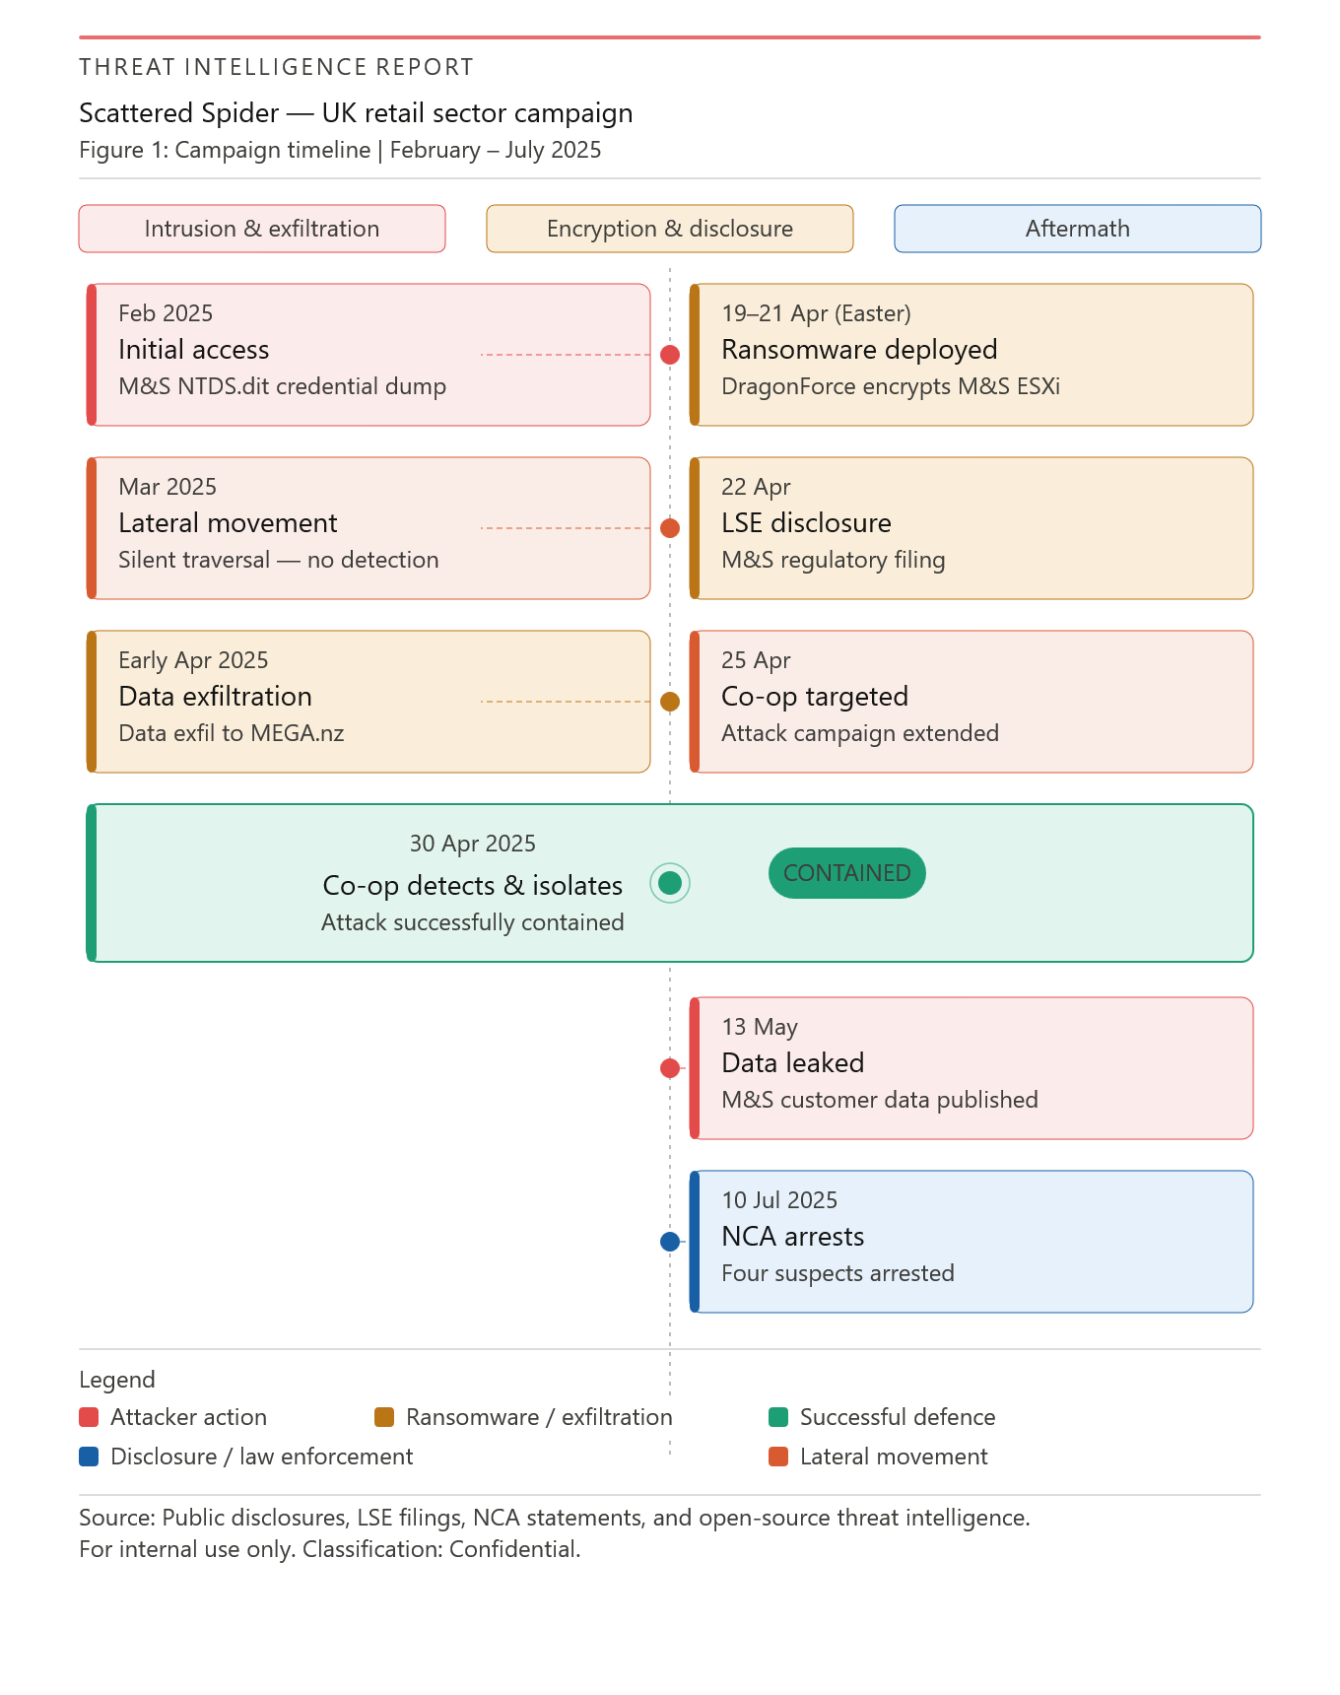
Figure 1: Incident Timeline — Scattered Spider UK Retail Campaign (2025)

Table 1: Verified Incident Timeline — Scattered Spider UK Retail Campaign (2025)
DATE | KEY EVENT | SOURCE
Feb 2025 | Scattered Spider vishings TCS help desk; M&S Active Directory compromised and NTDS.dit extracted, yielding hashes for all 65,000 accounts. | [10][16]
Mar 2025 | Silent lateral movement via LOLBin techniques (PowerShell, AWS Systems Manager); VMware ESXi hosts mapped. | [16][17]
Early Apr 2025 | Customer databases exfiltrated to MEGA.nz via the Rclone utility. | [8][10]
17 Apr 2025 | M&S security team begins internal investigation following impersonation attempts against senior accounts; breach scope not yet identified. | [1][12]
19–21 Apr 2025 | DragonForce encrypts M&S ESXi hypervisors over Easter weekend; contactless payments, click-and-collect, and logistics fail nationwide. | [3][4]
22 Apr 2025 | M&S files LSE regulatory disclosure; losses later confirmed at ~£300 million. | [1][3]
23 Apr 2025 | DragonForce emails M&S CEO demanding ransom, threatening data publication. | [4][12]
25 Apr 2025 | M&S suspends online shopping (46 days). Scattered Spider pivots to Co-op. | [3][10]
30 Apr–1 May 2025 | Co-op SOC detects anomalous privileged activity; VPN severed within hours — ransomware execution prevented. | [4][13]
13 May 2025 | DragonForce publishes stolen M&S customer data on dark web portal. | [3][12]
Jun 2025 | Cyber Monitoring Centre classifies campaign as Category 2 systemic event; damages estimated £270m–£440m. | [11]
8 Jul 2025 | M&S Chairman confirms to UK Parliament that third-party social engineering was the root access vector. | [15]
10 Jul 2025 | NCA arrests four individuals aged 17–20; CISA/FBI advisory AA23-320A updated. | [14][9]

Sources: M&S regulatory filings [1], Co-op press releases [2][3], NCSC advisory [10], CISA AA23-320A [9], BBC News [4][12], Cyber Monitoring Centre [11], UK Parliament [15], NCA [14].

3. MITRE ATT&CK TTP Mapping
The attacker's campaign aligns well with twelve MITRE ATT&CK Enterprise v17 techniques, showing a systematic, identity-driven attack chain. Significantly, every technique that was leveraged involved abusing a human trust relationship or an improperly configured identity control, as outlined below in Table 2, and not a single software vulnerability was leveraged during the entire campaign.

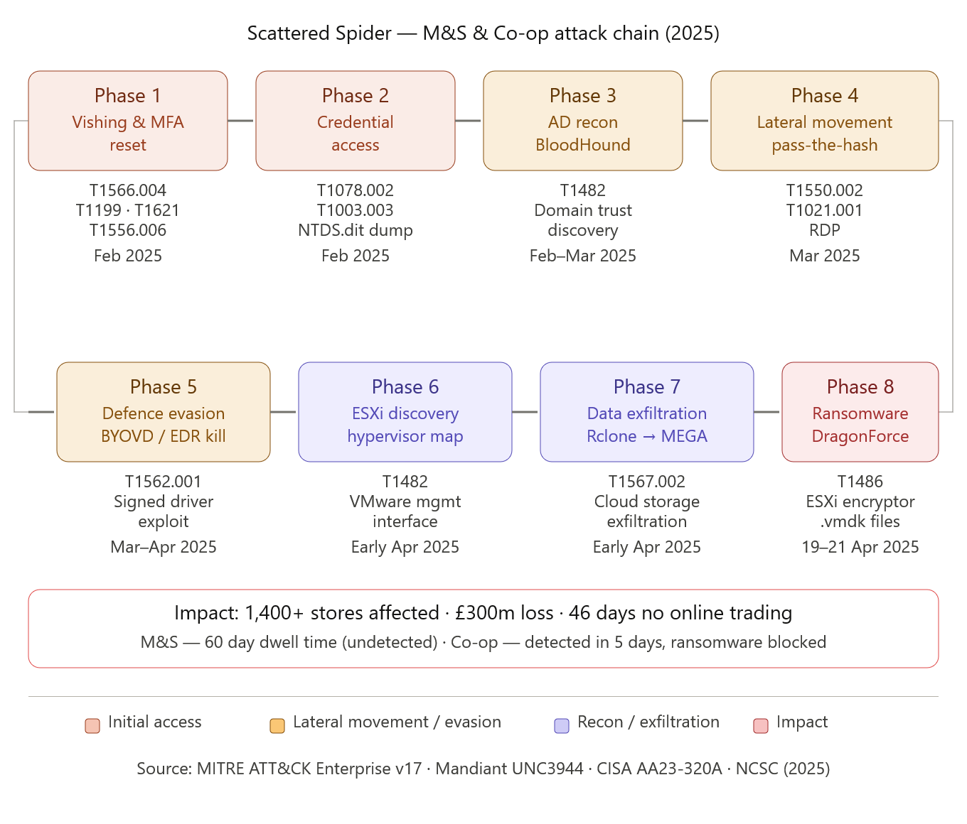
Figure 2: Scattered Spider Kill Chain — MITRE ATT&CK TTP Mapping, Feb–Apr 2025

Table 2: MITRE ATT&CK TTP Mapping — Scattered Spider / DragonForce Campaign
12 key techniques mapped across the full attack chain — Initial Access through Impact.
ATT&CK ID | TACTIC | TECHNIQUE | WHAT THE ATTACKERS ACTUALLY DID
T1566.004 | Initial Access | Spearphishing Voice | Native English-speaking operators called the TCS IT helpdesk, impersonating M&S employees who had lost their phones to trigger credential and MFA resets.
T1199 | Initial Access | Trusted Relationship Abuse | Exploited standing administrative privileges held by third-party TCS contractors, converting a routine support relationship into a privileged entry point.
T1621 | Credential Access | MFA Request Generation | Flooded legitimate employees with repeated MFA push notifications late at night until an exhausted user approved one (MFA fatigue attack).
T1556.006 | Defense Evasion | Modify Authentication Process: MFA | After resetting the victim's password, attackers de-registered their legitimate device from the MFA portal and enrolled their own, ensuring persistent silent access.
T1078.002 | Persistence | Valid Accounts: Domain Accounts | Used the freshly reset corporate credentials to authenticate into VPN and SSO portals, appearing as a legitimate employee throughout the operation.
T1482 | Discovery | Domain Trust Discovery | Ran BloodHound and SharpHound to map Active Directory and identify the shortest privilege-escalation path from the compromised contractor account to Domain Admin.
T1003.003 | Credential Access | OS Credential Dumping: NTDS | Used vssadmin to shadow-copy the Domain Controller disk and extract NTDS.dit, capturing NTLM hashes for all 65,000 domain accounts.
T1550.002 | Lateral Movement | Pass-the-Hash | Replayed extracted NTLM hashes to authenticate across internal servers without plaintext passwords, bypassing conventional login monitoring.
T1021.001 | Lateral Movement | Remote Desktop Protocol | Used native Windows RDP to move laterally from the initial helpdesk beachhead to the ESXi management network jump box.
T1567.002 | Exfiltration | Exfiltration to Cloud Storage | Used the Rclone utility to silently upload gigabytes of customer PII and internal documents to attacker-controlled MEGA.nz cloud storage.
T1562.001 | Defense Evasion | Impair Defenses: BYOVD | Deployed a signed but vulnerable kernel driver (BYOVD) to terminate EDR sensor processes at ring-0 privilege level prior to ransomware execution.
T1486 | Impact | Data Encrypted for Impact | DragonForce affiliates ran a bespoke Linux encryptor against VMware ESXi hypervisors via the /ui/ management interface, simultaneously crashing all hosted VMs.

3.1 T1566.004 — Voice Spearphishing
The operators of Scattered Spider spoke English as a first language and utilized terminology and employee names from LinkedIn research [16]. The TCS help desk employees, drilled to respond with extreme alacrity, were ready to be socially engineered. Heartfield & Loukas [6] note that the success of voice-based social engineering depends largely on whether the social engineers utilize "in-group linguistic markers" — exactly the thing that happened here. One five-minute phone call provided access to networks with billion-dollar valuation.

3.2 T1003.003 — NTDS.dit Credential Dumping
When domain admin access was gained through the hacked TCS account, the attacker then used the vssadmin native tool to snapshot the Domain Controller disk and read the NTDS.dit in order to copy across the NTLM and Kerberos hashes of all 65,000 M&S accounts without AV raising an alert [7]. This was only allowed as the domain controller was accessible from the helpdesk network segment — the core of the micro-segmentation failure.

3.3 T1486 — ESXi Hypervisor Encryption
Selecting the hypervisor (ESXi) instead of the end devices represents a logical development, since a single hypervisor hosts multiple — potentially dozens of — virtual machines simultaneously. Encrypting the .vmdk files through the /ui/ management interface — simultaneously all 1,400 store payment, logistics, and click-and-collect systems — was executed in one command using the DragonForce payload. This operation was timed around the Easter weekend for operational reasons [8].

3.4 T1621 + T1556.006 — MFA Fatigue and Registration Abuse
Two types of MFA bypass were utilized within the attack. T1621 worked by sending a constant stream of push notification requests until the employee was worn down enough to accept one. More concerningly, T1556.006 successfully convinced the help desk to perform a full MFA reset and register an attacker-controlled device. Unlike MFA fatigue, T1556.006 provides an insidious, persistent presence that survives even a password reset, as the attacker's registered device remains a trusted second factor [9].

4. Root Cause Analysis
This campaign was successful due to no individual broken control, but due to cascading failures within three separate groups: technical architecture, corporate governance and human psychology. The failures themselves can each be directly attributed to one of the ATT&CK techniques in the chain shown above.

4.1 Technical Control Failures
Three technical failures facilitated the attack: First push-notification MFA instead of FIDO2 hardware tokens — Barbosa et al [19] show FIDO2 credentials cannot be approved by telephone call which would have halted the attack in initial access. Second management interfaces to the ESXi were accessible from the general corporate network; Mandiant note this is exactly the architecture UNC3944 exploit [8]. Third, no DCSync detection was in place within the SIEM — no alarm was raised when the NTDS.dit file was exfiltrated on February 2025 (discussed further in Section 6).

4.2 Process and Policy Failures
Two further governance failures also played a role alongside the technical shortcomings. Firstly, the TCS contractor had administrative standing on M&S systems and was thus able to reset any M&S employee's password and MFA. This configuration is deemed "one of the most high-risk in enterprise configurations" by the Cloud Security Alliance [22] and gives "enterprise-wide access if even just one contractor account gets compromised". Secondly, the caller verification procedure relied solely on pre-collected static personal information (employee IDs and dates of birth) obtained through LinkedIn recon and no form of out-of-band callback or manager verification was included. This is also stated as the primary procedural enabler by UK Parliamentary evidence [15].

4.3 Human Factors
The human element was again instrumental. The vishing scripts offered by Scattered Spider combined three cognitive biases: urgency (time-sensitive threats requiring a quick decision), authority (throwing around names of executives and internal company acronyms picked up by OSINT), and helpfulness (the desire of a level-1 tech to close their ticket quickly and without fuss). Bullee et al. [21] provide experimental proof of both urgency and authority reducing compliance checking in help desk staff. This attack did not compromise any computers, but it did compromise the trust relationships established for efficiency and convenience rather than security.
Among the three categories of failure, the process failure had the greatest impact. A simple verification over the phone that didn't occur is enough to turn a regular support request into a breach worth 300 million, which only proves that there's no security control that can replace the need for a stringent identity verification policy [15].

5. Threat Actor Profile
Scattered Spider (UNC3944 (Mandiant), Octo Tempest (Microsoft) and Muddled Libra (CrowdStrike)) is identified as a distributed criminal group. The core members are young, 17–22, English speaking and from UK/USA — evident in the NCA arrest in July 2025 [16]. Their western identity is the key of the operation — native speakers can successfully use vishing to manipulate UK corporate help desks.
Their rise to prominence was marked by two casino breaches in 2023 — MGM Resorts and Caesars Entertainment ($100m+ loss) using a similar vishing + IdP manipulation [16]. By spring 2025 the group had switched over entirely to targeting retail in the UK, attacking M&S, Co-op and Harrods in a 14-day period. The group does not excel in malware; but in social engineering, SIM-swapping, and LOLBin tradecraft. The 2025 attack operation was a RaaS partnership, where Scattered Spider handled initial access and lateral movement, while DragonForce provide the ESXi encryptor and the extortion platform; an example of how Gyimah et al [5] describe the features of modern RaaS economies.
While Lapsus$ hacked to be known and release information publicly, Scattered Spider has more of a financial incentive — staying dormant within an organization for longer periods and securing financial gain through the double-extortion methodology, making them far more dangerous.

6. Detection and Response Analysis
In contrast to M&S the Co-op SOC detected abnormal privileged activity with the SIEM in less than five days, which leadership responded to in two steps, blocking remote VPN access within a few hours and stopping the ransomware altogether [13]. The rapid action was entirely down to an established, and annually exercised incident response playbook, and illustrates that technology is not a panacea for cyber-attacks — planning is paramount.

Table 3: Comparative Response Outcome — M&S vs. Co-operative Group
METRIC | MARKS & SPENCER | CO-OPERATIVE GROUP
Dwell Time | Approx. 60 days (Feb to Apr 2025) | Less than 5 days (detected 30 Apr 2025)
Ransomware Deployed | YES — DragonForce ESXi encryptor | NO — Blocked before execution
Stores Affected | 1,400+ stores (severe till, stock, logistics failures) | 2,300+ stores remained open throughout
Data Stolen | Customer records, order histories, full AD database | Approx. 6.5 million member records exfiltrated
Financial Impact | ~£300 million lost operating profit (FY25 confirmed) | Substantially lower operational disruption costs
Detection Method | Post-impact (ransomware detonation — REACTIVE) | Identity anomaly alerts before encryption (PROACTIVE)
Response Speed | Slow — 46-day online suspension post-encryption | Rapid — VPN severed within hours of anomaly detection

This lacked for M&S as the SIEM at that point had not had a correct tune, so the February 2025 NTDS.dit access was generated without any warning flags. The adversaries had visibility into the internal teams' communications throughout their entire dwell time and proactively predicted and then countered all containment strategies [8].

6.1 The Detection Gap: Critical Windows Event IDs
Three Windows Event IDs can be strung together into a high-fidelity chain that would have revealed the attack weeks before Easter. M&S had a problem with lack of alerts, not lack of data.
Event ID 4662 — Fired whenever a user or group reads an AD object. Filtering this for {1131f6ad-9c07-11d1-f79f-00c04fc2dcd2} (DS-Replication-Get-Changes-All) will instantly identify DCSync attempts, as this right should never be read by a non-domain controller: "If an account requests this right, a T1003.003 immediately." [7]
Event ID 4624 — A Logon Type 3 utilizing the NTLM authentication package coming from a helpdesk subnet, and not from the intended management jump host, is a strong Pass-the-Hash (T1550.002) indicator and would have alerted to the lateral movement performed in March 2025. [7]
Event ID 7045 — Any Remote Management Tool installed will register as a Windows service, firing this event when created. If a new service appears to be created on a Domain Controller or ESXi host, it should be treated as a definite indicator of compromise, appearing minutes prior to ransomware staging. [7]

7. Strategic Recommendations
Seven recommendations address the control failures identified above, each mapped to mitigated ATT&CK techniques.

R1 — FIDO2 Hardware MFA (T1566.004, T1621, T1556.006 | High | £10k–£100k) — Replace push-notification MFA with FIDO2 hardware keys for all privileged users and help desk administrators. Barbosa et al. [19] prove FIDO2 credentials cannot be approved via phone call or replayed against a fake portal.
R2 — Out-of-Band Help Desk Verification (T1566.004, T1199 | Low | Under £10k) — All MFA resets must require HR-registered callback and manager video approval. Parliamentary evidence [15] confirms one unverified call enabled the entire breach. Lowest cost, highest impact.
R3 — SIEM DCSync Alerting (T1003.003, T1550.002 | Medium | Under £10k) — Alert on Event ID 4662 (DS-Replication GUID), vssadmin.exe on Domain Controllers, and NTLM Logon Type 3 anomalies [7]. Would have detected the attack eight weeks before Easter.
R4 — ESXi VLAN Isolation (T1486, T1021.001 | High | £10k–£100k) — Place ESXi management interfaces on a dedicated VLAN behind a hardened PAW jump host. Mandiant [8] confirm this gap directly enables hypervisor ransomware.
R5 — ITDR Platform (T1078, T1550.002, T1621 | Medium | Over £100k) — Deploy Entra ID Protection or Vectra AI [18] for ML-based impossible travel and NTLM anomaly detection. Co-op's five-day detection reflects this; M&S's 60-day dwell time reflects its absence.
R6 — JIT Vendor Access via PAM (T1199, T1078 | High | Over £100k) — Replace TCS standing privileges with time-bounded JIT access via CyberArk or BeyondTrust. CSA [22] identify zero standing privileges as the most effective third-party control.
R7 — Annual Tabletop IR Exercise (T1486, T1567 | Medium | £10k–£100k) — Rehearse hypervisor-level ransomware scenarios annually — VPN severance authority, manual payment fallback. Co-op's rapid containment reflected this preparation; M&S's 46-day collapse did not [4][15][20].

8. Conclusion
The verdict from the 2025 Scattered Spider campaign is clear: highly skilled attackers don't break systems, they break people. This campaign managed to penetrate hundreds of millions of pounds of perimeter security without breaking any infrastructure, with damages in the sector running into hundreds of millions of pounds [11].
It is the victims and their differences that offer the clear lesson. M&S plummeted £300 million because their architecture flagged malware, but not any identities. The Co-op survived by monitoring behavior for identity all the time, and taking the painful business decision to isolate at first reasonable suspicion. It was not about how much money, but about the architecture, monitoring and preparation.
The time of the "trusted internal network" is well and truly over. The only secure architecture for this class of threat is an identity-centric zero-trust architecture with FIDO2 authentication, micro-segmented networks, continuous monitoring, and JIT access controls. Without the UK retail sector embracing this posture at scale, the helpdesk will continue to represent the adversaries' cheapest attack.

Appendix A — Timeline Sources and OSINT Methodology

Verified Timeline Sources
[1] Marks & Spencer plc, Cyber Update, 7 May 2025: https://corporate.marksandspencer.com/cyber-update
[2] Co-op Group, Cyber Incident Update, 2 May 2025: https://www.co-operative.coop/media/news-releases/cyber-incident-update
[3] Co-op Group, Cyber Incident: Further Update, 14 May 2025: https://www.co-operative.coop/media/news-releases/cyber-incident-further-update
[4] BBC News, 'M&S cyber attack: What we know about it and its impact', 1 May 2025: https://www.bbc.co.uk/news/articles/c0el31nqnpvo
[8] Mandiant/Google Cloud Security, 'From Help Desk to Hypervisor: Defending Your VMware vSphere Estate from UNC3944': https://cloud.google.com/blog/topics/threat-intelligence/defending-vsphere-from-unc3944/
[9] CISA/FBI/NCSC Joint Advisory AA23-320A (updated 29 Jul 2025): https://www.cisa.gov/news-events/cybersecurity-advisories/aa23-320a
[10] NCSC, 'Incidents impacting retailers — recommendations from the NCSC', 3 May 2025: https://www.ncsc.gov.uk/blog-post/incidents-impacting-retailers
[11] Cyber Monitoring Centre, Category 2 Event Report, Jun 2025: https://cybermonitoringcentre.com
[12] BBC News, 'Co-op DragonForce cyber attack includes customer data, firm admits', 2 May 2025: https://www.bbc.co.uk/news/articles/crkx3vy54nzo
[13] MTI Technology, 'M&S vs Co-op: How Two 2025 Cyber-Attacks Ended So Differently', Aug 2025: https://mti.com/ms-and-coop-2025-cyber-attacks-lessons-learned/
[14] The Hacker News, 'Scattered Spider Hacker Arrests Halt Attacks', Jul 2025: https://thehackernews.com/2025/07/scattered-spider-hacker-arrests-halt.html
[15] UK Parliament Business and Trade Sub-Committee, Oral Evidence, 8 Jul 2025: https://committees.parliament.uk/
[16] CrowdStrike, 'SCATTERED SPIDER Escalates Attacks Across Industries', Apr 2026: https://www.crowdstrike.com/en-us/blog/crowdstrike-services-observes-scattered-spider-escalate-attacks/

OSINT Methodology Note
The information that was obtained via the OSINT procedure detailed below, from the following sources. Primary sources included M&S LSE filings and FY25 results, press releases from the Co-op Group, Mandiant/Google's description of UNC3944, profiles of adversaries from CrowdStrike and CISA/FBI/NCSC joint advisory AA23-320A (updated 20 July 2025). Context of the UK's position on the issue was found from NCSC advisory posts, oral evidence before the Business and Trade Sub-Committee of 8 July 2025. Academic materials were downloaded from IEEE Xplore, ACM Digital Library, Springer LNCS, and no references were found to dark web forums, unverified social media sources or Wikipedia.

References
[1] Marks & Spencer Group plc, "Full Year Results FY25 and Cyber Incident Regulatory Disclosure," London Stock Exchange RNS, 21 May 2025. [Online]. Available: https://corporate.marksandspencer.com/sites/marksandspencer/files/05-2025/fy25-rns.pdf. [Accessed: 11 Apr. 2026].
[2] Co-operative Group, "Cyber Incident Update," Co-op Group Press Release, 2 May 2025. [Online]. Available: https://www.co-operative.coop/media/news-releases/cyber-incident-update. [Accessed: 11 Apr. 2026].
[3] Co-operative Group, "Cyber Incident: Further Update," Co-op Group Press Release, 14 May 2025. [Online]. Available: https://www.co-operative.coop/media/news-releases/cyber-incident-further-update. [Accessed: 11 Apr. 2026].
[4] J. Morris, "How Co-op averted an even worse cyber attack," BBC News, 14 May 2025. [Online]. Available: https://www.bbc.co.uk/news/articles/cwy382w9eglo. [Accessed: 11 Apr. 2026].
[5] F. O. Gyimah, E. Ofori-Mensah, H. Boowuo, and S. Aggrawal, "Friend or foe? AI and the evolving landscape of Ransomware-as-a-Service (RaaS)," in Proc. 2024 Cyber Awareness and Research Symposium (CARS), IEEE, 2024, pp. 1–5.
[6] R. Heartfield and G. Loukas, "A taxonomy of attacks and a survey of defence mechanisms for semantic social engineering attacks," ACM Computing Surveys (CSUR), vol. 48, no. 3, pp. 1–39, 2016. [Online]. Available: https://dl.acm.org/doi/10.1145/2835375. [Accessed: 11 Apr. 2026].
[7] Microsoft, "Event 4662: An operation was performed on an object," Microsoft Security Documentation, 2024. [Online]. Available: https://learn.microsoft.com/en-us/previous-versions/windows/it-pro/windows-10/security/threat-protection/auditing/event-4662. [Accessed: 11 Apr. 2026].
[8] Mandiant / Google Cloud Threat Intelligence, "From Help Desk to Hypervisor: Defending Your VMware vSphere Estate from UNC3944," Google Cloud Security Blog, 2025. [Online]. Available: https://cloud.google.com/blog/topics/threat-intelligence/defending-vsphere-from-unc3944/. [Accessed: 11 Apr. 2026].
[9] CISA / FBI / NCSC-UK, "Joint Cybersecurity Advisory: Scattered Spider (AA23-320A)," CISA, updated 29 Jul. 2025. [Online]. Available: https://www.cisa.gov/news-events/cybersecurity-advisories/aa23-320a. [Accessed: 11 Apr. 2026].
[10] UK National Cyber Security Centre (NCSC), "Incidents impacting retailers — recommendations from the NCSC," NCSC Blog Post, 3 May 2025. [Online]. Available: https://www.ncsc.gov.uk/blog-post/incidents-impacting-retailers. [Accessed: 11 Apr. 2026].
[11] Cyber Monitoring Centre (CMC), "Statement on Ransomware Incidents in the Retail Sector," CMC Category 2 Event Report, Jun. 2025. [Online]. Available: https://cybermonitoringcentre.com. [Accessed: 11 Apr. 2026].
[12] R. Plummer, "Co-op fends off hackers as police probe M&S cyber attack," BBC News, 30 Apr. 2025. [Online]. Available: https://www.bbc.co.uk/news/articles/c3wx092exlzo. [Accessed: 11 Apr. 2026].
[13] MTI Technology, "M&S vs Co-op: How Two 2025 Cyber-Attacks Ended So Differently," MTI Insight, Aug. 2025. [Online]. Available: https://mti.com/ms-and-coop-2025-cyber-attacks-lessons-learned/. [Accessed: 11 Apr. 2026].
[14] The Hacker News, "Scattered Spider Hacker Arrests Halt Attacks, But Copycat Threats Emerge," The Hacker News, Jul. 2025. [Online]. Available: https://thehackernews.com/2025/07/scattered-spider-hacker-arrests-halt.html. [Accessed: 11 Apr. 2026].
[15] UK Parliament Business and Trade Sub-Committee, "Oral Evidence: Cyber Resilience in the Retail Sector — Evidence from Marks & Spencer and Co-op," House of Commons, 8 Jul. 2025. [Online]. Available: https://committees.parliament.uk/. [Accessed: 11 Apr. 2026].
[16] CrowdStrike Intelligence, "SCATTERED SPIDER Escalates Attacks Across Industries," CrowdStrike Blog, Apr. 2026. [Online]. Available: https://www.crowdstrike.com/en-us/blog/crowdstrike-services-observes-scattered-spider-escalate-attacks/. [Accessed: 11 Apr. 2026].
[17] Mandiant / Google Cloud Threat Intelligence, "Proactive Hardening Recommendations for UNC3944 (Scattered Spider)," Google Cloud Security Blog, 2025. [Online]. Available: https://cloud.google.com/blog/topics/threat-intelligence/unc3944-proactive-hardening-recommendations/. [Accessed: 11 Apr. 2026].
[18] Vectra AI, "Identity Threat Detection and Response (ITDR)," Vectra AI Product Documentation, 2025. [Online]. Available: https://www.vectra.ai/products/itdr. [Accessed: 11 Apr. 2026].
[19] M. Barbosa, A. Boldyreva, S. Chen, and B. Warinschi, "Provable Security Analysis of FIDO2," in Advances in Cryptology — CRYPTO 2021, Lecture Notes in Computer Science, vol. 12827, Springer, 2021, pp. 125–156. DOI: 10.1007/978-3-030-84245-1_7.
[20] S. Rose, O. Borchert, S. Mitchell, and S. Connelly, "Zero Trust Architecture," NIST Special Publication 800-207, National Institute of Standards and Technology, Gaithersburg, MD, 2020. DOI: 10.6028/NIST.SP.800-207.
[21] J.-W. Bullee, L. Montoya, M. Junger, and P. Hartel, "Telephone-based social engineering attacks: An experiment testing the success and time decay of an intervention," in Proc. Singapore Cyber-Security Conference (SgCS 2016), 2016. [Online]. Available: https://www.semanticscholar.org/paper/9b0bac7fb14c371466562b58c0f336148a8db640. [Accessed: 11 Apr. 2026].
[22] Cloud Security Alliance, "Killing Standing Privileges — Why Just-in-Time Access is the Future of PAM," Cloud Security Alliance Blog, Dec. 2025. [Online]. Available: https://cloudsecurityalliance.org/blog/2025/12/04/killing-standing-privileges-why-just-in-time-access-is-the-future-of-pam. [Accessed: 11 Apr. 2026].
[23] M. Satter, "M&S, Co-op cyberattackers duped IT help desks into resetting passwords, says report," Reuters, 6 May 2025. [Online]. Available: https://www.reuters.com/business/retail-consumer/ms-co-op-cyberattackers-duped-it-help-desks-into-resetting-passwords-says-report-2025-05-06. [Accessed: 11 Apr. 2026].
[24] B. I. Mokhtar, A. Jurcut, M. S. Elsayed, and M. A. Azer, "Active Directory Attacks — Steps, Types, and Signatures," Electronics, vol. 11, no. 16, p. 2629, 2022. [Online]. Available: https://www.mdpi.com/2079-9292/11/16/2629. [Accessed: 11 Apr. 2026].

