ABSTRACT

The realm of information security is governed by a variety of established frameworks and standards, each offering a structured approach to safeguarding organizational assets. Notable frameworks such as ISO 27001, NIST SP 800-39, ISO 31000, ITIL, and COBIT provide comprehensive guidance for managing information security risks, ensuring compliance, and fostering a proactive security posture. In the context of NatureGarden, a global brand facing pressures to integrate personal devices and protect sensitive data, the adoption of these frameworks becomes crucial.

INTRODUCTION

Information security is a valuable asset of an organization that can be either tangible or intangible, and that needs to be kept secured and protected from unauthorized access.
In simple terms, information security is the adoption of different techniques to ensure the safety of information by an organization. An organization can decide to adopt any ISMS to monitor, identify, and remediate any potential risks that could lead to the loss of their information.
An ISMS is a security management system that defines and manages different controls that help organizations implement the best practices for maintaining their assets' confidentiality, availability, and integrity from threats and vulnerabilities.
For an organization to ensure its information security meets the acceptable and required standards of security, governance, and compliance, different information security frameworks must be considered, adopted, and implemented.
From the given scenario, NatureGroup is facing significant challenges in terms of ensuring the security of its assets. It is noted that NatureGroup doesn’t have an established policy that covers its information security. Hence, establishing a robust security framework is crucial for protecting sensitive data, maintaining customer trust, and safeguarding intellectual property.

INFORMATION SECURITY FRAMEWORKS AND STANDARDS
Before setting up a security policy for the above company, it is important to discuss different security models and frameworks that incorporate all the above challenges faced by the company.
For the nature of this research, I will discuss on several security models.

2.1. ISO/IEC 27001 Standard
The International Organisation for Standardization is a widely acceptable and recognized organization that regulates the international standards for electrical, electronic, and other technological-related groups. This standard constitutes the required models to set up, implement, maintain, and occasionally improve the security standard of an organization.

The ISO/IEC 27001 outlines multiple standards and control mechanisms that help organizations of all sizes and types secure their information assets. It constitutes a framework of policies like physical, legal, and technical controls required to manage an organization's information risk.

ISO/IEC 27001 contains 7 mandatory clauses, and part of its Annex (A) HAS OVER 14 categories with 114 different controls as indicated in Fig. 1.

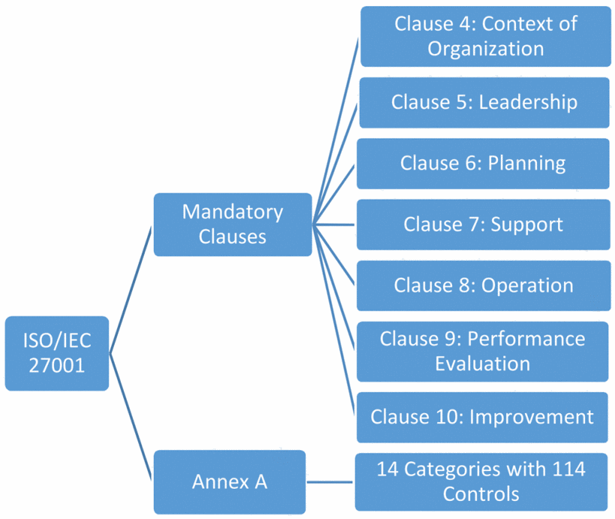
Fig. 1. ISO/IEC standard showing the mandatory clauses

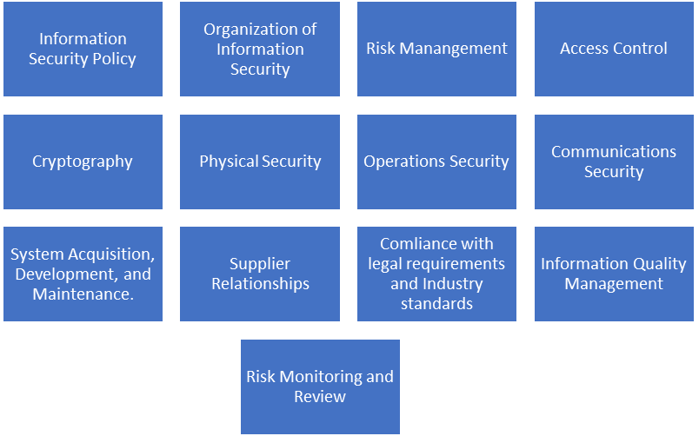
ANNEX A
(14 categories)

Fig. 2. Different categories in Annex A of the ISO/IEC 27001 standard
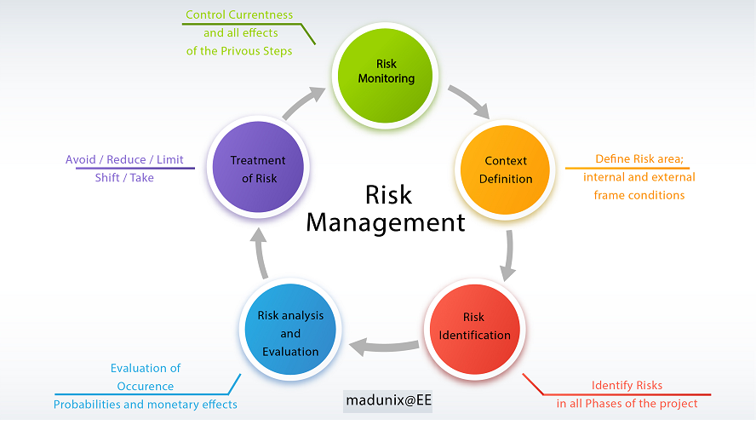

Fig. 3. ISO 27001 Risk management methodology [7]

(Information Technology Infrastructure Library (ITIL)
ITIL is a framework made available publicly to manage IT services for businesses. It provides the best practices for the governance of IT management and the control of different IT services. ITIL aims to constantly measure the improvement of the quality of IT service delivered, either from a customer or business perspective, or both.
ITIL has been modified and updated from one version to another. The first version of ITIL was developed between 2000 to 2004, with over 31 books. This book covered several aspects of IT service provision and was later replaced with an updated version called ITIL V2, with seven more closely connected, and consolidated books added to the framework. By 2007, ITIL v3 was established, consisting of five major publications, which covered the service lifecycle. Another edition of ITIL was published to address business feedback and improve clarity, and consistency through the five core publications. The essence of this update was to ensure business IT service meets industry demand.

2.2.1. ITIL consists of different cycles;
1. Service Strategy: This ensures that clear principles are set to provide adequate solutions to any problem or situation the business faces.
2. Service Design: ensures any new changed services are designed or redesigned to align with the requirements of the business.
3. Service Transition: this ensures that every recent, modified, or retired service meets the requirements of the business as recorded in the service strategy and service design phases of the service lifecycle.
4. Service Operations: this ensures the required level of services is provided to users and customers, to allow for smooth management of different applications, technology, and infrastructure.
5. Continual Service Improvement: ITIL ensures that the quality of services provided to customers is constantly evaluated and improved to meet the overall maturity of the ITSM lifecycle service and other processes running within the system.
Since Nature-garden is trying to control its IT security system, ITIL v3 is highly recommended as one of the best practices for setting up a security policy. The aspect of service request management (SRM), Knowledge management, change management, Incident management, Problem and Release management.

2.2.2. The four dimensions of ITIL 4 include:
- Organizations and people
- Information and technology
- Partners and suppliers
- Value streams and processes

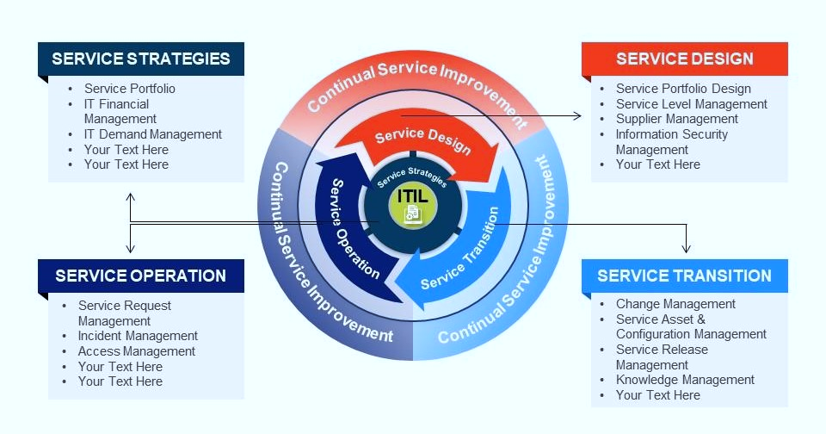
Figure 4. ITIL Framework Overview

COBIT
Control Objectives for Information and Related Technologies or COBIT is a framework designed and developed by ISACA in 2019, which can be used by enterprises or organizations to govern and manage their information and technology. COBIT provides detailed guidelines and practices that empower organizations to align the objectives of their business with IT goals and to also manage information and technology-related risks, effectively. It helps create, control, and maintain risk and security for organizations worldwide.
COBIT 2019 is the latest edition of COBIT, and it is categorized into 3 levels of structure. They include;
1. Information criteria: every organization needs information to grow, and such information has to be measured for efficiency, effectiveness, integrity, secrecy, availability, compliance, and dependability.
2. IT resources: these are resources that are required for the smooth operation of the organization. resources like software, hardware, information, and personnel.
3. Processes: this includes every necessary step and procedure the organization takes towards ensuring the effective operation of the businesses.

2.3.1. Benefits of COBIT
1. Effective Governance: COBIT has an effective framework that can guide organizations toward establishing and maintaining effective governance of IT.
2. Risk Management: with the COBIT framework, an organization can manage risks associated with IT processes.
3. Alignment with Business Goals: this framework ensures every business goal and objectives aligns with their IT activities.
4. Improved Decision-Making: making better decision processes that provide a structured approach to IT management drives is made possible by the COBIT framework.

ISO 31000
This is a framework set up by the International Organization for Standardization, to provide principles and guidelines for effective risk management. The difference between ISO 31000 and other ISO families is that it can be adopted and applied to any organization regardless of size, type, or sector. The aim of this standard is geared towards helping organizations develop a more systematic and structured approach to manage risk for better decision-making enhancing resilience and the ability to achieve objectives. The guidelines set out in ISO 31000 can be modified to fit every organization's IT needs and its environment.
The ISO 31000 standard can be adopted and applied to the following aspects of an organization.
- Risk analysts and Officers in management
- Asset Management
- Line and Project Supervision
- Internal and Compliance Auditing
- Independent Professionals
- Access Control
- Incident Management
- Human Resource Security
- Data Privacy
- System Security
- Network Security
- Audit and Accountability
- Physical Environment Security
- Training and Awareness of Human

NIST SP 800-39
NIST SP 800-39 is a special publication by the National Institute of Standards and Technology, within the U.S. Department of Commerce. It guides the effective establishment of a Risk Management Framework, for use by organizations who want to manage their information security risks and protect their information systems and assets.

2.5.1 The key components of this publication are:
1. Risk Management Framework: provides a structured and organized framework for handling information security risks. This is done by setting up a dynamic risk approach which helps incorporate security into the system development life cycle.
The steps adopted in the Risk Management Framework are discussed below:
- Prepare: At this stage, the risk management strategy will be discussed and established according to the context of the organization.
- Categorize: The sensitivity and criticality of the organizational information will be identified, classified, and processed based on the impact levels.
Security controls needed to mitigate identified risks are adopted according to the sensitivity of the information.
- Implement: The selected security control is been implemented in the information system.
- Assess: the effectiveness of the security control is been evaluated to ensure proper implementation.
- Authorize: the information system will be authorized to function only based on the assessment of security control and risks.
- Monitor: Continuous monitoring of the effectiveness of the security controls and the security status of the information system is performed at this stage. This is to identify and respond to changes in risk.
- Life Cycle Approach: It has a life cycle approach to risk management, with emphasis geared towards the continuous and recurring nature of risk management. The phases include Preparation, Categorisation, Selection, Implementation, Assessment, Authorisation, and Monitoring.
- Integration with other Frameworks: the NIST SP 800-39 can easily integrate with other NIST publications, to provide more layers of security support.
- Adaptability and Flexibility: it can adapt to different organizations' needs.
- Continuous Monitoring and Improvement: it encourages organizations to continuously monitor how the security control is supporting the information systems in regulating and managing.

The NIST SP-39 is highly valuable for organizations that intend to implement a robust and adaptable information security structure.

General Data Protection Regulation (GDPR) 2018
GDPR is a laid down rule that protects how an individual personal data is been used, processed, transferred, or stored. It gives fundamental rights and freedom to an individual rights personal data. The effectiveness of the law can be observed in the latest fine of over 205 million Euros, imposed on British Airways and 110 million Euros on Marriot Hotel Group, due to data compromised of their customer's bank credit card details that was leaked.
Article 4 (1) of GDPR defines 'personal data' as information that relates to a natural person and such a person can be identified with particular reference to the concerned person's identifier like the name, identification number or location data or maybe an online identifier []

The GDPR contains certain principles for safeguarding personal data
- Lawfulness, fairness, and transparency
- Data minimization
- Purpose Limitation
- Storage Limitation
- Accuracy
- Accountability
- Confidentiality and Integrity

Payment Card Industry Data Security Standards (PCI DSS)
PCI DSS is a security standard and technical operational requirement implemented by the PCI Security Standard Council, to protect cardholders' data. Any organization or company that stores, processes, or transmits data belonging to cardholders is bond by this standard

PCI DSS operates on 3 steps
Assess: Identifying all locations of cardholder data, while taking an inventory of IT assets and business processes for payment cards.
Repair: fixing identified vulnerabilities, and removing any unwanted or old data.
Report: document assessment and mitigation details.
This standard comprises requirements that cover different aspects of information security of users' card details.
- PCI Data security standard
- PIN Transaction Security
- Payment Application Data Security Standard (PA-DSS)
- PCI Point-to-Point Encryption Standard (P2PE)
- PCI Card Production Logical Security Requirements and Physical Security
- Token Service Provider Security Requirement

To Develop a comprehensive security policy for NatureGarden, I considered various aspects of information security and aligned them with widely recognized and acceptable security frameworks. I have discussed several security models and frameworks like ISO/EC 27001, ITIL, COBIT, ISO 3100, NIST SP 800-39, GDPR 2018, and the PCI DSS. These frameworks and models will guide the development of these security policies.

3. NatureGarden Information Security Policy

3.1. Introduction
Overview of NatureGarden (NG) and its global presence.
"NatureGarden (NG) sells products that are used to maintain healthy living and is one of the most sought-after brands in the world. NG has an extensive presence around the globe. The company uses cloud services to deliver IT services to its staff and clients. It is estimated that almost 95% of the company's network is wireless-based. The company also has a massive online presence and social media presence to promote its activities.
Information security incidents can give rise to embarrassment, financial loss, non-compliance with standards and legislation, as well as possible sanctions that could be awarded made against the above organisation.
This comprehensive Information Security Policy aligns ‘Information Risk Management Policy’ and ‘Data Protection Policy’. This is to provide high-level guidance and support for NatureGarden’s risk-based information security controls.

3.2. Scope
This Information Security Policy and its supporting controls, processes, and procedures apply to all information used at NatureGarden, in all formats. This includes information processed by other organisations in their dealings with NatureGarden,
inclusion of all employees, contractors, clients, and third parties accessing NatureGarden network/resources, Including personal device usage for both staff and clients.

3.3. Information Security Objectives
The following are the objectives of this information security:
- Protecting the confidentiality, integrity, and availability of information assets.
- Ensuring compliance with relevant laws, regulations, and industry standards.
- Safeguarding personal staff and client data.
- Securing NG's intellectual property.

3.4. Policy Statement
It is NatureGarden’s responsibility to ensure that all customer's and employees’ information is protected from a loss of:
•Confidentiality – information will be accessible only to authorized individuals
•Integrity – the accuracy and completeness of information will be maintained
•Availability – information will be accessible to authorized users and processes when required

3.5. Regulatory Compliance and Monitoring
Adherence to ISO 27001, NIST SP 800-39, ISO 31000, ITIL, and COBIT standards.
Compliance with the controls in this policy will be regulated and monitored by the Infosec team and reported to the information governance board.

3.6. Risk Management
NatureGarden will implement an Information Security Management System based on certified standards as required. It will be mindful of the approaches adopted by its stakeholders, including research partners. This will be achieved by Identifying, assessing, and managing information security risks. The adoption of ISO 31000, COBIT, and ISO/IEC 27001 standards will guide the risk management processes, and regular risk assessments and mitigation strategies.

3.7. Access Control
Access to information and resources will be controlled and regulated by business requirements, and will only be assigned to staff according to their roles. Secure authentication and authorization mechanisms must be implemented. Staff who bring their devices to the office or who want to connect to the company’s network must connect through a virtual private network or tunnel (VPN). The ITIL, ISO/IEC 2700, and NIST standards will guide this policy.

3.8. Cryptography
NatureGarden will make available tools, for the proper effective use of cryptography to ensure the confidentiality, authenticity, and integrity of information and systems. The ISO/IEC 27001 and ISO 3100 recommend that sensitive data must be encrypted from unauthorised access.
To ensure the integrity of data, it must only be made accessible and available for use by an authorised person.

3.9. Physical and Environmental Security
The premises housing the infrastructure of NatureGarden's information must be protected with security perimeters, CCTV cameras must be installed, digital security locks must be installed and access restricted to authorized staff. The ISO/IEC 27001 ensures the implementation of physical security within the premises housing the data infrastructure of the company.

4. Operations Security
NatureGarden will maintain secure operations of information processing systems. This will be achieved by: documenting operating procedures, the use of formal change and capacity management, controls against malware, and vulnerability management. NIST SP 800-39, ITIL, and ITIL standards must be adopted.

4.1. Network Security
- Protection of the company’s wireless-based network infrastructure must be done according to the ISO 3100 standards.
- Implementation of NIST SP 800-39, COBIT, and ISO 3100 for risk management in the network.
- Regular security audits and vulnerability assessments.

4.2. Data Protection
- Data in transit or at rest must be encrypted of sensitive data in transit and at rest.
- Secure processing, use, and storage of customer data must be observed.
- The customer’s payment card details must be encrypted and stored on a secured server, according to PCI DSS guidance.
- Compliance with relevant data protection laws and regulations must be observed. [GDPR 2018]

4.3. Intellectual Property Protection
- Intellectual property assets must be classified and identified
- Implementation of COBIT to manage and protect intellectual property.
- Employee training on the importance of intellectual property security.

4.4. Bring Your Own Device (BYOD)
- Clear and comprehensive security policies governing the use of end-user devices must be established. [ITIL, GDPR, NIST, and COBIT]
- Acceptable use policies, password policies, and guidelines for software installation and updates must be implemented.

4.5 Incident Response and Management
An incident response plan must be established based on NIST SP 800-39, with clear reporting procedures for security incidents.
Ensure regular drills and updates to the incident response plan [ISO/IEC 27001].

4.6. Training and Awareness
Training programs for employees on information security must be conducted as regularly as possible. Security-awareness culture must be promoted within the organization [ISO/IEC 27001].

4.7. Continuous Improvement
- There’s a need to implement regular audits and assessments to identify areas for improvement.
- Use of ITIL for continuous service improvement.
- Periodic updates to the information security policy based on lessons learned.

4.8. Policy Enforcement
Defaulters of this policy should face some level of consequences for non-compliance with information security policies. The consequences should be discussed by the management.
Consistent enforcement of security measures [ISO/IEC 2700].

4.9. Policy Review and Approval
There must be a regular review of the information security policy for relevance and effectiveness and approval must be made by senior management. [COBIT]

5. Document Control
Any changes made to the policy must be documented, and permission to edit this policy must be restricted to just the management team. [ISO/IEC 27001]

CONCLUSION

The integration of diverse information security frameworks enables NatureGarden to develop a robust and tailored Information Security Policy. This policy, rooted in internationally recognized standards, not only safeguards sensitive data and intellectual property but also establishes a proactive and adaptive approach to emerging threats in the dynamic landscape of information security.

