

Student name: Marie France Aurelie BODO BODO
Student ID: 2426167

Module name: Introduction to Physiology
Module code: BMHP5023
Lecturer name: Shaila Hussain

Assessment: Component 1 - Case Study Report: Type 2 Diabetes

1. Introduction
In this case study, a practice nurse in a local GP surgery has identified an increasing number of patients with diabetes and a need for clearer education about their condition. The nurse, therefore, requires accessible, evidence-based information that explains the underlying physiology, the value of appropriate glucose monitoring, and the lifestyle factors patients can address. This knowledge can help patients participate in care planning rather than viewing diabetes management as a set of instructions imposed by professionals.
Diabetes mellitus describes metabolic disorders characterised by persistent hyperglycaemia. Type 1 diabetes is usually caused by autoimmune destruction of pancreatic beta cells, producing an absolute insulin deficiency and a lifelong need for insulin replacement. Type 2 diabetes, the focus here, develops when insulin-sensitive tissues respond inadequately to insulin, and beta cells eventually cannot secrete enough insulin to compensate. Glucose consequently remains in the circulation instead of being regulated and used normally. Type 2 accounts for more than 95% of diabetes worldwide; prolonged hyperglycaemia can damage blood vessels, kidneys, retina and peripheral nerves (World Health Organisation, 2024).
Risk reflects the interaction between biology, behaviour and environment. Non-modifiable factors include increasing age, family history, previous gestational diabetes and some ethnic backgrounds; in the UK, risk rises at a younger age among South Asian, Black African, African-Caribbean and Chinese populations (Diabetes UK, n.d.). Modifiable contributors include excess visceral or ectopic fat, inactivity, an energy-dense diet and smoking. However, weight is not the sole cause: medicines, disability, income, food access and genetic susceptibility also matter. Education in primary care should therefore be non-judgemental and tailored to culture, literacy, circumstances and readiness to change. Structured education at diagnosis, reinforced annually, develops the knowledge and skills required for safe self-management (NICE, 2026c).

2. Blood Sugar Regulation
Homeostasis is the maintenance of a relatively stable internal environment despite external or internal change. Blood glucose is controlled by negative feedback involving the endocrine pancreas, liver, skeletal muscle, adipose tissue and several hormones. A fasting concentration of approximately 4-6 mmol/L supplies fuel without exposing tissues to excessive glucose. Marked hypoglycaemia can cause sweating, confusion, seizures or loss of consciousness, whereas sustained hyperglycaemia causes thirst and polyuria and, over time, vascular and neurological injury (Hall and Hall, 2021).
After a carbohydrate-containing meal, digestion releases glucose, which is absorbed from the small intestine. Rising plasma glucose is detected by beta cells within the islets of Langerhans. Glucose metabolism raises the beta-cell ATP-to-ADP ratio, closes ATP-sensitive potassium channels, depolarises the membrane and opens calcium channels; calcium entry triggers insulin release. Insulin binds to receptors on target tissues. In skeletal muscle and adipose tissue, signalling moves GLUT4 transporters to the cell membrane, increasing glucose uptake. It also promotes glycogenesis in the liver and muscle while suppressing hepatic glycogenolysis and gluconeogenesis. These coordinated actions return glucose towards the normal range (Rahman et al., 2021).
When glucose falls between meals or during activity, insulin secretion decreases, and alpha cells in the pancreatic islets release glucagon. Glucagon acts mainly on the liver, stimulating glycogenolysis and gluconeogenesis from lactate, glycerol and amino acids. The liver releases the resulting glucose into the circulation. Adrenaline, cortisol and growth hormone provide additional counter-regulation during exercise, prolonged fasting or stress (Zeigerer et al., 2021). Insulin and glucagon, therefore, form an opposing but integrated feedback system, illustrated in Figure 1.
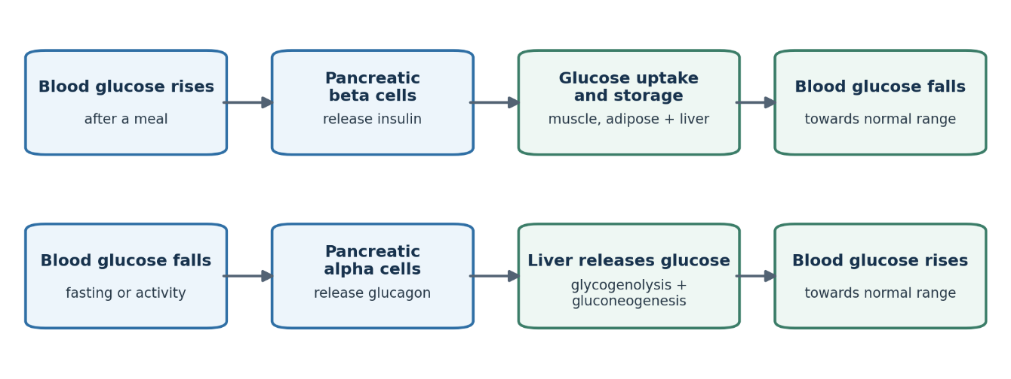
Figure 1. Negative-feedback regulation of blood glucose. Author-created schematic based on Hall and Hall (2021), Rahman et al. (2021) and Zeigerer et al. (2021).
In Type 2 diabetes, insulin signalling becomes less effective in skeletal muscle, liver and adipose tissue. Muscle removes less post-meal glucose; adipose lipolysis releases fatty acids that can worsen resistance; and the liver continues producing glucose despite circulating insulin. Beta cells initially compensate by secreting more insulin, but progressive dysfunction makes secretion inadequate. Both postprandial and fasting glucose then rise (Petersen and Shulman, 2018). This explains why a patient may have high circulating glucose while insulin-dependent tissues cannot handle fuel normally.
Persistent hyperglycaemia promotes oxidative stress, formation of advanced glycation end-products and endothelial injury. These mechanisms connect failed homeostasis to retinopathy, nephropathy, neuropathy and accelerated cardiovascular disease. Safe management must therefore address glucose alongside blood pressure, lipids, smoking and the patient's overall cardiovascular risk, rather than treating an HbA1c value in isolation.

3. Oxygen and Glucose in Cellular Metabolism
Cellular respiration converts chemical energy in glucose into adenosine triphosphate (ATP), the immediately usable energy source for active transport, muscle contraction, biosynthesis and other cellular work. Oxygen enters the lungs, diffuses across the alveolar-capillary membrane, binds mainly to haemoglobin and is delivered through the circulation. Glucose also reaches tissues in the blood and enters cells through specific transporters, including insulin-responsive GLUT4 in skeletal muscle and adipose tissue. Figure 2 provides an overview of the aerobic pathway.
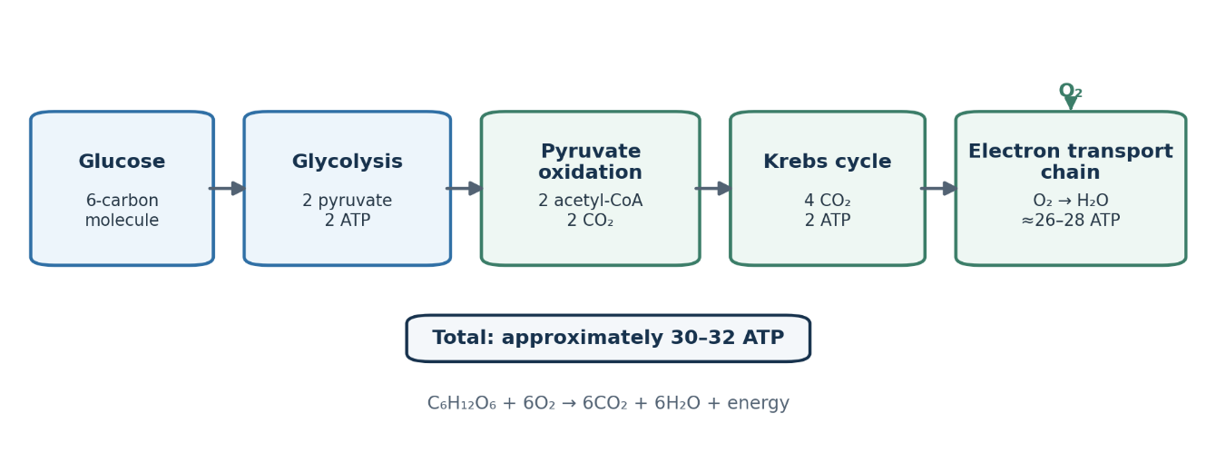
Figure 2. Principal stages of aerobic cellular respiration. Author-created schematic based on Tortora and Derrickson (2021).
The first stage of glycolysis, which occurs in the cytosol, does not require oxygen. One six-carbon glucose molecule is split into two three-carbon pyruvate molecules, producing a net two ATP and two reduced nicotinamide adenine dinucleotide (NADH) molecules. When oxygen and functioning mitochondria are available, pyruvate enters the mitochondrial matrix and is converted to acetyl-CoA, releasing carbon dioxide.
Acetyl-CoA enters the citric acid cycle, or Krebs cycle, in the mitochondrial matrix. The cycle generates more carbon dioxide, a small amount of ATP, and the electron carriers NADH and FADH2. These carriers supply the electron transport chain in the inner mitochondrial membrane. Electron transfer pumps protons; their return through ATP synthase drives oxidative phosphorylation. Oxygen is the final electron acceptor and forms water. Overall, aerobic respiration can be summarised as C6H12O6 + 6O2 -> 6CO2 + 6H2O + energy, with approximately 30-32 ATP generated per glucose molecule (Tortora and Derrickson, 2021).
If oxygen delivery is insufficient, pyruvate is reduced to lactate so glycolysis can continue, but only two ATP are obtained per glucose. This lower-yield pathway is relevant during intense activity or tissue hypoxia. It should not be confused with diabetic ketoacidosis (DKA): DKA results primarily from severe insulin deficiency, accelerated fat breakdown and accumulation of acidic ketone bodies, not from ordinary anaerobic glycolysis. Although DKA is more common in Type 1 diabetes, it can occur in Type 2 diabetes during severe illness or with particular medicines. In Type 2 diabetes, elevated circulating glucose levels do not necessarily reflect abundant cellular energy, as insulin resistance disrupts the regulation of uptake and storage.

4. Recording and Tracking Blood Sugar Levels
Tracking turns isolated measurements into information for care planning. HbA1c measures glycated haemoglobin and estimates average glycaemia over approximately two to three months. NICE (2026a) recommends testing every 3 to 6 months until control is stable, and every 6 months thereafter. A commonly supported target is 48 mmol/mol (6.5%) for adults managed by healthy living or medicines not associated with hypoglycaemia, and 53 mmol/mol (7.0%) when treatment can cause hypoglycaemia. Targets should be individualised for frailty, comorbidity, occupation, treatment burden and preference.
Capillary self-monitoring provides a glucose value at a single point in time, while continuous glucose monitoring (CGM) records interstitial glucose trends, direction of change, and time in range. A useful diary links readings with meals, activities, medication, illness, and symptoms, enabling the patient and clinician to recognise recurring post-meal rises or possible hypoglycaemia and to evaluate agreed changes. A meta-analysis of 14 randomised trials found that CGM produced a modest mean HbA1c reduction of about 0.32%, although trials were relatively short and evidence about hospitalisation and adverse events was limited (Uhl et al., 2024).
Testing must have a purpose. NICE (2026a) does not recommend routine capillary self-monitoring for every adult with Type 2 diabetes; it is mainly indicated in insulin-treated adults with actual or suspected hypoglycaemia, when driving or operating machinery, during pregnancy, and in selected short-term situations such as corticosteroid treatment. Where monitoring is used, the patient needs correct technique, personalised targets and an agreed response plan. Otherwise, pain, anxiety, inaccurate readings and cost may add burden without improving decisions. HbA1c can also conceal different peaks and troughs, while a few finger-prick readings may miss overnight changes. In addition, altered red-cell turnover or haemoglobin variants may make HbA1c misleading. Clinicians should therefore interpret each measure in context rather than treating one number as a complete account of control. Results outside the action plan or accompanied by concerning symptoms require clinical advice, not unsupervised medication changes.

5. Evidence-Based Lifestyle Recommendations

Diet and weight management
Dietary advice should be individualised, culturally acceptable and developed with a suitably trained professional. NICE (2026b) recommends high-fibre, lower-glycaemic-index carbohydrate sources such as vegetables, fruit, pulses and wholegrains, together with oily fish and control of saturated and trans fats. Sugar-sweetened drinks and highly refined foods can be reduced, while portion size and total energy remain important. Carbohydrate does not need to be eliminated; amount, quality and distribution affect post-meal glucose and must be considered alongside any medication that can cause hypoglycaemia. No single eating pattern is universally superior: nutritional adequacy, cardiometabolic effects, affordability and long-term adherence are more useful criteria than a restrictive label.
For people living with overweight or obesity, sustained weight loss can improve hepatic and peripheral insulin sensitivity and may permit remission, especially soon after diagnosis. In the DiRECT programme, high early remission rates declined over time: only 13% of extension participants were in remission at five years, and weight regain was common (Lean et al., 2024). This shows both the potential of intensive weight management and the difficulty of maintenance. Low-energy meal-replacement diets require an appropriate clinical programme, medication review and long-term support. Remission also requires continuing surveillance because hyperglycaemia can return.

Physical activity
Adults should progress towards at least 150 minutes of moderate aerobic activity each week, or an equivalent combination, and undertake muscle-strengthening activity on at least two days while reducing prolonged sitting (Department of Health and Social Care, 2019). Brisk walking, cycling, swimming and resistance exercises are practical options. Muscle contraction increases glucose uptake through pathways partly independent of insulin, while regular activity improves insulin sensitivity, muscle mass, blood pressure and cardiorespiratory fitness.
A meta-analysis of 46 randomised trials found resistance training reduced HbA1c by a mean of 0.50 percentage points, although effects varied across studies (Wan and Su, 2024). Plans should start gradually and reflect preference, mobility and complications. Patients using insulin or insulin secretagogues need advice on monitoring, carbohydrate intake and dose adjustment to reduce exercise-related hypoglycaemia. Foot disease, proliferative retinopathy or cardiovascular symptoms may require assessment before intensity increases.

Smoking cessation and sustainable self-management
Smoking compounds diabetes-related vascular risk through endothelial dysfunction, inflammation and thrombosis. The practice nurse should offer non-judgemental cessation support, referral to an NHS stop-smoking service and suitable behavioural and pharmacological options. A 2024 review found quitting was generally associated with lower risks of myocardial infarction and ischaemic stroke among people with diabetes, although evidence for some microvascular outcomes remained limited (Walicka et al., 2024). Temporary weight gain or short-term changes in glucose after cessation should be anticipated, monitored and managed supportively; neither is a reason to continue smoking.
Lifestyle measures complement rather than replace prescribed treatment and routine kidney, eye and foot review. Agreeing on one achievable change at a time, recording it and reviewing relevant HbA1c or glucose patterns can strengthen self-efficacy. Recommendations should be tailored to income, working hours, culture, health literacy, disability, and mental health, ensuring the care plan is both evidence-based and sustainable.

6. Conclusion
Type 2 diabetes develops when insulin resistance and progressive beta-cell dysfunction disrupt the insulin-glucagon feedback system that normally matches glucose availability to the body's needs. Glucose and oxygen ordinarily support efficient mitochondrial ATP production, yet hyperglycaemia does not guarantee effective cellular fuel handling. Monitoring is most useful when it answers a clinical question: HbA1c identifies longer-term trends, while selected capillary or continuous readings reveal actionable daily patterns. Routine testing without indication or interpretation adds burden rather than safety. Individualised dietary improvement, sustainable weight loss, combined aerobic and resistance training, and smoking cessation can improve glycaemia and cardiovascular health; substantial, sustained weight loss can produce remission in some patients. Effective practice-nurse support connects these measures with structured education, prescribed treatment and shared review, enabling patients to make informed, realistic decisions and engage safely with their care plans.

Reference List
- Department of Health and Social Care (2019) UK Chief Medical Officers' physical activity guidelines. Available at: https://www.gov.uk/government/publications/physical-activity-guidelines-uk-chief-medical-officers-report (Accessed: 20 July 2026).
- Diabetes UK (n.d.) Type 2 diabetes risk factors. Available at: https://www.diabetes.org.uk/about-diabetes/type-2-diabetes/diabetes-risk-factors (Accessed: 20 July 2026).
- Hall, J.E. and Hall, M.E. (2021) Guyton and Hall textbook of medical physiology. 14th edn. Philadelphia: Elsevier.
- Lean, M.E.J. et al. (2024) '5-year follow-up of the randomised Diabetes Remission Clinical Trial (DiRECT) of continued support for weight loss maintenance in the UK: an extension study', The Lancet Diabetes & Endocrinology, 12(4), pp. 233-246. doi: 10.1016/S2213-8587(23)00385-6.
- National Institute for Health and Care Excellence (NICE) (2026a) Type 2 diabetes in adults: management (NG28): Blood glucose management. Available at: https://www.nice.org.uk/guidance/ng28/chapter/Blood-glucose-management (Accessed: 20 July 2026).
- National Institute for Health and Care Excellence (NICE) (2026b) Type 2 diabetes in adults: management (NG28): Dietary advice and interventions. Available at: https://www.nice.org.uk/guidance/ng28/chapter/Dietary-advice-and-interventions (Accessed: 20 July 2026).
- National Institute for Health and Care Excellence (NICE) (2026c) Type 2 diabetes in adults: management (NG28): Education. Available at: https://www.nice.org.uk/guidance/ng28/chapter/Education (Accessed: 20 July 2026).
- Petersen, M.C. and Shulman, G.I. (2018) 'Mechanisms of insulin action and insulin resistance', Physiological Reviews, 98(4), pp. 2133-2223. doi: 10.1152/physrev.00063.2017.
- Rahman, M.S. et al. (2021) 'Role of insulin in health and disease: An update', International Journal of Molecular Sciences, 22(12), article 6403. doi: 10.3390/ijms22126403.
- Tortora, G.J. and Derrickson, B. (2021) Principles of anatomy and physiology. 16th edn. Hoboken, NJ: Wiley.
- Uhl, S., Choure, A., Rouse, B., Loblack, A. and Reaven, P. (2024) 'Effectiveness of continuous glucose monitoring on metrics of glycemic control in Type 2 diabetes mellitus: A systematic review and meta-analysis of randomized controlled trials', The Journal of Clinical Endocrinology & Metabolism, 109(4), pp. 1119-1131. doi: 10.1210/clinem/dgad652.
- Walicka, M. et al. (2024) 'Influence of quitting smoking on diabetes-related complications: A scoping review with a systematic search strategy', Diabetes & Metabolic Syndrome: Clinical Research & Reviews, 18(5), article 103044. doi: 10.1016/j.dsx.2024.103044.
- Wan, Y. and Su, Z. (2024) 'The impact of resistance exercise training on glycemic control among adults with Type 2 diabetes: A systematic review and meta-analysis of randomized controlled trials', Biological Research for Nursing, 26(4), pp. 597-623. doi: 10.1177/10998004241246272.
- World Health Organization (2024) Diabetes. Available at: https://www.who.int/news-room/fact-sheets/detail/diabetes (Accessed: 20 July 2026).
- Zeigerer, A., Sekar, R., Kleinert, M., Nason, S., Habegger, K.M. and Muller, T.D. (2021) 'Glucagon's metabolic action in health and disease', Comprehensive Physiology, 11, pp. 1759-1783. doi: 10.1002/cphy.c200013.

