School of Sport, Health & Outdoor Education

Assessment Feedback Sheet

Student No./Name: 97010606/Menna Jones
Module: Advanced Training Methods
Module Code: SHSS6089

Personal Evaluation – to support your academic progress please complete the section below BEFORE submitting your work.
What do you consider to be the best aspects of this work? |  |  | Structure of the assignment.
Which aspects do you consider could have been improved in this piece of work? |  |  | Time management - more in depth research.
What have you found most satisfying whilst undertaking this submission? |  |  | Researching, putting theory into practise.
ASSESSMENT CRITERIA | Learning  Outcomes |  | GRADE
 |  |  | Poor  0-25% | Unsatisfactory  26-39% |  | Satisfactory  40 – 49% | Good  50 – 59% | Very Good  60 – 69% | Excellent  70 – 85% |  | Exceptional  86– 100% |  | %
Rationale for use of training method | 1,2 |  |  |  |  |  |  |  |  |  |  |  | 20
Programme design following best practice | 2 |  |  |  |  |  |  |  |  |  |  |  | 20
Critical evaluation of effectiveness of training method | 1,2 |  |  |  |  |  |  |  |  |  |  |  | 35
Evaluation of use of technology for monitoring and enhancement | 1,3 |  |  |  |  |  |  |  |  |  |  |  | 15
Engagement with the process and professionalism | 2 |  |  |  |  |  |  |  |  |  |  |  | 10
It is expected that students will present work that is proof read and follows the School Reference Guide and Assessment Checklist. Therefore a range of 0 – 10 marks will be deducted for non-completion of any of the points on the checklist below.
TUTOR COMMENTS:

Submission date: 8/03/19 |  | Return date:  (at least within 4 weeks) |  |  | Tutor: Geraint Forster |  |  |  |  | Mark:

An evaluative report on the effectiveness of a three-week polarised training programme for a recreational runner.

Client profile
The client was a 41-year-old female who had been training regularly for the last five years. She had completed several 10K road, trail and obstacle races before progressing to half marathons and last year saw her attempt her first marathon. Her half marathon personal best (PB) time stands at 1hr 56mins and she ran the marathon in a time of 4hrs 21mins. The client approached me having completed the Run Every Day January (RED Jan) challenge which she signed up to with a group of friends to kick start her training after the Christmas period. Over the month of January, she accumulated approximately 112 miles of running (appendix 1) which she felt had given her a good base to work from but was now lacking in motivation and direction.

Usual training for the client consisted of a mix of interval sessions, fartlek runs, pyramid sessions and one longer weekend run at a comfortable pace if, and when she had the time. Although she wears a Garmin Vìvoactive® HR global positioning system monitor that records the duration, distance and intensity of each running session, she has never really paid attention to her heart rate (HR) and generally runs at a self-selected pace. The client also uses the mobile app Strava which is linked to her Garmin® global positioning system monitor to keep a log of her training.

The client had recently developed an interest in polarised training. Her curiosity had been sparked having read various articles and books written by proponents of the method and she was keen to experiment with HR monitoring or a polarised training plan as she was toying with the idea of entering another marathon towards the end of the year.

Initial testing
The client was invited to attend The Laboratory for Human Performance at The University of Wales Trinity Saint David, Carmarthen for initial testing. All test results can be seen in Table 1 below.

Variable | Measure
HR at VT (bpm) | 143
Time to VT (Minutes) | 8.48
HR at RCP (bpm) | 67.3
Time to RCP (Minutes) | 28.4
VO_{2max} (mL O₂. Kg⁻¹ . min ⁻¹) | 43
Height (cm) | 166
Total body weight (kg) | 67.3
Body fat (%) | 28.4
Muscle mass (kg) | 45.8
Fat free mass (kg) | 48.2
10K time trial (minutes) | 55.43

Table 1. Results from pre-programme testing

Having completed a Physical Readiness Activity Questionnaire (PAR-Q) form (appendix 2), height, weight and anthropometric measures were taken. The client’s weight was recorded as 67.3kg and she was found to have a body fat percentage of 28.4%. This % falls into the ‘poor’ fitness category for body composition (ACSM, 2018). Studies have found a high body fat percentage negatively affects marathon performance times (Knechtle and Tanda, 2013; Schmid et al., 2012) therefore should the client want to improve her performance as a distance runner she would need to focus on losing body fat. The client performed an incremental treadmill test until volitional exhaustion was achieved. This allowed me to record her HR at her anaerobic threshold (VT), and at her respiratory compensation point (RCP). I also recorded her VO_{2max}. The two HR readings would prove crucial in order to determine her training zones. Intensity distribution has been investigated in many studies where VT and RCP have been used as anchor points to establish intensity zones (Seiler and Kjerland, 2006; Esteve-Lanao et al., 2005). Using these points allows for a more individually tailored training plan as the measures are of an inter-individual nature. The client’s HR at VT and RCP was 143 beats per minute (bpm) and 171bpm respectively. This allowed me to set the training intensity zones as seen in Table 2 below.
Zone | HR BPM
Zone 1 | up to 143
Zone 2 | 143-171
Zone 3 | >171

Table 2. HR (heart rate) zones as defined by VT (ventilatory threshold) and RCP (respiratory compensation point)

The time taken to reach both points was also recorded. It has been postulated that rather than VO_{2max}, VT may be a better marker of aerobic endurance as VT can increase without affecting VO₂ max (Ghosh, 2004). Ultimately, the higher the thresholds and the longer it takes for a runner to hit those thresholds, the longer they should be able to delay fatigue. The client achieved a Vo_{2max} of 43, which is classed as ‘superior’ for her age category (ACSM, 2018). Countless studies have demonstrated that in order to perform well in endurance sports a high VO_{2max} is essential. (Lucia et al., 2006; Lucia et al., 2008). Two days after the testing the client undertook a 10km time trial (TT) along a coastal path route used regularly during her RED Jan challenge and completed the run without wearing her Garmin® global positioning system monitor to prevent her from seeing her pace, which could have influenced her effort.

The client provided access to her Garmin® Connect and Strava account for retrospective analysis of her running throughout the month of January.
Table 3 below contains data taken from her Garmin® Connect account.

 | Distance (miles) | Time (minutes) | Zone 1  (% of time) | Zone 2  (% of time) | Zone 3  (% of time) | Zone 4  (% of time) | Zone 5  (% of time)
Totals | 112.62 | 1029.79 | 3 | 22 | 57 | 12 | 0
Table 2. January running log taken from Garmin® Connect indicating distance (miles), time (minutes) and intensity (% time in zone)

Zones had been calculated and set in the client’s Garmin® Connect account prior to testing based on percentage (%) of HR_{max}. The client had calculated her Max HR using the 220-age method (Fox, Naughton and Haskell, 1971) as well as the modified method: HR_{max} = 207 − 0.7 × age (Tanaka, Monahan and Seals, 2001), both are listed as equations commonly used for HR estimation in the ACSM Guidelines for Exercise Testing and Prescription (2018). An average of both results was taken, and she set her max HR at 179. Table 4 below indicates the HR range in bpm of each zone as calculated based on % of HR_{max}

Zone | % HR_{Max} | BPM
Zone 1 | 50-60% | 90-107
Zone 2 | 60-70% | 107-125
Zone 3 | 70-80% | 125-143
Zone 4 | 80-90% | 143-161
Zone 5 | 90-100% | 161-179+

Table 3. HR Zones in beats per minute (bpm)

Based on a max HR of 179, of the 17 hours and 16 minutes running in January, approximately 3% of total running time was spent in Zone 1, 22% in Zone 2, 57% in Zone 3, 12% in Zone 4 and 0% in Zone 5. Had the client been following a three-zone intensity model throughout January, based on HR_{max} she would have completed 83% of her time in Zone 1, 12% in zone 2 and no time at all in zone 3. In effect, she had already completed a month of polarised training – based on the model of 80%-20% distribution.

Rationale
Having discussed at length with the client it became clear that she had an outcome goal of improving as an endurance runner. Studies have shown that to be a successful endurance runner a number of pivotal factors must be taken into account (Lucia et al., 2008). These include VO_{2max}, fractional utilisation of VO_{2max}, lactate thresholds and running economy (Mclaughlin et al., 2010; Coyle, 1995; Allen et al., 1985). I explained that in order to improve as an endurance runner we would need to set a performance goal which ideally would be to run her next marathon improving her PB time. The immediate task was to set process goals that would result in raising her lactate thresholds and/or improving her running economy – improving her VO_{2max} would also be beneficial however as it was already quite high for her age, and isn’t regarded as a single determinant of endurance running performance, I didn’t regard that as a priority for the client.

The client was interested in polarised training and in order to create a sense of autonomy and as she had quite some time until her next marathon, I felt it would be an ideal time for her to trial this training method, especially considering she had already completed a month of what was in effect polarised training (based on the 80%-20% rule). Recent evidence (Kenneally, M., Casado, A. and Santos-Concejero, J. (2018) leans in favour of polarised training claiming it is more effective than threshold training. Critics of this method however have sought to prove it cannot be effective for recreational runners (Høydal and Hareide 2016) claiming polarised training is a method best suited to elite athletes who spend considerably more hours than recreational athletes training each week – both anecdotal and empirical evidence does include vast amounts of data collected from elite cross-country skiers, cyclists, rowers or marathon runners (Seiler and Tønnesen, 2009). Nevertheless, there is growing empirical evidence that even in recreational runners, polarised training can lead to greater training adaptations than threshold training or high-intensity training alone (Munoz et al., 2014; Carnes and Mahoney, 2019)

Summary of programme
The client had a window of three weeks to train with me before heading off on a break then returning to commence a 12-week block of training. From the data gathered in January it became clear that the client had completed most of her runs at an intensity under the first ventilatory threshold (VT) but spent very little time above the second ventilatory threshold (or RCP). As most intervention studies would need longer than three weeks to see results, we decided to use the three weeks to experiment with Hiit training to discover which Hiit session elicited the necessary HR needed to qualify for zone 2/3 classification. The client committed to completing at least 6 sessions a week ensuring that two sessions were Hiit sessions. This would then hopefully follow (as practically applicable as possible for the client) the 80%-20% distribution required of polarised training where for 80% of the time an athlete performs below their VT and 20% above (Tønnessen et al., 2014). Whilst some studies have distributed training into two distinct ‘polarised’ zones of low intensity (under the first VT) and high intensity (above the RCP) (Zapata-Lamana et al., 2018) others have allocated a certain amount in the middle zone or zone 2 (between both threshold anchor points) (Muñoz et al., 2014; Carnes and Mahoney 2019). As this was an experimental programme and the client had already demonstrated that she could adhere to the 80%-20% two zone model, the client agreed that having completed the three weeks of training an assessment would be made as to which method (no zone 2 or some zone 2) would be followed for the subsequent 12-week period. Allowing her a certain amount of autonomy in the process would hopefully lead to better long-term adherence to her training and subsequently achievement of her distal goals. I was also mindful how hard she would have to push herself in the interval sessions to achieve the adequate zone 3 HR and didn’t want to set her up for failure – rather allow for an alternative should the target HR not be reached.
The client was instructed to complete all zone 1 or low intensity runs either on a treadmill or outdoors. These runs would be completed alone in her own time using her Garmin® global positioning system monitor to observe her HR – making sure she remained in Zone 1. She was to run three runs of approximately an hour each week, one slightly longer run of 80 mins a week and one long weekend run of 90 mins a week. Twice a week she would attend the gym at the University where we would experiment with Hiit interval sessions on the treadmill.
The interval sessions would vary. Buchheit and Laursen, (2013) identified nine variables that could be manipulated to create varying Hiit sessions: Work duration, modality and intensity; relief intensity and duration; the number and duration of sets as well as the time between sets and the recovery intensity between sets. For endurance runners García-Pinillos, Soto-Hermoso and Latorre-Román (2017) suggest good practice would involve work duration (<1min) and ratios of work-rest of 1:1 – 1:2 with each session performed at almost all-out effort. I was mindful however that pushing the client to work at such a high intensity may place too much stress on the body when her lifestyle already places her under great stress. The intervals therefore chosen to experiment with were two longer interval sessions, one short session and a sprint session. Speed was initially selected based on analysis of her previous runs where she was at a comfortable pace when running between 9.5-10km/hr. The sessions followed the following structures:
- 10x2 minutes work, 1-minute rest at 14km/hr, 0% incline.
- 3x6 minute blocks of 1-minute work, 30 seconds rest at 13km/hr, 0% incline, 1-minute rest in between blocks.
- 2 blocks of 10x40 seconds work, 1-minute rest at 16km/hr and treadmill set to 1% incline with a 2-minute rest between blocks.
- 2x6 minute blocks of 15 seconds sprinting/15 seconds rest at 18km/hr and treadmill set to 1% incline with a 2-minute rest between blocks.

Duration was to remain the same throughout the programme however, speed could be manipulated to increase/decrease effort to elicit the necessary HR. All sessions were to be recorded via Garmin® Connect and Strava to enable me to remotely monitor effort, progress and adherence.

Evaluation of technology used within programme
The client used her Garmin Vìvoactive® HR global positioning system monitor to monitor her HR and upload her sessions to the Garmin Connect® account and Strava. The Vìvoactive® HR monitors HR at the wrist. This utilizes photoplethysmography technology which isn’t always a valid or reliable method of recording intensity. Running in particular can cause discrepancies in readings given the nature of the activity whereas cycling doesn’t as the wrist stays in a more static position (Støve et al., 2018). It is possible to wear a chest strap HR monitor which has been shown to provide a more accurate HR reading (Dooley, Golaszewski, and Bartholomew. 2017) however many women in particular find them uncomfortable and prefer to wear an all-day activity tracker. Wearing the monitor allowed the client to monitor distance, duration, speed, and zone. There were benefits and draw backs. The client reported that she frequently became obsessed with pace/HR and therefore enjoyment of the session dissipated. However, monitoring pace/HR was beneficial when trying to pace a longer run – it prevented the client from running too fast or too slow. Occasionally it impacted negatively on her mood as when she was ‘off the pace’ for any number of reasons, she became quite defeatist and the battle began in her mind to keep going. Occasionally the monitor malfunctioned and she found herself running at a comfortable pace however the reading indicated she was in zone 5!

What is useful is the transfer of all the data to a Garmin® Connect account where either the athlete or their trainer/coach can monitor their performance remotely.
Figures 1, 2 and 3 below show how Garmin breaks down your data into convenient visual representation of your training allowing you or your trainer/coach to quickly analyse any training session. Strava does much the same however in-depth analysis requires subscription and the client reported that she felt Strava had become more of a social media network for fitness enthusiasts rather than a method of keeping a log of training, so much so she was considering closing her Strava account as she was finding it was negatively impacting on her mood seeing others training for longer or at higher intensities and achieving PBs, commenting it was now a fitness Facebook.

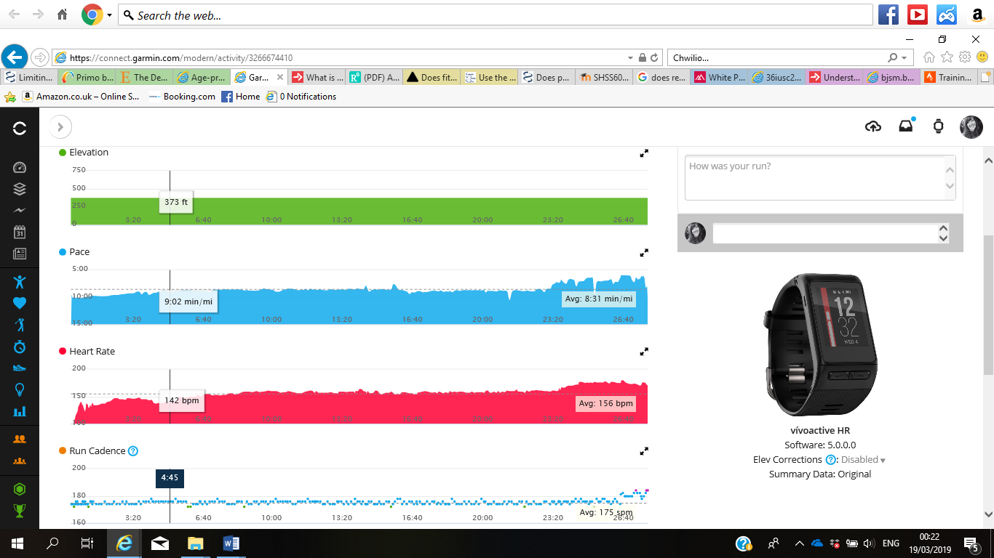
Fig1. Garmin connect training analysis.
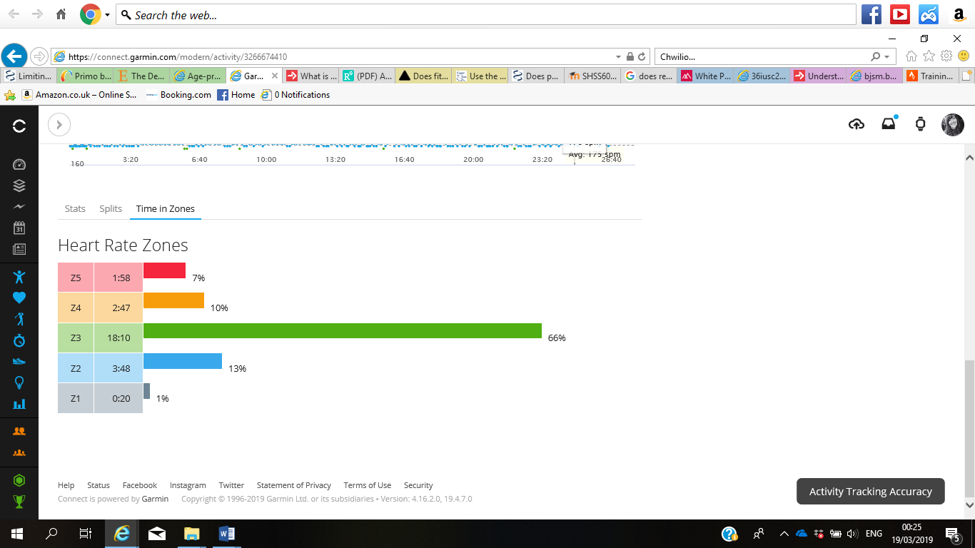
Fig2. Garmin connect training analysis.

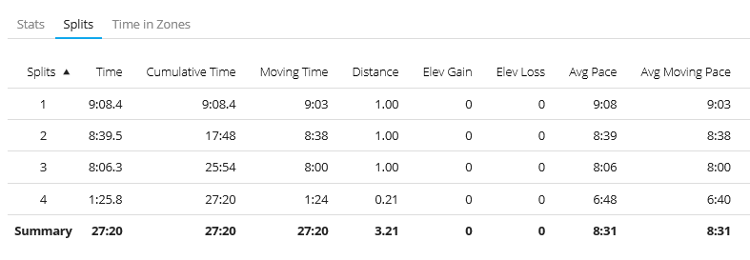
Fig3. Garmin connect training analysis.

Critical evaluation
Having completed the three-week programme, the client returned to the University for testing. Table 5 below contains a breakdown of all sessions. This information was taken from the client’s Garmin Connect account. Distance ran, time taken and the percentage of that time in each zone are listed.
Date | Intended session intensity (Low or High) | Distance (miles) | Time (mins) | Zone 1 (% of total time) | Zone 2 (% of total time) | Zone 3 (% of total time)
Tuesday 12 | L | 6.2 | 60 | 87 | 2 | 0
Wednesday 13 | L | 0.5 | 4.59 | 68 | 0 | 0
Wednesday 13 (A) | H | 1.63 | 22.44 | 61 | 38 | 0
Wednesday 13 | L | 0.5 | 4.55 | 56 | 41 | 0
Thursday 14 | L | 0.5 | 4.52 | 98 | 0 | 0
Thursday 14 (B) | H | 1.67 | 13.44 | 92 | 0 | 0
Thursday 14 | L | 0.5 | 4.48 | 68 | 25 | 0
Friday 15 | L | 6.19 | 60 | 90 | 8 | 0
Saturday 16 | L | 5.51 | 54.22 | 96 | 0 | 0
Sunday 17 | L | 10 | 95 | 94 | 3 | 0
Monday 18 | L | 6.23 | 60 | 98 | 0 | 0
Tuesday 19 | L | 6.2 | 60 | 95 | 0 | 0
Wednesday 20 | L | 0.5 | 5.1 | 86 | 0 | 0
Wednesday 20 (C) | H | 0.7 | 14.14 | 91 | 0 | 0
Wednesday 20 | L | 0.5 | 4.49 | 86 | 0 | 0
Thursday 21 | L | 10 | 98 | 96 | 2 | 0
Friday 22 | L | 0.5 | 4.49 | 87 | 4 | 0
Friday 22 (D) | H | 3.02 | 30.43 | 67 | 30 | 0
Friday 22 | L | 0.5 | 5.13 | 84 | 7 | 0
Saturday 23 | L | 5 | 54.12 | 97 | 0 | 0
Sunday 24 | L | 8.2 | 77.49 | 95 | 2 | 0
Monday 25 | L | 0.5 | 5.12 | 70 | 0 | 0
Monday 25 (E) | H | 1.7 | 14.2 | 96 | 0 | 0
Monday 25 | L | 0.5 | 4.5 | 96 | 2 | 0
Tuesday 26 | L | 5 | 56.45 | 98 | 0 | 0
Wednesday 27 | L | 0.5 | 4.51 | 86 | 4 | 0
Wednesday 27 (F) | H | 3.1 | 40.05 | 10 | 32 | 57
Wednesday 27 | L | 0.5 | 4.6 | 96 | 2 | 0
Thursday 28 | L | 5 | 56 | 97 | 1 | 0
Friday 1 | L | 8.2 | 78.3 | 94 | 2 | 0
Saturday 2 | L | 6.2 | 60 | 94 | 4 | 0
Sunday 3 | L | 10 | 98 | 96 | 0 | 0
TOTALS: | L | 115.75 | 1158.36 | 88% | 7% | 2%
Table 5. Record of sessions conducted by client over three-week period indicating intended intensity (Low or High), distance run (miles), time taken (minutes), time in each zone (% of total).

The client completed all but one of the prescribed sessions. Feedback from her Garmin account showed she was staying within the prescribed zone for her low intensity runs (below her VT) although her verbal feedback suggested she found this difficult at times, particularly outdoors where she naturally wanted to run at a quicker pace, but her HR was indicating she shouldn’t. This could tie in with the theory that green exercise (exercise that occurs in a natural environment) lowers the rate of perceived exertion (RPE), allowing the athlete to perform at a higher intensity without perceiving it as higher (Ceci and Hassman, 1991; Focht, 2009). She spent 88% of her time over the three weeks in this zone which doesn’t correspond with the 80%-20% distribution we were hoping for. Consequently, she did not spend enough time in the zone above her VT. This does seem to be a limiting factor to polarised training amongst the amateur population with such athletes reporting that not only does the low intensity creep up into threshold zone, but the high intensity isn’t high enough.

One of the main aims of the programme was to investigate which Hiit session elicited the necessary HR response to be regarded as zone 3. From analysing the data, there were three Hiit sessions that resulted in a HR classed as zone 2 or 3. In Table 5 above they are noted as session A, D and F.

Session A was the 3x6 minute blocks of 1-minute work, 30 seconds rest at 13km/hr, 0% incline, 1-minute rest in between blocks. Having completed this session, the client noted she could have run at a higher pace for the duration of the session however she was wary having not undertaken such a session previously whether she would be able to successfully complete it. This was good to note as her HR was successfully above VT for 38% of the time therefore increasing the pace next time should see that figure rise.

Session D was the 10x2 minutes work, 1-minute rest at 14km/hr, 0% incline. The client was very familiar with this session as it was her go-to ‘short on time’ interval run. She fed back that she didn’t think she could increase the speed for the session however if the session was broken down to two or possibly three blocks of 6x2 minutes, again with the 1-minute rest period and same speed and incline but adding a 2 minute rest period between blocks that would be achievable and would probably see her in her zone 2 for a longer % of time.

Session F was the 2 blocks of 10x40 seconds work, 1-minute rest at 16km/hr and treadmill set to 1% incline with a 2-minute rest between blocks. The client enjoyed this session most and it saw her HR enter zone 3 for the first time. Incorporating this more frequently into her weekly Hiit programme would see her achieve the 80%-20% balance needed for the polarised model.

Despite the programme lasting only three weeks and the 80%-20% model wasn’t strictly adhered to there were marked improvements in almost all measured physiological parameters with only HR at RCP being unaffected. The client was happy to see her performance in the 10K time trial had improved quite considerably and ultimately performance is where we need to see improvement. Physiological adaptations after all cannot account for anything if they aren’t translated into performance gains. Table 6 below contains the results of post-programme testing.

Measure | 7.2.19 | 12.3.19 | Difference
HR at VT (bpm) | 143 | 148 | +5
Time to VT (mins) | 4 | 5.27 | +1.27
HR at RCP (bpm) | 171 | 171 | 0
Time to RCP (mins) | 8.48 | 13 | +4.12
VO_{2max} (mL O₂. Kg⁻¹ . min ⁻¹) | 43 | 47 | +4
Total body weight (Kg) | 67.3 | 67.8 | -0.5
Body fat (%) | 28.4 | 27.5 | -0.9
Muscle mass (Kg) | 45.8 | 46.7 | +0.9
Fat Free mass (Kg) | 48.2 | 49.2 | -1
10K Time Trial (mins) | 55.43 | 52.08 | -3.35

Table 6. Differences in results between initial testing and post-programme testing

Many studies would support these findings. Neal et al., (2012) found that a polarised training programme of only six weeks saw more systemic adaptations than a threshold model of training. Whether this would be achieved from exclusively a low intensity programme or exclusively a high intensity programme is still unclear as there are many studies that demonstrate significant improvement in the oxidative capacity of skeletal muscle and mitochondrial function after only few Hiit sessions (Talanian et al., 2007; Stepto et al., 1999) just as there are many studies that demonstrate positive effects on performance and VT after high volume, low intensity training (Esteve- Lanao et al., 2007; Esteve-Lanao et al., 2005).

What is clear is that for this recreational athlete, a polarised training plan is achievable following the 80%-20% method and although not adhered to strictly it did produce some marked physiological and performance improvements. What is promising is that these gains were made after three weeks. Re-testing will occur after her next 12-week training programme with increasing interest in the results.

References
ACSM's guidelines for exercise testing and prescription. (2018). Philadelphia: Wolters Kluwer.
Allen, W., Seals, D., Hurley, B., Ehsani, A. and Hagberg, J. (1985). Lactate threshold and distance-running performance in young and older endurance athletes. Journal of Applied Physiology, 58(4), pp.1281-1284.
Buchheit, M. and Laursen, P. (2013). High-Intensity Interval Training, Solutions to the Programming Puzzle. Sports Medicine, 43(5), pp.313-338.
Carnes, A. and Mahoney, S. (2019). Polarized Versus High-Intensity Multimodal Training in Recreational Runners. International Journal of Sports Physiology and Performance, 14(1), pp.105-112.
Coyle, E. (1995). Integration of the Physiological Factors Determining Endurance Performance Ability. Exercise and Sport Sciences Reviews, 23, pp.25-64.
Dooley, E., Golaszewski, N. and Bartholomew, J. (2017). Estimating Accuracy at Exercise Intensities: A Comparative Study of Self-Monitoring Heart Rate and Physical Activity Wearable Devices. JMIR mHealth and uHealth, 5(3), p.e34.
Esteve-Lanao, J., Juan, A., Earnest, C., Foster, C. and Lucia, A. (2005). How Do Endurance Runners Actually Train? Relationship with Competition Performance. Medicine & Science in Sports & Exercise, 37(3), pp.496-504.
Esteve-Lanao, Foster, C. Seiler, S. and Lucia, A. (2007). Impact of training intensity distribution on performance in endurance athletes. Journal of Strength and Conditioning Research, 21(3), pp.943-949.
Fox S.M., Naughton J.P., Haskell W.L. (1971) Physical activity and the prevention of coronary heart disease. Ann Clin Res 3:404–432.
García-Pinillos, F., Soto-Hermoso, V. and Latorre-Román, P. (2017). How does high-intensity intermittent training affect recreational endurance runners? Acute and chronic adaptations: A systematic review. Journal of Sport and Health Science, 6(1), pp.54-67.
Ghosh, A., K. (2004). Anaerobic Threshold: Its concept and role in Endurance Sport. Malaysian Journal of Medical Sciences, 11(1).
Kjetil L. Høydal and Svein Hareide (2016). Evaluating and comparing the effect of high intensity interval training vs. low intense, longer-lasting training on endurance performance in recreational runners. IJASS (International Journal of Applied Sports Sciences), 28(2), pp.101-110.
Kenneally, M., Casado, A. and Santos-Concejero, J. (2018). The Effect of Periodization and Training Intensity Distribution on Middle- and Long-Distance Running Performance: A Systematic Review. International Journal of Sports Physiology and Performance, 13(9), pp.1114-1121.
Knechtle, B. and Tanda, G. (2013). Marathon performance in relation to body fat percentage and training indices in recreational male runners. Open Access Journal of Sports Medicine, p.141.
Lucia, A., Esteve-Lanao, J., Oliván, J., Gómez-Gallego, F., San Juan, A., Santiago, C., Pérez, M., Chamorro-Viña, C. and Foster, C. (2006). Physiological characteristics of the best Eritrean runners—exceptional running economy. Applied Physiology, Nutrition, and Metabolism, 31(5), pp.530-540.
Lucia, A., Olivan, J., Bravo, J., Gonzalez-Freire, M. and Foster, C. (2008). The key to top-level endurance running performance: a unique example. British Journal of Sports Medicine, 42(3), pp.172-174.
Mclaughlin, J., Hwoley, E., Bassett, D., Thompson, D. and Fitzhugh, E. (2010). Test of the Classic Model for Predicting Endurance Running Performance. Medicine & Science in Sports & Exercise, 42(5), pp.991-997.
Muñoz, I., Seiler, S., Bautista, J., España, J., Larumbe, E. and Esteve-Lanao, J. (2014). Does Polarized Training Improve Performance in Recreational Runners? International Journal of Sports Physiology and Performance, 9(2), pp.265-272.
Schmid, W., Knechtle, B., Knechtle, P., Barandun, U., Rüst, C., Rosemann, T. and Lepers, R. (2012). Predictor Variables for Marathon Race Time in Recreational Female Runners. Asian Journal of Sports Medicine, 3(2).
Seiler, K. and Kjerland, G. (2006). Quantifying training intensity distribution in elite endurance athletes: is there evidence for an "optimal" distribution? Scandinavian Journal of Medicine and Science in Sports, 16(1), pp.49-56.
Seiler, S. and Tonnessen, E. (2009). Intervals, Thresholds, and Long Slow Distance:The Role of Intensity and Duration in Endurance Training. Sportscience. 13, pp. 35-53.

Stepto, N., Hawley, J., Dennis, S. and Hopkins, W. (1999). Effects of different interval-training programs on cycling time-trial performance. Medicine & Science in Sports & Exercise, 31(5), pp.736-741.
Støve, M., Haucke, E., Nymann, M., Sigurdsson, T. and Larsen, B. (2018). Accuracy of the wearable activity tracker Garmin Forerunner 235 for the assessment of heart rate during rest and activity. Journal of Sports Sciences, 37(8), pp.895-901.
Talanian, J., Galloway, S., Heigenhauser, G., Bonen, A. and Spriet, L. (2007). Two weeks of high-intensity aerobic interval training increases the capacity for fat oxidation during exercise in women. Journal of Applied Physiology, 102(4), pp.1439-1447.
Tanaka, H., Monahan, K. and Seals, D. (2001). Age-predicted maximal heart rate revisited. Journal of the American College of Cardiology, 37(1), pp.153-156.
Tønnessen, E., Sylta, Ø., Haugen, T., Hem, E., Svendsen, I. and Seiler, S. (2014). The Road to Gold: Training and Peaking Characteristics in the Year Prior to a Gold Medal Endurance Performance. PLoS ONE, 9(7), p.e101796.
Zapata-Lamana, R., Henríquez-Olguín, C., Burgos, C., Meneses-Valdés, R., Cigarroa, I., Soto, C., Fernández-Elías, V., García-Merino, S., Ramirez-Campillo, R., García-Hermoso, A. and Cerda-Kohler, H. (2018). Effects of Polarized Training on Cardiometabolic Risk Factors in Young Overweight and Obese Women: A Randomized-Controlled Trial. Frontiers in Physiology, 9.

Appendix
Appendix 1.
 | Distance (miles) | Time (minutes) | Zone 1 (% of total time) | Zone 2 (% of total time) | Zone 3 (% of total time) | Zone 4 (% of total time) | Zone 5 (% of total time)
Jan 1 | 3.21 | 28.44 | 0 | 10 | 46 | 40 | 1
Jan 2 | 3.21 | 27.2 | 1 | 13 | 66 | 10 | 7
Jan 3 | 3.22 | 29.01 | 0 | 5 | 90 | 2 | 0
Jan 4 | 3.24 | 29.41 | 0 | 8 | 65 | 24 | 0
Jan 5 | 3.21 | 28.22 | 7 | 11 | 61 | 18 | 0
Jan 6 | 5.16 | 49.37 | 0 | 11 | 69 | 16 | 0
Jan 7 | 3.21 | 29.57 | 1 | 19 | 45 | 31 | 0
Jan 8 | 5.01 | 49.35 | 0 | 3 | 81 | 14 | 0
Jan 9 | 1 | 9.42 | 1 | 37 | 56 | 3 | 0
Jan 10 | 3.22 | 29.41 | 0 | 0 | 74 | 23 | 0
Jan 11 | 5 | 43.57 | 0 | 2 | 46 | 46 | 4
Jan 12 | 1.01 | 10.03 | 22 | 50 | 26 | 0 | 0
Jan 13 | 9.01 | 88.39 | 0 | 9 | 64 | 25 | 0
Jan 14 | 1 | 9.39 | 10 | 45 | 42 | 0 | 0
Jan 15 | 0.51 | 5.06 | 1 | 3 | 27 | 64 | 0
Jan 15 | 2.79 | 25.57 | 10 | 38 | 45 | 2 | 0
Jan 15 | 0.51 | 5.08 | 5 | 72 | 19 | 0 | 0
Jan 16 | 3.2 | 30.34 | 0 | 14 | 84 | 0 | 0
Jan 17 | 2 | 19.01 | 3 | 18 | 77 | 0 | 0
Jan 18 | 5.51 | 48.39 | 0 | 23 | 53 | 20 | 0
Jan 19 | 1.01 | 9.55 | 9 | 31 | 58 | 0 | 0
Jan 20 | 10 | 93.25 | 0 | 2 | 80 | 16 | 0
Jan 21 | 2.01 | 18.4 | 1 | 19 | 72 | 3 | 0
Jan 22 | 5 | 43.13 | 0 | 10 | 55 | 32 | 0
Jan 23 | 3.43 | 30.03 | 0 | 4 | 85 | 9 | 0
Jan 24 | 3.21 | 28.4 | 0 | 22 | 72 | 4 | 0
Jan 25 | 2 | 19.14 | 1 | 59 | 38 | 18 | 0
Jan 25 | 3.01 | 26.09 | 0 | 9 | 71 | 0 | 0
Jan 26 | 1.25 | 10.41 | 33 | 60 | 0 | 0 | 0
Jan 26 | 1.01 | 9.2 | 11 | 75 | 9 | 0 | 0
Jan 27 | 5.15 | 46.4 | 0 | 10 | 84 | 3 | 0
Jan 28 | 3.1 | 27.4 | 3 | 36 | 56 | 0 | 0
Jan 29 | 2 | 18.59 | 1 | 27 | 70 | 0 | 0
Jan 30 | 3.2 | 27.38 | 2 | 24 | 55 | 16 | 0
Jan 31 | 3.01 | 28.19 | 1 | 3 | 93 | 1 | 0
Totals | 112.62 | 1029.79 | 3% | 22% | 57% | 12% | 0%

Appendix 2.

ParQ

Please answer the following questions honestly and truthfully as it may affect your safety whilst exercising.

Name Date

- Have you ever been advised to seek medical advice regarding your heart when participating in exercise? Y / N
- Do you feel any pain or discomfort in your chest when you exercise? Y / N
- Have you ever experienced chest pain at rest? Y / N
- Have you ever lost your balance due to dizziness or unconsciousness? Y / N
- Do you have any known bone or joint conditions that may be made worse through exercise? Y / N
- Are you currently taking medication for any heart conditions? Y / N
- Are you taking any other regular health related medication? Y / N
- Are you a regular smoker? Y / N
- Have you recently undergone and surgery? Y / N
- Are you aware of any chronic health conditions such as Asthma or Diabetes? Y / N

If you have answered yes to any of the above questions, please provide a brief description below relating to the question number.

If you have answered YES to any of the above, then it may be advisable to speak with your GP before continuing with any exercise.
I have read, completed and understood this questionnaire to the best of my knowledge, if any changes occur it is in my interest to let the test administrator know as soon as possible.

Participant Signature: ________________________________

Test Admin: _______________________________________

Appendix 3

Date | Distance (miles) | Time (mins) | Zone 1 (% of total time) | Zone 2 (% of total time) | Zone 3 (% of total time)
Tuesday 12 | 6.2 | 60 | 87 | 2 | 0
Wednesday 13 | 0.5 | 4.59 | 68 | 0 | 0
Wednesday 13 | 1.63 | 22.44 | 61 | 38 | 0
Wednesday 13 | 0.5 | 4.55 | 56 | 41 | 0
Thursday 14 | 0.5 | 4.52 | 98 | 0 | 0
Thursday 14 | 1.67 | 13.44 | 92 | 0 | 0
Thursday 14 | 0.5 | 4.48 | 68 | 25 | 0
Friday 15 | 6.19 | 60 | 90 | 8 | 0
Saturday 16 | 5.51 | 54.22 | 96 | 0 | 0
Sunday 17 | 10 | 95 | 94 | 3 | 0
Monday 18 | 6.23 | 60 | 98 | 0 | 0
Tuesday 19 | 6.2 | 60 | 95 | 0 | 0
Wednesday 20 | 0.5 | 5.1 | 86 | 0 | 0
Wednesday 20 | 0.7 | 14.14 | 91 | 0 | 0
Wednesday 20 | 0.5 | 4.49 | 86 | 0 | 0
Thursday 21 | 10 | 98 | 96 | 2 | 0
Friday 22 | 0.5 | 4.49 | 87 | 4 | 0
Friday 22 | 3.02 | 30.43 | 67 | 30 | 0
Friday 22 | 0.5 | 5.13 | 84 | 7 | 0
Saturday 23 | 5 | 54.12 | 97 | 0 | 0
Sunday 24 | 8.2 | 77.49 | 95 | 2 | 0
Monday 25 | 0.5 | 5.12 | 70 | 0 | 0
Monday 25 | 1.7 | 14.2 | 96 | 0 | 0
Monday 25 | 0.5 | 4.5 | 96 | 2 | 0
Tuesday 26 | 5 | 56.45 | 98 | 0 | 0
Wednesday 27 | 0.5 | 4.51 | 86 | 4 | 0
Wednesday 27 | 3.1 | 40.05 | 10 | 32 | 57
Wednesday 27 | 0.5 | 4.6 | 96 | 2 | 0
Thursday 28 | 5 | 56 | 97 | 1 | 0
Friday 1 | 8.2 | 78.3 | 94 | 2 | 0
Saturday 2 | 6.2 | 60 | 94 | 4 | 0
Sunday 3 | 10 | 98 | 96 | 0 | 0
TOTALS: | 115.75 | 1158.36 | 88% | 7% | 2%

