Choose either ‘the beach’ or ‘the woods’ to plan a visit for a group of children. Describe how visiting this location can support learning.

Throughout this assignment, I will be discussing the term ‘learning environment’ and how out of school learning opportunities play a key role in children’s learning as part of a planned curriculum within Primary Schools. I will do this by discussing a visit that I have planned in a woodland area for a class within a Primary school in Wales. To be an effective teacher, the teacher must be aware that teaching and learning should not be confined to a classroom setting. Children should be given the opportunity to experience learning within a range of environments including the outdoors and indoors.
Firstly, outdoor learning is an environment that can be anywhere in the outdoor space where children can explore and experiment. Tovey, (2007, p13) supports this by stating that an outdoor environment offers “space and a greater degree of freedom to try things out”. Within Wales the outdoor environment plays a key role in the new Curriculum for Wales 2022 as Donaldson (2015) states that “in order to fully engage with learning, children and young people require rich, stimulating environments where they can explore and experiment”. This implies that within the new curriculum there is an emphasis on allowing the children to learn in a range of different environments.
A learning environment can be defined as “diverse physical locations, contexts, and cultures in which students learn” (The Glossary of Education Reform, 2014). This suggests that a learning environment can be more than just a classroom but any place that can promote children’s learning. Learning environments can come in many different forms of locations such as beaches, woodland areas, the local area, classrooms, homes, farms etc. It is vital that teachers guide children through their learning within the classroom, however children should be able to use their initiative to learn by using the environment around them. Learning environments plays an important part of a child’s learning, as it opens the children to new experiences by allowing them to interact with their surroundings including toys, materials, children, adults etc. Reggio Emilia Approach supports this as they believe that “Children thrive in environments that are suited to their interests and developmental stages” (Reggio Emilia Approach, 2015). This implies that an environment, that has the interest of the learners and is suitable for their age, is an effective resource to use when teaching as it allows the children to receive experiences that they may not have previously had. It is important to use the environment as a resource when teaching children as it allows them to improve their knowledge of the world. Children “have heightened senses which they use to expand their knowledge” (Torka, 2012, p18). This suggests that a child’s learning will be developed in an enabling learning environment as they will develop the use of their senses including their touch, smell, sight, taste and hearing. It is important that when creating an enabling learning environment, the teacher must ensure that, the children feel comfortable with the environment physically and emotionally. It is important that teachers extend the learning environment away from the classroom by including the outdoors. Within Wales it has been important that the teacher incorporates the outdoors as part of their teaching. It is believed that the outdoors “is full of special stimuli such as weather, sounds, smells and textures which can enrich and enhance a child’s learning environment” (DCELLS, 2009, p2). This shows that by giving children the opportunity to participate in outdoor learning they will be able to explore natural resources that will enhance their learning.
An educational visit is “any trip that takes children away from their normal place of learning to enhance their learning” (L.C.C, 2018). This shows that an educational visit has a key role in enhancing the child’s learning within different environments than the normal learning environment. Many believe that the key value of educational visits is that it can enhance the pupils’ learning and their understanding of the theme they are learning about. Ofsted, 2008 supports this by stating that educational visits “can help to make subjects more vivid and interesting for pupils and enhance their understanding”. These first-hand experiences can introduce the children to resources and materials they may never have seen before, offering them the real-life experiences that will aid them in their learning and development.
Furthermore, educational visits often provide “the most enjoyable experiences and enduring memories from school days” (Welsh Assembly Government, 2008). This shows that even though teachers can provide children with a range of information in class, educational trips prove to be the most memorable parts as the children will remember these trips in their adult life. Within Wales learning outside the classroom plays a vital role in the curriculum as it “is a strong theme that runs through all stages of education in Wales” (Welsh Assembly Government, 2008).
I chose to promote the learning within a woodland environment as this environment can “provide a particularly appropriate experience for children” (Knight, 2009, p1). This environment can offer the children a range of experiences and promote the children’s development as it aims to “promote the holistic development of all those involved, fostering resilient, confident, independent and creative learners” (Knight, 2013, p6). The aims of this environment will contribute to promoting the four purposes that have been used to influence the New Curriculum for Wales 2022. As the environment will develop confidence and independence this will develop the purpose that children will be “healthy, confident individuals” (Welsh Government, 2019, p6). Also, the environment will encourage the children to be creative learners which will develop the purpose that children will be “enterprising, creative contributors” (Welsh Government, 2019a).
As a result, the woodland area that I have chosen is ‘Afan Forest Park’ which is in Cynonville within the Neath Port Talbot area (See Appendix 1). This area has a range of activities that will promote outdoor learning in a kinaesthetic approach to all pupils. Kinaesthetic learning is “learning by moving and doing” (School Run, 2019). This implies that the physical activities that have been set for the children to participate within the outdoor area will support the pupils learning. The environment offers a large amount of forest area with walking trails and a garden. Afan Forest Park is within the school’s community with it only being a twenty-minute bus ride from the school (See Appendix 2). The overall cost of travel is £100 for a return to and from Afan Forest Park, the price is quoted from ‘Llynfi Coaches’ a local bus company within the area (See Appendix 3). However, the parents have been asked to make a voluntary contribution of £3.00 per child to cover the cost of the bus. The woodland area that will be the key area of the trip is the Forest Garden, located at the bottom of the Park. This area will promote Friedrich Froebel’s theory that the garden “offered an ideal environment for young children” (Tovey, no date). This implies that a forest garden is a positive area for a child’s learning and development. The children will gain a strong solid knowledge of their own local area and the area that is within Afan Forest Park.
Furthermore, this environment offers accessibility to all learners as there are paths leading down to the garden area. The garden is an open area that allows all members of staff to see what is always happening. However, the area is cordoned off as the trees will act as boundaries for the children, which is supporting the health and safety guidelines.
Additionally, the educational visit will promote a range of subjects from the current Key Stage 2 curriculum such as English, Geography and Personal and social education (PSE). The main area of the curriculum that will be developed throughout this trip is the PSE subject. PSE covers the topic that the class will be focusing on during the visit alongside Geography. The children will be learning about “the links between society, economy and the environment” (DCELLS, 2008a), which will become the children’s learning objective of the day. This learning objective will promote the theme ‘Global citizenship and Sustainability’ which will try to “improve the quality of life now without damaging the planet for the future” (DCELLS, 2008a). There will be a focus on Education for Sustainable Development and Global Citizenship (ESDGC) throughout the visit. The ESDGC aspect of the visit will ensure that the children are knowledgeable about the ‘Global Goals’ of the United Nations. The global goal that will be focused on during this visit will be “Sustainable Cities and Communities” (DID, 2018). The area will promote this as the children will discuss the environment and how we as a community can make it more sustainable.
The educational visit will promote a variety of areas of learning from the curriculum for Wales 2022. These areas of learning are Humanities, Language, literacy and Communication and Health and Well-being. Health and Well-being will be promoted as this area of learning will “build learners’ capacity to make informed decisions” (Welsh Government, 2019b), which will be promoted during the activities that are based around sustainability. The area of Afan Forest Park will promote the development of the Curriculum Cymreig (YCC) as during the visit the children will be able to “understand and appreciate where they are” (Welsh Assembly Government, 2003).
Also, a school must follow the correct protocol when taking children on an educational visit. They are required to follow their Educational Visit Policy, which includes requirements that the schools must follow such as planning the visit itself, adult to pupil ratio, risk assessing the area, parent’s consent, arranging the travel, accessibility of the area and ensuring that the visit is inclusive to all learners. It is important that the teacher follows the Educational Visit Policy (See Appendix 4) of the school before and during the planning of the visit. The policy outlines the different elements of the trip that the teacher must take into consideration before planning the educational visit such as the purpose of the visit, location, behaviour management, clothing, equipment, toilet availability, risk management, staffing, additional learning needs of the pupils, medical arrangements, parent/ carer consent, transport and risk assessment.
Furthermore, the educational visit has been planned for is a Year 5 class, with children aged nine and ten. This will be a mixed class of twenty-four. There are two children with Additional Learning Needs (ALN) within the class. The class itself has one class teacher and three Learning Support Officers (LSO), there is one general LSO within the class that supports the teacher and two LSO’s that are one to one with both children with ALN. One child with ALN has Autistic Spectrum Disorder (ASD) and the other has Hearing Impairment difficulties (HI) which has affected the child’s ability to speak, therefore it is important that one member of staff is trained in ‘Sign Along’ which the child uses to communicate. It is important that when planning and carrying out an educational visit the teacher considers the needs of all the children including those with ALN. The Open Society Foundations (2015) supports this as they state that “when all children, regardless of their differences, are educated together, everyone benefits”. Outdoor play can help the children with ALN become more engaged and will benefit the children throughout their development. Research from teachers and parents have shown that the main benefits “were improved physical activity, better social interactions and communication, and in some cases that child specific sensitivities decreased” (Homan, 2017).
Throughout the day the children will be split into four groups to complete each of the activities (See Appendix 5). The children will be split into mixed ability groups to ensure that all children work collaboratively to help each other. It is important to remember that “when a team works together to solve a challenge, everyone in the group wins and all children have a positive experience” (PennState Extension, 2012). This shows that when children work collaboratively no matter their differences they will succeed.
In addition, the trip will be used to introduce the new theme of ‘Global Citizenship and Sustainability’ to the class. This topic will build the children’s understanding that “choices and actions may have repercussions for people and communities locally” (HOW, 2014). The theme itself, will promote aspects of ESDGC, Humanities, Health and Well-being and the Global Goals of the United Nations. Throughout the day the children will be focusing on two learning objects: “appreciating their role in the school community, the local community and the global community” and “gaining skills and exploring issues in ways which will enable them to make up their own minds and decide how to act” (DCELLS, 2008b). These learning objectives will ensure that the children can create ways in which they can help the local community and if the decisions they make will be positive or negative to the community. The trip itself will be used as a ‘hook’ to introduce the children to their new theme. A hook is described by Astrachan 1998 as “A mental or physical image on which students can hang their understanding as they learn a new concept” (Biggerstaff, no date). The educational visit will be used as the hook to encourage pupils to ask questions and to think about the environment to enhance their learning when they are back in the classroom.
Also, the children will take part in three activities during the time spent at Afan Forest Park. (See Appendix 5). The first activity of the day that the children will undertake is a Treasure Hunt around the Forest Garden. The children will be split into four mixed ability groups. Both the one to one LSO’s will support the two groups with both children with ALN. Another group of children will be supervised and supported by the other LSO while the last group will complete the activity independently while being supervised by the teacher. This activity will develop the children’s skills to “follow directions” and “use maps” (DCELLS, 2008c). The children will need to follow a map of the forest garden to locate the treasure (litter) that are in each of the marked areas.
In addition, the children will take part in a ‘Team den building’ activity, where they will use natural materials such as sticks, logs and leaves that will be provided by Afan Forest Park to create the den. The children will have to use their problem-solving skills to work collaboratively to create a den using natural materials to keep every member of their team dry. This will be tested as the teacher will have a bucket of water to tip over the den when the whole class has finished. The skills that will be developed through this activity will be to “overcome challenges of a physical and problem-solving nature with a partner or in a small group” (DCELLS, 2008d). The children will develop personal and social skills as they will “work cooperatively to solve problems” (DCELLS, 2008e).

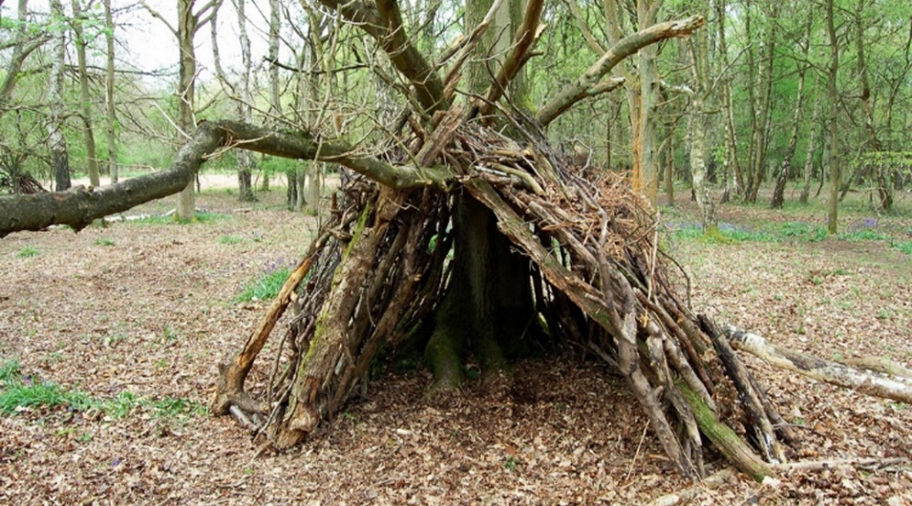
(Google Images)

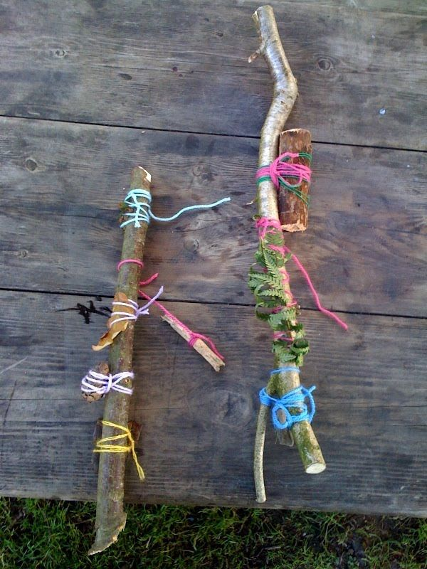
Moreover, the last activity will require the children to choose a stick in the forest garden and create a ‘Journey Stick’. The children will collect items on their journey back to the Visitors centre. The children will develop their creativity as they can choose objects, they find whether it be a leaf, stone, grass, litter etc. The skill that will be promoted will be “explore, experiment with and apply the elements of the visual and sensory language of art, craft and design which include texture” (DCELLS, 2008f). The children will develop their senses during this activity by seeing and touching different textured materials.

(Google Images)

The children will develop their spatial awareness throughout the course of the visit as the children will “begin to learn more about their environment and the space they explore” (Integrated Learning Strategies, 2015) by taking part in each activity and being out in the environment.
There are many aspects a teacher must take into consideration prior to an educational visit. For example, risk assessing the area, transport, itinerary, accessibility, the allergies of the children and staff, parents’ consent, staffing and timings.
Risk assessment are used to identify the risks that could arise during the visit. It is the teacher’s duty to “ensure that health and safety of those who are involved is properly considered” (FSAUV, 2014). A risk assessment will help the teacher “identify hazard and risk factors that have the potential to cause harm” (CCOHS, 2019). A risk assessment will help as becoming the person who is responsible for taking the children into a different learning environment it is important to be aware of the risks that may arise and determine ways in which they can be minimised or avoided. (See Appendix 6).
A teacher must ensure that a parent has given the school consent to take their child on a visit. Although consent is not required for an educational visit during school hours, it is required if the visit can “involve a higher level of risk, such as a visit involving a long journey or adventure activity” (National Guidance, 2019a). The consent form will give the parents information about the visit and ask for additional information about the child (See Appendix 7).
Before planning the trip, the teacher must ensure that there are enough adults to supervise the pupils. As this “enables leaders to supervise young people effectively” (National Guidance, 2019b) this shows that by having the appropriate amount of staff it will ensure that the visit will run smoothly. In this case, there will be four members of staff attending the visit, the adult pupil ratio will be 1:8.
Since the children will not have much prior knowledge of the theme as the visit will introduce them to it. This visit will hopefully make the children think about questions to ask later and make them aware of the environment. This will enhance the children’s learning in class as they will know what environments we will be talking about.
During the visit the teacher will need to ensure that the children are always supervised and present. Also, teachers must monitor behaviour and monitor risks during the day. It is important to refer to the risk assessment during the day to ensure that nothing has changed and that any risks that have been identified are being controlled. The children will be able to ask questions, take part in all activities, have the chance to explore the areas independently, make themselves aware of the boundaries and behave appropriately. It is important that as teachers we observe and assess children throughout the day on their engagement and behaviour as this could have a negative affect on the visit.
Once the children arrive back to class, they will participate in a verbal recount of the trip by answering questions. The children will view the images that were taken of the day using the Apple TV which will give the children the chance to relive the day. “the act of photographing something helps us remember the visual aspects of the moment better” (Chen, 2017). This activity will make the children think about the environment and the activities of the day there for showing repetitional learning. Steiner believes that repetition is used to “support learning and memory” (Pound, 2014, p35). This shows that by asking children questions it will ensure that they know the event of the day, which will benefit them when writing their recount of the visit.
To conclude, allowing the children to experience learning within a new environment such as educational visits will give them greater knowledge and understanding about a theme that is being taught. A child’s education should include these experiences as they are equally important in a child’s learning and development. Donaldson 2015 states that educational experiences “broaden children and young people’s horizons, stimulate their imaginations and promote enjoyment in learning”. This implies that as teachers we must provide opportunities for children to become experiential learners as the environment is one of many factors that can promote a child’s learning and development.
Word count excluding reference list and title: 3298.

References
Canadian Centre for Occupational Health & Safety (CCOHS) (2019) Risk Assessment. Available at: https://www.ccohs.ca/oshanswers/hsprograms/risk_assessment.html (Accessed: 18/05/19)
Chen. J (2017) How Taking Photos Affects Your Memory of the Moment Later On. Available at: https://www.thecut.com/2017/08/how-taking-photos-affects-your-memory.html (Accessed: 21/05/19)
DCELLS – Welsh Assembly Government (2009) Foundation Phase: Outdoor Learning Handbook. Available at: https://learning.gov.wales/docs/learningwales/publications/140828-foundation-phase-outdoor-learning-handbook-en.pdf (Accessed: 18/05/19)
DCELLS (2008a) Welsh Government. Personal and social education framework for 7 to 19-year-olds in Wales. Available at: https://s3-eu-west-1.amazonaws.com/hwb-live-storage/fc/4c/38/80/f8af416da62254e605aac9dc/personal-and-social-education-framework.pdf (Accessed:18/05/19)
DCELLS (2008b) - Welsh Government. Education for Sustainable Development and Global Citizenship: A Common Understanding for Schools. Available at: https://learning.gov.wales/docs/learningwales/publications/081204commonunderstschoolsen.pdf (Accessed: 19/05/19)
DCELLS (2008c) Welsh Government. Key Stages 2-3: Geography in the National Curriculum for Wales. Available at: https://s3-eu-west-1.amazonaws.com/hwb-live-storage/48/69/a0/be/fea54ae8bf819f0664bb129e/geography-in-the-national-curriculum.pdf (Accessed: 19/05/19)
DCELLS (2008d) Welsh Government. Key Stage 2-3: Physical Education in the National Curriculum for Wales. Available at: https://learning.gov.wales/docs/learningwales/publications/130425-physical-education-inthe-national-curriculum-en.pdf (Accessed:20/05/19)
DCELLS (2008e) Welsh Government. Key Stage 2-3: Personal and Social Education in the National Curriculum for Wales. Available at: https://s3-eu-west-1.amazonaws.com/hwb-live-storage/fc/4c/38/80/f8af416da62254e605aac9dc/personal-and-social-education-framework.pdf (Accessed: 20/05/19)
DCELLS (2008f) Welsh Government. Key Stages 2-3: Art and Design in the National Curriculum for Wales. Available at: https://s3-eu-west-1.amazonaws.com/hwb-live-storage/bc/07/01/39/22d34f35b10cb1bf2a180ab3/art-and-design-in-the-national-curriculum.pdf (Accessed:20/05/19)
Department for International Development (DID) (2018) Implementing the Sustainable Development Goals – December 2017. Available at: https://www.gov.uk/government/publications/implementing-the-sustainable-development-goals/implementing-the-sustainable-development-goals (Accessed:18/05/19)
Donaldson. G (2015) Successful Futures: Independent Review of Curriculum and Assessment Arrangements in Wales. Available at: https://gweddill.gov.wales/docs/dcells/publications/150225-successful-futures-en.pdf (Accessed: 14/05/19).
Homan. E (2017) Outdoor Learning Spaces for Children with Autism. Available at: https://www.pentagonplay.co.uk/news-and-info/outdoor-learning-spaces-for-children-with-autism (Accessed: 19/05/19).
Integrated Learning Strategies (2015) Spatial Awareness: How to Improve Your Child’s Spatial Awareness with Development Activities. Available at: https://ilslearningcorner.com/2015-02-6-activities-improve-spatial-awareness/ (Accessed: 20/05/19)
Knight. S (2009). Forest Schools and Outdoor Learning in the Early Years. London: SAGE Publications.
Knight. S (2013) International Perspectives on Forest School; Natural Spaces to Play and Learn. London: SAGE Publications.
Lincolnshire County Council (L.C.C) (2018) School trips and educational visits. Available at: https://www.lincolnshire.gov.uk/schools-and-education/school-attendance-and-behaviour/school-trips-and-educational-visits/35375.article (Accessed: 18/05/19)
National Guidance (2019a) Parental Consent. Available at: file:///C:/Users/Josh%20Phelps/AppData/Local/Packages/Microsoft.MicrosoftEdge_8wekyb3d8bbwe/TempState/Downloads/4.3d-Parental-Consent%20(1).pdf (Accessed: 21/05/19)
National Guidance (2019b) Ratios and Effective Supervision. Available at: file:///C:/Users/Josh%20Phelps/AppData/Local/Packages/Microsoft.MicrosoftEdge_8wekyb3d8bbwe/TempState/Downloads/4.3b-Ratios-and-effective-supervision%20(1).pdf (Accessed: 21/05/19)
Ofsted (2008) Learning Outside the Classroom: How far should you go? Available at: http://www.lotc.org.uk/wp-content/uploads/2010/12/Ofsted-Report-Oct-2008.pdf (Accessed: 18/05/19)
Open Society Foundations (2015) The Value of Inclusive Education. Available at: https://www.opensocietyfoundations.org/explainers/value-inclusive-education (Accessed: 19/05/19)
PennState Extension (2012) The Basics for Caring for Children in Your Home: Let’s Work Together. Available at: https://bkc-od-media.vmhost.psu.edu/documents/Activities1503.pdf (Accessed: 19/05/19)
Pound. L (2014) How children learn. London: Practical Pre School Books.
Reggio Emilia Approach (2015) The Environment as the Third Teacher. Available at: https://reggioemilia2015.weebly.com/environment-as-a-third-teacher.html (Accessed: 15/05/19)
The Federated Schools of the Upper Afan Valley (FSUAV) (2014) Corporate Health & Safety Policy. Available at: GET THE WEBSITE ON PEN AFANS WEBSITE FOR THIS.
The Glossary of Education Reform (2014) Learning Environments. Available at: https://www.edglossary.org/learning-environment/ (Accessed: 15/05/19)
The School Run (2019) Learning tips for Kinaesthetic learners. Available at: https://www.theschoolrun.com/learning-tips-kinaesthetic-learners (Accessed: 18/05/19)
Torka. J (2012) Montessori Education in nurseries in England: Two case studies. Available at: http://e.bangor.ac.uk/5156/1/EdD%20THESIS%20-%20TORKA%20%20JOYCE%20ABU%20Revised%2026nov2012.pdf (Accessed: 15/05/19)
Tovey. A (2007). Playing Outdoors: Spaces and Places, Risk and Challenge. Berkshire: England: McGraw Hill Publications.
Tovey. H (no date) A Frobelian Approach: Outdoor Play and Exploration. Available at: file:///C:/Users/Josh%20Phelps/AppData/Local/Packages/Microsoft.MicrosoftEdge_8wekyb3d8bbwe/TempState/Downloads/FT%20Play%20Pamphlet%20(1).pdf (Accessed: 18/05/19).
Welsh Assembly Government (2008) Educational visits: A safety guide for learning outside the classroom – All Wales Guidance 2010. Available at: https://swansea-edunet.gov.uk/en/schools/Gwyrosydd/Documents/School%20Policies%20Updated/Educational%20Visits%20Guidance.pdf (Accessed: 18/05/19).
Welsh Government (2003) Developing the Curriculum Cymreig. Available at: https://learning.gov.wales/docs/learningwales/publications/130424-developing-the-curriculum-cymreig-en.pdf (Accessed: 18/05/19)
Welsh Government (2019a) A guide to Curriculum for Wale 2022. Available at: https://s3-eu-west-1.amazonaws.com/hwb-live-storage/cd/b4/f8/7c/b7d34ffb968d9a09de4d460c/a-guide-to-curriculum-for-wales-2022.pdf (Accessed: 18/05/19)

