University of Wales

Trinity Saint David

Student Name: Rusti Monica

Student Number: 1909952

Lecture name: Noura Mohamed

Module name: Introduction to Physiology

Module Code: BMHP5003

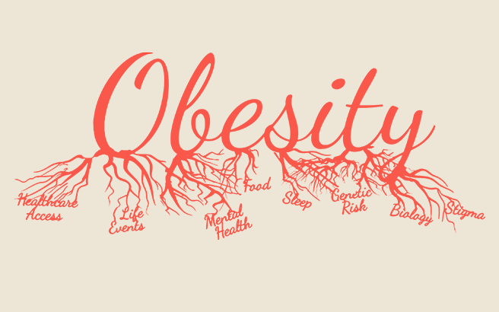
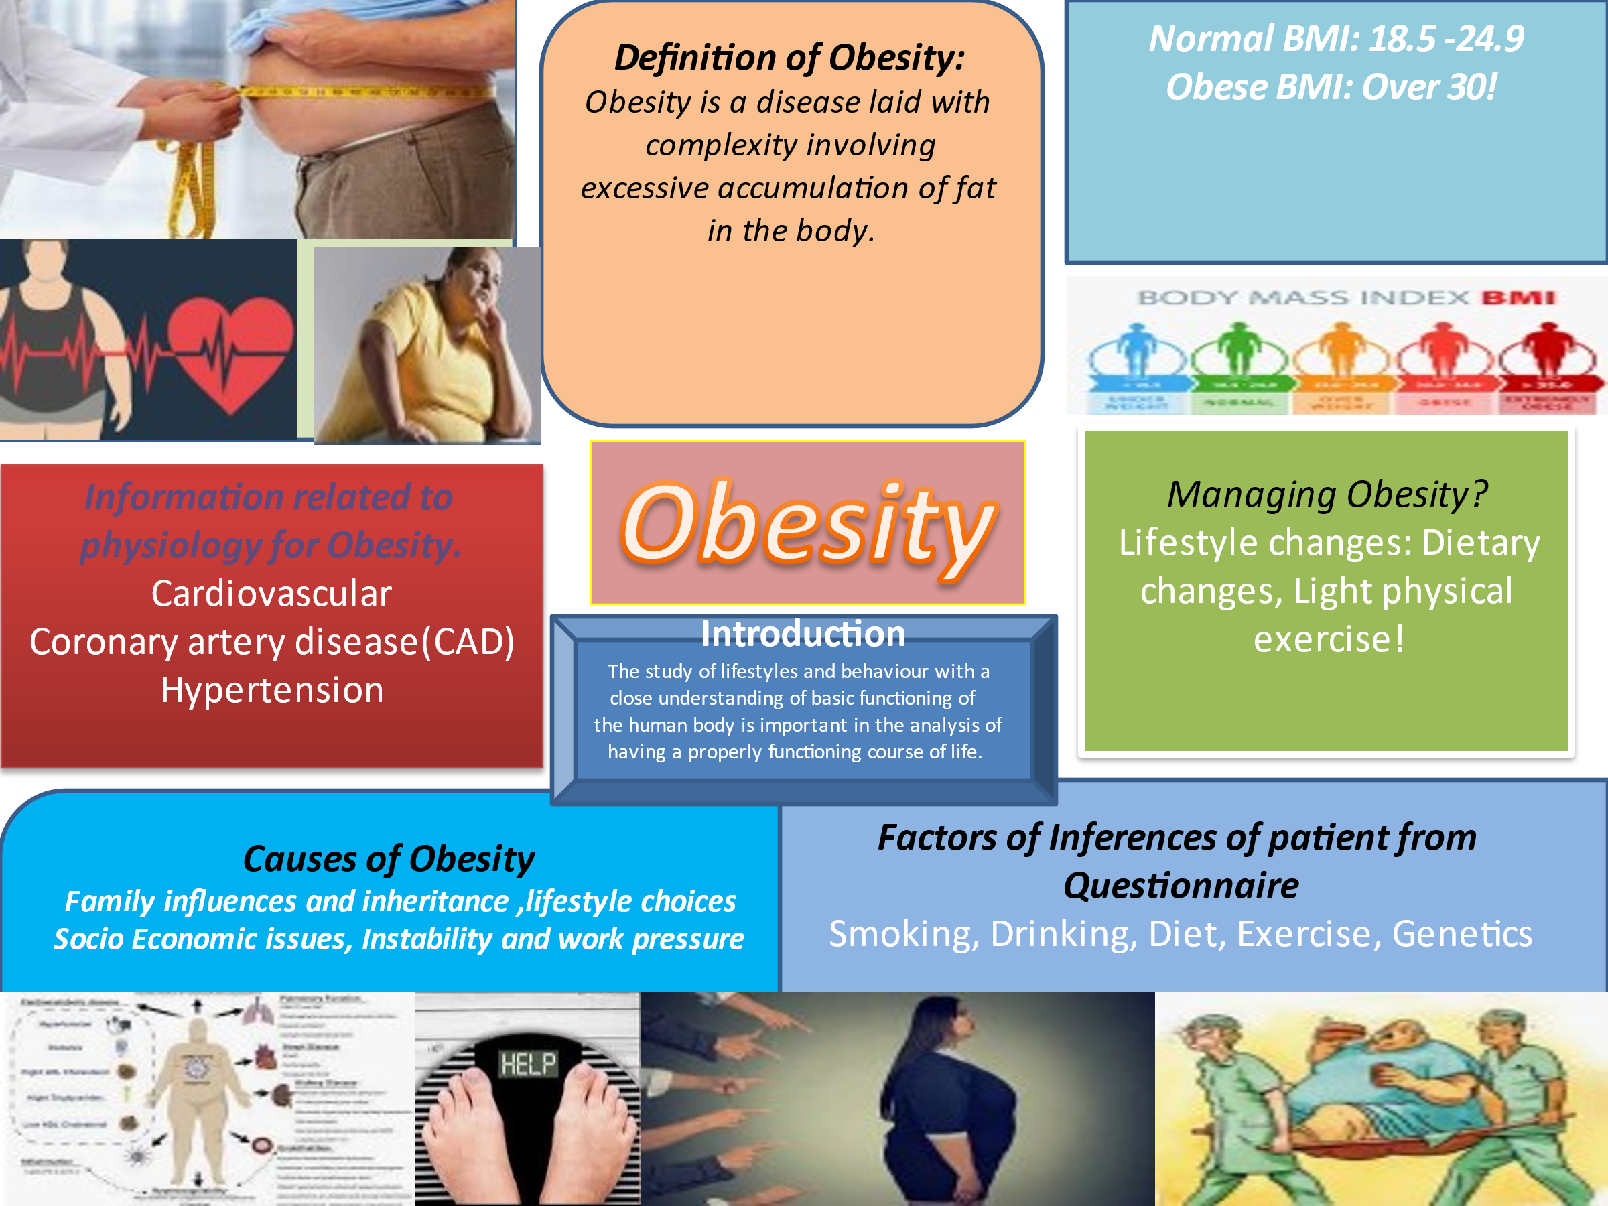
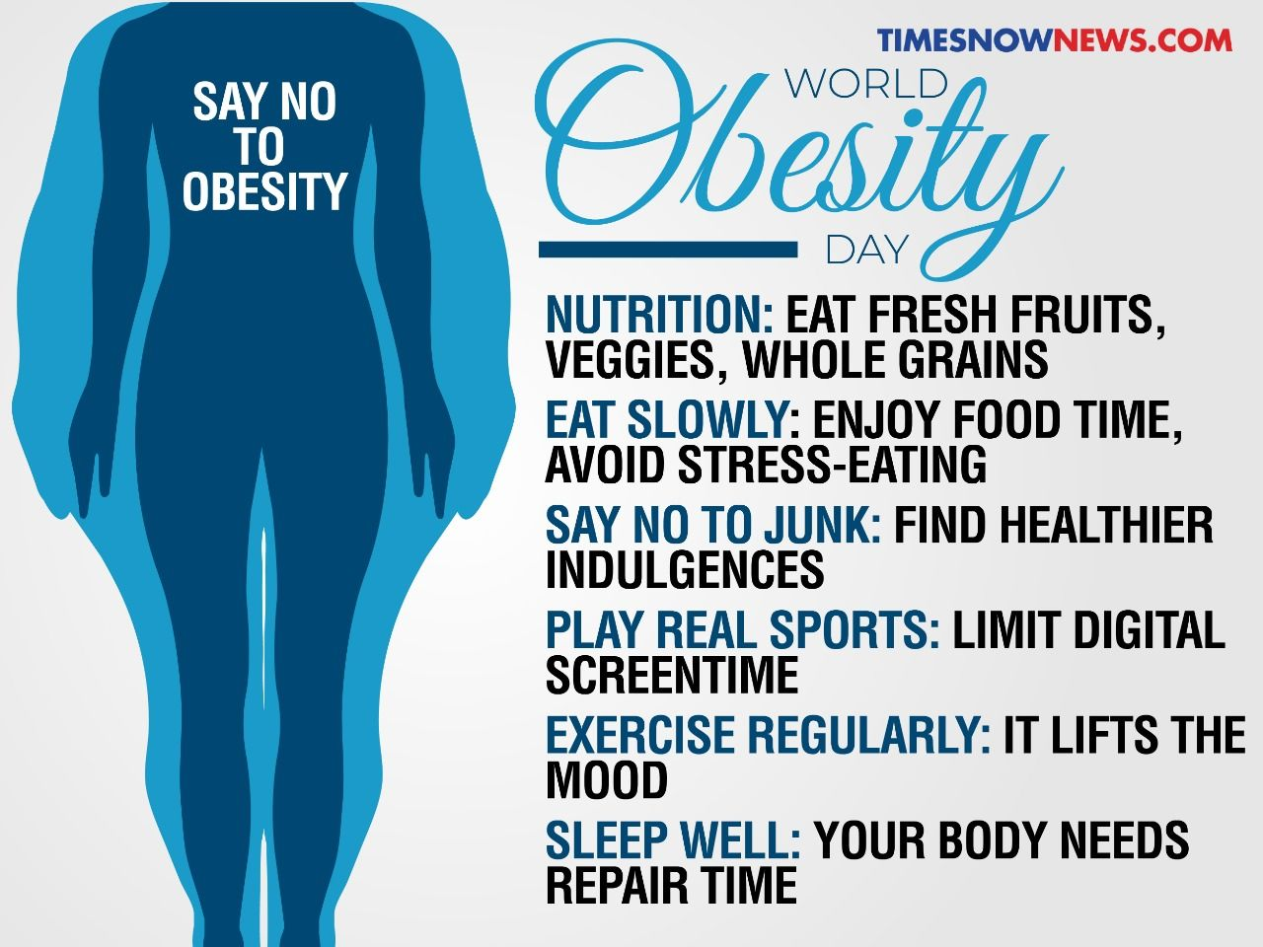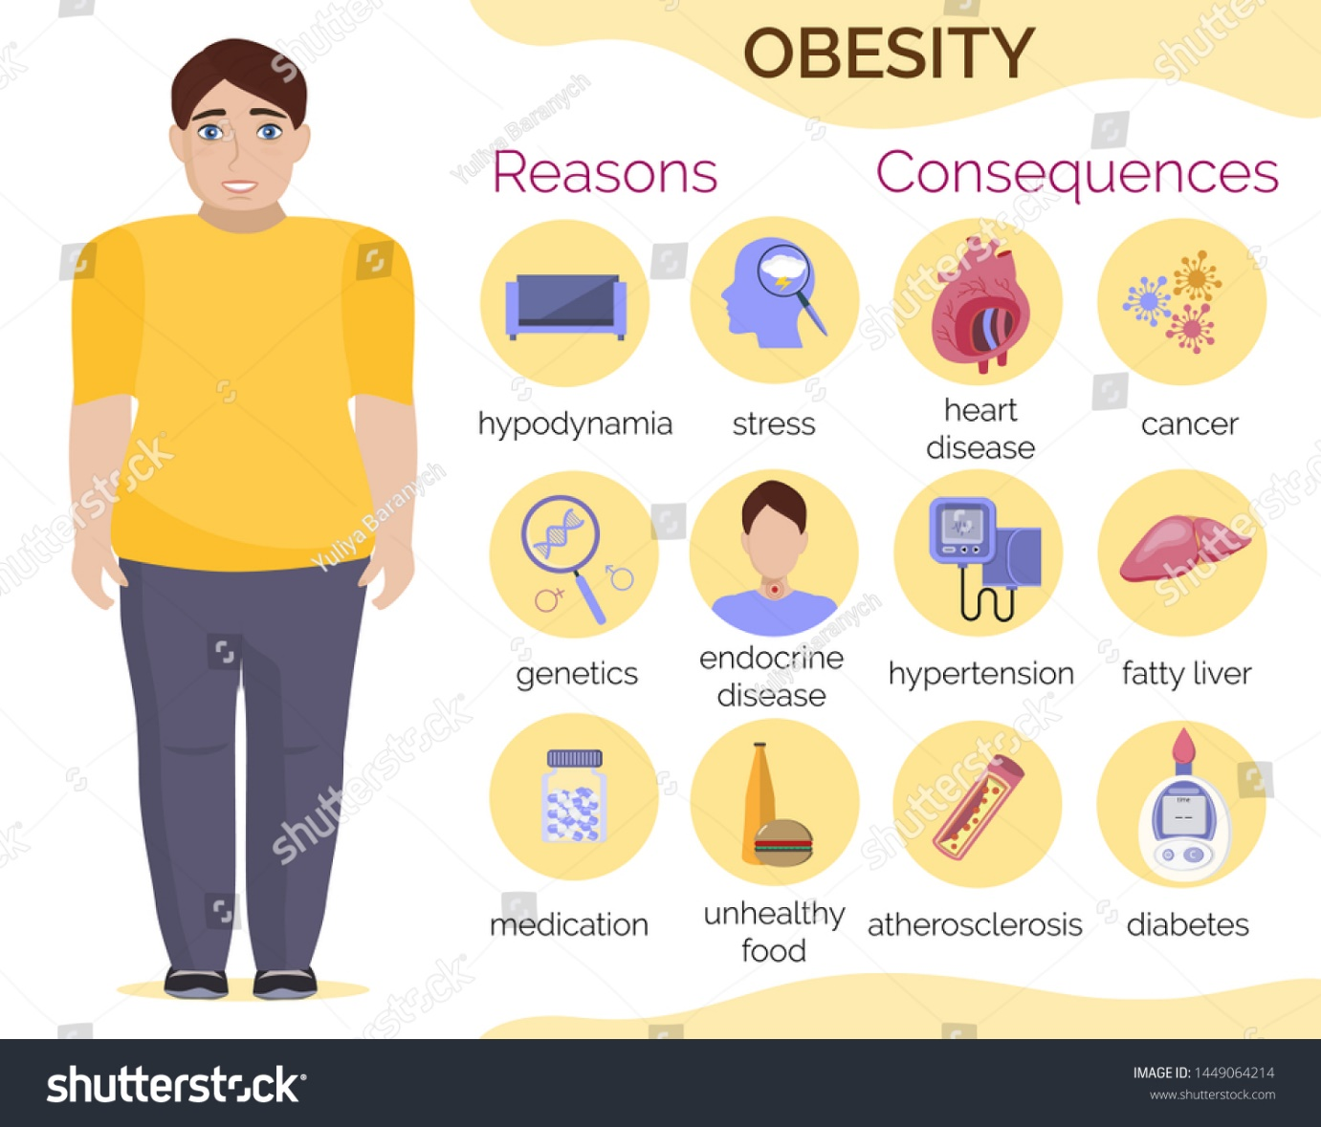

By means of a lifestyle questionnaire that has been conducted on a Patient A, and has been provided, the following inferences on the various factors can be made: Physical constitution: The person is weighted 80 kgs for a height of 1.60 m which shows his disability of having quite a bit of weight for a comparatively shorter stature. The blood pressure has been shown to be 114/90 which is a bit higher on the lower part of the body owing to the causes of accumulation of fat in the body.
It is observed that a member of the patient’s family had been diagnosed with high cholesterol, hyperlipidaemia and had the occurrence of a stroke. These are symptoms that might be carried forward to the present generation from the reflection of his obese patterns (Bouchard,2020). It is possible for obesity to be carried forward in the blood line through hormonal influences.
There is no inclusion of nutritional foods including fruits, vegetables, sources of protein, but there is heavy intake of high calorie rich foods and carbohydrates. This leads to excessive gain of weight. The patient A also claims to get no time out in his busy lifestyle for conducting cooking procedures and maintaining a proper diet. He relies on fast food and junk food items daily which substantially accumulates fat in his body. Heavy smoking has often been associated with high BMI indexes (Dare et al., 2015). Risks of obesity can be terminated by reducing smoking to a considerable index. Drinking to over two glasses daily causes an immediate influence on appetite which in turn affects energy stored in the body.
Cardiovascular diseases and diabetes which are other related malfunctions of obesity can be reduced considerably if motivated patients start inducing some physical movements during their day, regularly (Swift et al., 2018). Since the patient cannot exercise enough or his incapability and he does not restrict calories by eating in a non-regulated way, his symptoms of obesity would only be on the rise. Remedies of management of obesity need to be utilized for aiding reduction in weight or at least bringing about significant changes in the ways an obese patient leads their lives.
Dietary Changes: Processed and refined foods containing additives, readymade foods rich in fat and sugar should be avoided and intake of whole grains and fibre rich foods should be induced. It might be difficult initially to adjust to changes but it is a basic determination, and which will bring about healthier modifications. High fibre diets make the body fuller for longer as the body releases energy more slowly and it would stop patients from overeating. They also reduce risks related to metabolic syndromes. Light physical activity: The more active a patient is, the more calories they burn. For an obese person to engage in hard physical activities is difficult so lighter activities like brisk walking, swimming, using stairs instead of elevators, doing household chores, gardening, can be included in the lifestyle (Schmidt et al., 2015).
1. Schmidt, S., Monk, J.M., Robinson, L.E. and Mourtzakis, M., 2015. The integrative role of leptin, oestrogen and the insulin family in obesity associated breast cancer: potential effects of exercise. obesity reviews, 16(6), pp.473-487.
2. Dare, S., Mackay, D.F. and Pell, J.P., 2015. Relationship between smoking and obesity: a crosssectional study of 499,504 middle-aged adults in the UK general population. PloS one, 10(4), p.e0123579.
3. Bouchard, C., 2020. Genetics of obesity: overview and research directions. The genetics of obesity, pp.223-233.

