Motion Simulation and FEA
M6X02210
Bsc Motorsport Engineering
Level 6
P149609
Daniel Salathiel

Contents:
- Introduction Page 3
- Literature Review Page 4
  - Solid Works Software Page 4
  - Motion Analysis Page 4
  - Finite Evaluation Analysis Page 4
- Methodology Page 5
  - Parts Modelling using Solid Works Page 5
  - Motion Analysis Page 6
    - Contact Surface Page 6-7
    - Dampener Functions in Motion Analysis Page 8
    - Spring Functions in Motion Analysis Page 9
    - Adding gravitational Force to solid works Motion Study Page 10
    - Solid Works Linear Motion Motor Page 11
    - Solid Works Rotary Motion motor application Page 12
    - Operation of Motion Analysis Page 13
    - Solid Works FEA Analysis Tool Page 14
- Analysis Page 15
  - Motion Analysis Displacement Graph Page 15
  - Finite Element Analysis of the original Design Page16
    - Finite Element Analysis Displacement results Page 17
  - Finite Element Analysis of adapted wishbone Page 18-19
    - FEA displacement results for adapted wishbone design Page 20
  - Costing Comparison for wishbone Designs Page 21
- Conclusion Page 22
- Bibliography Page 23
Introduction:

The utilisation of Computer Aided Design is a versatile tool used widely by the Automotive and Motorsport Industry. The software has a vast range of capabilities to aid an engineering in their designing and testing of new parts. This report will investigate the utilisation of Solid Works, and how the software can be used to model a suspension system off of a vehicle. It will also look into how the software can be used to develop a motion analysis of the assembly created to help give a clearer understanding of the forces experienced by a specific component when handling with various road conditions. (Engineeringrules.com, 2019).
From the motion Analysis forces can be imported into an FEA analysis of the specific component selected. This can be achieved using loading point and attachment points to identify the yield point of the component. The software enables the forces on the component to be analysed, and the displacement of the component to be analysis to ensure the safety of the designed suspension component.
This report will explain the design process of a MacPherson strut design on a vehicle and the how the different components are mated together in an assembly using solid works. It will also give an insight into how to properly set up a motion simulation for the assembly, and the tools that can be used to analyse the design, and test how the forces acting upon the design effect a wishbone of a vehicle using FEA analysis.

2.0- Literature Review:
2.1- Solid Works Software:
Solid works is a widely used software that was first realised in 1995. The software contains disciplines such as 3D CAD design functions, electrical design tools, simulation and technical communications. It is a powerful tool that allows engineers to develop designs and prototype testing, without the large costs of materials and tooling techniques. (Scan2CAD, 2017).
2.2- Motion Analysis:
Motion Analysis is a tool that can be used to create a motion simulation. It can simulate moving or dynamic systems that will give realistic outcomes and variables. It can output variables such as displacements, Reaction forces, Accelerations and motor power (V.Farrell, 2019).
The motion features of the solid works software assist the user in a wide range of motion studies. The motion study tool contains an animation tool for simply creating a visual representation of the design for marketing, without the consideration of forces such as mass and gravity. It also has a basic motion function to allow for the mass, springs, gravity and physical collision detection, which allows the used to carry out a basic motion study. A motion analysis function is the top tier motion study, where it takes into account a wide range of variables to demonstrate physical interactions such as impact affects, dampening, force and momentum. Adapted from (Engineersrule.com 2019).
2.3- Finite Element Analysis:
Finite Element analysis FEA, is a computer-aided engineering software used to analyse how a design reacts under real world conditions as stated by (SAE International, 2018). Finite Element analysis is utilised by the industry for virtual prototyping. FEA model verification and validation is necessary to increase accuracy (J. WEN, 2007). These include model assumptions, meshing quality and boundary conditions. This software tool can be used to measure the capabilities of a designed part to with stand forces it will face in its service life. It can also import data from other tools to evaluate the yield strength, deflection and of loads faced by the part that has been designed. (J. WEN, 2007).

3.0 Methodology:
3.1 Parts Modelling using Solid Works:
Before the analysis stage of the assembly can be carried out the individual components of the suspension system needed to be modelled. Key components such as wishbones, hub plates, hubs track rod ends, rose joints, shock absorbers and top mounts need to be accurately measured. From these measurements the different tools Solid Works has to offer can be used to model the suspension system components ready to be placed into an assembly. Care must be taken to ensure the mounting points for each connecting part are identical to allow the software to mate the parts in the assembly function.
Once each part has been made using the various drawing techniques, defined measurement tools and the different extrude and cut methods, the components can be inserted into an assembly. Various mates such as concentric, coincidence, distance and parallel mates can be used to get the desired behavioural characteristics of the components within the assembly.
The chassis must be fixed to a plain to ensure the rest of the inserted moving components can move around it. Once completed the modelled components can be inserted and mated correctly to give a full range of suspension motion ready for the simulation testing.

3.2 Motion Analysis:
The next step for testing the suspension system is to set up a Motion study using the solid works add-ins menu. Once opened parameters can be set to allow the model to fully function. In the case of this report the chassis with the suspension components will travel along the 2000mm road section, hitting a 45mm bump and a 95mm bump.
3.2.1 Contact Surface:
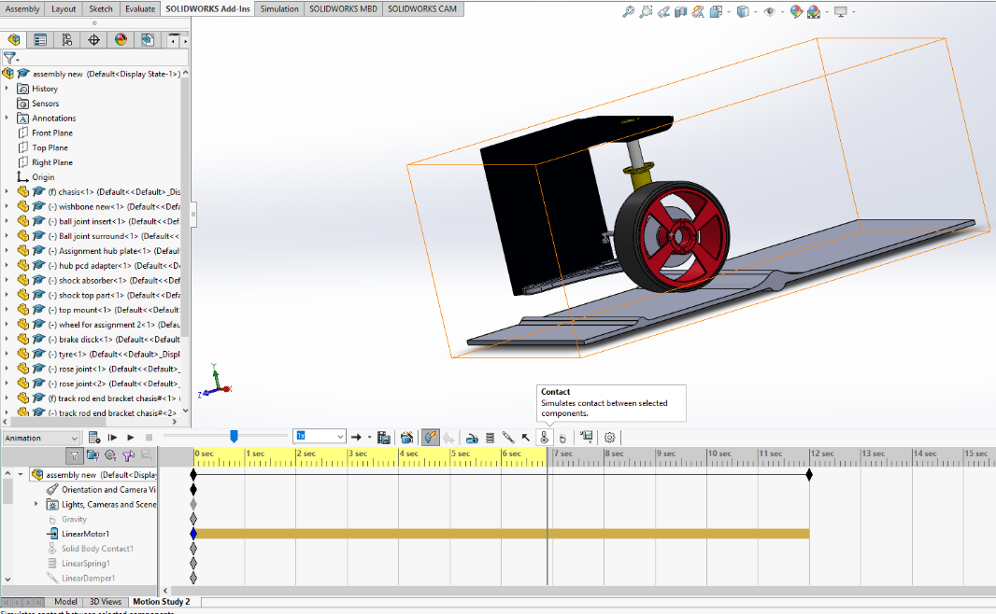
A contact area between the tyre and the road surface must be inserted into the model. This is achieved by selecting the contact icon shown in figure 1 below.
Figure 1: Solid Works Motion Study Contact tool, (Daniel Salathiel, 2019).
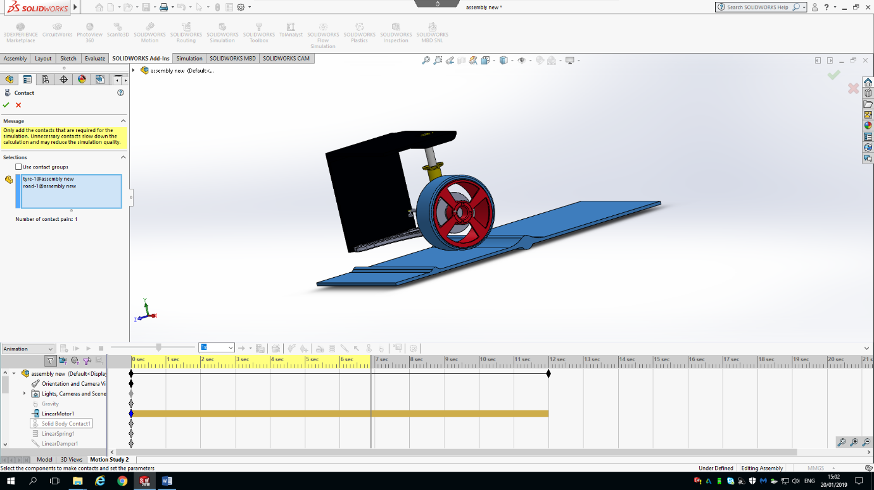
Once selected the contact surfaces can be selected as highlighted by figure 2. The surface of the tyre should be selected, and the surface of the road should also be selected, both being highlighted in blue. The surface for the tyre should be set to rubber, and the surface for the road dry steel.
Figure 2: Solid Works contact surfaces, (Daniel Salathiel, 2019).

3.2.2 Dampener functions in Motion Analysis:
For the design to be fully functioning like a suspension system, a damper function needs to be set on the upper and lower surfaces of the shock absorber. This is applied using the damper tool shown in figure 3 below. Face 1 of the shock absorber is selected and face 2 of the shock absorber lower assembly is selected. The dampener rate is set to 8 N/mm squared to allow for a realistic rebound characteristic as the components travel over the bump in the road shown in the figure below. This will allow for resistive forces to be considered when the suspension system reacts to the bump in the road.
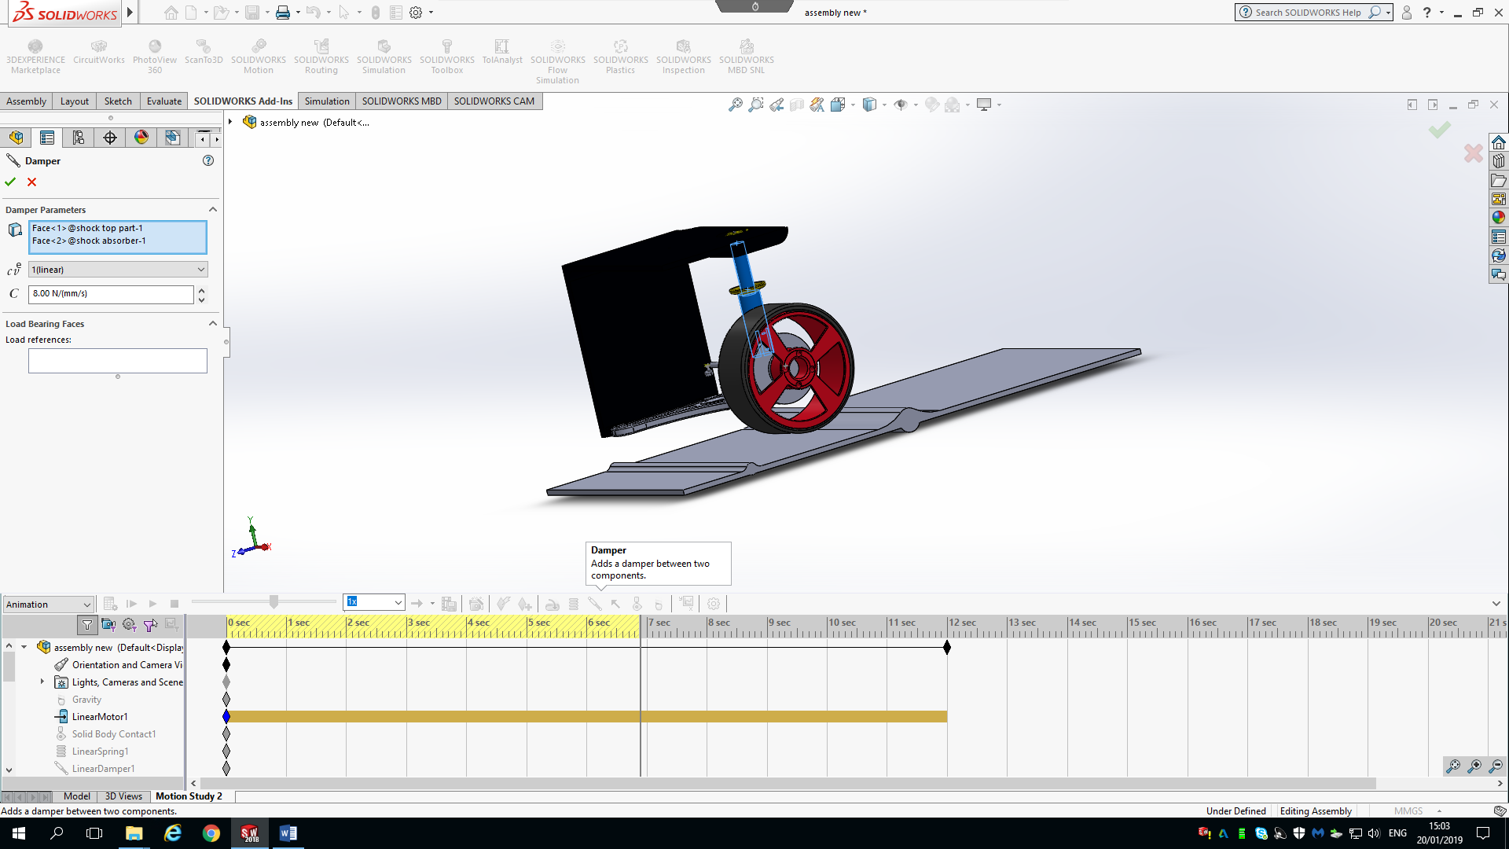
Figure 3: Solid works Dampener function tool, (Daniel Salathiel, 2019).

3.2.3 Spring Functions in Motion Analysis:
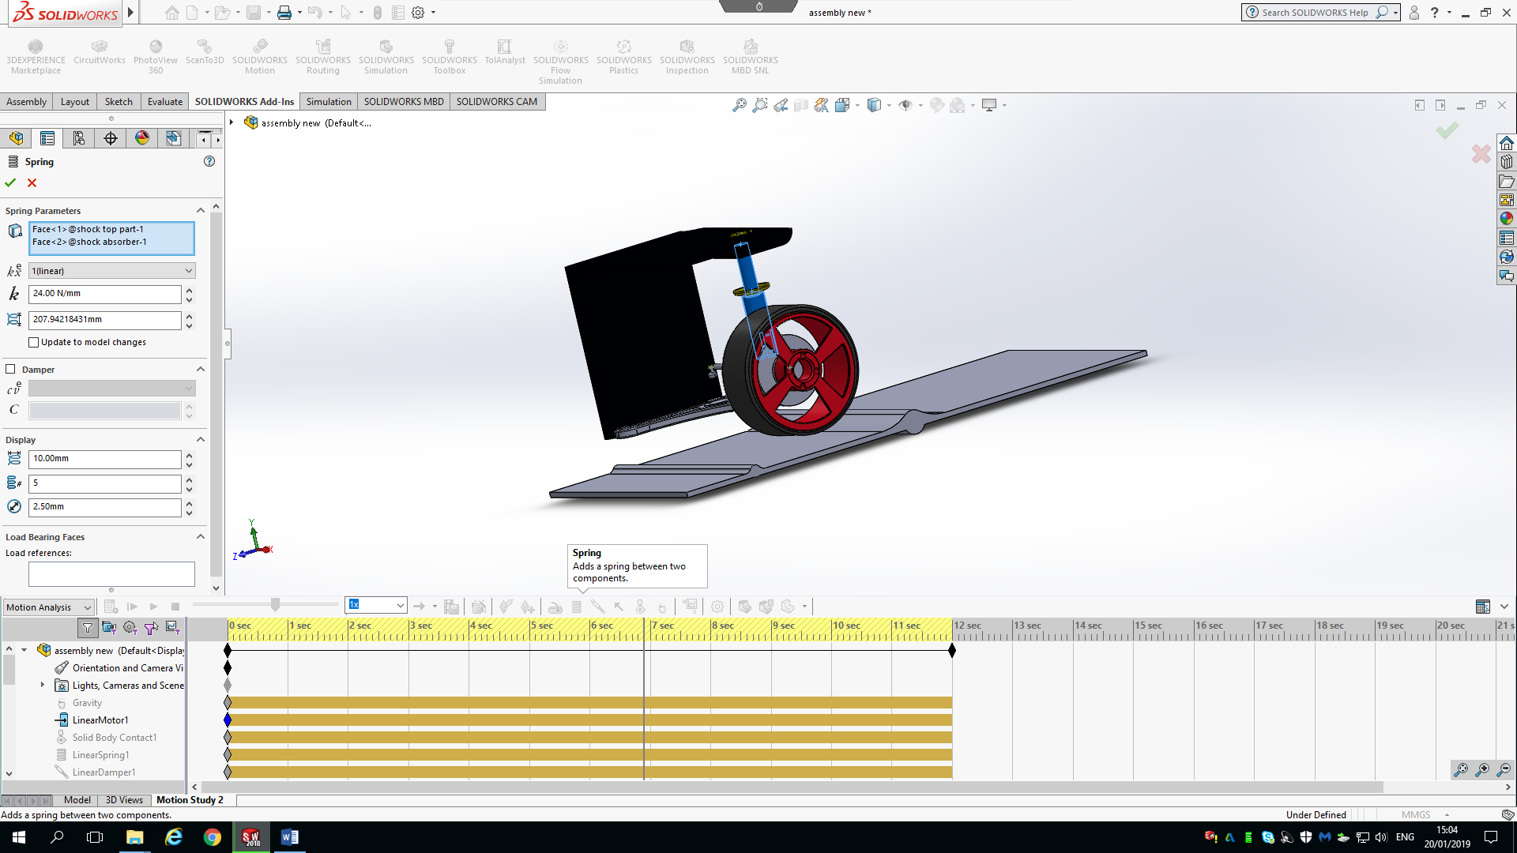
Inserting a spring function will act upon the simulation in the same manner as the dampener function. It will allow the model to create a spring to the existing measurements of the model, creating a simulated motion of a spring within the suspension system. To insert this function the spring function icon can be selected shown in the figure below. Once selected the same faces as the dampener function can be selected; Face 1 shock top part, and face 2 the shock absorber lower body. To create a realistic resistance as the components, travel over the bump in the road, the spring rate is set to 25 N/mm squared.
Figure 4: Solid Works Spring function tool, (Daniel Salathiel, 2019).
The height of the spring modelled by the Solid works tool is 207.94mm high and 10.00mm wide as shown in figure 5 below:

Figure 5: Modelled Spring Dimensions, (Daniel Salathiel, 2019).

3.2.4 Adding Gravitational forces to Solid Works Motion Study:
To enable the simulation motion study to react in a realistic manner, the software needs to register gravitational forces acting upon the appropriate points on the model. This is added through the solid works gravity tools shown in the figure below. Once selected the value for gravity can be added to the points required on the suspension system. The value for gravity with in the model is 9806.65 mm per second squared. This gives the model realistic values to allow the forces to be calculated when the model is run ready the next step, the Finite Evaluation Analysis, this force pushes the wheel and suspension components into the road surface.
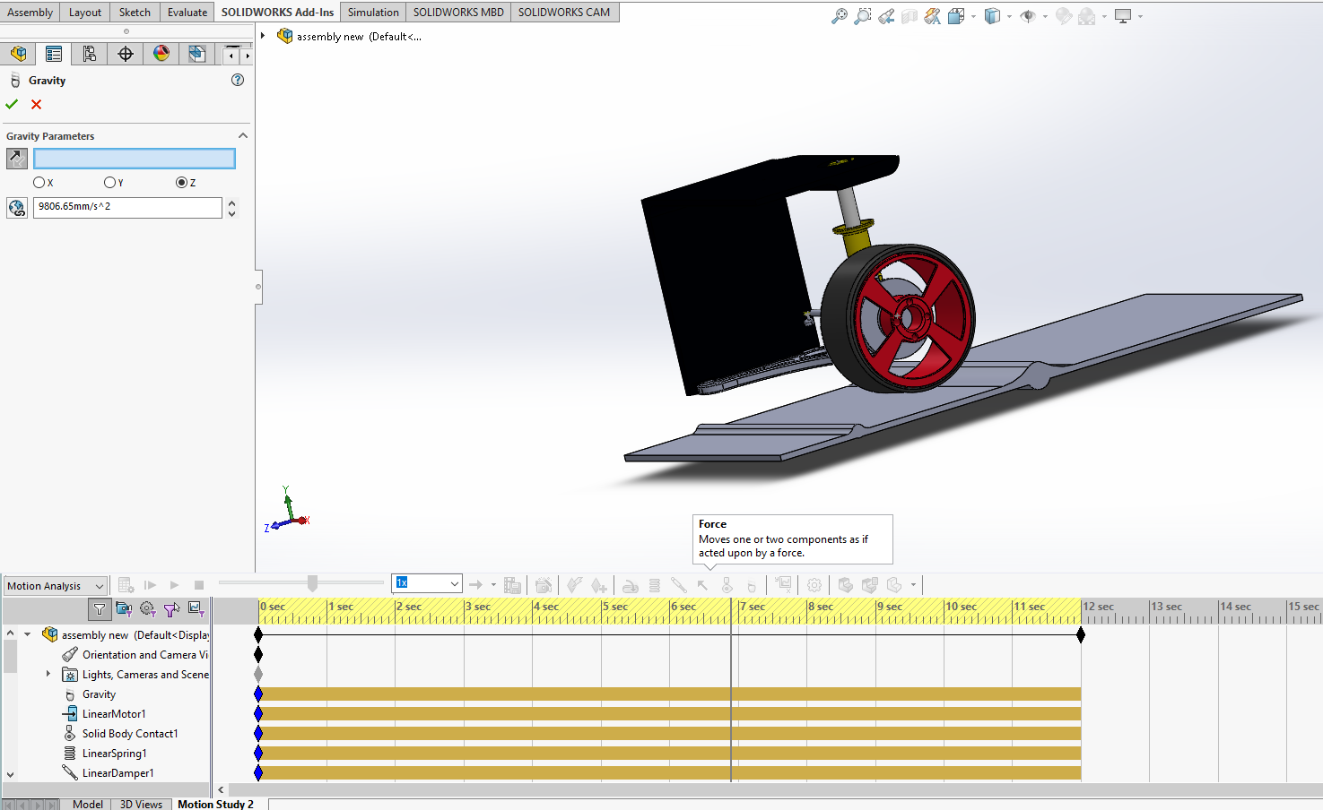
Figure 6: Solid Works Gravity values, (Daniel Salathiel, 2019).

3.2.5 Solid Works Linear motion motor:
The linear motion of the road surface in the Solid works motion analysis can be achieved through the use of a linear motor, applied to the leading edge of the road surface. To apply the linear motor, the motor icon shown in figure 7 below should be selected. Once selected the leading edge of the road is selected and the speed of the motor is set as seen in the figure. It is key to note direction of travel, ensuring the chassis is moving along the road surface not away from it. Once completed the road should move at the desire speed allowing the motion study to be carried out smoothly.
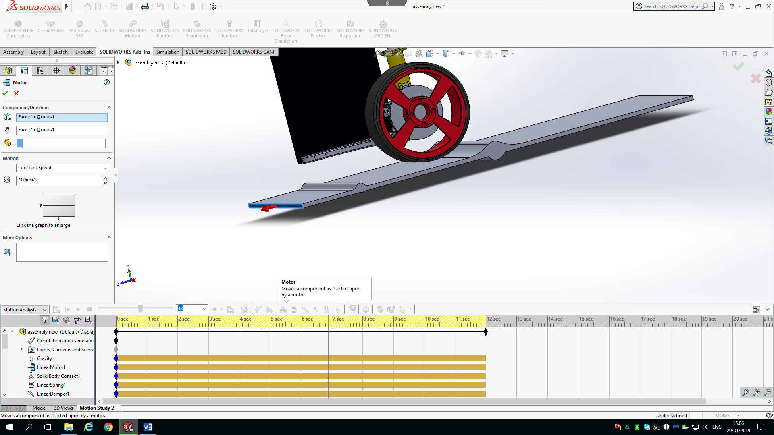
Figure 7: Solid Works Linear motor application, (Daniel Salathiel, 2019).

3.2.6 Solid Works Rotary Motor Application:
To make the motion analysis look realistic, a rotary motor is applied to the wheel to allow it to turn in the desired direction. This is applied using the same method as section ‘3.2.5’, but the option for rotary motor is selected instead. The face of the wheel is to be selected, and attention needs to be payed to the direction the motor will turn. This can be seen by the directional arrow circled In ‘figure 8’ below.
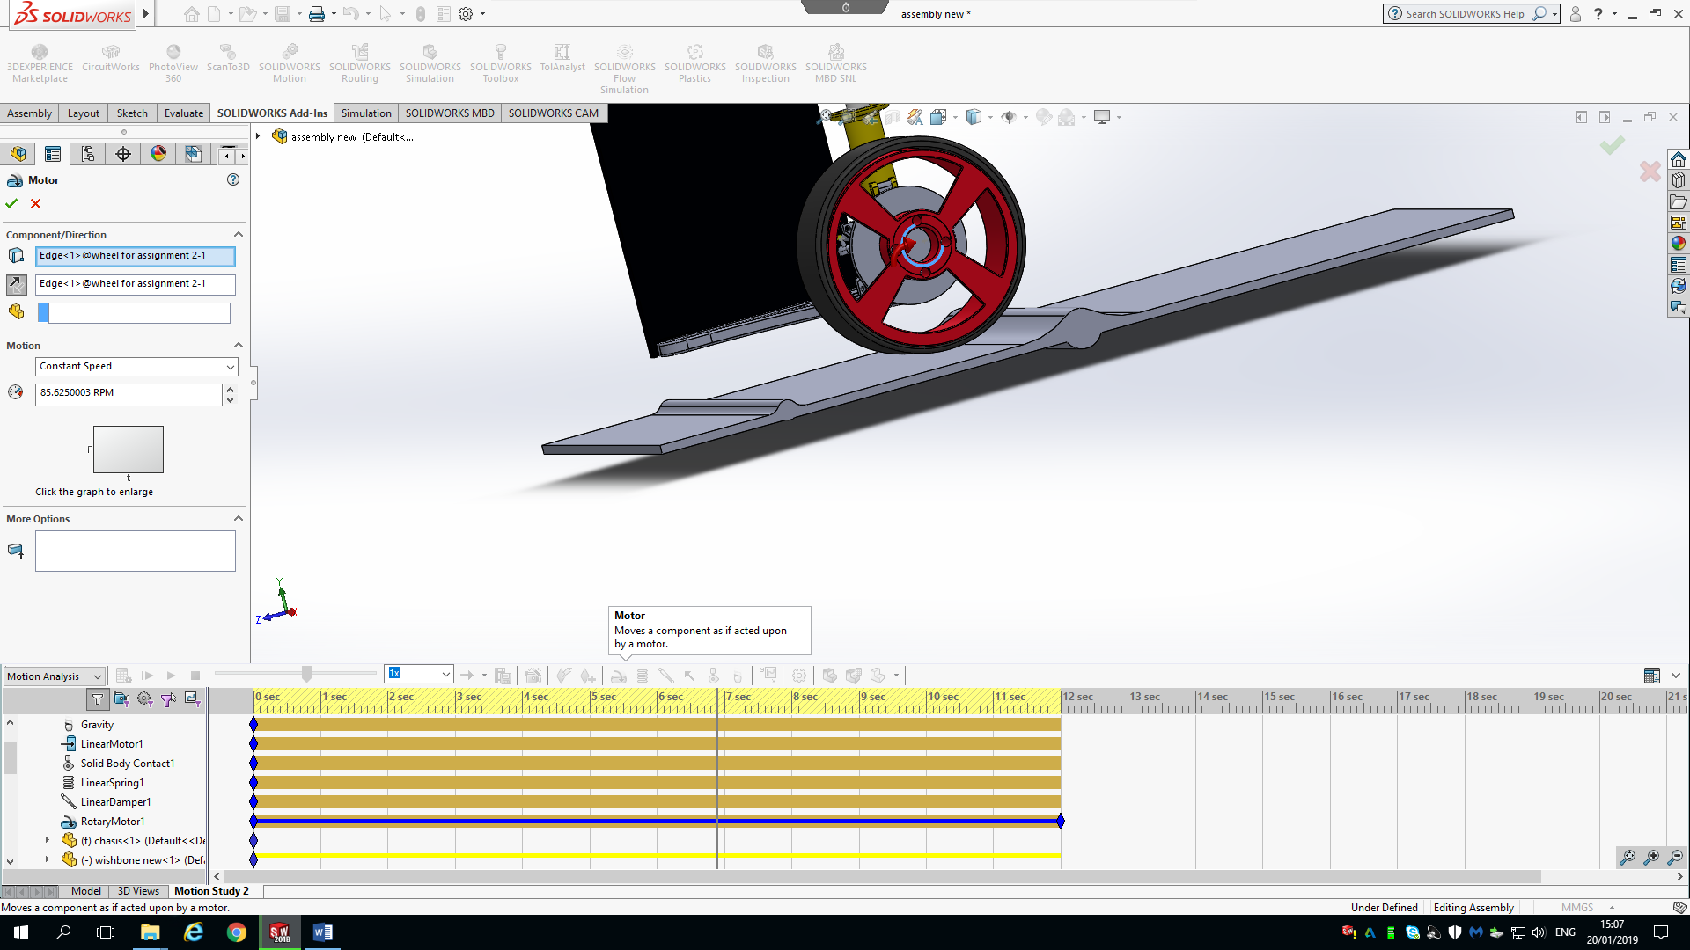

Figure 8: Solid Works Rotary Motor Tool, (Daniel Salathiel, 2019).

3.2.7 Operating the Motion analysis
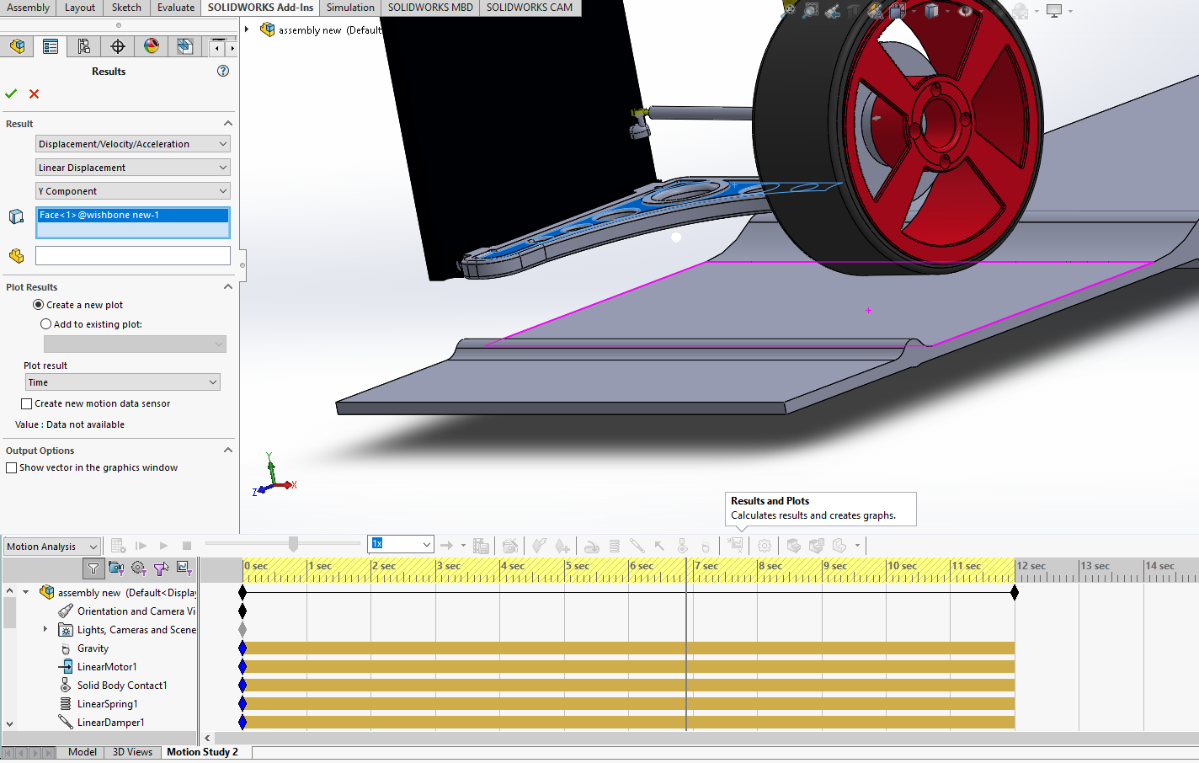
The steps above have enabled the motion study to be carried out more accurately. The motion analysis can now be calculated to obtain the forces needed for the FEA. To do this the X/Y icon seen in the below figure needs to be selected. Once selected the parameters for the graph to show the displacement can be setup. The first drop-down box should be set to displacement/ Velocity/ Acceleration, the second should be set to Linear Displacement and the third should be set to the Y axis Component. The face of the component you want to test should also be selected. In the case of this report the wishbone has been selected to see the total distance the components move while travelling over the bumps. The results for Which will be analysed in the Analysis section of the Report.
Figure 9: Solid Works Linear Displacement graph setup, (Daniel Salathiel, 2019).

3.2.8 Solid Works Finite Element Analysis tool:
The Finite Element Analysis (FEA) is a powerful tool for conduction simulation testing on the various components of the suspension design. The motion loads from the motion analysis are imported into an FEA study in the solid works software (J. Wen, 2007). Once the motion loads have been Imported, analysis of the component’s behaviour under the motion study conditions can be looked at. The results for these tests will be looked at in the analysis section. Looking at whether the design will need to be strengthened or lightened dependant on the Finite Element Analysis that is carried out to determine the yield stress point of the wishbone, and the total displacement under the linear forces.
To carry out the Finite analysis once the loads have been imported, the component needs to be meshed. This breaks the component down into controlled sized pieces to analyse the forces being applied to that specific area. Once meshed the FEA tool can be run to calculate the total yield forces being experienced by the component as it hits the larger bump, and the total displacement of the material.

4.0 Analysis:
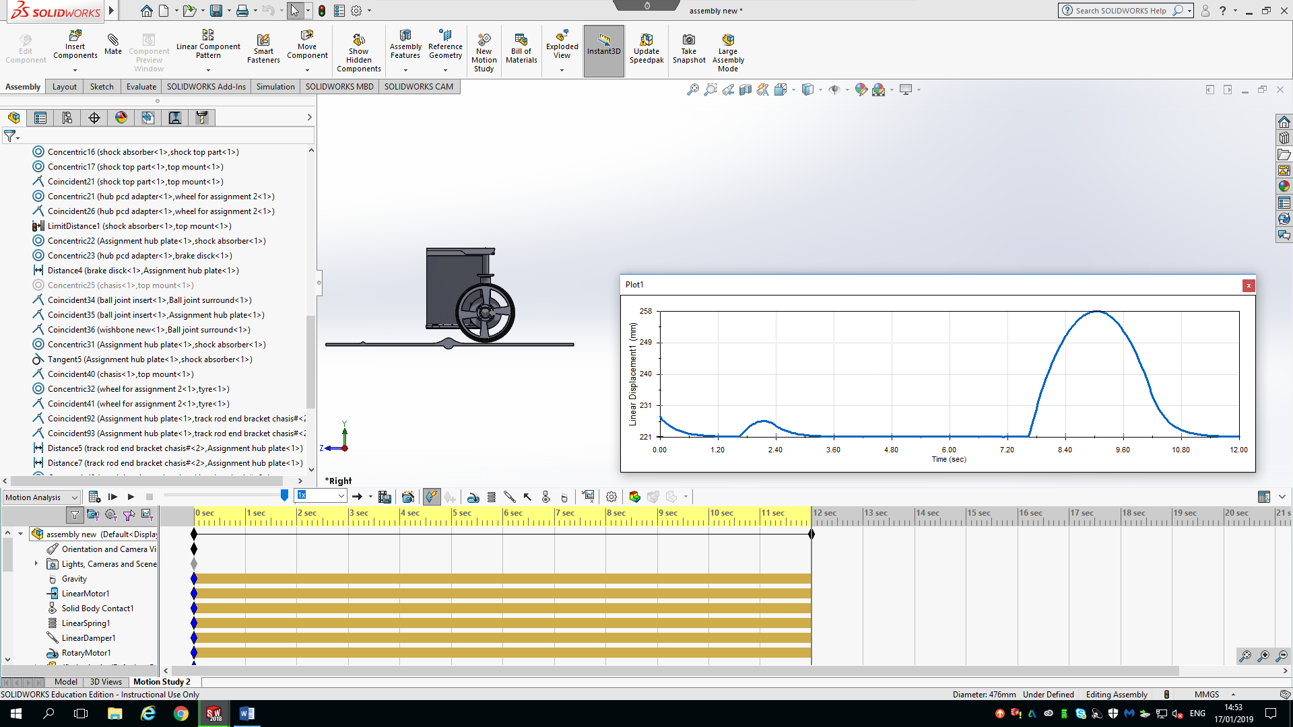
4.1 Motion Analysis Displacement Graph:
Figure 10: Linear Displacement of suspension, (Daniel Salathiel, 2019).
The graph shows the displacement of the wishbone connected to the strut in millimetres. This is set across the total time of the motion analysis. Over the first bump in the road the wishbone is seen to travel smoothly up to 227mm, meaning a displacement of 5mm before smoothly moving back down to the resting travel of 221mm. At 7.40 seconds the suspension is seen to start to displace, reaching a total displacement of 37mm at 8.65 seconds. This graph shows a very smooth travel of the suspension with no sudden spikes, this means the travel of the suspension displaces and disperses the energy from the bump in an efficient manner (T.D. Gillespie, 1992). It can also be noted that there isn’t excess play in the rose joints or ball joints causing oscillations along the motion path. (T.D. Gillespie, 1992)

4.2 Finite Element Analysis of the original Wishbone Design:
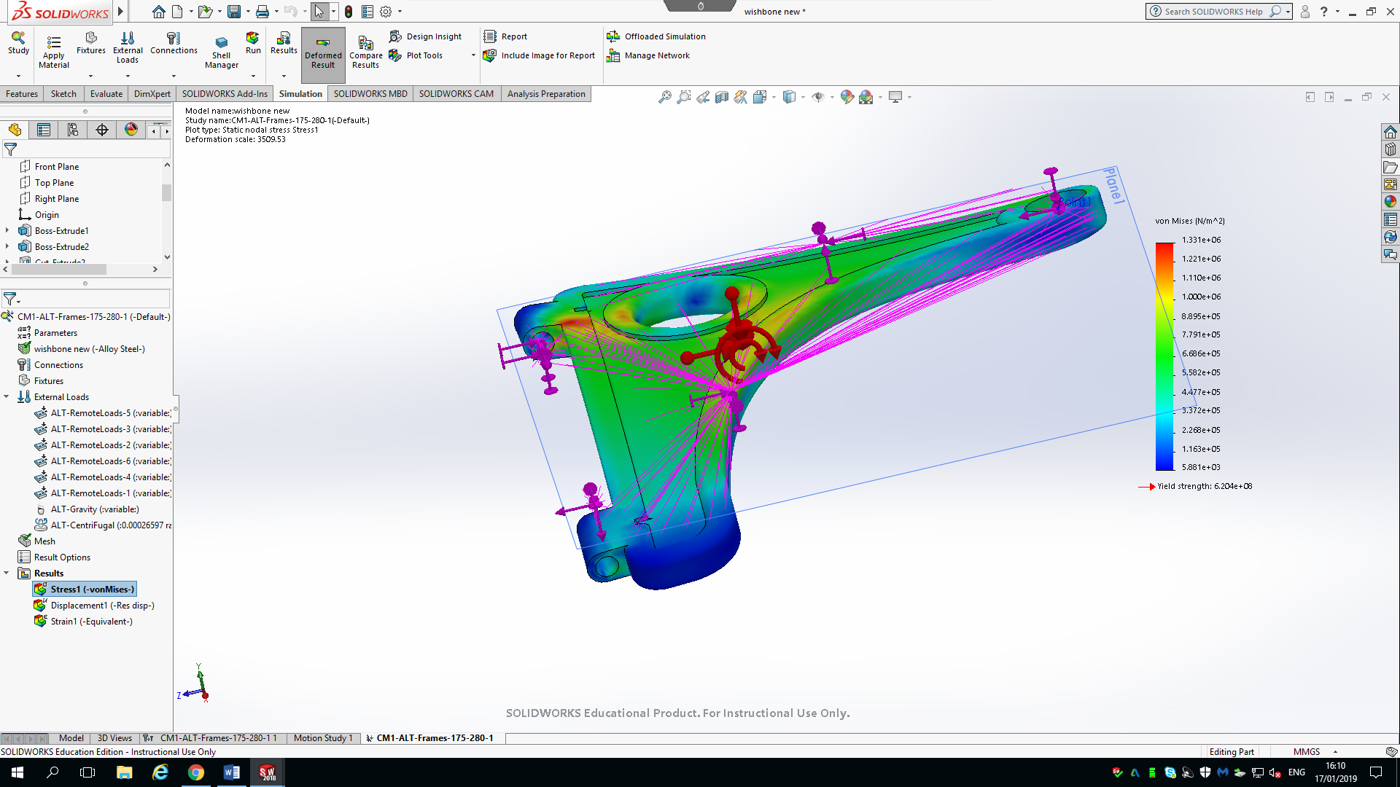
Figure 11: FEA Analysis of Original Design 1 of wishbone, (Daniel Salathiel, 2019).
The FEA for the lower wishbone seen in the figure below shows the yield strength of the alloy steel used for this component is 6.206e + 08, the maximum yield forces experience by the wishbone in the motion study was that of 1.331e +06. This means that the wishbone is well within tolerance and safe to use on the vehicle. The colour spectrum shows the specific points at which the forces are acting upon the wishbone. The key on the right-hand side shows the measured forces for yield strength and the correlating colour shown on the diagram to highlight the forces experienced by the points. Due to the yield being well within the safety margin of the material used, the wishbone design can be made lighter. (V. Kulkarni. Et al, 2012).

4.1.2 Finite Element Analysis displacement results:
The figure below shows the total displacement at a given point along the wishbones surface. It shows the degree of movement within the component’s material as the maximum forces from the motion study are applied. The figure below shows the wishbone moves a maximum of 0.01486 milometers. This is a fractional amount compared which can be seen with the yield strength values of the material. (V. Kulkarni. Et al, 2012).
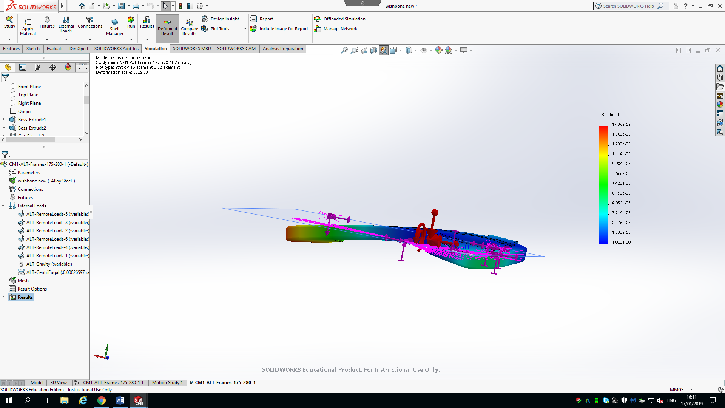
Figure 12: FEA Displacement analysis, (Daniel Salathiel, 2019).

4.2 Finite Element Analysis of the adapted wishbone design:
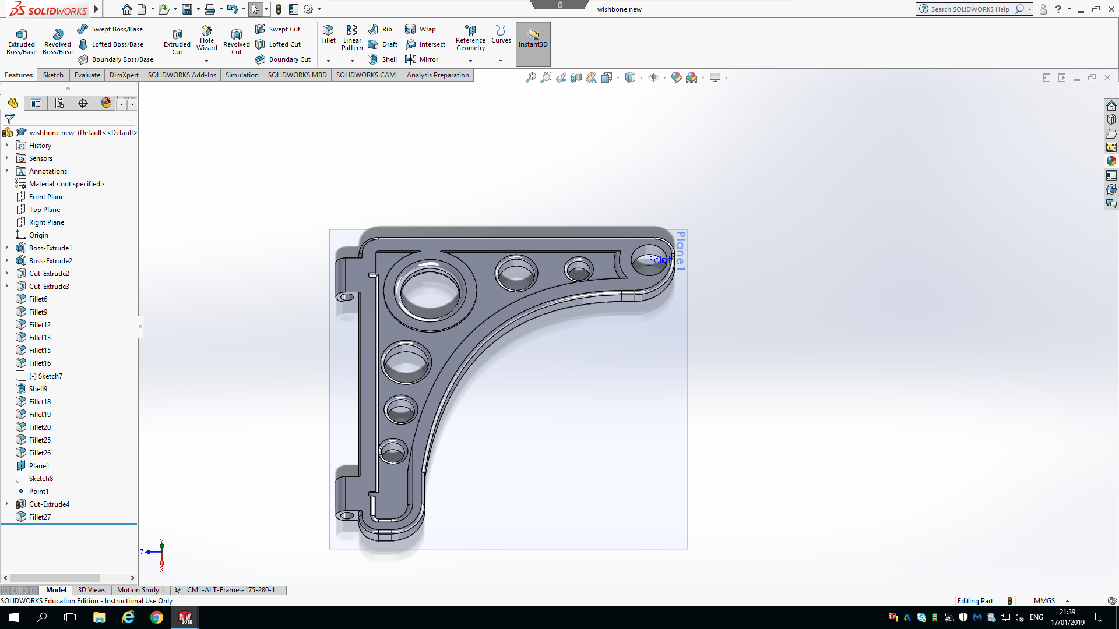
Figure 13: Redesigned Wishbone Model, (Daniel Salathiel, 2019).
The design of the wishbone was lightened by a total of 1902.06 grams over the original design through the use of extruded holes along the upper face of the wishbone. This dramatic decrease in un-sprung mass was tested via the FEA methods to ensure it was still within the acceptable yield strength and displacement values to deem it safe for use as a suspension component on a vehicle.

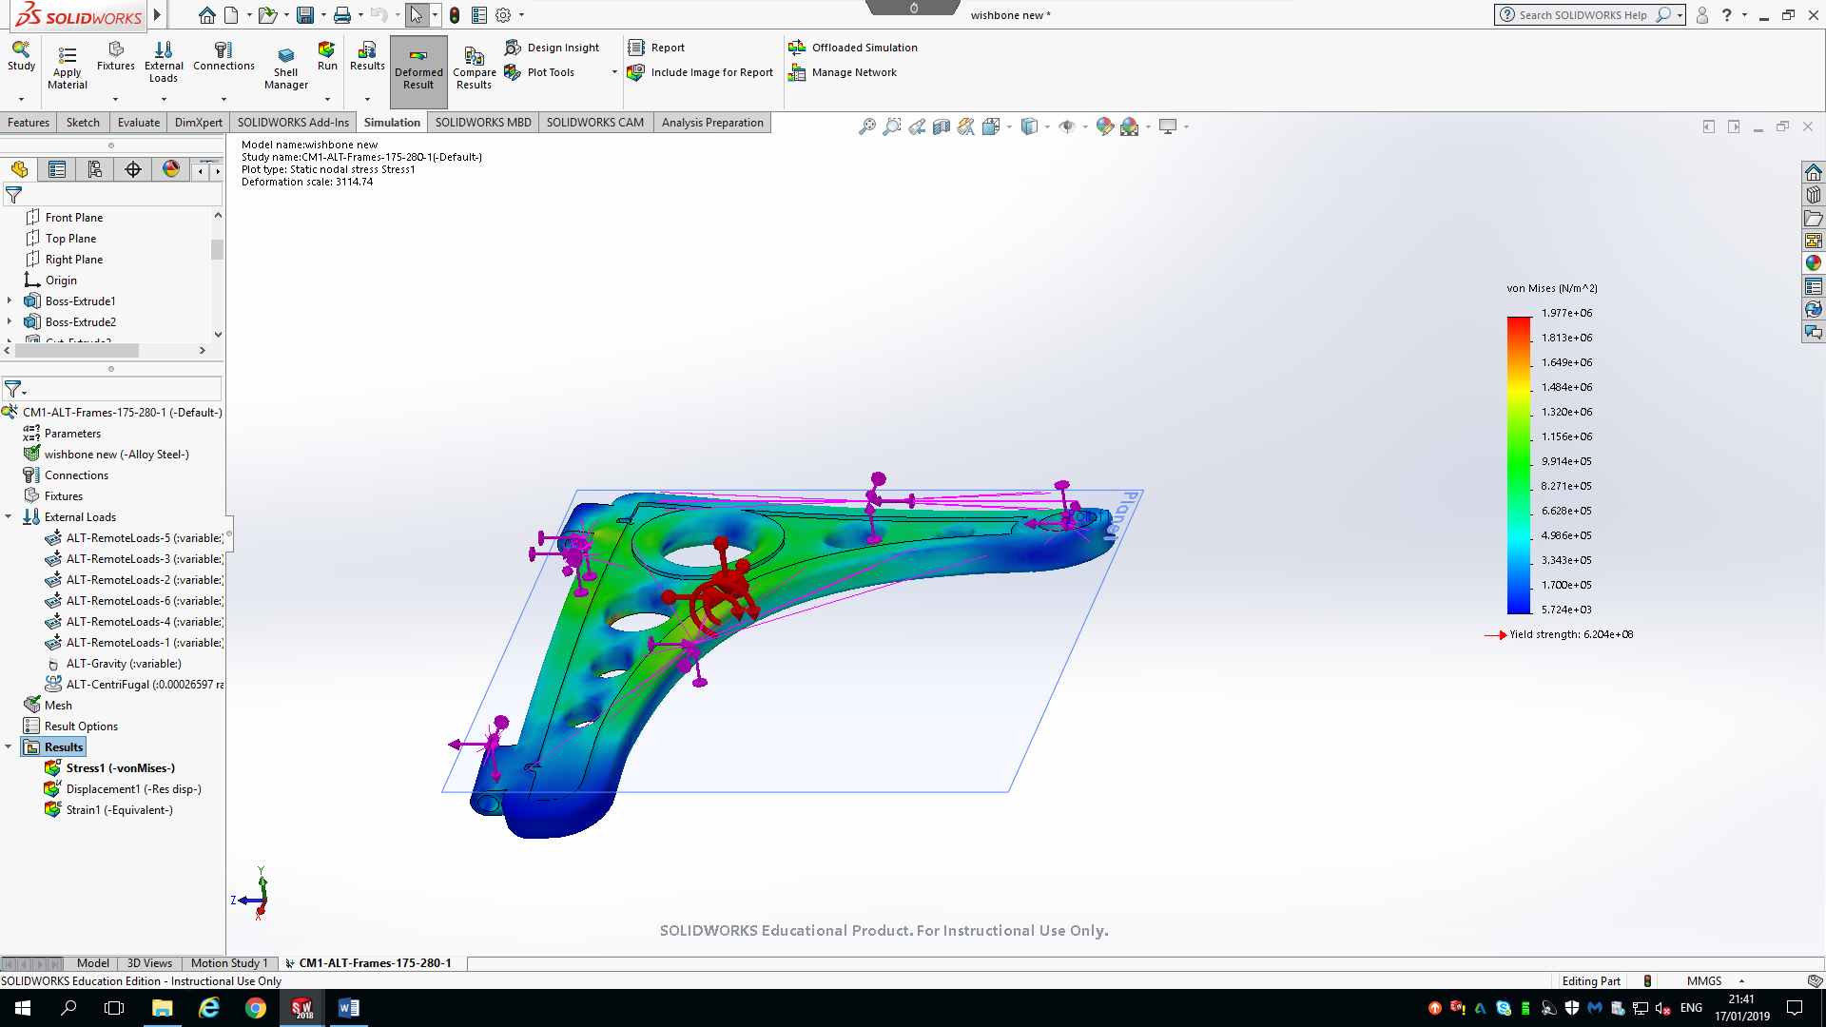
Figure 14: FEA Yield Strength for Design 2, (Daniel Salathiel, 2019).
Figure 14 shows the new yield results for the adapted wishbone design after the model had been run though the motion analysis simulation. The imported loads show that the wishbone experiences a max force of 1.977 to the power of 6 pascals. It can be noted that the lightened design is still well with in the limit tolerance of 6.204e +08, meaning the new lightened design is acceptable for use on the vehicle. It can also be noted that there are far less red markers across the upper surface, meaning that the force is being spread more efficiently across the wishbone design. (V. Kulkarni. Et al, 2012).

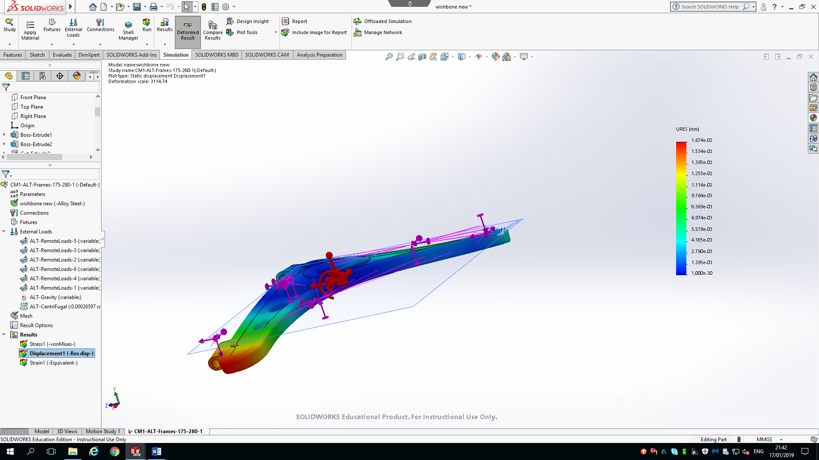
4.2.1 Finite Element Analysis displacement results for altered Design:

Figure 15: FEA Displacement for Design 2, (Daniel Salathiel, 2019).
The displacement of the second design shows a greater displacement value of 0.188mm, which isn’t a considerable difference when the weigh saving of 1902.06 grams is taking into consideration. The deflection points along the bushing joint hasn’t changed from the original design, just that it has displaced a larger amount. This is well within the tolerance for safety when coupled with the yield strength safety factor. This part offers greater advantage in reduced un-sprung mass and can still with stand the forces action on It when it hits the 90mm bump in the road. (V. Kulkarni. Et al, 2012).

4.3 Costing comparison for the Wishbone Designs:
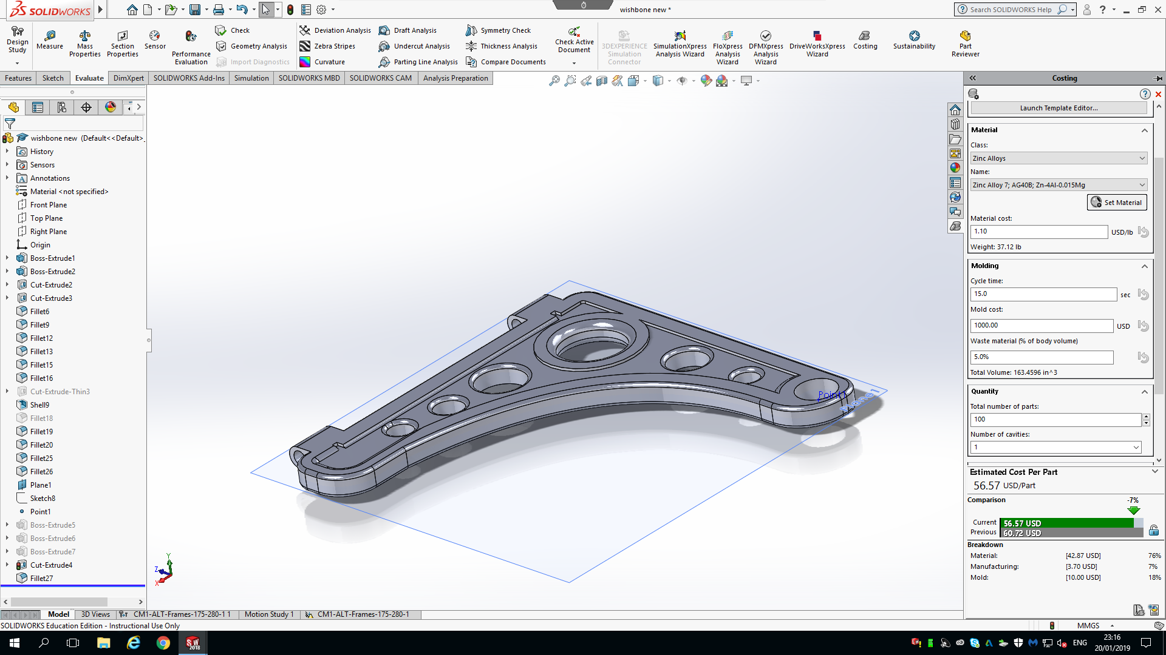
Figure 16: Manufacture costings for both designs, (Daniel Salathiel, 2019).
The costing comparison for the two designs takes into account the most expensive manufacturing scenario. The current costing represents the adapted design and the previous represents the original wishbone design. The results from the comparison show that the adapted design is $4.15 USD cheaper than the original design due to less material needed to manufacture the part. Meaning the second design is a more cost affective application to process.

5.0 Conclusion:
The process of modelling an accurate suspension system from a donor car was carried out efficiently to carry out a realistic motion analysis simulation. This allowed for accurate loads and forces in a linear range along the ‘Y’ axis to be recorded. The correct components and tools in the Solid Works software allowed for realistic characteristics for a range of suspension movements. This included the correct application of mates in the assembly.
The motion loads were imported into the Finite Element Analysis for the two designs to allow for an accurate comparison. This was concluded with an adapted design that weighs 1902.06 grams (1.9 Kg) lighter than the original design, while maintaining the structural integrity to be with in the safety tolerance of the yield strengths and the displacement tolerance. (V. Kulkarni. Et al, 2012). This allowed for the dynamics of the design to be acceptable for a suspension system on a passenger car. (J. WEN, 2007).
Further improvement to the testing of the designs in the future would be to increase the forces acting on the wishbones in a longitudinal direction to allow for the consideration of cornering forces, and how they might also affect the real-world application of the designs.
Based on the findings from the FEA and the costings for the two designs, the second adapted design is proposed as an improvement over the original design. This is due to key attributes such as reduced weight meaning decreased un-sprung mass (V. Kulkarni. Et al, 2012), and the design being cheaper to manufacture making it more economically desirable for a real-world application.

6.0 Bibliography:

(V. Kulkarni. Et al, 2012) KPdfs.semanticscholar.org. (2019). [online] Available at: https://pdfs.semanticscholar.org/2069/f190530031e30f3e6875b017739a15cd829a.pdf [Accessed Jan. 2019].
D. Salathiel. 2019. Solid works screenshots
Engineers Rule. (2019). Motion Studies (and How to Do Them) - Engineers Rule. [online] Available at: https://www.engineersrule.com/motion-studies-and-how-to-do-them/ [Accessed Jan. 2019].
Farrell, V. (2019). SOLIDWORKS Simulation: Introduction to Motion Analysis. [online] Hawk Ridge Systems. Available at: https://hawkridgesys.com/blog/solidworks-simulation-introduction-motion-analysis [Accessed Dec. 2018].
Finite Element Analysis for Design Engineers. (2019). SAE Mobilus.
Gillespie, T. (1992). Fundimental Of Vehicle Dynamics.
Saemobilus-sae-org.ezproxy.uwtsd.ac.uk. (2019). [online] Available at: https://saemobilus-sae-org.ezproxy.uwtsd.ac.uk/content/2007-01-1745/#abstract [Accessed Jan. 2019].
Wen, J., "FEA Modeling Verification and Validation: Correlating Model with Test Data by Optimization Analysis," SAE Technical Paper 2007-01-1745, 2007, https://doi-org.ezproxy.uwtsd.ac.uk/10.4271/2007-01-1745.

CAD Work Folder link for one drive:

https://uowtsd-my.sharepoint.com/:f:/g/personal/dsalathiel_149609_student_uwtsd_ac_uk/EupqDiuyPGlBloYh-gE3y4EBKqyb135YPQPgLmFouxScAQ?e=tVgmyc

