Employability and Career Development
LCLM4005
Name: Mohammod Amirul Awal Chowdhury
Student ID: 2511404
Lecturer Name: Konstantina Mari

Contents
Task 1: Comparison of Job Advertisements and Key Employability Skills 3
1.1 Comparison of Two Marketing Assistant Job Advertisements 3
1.2 Application of a Key Skill to Future Employment 4
Task 2: Self-Assessment, SWOT Analysis and Employability Readiness 5
2.1 Personal SWOT Analysis 5
2.2 Critical Self-Assessment 6
2.3 Evidence of Employability Readiness 7
Task 3: Employment Goals and Personal Development Plan 8
3.1 Short-Term and Long-Term Employment Goals 8
3.2 Personal Development Plan 8
References 10

Task 1: Comparison of Job Advertisements and Key Employability Skills

1.1 Comparison of Two Marketing Assistant Job Advertisements
Two new UK ads show two ways to get into marketing. The Wycliffe College Marketing and Communications Assistant is responsible for marketing, recruitment, brand development, digital content, events and data. St. Luke’s Hospice Marketing Assistants are responsible for social media, website and email updates, design, audience research and reporting (Wycliffe College, 2026; St Luke’s Hospice, 2026).
Table 1: Comparison of contemporary UK Marketing Assistant advertisements
Requirement area | Wycliffe College | St Luke’s Hospice | Commonality / difference
Purpose and audiences | Brand profile, pupil recruitment and engagement with families, alumni, staff and the community. | Fundraising, retail and hospice communications for supporters, patients, families and internal teams. | Both support engagement, but the audiences and organisational purpose differ.
Communication and teamwork | Written and verbal communication, consistent branding, events and liaison with agencies. | Sensitive responses, accurate messaging and collaboration across clinical, fundraising, retail and corporate teams. | Communication is central in both; St Luke’s requires greater sensitivity.
Digital content | Social media, website, newsletters, copy, photography, video and design. | Social scheduling, Mailchimp, website, Canva, photography, video and digital screens. | Both require multi-channel content; St Luke’s specifies more operational tools.
Analysis, organization and entry expectations | Data and analytics, multiple deadlines and relevant marketing, communications or digital experience. | Analytics, audience research, time management, organizational social-media experience and basic design. | Both combine creativity with evidence and organization; Wycliffe states the broader prior-experience threshold.
Sources: Wycliffe College (2026) and St Luke’s Hospice (2026).
The contrast shows a Marketing Assistant is more than just a creative junior employee. The role includes people skills, task management, digital creation, and basic analysis. Consistent delivery across channels, individuals and timeframes is achieved using basic communication and time management abilities. Digital capability and demonstrable evidence of achievement can strengthen a candidate’s competitiveness in the employment market. Communication, critical thinking, cooperation, and software skills are some of the early job needs that marketing recruiters are looking for (Flynn, Raymond and Siemens, 2026). The comparison between the two UK advertisements support this. Arumugham et al. (2026) study Indian MBA employment adverts, not UK assistant jobs. Their study of job postings also connects client relationships, digital marketing, communication and analytics. This context uniformity is beneficial; however, the two UK advertisements are more relevant for this employment choice. Soft skills are thus important but cannot substitute for digital proof (Elhajjar, 2022). Thus, contemporary marketing assistants require more than organizational and communication skills. They also have to manage digital content, evaluate audiences, interact across media and do basic marketing analytics.

1.2 Application of a Key Skill to Future Employment
Communication is the most flexible skill. For over 15 years, I have dealt with customers and have learnt to listen, change my responses, suggest items without pressuring them and handle problems gently when things become crazy. These processes may be helpful in audience research, colleague cooperation, event preparation, and customer-focused communications. Marketing communication and service are not the same. Marketing needs short language, a suitable tone for the brand and adjustments for email, social media and print. I have a strong understanding of behaviour from my experience, but I need more campaign writing and digital channel skills to use it in the work.

Task 2: Self-Assessment, SWOT Analysis and Employability Readiness

2.1 Personal SWOT Analysis
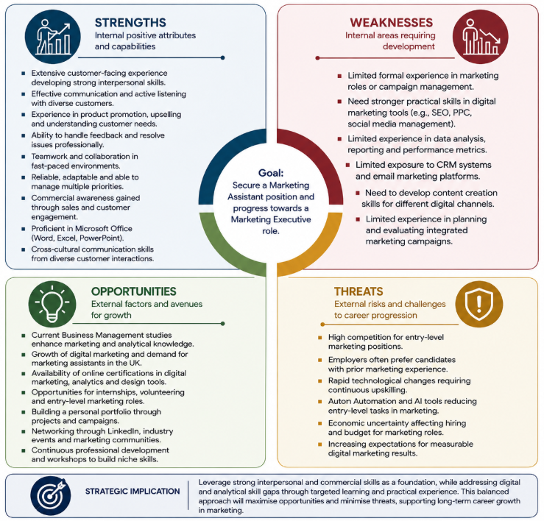
Figure 1: Personal SWOT analysis for progression towards a Marketing Assistant role (Self-developed in Canva, 2026)

2.2 Critical Self-Assessment
My SWOT analysis shows that I am, but not completely, qualified for the role I want. My biggest reward is not having a marketing job title, but being with people. Practical client focus has evolved via the constant collection of examples, the description of discounts and the answering of issues. This is helpful since employability demands self-belief, experience and the ability to talk persuasively about these things (Bennett and Ananthram, 2022). The main problem is translation. If I do not show how talking to customers helps me understand my audience, represent my brand and make business choices, employers may think my experience is just service labour.
My strength is business understanding and being able to communicate well. I've had to adjust my approach to communicating with different sorts of customers, promoting certain items, recommending wise choices, and maintaining the client relationship when issues arose in hectic scenarios. This experience shows that I can listen, persuade, maintain calm and decide. Employers appreciate business graduates’ organizational, digital, problem-solving, cooperation and communication skills (Bhatti et al., 2023). My strongest evidence is the customer service and product promotion, rather than the marketing plans. It would be unrealistic for me to claim expertise across all areas of business. Better software would link each conduct related to a marketing assistant job and show technological progress.
The main gap identified as lack of practical digital and analytical evidence. Both ads need cross-channel content, site activity and success stats. At St. Luke’s, email and basic design are also a must. According to recruiters’ study, current vacancies in digital marketing need technical and soft skills. This shows that bad tool use cannot be compensated by social skills (Elhajjar, 2022). I therefore need portfolio examples that demonstrate my ability to identify target audiences, structure content for different platforms, use appropriate digital tools and monitor reach, engagement and audience response. This would make the marketing interest claim verifiable and thus alleviate the disadvantage of direct experience candidates.
The opportunities identified in the SWOT matrix have limited value unless they are actively pursued. My current analysis can strengthen theoretical understanding, but its employability value will remain limited unless that learning is converted into practical evidence. To adjust to shifting jobs, problem-solving, self-reliance, teamwork, communication, and workplace literacy are all needed (Finch et al., 2023). I can do this by changing my customer service approach, learning some new tools and asking for a little campaign work instead of waiting for my company to grow. Defined aims, self-efficacy, active behavior, experience and networks facilitate job transitions (Tuononen and Hyytinen, 2022). Structured learning, observable practice and focused job market activities must be part of my development strategy.

2.3 Evidence of Employability Readiness
Employability readiness is demonstrated through consistent professional behaviours developed over time. Working in product promotion and discounting has taught me how to come up with client-focused concepts, enhancing my communication, consumer understanding and commercial acumen. Companies seek employees who have great communication, collaboration, problem-solving and organizational skills (Bhatti et al., 2023). During busy times, I was able to priorities work, work with coworkers to get things done and maintain quality of service. This demonstrates that I am reliable and a team player. Learning at work may develop adaptable and collaborative employability skills (Jackson and Dean, 2023) and self-belief and explaining experience can help to improve employability (Bennett and Ananthram, 2022).
My current studies in business management improve my educational knowledge and demonstrate my will to progress after much experience in the field. This knowledge could support marketing by working with partners, events, management, customers and content. An important limitation highlights the lack of evidence demonstrating my ability to deliver and evaluate multi-channel marketing activities. I have not proved my ability to create or report on multi-channel strategy results. My employability readiness should therefore be viewed as developing rather than complete. I have a mature social and professional skillset, but I need to work on my digital execution and quantitative campaign evidence.

Task 3: Employment Goals and Personal Development Plan

3.1 Short-Term and Long-Term Employment Goals
My short-term goal is to complete a popular digital marketing course and design a multichannel campaign within three months. In six months, I will need to show a small portfolio with basic social media, email and performance reporting abilities. These goals are helping me close the gap between the customer service skills I have and the concrete evidence asked for in the two ads. Structured career solutions are effective in helping people to prepare, choose and comprehend the work market (Soares, Carvalho and Silva, 2022).
I want to work as a marketing assistant, marketing and communications assistant or anything similar within a year. I want to be a marketing executive in two to three years’ time after I have shown that I can organize and report on campaigns. This makes sense, since it sees entry into marketing as a sequence of steps, rather than assuming that knowledge gained in other professions will automatically lead to progression in marketing.

3.2 Personal Development Plan
Table 3. SMART personal development plan
Development need | SMART action | Resources required | Target timescale | Evidence / measure of success
Integrated campaign planning | Complete a recognized introductory course and create one campaign pack containing a brief, audience profile, three channel assets, schedule and KPI plan. | Online course, university library, free design software and tutor or peer feedback. | Within 3 months | Course certificate, completed campaign pack and written feedback against a checklist.
Digital tools and analytics | Practice social scheduling, prepare a test email campaign and build a simple Excel dashboard that reports and interprets at least three KPIs. | Training accounts, Microsoft Excel, guided tutorials and feedback from a tutor or experienced practitioner. | Within 6 months | Scheduling demonstration, test email, KPI dashboard and a 300-word interpretation of results.
Formal marketing evidence | Complete a voluntary or short campaign for a suitable local organization and submit 20 tailored applications for entry-level marketing roles. | University careers service, LinkedIn, local organizations, portfolio and job-alert platforms. | Within 12 months | Project reference, portfolio case study, application log and at least two interviews or documented employer feedback.

References
Arumugham, L., Palanisamy, M., Vincent, M.T.P. and Hossain, M.B. (2026) ‘Unveiling marketing competencies for MBA graduates through text mining and machine learning applications’, Applied AI Letters, 7(2), e70020. Available at: https://doi.org/10.1002/ail2.70020.
Bennett, D. and Ananthram, S. (2022) ‘Development, validation and deployment of the Employability scale’, Studies in Higher Education, 47(7), pp. 1311–1325. Available at: https://doi.org/10.1080/03075079.2021.1888079.
Bhatti, M., Alyahya, M., Alshiha, A.A., Qureshi, M.G., Juhari, A.S. and Aldossary, M. (2023) ‘Exploring business graduates employability skills and teaching/learning techniques’, Innovations in Education and Teaching International, 60(2), pp. 207–217. Available at: https://doi.org/10.1080/14703297.2022.2049851.
Elhajjar, S. (2022) ‘Digital marketing jobs: What are recruiters looking for?’, Journal of Education for Business, 97(1), pp. 29–35. Available at: https://doi.org/10.1080/08832323.2021.1884520.
Finch, D.J., Levallet, N., Saunders, C., Field, E., Ribeiro, J., Raby, S., Roberts, M., Uzoka, F.-M. and Campbell, A. (2023) ‘A dynamic capability view of career adaptation: an exploratory study’, Education + Training, 65(5), pp. 769–789. Available at: https://doi.org/10.1108/ET-06-2021-0235.
Flynn, K., Raymond, M.A. and Siemens, J. (2026) ‘Marketing career readiness in the digital era: required skills and knockout factors’, Marketing Education Review, advance online publication. Available at: https://doi.org/10.1080/10528008.2026.2658751.
Jackson, D. and Dean, B.A. (2023) ‘The contribution of different types of work-integrated learning to graduate employability’, Higher Education Research & Development, 42(1), pp. 93–110. Available at: https://doi.org/10.1080/07294360.2022.2048638.
Soares, J., Carvalho, C. and Silva, A.D. (2022) ‘A systematic review on career interventions for university students: framework, effectiveness, and outcomes’, Australian Journal of Career Development, 31(2), pp. 81–92. Available at: https://doi.org/10.1177/10384162221100460.
St Luke’s Hospice (2026) ‘Marketing Assistant’, Find a Job, 27 February. Available at: https://findajob.dwp.gov.uk/details/17952088 (Accessed: 16 August 2026).
Tuononen, T. and Hyytinen, H. (2022) ‘Towards a successful transition to work: which employability factors contribute to early career success?’, Journal of Education and Work, 35(6–7), pp. 599–613. Available at: https://doi.org/10.1080/13639080.2022.2126969.
Wycliffe College (2026) ‘Marketing and Communications Assistant’, Find a Job, 13 March. Available at: https://findajob.dwp.gov.uk/details/18030673 (Accessed: 16 August 2026).

